1. Start this application in local and hit the below mentioned end point

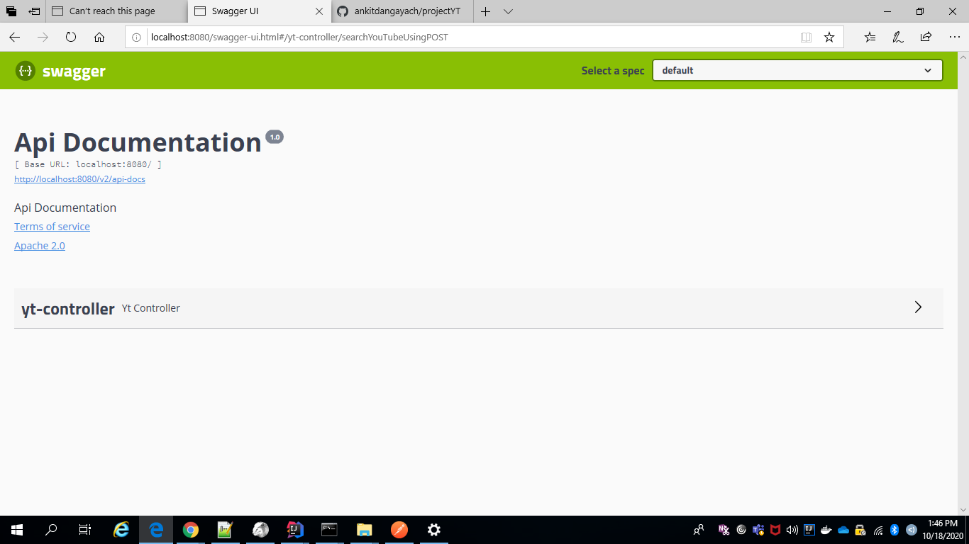

1. Expand the yt-controller and provide input string as “Telecom” and items here is describing how much data you want as part of your post request(By default I have setup this as a 25)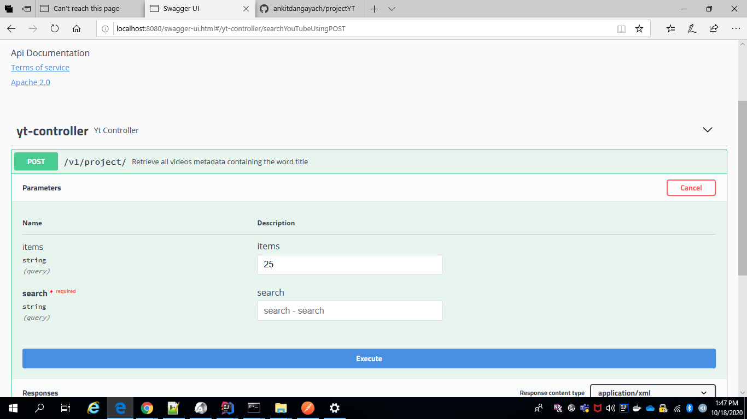
2. After hitting the endpoint see the console logs over there you can see QueueAMessage and QueueBMessage in XML format.  
   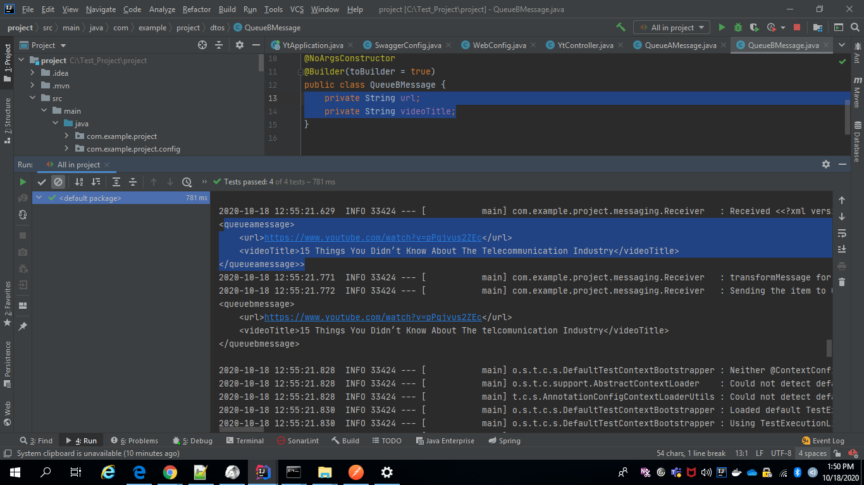

Please let me know in case of any issues.