

Group 3 | OST LAB | April 6, 2016

Emailing Service

WITH spam filtering

# Get Started Right Away

When you click this placeholder text, just start typing to replace it all. But don’t do that just yet!

This placeholder includes tips to help you quickly format your report and add other elements, such as a chart, diagram, or table of contents. You might be amazed at how easy it is.

# Make It Gorgeous

* Need a heading? On the Home tab, in the Styles gallery, just click the heading style you want. Notice other styles in that gallery as well, such as for a quote or a numbered list.
* You might like the cool, blue ice pond on the cover page as much as we do, but if it’s not ideal for your report, right-click it and then click Change Picture to add your own photo.
* Adding a professional-quality graphic is a snap. In fact, when you add a chart or a SmartArt diagram from the Insert tab, it automatically matches the look of your document.

# Give It That Finishing Touch

Need to add a table of contents or a bibliography? No sweat.

## Add a Table of Contents

It couldn’t be easier to add a table of contents to your report. On the Insert tab, click Cover Page to see cover page designs that include a table of contents page — look for TOC.

Just click to insert one of these and you’ll be prompted to update the TOC. When you do, text you formatted using Heading 1, Heading 2, and Heading 3 styles is automatically added.

## Add a Bibliography

On the References tab, in the Citations & Bibliography group, click Insert Citation for the option to add sources and then place citations in the document.

When you’ve added all the citations you need for your report, on the References tab, click Bibliography to insert a formatted bibliography in your choice of styles.

And you’re done. Nice work!

# Submitted By

Shreyas Satardekar 141070008 (04)

Anmol Yash 141070020 (12)

Ankitesh Gupta 141070022 (14)

# Under the Guidance of

Prof. Abhijit Bhusale



**VEERMATA JIJABAI TECHNOLOGICAL INSTITUE**

**DEPARTMENT OF COMPUTER ENGINEERING**

**ACADEMIC YEAR 2015-16**

# **ABSTRACT**

As we know, email services have grown at a very fast rate in the past few years. Emails are delivered extremely fast when compared to traditional post and can also be sent at any given time and any given day provided that you have internet connection. This is the reason behind choosing emailing service as our topic.

We are creating an emailing platform consisting of most of the functions which are carried out by mail clients today. If the user doesn’t have an account created, then he/she will have to create a new account by entering their details. Each user will have a unique User ID. The information of all the users will be stored in a database and the User ID of the student will act as a primary key. The user can log in with the help of User ID and a password of his/her choice. The user will be able to compose a mail and send the mail to other users. The user will also be able to receive mails from other users and he/she will be able to look at the details of the mail received. The user will be able to change the information in his/her profile at any time. The user will also be able to add a profile picture for the account.

Another important feature which we have included is spam filtering. If any message received is to be treated as spam, then the message will automatically be stored in the spam folder and not in the inbox of the user thus sorting out the unnecessary messages from the important ones.

# **INTRODUCTION**

This web application will serve as a destination for all the students as well as other people to mail each other very easily. It consists of interactive Graphical User Interface which is easy to use and navigate through. All the people will find it easy to use all the functions and facilities provided by this application.

Due to the added functionality of spam filtering, it’ll be easy for the user to view messages which are of use to him. The user is also able to send an attachment along with the mail if he/she wishes to do so. Along with this, the user can also send Rich Text i.e. **Bold,** *Italics,* Underline, etc.

The usage of open source technologies gave us the great ability to customize the system the way we wanted to and implement ease of access at the back end as well.

For the Front End, we have used HTML, CSS and JavaScript. The backend is handled with the help of Apache Server and MySQL database. PHP is used to then implement the features of both frontend and backend to create this emailing service of ours.

# Features of Emailing Service:

* Existing users can log in.
* A new user can register within minutes.
* A user can add a profile picture with his/her account.
* User can add personal details such as DOB, age, etc. and change them at any time he wants to.
* User will be able to see if he/she has read the current mail or not.
* User can mark any mail as **starred,** so it can be accessed more easily.
* Similarly, any mail can be un-starred at any time.
* The user has the ability to view his sent mail as well as his trash along with his inbox.
* The deleted mail will be permanently deleted after 30 days.
* The user can un-trash a mail if he/she wishes to do so.
* It is possible to quickly reply to a mail from within the mail.
* The user can attach files along with the mail.
* Rich text can be sent such as **Bold,** *Italics,* Underline, etc.
* The user can change the password at any time he wants.
* The user can delete his account at any time he wants.

# Technologies Used:

* Apache Open Source Server.
* HTML, CSS, JavaScript and PHP for web development.
* Xampp was used for Apache Server and MySQL and Sublime Text Editor as the text editor.
* Database was handled with the help of MySQL.

# **BACK END**

# Entities:

1. Userdetails:

The userdetails table consists of several attributes related to the user as the name itself suggests.

1. id – This is an auto incremented attribute which automatically assigns a new id to a new user.
2. Username – This is a unique username and this along with the id acts as a primary key.
3. Password – md5 hashing is used to save the password in an encrypted format.
4. Firstname – This stores the first name of the user.
5. Lastname – This stores the last name of the user.
6. Emailaddress – This stores the email address of the user.
7. PhoneNo. – This stores the phone number of the user.
8. Gender – Gender is stored here.
9. DOB – The user’s Date of Birth is stored here.
10. Country – User’s country is stored in this column.
11. Profilepic – The user’s profile pic is stored here.
12. datetime – This stores current date and time details to see when the account was created.
13. mails:

The userdetails table consists of several attributes related to the user as the name itself suggests.

1. Id - This is an auto incremented attribute which automatically assigns a new id to a new mail. It acts as a primary key.
2. Sender – This is the sender of the mail.
3. Receiver – This is the receiver of the mail.
4. Subject – Subject of the mail is stored in this column.
5. Body - Body of the mail is stored in this column.
6. Attachname – This is the name of the attachment.
7. Attachment – This stores the attachment file.
8. Currtime – This stores the current time.
9. deletedtime – This stores time for when mail was deleted.
10. readcount – This is used to see if the mail is read or not.
11. Starred – This is used to see if the mail is starred or not.
12. trash – This is used to see if the mail is deleted or not.
13. delfromsent - This is used to see if the mail is deleted by sender or not.
14. spam – This is used to see if the mail is treated as spam or not.
15. spam

The spam table consists of several attributes related to the spammers as the name itself suggests.

1. Id – This stores the id of the spammer.
2. Spammers – This is the username of the spammer.
3. Password - md5 hashing is used to save the password in an encrypted format.
4. The trash table has attributes similar to that of mails table. It is used to store trash mails in it.

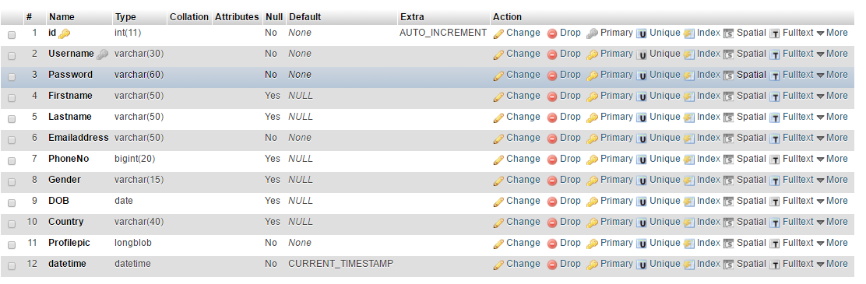

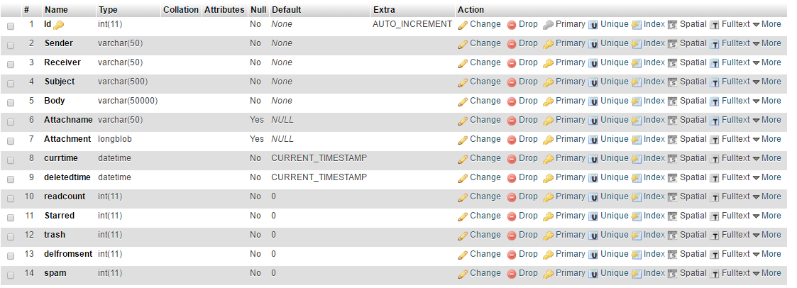

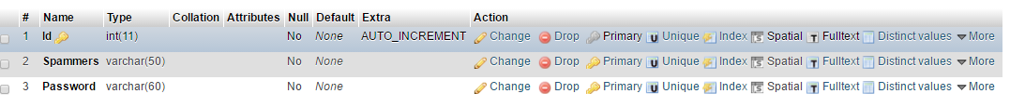

# **EVENTS**

The MySQL Event Scheduler manages the scheduling and execution of events, that is, tasks that run according to a schedule. An event is similar to a trigger. However, rather than running in response to a data change, events can be scheduled to run any number of times during a specific period. In effect, it’s a database-only cron job.

We have used event in mailing service.

Whenever a user deletes a mail, then an event will be automatically generated which will delete the mail permanently exactly after 30 days of the current time stamp.

The query for it is as follows:

$qevent = "CREATE EVENT test_event_$idofmail

ON SCHEDULE AT CURRENT_TIMESTAMP + INTERVAL 30 DAY

DO

DELETE FROM mails WHERE mailid= '$idofmail'";

Every event has a unique name based on the unique id of the mail currently being treated.

If the user decides to remove a mail from trash, then the event has to be deleted the query for which is as follows:

$devent = "DROP EVENT test_event_$idofmail";

# **Login/SignUp Form**

We have modularized the code into two folders, Finalwelcomepage and LoginForm, for clarity. All the files related to the login page are in the second folder, while the rest of the details such as Inbox, Compose, Sent, Trash, Spam etc. are in the first folder. At the beginning of the code for the login form, we check whether a user is already logged in. If he/she is, then the user will directly be taken to the welcome page, otherwise he/she will be taken to the login page. We have used the font family Open Sans. All the Cascading Style Sheets(CSS), images and JavaScript files(js) are stored in their respective folders. The background image is set to ‘cover’ the entire page. For the main login form in the center, the CSS is defined in the class ‘demo’. The size and position of the login form is defined in ‘demo’. One of the relatively new tags used here is the svg tag. This tag is used to define graphics and small animations. First, the viewBox is used to define the size of the box in which we are going to draw the animation. Then, the path attribute defines the exact path in which the animation must be made.

The <path> element is used to define a path.

The following commands are available for path data:

* M = moveto
* L = lineto
* H = horizontal lineto
* V = vertical lineto
* C = curveto
* S = smooth curveto
* Q = quadratic Bézier curve
* T = smooth quadratic Bézier curveto
* A = elliptical Arc
* Z = closepath

Bézier curves are used to model smooth curves that can be scaled indefinitely. Generally, the user selects two endpoints and one or two control points. A Bézier curve with one control point is called a quadratic Bézier curve and the kind with two control points is called cubic.

The login fields, that is username and password, are required. Without it, the user cannot log in. In the sign up page, the e-mail address, username, password and confirm password, all fields are compulsorily required to be filled. The log in page has a link to the sign up page and the sign up page has a link to the log in page.

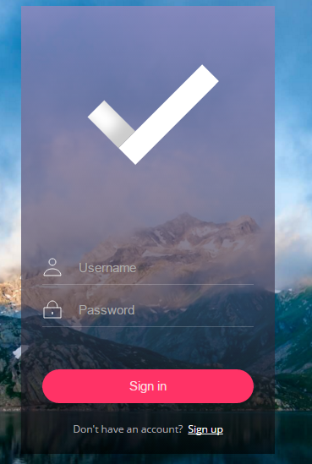

***Fig 1.1: Login Form***

Sign up form is the same as that of login form only that the input fields are different. After taking the input from the user the validity of it being a correct input format is checked in javascript. If the input is in the correct format the data is passed onto the backend(PHP) where it authenticates the user. If the credentials are wrong a message is displayed saying that “wrong input”, and redirecting user to the login page, whereas if the credentials entered are correct a session is started and his home page is displayed.

# **Home Page**

Once the user is logged in successfully a Welcome/Home page is displayed on his/her device. There are different options on the home Page that a user can select from. The page as basically two sections Top and the Body. At the Top toolbar is located where these options are given.

* Settings
* Account
* Contact Us
* Starred
* Schedule an email
* Logout

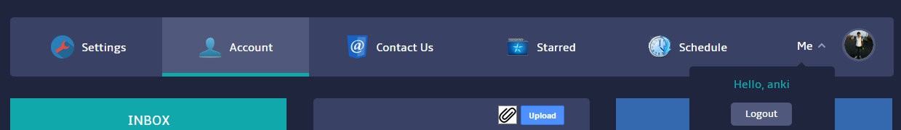

***Fig 2.1****:* ***Top Menu bar***

**ACCOUNT PAGE**

The default page that is set is the Account Page.

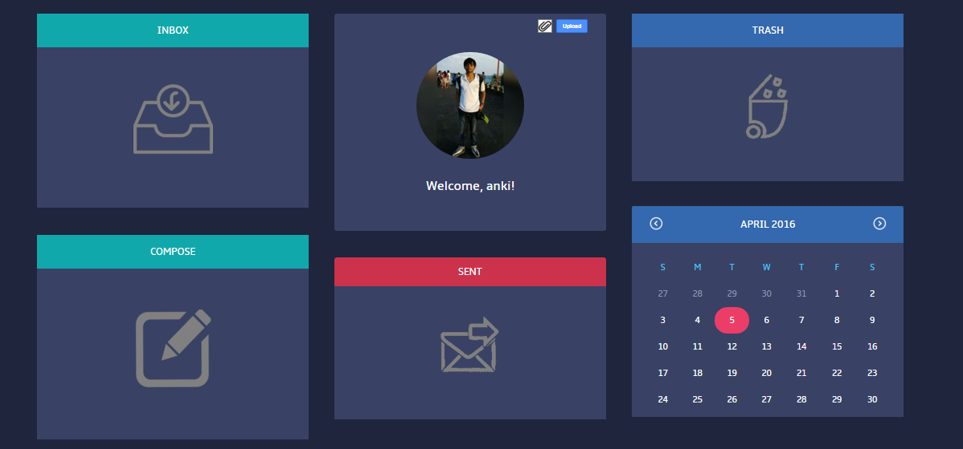

***Fig 2.2: Account Page View***

The Account Page provides the following options

* Profile picture and name
* Inbox
* Compose a mail
* Sent
* Trash
* Calendar

The background color is a material design color of bluish shade. This page is divided into three sections Left, Middle, Right. As it can be seen in the fig 2.2 that the left one has Inbox and compose, the middle one has Profile details and Sent, whereas the right column has Trash and Calendar. Calendar is just for showing dates.

**PROFILE PICTURE AND NAME.**

This section displays “Welcome, ‘your name’ “. If you are a new User it displays a default profile picture. It provides an option to upload your own profile picture this can be done by selecting the attach icon and selecting appropriate image file and then by clicking upload button it will update your profile picture this will also reflect in the database at the backend.

**INBOX**

Once you click this option this will redirect you to a page where the mails that you receive will be displayed.

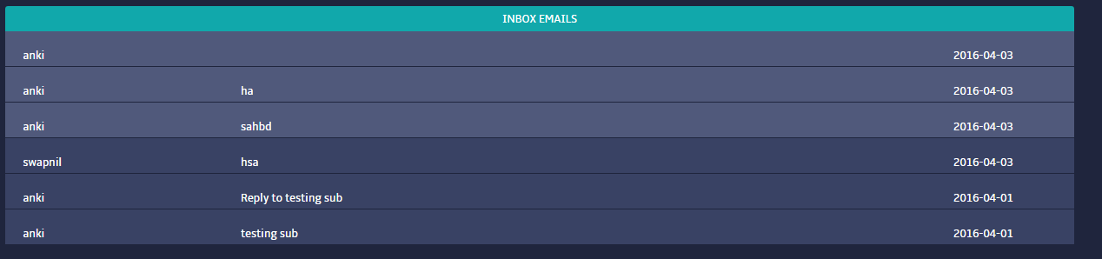

***Fig 3.1: Inbox Emails***

As it can be seen in Fig 3.1 it displays all the mails that the logged in user has received. These mails list has two colors light and dark. When you hover over any message its color becomes the lighter shade. But some of them are lighter from before as shown in the above figure. That is because those messages are unread and the one with the darker shade are read. Every mail has three columns as shown Sender, Subject, Time of receiving.

Now when you click any email it will redirect the user to a new page where the details of the mail are displayed.

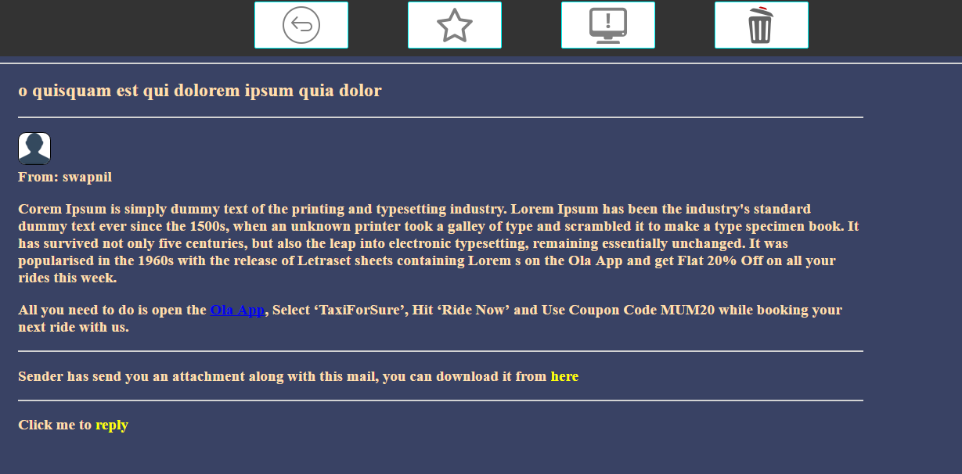

***Fig 3.2: Expanded view of a mail.***

As shown in fig 3.2 there are 5 sections in all. One show the header that has options such as **BACK** which will take you back a page, **STAR** which will star this mail, **REPORT SPAM** which will report this mail as a spam and will remove it from the inbox and **DELETE** which will delete this mail and will store in trash for 30 days but after 30days this mail will be permanently deleted.

Now, coming to the next section which will display the subject of the mail. Below it in the next section information of the sender is displayed along with its profile pic. The next part displays the Body of the mail. Below it is the attachment section which will only be shown if the sender has sent an attachment, if yes then there is an option to download the attachment too :). The last section is the reply section where one can reply to a particular message that he receives.

For SENT, TRASH the UI is same as that of inbox except that there are some minor changes below shown is the snip of code of sent/trash

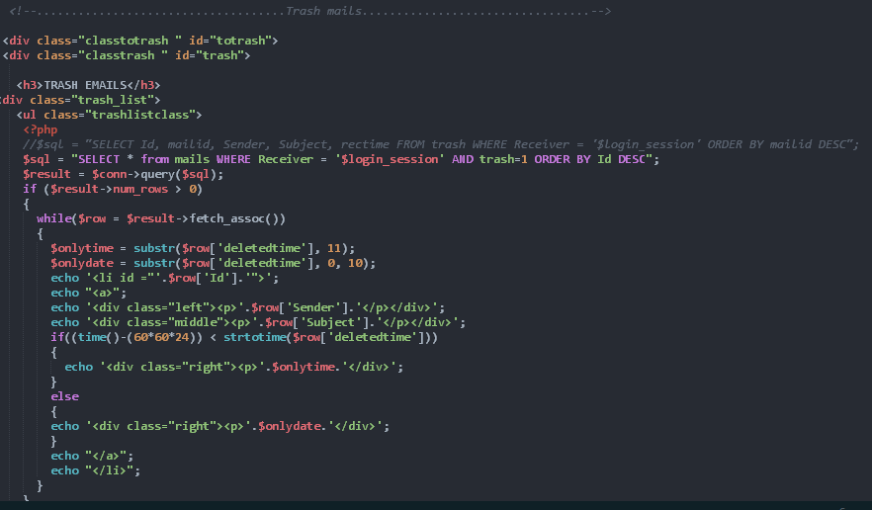

***Fig 3.3: Snap of code of trah/sent***

**COMPOSE MAIL**

Now if a user wants to send a mail, he/she can click the option of compose mail and within seconds a modal will pop-up at the right corner of your screen which will asks some information and has a submit button so that when you click on it the mail will be sent and a message will be displayed saying that “mail successfully sent”. This information will stored in a database at the backend and this mail will start reflecting in the sent box. What if the information entered was wrong? Of course the mail won’t be sent and it will display “mail was not sent due to invalid information”. Below attached is the screenshot of the compose mail pop

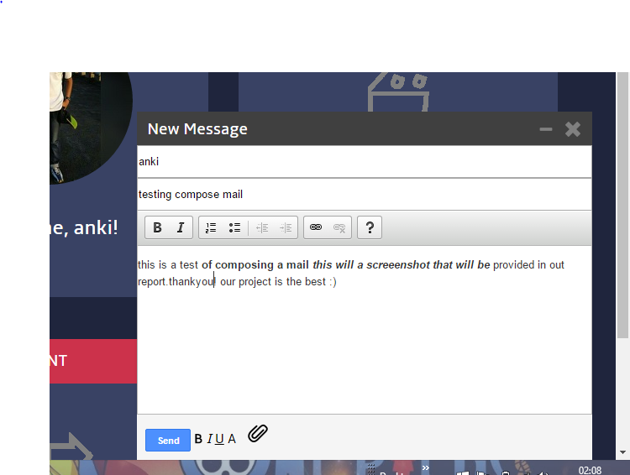

***Fig 3.4: Compose a mail***

As shown in the above figure the 1st input asks for the receiver, the 2nd one asks for the subject and then we have the body of a mail with an inline editor attached to it so that one can edit its mail while composing it. Then at the bottom we have an attach icon that lets the user attach a file and lastly send button which when clicked will send your mail. Below shown is the code snippet.

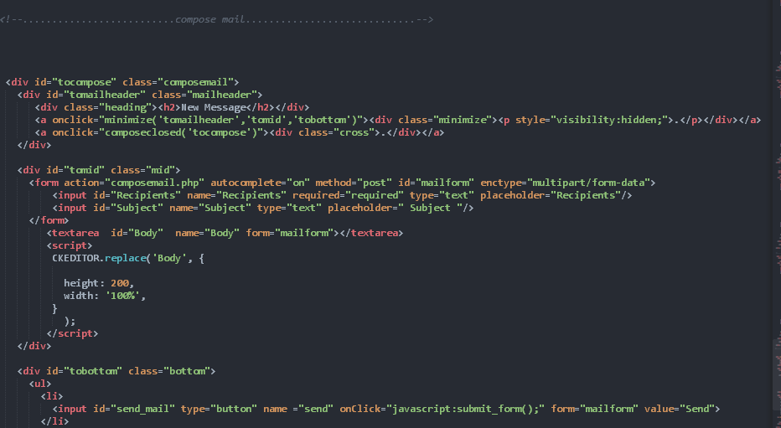

***Fig 3.5: Compose mail code snip.***

**SETTINGS**

Now, in this section we can set our preferences. There are four options provided under this section i.e.

* View Profile
* Change password
* View Spams
* Delete Account

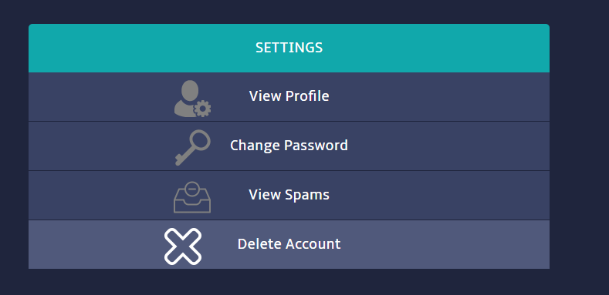

***Fig 4.1: Settings list***

**VIEW PROFILE.**

As the title suggest one can view his profile details. If he/she is a new user then by default only his mail and account created will be there one will need to update its information, as about styling this section collapse has been implemented. Modal is implemented here too. Note here the background is disabled, if a user needs to update his/her information he/she can click the edit button and enter valid information and click the update button, this entry will be added into the database and the page will be reloaded automatically and the updated information will start reflecting.

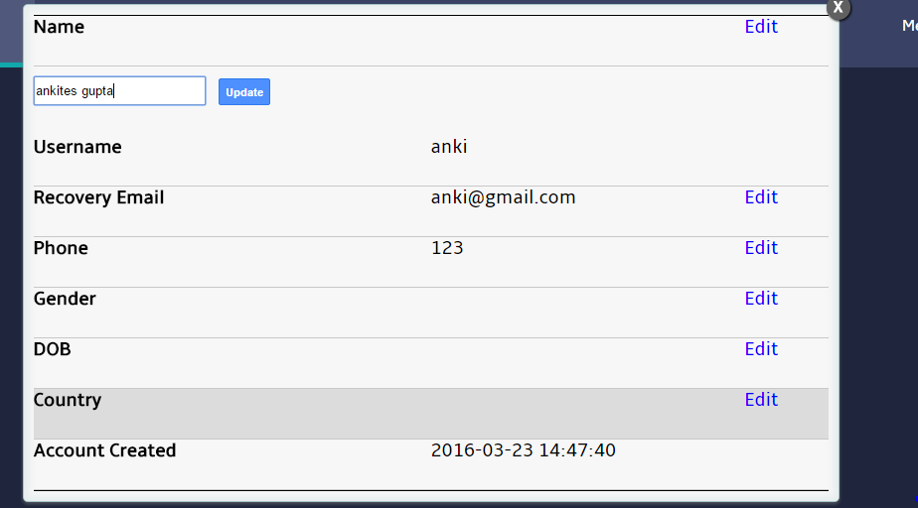

***Fig 4.2: View Profile.***

**CHANGE PASSWORD**

Here one can change his/her password screen shot of ui has been provided.

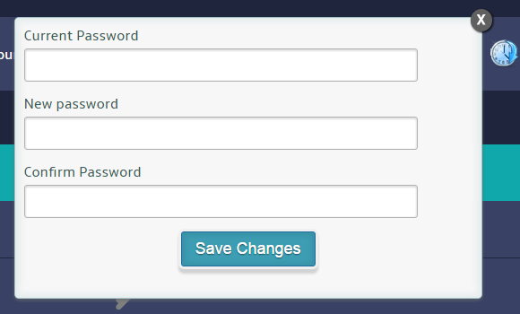

***Fig 4.3: Change Password.***

**DELETE ACCOUNT**

One can delete his/her account.

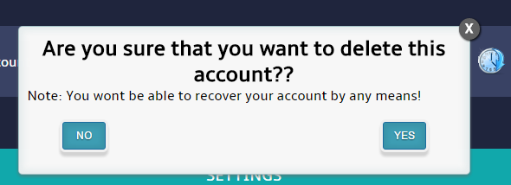

***Fig 4.4: Delete Account.***

NOTE: We will cover spam in later sections.

**CONTACT US**

Here the information of the developers has been displayed, when one hover overs developer’s pic an animation will be displayed and his information will be shown.

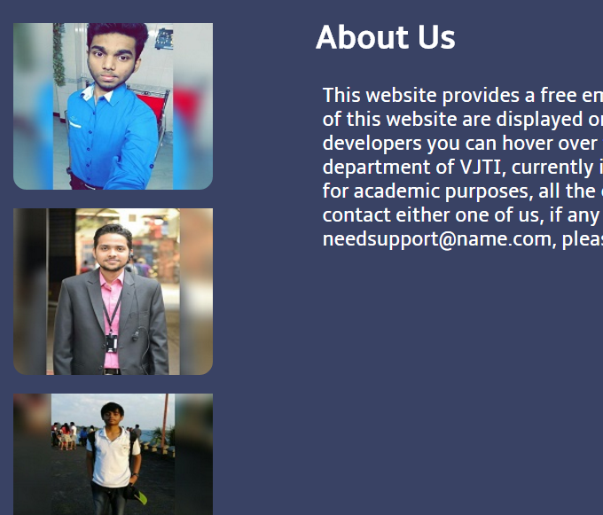

***Fig 4.5: Contact Us.***

STARRED MAILS

In this section the ui is just like the inbox except that here an entry will only be displayed when a user stars a mail. By clicking on the stars mail list the mail information will be displayed.

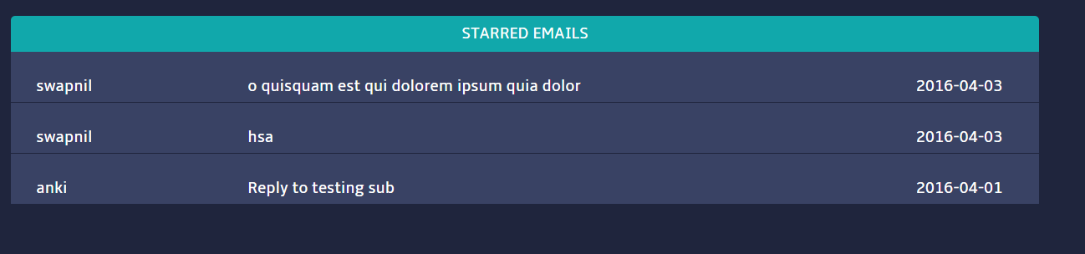

***Fig 4.6: Starred Emails.***

# NEW FEATURES

Here we have two new features in our mailing service that one can’t find in any other mailing service platform. If you can find it then either they have applied some other logic to implement it (Spam filtering), or it is not officially released by the vendor (scheduling an email). These are

* Spam filtering
* Scheduling an email

SPAM FILTERING

Spam is an irrelevant or unsolicited message sent over the internet, typically to large number of users. Now to avoid these kind of messages there should be a spam filtering system. Let us take example of gmail that how does it implement spam filtering.

What it does is it has two conditions

1. It looks in his mails database and checks for an user that has sent an email in lots i.e. to large number of users at a time and it declares him/her as a spammer.
2. Now whenever one receives an email it checks the sender of the mail if it is send by one of the spammers then it declares it as a spam.

This is not a good implementation as there can be an user that has sent emails in lot and he/she is not a spammer.

So to improve this we have deployed our own logic. What we have done is we have created a table as spam_words which has two columns spam_phrase and a corresponding score.

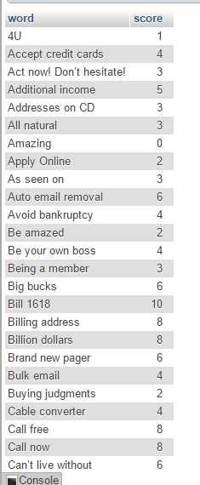

***Fig 5.1: Spam*** Words ***database***

So in this table we have entered around 200 entries that are of common phrases that are used in a spam email. So whenever a user receives an email we have a script ready that checks for these phrases in the mail if it finds one it adds the corresponding score to the previous score after reading the whole email the final score is stored in a variable, we have a formula ready in which just plugin in the total score it will give a final score out of 10 if it is greater than 6.84 then it is declared as a spam or else not. Once it is declared as spam it makes its entry in the spam table. The spam mails can be viewed by going into settings.

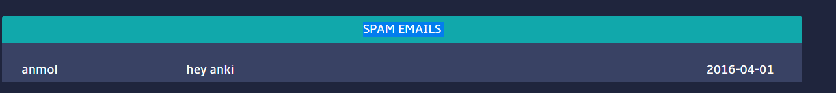

***Fig 5.2: Spam mails section***

SCHEDULING AN EMAIL

Now this is another new feature that one can’t find in any mailing service. For instance let’s consider your boss tells you to send an email after 10hours, but you are going on a vacation where you won’t have internet accesses in that case what will you do? Our mailing service solves this issue by providing “scheduling an email” option. To use it click the scheduling button in the top toolbar as soon as you click it an modal will be opened just like compose mail but in the left corner of your screen.

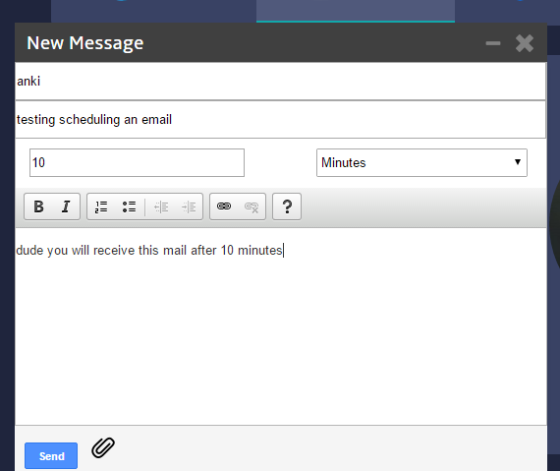

***Fig 6.1: Scheduling an email UI***

As shown in the figure all the fields are same as that of compose mail except there is a new field i.e. scheduling time in the picture shown above this is 10 minutes.

That means this mail will be delivered after 10minutes.

Units that are allowed are seconds, minutes, hours, days, months.