Mobile Application Development (Lab Evaluation)
Lab 5
Name – Ankit Agrawal
Registration No. – 180953278
Branch – Computer & Communication Eng.
Batch – 2

Q1. Create an App ,”Vehicle Parking Registration”, where in the user selects from a range of different vehicles type such as car, bike etc. from a spinner list ,and enters the vehicle no and RC no into a text area .Once the user clicks on the submit button ,details entered by user should display in other View and ask for user confirmation or give an edit option. Once the details are confirmed from the user, the details should be displayed in a toast message with a specific serial no. confirming allotment of parking.
Ans.

AndroidManifest.xml –
<?xml version="1.0" encoding="utf-8"?>
<manifest xmlns:android="http://schemas.android.com/apk/res/android"
package="com.example.l5q1">
<application
android:allowBackup="true"
android:icon="@mipmap/ic_launcher"
android:label="@string/app_name"
android:roundIcon="@mipmap/ic_launcher_round"
android:supportsRtl="true"
android:theme="@style/AppTheme">
<activity android:name=".MainActivity">
<intent-filter>
<action android:name="android.intent.action.MAIN"/>
<category android:name="android.intent.category.LAUNCHER"/>
</intent-filter>
</activity>
<activity android:name=".EditActivity">
</activity>
</application>
</manifest>

MainActivity.java –
package com.example.l5q1;
import android.content.Intent;
import android.os.Bundle;
import android.support.v7.app.AppCompatActivity;
import android.view.View;
import android.widget.ArrayAdapter;
import android.widget.Button;
import android.widget.EditText;
import android.widget.Spinner;
public class MainActivity extends AppCompatActivity
{
Spinner spinVehicle;
EditText editVNo;
EditText editRCNo;
Button btnSubmit;
DataOper dataOper;
@Override
protected void onCreate(Bundle savedInstanceState)
{
super.onCreate(savedInstanceState);
setContentView(R.layout.activity_main);
dataOper1 = new DataOper(this);
spinVehicle = findViewById(R.id.spin_vehicle);
editVNo = findViewById(R.id.edit_vno);
editRCNo = findViewById(R.id.edit_rcno);
btnSubmit = findViewById(R.id.btn_submit);
btnSubmit.setOnClickListener(new View.OnClickListener()
{
@Override
public void onClick(View v)
{
if(editRCNo.getText().toString().isEmpty())
editRCNo.setError("Enter RC number");
else if(editVNo.getText().toString().isEmpty())
editVNo.setError("Enter vehicle number");
else
{
dataOper1.setType(spinVehicle.getSelectedItemPosition());
dataOper1.setRCNo(editRCNo.getText().toString());
dataOper1.setVNo(editVNo.getText().toString());
dataOper1.save();
startActivity(new Intent(MainActivity.this, EditActivity.class));
}
}
});
ArrayAdapter<String> adapter = new ArrayAdapter<String>(this,
android.R.layout.simple_spinner_dropdown_item);
adapter.addAll(getResources().getStringArray(R.array.vehicle_types));
spinVehicle.setAdapter(adapter);
}
@Override
protected void onResume()
{
super.onResume();
if(!dataOper.isEdit())
{
spinVehicle.setSelection(0);
editRCNo.setText("");
editVNo.setText("");
}
}
}

activity_main.xml –
<?xml version="1.0" encoding="utf-8"?>
<LinearLayout xmlns:android="http://schemas.android.com/apk/res/android"
xmlns:tools="http://schemas.android.com/tools"
android:layout_width="match_parent"
android:layout_height="match_parent"
android:background="#000000"
android:orientation="vertical"
android:padding="16dp"
tools:context="com.example.l5q1.MainActivity">
<TextView
android:layout_width="match_parent"
android:layout_height="wrap_content"
android:textAlignment="center"
android:textSize="35dp"
android:text="Parking Lot App"
android:textColor="#009688"
android:layout_marginTop="50dp"/>
<LinearLayout
android:layout_width="match_parent"
android:layout_height="0dp"
android:layout_weight="1"
android:gravity="center"
android:orientation="vertical">
<LinearLayout
android:layout_width="match_parent"
android:layout_height="wrap_content"
android:layout_marginStart="2dp"
android:gravity="center_vertical"
android:orientation="horizontal">
<TextView
android:layout_width="wrap_content"
android:layout_height="wrap_content"
android:text="Select vehicle type"
android:textColor="#00BCD4"
android:textSize="16sp" />
<Spinner
android:id="@+id/spin_vehicle"
android:layout_width="match_parent"
android:layout_height="wrap_content"
android:layout_marginStart="16dp"
android:background="#009688" />
</LinearLayout>
<EditText
android:id="@+id/edit_vno"
android:layout_width="match_parent"
android:layout_height="wrap_content"
android:layout_marginTop="16dp"
android:hint="Vehicle number"
android:textColor="#00BCD4"
android:textColorHint="#00BCD4" />
<EditText
android:id="@+id/edit_rcno"
android:layout_width="match_parent"
android:layout_height="wrap_content"
android:layout_marginTop="16dp"
android:hint="RC number"
android:textColor="#00BCD4"
android:textColorHint="#00BCD4" />
</LinearLayout>
<Button
android:id="@+id/btn_submit"
android:layout_width="match_parent"
android:layout_height="wrap_content"
android:layout_marginBottom="16dp"
android:background="#9BE7F1"
android:text="submit"
android:textColor="#009688" />
</LinearLayout>

EditActivity.java –
package com.example.l5q1;
import android.support.v7.app.AppCompatActivity;
import android.os.Bundle;
import android.view.View;
import android.widget.Button;
import android.widget.TextView;
import android.widget.Toast;
import java.util.Random;
public class EditActivity extends AppCompatActivity
{
TextView tvType;
TextView tvVNo;
TextView tvRCNo;
Button btnEdit;
Button btnConfirm;
@Override
protected void onCreate(Bundle savedInstanceState)
{
super.onCreate(savedInstanceState);
setContentView(R.layout.activity_edit);
final DataOper dataOper = new DataOper(this);
tvRCNo = findViewById(R.id.tv_rcno);
tvVNo = findViewById(R.id.tv_vno);
tvType = findViewById(R.id.tv_type);
btnConfirm = findViewById(R.id.btn_confirm);
btnEdit = findViewById(R.id.btn_edit);
tvType.append(getResources().getStringArray(R.array.vehicle_types)[dataOper.getType()]);
tvVNo.append(dataOper.getVNo());
tvRCNo.append(dataOper.getRCNo());
btnEdit.setOnClickListener(new View.OnClickListener()
{
@Override
public void onClick(View v)
{
finish();
dataOper.setEdit(true);
dataOper.save();
}
});
btnConfirm.setOnClickListener(new View.OnClickListener()
{
@Override
public void onClick(View v)
{
dataOper.clear();
Toast.makeText(EditActivity.this, "parking number: " + new Random().nextInt(20), Toast.LENGTH_SHORT).show();
finish();
}
});
}
}

activity_edit_view.xml –
<?xml version="1.0" encoding="utf-8"?>
<LinearLayout xmlns:android="http://schemas.android.com/apk/res/android"
xmlns:tools="http://schemas.android.com/tools"
android:layout_width="match_parent"
android:layout_height="match_parent"
android:background="#000000"
android:gravity="center_vertical"
android:orientation="vertical"
android:padding="32dp"
tools:context="com.example.l5q1.EditActivity">
<TextView
android:id="@+id/tv_type"
android:layout_width="wrap_content"
android:layout_height="wrap_content"
android:text="Type: "
android:textColor="#009688"
android:textSize="18sp" />
<TextView
android:id="@+id/tv_vno"
android:layout_width="wrap_content"
android:layout_height="wrap_content"
android:layout_marginTop="16dp"
android:text="Vehicle number: "
android:textColor="#009688"
android:textSize="18sp" />
<TextView
android:id="@+id/tv_rcno"
android:layout_width="wrap_content"
android:layout_height="wrap_content"
android:layout_marginTop="16dp"
android:text="RC number: "
android:textColor="#009688"
android:textSize="18sp" />
<Button
android:id="@+id/btn_edit"
android:layout_width="match_parent"
android:layout_height="wrap_content"
android:layout_marginTop="64dp"
android:background="#9BE7F1"
android:text="Edit"
android:textColor="#009688" />
<Button
android:id="@+id/btn_confirm"
android:layout_width="match_parent"
android:layout_height="wrap_content"
android:layout_marginTop="16dp"
android:background="#9BE7F1"
android:text="confirm"
android:textColor="#009688" />
</LinearLayout>

DataOper.java –
package com.example.l5q1;
import android.content.Context;
import android.content.SharedPreferences;
public class DataOper
{
SharedPreferences preferences;
SharedPreferences.Editor editor;
Context context;
private int type;
private String VNo;
private String RCNo;
private boolean edit;
public DataOper(Context context)
{
this.context = context;
preferences = context.getSharedPreferences("Data", 0);
editor = preferences.edit();
}
public int getType()
{
return preferences.getInt("type", 0);
}
public void setType(int type)
{
editor.putInt("type", type);
}
public String getVNo()
{
return preferences.getString("VNO", "");
}
public void setVNo(String VNo)
{
editor.putString("VNO", VNo);
}
public String getRCNo()
{
return preferences.getString("RCNO", "");
}
public void setRCNo(String RCNo)
{
editor.putString("RCNO", RCNo);
}
public boolean isEdit()
{
return preferences.getBoolean("edit", false);
}
public void setEdit(boolean edit)
{
editor.putBoolean("edit", edit);
}
public void save()
{
editor.commit();
}
public void clear()
{
editor.clear();
editor.commit();
}
}

arrays.xml –
<?xml version="1.0" encoding="utf-8"?>
<resources>
<string-array name="vehicle_types">
<item>@string/type_vehicle</item>
<item>@string/type_bike</item>
<item>@string/type_scooty</item>
<item>@string/type_auto</item>
<item>@string/type_car</item>
<item>@string/type_truck</item>
</string-array>
</resources>

strings.xml –
<resources>
<string name="app_name">L5Q1</string>
<!-- Vehicle types -->
<string name="type_vehicle">Select</string>
<string name="type_bike">Bike</string>
<string name="type_scooty">Scooty</string>
<string name="type_auto">Auto rickshaw</string>
<string name="type_car">Car</string>
<string name="type_truck">Truck</string>
</resources>

Outputs –

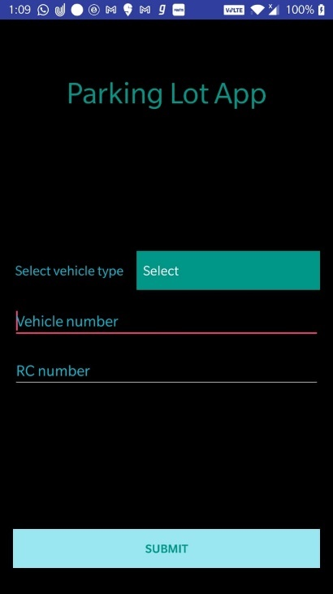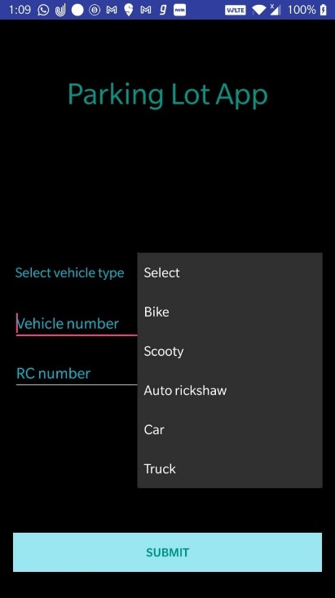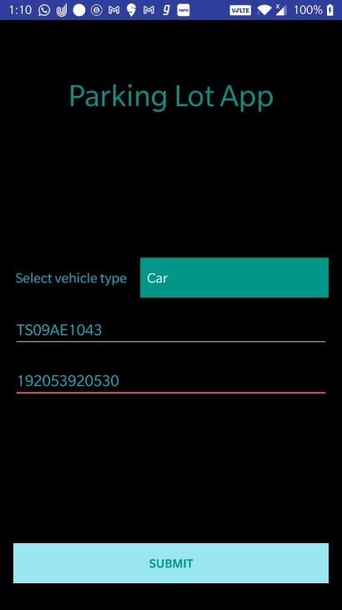
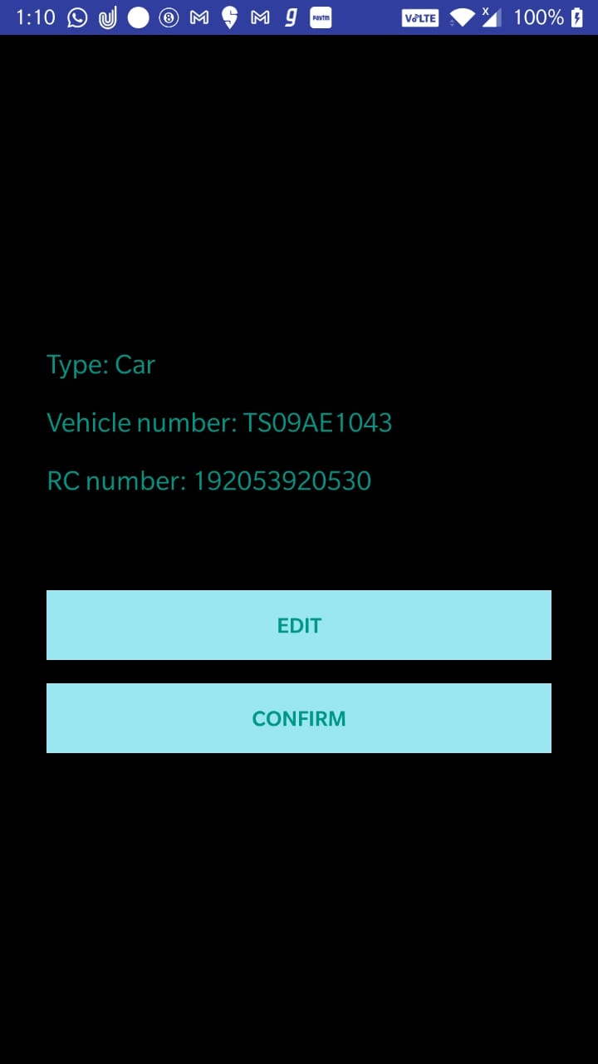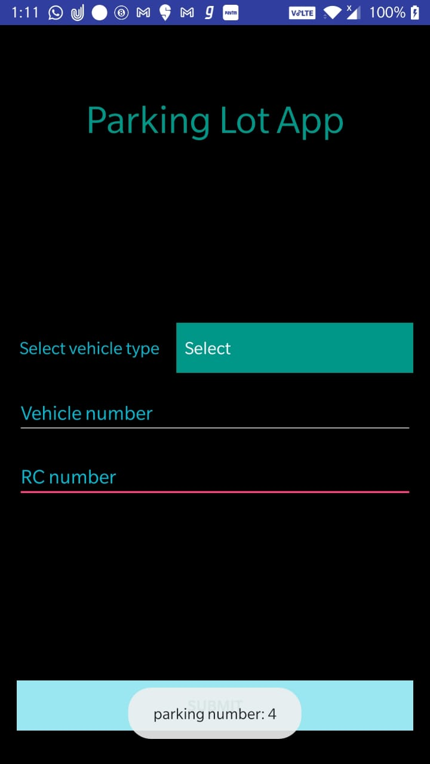

Q2. Create a ticket booking app, where in the user select destination and source from spinner and date of journey from the date picker. Using toggle button provide and option to select to –fro ticket or for just one-way journey. Provide “Submit”, “Clear” button. On click of “Submit ” button all the entered details should be displayed in next form in proper format. “Clear ” button should clear all the fields and reset the date picker to current time of the system.
Ans.
AndroidManifest.xml –
<?xml version="1.0" encoding="utf-8"?>
<manifest xmlns:android="http://schemas.android.com/apk/res/android"
package="com.example.l5q2">
<application
android:allowBackup="true"
android:icon="@mipmap/ic_launcher"
android:label="@string/app_name"
android:roundIcon="@mipmap/ic_launcher_round"
android:supportsRtl="true"
android:theme="@style/Theme.Lab5">
<activity android:name=".Display"></activity>
<activity android:name=".MainActivity">
<intent-filter>
<action android:name="android.intent.action.MAIN" />
<category android:name="android.intent.category.LAUNCHER" />
</intent-filter>
</activity>
</application>
</manifest>

MainActivity.java –
package com.example.l5q2;
import androidx.appcompat.app.AppCompatActivity;
import android.app.DatePickerDialog;
import android.content.Intent;
import android.graphics.Color;
import android.graphics.drawable.ColorDrawable;
import android.os.Bundle;
import android.view.View;
import android.widget.AdapterView;
import android.widget.ArrayAdapter;
import android.widget.DatePicker;
import android.widget.Spinner;
import android.widget.TextView;
import android.widget.ToggleButton;
import java.util.Calendar;
public class MainActivity extends AppCompatActivity{
ToggleButton t_btn;
Spinner spinner_s, spinner_d;
private TextView disp_date;
private DatePickerDialog.OnDateSetListener onDateSetListener;
@Override
protected void onCreate(Bundle savedInstanceState) {
super.onCreate(savedInstanceState);
setContentView(R.layout.activity_main);
t_btn=(ToggleButton)findViewById(R.id.toggleButton);
spinner_s=(Spinner)findViewById(R.id.src);
spinner_d=(Spinner)findViewById(R.id.dstn);
ArrayAdapter<CharSequence> s_adapter = ArrayAdapter.createFromResource(this, R.array.source, android.R.layout.simple_spinner_item);
s_adapter.setDropDownViewResource(android.R.layout.simple_spinner_dropdown_item);
spinner_s.setAdapter(s_adapter);
ArrayAdapter<CharSequence> d_adapter = ArrayAdapter.createFromResource(this, R.array.source, android.R.layout.simple_spinner_item);
s_adapter.setDropDownViewResource(android.R.layout.simple_spinner_dropdown_item);
spinner_d.setAdapter(d_adapter);
spinner_s.setOnItemSelectedListener(new AdapterView.OnItemSelectedListener() {
@Override
public void onItemSelected(AdapterView<?> parent, View view, int position, long id) {
String loc1=parent.getItemAtPosition(position).toString();
}
@Override
public void onNothingSelected(AdapterView<?> parent) {
}
});
spinner_d.setOnItemSelectedListener(new AdapterView.OnItemSelectedListener() {
@Override
public void onItemSelected(AdapterView<?> parent, View view, int position, long id) {
String loc2=parent.getItemAtPosition(position).toString();
}
@Override
public void onNothingSelected(AdapterView<?> parent) {
}
});
disp_date=(TextView)findViewById(R.id.date);
disp_date.setOnClickListener(new View.OnClickListener() {
@Override
public void onClick(View v) {
Calendar cal = Calendar.getInstance();
int year = cal.get(Calendar.YEAR);
int month = cal.get(Calendar.MONTH);
int day = cal.get(Calendar.DAY_OF_MONTH);
DatePickerDialog dialog= new DatePickerDialog(MainActivity.this, android.R.style.Theme_Holo_Light_Dialog_MinWidth, onDateSetListener, year, month, day);
dialog.getWindow().setBackgroundDrawable(new ColorDrawable(Color.TRANSPARENT));
dialog.show();
}
});
onDateSetListener= new DatePickerDialog.OnDateSetListener() {
@Override
public void onDateSet(DatePicker view, int year, int month, int dayOfMonth) {
month +=1;
String date = month + "/" + dayOfMonth + "/" + "/" + year;
disp_date.setText(date);
}
};
t_btn.setOnClickListener(new View.OnClickListener() {
@Override
public void onClick(View v) {
if(t_btn.isChecked()){
t_btn.setEnabled(true);
}
else{
}
}
});
}
public void Clear(View v){
spinner_s.setSelection(0);
spinner_d.setSelection(0);
disp_date.setText("Select Date");
}
public void goToDisp(View v){
Intent intent = new Intent(MainActivity.this, Display.class);
intent.putExtra("type", t_btn.isChecked());
intent.putExtra("date", disp_date.getText().toString());
intent.putExtra("src", spinner_s.getSelectedItemPosition());
intent.putExtra("dst", spinner_d.getSelectedItemPosition());
startActivity(intent);
}
}

activity_main.xml –
<?xml version="1.0" encoding="utf-8"?>
<RelativeLayout xmlns:android="http://schemas.android.com/apk/res/android"
xmlns:app="http://schemas.android.com/apk/res-auto"
xmlns:tools="http://schemas.android.com/tools"
android:layout_width="match_parent"
android:layout_height="match_parent"
android:background="@color/black"
tools:context=".MainActivity">
<TextView
android:id="@+id/app_name"
android:layout_width="match_parent"
android:layout_height="56dp"
android:layout_alignParentTop="true"
android:layout_alignParentEnd="true"
android:layout_alignParentRight="true"
android:layout_marginTop="100dp"
android:layout_marginEnd="0dp"
android:layout_marginRight="0dp"
android:gravity="center_horizontal"
android:text="Ticket Booking App"
android:textAlignment="center"
android:textColor="#009688"
android:textSize="30dp" />
<ToggleButton
android:id="@+id/toggleButton"
android:layout_width="wrap_content"
android:layout_height="wrap_content"
android:layout_alignParentBottom="true"
android:layout_centerHorizontal="true"
android:layout_marginBottom="177dp"
android:background="#22D3EA"
android:text="ToggleButton"
android:textOff="One-Way"
android:textOn="To-Fro" />
<TextView
android:id="@+id/source"
android:layout_width="wrap_content"
android:layout_height="wrap_content"
android:layout_alignParentStart="true"
android:layout_alignParentLeft="true"
android:layout_alignParentTop="true"
android:layout_marginStart="50dp"
android:layout_marginLeft="50dp"
android:layout_marginTop="220dp"
android:text="From - "
android:textColor="#22D3EA"
android:textSize="20dp" />
<TextView
android:id="@+id/dest"
android:layout_width="wrap_content"
android:layout_height="wrap_content"
android:layout_alignParentStart="true"
android:layout_alignParentLeft="true"
android:layout_alignParentTop="true"
android:layout_marginStart="50dp"
android:layout_marginLeft="50dp"
android:layout_marginTop="290dp"
android:text="To -"
android:textColor="#22D3EA"
android:textSize="20dp" />
<TextView
android:id="@+id/textView4"
android:layout_width="wrap_content"
android:layout_height="wrap_content"
android:layout_alignParentStart="true"
android:layout_alignParentLeft="true"
android:layout_alignParentTop="true"
android:layout_marginStart="50dp"
android:layout_marginLeft="50dp"
android:layout_marginTop="360dp"
android:text="Date -"
android:textColor="#22D3EA"
android:textSize="20dp" />
<Spinner
android:id="@+id/src"
android:layout_width="155dp"
android:layout_height="wrap_content"
android:layout_alignParentTop="true"
android:layout_marginStart="70dp"
android:layout_marginLeft="70dp"
android:layout_marginTop="220dp"
android:layout_toEndOf="@+id/source"
android:layout_toRightOf="@+id/source" />
<Spinner
android:id="@+id/dstn"
android:layout_width="155dp"
android:layout_height="wrap_content"
android:layout_alignParentTop="true"
android:layout_marginStart="70dp"
android:layout_marginLeft="70dp"
android:layout_marginTop="290dp"
android:layout_toEndOf="@+id/source"
android:layout_toRightOf="@+id/source" />
<TextView
android:id="@+id/date"
android:layout_width="155dp"
android:layout_height="wrap_content"
android:layout_alignParentTop="true"
android:layout_marginStart="70dp"
android:layout_marginLeft="70dp"
android:layout_marginTop="360dp"
android:layout_toEndOf="@+id/source"
android:layout_toRightOf="@+id/source"
android:text="Select Date"
android:textColor="@color/white"
android:textSize="15dp" />
<Button
android:id="@+id/submit"
android:layout_width="wrap_content"
android:layout_height="wrap_content"
android:layout_alignParentStart="true"
android:layout_alignParentLeft="true"
android:layout_alignParentBottom="true"
android:layout_marginStart="74dp"
android:layout_marginLeft="74dp"
android:layout_marginBottom="62dp"
android:text="Submit"
app:backgroundTint="#03A9F4"
android:onClick="goToDisp"/>
<Button
android:id="@+id/clear"
android:layout_width="wrap_content"
android:layout_height="wrap_content"
android:layout_alignParentEnd="true"
android:layout_alignParentRight="true"
android:layout_alignParentBottom="true"
android:layout_marginEnd="73dp"
android:layout_marginRight="73dp"
android:layout_marginBottom="62dp"
android:text="Clear"
app:backgroundTint="#03A9F4"
android:onClick="Clear"/>
</RelativeLayout>

Display.java –
package com.example.l5q2;
import androidx.appcompat.app.AppCompatActivity;
import android.content.Intent;
import android.os.Bundle;
import android.widget.TextView;
public class Display extends AppCompatActivity {
private TextView fr, to,dmy, ty;
@Override
protected void onCreate(Bundle savedInstanceState) {
super.onCreate(savedInstanceState);
setContentView(R.layout.activity_display);
Intent i = getIntent();
String src = getResources().getStringArray(R.array.source)[i.getIntExtra("src", 0)];
String dst = getResources().getStringArray(R.array.destination)[i.getIntExtra("dst", 0)];
String date = i.getStringExtra("date");
String type = !i.getBooleanExtra("type", false) ? "One-Way": "To-Fro";
fr =(TextView)findViewById(R.id.source_f);
to =(TextView)findViewById(R.id.dest_f);
dmy =(TextView)findViewById(R.id.date_f);
ty =(TextView)findViewById(R.id.type_f);
fr.append(src);
to.append(dst);
dmy.append(date);
ty.append(type);
}
}

activity_display.xml –
<?xml version="1.0" encoding="utf-8"?>
<RelativeLayout xmlns:android="http://schemas.android.com/apk/res/android"
xmlns:app="http://schemas.android.com/apk/res-auto"
xmlns:tools="http://schemas.android.com/tools"
android:layout_width="match_parent"
android:layout_height="match_parent"
android:background="@color/black"
tools:context=".MainActivity">
<TextView
android:id="@+id/details"
android:layout_width="match_parent"
android:layout_height="56dp"
android:layout_alignParentStart="true"
android:layout_alignParentTop="true"
android:layout_alignParentEnd="true"
android:layout_alignParentRight="true"
android:layout_marginStart="0dp"
android:layout_marginTop="71dp"
android:layout_marginEnd="0dp"
android:layout_marginRight="0dp"
android:gravity="center_horizontal"
android:text="Ticket Details"
android:textAlignment="center"
android:textColor="#009688"
android:textSize="30dp"
android:layout_alignParentLeft="true" />
<TextView
android:id="@+id/source_f"
android:layout_width="wrap_content"
android:layout_height="wrap_content"
android:layout_alignParentStart="true"
android:layout_alignParentLeft="true"
android:layout_alignParentTop="true"
android:layout_marginStart="50dp"
android:layout_marginLeft="50dp"
android:layout_marginTop="220dp"
android:text="From - "
android:textColor="#22D3EA"
android:textSize="20dp" />
<TextView
android:id="@+id/dest_f"
android:layout_width="wrap_content"
android:layout_height="wrap_content"
android:layout_alignParentStart="true"
android:layout_alignParentLeft="true"
android:layout_alignParentTop="true"
android:layout_marginStart="50dp"
android:layout_marginLeft="50dp"
android:layout_marginTop="290dp"
android:text="To - "
android:textColor="#22D3EA"
android:textSize="20dp" />
<TextView
android:id="@+id/date_f"
android:layout_width="wrap_content"
android:layout_height="wrap_content"
android:layout_alignParentStart="true"
android:layout_alignParentLeft="true"
android:layout_alignParentTop="true"
android:layout_marginStart="50dp"
android:layout_marginLeft="50dp"
android:layout_marginTop="360dp"
android:text="Date - "
android:textColor="#22D3EA"
android:textSize="20dp" />
<TextView
android:id="@+id/type_f"
android:layout_width="wrap_content"
android:layout_height="wrap_content"
android:layout_alignParentStart="true"
android:layout_alignParentLeft="true"
android:layout_alignParentTop="true"
android:layout_marginStart="50dp"
android:layout_marginLeft="50dp"
android:layout_marginTop="430dp"
android:text="Type - "
android:textColor="#22D3EA"
android:textSize="20dp" />
</RelativeLayout>

strings.xml –
<resources>
<string name="app_name">Lab5</string>
<string-array name="source">
<item>Select City</item>
<item>Mumbai</item>
<item>Hyderabad</item>
<item>Kolkata</item>
<item>Chennai</item>
<item>Bangalore</item>
<item>Jaipur</item>
<item>Ranchi</item>
<item>Jammu</item>
<item>Gangtok</item>
<item>Goa</item>
</string-array>
<string-array name="destination">
<item>Select City</item>
<item>Mumbai</item>
<item>Hyderabad</item>
<item>Kolkata</item>
<item>Chennai</item>
<item>Bangalore</item>
<item>Jaipur</item>
<item>Ranchi</item>
<item>Jammu</item>
<item>Gangtok</item>
<item>Goa</item>
</string-array>
</resources>

Output –
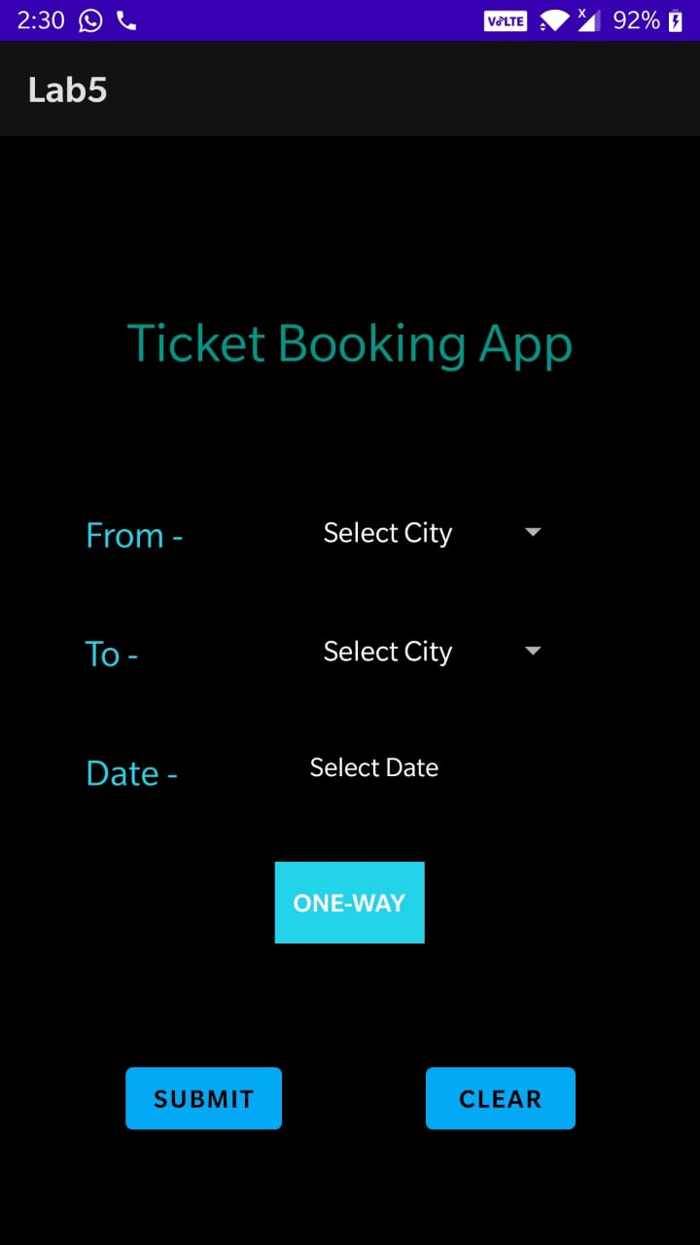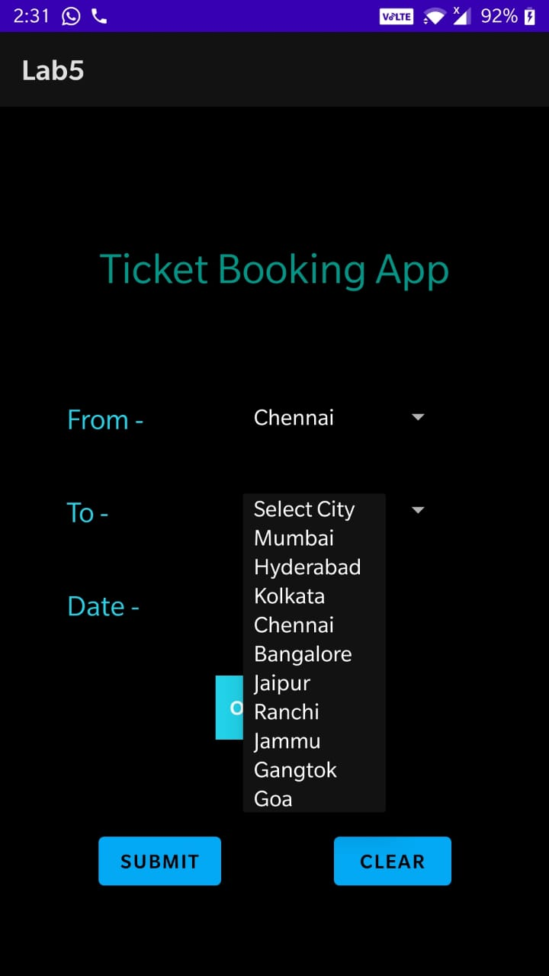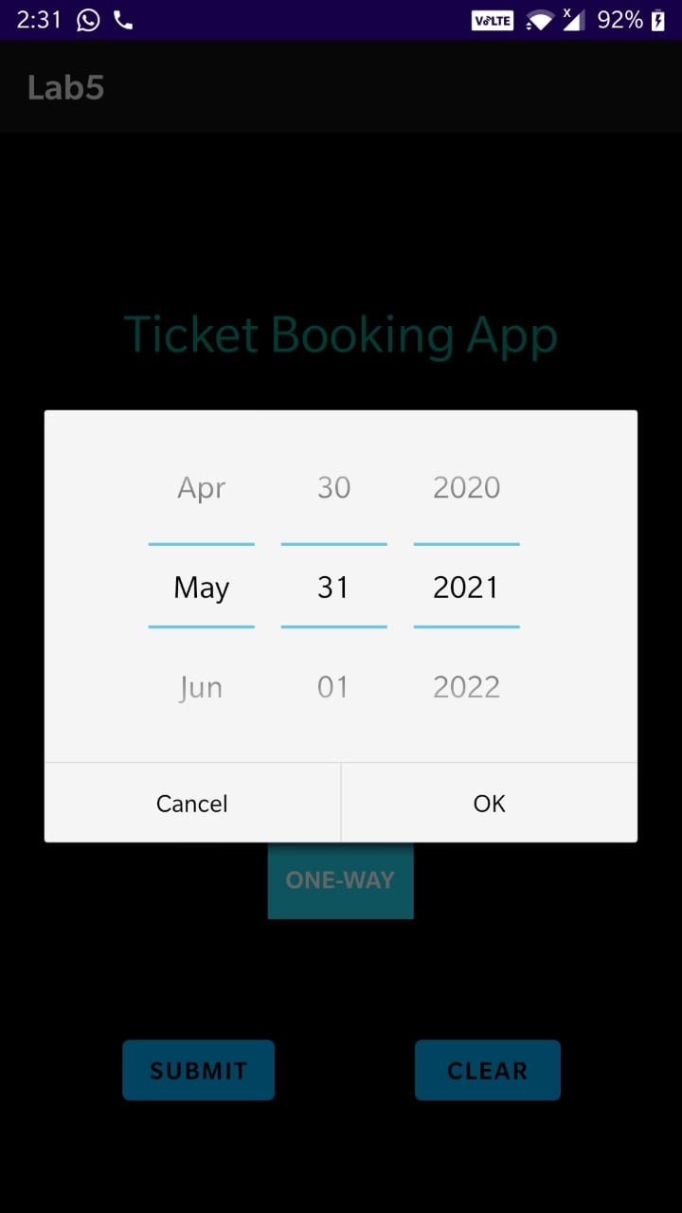
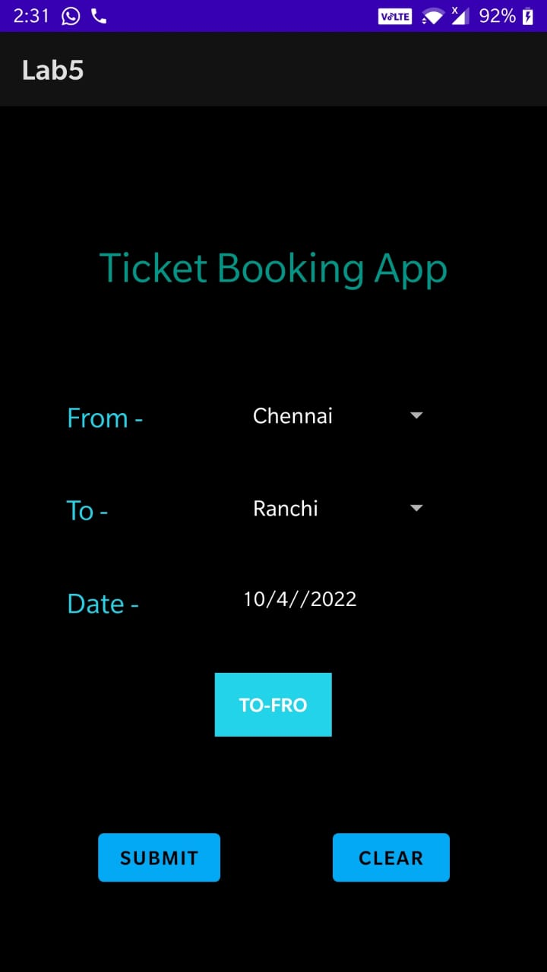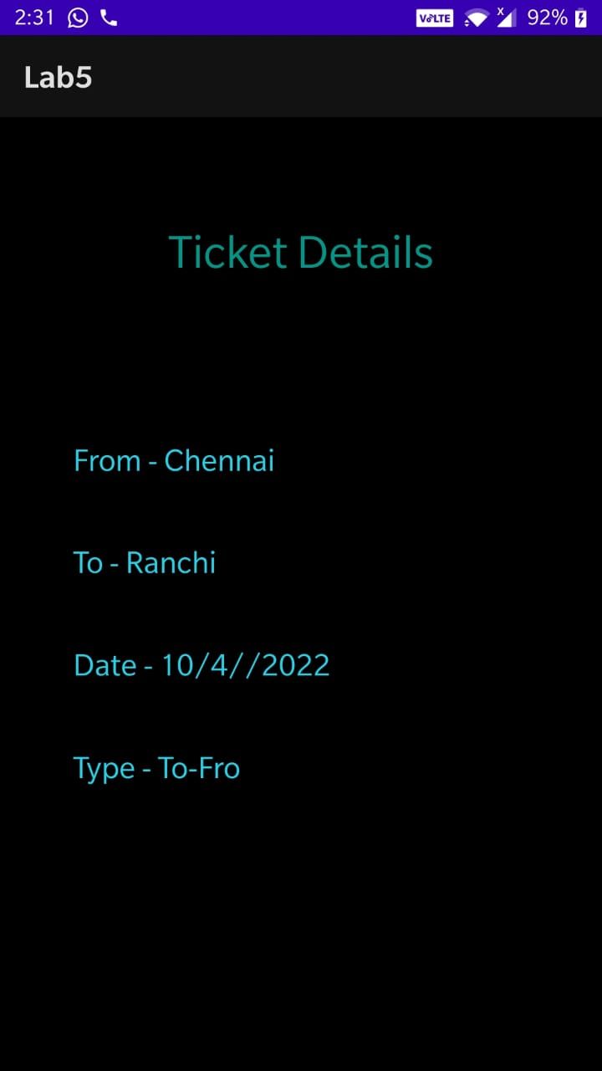

Q3. Create a ticket booking app, where in the user select destination and source from spinner and date of journey from the date picker, suitable time of journey from time picker. Provide “Submit”, “Clear” button. On click of “Submit ” button all the entered details should be displayed in next form in proper format along with available trains in those time durations. “Clear ” button should clear all the fields and reset the date picker to current time of the system. Using toggle button provide option to either book general ticket or tatkal. If the option states “tatkal ” is on ,then the user should be allowed to click on the submit button only after 1100 hours. Do all the validations required.
Ans.
AndroidManifest.xml –
<?xml version="1.0" encoding="utf-8"?>
<manifest xmlns:android="http://schemas.android.com/apk/res/android"
package="com.example.l5q3">
<application
android:allowBackup="true"
android:icon="@mipmap/ic_launcher"
android:label="@string/app_name"
android:roundIcon="@mipmap/ic_launcher_round"
android:supportsRtl="true"
android:theme="@style/AppTheme">
<activity android:name=".MainActivity">
<intent-filter>
<action android:name="android.intent.action.MAIN"/>
<category android:name="android.intent.category.LAUNCHER"/>
</intent-filter>
</activity>
<activity android:name=".ViewActivity">
</activity>
</application>
</manifest>

MainActivity.java –
package com.example.l5q3;
import android.app.DatePickerDialog;
import android.app.TimePickerDialog;
import android.content.Intent;
import android.os.Bundle;
import android.support.v7.app.AppCompatActivity;
import android.view.View;
import android.widget.ArrayAdapter;
import android.widget.Button;
import android.widget.DatePicker;
import android.widget.EditText;
import android.widget.Spinner;
import android.widget.TimePicker;
import android.widget.Toast;
import android.widget.ToggleButton;
import java.text.SimpleDateFormat;
import java.util.Calendar;
import java.util.Date;
import java.util.Locale;
public class MainActivity extends AppCompatActivity
{
Spinner spinSrc;
Spinner spinDst;
EditText editDate;
EditText editTime;
ToggleButton toggle;
Button btnSubmit;
Button btnClear;
@Override
protected void onCreate(Bundle savedInstanceState)
{
super.onCreate(savedInstanceState);
setContentView(R.layout.activity_main);
spinSrc = findViewById(R.id.spin_src);
spinDst = findViewById(R.id.spin_dest);
editDate = findViewById(R.id.edit_date);
editTime = findViewById(R.id.edit_time);
toggle = findViewById(R.id.toggle_ticket);
btnClear = findViewById(R.id.btn_clear);
btnSubmit = findViewById(R.id.btn_submit);
ArrayAdapter<String> adapter1 = new ArrayAdapter<>(this,
android.R.layout.simple_spinner_dropdown_item);
adapter1.addAll(getResources().getStringArray(R.array.places));
spinSrc.setAdapter(adapter1);
ArrayAdapter<String> adapter2 = new ArrayAdapter<>(this,
android.R.layout.simple_spinner_dropdown_item);
adapter2.addAll(getResources().getStringArray(R.array.places));
spinDst.setAdapter(adapter2);
final Calendar calendar1 = Calendar.getInstance();
final Calendar calendar2 = Calendar.getInstance();
final SimpleDateFormat dateFormat = new SimpleDateFormat("dd/MM/yyyy", Locale.getDefault());
final SimpleDateFormat timeFormat = new SimpleDateFormat("HH:mm", Locale.getDefault());
editTime.setText(timeFormat.format(calendar2.getTimeInMillis()));
editDate.setText(dateFormat.format(calendar1.getTimeInMillis()));
final DatePickerDialog.OnDateSetListener dateChangedListener = new DatePickerDialog.OnDateSetListener()
{
@Override
public void onDateSet(DatePicker view, int year, int month, int dayOfMonth)
{
calendar1.set(Calendar.YEAR, year);
calendar1.set(Calendar.MONTH, month);
calendar1.set(Calendar.DAY_OF_MONTH, dayOfMonth);
String toDisplay = dateFormat.format(new Date(calendar1.getTimeInMillis()));
editDate.setText(toDisplay);
}
};
editDate.setOnClickListener(new View.OnClickListener()
{
@Override
public void onClick(View v)
{
new DatePickerDialog(MainActivity.this, dateChangedListener, calendar1.get(Calendar.YEAR), calendar1.get(Calendar.MONTH), calendar1.get(Calendar.DAY_OF_MONTH)).show();
}
});
final TimePickerDialog.OnTimeSetListener timeSetListener = new TimePickerDialog.OnTimeSetListener()
{
@Override
public void onTimeSet(TimePicker view, int hourOfDay, int minute)
{
calendar2.set(Calendar.HOUR_OF_DAY, hourOfDay);
calendar2.set(Calendar.MINUTE, minute);
String toDisplay = timeFormat.format(new Date(calendar2.getTimeInMillis()));
editTime.setText(toDisplay);
}
};
editTime.setOnClickListener(new View.OnClickListener()
{
@Override
public void onClick(View v)
{
new TimePickerDialog(MainActivity.this, timeSetListener, calendar2.get(Calendar.HOUR_OF_DAY), calendar2.get(Calendar.MINUTE), true).show();
}
});
btnClear.setOnClickListener(new View.OnClickListener()
{
@Override
public void onClick(View v)
{
editDate.setText(dateFormat.format(Calendar.getInstance().getTimeInMillis()));
editTime.setText(timeFormat.format(Calendar.getInstance().getTimeInMillis()));
spinDst.setSelection(0);
spinSrc.setSelection(0);
}
});
btnSubmit.setOnClickListener(new View.OnClickListener()
{
@Override
public void onClick(View v)
{
if(toggle.isChecked() && Integer.parseInt(editTime.getText().toString().split(":")[0])<11)
Toast.makeText(MainActivity.this, "Time has to be more than 11am if booking in Tatkal", Toast.LENGTH_SHORT).show();
else
{
Intent intent = new Intent(MainActivity.this, ViewActivity.class);
intent.putExtra("type", toggle.isChecked());
intent.putExtra("date", editDate.getText().toString());
intent.putExtra("time", editTime.getText().toString());
intent.putExtra("src", spinSrc.getSelectedItemPosition());
intent.putExtra("dst", spinDst.getSelectedItemPosition());
startActivity(intent);
}
}
});
}
}

activity_main.xml –
<?xml version="1.0" encoding="utf-8"?>
<LinearLayout xmlns:android="http://schemas.android.com/apk/res/android"
xmlns:tools="http://schemas.android.com/tools"
android:layout_width="match_parent"
android:layout_height="match_parent"
android:background="@android:color/black"
android:orientation="vertical"
android:padding="16dp"
tools:context="com.example.l5q3.MainActivity">
<TextView
android:layout_width="match_parent"
android:layout_height="wrap_content"
android:text="Ticket Booking App"
android:textAlignment="center"
android:textSize="30dp"
android:layout_marginTop="75dp"/>
<LinearLayout
android:layout_width="match_parent"
android:layout_height="0dp"
android:layout_weight="1"
android:gravity="center_vertical"
android:orientation="vertical">
<LinearLayout
android:layout_width="match_parent"
android:layout_height="wrap_content"
android:layout_marginStart="2dp"
android:gravity="center_vertical"
android:orientation="horizontal">
<TextView
android:layout_width="0dp"
android:layout_height="wrap_content"
android:layout_weight="1"
android:text="Select source"
android:textColor="#009688"
android:textSize="18sp" />
<Spinner
android:id="@+id/spin_src"
android:layout_width="0dp"
android:layout_height="wrap_content"
android:layout_marginStart="16dp"
android:layout_weight="1" />
</LinearLayout>
<LinearLayout
android:layout_width="match_parent"
android:layout_height="wrap_content"
android:layout_marginStart="2dp"
android:layout_marginTop="16dp"
android:gravity="center_vertical"
android:orientation="horizontal">
<TextView
android:layout_width="0dp"
android:layout_height="wrap_content"
android:layout_weight="1"
android:text="Select destination"
android:textColor="#009688"
android:textSize="18sp" />
<Spinner
android:id="@+id/spin_dest"
android:layout_width="0dp"
android:layout_height="wrap_content"
android:layout_marginStart="16dp"
android:layout_weight="1" />
</LinearLayout>
<LinearLayout
android:layout_width="match_parent"
android:layout_height="wrap_content"
android:layout_marginTop="16dp"
android:orientation="horizontal">
<EditText
android:id="@+id/edit_date"
android:layout_width="0dp"
android:layout_height="wrap_content"
android:layout_weight="1"
android:focusable="false"
android:hint="Date of journey"
android:inputType="none"
android:textColor="#009688"/>
<ToggleButton
android:id="@+id/toggle_ticket"
android:layout_width="wrap_content"
android:layout_height="wrap_content"
android:layout_marginStart="8dp"
android:textColor="#03A9F4"
android:textOff="General"
android:textOn="Tatkal" />
</LinearLayout>
<EditText
android:id="@+id/edit_time"
android:layout_width="match_parent"
android:layout_height="wrap_content"
android:layout_marginTop="16dp"
android:focusable="false"
android:hint="Time of journey"
android:inputType="none"
android:textColor="#009688"/>
</LinearLayout>
<Button
android:id="@+id/btn_clear"
android:layout_width="match_parent"
android:layout_height="wrap_content"
android:layout_marginBottom="16dp"
android:text="clear"
android:textColor="#009688"/>
<Button
android:id="@+id/btn_submit"
android:layout_width="match_parent"
android:layout_height="wrap_content"
android:layout_marginBottom="16dp"
android:text="submit"
android:textColor="#009688" />
</LinearLayout>

ViewActivity.java –
package com.example.l5q3;
import android.content.Intent;
import android.os.Bundle;
import android.support.v7.app.AppCompatActivity;
import android.widget.TextView;
public class ViewActivity extends AppCompatActivity
{
TextView tvSrc;
TextView tvDst;
TextView tvDate;
TextView tvTime;
TextView tvType;
@Override
protected void onCreate(Bundle savedInstanceState)
{
super.onCreate(savedInstanceState);
setContentView(R.layout.activity_view);
Intent i = getIntent();
String src = getResources().getStringArray(R.array.places)[i.getIntExtra("src", 0)];
String dst = getResources().getStringArray(R.array.places)[i.getIntExtra("dst", 0)];
String date = i.getStringExtra("date");
String time = i.getStringExtra("time");
String type = !i.getBooleanExtra("type", false) ? "General": "Tatkal";
tvType = findViewById(R.id.tv_type);
tvSrc = findViewById(R.id.tv_src);
tvDst = findViewById(R.id.tv_dst);
tvDate = findViewById(R.id.tv_date);
tvTime = findViewById(R.id.tv_time);
tvDate.append(date);
tvTime.append(time);
tvDst.append(dst);
tvSrc.append(src);
tvType.append(type);
}
}

activity_view.xml –
<?xml version="1.0" encoding="utf-8"?>
<LinearLayout xmlns:android="http://schemas.android.com/apk/res/android"
xmlns:tools="http://schemas.android.com/tools"
android:layout_width="match_parent"
android:layout_height="match_parent"
android:background="#000000"
android:gravity="center_vertical"
android:orientation="vertical"
android:padding="32dp"
tools:context="com.example.l5q3.ViewActivity">
<TextView
android:id="@+id/tv_src"
android:layout_width="wrap_content"
android:layout_height="wrap_content"
android:text="From:"
android:textColor="#00BCD4"
android:textSize="18sp" />
<TextView
android:id="@+id/tv_dst"
android:layout_width="wrap_content"
android:layout_height="wrap_content"
android:layout_marginTop="16dp"
android:text="To:"
android:textColor="#00BCD4"
android:textSize="18sp" />
<TextView
android:id="@+id/tv_date"
android:layout_width="wrap_content"
android:layout_height="wrap_content"
android:layout_marginTop="16dp"
android:text="Date of Journey: "
android:textColor="#00BCD4"
android:textSize="18sp" />
<TextView
android:id="@+id/tv_time"
android:layout_width="wrap_content"
android:layout_height="wrap_content"
android:layout_marginTop="16dp"
android:text="Time of Journey: "
android:textColor="#00BCD4"
android:textSize="18sp" />
<TextView
android:id="@+id/tv_type"
android:layout_width="wrap_content"
android:layout_height="wrap_content"
android:layout_marginTop="16dp"
android:text="Category:"
android:textColor="#00BCD4"
android:textSize="18sp" />
</LinearLayout>

arrays.xml –
<?xml version="1.0" encoding="utf-8"?>
<resources>
<string-array name="places">
<item>@string/place_1</item>
<item>@string/place_2</item>
<item>@string/place_3</item>
<item>@string/place_4</item>
<item>@string/place_5</item>
<item>@string/place_6</item>
<item>@string/place_7</item>
<item>@string/place_8</item>
</string-array>
</resources>

strings.xml –
<resources>
<string name="app_name">L5Q3</string>
<!-- Places -->
<string name="place_1">Select a Place </string>
<string name="place_2"> Hyderabad</string>
<string name="place_3">Goa</string>
<string name="place_4">Delhi</string>
<string name="place_5">Kolkata</string>
<string name="place_6">Jaipur</string>
<string name="place_7">Bangalore</string>
<string name="place_8">Chennai</string>
</resources>

Output –
