Campaign Library Import

An industrial training project report submitted to
MANIPAL ACADEMY OF HIGHER EDUCATION

For Partial Fulfillment of the Requirement for the Award of the Degree
of
Bachelor of Technology
in
Computer and Communication Engineering

by
Ankit Agrawal Reg. No. 180953278

Under the guidance of
Nitin Gupta
Senior Technical Lead-CVS
Comviva Technologies Limited



1st July-23rd August,2021

ACKNOWLEDGEMENTS

I would like to take this opportunity to express my gratitude to those without whose help and support this Industrial Training would not have been possible. I would like to extend my sincere thanks to all of them.

I would like to thank Mr. Daya Shanker, who provided me with the opportunity to work at this esteemed organization. I would also like to thank Mr. Nitin Gupta, Mr. Ashutosh Ranjan and Mr. Aishwary for guiding me and helping me with throughout the project.

I would also like to thank the industry persons for giving me this opportunity and their time. My thanks and appreciation go to my colleague in this project for working on this project alongside and to all those people who have willingly helped me with their abilities.

Ankit Agrawal
Computer and Communication
MIT Manipal

ABSTRACT

The internship was about creating a SpringBoot application which would load, manipulate, delete JSON data and storing the data in the database with the required mappings and logging functionalities.

For this project the tools required were:
- SpringBoot-to create the SpingBoot Application
- DBeaver-to connect the application to the database
- Swagger-for documentation
- MySQL-as database
- STS-Eclipse-based development environment that is customized for the development of Spring Applications
- JAVA-programming Language

Since microservice architecture was being used in SpringBoot, the loading and manipulation of campaign data could be considered as a small autonomous service which was a part of a bigger project.

Contents

Acknowledgements iii
Abstract iv
Abbreviations vii
- Chapter 1
Technologies used
1.1Project Statement . . . . . . . . . . . . . . . . . . . . . . . . . . . . . . . . . . . . . . . . . . . . . . . . . . . . . . . . . 7
1.2 Motivation. . . . . . . . . . . . . . . . . . . . . . . . . . . . . . . . . . . . . . . . . . . . . . . . . . . . . . . . . . . . . . . 7
1.3 Objectives. . . . . . . . . . . . . . . . . . . . . . . . . . . . . . . . . . . . . . . . . . . . . . . . . . . . . . . . . . . . . . . . 7
- Chapter 2
Details of the Organization . . . . . . . . . . . . . . . . . . . . . . . . . . . . . . . . . . . . . . . . . . . . . . . . . . . 8
- Chapter 3
Technologies used
3.1 Microservices . . . . . . . . . . . . . . . . . . . . . . . . . . . . . . . . . . . . . . . . . . . . . . . . . . . . . . . . . . . .9
3.2 SpringBoot . . . . . . . . . . . . . . . . . . . . . . . . . . . . . . . . . . . . . . . . . . . . . . . . . . . . . . . . . . . . . . 10
3.3 Swagger . . . . . . . . . . . . . . . . . . . . . . . . . . . . . . . . . . . . . . . . . . . . . . . . . . . . . . . . . . . . . . . . 11
3.4 DBeaver . . . . . . . . . . . . . . . . . . . . . . . . . . . . . . . . . . . . . . . . . . . . . . . . . . . . . . . . . . . . . . . . .12
- Chapter 4
The Project. . . . . . . . . . . . . . . . . . . . . . . . . . . . . . . . . . . . . . . . . . . . . . . . . . . . . . . . . . . . . . . . . 13

- Chapter 5
Conclusion. . . . . . . . . . . . .. . . . . . . . . . . . . . . . . . . . . . . . . . . . . . . . . . . . . . . . . . . . . . . . . . . . . 15
Appendices. . . . . . . . . . . . . . . . . . . . . . . . . . . . . . . . . . . . . . . . . . . . . . . . . . . . . . . . . . . . . . .16
A JSON data . . . . . . . . . . . . . . . . . . . . . . . . . . . . . . . . . . . . . . . . . . . . . . . . . . . . . . . . . . . . . .17

B Code
B.1 campaignLoaderApplication.java 18
B.2 campain.java 19
B.3 appendFields.java……………………………………………………………………………………..20
B.4 campaignRepository.java……………………………….………………………………………….21
B.5 campaignController.java …………………..………………………………………………………22
B.6 pom.xml….…………………………………………………………………………………………………25
B.7 application.properties…………………..…………………………………………………………..27
B.8 H2-console…………………..…………………………………………………………………………...28
References. . . . . . . . . . . . . . . . . . . . . . . . . . . . . . . . . . . . . . . . . . . . . . . . . . . . . . . . . . . . . . . . . 29

ABBREVIATIONS

API: Application Programming Interface

STS: Spring Tool Suite

CRUD: Create, Read, Update, Delete

Chapter 1

Introduction

1.1 Project Definition
The internship was about creating a SpringBoot application which would load, manipulate, delete JSON data and storing the data in the database with the required mappings and logging functionalities.

1.2 Motivation
The internship was a great opportunity to learn about SpringBoot applications and microservices which is beyond the scope of the college’s academic curriculum. This project provide a necessary exposure to the corporate life which was a new and exciting experience.

1.3 Objectives

The main objective of the internship was a produce a working SpringBoot Application which extracts JSON data and stores it in the database with the required mappings. The project also involved exploring and learning about the supporting technologies for a SpringBoot Application to run .The aim of the project was to create an application which could be included in a bigger project.

Chapter 2

Details of the Organization
Comviva (formerly known as Mahindra Comviva) is a telecommunications company headquartered in Gurgaon, Haryana with additional offices in Bangalore and Mumbai.

The company is a global leader of mobility solutions catering to The Business of Tomorrows. The company is a subsidiary of Tech Mahindra and a part of the $21 billion Mahindra Group. Its extensive portfolio of solutions spans mobile finance, content, infotainment, customer value management, messaging, mobile data, and managed VAS service. It enables service providers to enhance customer experience, rationalize costs and accelerate revenue growth. Comviva’s solutions are deployed by over 130 mobile service providers and financial institutions in over 95 countries and enrich the lives of over 2 billion people to deliver a better future.

Products and Services by Comviva:
-Digital wallet (mobiquityPay)
-Merchant Payments (PayPLUS)
-Real Time Marketing (MobiLytix)
And many more



Chapter 3

Technologies Used

3.1 Microservices

Microservices is a software development system which works with a set of smaller services which are executed independently and autonomously. Each of them may even be written in a different programming language. This type of services enables us to have more flexible and adaptable IT infrastructures, since when modifying a single service, it is now not necessary to modify the rest of the infrastructure.

Features of Microservices:
- Multiple Individually Deployable Components-Microservices architecture encourages you to break your application into smaller components. This makes it easy to apply changes. Deploying such components does not end up impacting a large part of the codebase
- Service Distribution- Based on Business Capability-In microservices, teams are based on expertise in a particular business function. Each team strives to be self-sufficient in terms of their technology stack. For example, in a typical microservices-based application, you could think of user registration as one microservice and billing management as another. Different teams manage these different services
- Decentralized-Each service will have ownership of the data related to the business functionality supported by that service. This isolates the impact of schema changes
- Black Box-Each microservice is defined as a black box. This means that details of their complexity is hidden from other components. Services communicate to each other using a set of well-defined APIs or messaging channels. This prevents the proliferation of dependencies between microservice

3.2 SpringBoot 

Java Spring Framework (Spring Framework) is a popular, open source, enterprise-level framework for creating standalone, production-grade applications that run on the Java Virtual Machine (JVM). Java Spring Boot (Spring Boot) is a tool that makes developing web application and microservices with Spring Framework faster and easier.

Spring Framework offers a dependency injection feature that lets objects define their own dependencies that the Spring container later injects into them. This enables developers to create modular applications consisting of loosely coupled components that are ideal for microservices and distributed network systems.

Spring Framework also offers built-in support for typical tasks that an application needs to perform, such as data binding, type conversion, validation, exception handling and more.

Features of SpringBoot:

Create stand-alone Spring applications

Embedded Tomcat server, no need to deploy WAR files

Provides opinionated ‘starter’ dependencies to simplify build configuration

No code generation and no requirement for XML configuration

It follows microservice architecture where each microservice can be considered as a separate project or entity.

3.3 Swagger 

Swagger allows the user to describe the structure of you APIs so that machines can read them. By reading the API’s structure, Swagger can automatically build interactive API documentation. It also automatically generates client libraries for your API documentation.

The user can write a Swagger spec for your API manually, or have it generated automatically from annotations in your source code.

Benefits of Swagger-

It creates clear documentation which is comprehensible for developers and non-developers

The documentation is human readable and machine readable

It is easily adjustable

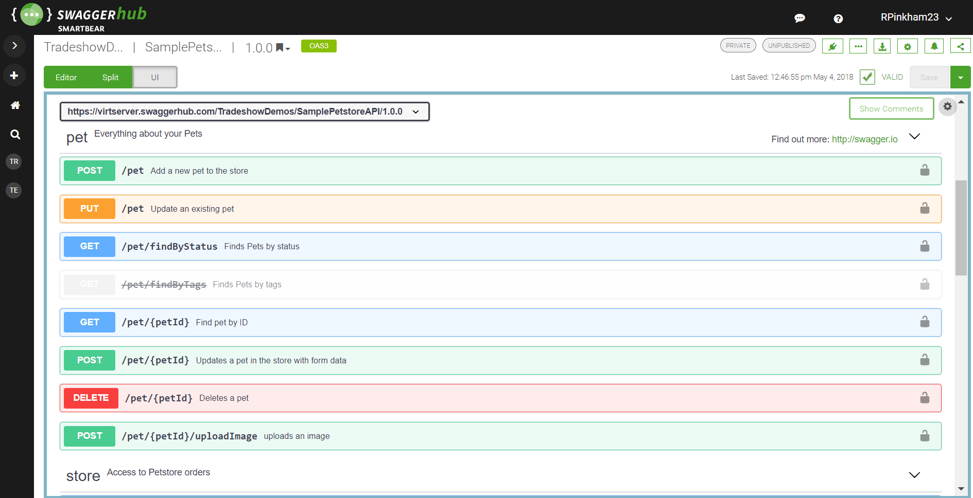

3.4 DBeaver 

DBeaver is a free, open source, graphical database management tool for database developers and administrators. It can be used to create and manage databases across a wide range of database management systems (DBMSs).

DBeaver works with most of the popular DBMSs, such as MySQL, PostgreSQL Server and many more.

DBeaver has a navigator that allows the user to navigate through the list of databases and expand them to navigate the database objects within each database.

Main Features of DBeaver:

Graphical User Interface (GUI)-Enables the user to see a list of databases and their objects.

Data Editing-data can directly be edited within the table just like a spreadsheet.

Database Analysis-Used in creation of visual diagrams of database objects and whole schemas and export as required.

SQL Editor- Enables the user to create ad hoc SQL queries and run them against the database. You can also load and save the scripts as required.

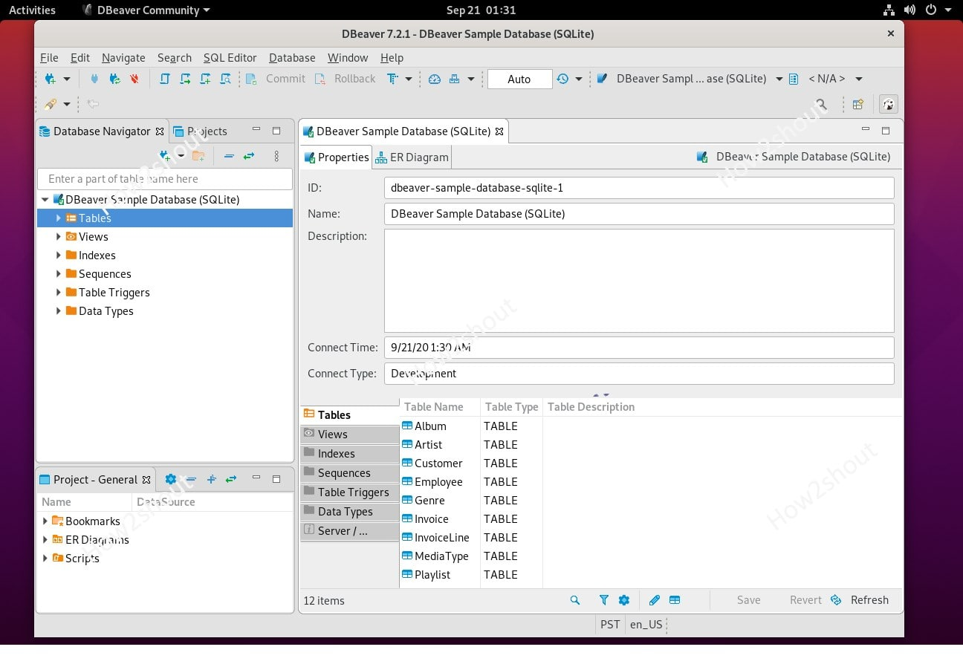

Chapter 4

The Project

The project was to create a SpringBoot Application which would load the JSON data from the given data file and store it in the database. STS was used to create a SpringBoot Application which would do this task, MySQL and DBeaver as the database which needed to be integrated with the SpringBoot Application.

After the data was loaded in the database, APIs were created to get, update, and delete the data from the database. At every step implicit logger class was used to log the required action on the console which provided information about the log level, date and time and helps in overall debugging of the project.

This project was integrated into the bigger deliverable project on which the entire team was working on.

The workflow of the project is illustrated below:

Chapter 5

Conclusion

The experience of this internship was very insightful. Many challenges were faced but at the end of all of it, a great product came into existence and being a part of the developer team of the product made me truly believe the scope of coding and its importance and power.

The aim of the project was to create the SpingBoot Application. I got the opportunity to work on a new technology which was challenging and helped me learn a lot of new concepts and helped me in improving my knowledge and scope.

A lot of learning took place in this internship and today the application is part of a bigger project of the company, and it has a good future scope to add more features too.

Appendices
Appendix A

JSON Data
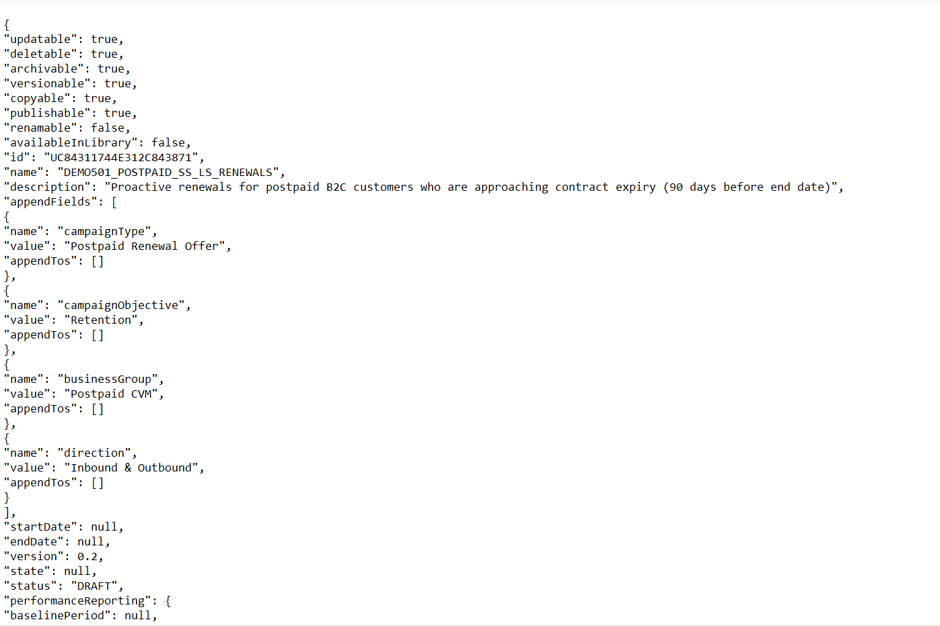
And so on..
- {}-Object
- []-Array

Appendix B

Code

B.1 CampaignLoaderApplication.java

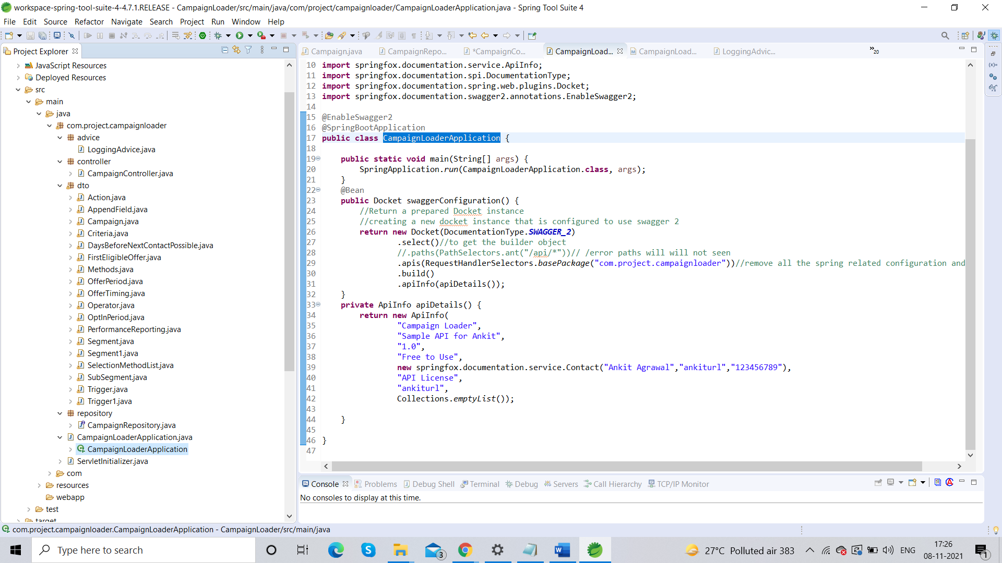

B.2 campaign.java

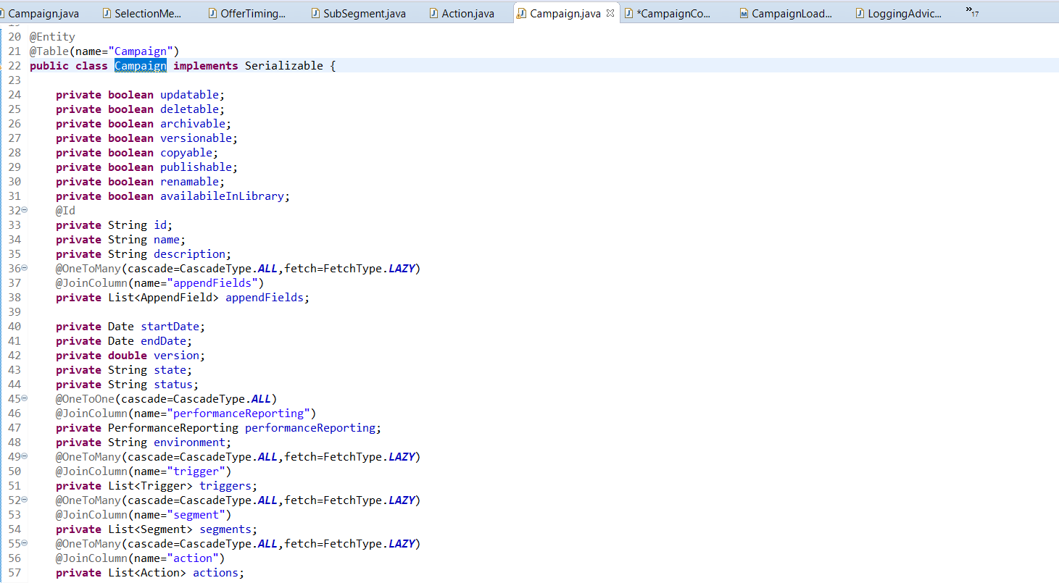
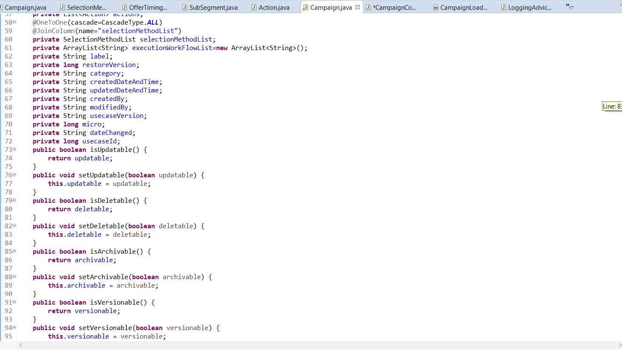

- Just like that there are getters and setters for every variable in campaign object
- At line 38, it can be seen that campaign object has an array of type ‘appendFields’ with a ‘one to many’ mapping which signifies that each ‘campaign’ object can have multiple instances of ‘appendFields’ objects

B.3 appendFields.java

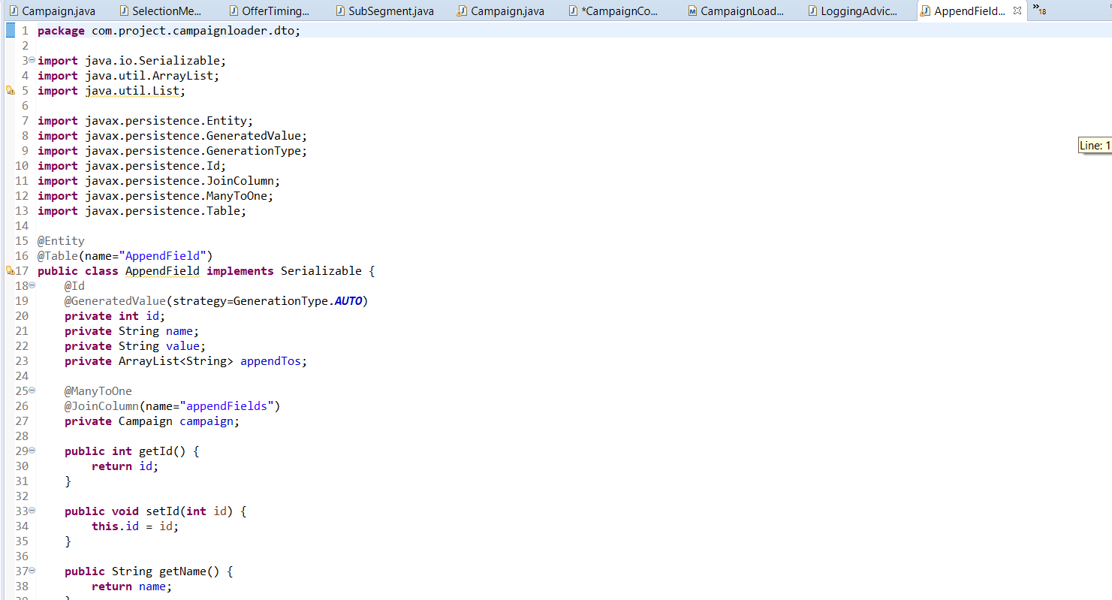
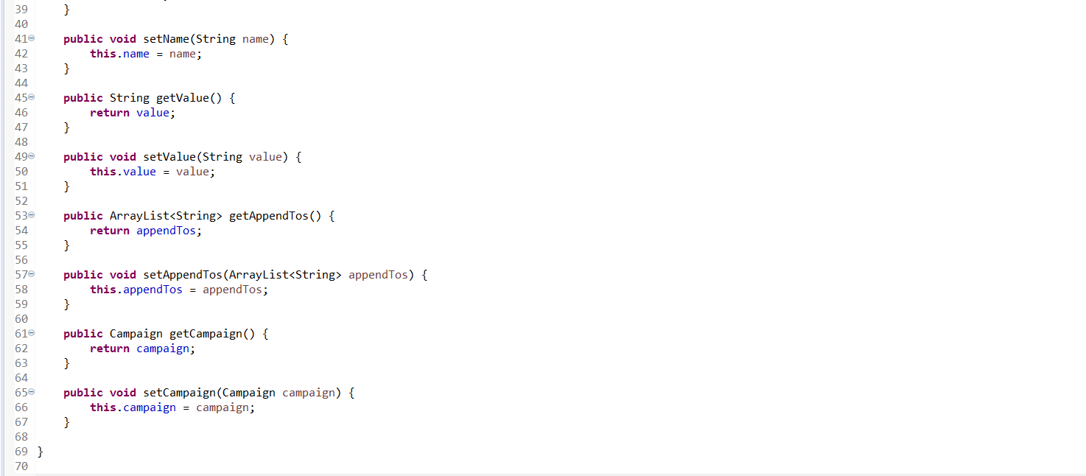
Similarly other objects are also created

B.4 campaignRepository.java

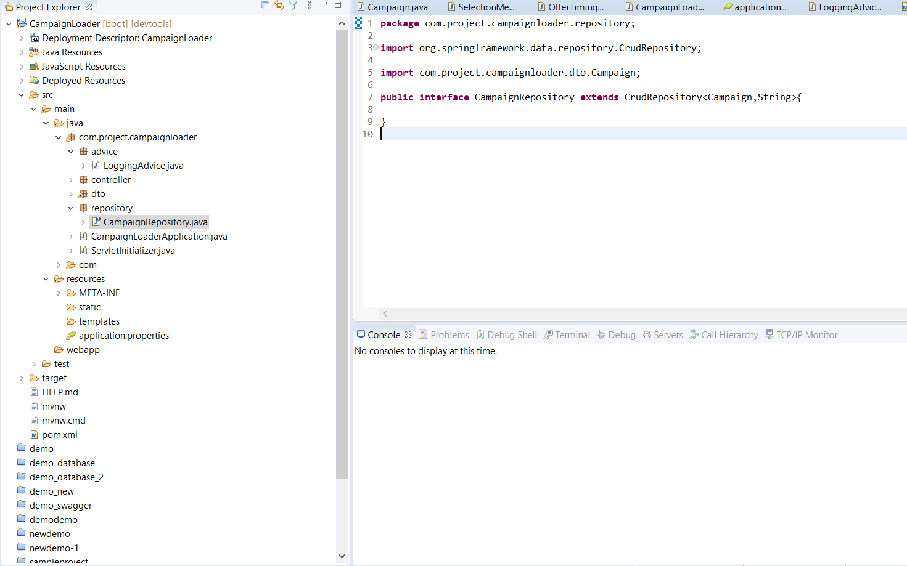

B.5 CampaignController.java

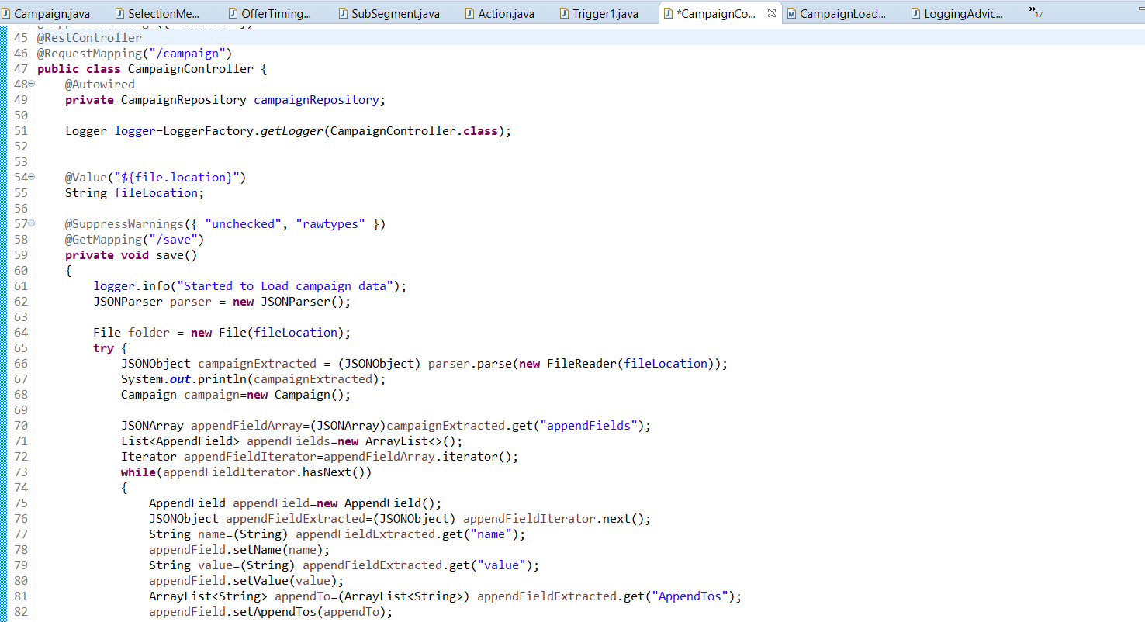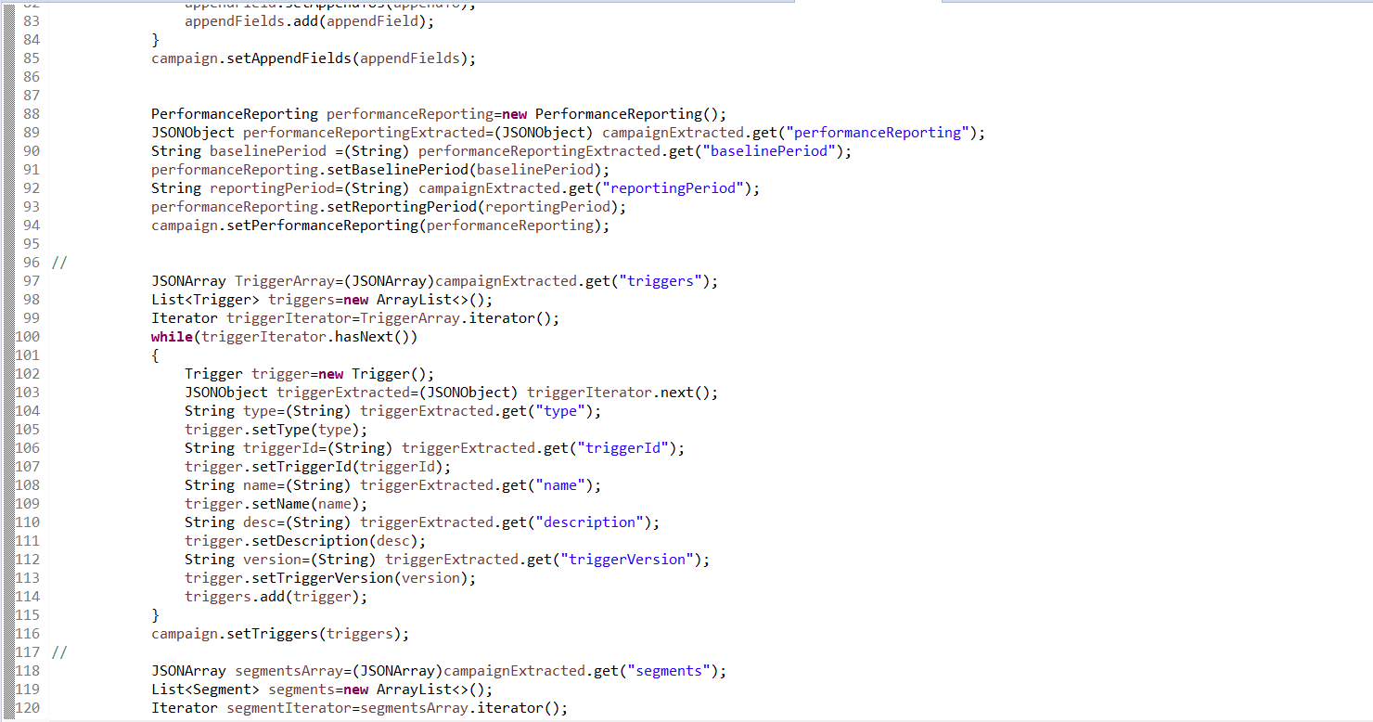

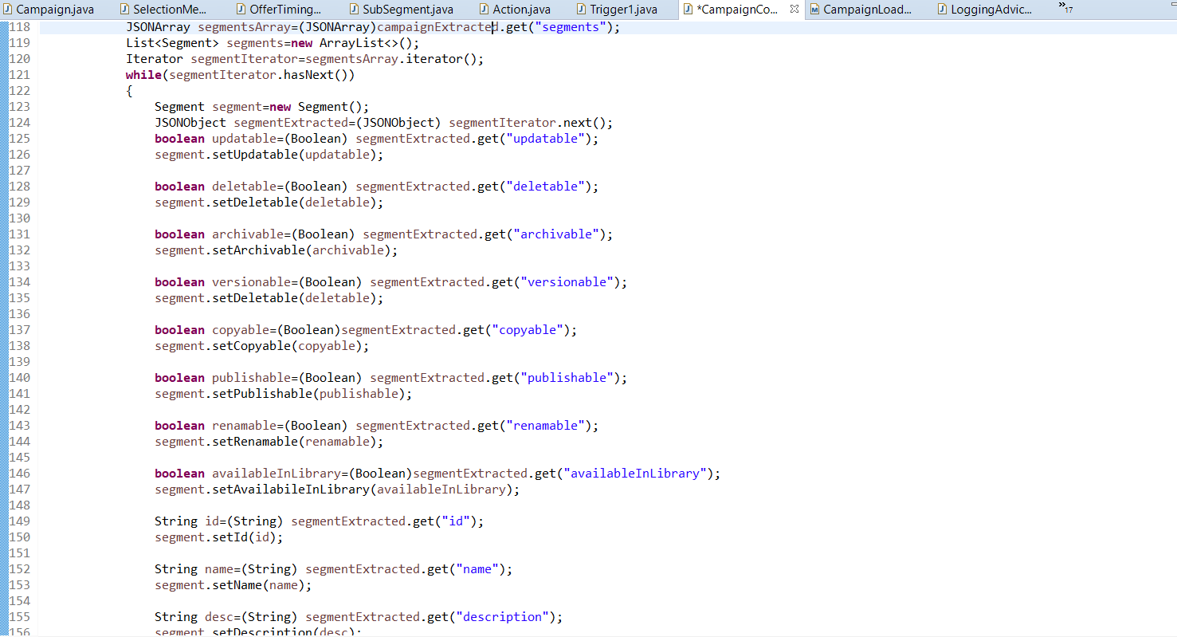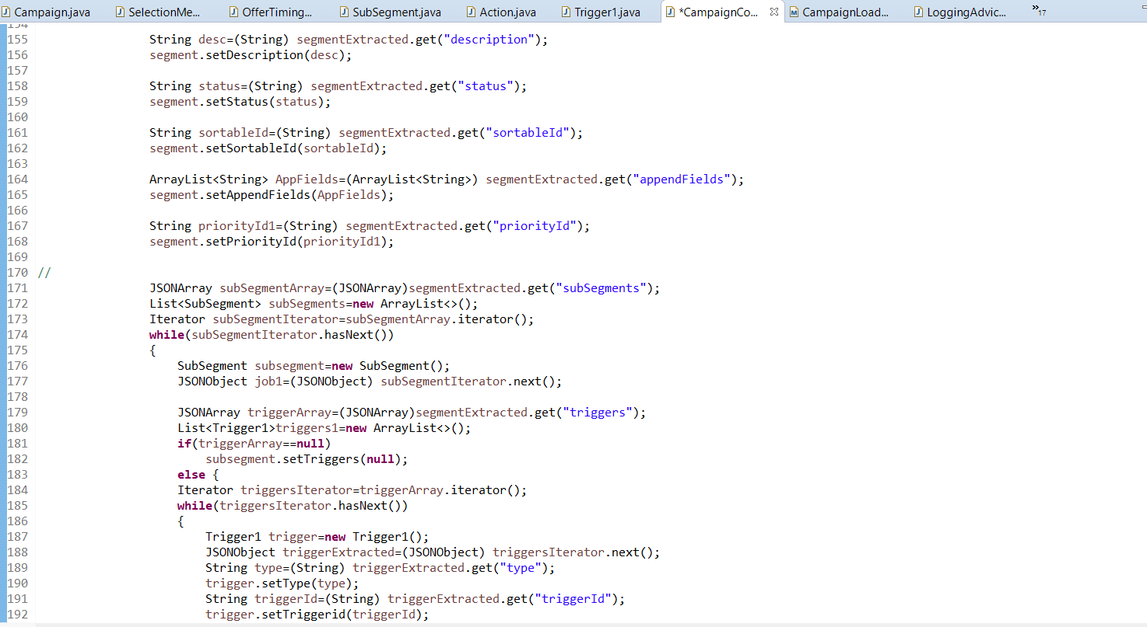

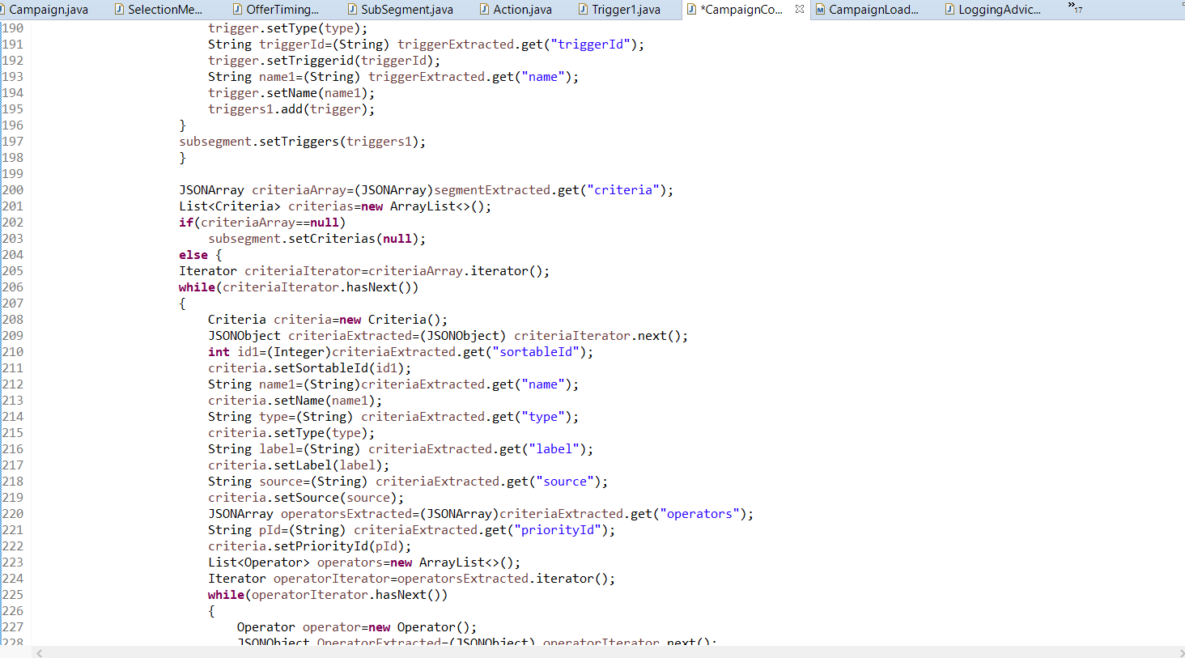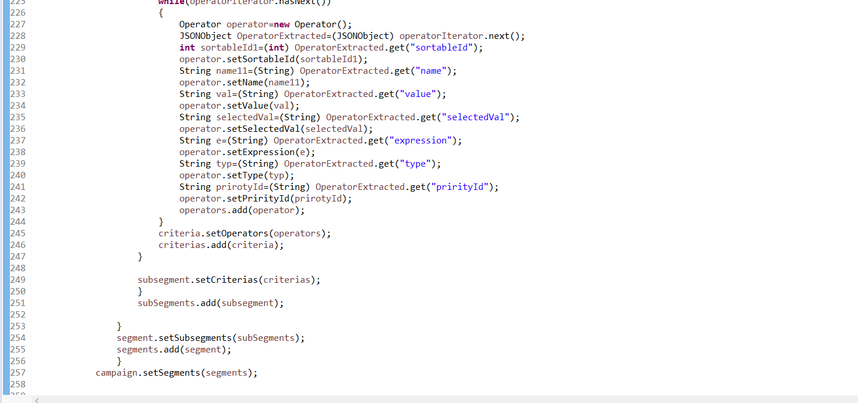

Just like that JSON data is extracted and stored in the respective JAVA objects

At line 61, the logger object is created to implement logging functionality

B.6 pom.xml

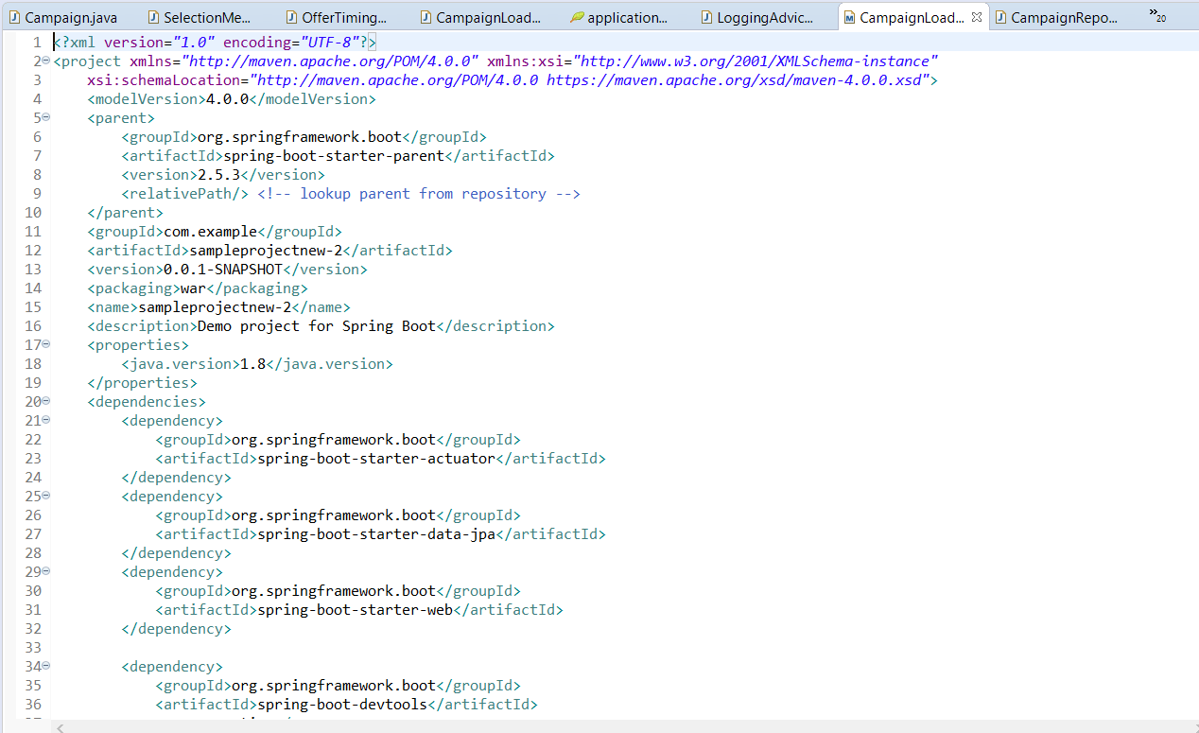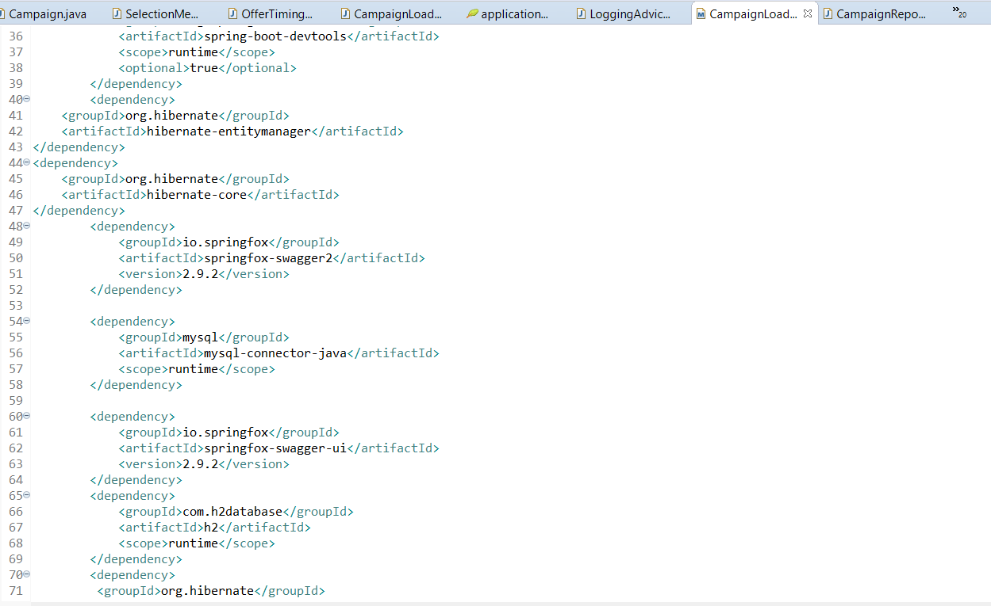

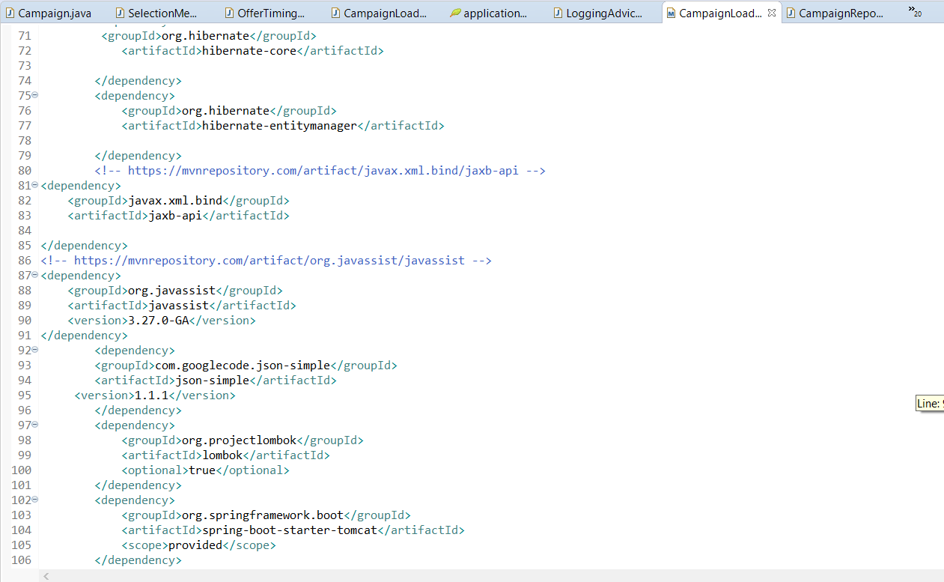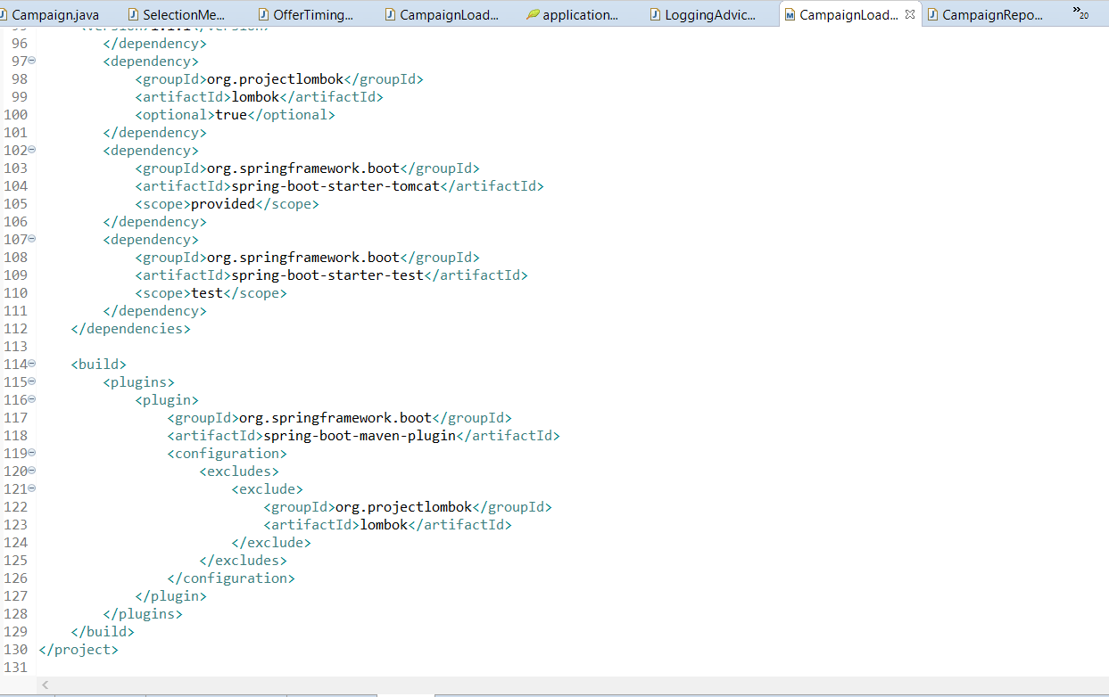

B.7 application.properties

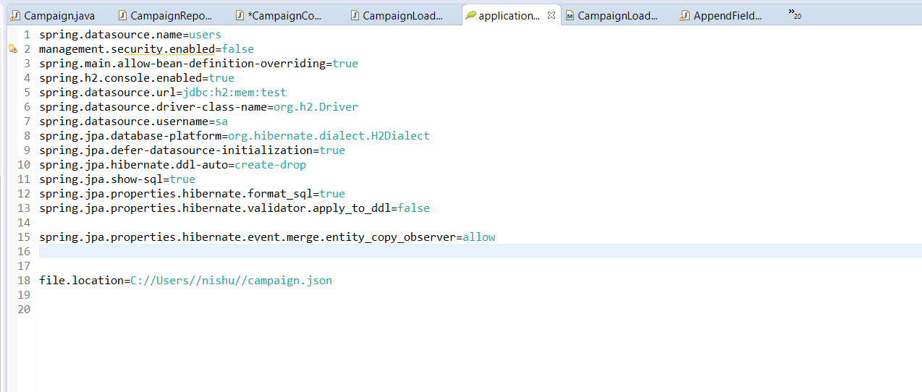

In this file the SpringBoot Application is connected to the h2-console and to the database in DBeaver

B8 H2-console

Before the save (Before API hit):

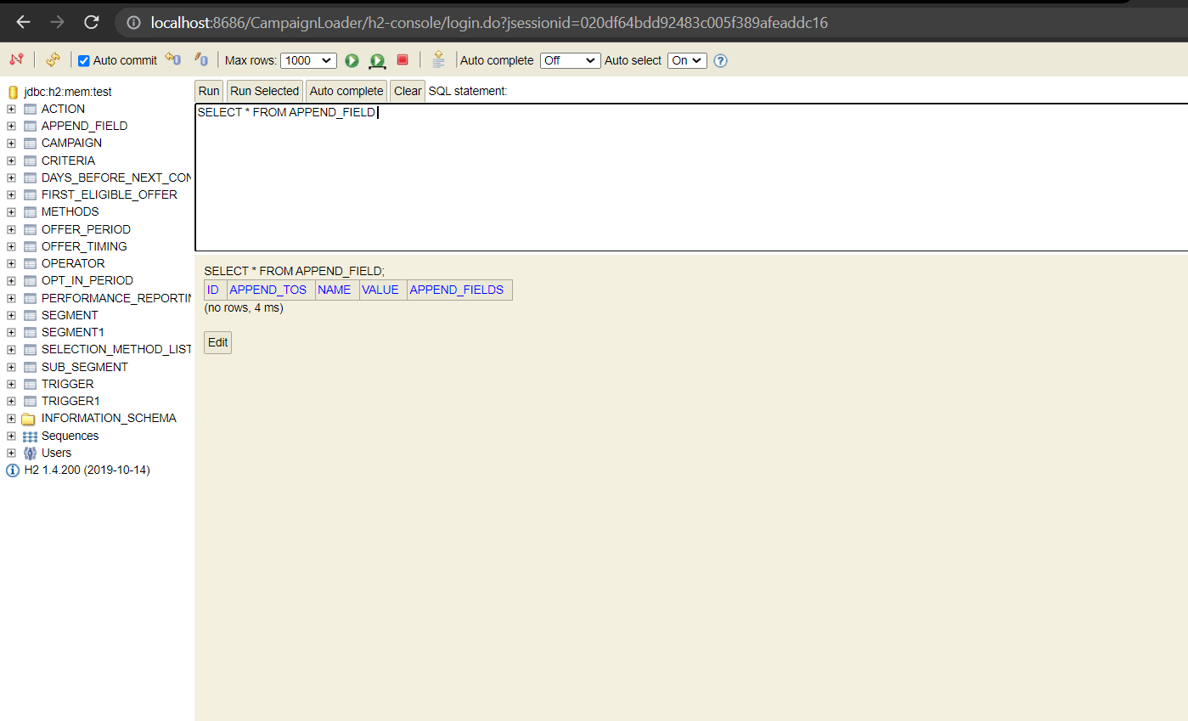

The required tables are created but there not filled

After save(After API hit):

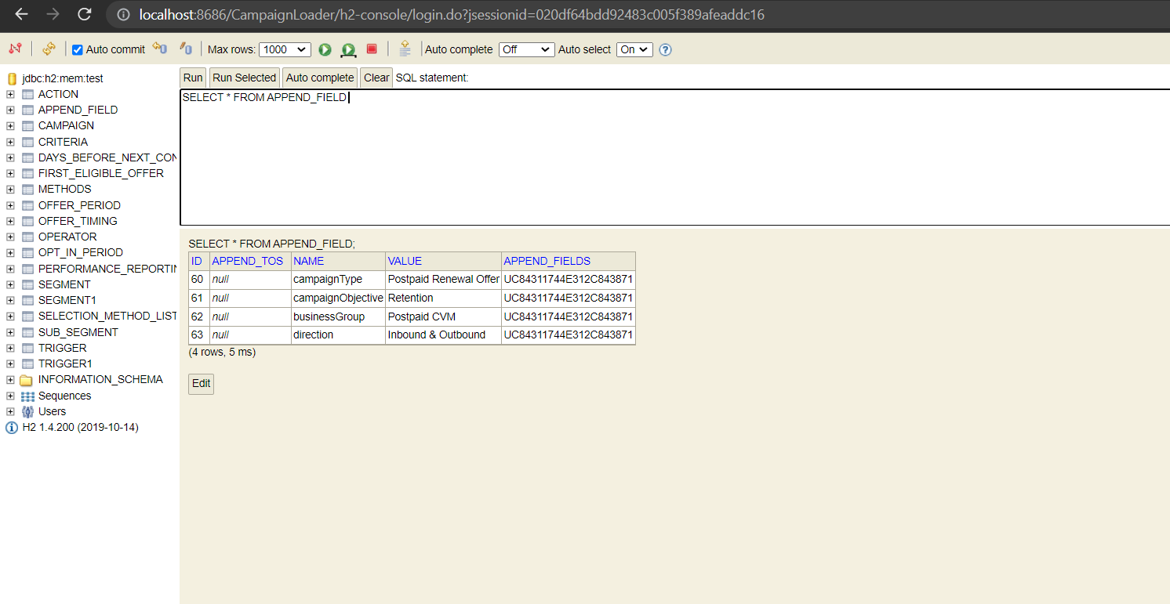

The data is stored in the database

References

- https://dzone.com/articles/6-defining-features-of-microservices
- https://spring.io/projects/spring-boot
- https://www.ibm.com/cloud/learn/java-spring-boot
- https://www.youtube.com/watch?v=msXL2oDexqw&list=PLqq-6Pq4lTTbx8p2oCgcAQGQyqN8XeA1x
- https://docs.spring.io/spring-boot/docs/current/reference/htmlsingle/
- https://dbeaver.com/docs/wiki/

