How can I get registered on **IBM bluemix**?

# Create an IBM Bluemix Account

**Step 1** In a web browser navigate to the following URL:

<https://console.bluemix.net/registration/trial/>

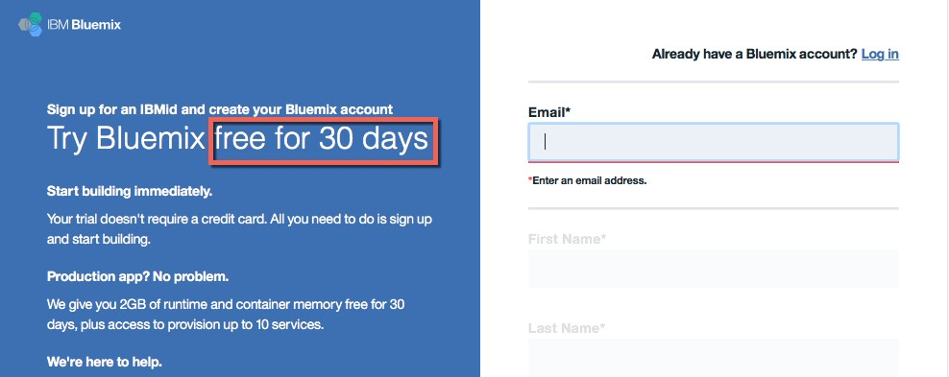

**Step 2** Fill in the required information and press the button 

**Step 3** After you submit your registration, you will receive an e-mail from the IBM Bluemix team with details about your account. In this e-mail, you will need to click the link provided to confirm your registration

**Step 4** Now you should login to your new Bluemix account to create the required *organization* and *space*.

1. As *organization* you have to specify something **unique** like your IBM id or anything else.
2. As *space* you can specify something like dev, test, or anything else.

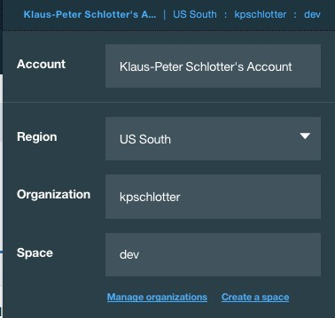

**Step 5** That’s it! You now have a free 30 day trial with IBM Bluemix! At this point, you can log in (using the URL in **Step 1**) and begin exploring its features and capabilities.

How do I get registered on **Slack**?

1. Open in [https://join.slack.com/t/ibmwatsonworkshop/signup](https://join.slack.com/t/ibmwatsonworkshop/signup%20) browser and Enter your official college email address and click on **Create Account**.

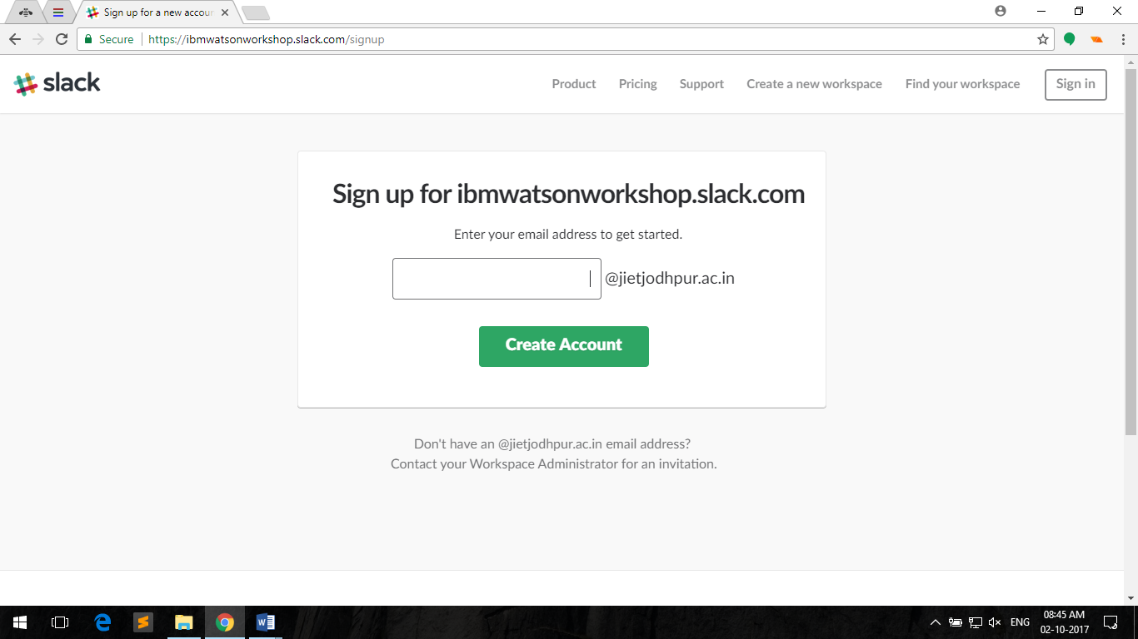

1. Verify your slack account in **Gmail.**

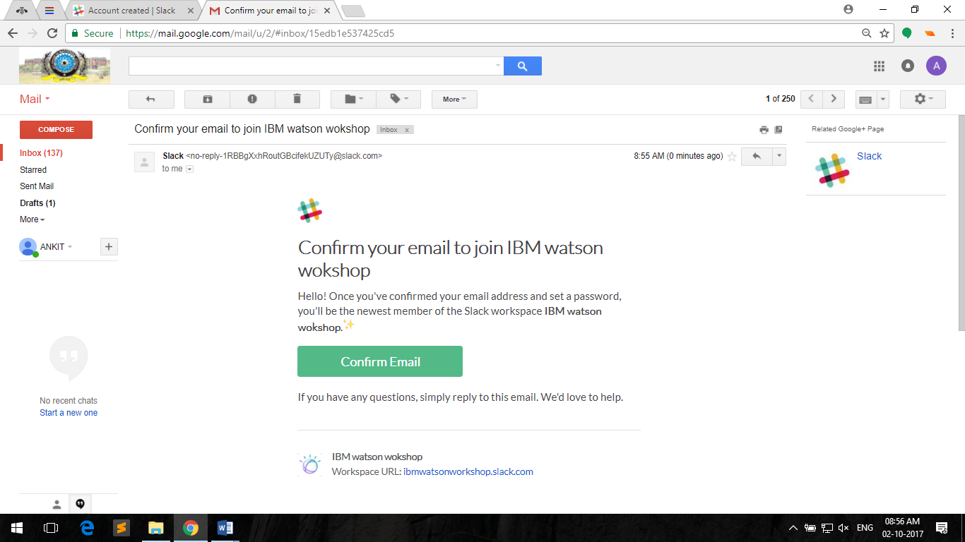

1. Now you can open slack from <https://ibmwatsonworkshop.slack.com/> .