Software Design Document
(SDD)

For

8085 Microprocessor Simulation

Version 0.2 08-April-2017



Department of Computer Science Engineering
Jodhpur Institute of Engineering and Technology
Session 2016-17

APPROVAL and Compulsory Review LIST
Role | Name | Date
Lab Faculty/ Incharge | Mr. Ashutosh Vyas | 08-April-2017

Version Tracking
Date | Version | Comments | Author
16-Feb-2017 | 0.1 | Initial Version | Ankit Gehlot
8-April-2017 | 0.2 | After Correction | Ankit Gehlot

Table of Contents
1 Introduction 2
2 High Level Functional Description 2
3 High Level Functional Partitions 2
3.1 Module Name: opSelect 2
3.2 Module Name: userGuide 2
3.3 Module Name: opInter 2
3.4 Module Name: output 2
3.5 Module Name: _exit_ 2
4 Data Description 2
4.1 Data Flow Diagram 2
4.2 Data Structure: 2
Structure: line 2
Structure: regis 2
Structure: Flag 2
4.3 Constant Definition 2
5 Low Level Module Description ( For C++) 2
5.1 Module Name: NA 2
6 Low Level Module Description (For C) 2
6.1 Module Name: opSelect 2
6.2 Module Name: userGuide 2
6.3 Module Name: opInter 2
6.4 Module Name: output 2
6.5 Module Name: _exit_ 2
7 Definitions and Acronyms 2
8 References 2

Introduction

- It is a byte level Simulation for the 8085 microprocessor which supports windows platform. It reads the standard opcodes of Instructions, interprets them line by line and displays output in command line environment.

- Initial Concept was taken from the actual working of 8085 Microprocessor in which the instructions are given in form of opcodes through interrupts and the operations are performed on 8-bit data by their memory addresses. Using the same concept, a simulator is developed which takes upto 3-byte Instruction and filters opcode and data and interprets the given instruction.

- 8085 Microprocessor trainer kit is not available to everyone due to its expenses for maintenance and availability. To make it available to every student for learning and practice without expenses, this simulator is made.

- It is applicable in Microprocessor Lab programs for learning and practicing.

- Problems: -
  - 8-bit Hexadecimal Data input and performs only arithmetic operations.
  - Only Keyboard and computer display can be used as I/O peripheral device respectively.
  - Supports Windows Platform only.

- Previous Studies done on this topic: -
  - 8085 Microprocessor Architecture.
  - Hexadecimal Opcodes of Instructions and their uses.

High Level Functional Description

2.1 List of features of the complete project:-

- User Manual.
- Line by Line Interpretation.
- Program Input from file.

2.2 Functional Block Diagram: -

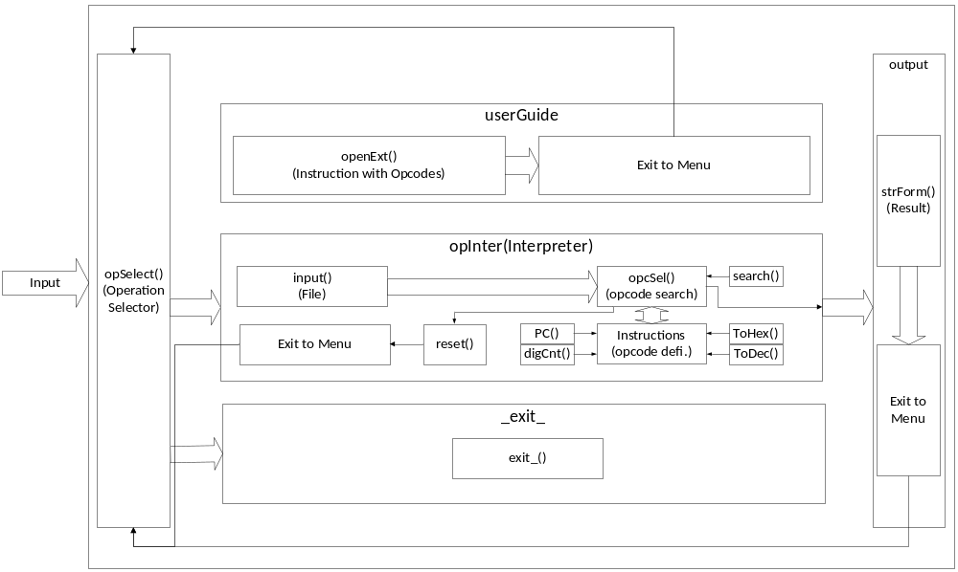

2.2.1 opSelect: -

opSelect (Operation Selector) module act as menu for the simulator which provide following 3 choices to the user: -

1. User Guide
2. Interpreter(Simulation)
3. Exit

In this Switch case is used to provide cases to user and takes input in integer form to choose 1 option.

2.2.3 userGuide: -

userGuide module provides the instructions and their opcodes respectively. It does take any input and open external notepad file with instructions and their opcodes.

2.2.3 opInter: -

opInter (Interpreter) is main module which simulates the instruction given by user by taking input in form of file then filtering the opcode and operand and allocating memory to both on array of structure then performing the operations and then sending output in form of string from address and also provide user option to return to menu.

2.2.4 _exit_: -

_exit module just exit the simulator to windows.

2.2.5 output: -

output module take input in form of string and after formatting it displays output through STDOUT and also provide option to return to main menu.

2.3 Flow Chart: -

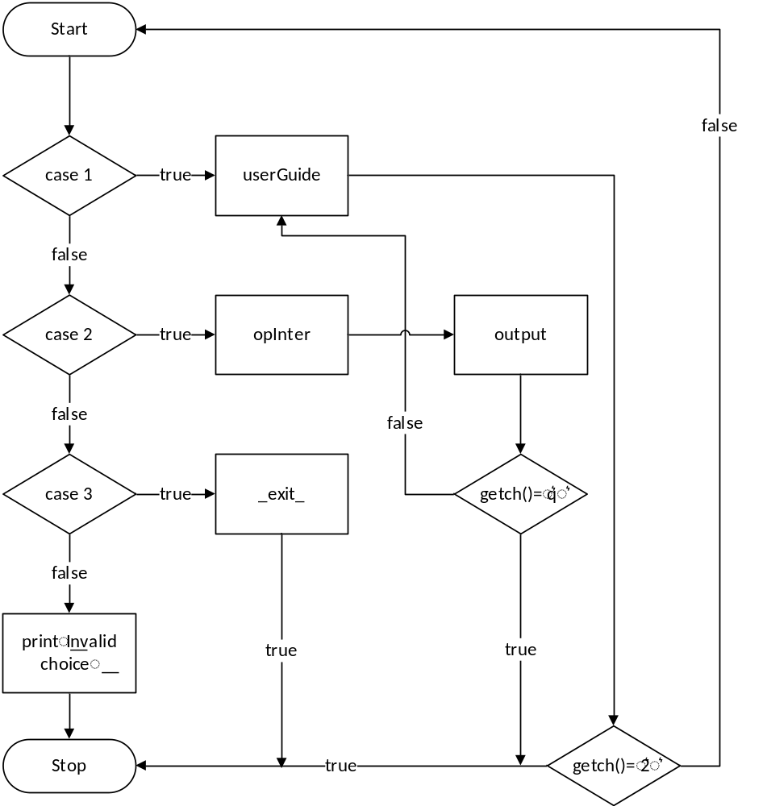

High Level Functional Partitions

Module Name: opSelect
opSelect module act as menu for the simulator which provide following 3 choices to the user: -

1. User Guide
2. Interpreter(Simulation)
3. Exit

In this Switch case is used to provide cases to user and takes input in integer form to choose 1 option.

Functional Block Diagram

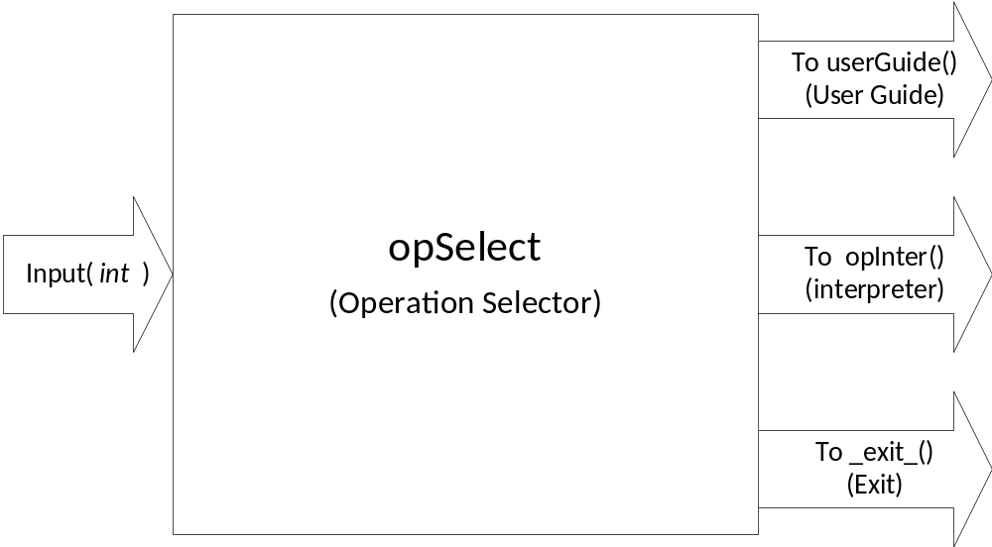

Flow Chart

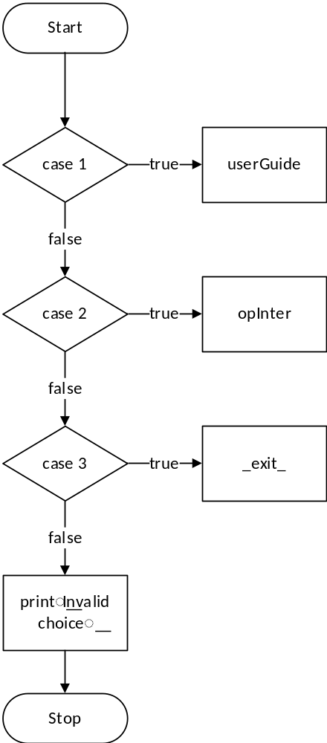

Module Name: userGuide

userGuide module provides the instructions and their opcodes respectively. It does take any input and open external notepad file with instructions and their opcodes.

Functional Block Diagram

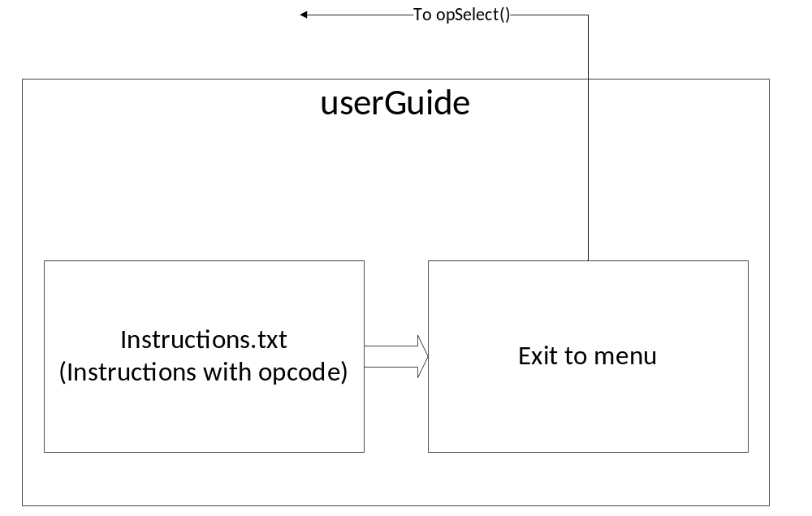

Flow Chart
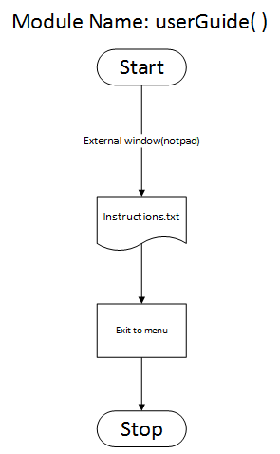

Module Name: opInter
opInter is main module which simulates the instruction given by user by taking input in form of command-line input or file input then filtering the opcode and operand and allocating memory to both on array then performing the arithmetic operations and array push and pop operations then sending output in form of string and also provide user option to return to menu.

Functional Block Diagram

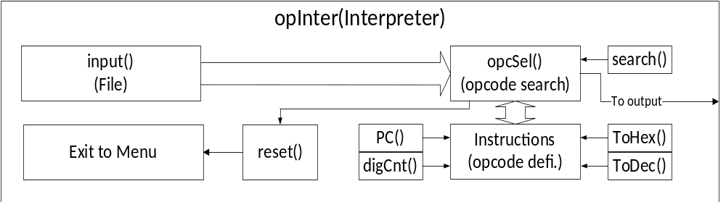

Flow Chart

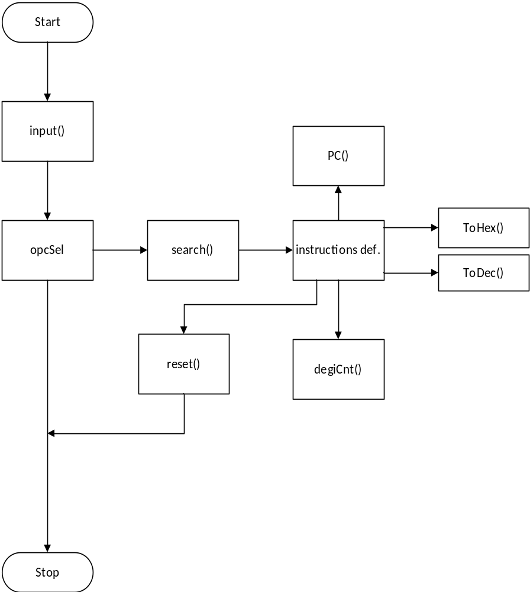

Module Name: output

output module take input in form of string and after formatting it displays output through STDOUT and also provide option to return to main menu.

Functional Block Diagram

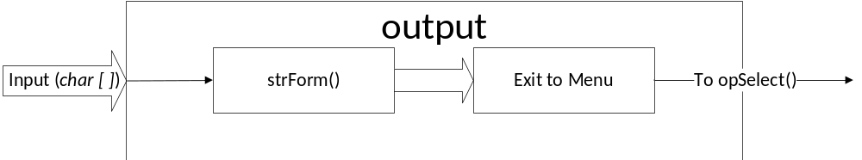

Flow Chart
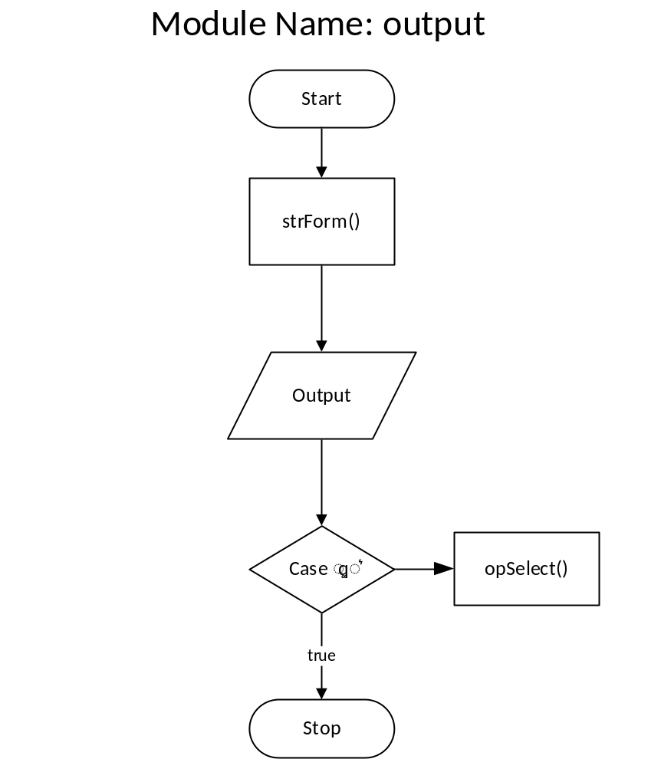

Module Name: _exit_
_exit_ module just exit the simulator to windows.

Functional Block Diagram
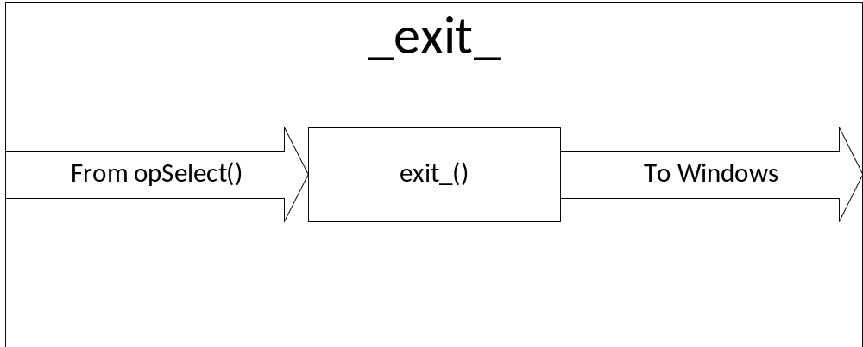

Flow Chart

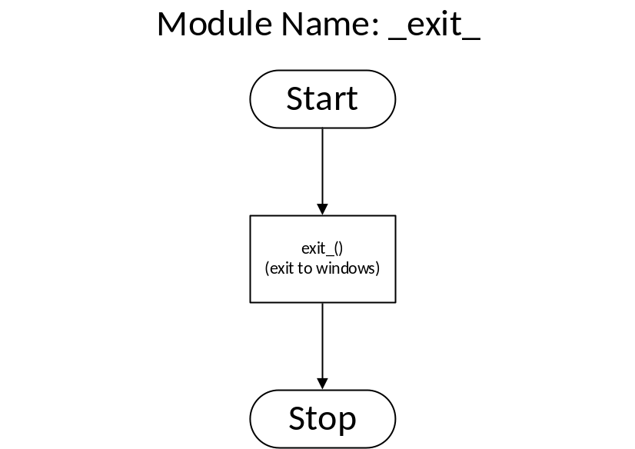

Data Description

Data Flow Diagram

Context Diagram (Level 0 D.F.D.)
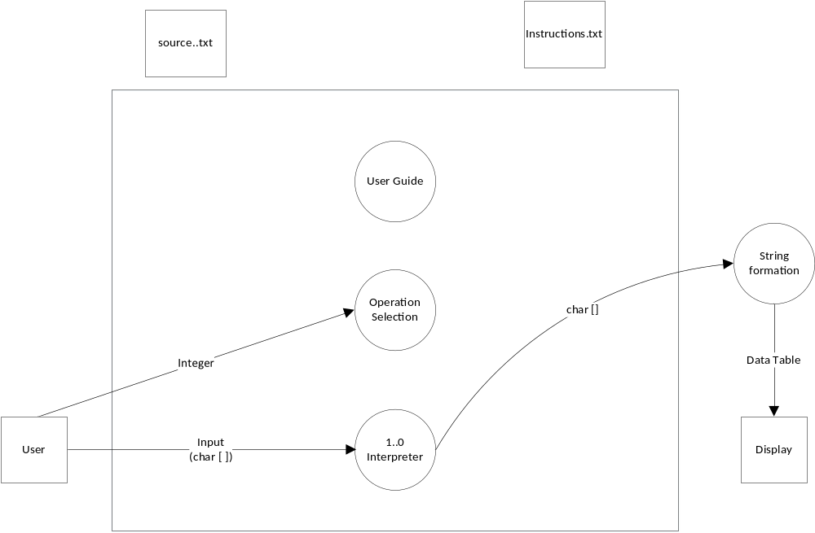

Level 1 D.F.D.

Process 1.0
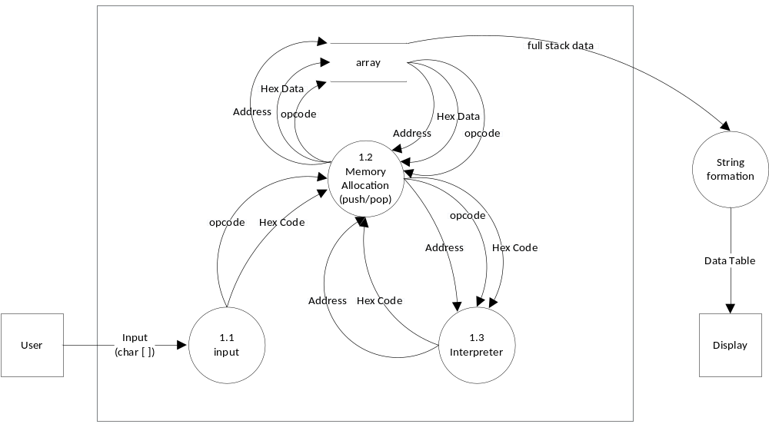

Data Structure:

Structure: line

Structure: regis

Structure: Flag

Constant Definition
NA

Low Level Module Description ( For C++)

Module Name: NA

Class Name: NA

Class Dependencies
NA

Functions in the Class
NA

Function Name: NA

Declaration
NA

Parameters List

Parameter Type | Parameter Name | Parameter Description
NA | NA | NA

Return values
NA

Algorithm / Pseudo code
NA

5.1.1.2.1.4 Flow Chart
NA

Low Level Module Description (For C)

Module Name: opSelect
It takes input as integer for switch cases to direct the control flow to different modules.

6.1.1.1 Function Name: opSelect
opSelect act as menu for the simulator which provide following 3 choices to the user.

6.1.1.2 Declaration
void opSelect(in)

6.1.1.3 Parameter List

Parameter Type | Parameter Name | Parameter Description
NA | NA | NA

6.1.1.4 Return values
NA

6.1.1.5 Algorithm/ Pseudo Code

void opSelect ()
{
char uchoice
menu:
print"MENU\n\n1.User Guide\n2.Simulate\n3.Exit\n\n"
print"Enter Choice:”
scan"%c”, uchoice
switch(uchoice)
{
case '1':
openExt () //userGuide-Instructions
break
case '2':
input () //File-input
break
case '3':
exit_ () //exit
break
default:
print” Invalid Choice!"
}
goto menu
}

6.1.1.6 Flow Chart
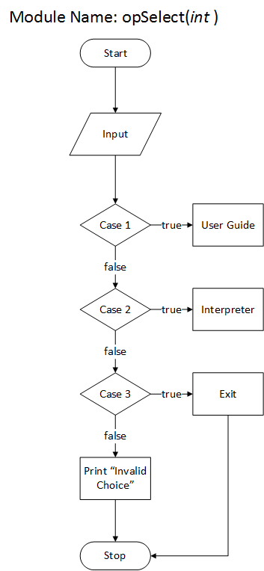

Module Name: userGuide
userGuide module provides the instructions and their opcodes respectively. It does take any input and open external notepad file with instructions and their opcodes.

6.2.1.1 Function Name: openExt
opExt opens an external txt file (instruction.txt)

6.2.1.2 Declaration
void openExt ()

6.2.1.3 Parameter List

Parameter Type | Parameter Name | Parameter Description
NA | NA | NA

6.2.1.4 Return values
NA

6.2.1.5 Algorithm/ Pseudo Code
void openExt ()
{
char c
extmenu:
system("cls")
print"\n __________________USERGUIDE___________________\n"
print"1.Instructions\n\2.Exit\n"
print"_______________________________________________\n"
print"Enter choice:"
scan"%c”, &c
if(c=='1')
{
system ("IF EXIST instructions.txt (notepad instructions.txt) ELSE (echo Error: instructions.txt missing.)")
goto extmenu
}
else if (c == '2')
{
system("cls")
opSelect ()
}
else
{
goto extmenu
}
}

6.2.1.6 Flow Chart

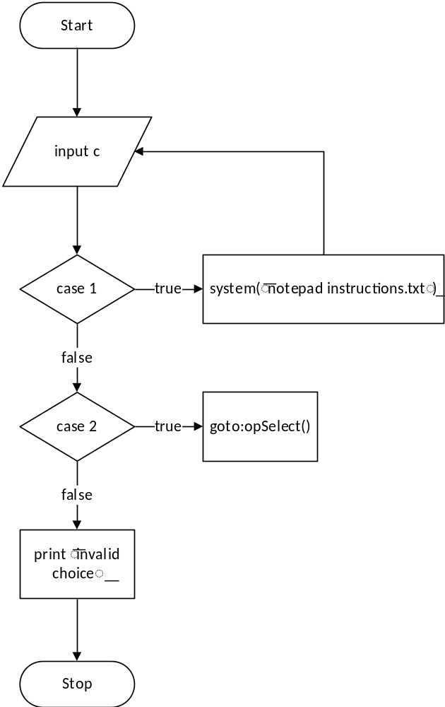

Module Name: opInter
opInter is main module which take the instruction given by user by taking input in form of command-line input or file input and gives ouput in form of string.

6.3.1.1 Function Name: input
input () function take input from user in form of string and returns string.

6.3.1.2 Declaration
void input ()

6.3.1.3 Parameter List

Parameter Type | Parameter Name | Parameter Description
NA | NA | NA

6.3.1.4 Return values
NA

6.3.1.5 Algorithm/ Pseudo Code
void input ()
{
FILE *f
int i=0
char c, *text=NULL
size_t length = 0
len=0

print"Enter you program in Source file and save.\n"
_insert:
system ("IF EXIST source.txt (notepad source.txt) ELSE (echo Error:source.txt missing.)")
f=fopen("source.txt","r")
if fgetc(f)==EOF
{
print"Source file is empty! \npress '1' to Try again or press any key to return to menu. \b\b"
if getch () =='1'
{goto _insert}
else {opSelect ()}
rewind(f)
}
else
{
while (getline (&text, &length, f)! = -1)
{
len++
}
}
rewind(f)
line= malloc(len*sizeof(cmdline))
Reg= malloc (sizeof (struct regis))
flag= malloc (sizeof (struct Flag))

while (getline (&text, &length, f)! = -1)
{
strncpy(line[i].data,"\0",5)
strncpy(line[i]. op,"\0",2)
sscantext,"% [^','], % [^','], %s”, line[i]. addr, line[i]. opine[i].data)
i++
}
fclose(f)
opcSel ()
reset ()
getch ()
}

6.3.1.6 Flow Chart

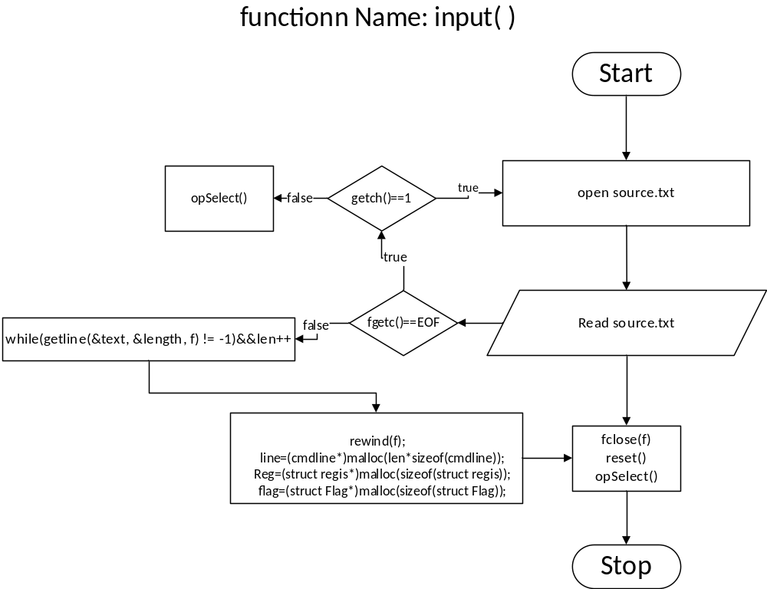

6.3.2.1 Function Name: opcSel
opcSel function select which opcode and call instruction functions.

6.3.2.2 Declaration
void opcSel ()

6.3.2.3 Parameter List

Parameter Type | Parameter Name | Parameter Description
NA | NA | NA

6.3.2.4 Return values
NA

6.3.2.5 Algorithm/ Pseudo Code
void opcSel ()
{
int i=0
print “_________________program_________________”
while(i<len)
{
if strcmp(line[i]. op,"21”) ==0
{
print"LXI H, %s\n”, line[i].data

strcpy(Reg->PC, line[i].data)

LXI(search(i))
}
else if strcmp(line[i]. op,"7E" ==0
{
print"MOV A, M”
MOV (0)
}
else if strcmp(line[i]. op,"72" ==0
{
print"MOV M, A”
MOV (1)
}
else if(strcmp(line[i]. op,"3E”) ==0
{
print"MVI A, %s\n”, line[i].data)
MVI (0, i)
}
else if strcmp(line[i]. op,"2E”) ==0
{
print"MVI L, %s\n”, line[i].data)
MVI (1, i)
}
else if strcmp(line[i]. op,"85”) ==0
{
print “ADD L”
ADD ()
}
else if strcmp(line[i]. op,"32”) ==0
{
print"STA %s\n”, line[i].data)
STA(search(i))
}
else if strcmp(line[i]. op,"23”) ==0
{
print"INX H”
INX ()
}
else if strcmp(line[i]. op,"90”) ==0
{
print"SUB B”
SUB ()
}
else if strcmp(line[i]. op,"46”) ==0
{
print"MOV B, M”
MOV (2)
}
else if strcmp(line[i]. op,"76”) ==0
{
print"HLT”
HLT ()
}
else //handle opcode selection errors
{
if strcmp(line[i]. op,"\0”) ==0
{
print"Line: %d ERROR: -Address(%s) have no opcode\n”, i+1, line[i]. op
}
print"Line: %d ERROR:-Invalid opcode: %s\n”, i+1, line[i]. op
}
i++
}
}

6.3.3.6 Flow Chart

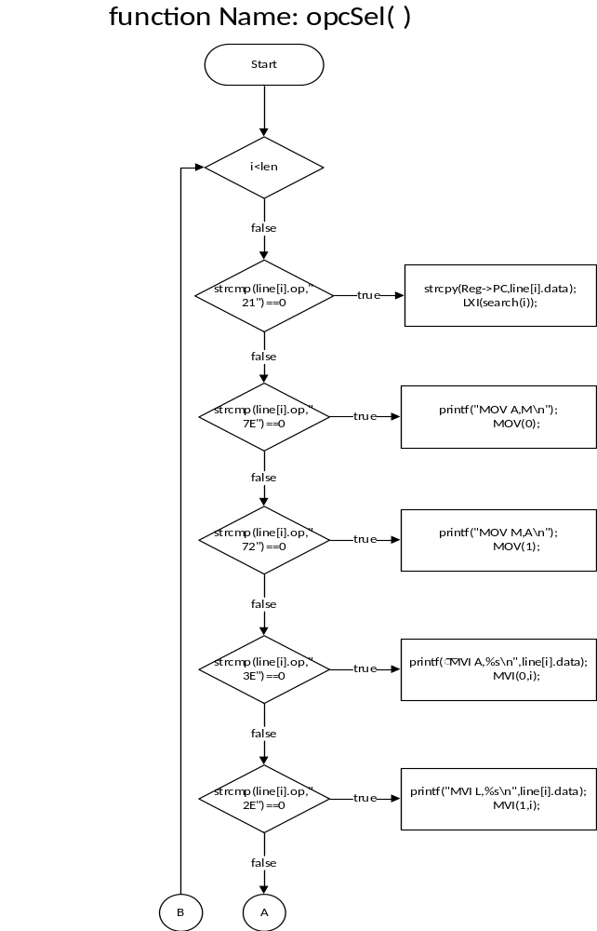
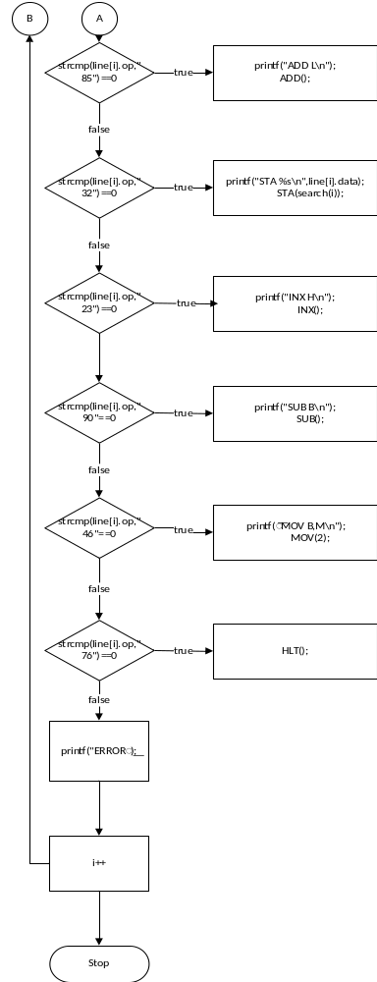

6.3.4.1 Function Name: digCnt
It determines the the no digit in interg value.

6.3.4.2 Declaration
int digCnt(int)

6.3.4.3 Parameter List

Parameter Type | Parameter Name | Parameter Description
int | x | input

6.3.4.4 Return values
x

6.3.4.5 Algorithm/ Pseudo Code
int digCnt (int x)
{
x = abs(x)
x = (x < 10? 1:
(x < 100? 2:
(x < 1000? 3:
(x < 10000? 4:
(x < 100000? 5 :6)))))
return x
}

6.3.4.6 Flow Chart

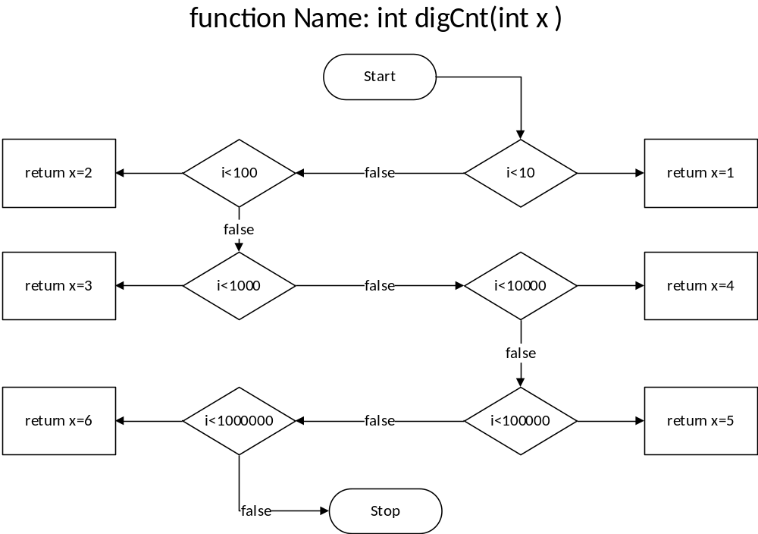

6.3.5.1 Function Name: reset
It will reset the structures line, Flag and regis for resuse.

6.3.5.2 Declaration
void reset ()

6.3.5.3 Parameter List

Parameter Type | Parameter Name | Parameter Description
NA | NA | NA

6.3.5.4 Return values
NA

6.3.5.5 Algorithm/ Pseudo Code
void reset ()
{
free(line)
free(Reg)
free(flag)
sleep (4000)
len=0
}

6.3.5.6 Flow Chart
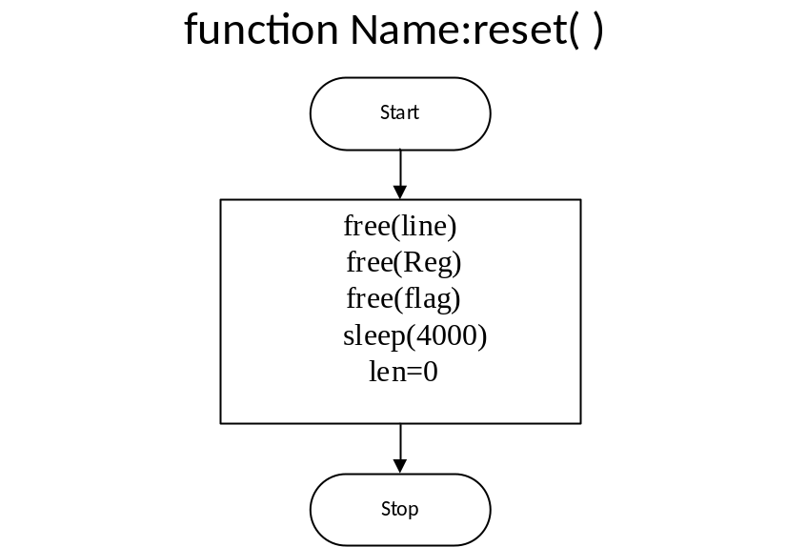

6.3.6.1Function Name: search
It returns the index no of address present in current line in form of data.

6.3.6.2 Declaration
int search (int i)

6.3.6.3 Parameter List

Parameter Type | Parameter Name | Parameter Description
int | i | index of address stored in data of instruction

6.3.6.4 Return values
j

6.3.6.5 Algorithm/ Pseudo Code
int search (int i)
{
int j, err=0

for (j=0 j<len j++)
{
if strcmp(line[i].data, line[j]. addr ==0
{
err=0
break
}
else
{
err=1
}
}
if err //handle error
{
print"Line: %d ERROR:-Invalid Address: %s\n”, j, line[i]. addr
print"\n\t\t\t\tPress any key to return to menu..."
reset ()
getch ()
opSelect ()
}
else
{
return j
}
}

6.3.6.6 Flow Chart
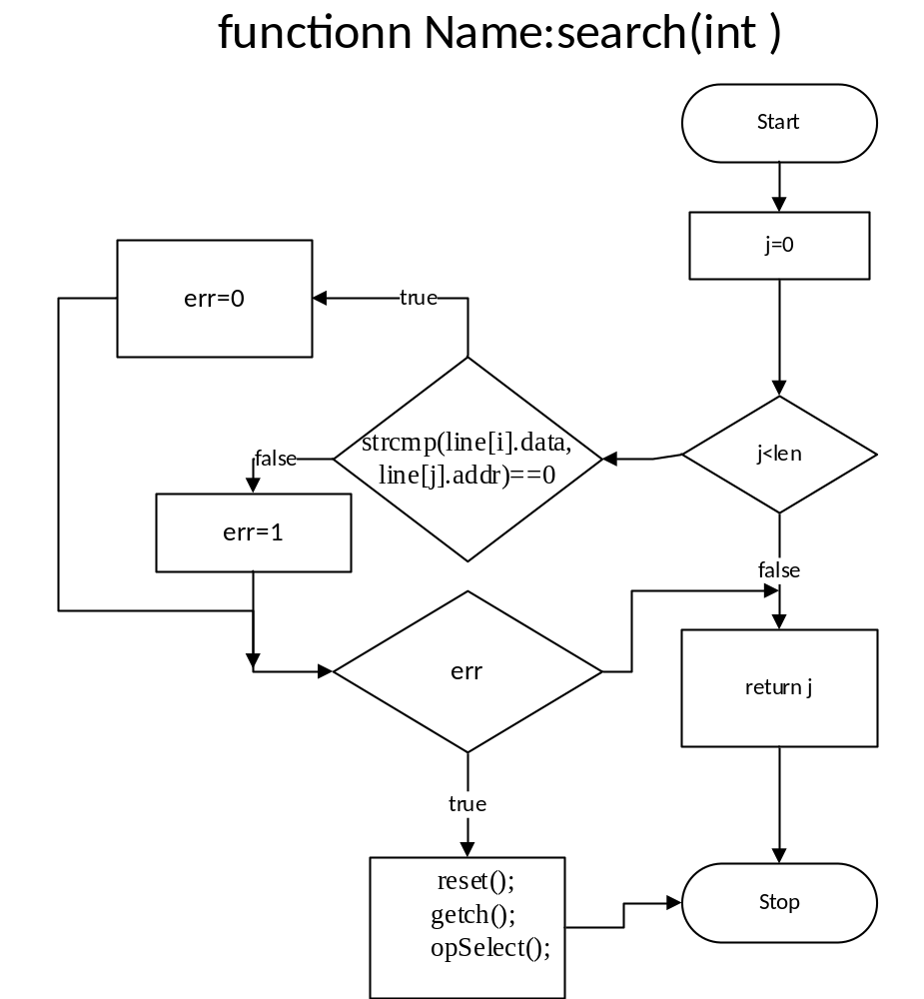

6.3.7.1 Function Name: LXI
It loads the register with 16-bit address.

6.3.7.2 Declaration
void LXI (int)

6.3.7.3 Parameter List

Parameter Type | Parameter Name | Parameter Description
int | j | index of data

6.3.7.4 Return values
NA

6.3.7.5 Algorithm/ Pseudo Code
void LXI (int j)
{
strcpy(Reg->H, line[j].data)

}
6.3.7.6 Flow Chart

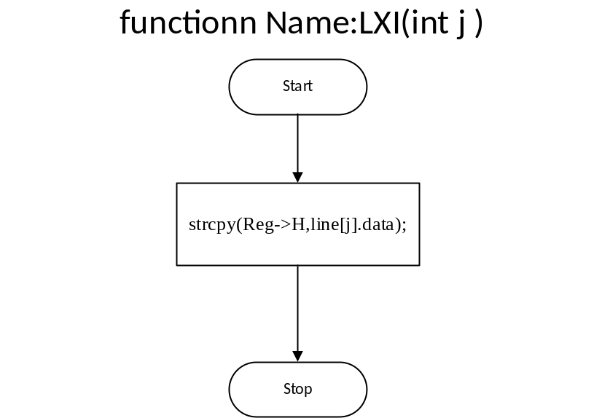

6.3.8.1 Function Name: MOV
It moves 8-bit data from one register to other

6.3.8.2 Declaration
void MOV (int)

6.3.8.3 Parameter List

Parameter Type | Parameter Name | Parameter Description
int | c | mode

6.3.8.4 Return values
NA

6.3.8.5 Algorithm/ Pseudo Code
void MOV (int c)
{
if !c
{
strcpy(Reg->A, Reg->H)
}
else if c==1
{
strcpy(Reg->H, Reg->A)
strcpy (line [PC ()].data, Reg->A)

}
else
{
strcpy(Reg->B, Reg->H)

}
}

6.3.8.6 Flow Chart

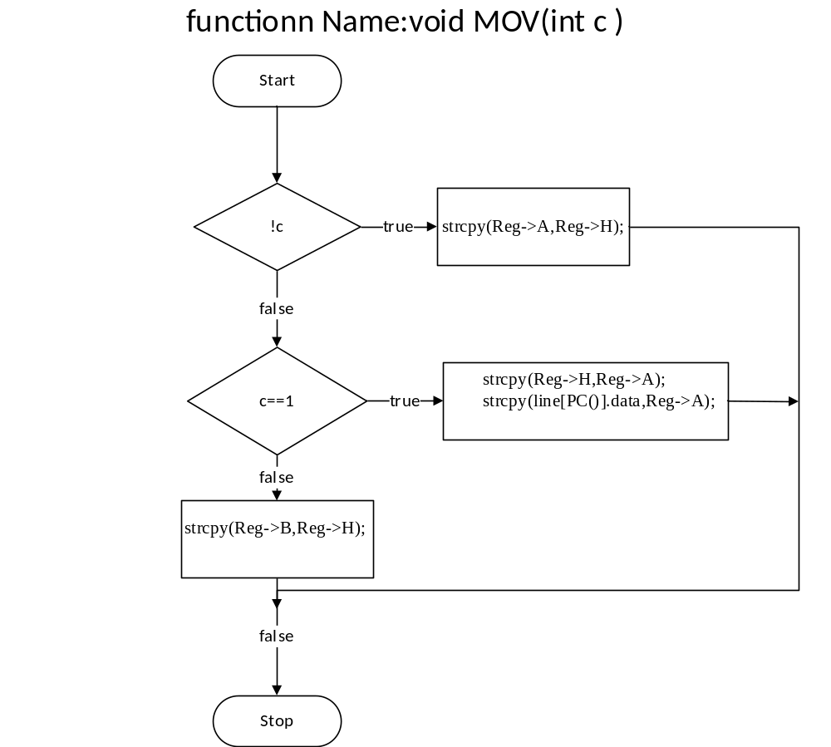

6.3.9.1 Function Name: MVI
It moves 8-bit data given in command to a register.

6.3.9.2 Declaration
void MVI (int, int)

6.3.9.3 Parameter List

Parameter Type | Parameter Name | Parameter Description
int | c | mode
int | i | index of data

6.3.9.4 Return values
NA

6.3.9.5 Algorithm/ Pseudo Code
void MVI (int c, int i)
{
if strcmp(line[i].data,"\0")! =0
{
if! c
{
strcpy(Reg->A, line[i].data)
}
else
{
strcpy(Reg->L, line[i].data)
}
}
else
{
print"Line: %d ERROR: -MVI:8bit data not found! \nil
print” Press any key to return to menu..."
getch ()
opSelect ()
}
}

6.3.9.6 Flow Chart

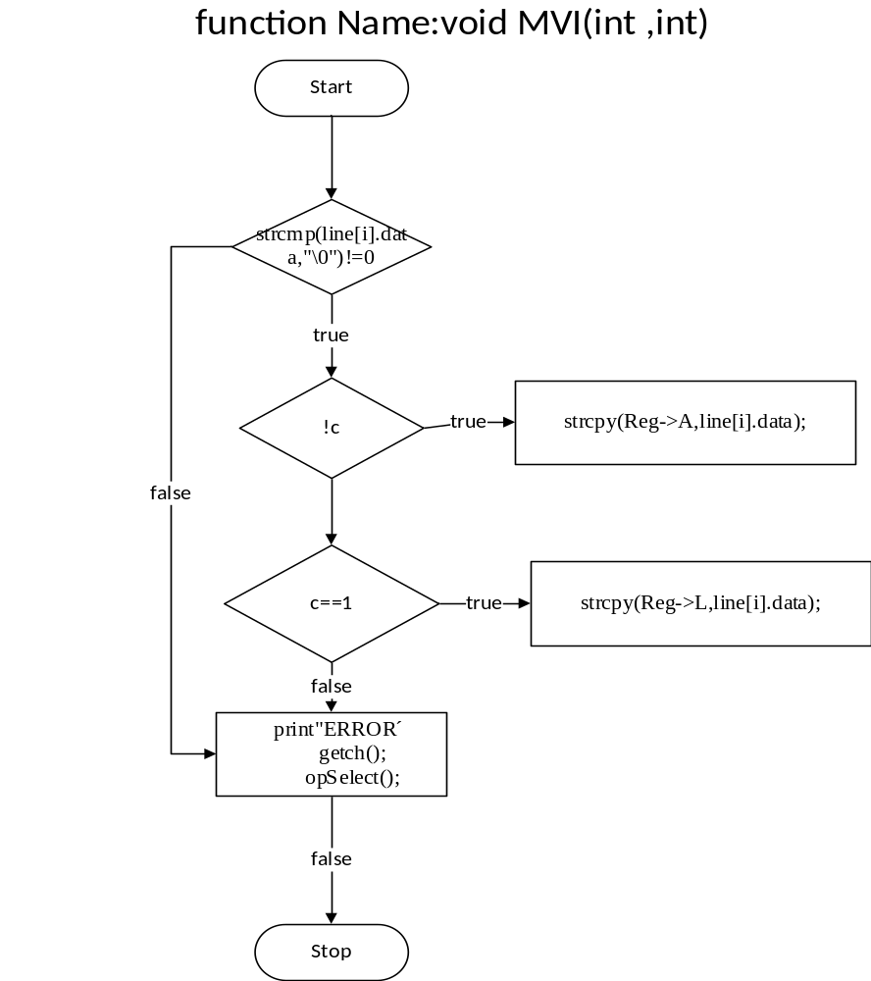

6.3.10.1 Function Name: STA
It stores accumulator 8-bit data to a specified 16-bit address.

6.3.10.2 Declaration
void STA (int)

6.3.10.3 Parameter List
Parameter Type | Parameter Name | Parameter Description
int | j | address of data

6.3.10.4 Return values
NA

6.3.10.5 Algorithm/ Pseudo Code
void STA (int j)
{
strcpy(line[j].data, Reg->A)
}
6.3.10.6 Flow Chart
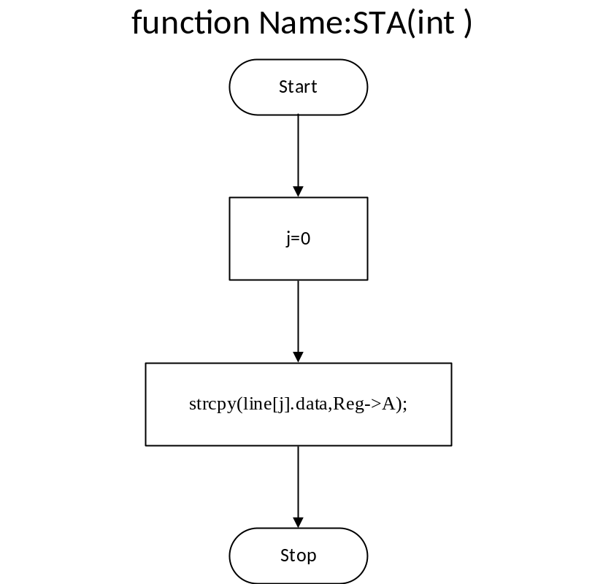

6.3.11.1Function Name: ADD
It adds two 8bit numbers without carry and stores result in accumulator.

6.3.11.2 Declaration

void ADD ()

6.3.11.3 Parameter List

Parameter Type | Parameter Name | Parameter Description
NA | NA | NA

6.3.11.4 Return values
NA

6.3.11.5 Algorithm/ Pseudo Code
void ADD ()
{
flag->CY=0
char *str
if NumDigits(ToDec(Reg->A) +ToDec(Reg->L))>2
{
flag->CY=1
ToHex(ToDec(Reg->A) +ToDec(Reg->L), Reg->A)
Reg->A [0] ='0'
Reg->A [1] ='0'
}
else
{
ToHex(ToDec(Reg->A) +ToDec(Reg->L), Reg->A)
}
free(str)
}

6.3.11.6 Flow Chart

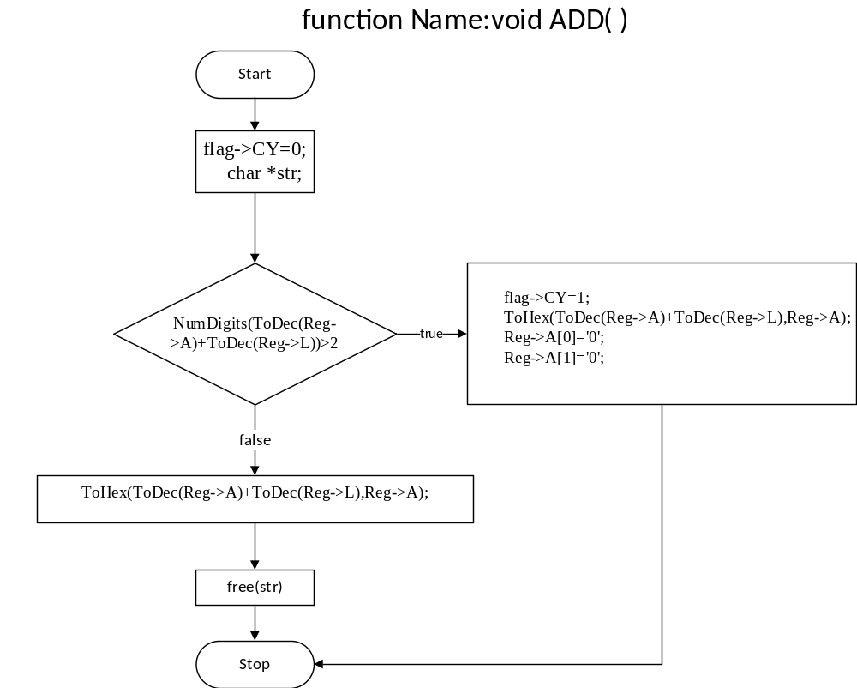

6.3.12.1 Function Name: SUB
It subtracts two 8-bit no without borrow and stores result in accumulator.

6.3.12.2 Declaration
void SUB ()

6.3.12.3 Parameter List

Parameter Type | Parameter Name | Parameter Description
NA | NA | NA

6.3.12.4 Return values
NA

6.3.12.5 Algorithm/ Pseudo Code
void SUB ()
{
flag->CY=0
if ToDec(Reg->A)-ToDec(Reg->B)) <0
{
flag->CY=1
strcpy(Reg->A,"0")
}
else
{
ToHex(ToDec(Reg->A)-ToDec(Reg->B), Reg->A)
}
}

6.3.12.6 Flow Chart

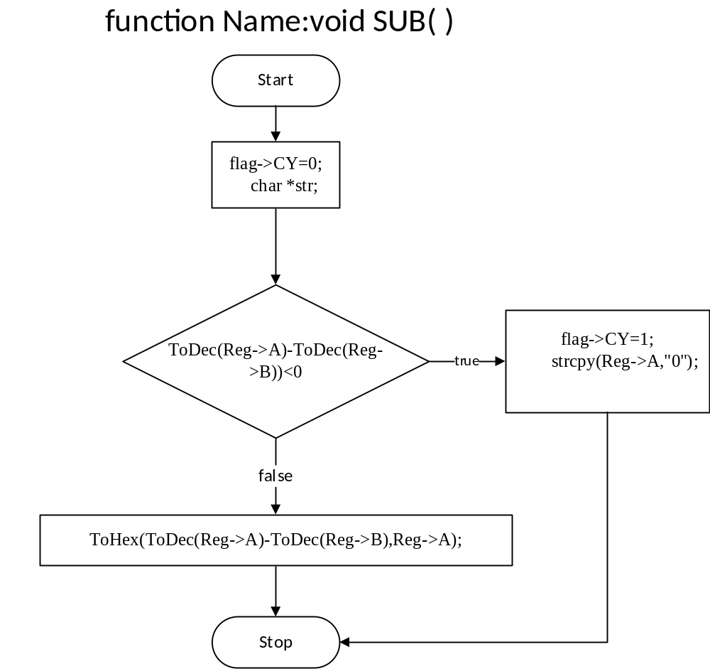

6.3.13.1 Function Name: INX
It increases 16-bit number present in register pair by 1.

6.3.13.2 Declaration
void INX ()

6.3.13.3 Parameter List

Parameter Type | Parameter Name | Parameter Description
NA | NA | NA

6.3.13.4 Return values
NA

6.3.13.5 Algorithm/ Pseudo Code
void INX ()
{
ToHex((ToDec(Reg->PC) +1), Reg->PC)
strcpy(Reg->H, line[PC()].data)

}
6.3.13.6 Flow Chart
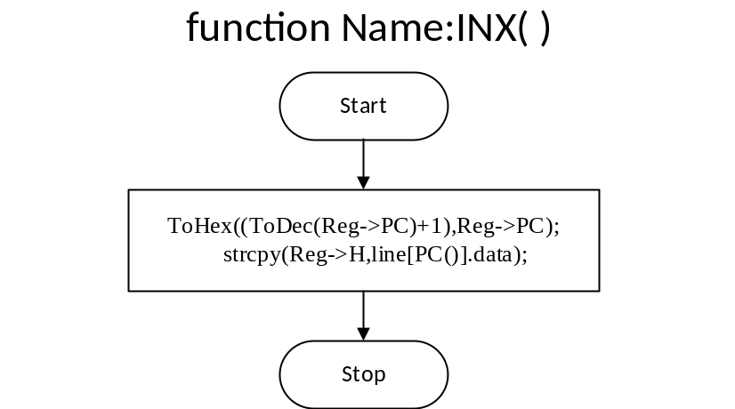

6.3.14.1 Function Name: HLT
HLT function terminate the program sequence and redirect control flow to output.

6.3.14.2 Declaration
void HLT ()

6.3.14.3 Parameter List

Parameter Type | Parameter Name | Parameter Description
NA | NA | NA

6.3.14.4 Return values
NA

6.3.14.5 Algorithm/ Pseudo Code
void HLT ()
{
print"Executed! \n\npress any key to continue..."
getch ()
strForm ()
reset ()
}

6.3.14.6 Flow Chart
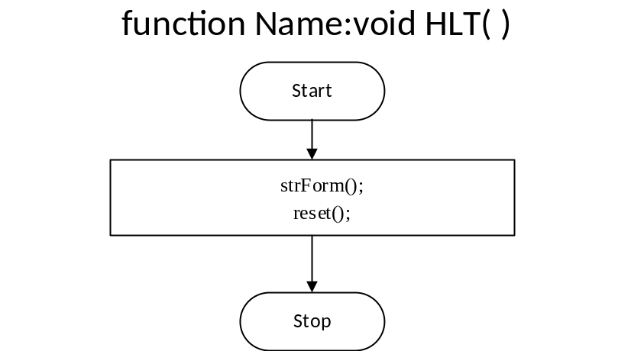

6.3.15.1 Function Name: ToDec
It converts hexadecimal number to decimal number.

6.3.15.2 Declaration
int ToDec (char [])

6.3.15.3 Parameter List

Parameter Type | Parameter Name | Parameter Description
char [ ] | HexVal | hexadecimal number

6.3.15.4 Return values
Res

6.3.15.5 Algorithm/ Pseudo Code
int ToDec (char HexVal [])
{
int i=0, Res=0
while(HexVal[i])
{
if HexVal[i]>=48 && HexVal[i]<=57
Res=(Res*16) +(HexVal[i]-48)
else if HexVal[i]>=65 && HexVal[i]<=70
Res=(Res*16) +(HexVal[i]-55)
else return -1
i++
}
return Res
}

6.3.15.6 Flow Chart

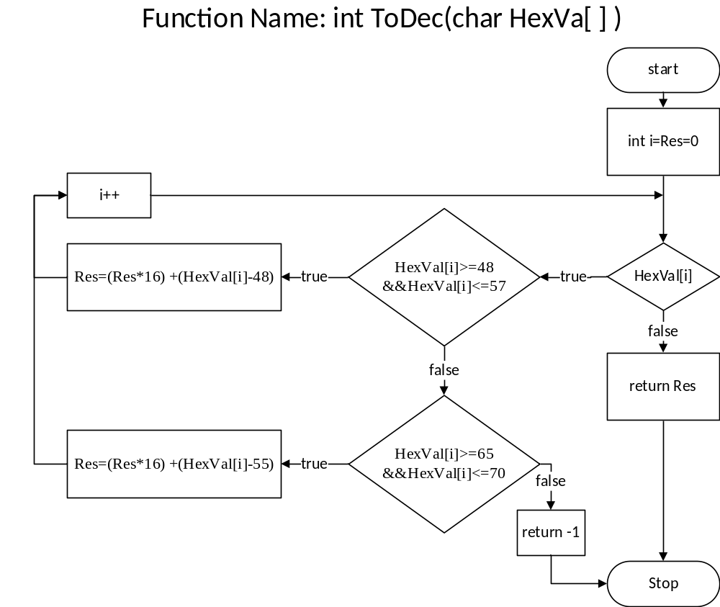

6.3.16.1 Function Name: ToHex
It converts decimal number to hexadecimal number.

6.3.16.2 Declaration
void ToHex (int, char [])

6.3.16.3 Parameter List

Parameter Type | Parameter Name | Parameter Description
int | N | decimal number
char [ ] | T | result in hexadecimal number

6.3.16.4 Return values
NA

6.3.16.5 Algorithm/ Pseudo Code
void ToHex (int N, char T [])
{
int Temp1, i=0
while(N)
{
Temp1=N%16
if(Temp1<=9)
{
T[i]=Temp1+48
i++
}
else
{
T[i]=Temp1+55
i++
}
N/=16
}
T[i]='\0'
strrev(T)
}

6.3.16.6 Flow Chart

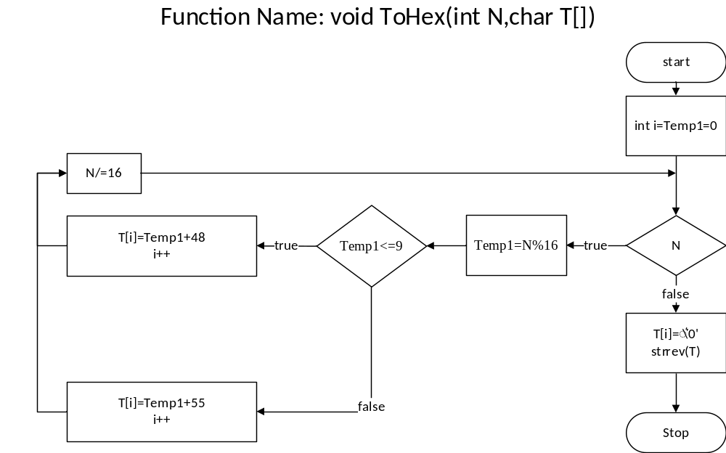

6.3.17.1 Function Name: PC
It stores the current register pair holding address.

6.3.17.2 Declaration
int PC( )

6.3.17.3 Parameter List

Parameter Type | Parameter Name | Parameter Description
NA | NA | NA

6.3.17.4 Return values
j

6.3.17.5 Algorithm/ Pseudo Code
int PC()
{
int j=0, err=0;

for (j=0; j<len; j++)
{
if strcmp(Reg->PC, line[j]. addr) == 0
{
err=0
break
}
else
{
err=1
}
}
if err
{
print"Line: %d ERROR:-Invalid Address: %s\n”, j, line[j]. addr
print"Press any key to return to menu..."
reset ()
getch ()
opSelect ()
}
return j
}

6.3.17.6 Flow Chart

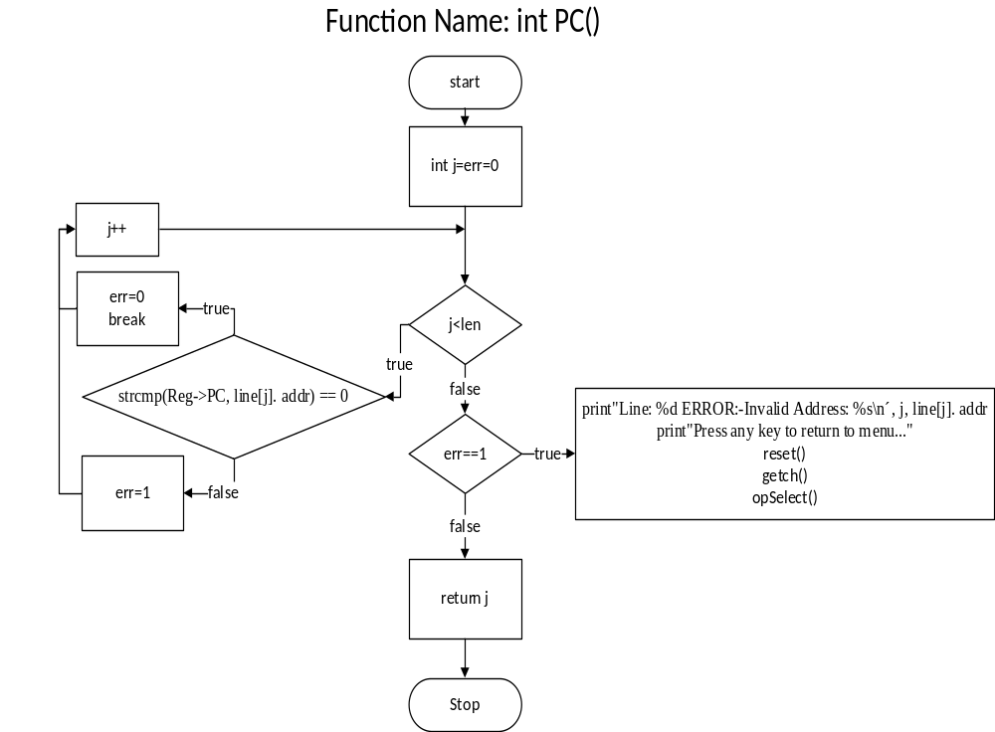

Module Name: output
output module take input in form of string and after formatting it displays output through STDOUT and also provide option to return to main menu.

6.4.1 Function Name: strform
strForm function pop the whole stack and displays result in form string (table).

6.4.2 Declaration
void strForm ()

6.4.3 Parameter List

Parameter Type | Parameter Name | Parameter Description
NA | NA | NA

6.4.4 Return values
NA

6.4.5 Algorithm/ Pseudo Code
void strForm ()
{
char s [5]
int j, err=0
out:
system("cls")
print"__________________OUTPUT___________________\nEnter Address:")
scan"%s”, s
for (j=0 j<len j++)
{
if strcmp (s, line[j]. addr) ==0
{
err=0
break
}
else
{
err=1
}
}

if err
{
print"ERROR:-Invalid Address: %s\n”, s)
goto xout
}
print"\nAddress\tdata\n%s\t%04s\n”, line[j]. addr, line[j].data
xout:
print"\nPress q to return to menu or any other key to continue...")
if getch () =='q' ||getch () =='Q'
{
reset ()
opSelect ()
}
else
{
goto out
}
}

6.4.6 Flow Chart
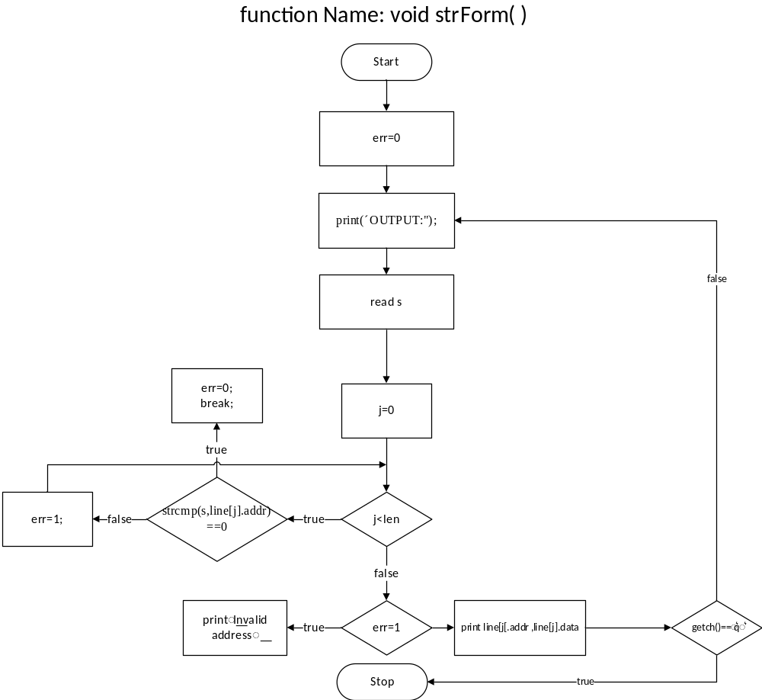

Module Name: _exit_
It will provide option to exit simulator

6.5.1Function Name: exit_
It will exit the program with EXIT_SUCCESS

6.5.2Declaration
void exit_()

6.5.3 Parameter List

Parameter Type | Parameter Name | Parameter Description
NA | NA | NA

6.5.4 Return values
NA

6.5.5 Algorithm/ Pseudo Code
void exit_(){
exit(EXIT_SUCCESS);
}

6.5.6 Flow Chart

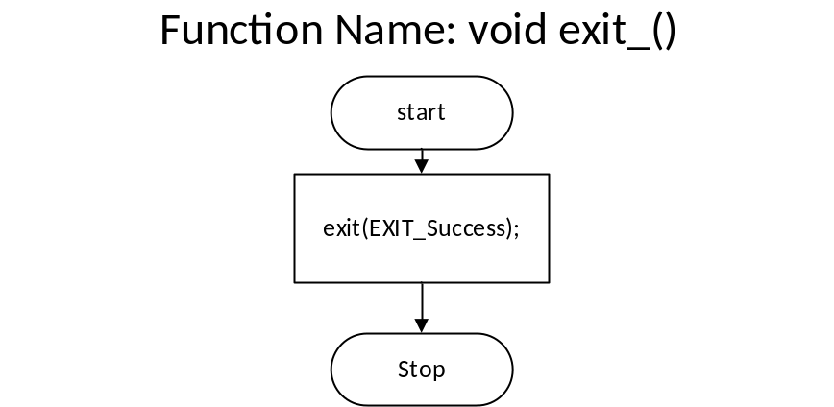

Definitions and Acronyms

Abbreviation | Description
D.F.D. | A data flow diagram (DFD) is a graphical representation of the "flow" of data through an information system, modelling its process aspects. A DFD is often used as a preliminary step to create an overview of the system without going into great detail, which can later be elaborated.
S.D.D. | Software Design Document

References

- INTEL 8085 ( https://en.wikipedia.org/wiki/Intel_8085 )
- Microprocessor architecture, programming, and applications with the 8085
- By Ramesh S. Gaonkar

- Mr. Nitin Mathur (Assistant Professor, Department of Computer Science Engineering)

