Software Requirements Specification
(SRS)

For

8085 Microprocessor Simulation

Version 0.1 16-Feb-2017



Department of Computer Science Engineering
Jodhpur Institute of Engineering and Technology
Session 2016-17

APPROVAL and Compulsory Review LIST
Role | Name | Date
Lab Faculty/ In charge | Mr. Ashutosh Vyas | 16-Feb-2017

Version Tracking
Date | Version | Comments | Author
16-Feb-2017 | 0.1 | Initial Version | Ankit Gehlot

Table of Contents

1.0 INTRODUCTION 2
1.1 Scope 2
1.2 Technologies to be used 2
2.0 GENERAL REQUIREMENTS 3
2.1 Functionalities 3
2.2 Use Case Model Diagrams 3
2.3 General Constraints 3
2.4 Supplementary requirements 3
3.0 Definition, Acronyms, and Abbreviations 4
4.0 References 5

INTRODUCTION

Scope
8085 Microprocessor Simulation is made for Windows Platform in which User uses the keyboard to insert the instructions and user is allowed to insert inputs using Hexadecimal opcodes and from specific file with extension ‘.85s’.

Technologies to be used
- Programming Language: C
- IDE: Eclipse Juno
- Version Control System: Git (85simulator)
- UML Diagram Tool: creately.com (online)

GENERAL REQUIREMENTS

Functionalities
- User Guide.
- Program Input from file.
- Interpretation

Use Case Model Diagrams
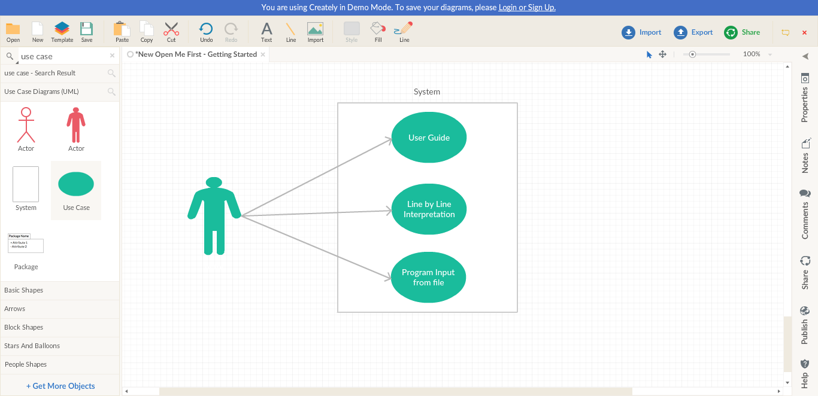

General Constraints
- 8-bit Hexadecimal Data input and performs only arithmetic operations.
- Only Keyboard and computer display can be used as I/O peripheral device respectively.
- Supports Windows Platform only.

Supplementary requirements
NA

Definition, Acronyms, and Abbreviations

- SRS (System Requirements Specification):
It is a requirements specification for a software system, is a complete description of the behavior of a system to be developed.one may include a set of use cases that describe interaction the users will have with the software. In addition, it also contains non-functional requirements. Nonfunctional requirements impose constraints on the or implementation.
- IDE: Integrated Development Environment
- Opcode: abbreviated from operation code.
- UML: UML stands for Unified Modeling Language. UML is a way of visualizing a software program using a collection of diagrams.

References

- INTEL 8085 ( https://en.wikipedia.org/wiki/Intel_8085 )
- Microprocessor architecture, programming, and applications with the 8085
- By Ramesh S. Gaonkar

- Mr. Nitin Mathur (Assistant Professor, Department of Computer Science Engineering)

