UC1_DATABASE

------------------------

mysql> CREATE DATABASE AddressBookSystem;

Query OK, 1 row affected (0.21 sec)

mysql> SHOW DATABASES;

+--------------------+

| Database |

+--------------------+

| addressbooksystem |

| information_schema |

| mysql |

| performance_schema |

| sys |

+--------------------+

5 rows in set (0.14 sec)

UC2_CreateTable

--------------------------

mysql> USE addressbooksystem;

Database changed

mysql> CREATE TABLE contacts ( FirstName VARCHAR(50) NOT NULL PRIMARY KEY , LastName VARCHAR(50) NOT NULL , Address VARCHAR(50) NOT NULL , City VARCHAR(50) NOT NULL , State VARCHAR(50) NOT NULL , Zip INT(30) NOT NULL , PhoneNumber INT(30) NOT NULL , Email VARCHAR(50) NOT NULL );

Query OK, 0 rows affected, 2 warnings (0.13 sec)

mysql> SHOW TABLES;

+-----------------------------+

| Tables_in_addressbooksystem |

+-----------------------------+

| contacts |

+-----------------------------+

1 row in set (0.04 sec)

UC3_InsertNewContacts

---------------------------------

mysql> INSERT INTO contacts ( FirstName, LastName, Address, City, State, Zip, PhoneNumber, Email ) VALUES ('Riya', 'Chaudhary', 'Sri Colony', 'Aurangabad', 'MH', 444001, 0987654321, 'Riya@gmail.com' ) , ( 'Surya', 'Reddy', 'Radhekrishna colony', 'Pune', 'MH', 444307, 1234567890, 'surya@gmail.com' );

Query OK, 2 rows affected (0.01 sec)

Records: 2 Duplicates: 0 Warnings: 0

UC4_EditExistingContact

----------------------------------

mysql> UPDATE contacts SET Zip = 444505 WHERE FirstName = 'Surya';

Query OK, 1 row affected (0.01 sec)

Rows matched: 1 Changed: 1 Warnings: 0

UC5_AbilityToDelete

---------------------------

mysql> DELETE FROM contacts WHERE FirstName = 'Surya';

Query OK, 1 row affected (0.01 sec)

UC6_AbilityToRetrieve

------------------------------

mysql> SELECT * FROM contacts WHERE city = 'Pune';

Empty set (0.01 sec)

UC7_AbilityToUnderstandSizeOfAddressBook

--------------------------------------------------------------

mysql> SELECT COUNT(*) FROM contacts WHERE State = 'TG';

+----------+

| COUNT(*) |

+----------+

| 0 |

+----------+

1 row in set (0.01 sec)

mysql> SELECT COUNT(*) FROM contacts WHERE State = 'MH';

+----------+

| COUNT(*) |

+----------+

| 1 |

+----------+

1 row in set (0.00 sec)

UC8_AbilityToRetrieveEntriesAlphabetically

----------------------------------------------------------

mysql> SELECT* FROM contacts WHERE City = 'Aurangabad' ORDER BY FirstName ASC;

+-----------+-----------+------------+------------+-------+--------+-------------+----------------+

| FirstName | LastName | Address | City | State | Zip | PhoneNumber | Email |

+-----------+-----------+------------+------------+-------+--------+-------------+----------------+

| Riya | Chaudhary | Sri Colony | Aurangabad | MH | 444001 | 987654321 | Riya@gmail.com |

+-----------+-----------+------------+------------+-------+--------+-------------+----------------+

1 row in set (0.01 sec)

mysql> SELECT* FROM contacts WHERE City = 'Pune' ORDER BY FirstName ASC;

Empty set (0.00 sec)

UC9_IdentifyAddressBook

-----------------------------------

mysql> ALTER TABLE contacts ADD AddressBookName VARCHAR(50);

Query OK, 0 rows affected (0.08 sec)

Records: 0 Duplicates: 0 Warnings: 0

mysql> ALTER TABLE contacts ADD AddressBookType VARCHAR(50);

Query OK, 0 rows affected (0.03 sec)

Records: 0 Duplicates: 0 Warnings: 0

mysql> UPDATE contacts SET AddressBookName = 'FamilyBook' WHERE FirstName = 'Riya';

Query OK, 1 row affected (0.01 sec)

Rows matched: 1 Changed: 1 Warnings: 0

mysql> UPDATE contacts SET AddressBookType = 'Family' WHERE FirstName = 'Riya';

Query OK, 1 row affected (0.01 sec)

Rows matched: 1 Changed: 1 Warnings: 0

mysql> UPDATE contacts SET AddressBookName = 'FriendsBook' WHERE FirstName = 'Surya';

Query OK, 0 rows affected (0.01 sec)

Rows matched: 0 Changed: 0 Warnings: 0

mysql> UPDATE contacts SET AddressBookType = 'Friends' WHERE FirstName = 'Surya';

Query OK, 0 rows affected (0.00 sec)

Rows matched: 0 Changed: 0 Warnings: 0

UC10_AbilityToGetNumber

-----------------------------------

mysql> SELECT COUNT(*) FROM contacts WHERE addressBookType = 'Family';

+----------+

| COUNT(*) |

+----------+

| 1 |

+----------+

1 row in set (0.00 sec)

UC11_AbilityToAddPersonToBothFriend&Family

----------------------------------------------------------------

mysql> CREATE TABLE Friend

-> (

-> FirstName VARCHAR(50) NOT NULL PRIMARY KEY,

-> LastName VARCHAR(50) NOT NULL,

-> Address VARCHAR(50) NOT NULL,

-> City VARCHAR(50) NOT NULL,

-> State VARCHAR(50) NOT NULL,

-> Zip INT(30) NOT NULL,

-> PhoneNumber INT(30) NOT NULL,

-> Email VARCHAR(50) NOT NULL

-> );

Query OK, 0 rows affected, 2 warnings (0.07 sec)

mysql> SHOW TABLES;

+-----------------------------+

| Tables_in_addressbooksystem |

+-----------------------------+

| contacts |

| friend |

+-----------------------------+

2 rows in set (0.01 sec)

mysql> CREATE TABLE Family

-> (

-> FirstName VARCHAR(50) NOT NULL PRIMARY KEY,

-> LastName VARCHAR(50) NOT NULL,

-> Address VARCHAR(50) NOT NULL,

-> City VARCHAR(50) NOT NULL,

-> State VARCHAR(50) NOT NULL,

-> Zip INT(30) NOT NULL,

-> PhoneNumber INT(30) NOT NULL,

-> Email VARCHAR(50) NOT NULL

-> );

Query OK, 0 rows affected, 2 warnings (0.04 sec)

mysql> SHOW TABLES;

+-----------------------------+

| Tables_in_addressbooksystem |

+-----------------------------+

| contacts |

| family |

| friend |

+-----------------------------+

3 rows in set (0.00 sec)

mysql> INSERT INTO Family (FirstName, LastName, Address, City, State, Zip, PhoneNumber, Email) VALUES ('Kishan', 'Agrawal', 'Rajpath Nagar', 'Delhi', 'UP', 444221, 9134567890, 'kishu@gmail.com') , ('Arti', 'Chauvhan', 'IUDP', 'AKola', 'MH', 444001, 7788334400, 'aarti00@gmail.com');

ERROR 1264 (22003): Out of range value for column 'PhoneNumber' at row 1

mysql> INSERT INTO Family (FirstName, LastName, Address, City, State, Zip, PhoneNumber, Email) VALUES ('Kishan', 'Agrawal', 'Rajpath Nagar', 'Delhi', 'UP', 444221, 1234567890, 'kishu@gmail.com') , ('Arti', 'Chauvhan', 'IUDP', 'AKola', 'MH', 444001, 0143265789, 'aarti00@gmail.com');

Query OK, 2 rows affected (0.01 sec)

Records: 2 Duplicates: 0 Warnings: 0

mysql> INSERT INTO Friend (FirstName, LastName, Address, City, State, Zip, PhoneNumber, Email) VALUES ('Abhi', 'Amber', 'STM', 'Andheri', 'MH', 6600011, 1123456678, 'abhi@gmail.com') , ('Priyank', 'Sharma', 'MG Road', 'Amravti', 'MH', 444601, 1902345678, 'priyank@gmail.com');

Query OK, 2 rows affected (0.02 sec)

Records: 2 Duplicates: 0 Warnings: 0

UC12_ERDiagram

-----------------------

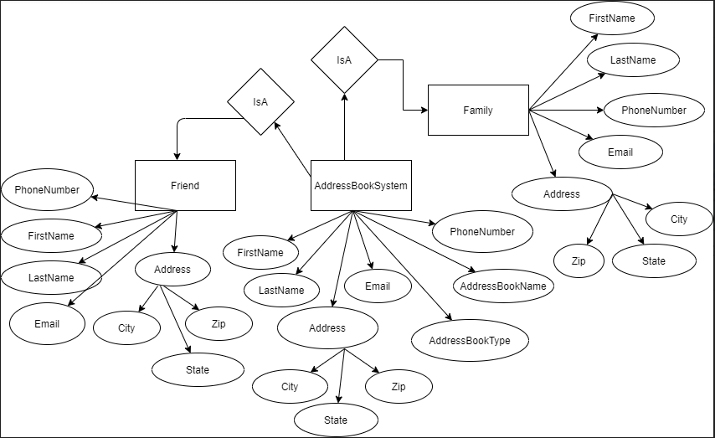

UC13_NewTable

----------------------

mysql> UPDATE contacts SET AddressBookName = 'FamilyBook' WHERE FirstName = 'Riya';

Query OK, 0 rows affected (0.01 sec)

Rows matched: 1 Changed: 0 Warnings: 0

mysql> UPDATE contacts SET AddressBookName = 'FriendsBook' WHERE FirstName = 'Surya';

Query OK, 0 rows affected (0.00 sec)

Rows matched: 0 Changed: 0 Warnings: 0