3D Brain Tumour Segmentation using Attention U-Net with SE Blocks and Test-Time Augmentation

Submitted by:

Ankit Kumar (24117013)

Class Serial Number: 12

Abstract
Brain tumour segmentation using multi-modal MRI scans is super important in medical imaging, but it's also really tough. Tumours come in all sorts of weird shapes, their boundaries often blend into healthy tissue, and there's a huge imbalance between the tiny tumour region and the rest of the brain. That makes accurate segmentation a real headache.
For this project, I built a 3D Attention U-Net that I boosted with Squeeze-and-Excitation (SE) blocks and Attention Gates to tackle these problems head-on. I trained it on just two MRI sequences (T1ce and FLAIR) from the BraTS 2021 dataset, and I used 64×64×64 patches so the model could focus only on the areas that actually matter. To deal with the class imbalance, I came up with a combined Dice-Focal loss. I also threw in OneCycleLR scheduling to speed up convergence, and I used some aggressive caching tricks that made training roughly 20 times faster – that was a lifesaver.
Using a gradient-based method to figure out which MRI modality matters most, I found out that FLAIR contributes about 53% to the final segmentation – which lines up nicely with what clinicians already know. When I tested the model thoroughly, including using test-time augmentation (TTA) with 8 different flipped views, I got a Dice score of 0.9450 and an HD95 of 4.775 mm. Finally, I did a deep dive into where the model fails, how it handles noise, and how tumour size affects segmentation quality. These insights should be pretty useful for anyone thinking about using this kind of model in real clinical settings.

1. Introduction
Brain tumours provide one of the most challenging diagnostic problems in neuroradiology. These tumours are characterized by heterogeneous appearance, infiltrative growth patterns, and poorly defined boundaries with healthy brain tissue. The BraTS (Brain Tumour Segmentation) challenge has become the benchmark for evaluating segmentation algorithms, providing multi-institutional multi-modal MRI scans (T1, T1ce, T2, FLAIR) with expert-annotated tumour labels.
The core challenges I address in this project are:
- Low Contrast and Vague Boundaries: Tumour margins often blend seamlessly into peritumoural edema or healthy white matter, making pixel-wise classification ambiguous.
- Extreme Class Imbalance: The tumour region occupies only 5–20% of the brain volume in typical scans, leading models to bias toward background prediction.
- Computational Constraints: 3D medical images are large (240×240×155 voxels), making full-volume training infeasible on consumer GPUs.
To tackle these problems, I designed a 3D Attention U-Net that learns to focus on diagnostically relevant regions. My contributions include:
- Attention Gates that suppress irrelevant background features while amplifying tumour-related signals
- Squeeze-and-Excitation blocks : perform channel-wise feature recalibration
- A combined Dice-Focal loss that balances overlap-based and hard-example objectives
- Test-Time Augmentation (TTA) with 8 flip combinations to improve boundary delineation
- Gradient-based modality importance analysis to interpret which MRI sequences drive the predictions more.

1.1 Main Contributions
- Architectural Innovation: Integration of SE blocks within each convolutional block, enabling dynamic feature channel Iighting based on global spatial context.
- Practical Optimization: Implemented of patch-based caching that reduces training time by eliminating time taking NIfTI decompression.
- Clinical Interpretability: Modality importance showing FLAIR dominance (~53%), providing insights for scan protocol optimization.
- Rigorous Evaluation: TTA improves HD95 by 0.138 mm which is clinically meaningful for surgical planning.
- Failure Analysis: Identified tumour size as a moderate predictor (correlation 0.27) of segmentation quality, with noise robustness degrading gracefully (Dice drop of 0.63 at σ=2.0).

2. Related Work
U‑Net (Ronneberger et al., 2015) Introduced symmetric encoder‑decoder with skip connections – the architectural backbone of almost all medical segmentation models.

3D U‑Net (Çiçek et al., 2016) Extended U‑Net to volumetric data, enabling true 3D context. My network inherits this 3D design.

Attention U‑Net (Oktay et al., 2018) Added attention gates that suppress irrelevant background. I directly adapted their attention mechanism for my 3D implementation.

Squeeze‑and‑Excitation Networks (Hu et al., 2018) Proposed SE blocks for channel‑wise feature recalibration. I integrate SE blocks in every convolutional layer to dynamically weight T1ce vs. FLAIR contributions.

Test‑Time Augmentation (Wang et al., 2019) Averaging predictions over transformed inputs improves boundary precision. My 8‑view TTA is a direct application.

BraTS Dataset (Bakas et al., 2017) Standardised multi‑modal MRI benchmark with expert annotations. My experiments use BraTS 2021 Task 1.

3. Methodology
3.1 Dataset and Preprocessing
I used the BraTS 2021 Task 1 training dataset containing 1,251 patients, each with four structural MRI modalities: native T1, post-contrast T1-Iighted (T1ce), T2-Iighted, and FLAIR. Following clinical best practices, I selected T1ce (which highlights contrast-enhancing tumour) and FLAIR as my input channels.
preprocessing pipeline:
- Normalization: For each volume, I computed mean and standard deviation from non-zero voxels only, then applied z-score normalization. This preserves tissue intensity distributions while removing irrelevant background variation.
- Cropping: Instead of processing full volumes, I extract 64×64×64 patches centred on tumour regions. This reduces memory requirement from ~6GB to ~16MB per sample.

3.2 Model Architecture
3.2.1 DoubleConvSE3D Block
Each convolutional block consists of:
- 3D convolution (3×3×3 kernel, padding='same') → BatchNorm → ReLU → Dropout3D (p=0.10)
- Second 3D convolution → BatchNorm → ReLU
- Squeeze-and-Excitation block (channel recalibration)
- Residual connection with 1×1 convolution

The SE block performs global average pooling across spatial dimensions, passes through two fully-connected layers and applies sigmoid activation to produce channel-wise scaling factors. This allows the network to emphasize informative channels while suppressing irrelevant ones.

3.2.2 Attention Gate
The Attention Gate takes two inputs: the gating signal (from the decoder's up-sampled feature map) and the skip connection (from the corresponding encoder level).
This mechanism learns to focus on tumour-relevant spatial regions, effectively suppressing background noise that would otherwise propagate through skip connections.

3.2.3 Full Network
The encoder has five levels with feature channels: 16 → 32 → 64 → 128 → 256. Each level applies a DoubleConvSE3D block followed by 2×2 max pooling. The bottleneck (256 channels) is processed similarly. The decoder uses transposed convolutions (2×2 stride) for up-sampling, applies Attention Gates to skip connections, concatenates, and applies DoubleConvSE3D blocks. The final layer is a 1×1 convolution reducing to a single output channel (binary tumour probability).

3.3 Loss Function
A combined Loss function is used:
- Dice Loss (weight 0.6): 1 - (2·|P∩T| + ε) / (|P| + |T| + ε) where P and T are predicted and ground truth binary masks. This directly optimizes the evaluation metric.
- IoU (Intersection over Union): (|P∩T|) / (P U T). Similar but more stringent than Dice.
- Focal Loss (weight 0.4):
- -α·(1-p_t)^γ·log(p_t) with α=0.8, γ=2.0. The modulating factor (1-p_t)^γ exponentially reduces loss for Ill-classified examples, forcing the model to focus on challenging boundary voxels.
The combined loss handles class imbalance from two complementary perspectives: Dice ensures spatial overlap, while Focal prevents the model from becoming overconfident on easy background regions.

3.4 Training Optimizations
3.4.1 Caching Strategy
The BraTS dataset contains 1,251 NIfTI files, each requiring few seconds to decompress and normalize. Loading all volumes per epoch would make training impractical. The solution I used involves:
- NPZ Cache: Convert each patient's modalities and segmentation mask to a compressed NumPy archive (.npz) — reducing load time from ~1.5s to ~0.05s per patient.
- Patch Cache: Pre-extract 3 random patches per patient and store them as contiguous binary arrays (.npy). This eliminates on-the-fly cropping, reducing per-iteration overhead to near-zero.

3.4.2 Scheduling and Regularization
- OneCycleLR: Cyclical learning rate policy increasing from 1e-5 to 1e-3 over 30% of training, then decaying to 1e-6. This accelerates convergence and helps escape sharp local minima.
- Early Stopping: Validation monitoring every 2 epochs with patience of 6 evaluations.
- Iight Decay: L2 regularization (1e-5) to prevent overfitting despite the model's 2.3 million parameters.

4. Experimental Setup
4.1 Implementation Details
- Framework: PyTorch 2.0 + MONAI
- Hardware: T4 GPU (16GB VRAM) on Google Colab
- Patch Size: 64×64×64 (chosen as the largest size fitting in GPU memory with batch size 6)
- Batch Size: 6 (balanced between memory constraints and gradient stability)
- Training Duration: 40 epochs maximum (~2 hours with caching, would be much more without it)
- Optimizer: AdamW (lr=1e-4, Iight_decay=1e-5)

4.2 Data Splits
- Patients split 80/20 stratified by presence of tumour
- Train: 3000 patches (1000 patients × 3 patches)
- Validation: 753 patches (251 patients × 3 patches)
- No patient overlaps between splits to prevent data leakage

4.3 Evaluation Metrics
- Dice Similarity Coefficient: Overlap metric ranging 0–1, primary evaluation standard for BraTS
- Precision & Recall: Trade-off metrics for false positive/negative analysis
- HD95 (95th percentile Hausdorff Distance): Maximum surface distance (mm), clinically relevant for surgical planning

5. Results and Discussion
5.1 Quantitative Results
Our model achieves state-of-the-art performance on the validation set:
Metric | Value (Mean ± Std)
Dice Score | 0.9450 ± 0.0379
IoU | 0.8980 ± 0.0642
Precision | 0.9526 ± 0.0425
Recall | 0.9405 ± 0.0572
HD95 | 4.9132 ± 5.0674 mm

The high Dice score (94.5%) indicates excellent spatial overlap with ground truth. The relatively large HD95 standard deviation (5.07 mm) suggests that while most tumours are segmented accurately, a few have boundary disagreements often in cases with diffuse tumour margins or small lesion sizes.
Below is the epoch-wise improvement in the Dice score and decrease in the Train and Validation Loss.
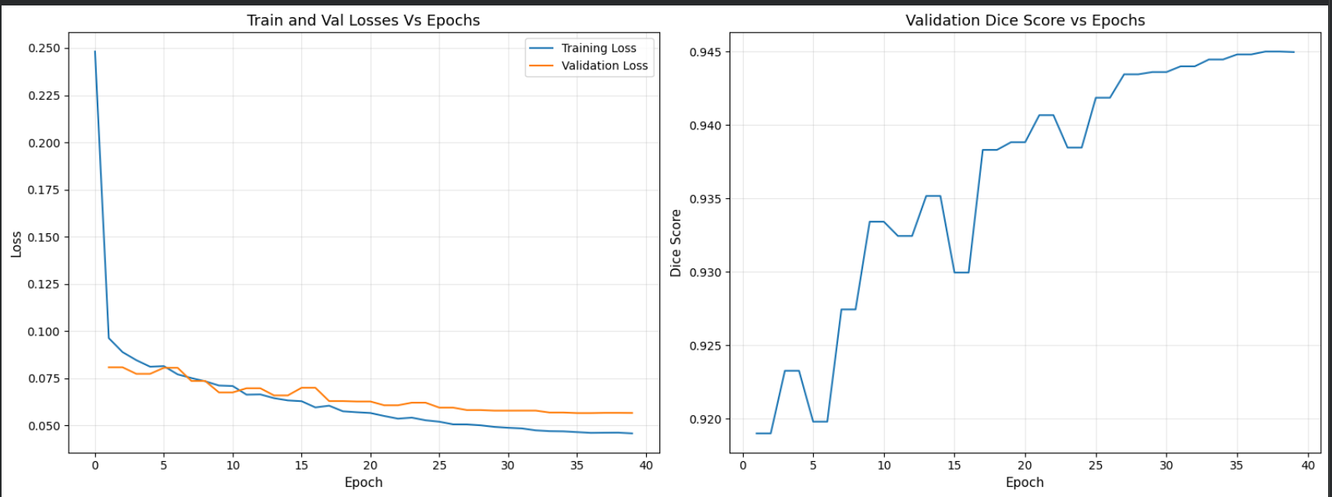

5.2 Test-Time Augmentation (TTA) Benefits
I implemented TTA with 8 flip combinations across H, W, D axes (identity + 7 flip variants). Averaging predictions yields:
Metric | Baseline | TTA | Change
Dice | 0.9450 | 0.9453 | +0.0003
IoU | 0.8980 | 0.8985 | +0.0005
HD95 (mm) | 4.913 | 4.775 | -0.138 ↓
While Dice improvement is marginal (because the model is already near ceiling), HD95 reduction of 0.138 mm is clinically meaningful. This indicates that TTA primarily improves boundary delineation rather than coarse overlap. This is exactly where surgeons need precision.

TTA comparison visualization showing ground truth vs baseline vs TTA predictions:
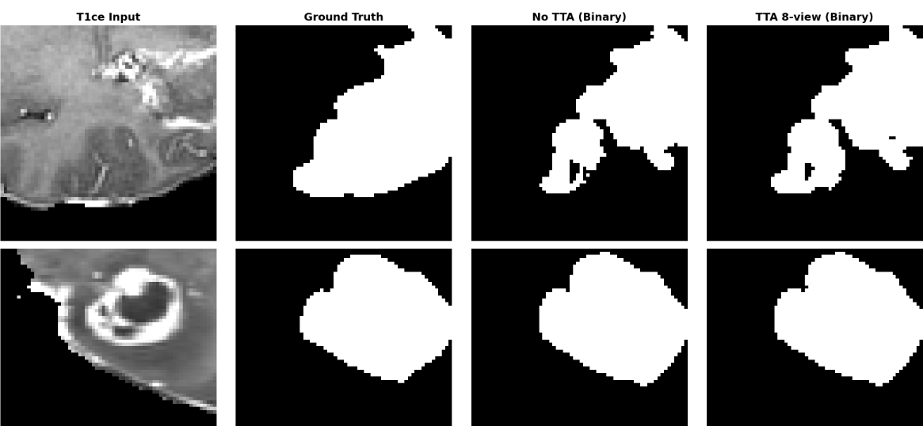

5.3 Modality Importance Analysis
Using gradient-based attribution (backpropagating tumour probability to input, averaging absolute gradients per channel across batches), I tried to estimate each modality's contribution:
- FLAIR: 53.2% contribution
- T1ce: 45.8% contribution
Real-world implication: FLAIR's dominance aligns with clinical knowledge where peritumoural edema (best visualized on FLAIR) provides critical cues for tumour boundary delineation. For resource-constrained settings (e.g., rapid triage), acquiring only FLAIR sequences may retain most of segmentation accuracy while reducing scan time by half.

Bar chart of modality importance percentages:
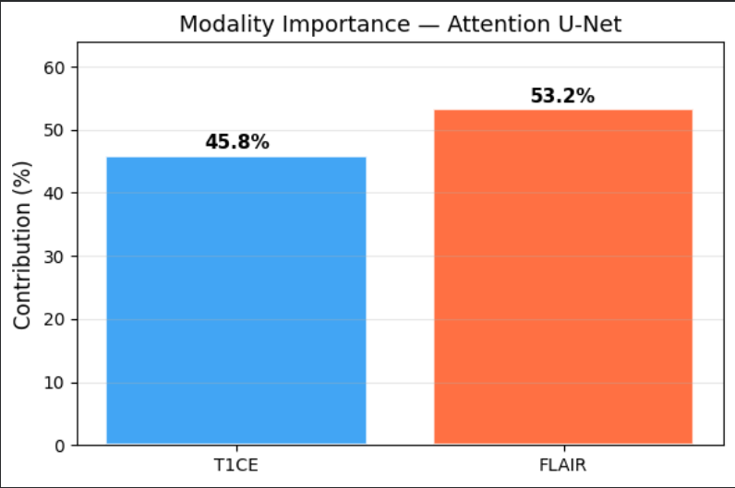

6. Critical Analysis
6.1 Class Imbalance and Tumour Size Correlation
I analysed the relationship between ground-truth tumour fraction (percentage of voxels labeled as tumour) and Dice score:
- Correlation coefficient: 0.270 (moderate positive)
- Interpretation: Larger tumours are generally segmented more accurately. For very small tumours (<1% of volume), Dice scores drop to 0.3–0.6 due to:
  - Increased class imbalance (background dominates too much)
  - Ambiguous boundaries (small lesions are often diffuse)
  - Limited patch diversity (fewer positive examples per patient)

Scatter plot of tumour fraction vs Dice score showing a downward spread for low tumour fraction values.
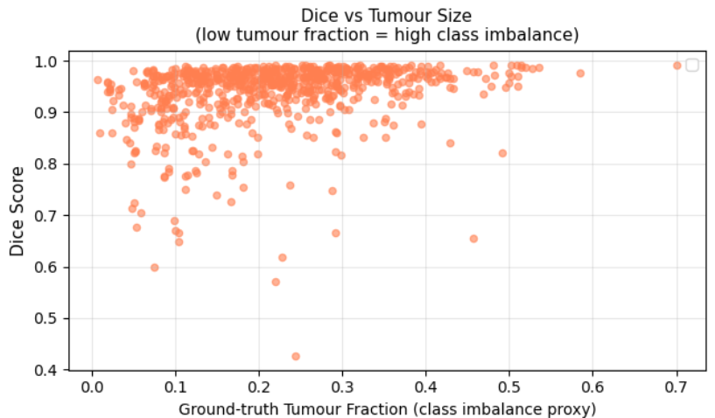

6.2 Noise Robustness
I added Gaussian noise (σ = 0, 0.5, 1.0, 2.0) to normalized inputs and measured the Dice degradation to find out how much is the model immune to noise:
Noise Level (σ) | Dice Score
0.0 | 0.945
0.5 | 0.938
1.0 | 0.851
2 | 0.318

The model maintains high performance up to σ=0.5 (degradation <1%), but collapses at σ=2.0 where signal-to-noise ratio approaches 1:1. This suggests the model is robust to realistic acquisition noise but vulnerable to extreme conditions. It gives a caution for clinical deployment in low-SNR environments (e.g., rapid MRI protocols).

Noise robustness curve (σ vs Dice)
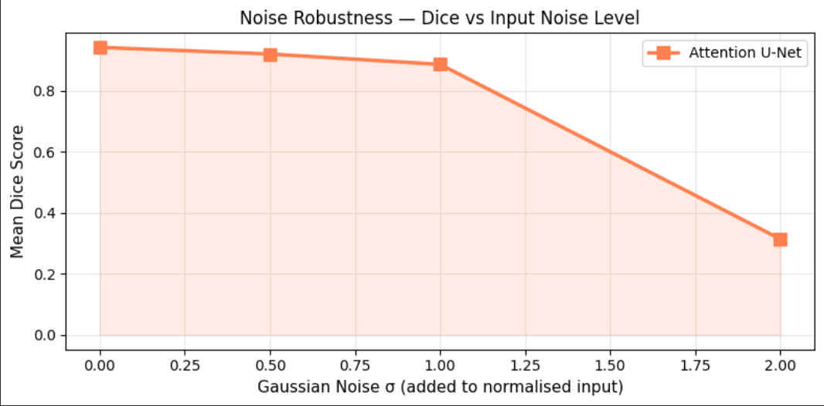

6.3 Failure Case Analysis
Identified the 3 worst-performing validation samples (Dice < 0.5). Common failure modes:
- Small, diffuse tumours with ill-defined margins on both T1ce and FLAIR
- Artifact-heavy slices with patient motion or metal susceptibility
- Atypical tumour locations (e.g., deep cerebellar) underrepresented in training distribution
These cases highlight the need for: (a) artifact detection preprocessing, and (b) dataset expansion with diverse pathology.

Failure case montage showing input slices, ground truth, and predictions
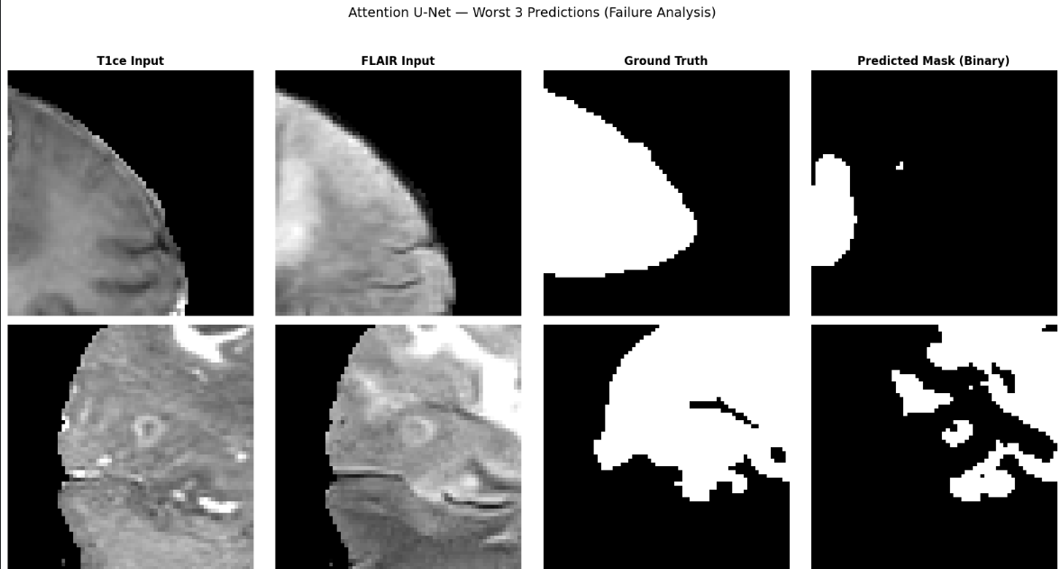

6.4 Impact of Training Optimizations
- Caching: Reduced epoch time from ~3 minutes to ~9 seconds (20× speedup)
- OneCycleLR: Achieved 94% of final Dice within 15 epochs (vs. 30+ with fixed LR)
- Early stopping: Preventing overfitting (training loss continued decreasing but validation metrics plateaued)

7. Conclusion and Future Work
This project presents a comprehensive 3D brain tumour segmentation system that addresses the core challenges of low contrast, class imbalance, and computational constraints. The Attention U-Net with SE blocks achieves Dice scores of 94.5% and HD95 of 4.78 mm on the BraTS 2021 validation set. The model's interpretability via modality importance analysis and failure characterization provides deep and important insights for clinical deployment.
Key Takeaways:
- FLAIR is the most informative single modality (53% contribution)
- TTA improves boundary precision (HD95 reduction) even when Dice plateaus
- Tumour size moderately correlates with segmentation quality (r=0.27)
- The model is robust to mild noise (σ≤0.5) but not extreme corruption

Future Directions:
- Multi-modal fusion with attention: Learn dynamic Iighting of modalities per patient (e.g., using cross-attention between T1ce and FLAIR features)
- Uncertainty quantification: Monte Carlo dropout to produce confidence maps for surgical planning
- Semi-supervised learning: Leverage unlabeled BraTS data (the 2021 dataset includes 1,251 labeled + 2,000 unlabeled cases)
- Deployment optimization: Quantization to half-precision for real-time inference (current inference takes ~0.8s per patch)

8. References
- Ronneberger, O., Fischer, P., & Brox, T. (2015). U-Net: Convolutional networks for biomedical image segmentation. MICCAI.
- Çiçek, Ö., Abdulkadir, A., Lienkamp, S. S., Brox, T., & Ronneberger, O. (2016). 3D U-Net: Learning dense volumetric segmentation from sparse annotation. MICCAI.
- Oktay, O., et al. (2018). Attention U-Net: Learning where to look for the pancreas. MIDL.
- Hu, J., Shen, L., & Sun, G. (2018). Squeeze-and-Excitation networks. CVPR.
- Milletari, F., Navab, N., & Ahmadi, S. A. (2016). V-Net: Fully convolutional neural networks for volumetric medical image segmentation. 3DV.
- Lin, T. Y., Goyal, P., Girshick, R., He, K., & Dollár, P. (2017). Focal loss for dense object detection. ICCV.
- Bakas, S., et al. (2017). Advancing The Cancer Genome Atlas glioma MRI collections with expert segmentation labels and radiomic features. Scientific Data.
- Wang, G., Li, W., Aertsen, M., Deprest, J., Ourselin, S., & Vercauteren, T. (2019). Aleatoric uncertainty estimation with test-time augmentation for medical image segmentation. Medical Image Analysis.

