**HomeMade**

**RecipeBowl**

Your Ingredients, Our Recipes



|  |
| --- |
| **Group - 10**  **Mentor - Poonam Saini, Faculty, Computer Science and Engineering**  **Students -**   * **Ankit Goyal - 18103018** * **Krish Garg - 18103027** * **Divyanshu Garg - 18103035** * **Anish Aggarwal - 18103039** |

**Problem Statement?**

Often, people get into a situation where they want to cook something delicious but are short on ingredients at home.

Many times people see an image of a delicious looking dish, but they don't know it’s recipe.

**What already exists?**

Recipes-by-name search system and Recipes recommender search system

**Existing Problems...**

* No Recipes-by-Ingredients search system
* No Recipes-by-Images search system
* No Ingredients-Recipe and Image-Recipe datasets.

**Our Contribution...**

* Scraped Ingredients-Recipe and Image-Recipe datasets.
* Training Image-to recipes model using Convolutional Neural Network
* Recipe generator using character-level RNN text generation ML technique.

**What is HomeMade RecipeBowl?**

* A dynamic website incorporating machine learning techniques.
* Search options:
  + Search by Ingredients
  + Search by food image
  + Search by cuisine
* Output: self generated recipes
* It is a recipe generator system and not a recommender system!!

**Technologies Used...**

* Website front end: React, CSS, HTML, JavaScript, AJAX
* Website Back end: Flask (Python Framework)
* Database: SQLite
* Deep learning: Tensorflow and Keras Framework
* Web Scraping: BeautifulSoup (Python)

**Web Technologies…**

* **Web Scraping:**
* Scraped datasets using BeautifulSoup library in Python.
* Scraped the following websites for [Ingredient-to-Recipe dataset](https://drive.google.com/drive/folders/1JqosRxBAxXXDz63fAWAw6zVtbVCa-wIB?usp=sharing):
  + Epicurious
  + All Recipes
  + Food Network
* Scraped the following website for [Image-to-Recipe dataset](https://drive.google.com/drive/folders/1ubu9QkzYW3WRQi3NIi9T56lQBzooAvsC?usp=sharing):
  + Chefkoch (has multiple images for many single recipes)
* Scraped the following website for [Cuisines dataset](https://drive.google.com/drive/folders/1hq0B1OVlEVXvA_ChwQVHGJD9vp7A5CKi?usp=sharing):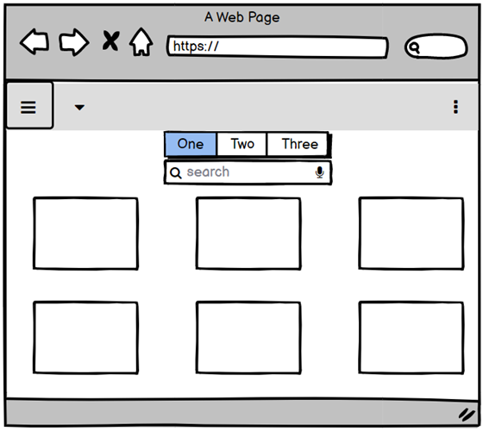
  + All Recipes
* **Website Frontend:**
* Used React framework for the website’s frontend. In particular:
  + JavaScript
  + CSS
  + AJAX
  + Router
* **Website Backend:**
* Used Flask, a Python framework, for the website’s backend.
* Laid several routes for the “POST” requests.
* **Database:**
* Used SQLite database management system for databases.
* Created the following two databases:
  + User Login

Users*(Id, username, email, password, bio)*

* + User Favorite Recipes

Favorites*(Id, username, recipe_name, recipe_ing, recipe_inst, recipe_img)*

* **Robots.txt added ;)**