**Homemade RecipeBowl: Your Ingredients, Our Recipes**

**Project Team:**

1. Ankit Goyal (18103018)
2. Krish Garg (18103027)
3. Divyanshu Garg (18103035)
4. Anish Agarwal (18103039)

**Project Mentor:** Dr. Poonam Saini, Faculty, Computer Science and Engineering

**BACKGROUND**

Most often, we get into a situation when we want to cook something delicious, however, we are short on ingredients at our home. It also creates a lot of confusion about what to cook with the available ingredients. Further, we might not have accessibility to more ingredients from the nearby market due to various reasons like non-availability or specifically the unprecedented times like Covid which has resulted in shutdowns. Finally, we are bound at home to make the best possible dish from leftover ingredients.

**MOTIVATION**

Our project aims to make a user aware of the various dishes which can be cooked from available set of ingredients being input by a user. There may be times when a person desires for new, delicious, healthy, or maybe presentable cuisines and above all it necessarily be homemade as the possibilities to get one from outside might be restricted like in recent pandemic period (Covid-19). An optimal solution to this could be design of an application wherein the user will be capable of exploring and preparing several new dishes which include those ingredients. Therefore, a system could be designed that could actually take ingredients as the input and returns the best matched recipe from an exhaustive list of most matching recipes.

In addition, this project would be a great platform for people to learn and expand their knowledge in the field of cooking. Moreover, it will help in exploring and spreading the taste of one region worldwide. It will also bring innovation to the art of cooking. Our motivation is not only restricted to these merits but also include more information about nutrition for respective recipes. Nutrition and health being the most important aspects of one’s life, are also one of the most neglected areas. This project will also ensure that a user is aware about his/her food intake value and thus plan to explore and make more healthier meals.

**OBJECTIVE**

Our objective is to create an application that will assist an end user to explore variety of recipes with the available ingredients in one’s kitchen. The steps to be followed are:

1. To explore various related datasets and perform data pre-processing in order to extract the desired attributes.
2. To perform model training using Machine Learning or Deep Learning algorithms to find the best matching recipes corresponding to a given set of ingredients.
3. To classify an input image of any dish and estimate its caloric value.

**WORKPLAN**

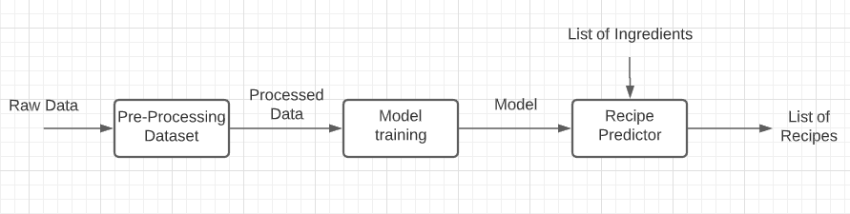

**Fetching Recipes**

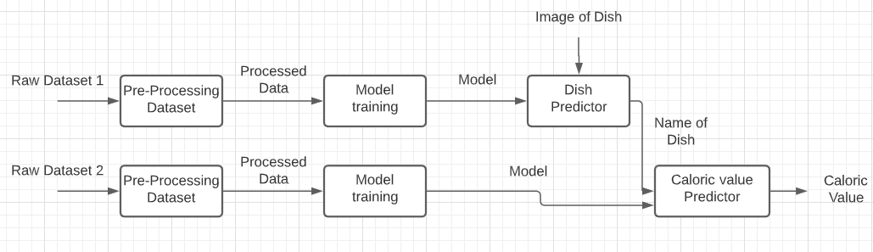

**Finding Caloric values of Recipes from images**

**DELIVERABLES**

The deliverable will be an application to assist an end user in order to explore variety of recipes with the available ingredients in one’s kitchen along with information upon their nutritional value.