**GROUP 10**

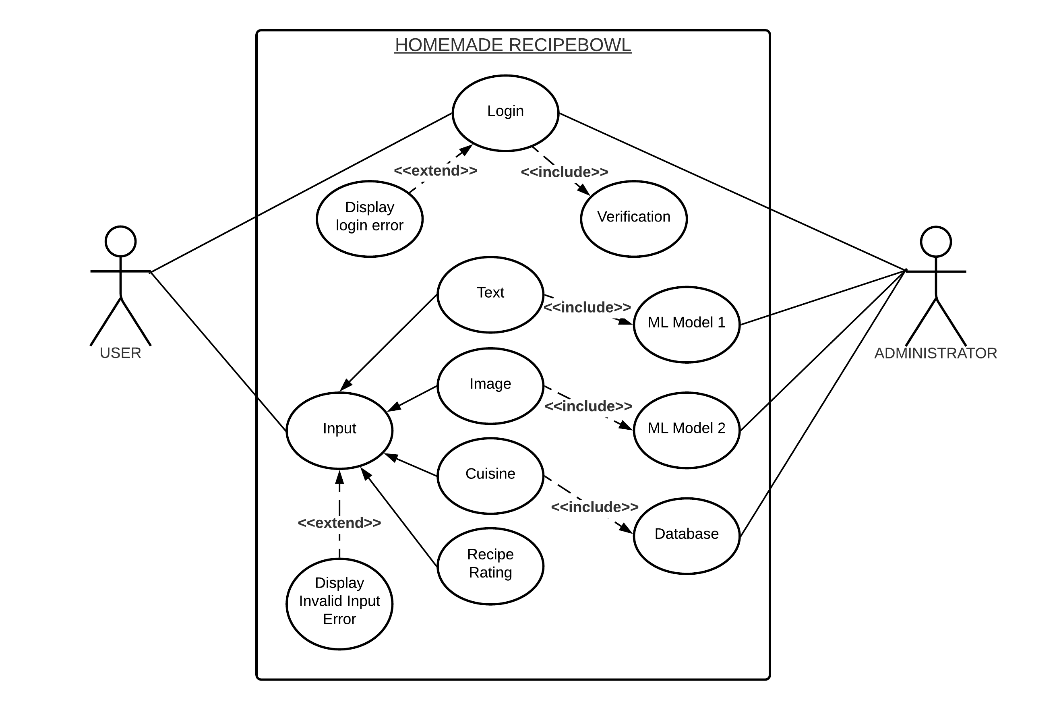**USE CASE DIAGRAM:**

**CLASS DIAGRAM:**