Oxymora GPS Device Tester
Comprehensive User & Hardware Integration Manual

1. Introduction
The Oxymora GPS Device Tester is a secure, web-based diagnostic platform designed explicitly for authenticating, testing, and troubleshooting GPS tracking hardware provisioned for financial institutions. Built on a modern React architecture, this software interfaces directly with hardware modules over USB using advanced Web Serial APIs, bypassing the need for native desktop applications.

1.1 Supported Hardware Modules
- State Bank of India (SBI) - Proprietary Cipher Authentication Hardware
- Bank of Baroda (BOB) - Advanced JSON Telemetry Hardware
- Bank of Maharashtra (BOM) - Legacy Command Hardware

2. System Prerequisites
Ensure your workstation meets the following requirements before operating the portal:
1. Web Browser: Google Chrome (v89+), Microsoft Edge (v89+), or Opera. Safari and Firefox are currently unsupported due to Web Serial API limitations.
2. USB Drivers: Ensure CH340, CP2102, or PL2303 UART-to-USB drivers are installed depending on your specific GPS dongle.
3. Network: Active broadband connection to sync payloads with the central Vercel/Firebase backend.

3. Getting Started: The Interface

3.1 Dashboard Landing & Bank Selection
Upon navigating to the portal URL, you are greeted by the primary Bank Selection interface. The system isolates testing protocols based on the target bank to prevent cryptographic mismatches.
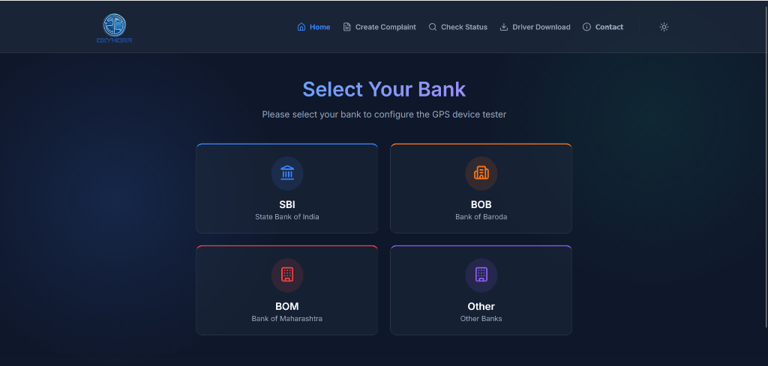
Figure 1: Main Landing Page

3.2 Security & Compliance (T&C)
Due to the sensitive nature of tracking telemetry, operators must consent to the Data Collection and Privacy Policy. Check the consent box to proceed.
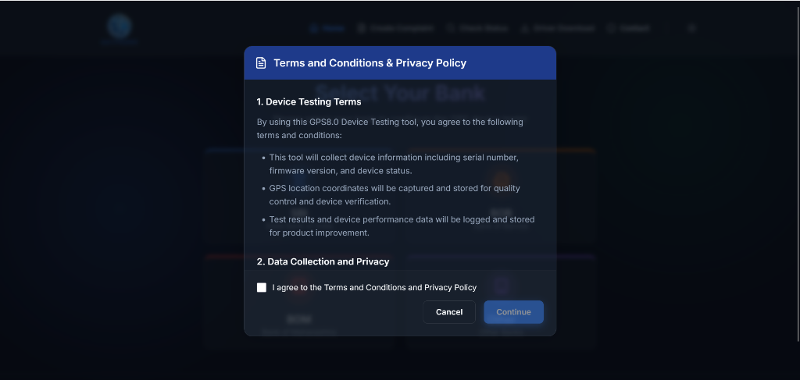

4. Hardware Connectivity via Web Serial
1. Connect your GPS hardware dongle to an available USB port.
2. Navigate to your target bank's testing suite and locate the blue "CONNECT DEVICE" button.

3. A native browser security prompt will appear. Select your paired COM port (e.g., COM16) and click "Connect".
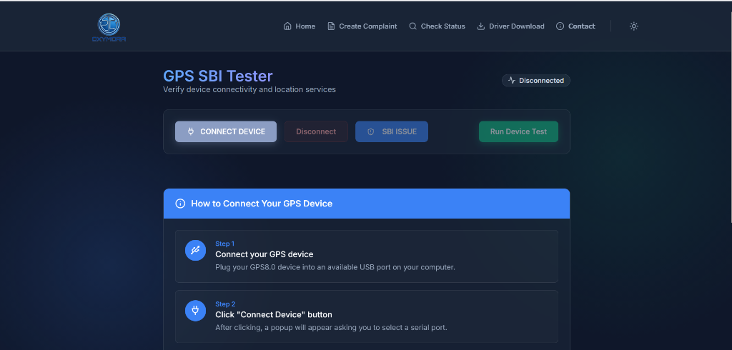
5. Running Diagnostic Tests
After successful connection, the indicator badge will switch to "Connected". Click "Run Device Test" to dispatch the command payload.

5.1 BOB Device Testing
The application will dispatch a JSON structure requesting hardware specifications. It will render the Firmware Version, Serial Number, and automatically trigger a background location poll to extract Live GPS Coordinates.

5.2 SBI Device Testing
SBI modules utilize proprietary cryptography. The portal will dispatch the SBI_MAGIC_STRING. If the hardware authenticates it, a "Success" flag is raised, verifying the hardware's integrity.
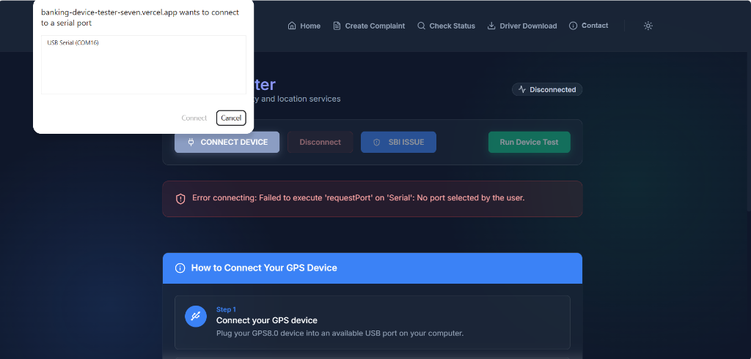

6. Support, Ticketing, and Settings

6.1 Helpdesk & Complaints
If a hardware dongle fails authentication, you can raise an internal ticket directly via the "Create Complaint" tab. Fill in your Device Serial Number and a description of the error trace.
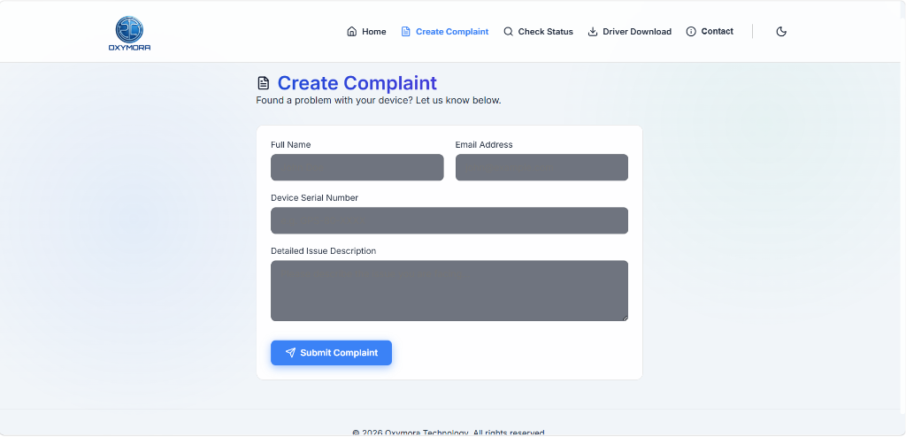
Alternatively, use the "Contact" button on the navigation bar to fetch live support details.
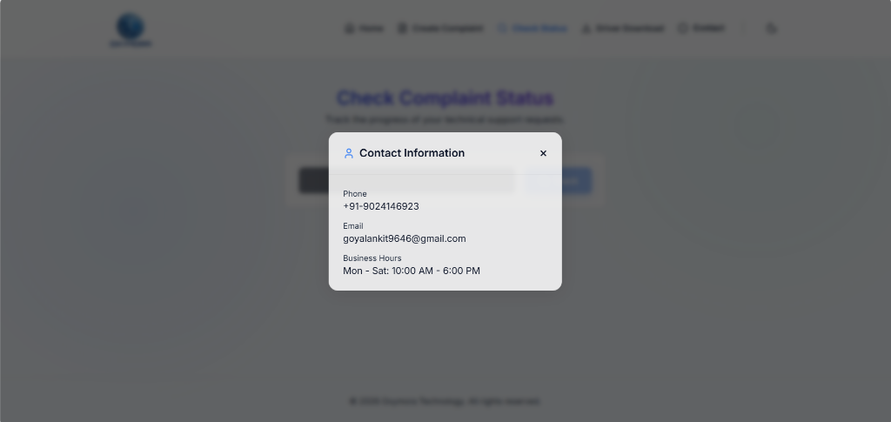

6.2 UI Accessibility
Users can toggle between Light and Dark mode using the sun/moon icon at the top right, accommodating varying workplace lighting conditions.
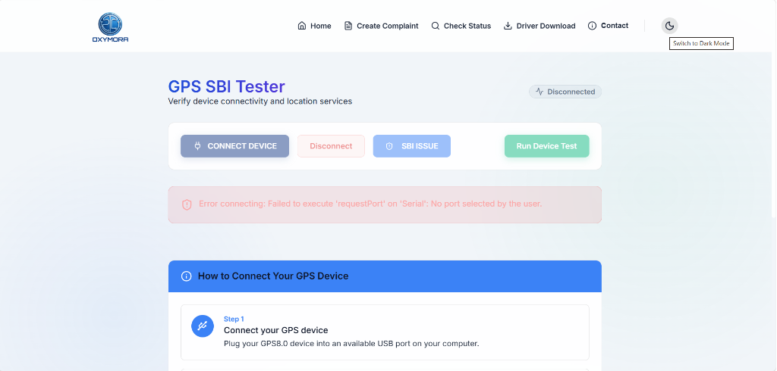

7. Troubleshooting
• No COM Port Found: Ensure the USB cable supports data transfer (not charging-only). Verify CH340 drivers are installed via Windows Device Manager.
• Invalid Response Error: Disconnect and reconnect the device. If the issue persists, the hardware may be bound to a different banking protocol.

