“Complaint Tracker: An Algorithm-Driven System for Efficient Customer Complaint Management”

Project Report submitted for the partial fulfilment of grade for the course

Data Structures and Algorithms -3 (25CS2103E)

in

DEPARTMENT OF COMPUTER SCIENCE ENGINEERING

by

SANTOSH KUMAR BAL :2520030474

U.ANKITH :2520030403

G.BHARGAV :2520030451

Team Number: 11
Section: 2

Under the Guidance of

Dr. S. Vinay Kumar
Associate Professor
Department of Computer Science and Engineering





2026-27

DEPARTMENT OF COMPUTER SCIENCE ENGINEERING

Declaration

The Project Report entitled “Complaint Tracker: An Algorithm-Driven System for Efficient Customer Complaint Management” is a record of Bonafide work of SANTOSH KUMAR BAL : 2520030474, U.ANKITH : 2520030403, G.BHARGAV : 2520030451 submitted in partial fulfillment for the award of B. Tech in Computer Science and Engineering. The results embodied in this report have not been copied from any other departments/University/Institute.

SANTOSH KUMAR BAL : 2520030474
U.ANKITH : 2520030403
G.BHARGAV : 2520030451

DEPARTMENT OF COMPUTER SCIENCE ENGINEERING

CERTIFICATE

This is certify that the mini project based report entitled “Complaint Tracker: An Algorithm-Driven System for Efficient Customer Complaint Management” is a bonafide work done and submitted by SANTOSH KUMAR BAL : 2520030474, U.ANKITH : 2520030403, G.BHARGAV : 2520030451 in partial fulfillment of the requirements for the award of the degree of BACHELOR OF TECHNOLOGY in Department of Computer Science Engineering, during the academic year 2026-27.

Signature of the Guide Signature of the HOD
(Dr. S. Vinay Kumar)

Signature of the External Examiner
ACKNOWLEDGEMENT

We express our sincere gratitude to our project guide, Dr. S. Vinay Kumar, Associate Professor, Department of Computer Science and Engineering, for his valuable guidance, constant encouragement and timely suggestions throughout the development of this mini project. His insights into algorithm design and analysis helped us shape the Complaint Tracker into a well-structured and efficient system.
We are thankful to Dr. P. Venkateshwara Rao, Associate Professor and Head of the Department of Computer Science and Engineering, for providing the facilities, support and academic environment needed to complete this work successfully.
We also thank all the faculty members of the department, our friends and our families for their continuous support, motivation and cooperation during the course of this project.

SANTOSH KUMAR BAL : 2520030474
U.ANKITH : 2520030403
G.BHARGAV : 2520030451

Abstract

The Complaint Tracker is a Java application developed to manage customer complaints efficiently and systematically. In many organizations, complaints are handled manually through emails, spreadsheets, and paper records, which can lead to lost information, delays in resolution, and difficulties in tracking complaint status. To overcome these problems, the proposed system provides a centralized platform for recording, organizing, searching and monitoring customer complaints.

Each complaint is stored as a text document that holds the customer details, complaint description, category, priority, department, assigned staff member, current status, remarks and status history. A corpus of 369 such documents is processed by a menu-driven program. The Z-Algorithm is used for fast pattern search over all complaint descriptions, Merge Sort arranges complaints by priority, Binary Search locates a complaint by its ID, an Edmonds-Karp maximum-flow model assigns pending complaints to staff members, a greedy set-cover approximation selects the staff needed to cover all pending complaints, and randomized sampling selects complaints for quality audit. The system also supports staff accountability by recording the responsible staff member and the status history of every complaint.

The main objective of the Complaint Tracker is to reduce manual work, improve data accuracy, avoid duplicate and lost records, and support faster complaint resolution by applying efficient data structures and algorithms. Overall, this project provides an organized, reliable and scalable solution for customer complaint management and helps organizations improve service quality and customer satisfaction.

Table of Contents
 |  | Page No.
 | Acknowledgement | iv
 | Abstract | v
 | Table of Contents | vi
 | List of Figures | vii
1 | Introduction  1.1 Overview  1.2 Problem Statement  1.3 Scope of the Project  1.4 Objectives  1.5 Existing versus Proposed System | 1-3
2 | System Requirements  2.1 Functional Requirements  2.2 Non-Functional Requirements  2.3 Hardware and Software Requirements | 4-5
3 | System Design  3.1 High-level Architecture Diagram  3.2 Description of each Layer  3.3 Complaint Document Format  3.4 Data Structures Used  3.5 Algorithm Design and Complexity  3.6 Program Flow  3.7 Flow Network Model for Staff Assignment | 6-10
4 | Implementation  4.1 Module-wise Implementation  4.2 User Interface (Console Menu)  4.3 Java API Integration  4.4 Corpus Handling and Record Parsing  4.5 Z-Algorithm Pattern Search (CO-1, CO-2)  4.6 Merge Sort and Binary Search (CO-3)  4.7 Max-Flow Staff Assignment (CO-4)  4.8 Greedy Staff Coverage (CO-5)  4.9 Randomized Audit Sampling (CO-6)  4.10 Project Structure and Execution | 11-17
5 | Results  5.1 Test Data  5.2 Output Screens  5.3 Program Output for Each Module  5.4 Test Cases and Observed Results  5.5 Analysis of Results | 18-22
6 | Challenges & Limitations  6.1 Issues Faced during Development  6.2 Solutions Applied  6.3 Limitations of the System | 23-24
7 | Conclusion & Future Work  7.1 Conclusion  7.2 Future Work  7.3 Skills Learned during Development | 25-26
 | References | 27
List of Figures
1.1 | Overview of the Complaint Tracker system | 1
3.1 | Layered architecture of the Complaint Tracker | 6
3.2 | Program flow of the Complaint Tracker | 9
3.3 | Flow network for assigning complaints to staff | 10
5.1 | Distribution of complaints by priority and department | 18
5.2 | Project in Visual Studio Code and main menu | 19
5.3 | Z-Algorithm search for the word "water" | 19

1. INTRODUCTION
1.1 Overview
Customer complaints are one of the most direct sources of feedback available to any organization. Banks, telecom operators, hospitals, colleges, retailers and civic bodies all receive a continuous stream of complaints through calls, emails, web forms and walk-ins. How quickly and fairly these complaints are handled strongly influences customer satisfaction and the reputation of the organization.
The Complaint Tracker is a Java console application that captures, searches, prioritizes, assigns and audits customer complaints. Every complaint is kept as a separate text document in a corpus (the folder data/corpus) and contains the customer details, the complaint description, its priority, category, department, the staff member responsible, the current status, remarks and the status history. The complete corpus used in this project contains 369 complaint documents.
As shown in Fig. 1.1, the user works with a menu-driven program written in a single Java source file, ComplaintTracker.java. The program offers nine functions and an exit option. Each function solves a practical complaint-handling problem with a classical algorithm: the Z-Algorithm for text search, Merge Sort and Binary Search for ordering and lookup, the Edmonds-Karp maximum-flow algorithm for staff assignment, a greedy approximation for staff coverage, and randomized sampling for audits.
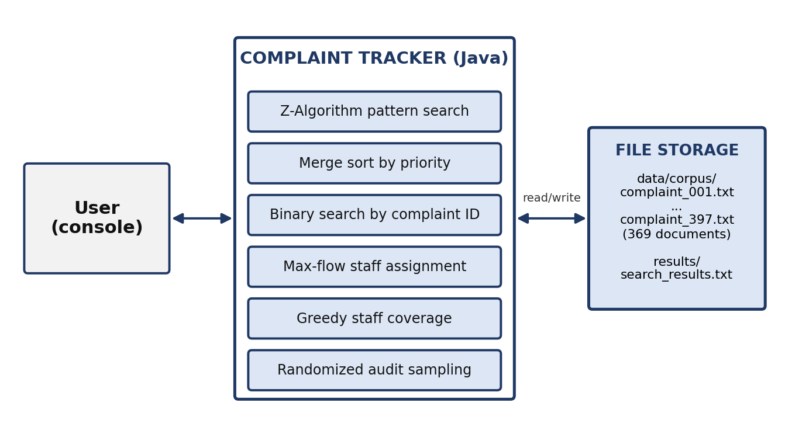
Fig. 1.1 Overview of the Complaint Tracker system
By keeping complaint data in one place and using efficient algorithms to process it, the system reduces duplication, enforces accountability through staff assignment and shortens the time needed to find and handle a complaint.
1.2 Problem Statement
In many organizations complaints are still handled manually through emails, spreadsheets and paper records. This approach does not scale as the number of complaints grows and leads to the following problems:
- Scattered records: complaints are logged across spreadsheets, emails and paper forms, with no single source of truth.
- Slow search: finding all complaints about a particular issue, for example water supply or billing, requires reading every record by hand.
- Slow resolution: without tracking of status or ownership, complaints stall and nobody is accountable for follow-up.
- Poor prioritization: urgent complaints are not separated from routine ones, so high-priority cases wait in the same queue.
- Unbalanced workload: there is no systematic way to match pending complaints with the staff of the right department.
- No quality control: management has no quick way to pick a fair sample of complaints to check the quality of handling.

There is therefore a need for a centralized program that stores every complaint in a structured form, searches it quickly, orders it by priority, assigns it to a responsible person and supports audits, using algorithms whose running time stays acceptable as the number of complaints grows.
1.3 Scope of the Project
The scope of the Complaint Tracker covers storage, retrieval, analysis and assignment of complaints held in a text corpus. The project includes:
- Storage of each complaint as a structured text document with fifteen fields.
- Pattern search over all complaint descriptions using the Z-Algorithm, with the result saved in a results file.
- Viewing of all registered complaints, with an optional text filter.
- Retrieval of the status, department, staff, remarks and address of a complaint by customer ID.
- Sorting of complaints by priority (High, Medium, Low) using Merge Sort and lookup by complaint ID using Binary Search.
- Assignment of pending complaints to staff using a maximum-flow model, and selection of staff coverage using a greedy approximation.
- Randomized selection of complaint records for audit.

The project is a single-user console program that reads its data from files. A graphical or web interface, a database back end and automatic registration of new complaints from the menu are outside the present scope and are listed as future enhancements in Chapter 7.
1.4 Objectives
The main objective of the Complaint Tracker is to reduce manual work, improve data accuracy, avoid duplicate and lost records and support faster complaint resolution. The specific objectives are:
- Centralize data: keep every complaint in a uniform document format inside one corpus.
- Enable fast retrieval: search the whole corpus for a phrase in linear time with the Z-Algorithm and find a complaint by ID in logarithmic time with Binary Search.
- Prioritize: order complaints by priority with Merge Sort in O(n log n) time.
- Assign accountability: model the assignment of pending complaints to staff as a maximum-flow problem and report who should handle which complaint.
- Plan coverage and audit: select a small set of staff who cover all pending complaints using a greedy approximation, and draw a random audit sample.
- Apply course concepts: demonstrate string algorithms, divide and conquer, network flow, NP-hardness with approximation and randomized algorithms on a real application.

1.5 Existing versus Proposed System
Table 1.1 compares the manual method commonly used at present with the proposed Complaint Tracker.
Table 1.1 Existing system versus proposed system
Aspect | Existing (Manual) System | Proposed (Complaint Tracker)
Storage | Spreadsheets, e-mails or paper logs | One text document per complaint in a common corpus
Searching | Reading records one by one | Z-Algorithm search over the whole corpus in linear time
Prioritizing | Done by hand, easy to miss urgent cases | Merge Sort orders all complaints High, Medium, Low
Lookup by ID | Scrolling through lists | Binary Search on the sorted complaint IDs
Staff assignment | Informal, workload is unbalanced | Maximum-flow model matches staff to pending complaints by department
Quality audit | No systematic sampling | Randomized audit sample of any size

2. SYSTEM REQUIREMENTS
This chapter lists what the Complaint Tracker must do (functional requirements), the qualities it must have (non-functional requirements) and the hardware and software needed to build and run it.
2.1 Functional Requirements
The program is operated by a single user, such as a complaint officer, through a numbered menu. Table 2.1 lists the functional requirements and the menu option that implements each of them.
Table 2.1 Functional requirements
ID | Requirement | Description | Menu option
FR-01 | Complaint corpus | Keep each complaint as a text document with fields such as Complaint ID, Customer ID, Priority, Department, Staff and Status. | -
FR-02 | Pattern search | Search a phrase in all complaint descriptions with the Z-Algorithm, count matches per file and save the result to results/search_results.txt. | 1
FR-03 | View complaints | Display all registered complaints or only those whose description contains a given text. | 2
FR-04 | Status retrieval | Show the complaint ID, department, staff, status and remarks for a customer ID. | 3
FR-05 | Address retrieval | Show the address stored for a customer ID. | 4
FR-06 | Priority sorting | Sort all complaints High, Medium, Low using Merge Sort and list them. | 5
FR-07 | Lookup by ID | Find a complaint by complaint ID (for example CMP-023) using Binary Search. | 6
FR-08 | Staff assignment | Compute the maximum number of pending complaints that can be assigned to staff of matching departments, and list the assignments. | 7
FR-09 | Staff coverage | Select a small set of staff who together cover all pending complaints using a greedy approximation. | 8
FR-10 | Audit sampling | Select a random sample of complaints of a user-given size for audit. | 9
FR-11 | Input validation | Reject non-numeric menu input, empty search text, unknown IDs and invalid sample sizes with a clear message. | 1-10

2.2 Non-Functional Requirements
Table 2.2 Non-functional requirements
Attribute | Requirement
Efficiency | Search must run in linear time in the size of the text, sorting in O(n log n) and ID lookup in O(log n), so that the program stays fast for hundreds of complaints.
Correctness | Each algorithm must give the exact result for its problem (for example the Z-Algorithm must report every occurrence of the pattern).
Reliability | The program must not stop on bad input or missing files; it must print a message such as "Complaint ID not found." and return to the menu.
Usability | A simple numbered menu with clear prompts and readable output.
Portability | Written in standard Java so that it runs on any operating system with a Java runtime.
Maintainability | Each module is a separate method with comments that state the algorithm, its course outcome and its complexity.
Persistence | Search results are saved to a file so that they can be reviewed later.

2.3 Hardware and Software Requirements
Table 2.3 Hardware requirements
Component | Minimum requirement
Processor | Intel Core i3 or equivalent
Memory (RAM) | 4 GB
Storage | 50 MB free disk space for the program and the complaint corpus
Display | Any display that can show a terminal window

Table 2.4 Software requirements
Component | Technology
Operating system | Windows 10 / 11 (also runs on Linux and macOS)
Programming language | Java (the project uses java.nio.file, streams and Files.readString, so JDK 11 or later is required; the supplied classes were compiled with JDK 25)
Development tool | Visual Studio Code with the Java extensions
Data store | Plain text files in data/corpus and results
Compile and run | javac ComplaintTracker.java and java ComplaintTracker from the project folder

3. SYSTEM DESIGN
This chapter presents the design of the Complaint Tracker: its layered architecture, the format of a complaint document, the data structures and algorithms chosen for each module and the flow of the program.
3.1 High-level Architecture Diagram
The Complaint Tracker is organized in three layers, shown in Fig. 3.1. The user interacts with the console menu; the menu calls the algorithm modules; the modules read complaint documents from the corpus and write results to the results folder. Keeping the layers separate means that, for example, the console menu could be replaced by a graphical interface without changing the algorithms.
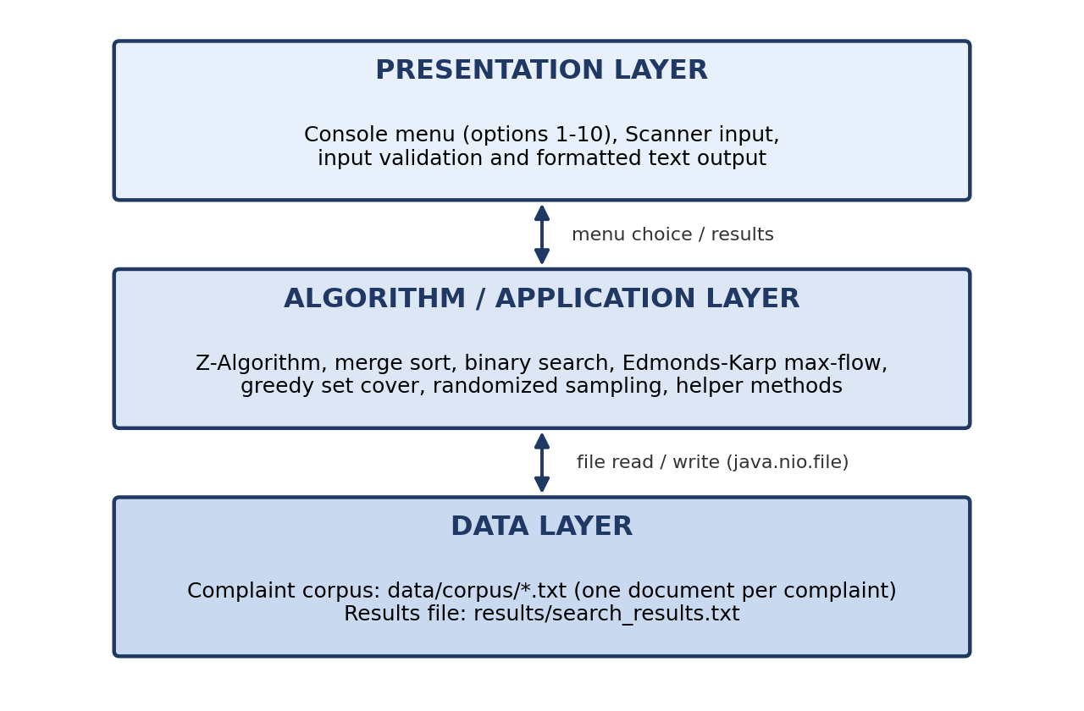
Fig. 3.1 Layered architecture of the Complaint Tracker
3.2 Description of each Layer
Presentation Layer
The presentation layer is the console menu implemented in the main method. It prints the menu of ten options, reads the choice with a Scanner, checks that the input is a number and displays the output of each module. If the input is not a number, the program asks again instead of failing.
Algorithm / Application Layer
This layer contains the logic of the system. Option 1 implements the Z-Algorithm directly in the menu code. Options 5 to 9 are separate methods: module3SortComplaints, module3BinarySearch, module4MaxFlowAssignment, module5ApproximateCoverage and module6RandomizedAudit. Helper methods such as loadComplaintRecords, getFieldValue, findComplaintFile, numericComplaintId and departmentForStaff support these modules.
Data Layer
The data layer consists of the folder data/corpus, which holds one text file per complaint, and the folder results, which holds search_results.txt. Both are accessed with the java.nio.file API (Paths, Files and streams). The program creates the two folders if they do not exist.
3.3 Complaint Document Format
Every complaint document is a text file of fifteen lines of the form Field: value. The same format is read by all modules through the method getFieldValue. Table 3.1 describes the fields, with values taken from complaint CMP-006 as an example.
Table 3.1 Fields of a complaint document
Field | Meaning | Example (CMP-006)
Complaint ID | Unique complaint number | CMP-006
Registered On | Date and time of registration | 21-09-2026 13:30:00
Customer ID | Unique customer number | 6
Customer Name | Name of the customer | Meera Rao
Customer Email | E-mail of the customer | meerarao6@example.com
Phone Number | Contact number | 9800047514
Address | Postal address | House 6, Begumpet Main Road, Hyderabad, Telangana
Complaint Description | Text of the complaint | Resident reports road potholes near Begumpet ...
Priority | High, Medium or Low | Medium
Category | Type of complaint | Civic Services
Department | Department that handles it | Public Works Department
Staff | Staff member responsible | Anil Rao
Status | Current status | In Progress
Remarks | Note about the action taken | Technical team is working on this complaint.
Status History | Time-stamped list of status changes | 23-09-2026 10:00:00 - In Progress

3.4 Data Structures Used
Table 3.2 Data structures used in the program
Data structure | Where it is used | Purpose
String and int[] (Z-array) | Option 1 | The combined string pattern + separator + text, and the array of Z-values
ArrayList<ComplaintRecord> | Options 5 to 9 | Holds the complaint records loaded from the corpus for sorting, searching, flow and sampling
ComplaintRecord (class) | Options 5 to 9 | Stores complaintId, customerName, description, priority, department, staff and status of one complaint
LinkedHashSet<String> | Option 1 | Keeps the distinct recognized words in order of discovery
List<FlowEdge>[] (adjacency list) | Option 7 | Stores the flow network; every edge keeps a reference to its reverse edge
ArrayDeque<Integer> | Option 7 | Queue for the breadth-first search in Edmonds-Karp
LinkedHashMap<String, Set<Integer>> | Option 8 | Maps every staff member to the set of pending complaints that the staff member can cover
LinkedHashSet<Integer> | Option 8 | The set of complaints not yet covered

3.5 Algorithm Design and Complexity
Table 3.3 lists the algorithm chosen for each module, the course outcome (CO) to which the program refers it, and its time complexity. Here n is the number of complaints, m the length of the pattern, t the length of a complaint description, V and E the number of vertices and edges of the flow network, and k the number of staff selected.
Table 3.3 Algorithms and their complexity
Module | CO | Algorithm | Time complexity
Pattern search (option 1) | CO-1, CO-2 | Z-Algorithm on pattern + separator + text | O(m + t) per document
Priority sorting (option 5) | CO-3 | Merge Sort (divide and conquer) | O(n log n); space O(n)
Lookup by ID (option 6) | CO-3 | Binary Search on sorted IDs | O(log n) after sorting
Staff assignment (option 7) | CO-4 | Edmonds-Karp maximum flow (BFS augmenting paths) | O(V E^2)
Staff coverage (option 8) | CO-5 | Greedy approximation of Set Cover (NP-hard) | O(k x total set size)
Audit sampling (option 9) | CO-6 | Random shuffle and selection of the first s records | O(n) expected

3.6 Program Flow
The program flow is shown in Fig. 3.2. At start-up the program makes sure that the data/corpus and results folders exist. It then repeatedly displays the menu, reads the choice, performs the selected function and returns to the menu until the user chooses option 10.
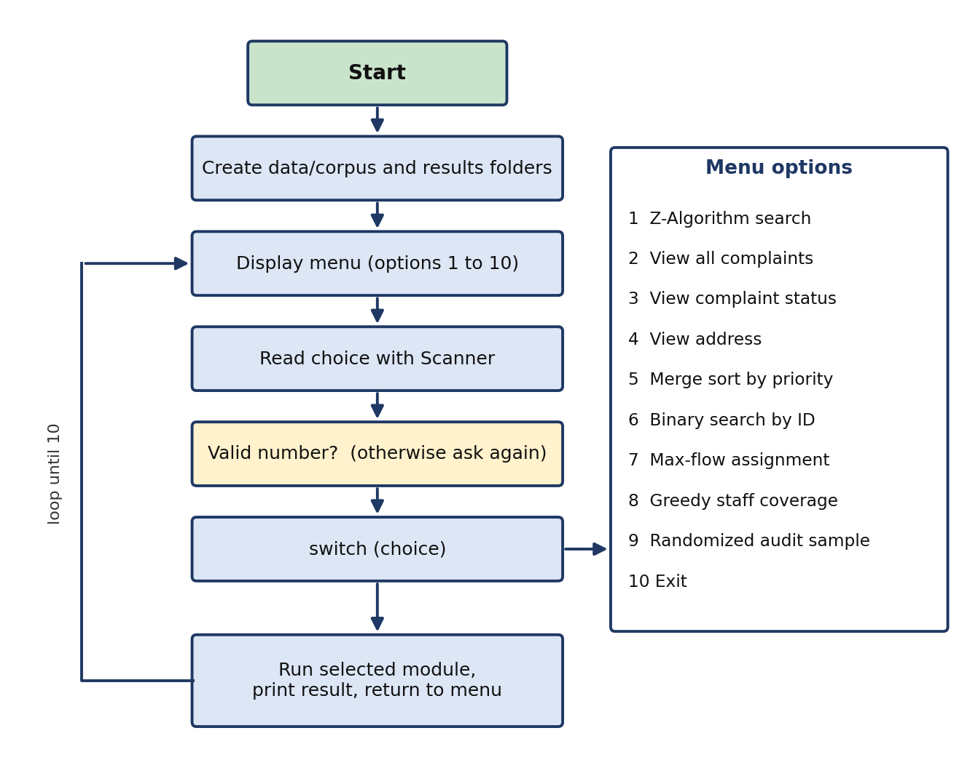
Fig. 3.2 Program flow of the Complaint Tracker
3.7 Flow Network Model for Staff Assignment
Assigning pending complaints to staff is modeled as a flow network, shown in Fig. 3.3. The source is connected to every staff member and every complaint is connected to the sink, all with capacity 1. A staff member is connected to a pending complaint only if the staff member's department equals the complaint's department. The maximum flow from the source to the sink is then the largest number of complaints that can be assigned so that every staff member receives at most one complaint and every complaint is handled by at most one staff member.
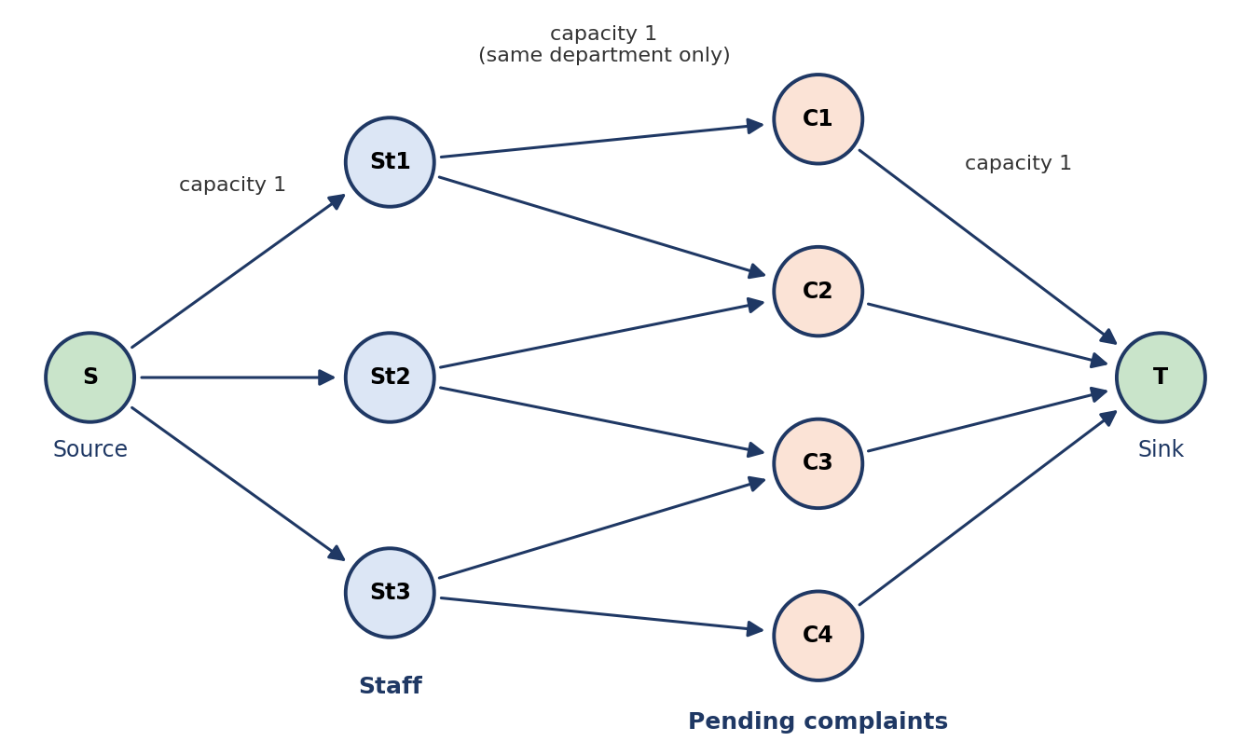
Fig. 3.3 Flow network for assigning complaints to staff
4. IMPLEMENTATION
This chapter describes how the design of Chapter 3 is implemented in Java. All code is in the file ComplaintTracker.java (1,238 lines). The code excerpts in this chapter are taken from that file; their layout has been condensed to save space. The program was developed, compiled and run in Visual Studio Code.
4.1 Module-wise Implementation
Table 4.1 maps every module of the system to the Java methods that implement it.
Table 4.1 Modules and their Java methods
Module | Java method(s) | Function
Menu and control | main | Displays the menu, reads and validates the choice and calls the modules (options 1 to 4 are written inside main)
Corpus access | loadComplaintRecords, getFieldValue, findComplaintFile | Reads the complaint documents and extracts a field; finds a document by customer ID
Pattern search (CO-1, CO-2) | case 1 of main | Z-Algorithm search over all documents and saving of the result
Priority sorting (CO-3) | module3SortComplaints, mergeSort, merge, priorityRank | Merge Sort of complaints by priority
Lookup by ID (CO-3) | module3BinarySearch, numericComplaintId | Binary Search of a complaint ID
Staff assignment (CO-4) | module4MaxFlowAssignment, FlowNetwork, FlowEdge | Builds the flow network and runs Edmonds-Karp
Staff coverage (CO-5) | module5ApproximateCoverage, departmentForStaff | Greedy set-cover approximation
Audit sampling (CO-6) | module6RandomizedAudit | Random shuffle and selection of a sample
Helpers | isClosed, departmentForStaff, updateFieldValue | Status check, staff-to-department lookup and a field-update utility

4.2 User Interface (Console Menu)
The user interface is a text menu. The main method creates the data/corpus and results folders, then loops until the choice is 10. A non-numeric input is rejected with the message "Please enter a number from 1 to 10."; a number outside the range prints "Invalid option." The choice is processed with a switch statement, which sends control to the code of the selected module. All output is printed to the console, and the search result is also written to a file.
4.3 Java API Integration
The program is written with the standard Java library only; no external package is needed. Table 4.2 lists the main classes used.
Table 4.2 Java library classes used
Class / package | Use in the program
java.nio.file.Files, Path, Paths | Create folders, list the corpus, read complaint files with Files.readString and write results with Files.writeString
java.util.stream.Stream, Collectors | List the .txt files, filter and sort them by file name and collect them into a list
java.util.Scanner | Read the menu choice and the user inputs from the keyboard
java.util.ArrayList, List, Comparator | Store records and sort them by numeric complaint ID
java.util.LinkedHashSet, LinkedHashMap, Set, Map | Keep recognized words, staff coverage sets and uncovered complaints in insertion order
java.util.ArrayDeque | Queue for breadth-first search in the flow algorithm
java.util.Collections, Random | Shuffle the records for the randomized audit
java.nio.charset.StandardCharsets | Read and write the files in UTF-8

4.4 Corpus Handling and Record Parsing
Complaint documents are listed with Files.list, filtered to .txt files and sorted by file name. The method getFieldValue splits the text into lines with the regular expression \R, so that both Windows and Unix line endings are handled, and returns the value that follows the prefix "Field: ". If the field is missing, the value "Not Available" is returned. The method loadComplaintRecords uses it to fill one ComplaintRecord object for every file.
Listing 4.1 ComplaintRecord, getFieldValue and loadComplaintRecords (condensed)
private static class ComplaintRecord {
Path file;
String complaintId, customerName, description;
String priority, department, staff, status;
}

private static String getFieldValue(String text, String fieldName) {
String prefix = fieldName + ": ";
for (String line : text.split("\\R")) {
if (line.startsWith(prefix)) {
return line.substring(prefix.length());
}
}
return "Not Available";
}

// inside loadComplaintRecords
for (Path file : files) {
String text = Files.readString(file, StandardCharsets.UTF_8);
ComplaintRecord record = new ComplaintRecord();
record.complaintId = getFieldValue(text, "Complaint ID");
record.priority = getFieldValue(text, "Priority");
record.department = getFieldValue(text, "Department");
record.staff = getFieldValue(text, "Staff");
record.status = getFieldValue(text, "Status");
records.add(record);
}

4.5 Z-Algorithm Pattern Search (CO-1, CO-2)
Option 1 asks for a complaint phrase, converts it to lower case and searches it in the Complaint Description of every document. If a word of the description starts with the phrase, that word is taken as the recognized pattern, so that a search for "water" also recognizes words that begin with it. For each document the program forms the string pattern + separator + text, where the separator is the character \u0000, which never occurs in complaint text. It then computes the Z-array: Z[i] is the length of the longest substring starting at position i that matches a prefix of the combined string. A Z-value that is at least the length of the pattern, at a position after the separator, marks one occurrence of the pattern in the text. The Z-box (left, right) lets the loop reuse earlier values, so each document is processed in O(m + t) time.
Listing 4.2 Z-Algorithm search in a complaint description
String combined = recognizedPattern + "\u0000" + complaintDescription;
int[] z = new int[combined.length()];
int left = 0;
int right = 0;

for (int i = 1; i < combined.length(); i++) {
if (i <= right) {
z[i] = Math.min(right - i + 1, z[i - left]);
}
while (i + z[i] < combined.length()
&& combined.charAt(z[i]) == combined.charAt(i + z[i])) {
z[i]++;
}
if (i + z[i] - 1 > right) {
left = i;
right = i + z[i] - 1;
}
}

int occurrencesInFile = 0;
for (int i = recognizedPattern.length() + 1; i < z.length; i++) {
if (z[i] >= recognizedPattern.length()) {
occurrencesInFile++;
}
}

The program counts the files that contain the phrase and the total number of occurrences, prints the list, and saves it to results/search_results.txt using Files.writeString with the options CREATE and TRUNCATE_EXISTING, so that the file always holds the latest search.
Options 2 to 4 support this module. Option 2 displays all complaint documents, or only those whose description contains a filter text. Options 3 and 4 call findComplaintFile, which scans the corpus for the document whose Customer ID line matches the entered number (the prefix CUS- is also accepted), and then print the status fields or the address.
4.6 Merge Sort and Binary Search (CO-3)
Option 5 loads all records and sorts them with Merge Sort, a divide-and-conquer algorithm: the list is divided into halves, each half is sorted recursively and the two sorted halves are merged. The method priorityRank gives High the rank 1, Medium 2, Low 3 and any other value 4. Because the merge step takes the left element when the ranks are equal (the comparison uses <=), the sort is stable and complaints of the same priority keep their original order.
Listing 4.3 Merge Sort of complaints by priority
private static void mergeSort(List<ComplaintRecord> records,
int left, int right) {
if (left >= right) {
return;
}
int mid = left + (right - left) / 2;
mergeSort(records, left, mid);
mergeSort(records, mid + 1, right);
merge(records, left, mid, right);
}

// merge step
while (i <= mid && j <= right) {
if (priorityRank(records.get(i).priority)
<= priorityRank(records.get(j).priority)) {
temp.add(records.get(i));
i++;
} else {
temp.add(records.get(j));
j++;
}
}

Option 6 sorts the records by the numeric part of the complaint ID (for example CMP-023 becomes 23) and then applies Binary Search. Comparing the numeric value instead of the text avoids the wrong order that string comparison could give for IDs of different length. Each step compares the target with the middle record and discards half of the remaining list, so a complaint is found in O(log n) steps.
Listing 4.4 Binary Search by complaint ID
records.sort(Comparator.comparingInt(
record -> numericComplaintId(record.complaintId)));

int low = 0;
int high = records.size() - 1;
while (low <= high) {
int mid = low + (high - low) / 2;
int midId = numericComplaintId(records.get(mid).complaintId);
int targetId = numericComplaintId(target);
if (midId == targetId) {
// print the complaint details and return
return;
}
if (midId < targetId) {
low = mid + 1;
} else {
high = mid - 1;
}
}
System.out.println("Complaint ID not found.");

4.7 Max-Flow Staff Assignment (CO-4)
Option 7 selects the pending complaints (those whose status is neither Resolved nor Closed) and the distinct staff members, and builds the flow network of Fig. 3.3: vertex 0 is the source, then one vertex per staff member, then one vertex per pending complaint, and finally the sink. An edge of capacity 1 joins the source to each staff member, each complaint to the sink, and each staff member to every pending complaint of the same department. The class FlowNetwork keeps the graph as adjacency lists; every FlowEdge stores its capacity, its original capacity and a reference to its reverse edge, which is needed to undo flow along an augmenting path.
Listing 4.5 Building the flow network
FlowNetwork network = new FlowNetwork(vertices);

for (int i = 0; i < staffList.size(); i++) {
network.addEdge(source, staffStart + i, 1);
}
for (int j = 0; j < pending.size(); j++) {
network.addEdge(complaintStart + j, sink, 1);
}
for (int i = 0; i < staffList.size(); i++) {
String staffDepartment = departmentForStaff(records, staffList.get(i));
for (int j = 0; j < pending.size(); j++) {
if (staffDepartment.equalsIgnoreCase(pending.get(j).department)) {
network.addEdge(staffStart + i, complaintStart + j, 1);
}
}
}
int maxFlow = network.edmondsKarp(source, sink);

The method edmondsKarp repeatedly finds a shortest augmenting path from the source to the sink with breadth-first search over edges that still have capacity, finds the bottleneck capacity along the path, reduces the capacity of the forward edges and increases that of the reverse edges, and adds the bottleneck to the total flow. It stops when the sink can no longer be reached. The total is the maximum number of complaints that can be assigned. The assignments are then read from the staff-to-complaint edges whose capacity has become 0.
Listing 4.6 Edmonds-Karp (core of edmondsKarp)
while (true) {
FlowEdge[] parent = new FlowEdge[graph.length];
boolean[] visited = new boolean[graph.length];
ArrayDeque<Integer> queue = new ArrayDeque<>();
queue.add(source);
visited[source] = true;
while (!queue.isEmpty() && !visited[sink]) {
int current = queue.poll();
for (FlowEdge edge : graph[current]) {
if (!visited[edge.to] && edge.capacity > 0) {
visited[edge.to] = true;
parent[edge.to] = edge;
queue.add(edge.to);
}
}
}
if (!visited[sink]) {
break;
}
int pathFlow = Integer.MAX_VALUE;
for (int v = sink; v != source; v = parent[v].reverse.to) {
pathFlow = Math.min(pathFlow, parent[v].capacity);
}
for (int v = sink; v != source; v = parent[v].reverse.to) {
parent[v].capacity -= pathFlow;
parent[v].reverse.capacity += pathFlow;
}
maxFlow += pathFlow;
}

4.8 Greedy Staff Coverage (CO-5)
Option 8 asks for the smallest set of staff members who together cover all pending complaints, where a staff member covers the pending complaints of his or her department. This is the Set Cover problem, which is NP-hard, so finding the exact minimum is impractical for large inputs. The program therefore uses the standard greedy approximation: in every round it chooses the staff member who covers the largest number of still-uncovered complaints, adds the staff member to the answer and removes the covered complaints. The greedy method is fast and, by a known result, its answer is within a logarithmic factor of the optimum, although it is not guaranteed to be optimal. Complaints that no staff member can cover are reported as uncovered.
Listing 4.7 Greedy set-cover approximation
while (!uncovered.isEmpty()) {
String bestStaff = null;
int bestGain = 0;
for (Map.Entry<String, Set<Integer>> entry : staffCoverage.entrySet()) {
int gain = 0;
for (Integer index : entry.getValue()) {
if (uncovered.contains(index)) {
gain++;
}
}
if (gain > bestGain) {
bestGain = gain;
bestStaff = entry.getKey();
}
}
if (bestStaff == null) {
break;
}
selectedStaff.add(bestStaff);
uncovered.removeAll(staffCoverage.get(bestStaff));
}

4.9 Randomized Audit Sampling (CO-6)
Option 9 supports quality control. The user enters a sample size between 1 and the number of records; otherwise the program prints the valid range. The records are copied into a new list, shuffled with Collections.shuffle using a new Random object, and the first s records of the shuffled list are printed. Because every ordering is equally likely, every set of s complaints has the same chance of being chosen, so the audit is unbiased. Shuffling takes O(n) expected time.
Listing 4.8 Randomized audit sample
List<ComplaintRecord> shuffled = new ArrayList<>(records);
Collections.shuffle(shuffled, new Random());

for (int i = 0; i < sampleSize; i++) {
ComplaintRecord record = shuffled.get(i);
System.out.println(record.complaintId + " | " + record.priority
+ " | " + record.status + " | " + record.department);
}

4.10 Project Structure and Execution
The project folder has the structure shown below. The program must be started from the project folder, because the corpus is read from the relative path data/corpus.
Listing 4.9 Structure of the project folder
ComplaintTracker_Updated_Project/
ComplaintTracker.java (source code, 1,238 lines)
ComplaintTracker.class (compiled classes, with
ComplaintTracker$ComplaintRecord.class, $FlowEdge.class,
$FlowNetwork.class)
README.txt
data/corpus/complaint_001.txt ... (369 complaint documents)
results/search_results.txt (latest search result)

Compile : javac ComplaintTracker.java
Run : java ComplaintTracker

5. RESULTS
This chapter describes how the Complaint Tracker was run and what it produced. The program was executed on the complaint corpus and each menu option was exercised. The outputs shown in this chapter are the actual outputs of the program.
5.1 Test Data
The corpus contains 369 complaint documents from 369 different customers. The documents cover 27 complaint categories, 65 departments and 73 staff members. Table 5.1 summarizes the data and Fig. 5.1 shows the distribution of complaints by priority and department.
Table 5.1 Summary of the complaint corpus
Item | Value
Number of complaint documents | 369
Priority (High / Medium / Low) | 147 / 119 / 103
Status values | In Progress 87, Checked 77, Verification Checking 77, Waiting for Superior Approval 77, Open 19, Pending 12, Assigned 12, Checking 8
Pending complaints (status not Resolved or Closed) | 369
Complaint categories | 27
Distinct staff members | 73
Distinct departments | 65
Largest department | Public Works Department (68 complaints)

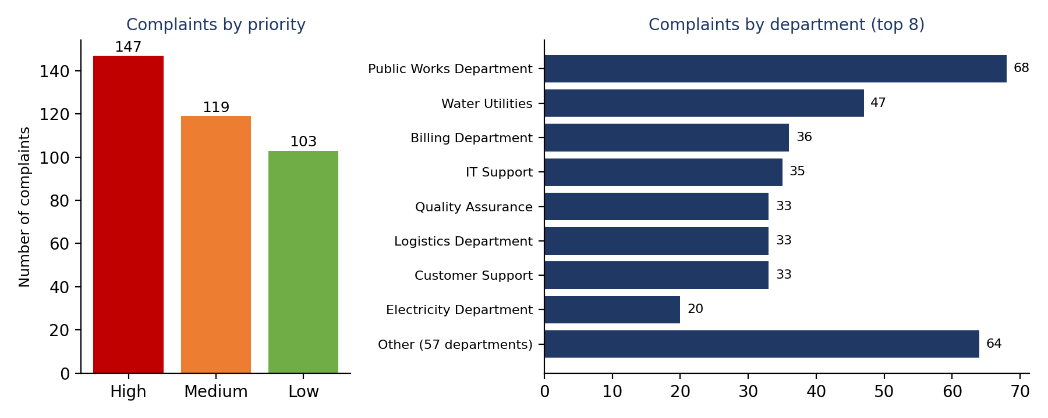
Fig. 5.1 Distribution of complaints by priority and department
5.2 Output Screens
Fig. 5.2 shows the project opened in Visual Studio Code and the main menu displayed in the terminal after the command java ComplaintTracker. Fig. 5.3 shows the result of searching the word "water" with the Z-Algorithm: 41 complaint files contain it, with 43 matches in total, and the result is saved in the results folder.
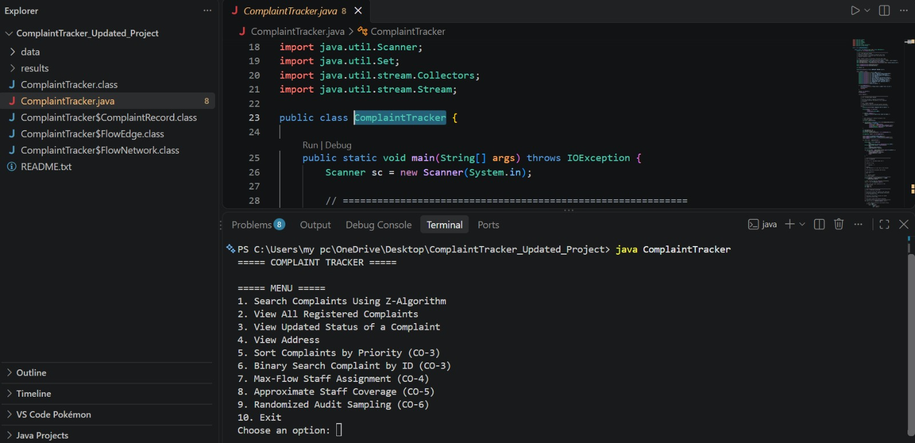
Fig. 5.2 Project in Visual Studio Code and main menu
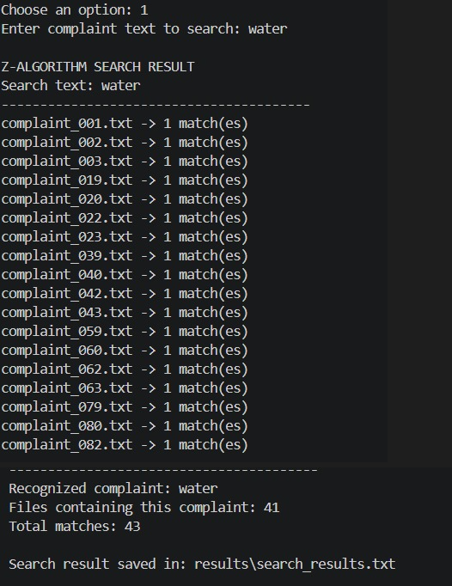
Fig. 5.3 Z-Algorithm search for the word "water"
5.3 Program Output for Each Module
Listings 5.1 to 5.6 show the output of the other modules. Long lists are shortened with dots.
Listing 5.1 Option 1 - Z-Algorithm search for "billing"
Z-ALGORITHM SEARCH RESULT
Search text: billing
----------------------------------------
complaint_102.txt -> 1 match(es)
complaint_108.txt -> 1 match(es)
complaint_114.txt -> 1 match(es)
... (36 files in total)
----------------------------------------
Recognized complaint: billing
Files containing this complaint: 36
Total matches: 36

Listing 5.2 Options 3 and 4 - status and address for customer ID 23
===== COMPLAINT STATUS =====
Complaint ID: CMP-023
Department: Water Utilities
Staff: Ravi Kumar
Status: Verification Checking
Remarks: Complaint details are under verification.

===== COMPLAINT ADDRESS =====
Complaint ID: CMP-023
Address: House 23, Madhapur Main Road, Hyderabad, Telangana

Listing 5.3 Option 5 - Merge Sort by priority (369 lines in total)
===== MODULE-3: SORTED COMPLAINTS =====
Priority order: High -> Medium -> Low
CMP-001 | High | Checked | water
CMP-004 | High | Waiting for Superior Approval | Resident reports street ...
... (147 High complaints)
CMP-003 | Medium | Verification Checking | Resident reports unsafe ...
CMP-006 | Medium | In Progress | Resident reports road potholes ...
... (119 Medium complaints)
CMP-002 | Low | In Progress | Resident reports water supply interruption ...
... (103 Low complaints)

Listing 5.4 Option 6 - Binary Search for CMP-023 and for CMP-999
Enter Complaint ID (example: CMP-023): CMP-023
===== BINARY SEARCH RESULT =====
Complaint ID: CMP-023
Customer: Ravi Reddy
Priority: Low
Department: Water Utilities
Staff: Ravi Kumar
Status: Verification Checking
Description: Resident reports unsafe drinking water near Madhapur ...

Enter Complaint ID (example: CMP-023): CMP-999
Complaint ID not found.

Listing 5.5 Option 7 - Max-flow staff assignment
===== MODULE-4: MAX-FLOW ASSIGNMENT =====
Maximum possible assignments: 73
Anil Rao -> CMP-006 (Public Works Department)
Anil Tiwari -> CMP-317 (Safety Department)
Anjali Sen -> CMP-383 (Road Safety Office)
Anusha Verma -> CMP-332 (City Cleanliness)
... (73 assignments in total)
Yogesh Rao -> CMP-325 (Industrial Safety)

Listing 5.6 Option 8 - Greedy staff coverage and option 9 - audit sample
===== MODULE-5: GREEDY APPROXIMATION =====
Selected staff members: 64
Anil Rao covers 68 pending complaint(s)
Kiran Reddy covers 47 pending complaint(s)
Sonia Das covers 36 pending complaint(s)
...
Yogesh Rao covers 1 pending complaint(s)
Uncovered complaints: 1 (no matching department staff found)

Enter audit sample size: 5
===== MODULE-6: RANDOMIZED AUDIT SAMPLE =====
CMP-313 | High | In Progress | Sewer Department
CMP-317 | High | Assigned | Safety Department
CMP-209 | High | Checked | Quality Assurance
CMP-195 | Low | Verification Checking | Billing Department
CMP-158 | Medium | In Progress | IT Support

5.4 Test Cases and Observed Results
Table 5.2 Test cases and observed results
ID | Option | Input | Observed result
TC-01 | 1 | water | 41 files contain the word, 43 matches in total; result saved in results/search_results.txt
TC-02 | 1 | billing | 36 files, 36 matches
TC-03 | 1 | xyzabc (not in any complaint) | 0 files, 0 matches; no file is listed
TC-04 | 3 | Customer ID 23 | CMP-023, Water Utilities, Ravi Kumar, Verification Checking
TC-05 | 4 | Customer ID 23 | House 23, Madhapur Main Road, Hyderabad, Telangana
TC-06 | 3 | Customer ID 9999 | "Complaint ID not found."
TC-07 | 5 | - | All 369 complaints listed: 147 High, then 119 Medium, then 103 Low
TC-08 | 6 | CMP-023 | Complaint found and its details printed
TC-09 | 6 | CMP-999 | "Complaint ID not found."
TC-10 | 7 | - | Maximum possible assignments: 73 (every staff member receives one complaint)
TC-11 | 8 | - | 64 staff members selected; 368 of 369 pending complaints covered; 1 reported as uncovered
TC-12 | 9 | Sample size 5 | Five complaint records printed; a different sample is drawn on each run

5.5 Analysis of Results
The search results agree with the data: the corpus contains 36 billing complaints (one billing complaint per document) and the search for "billing" found exactly 36 files. The sorted list contains the 147 High, 119 Medium and 103 Low complaints in that order, which matches the counts in the corpus. The maximum-flow result of 73 assignments equals the number of staff members, which means that every staff member can be given one pending complaint of his or her own department. The greedy coverage selects 64 of the 73 staff members; the one complaint that remains uncovered (CMP-310, Municipal Sanitation) belongs to a department to which no staff member is mapped in the corpus.
Table 5.3 Objectives and how they are achieved
Objective | How it is achieved
Centralize data | All 369 complaints are held in one corpus with a uniform fifteen-field format.
Fast retrieval | Z-Algorithm search over the whole corpus (option 1) and Binary Search by ID (option 6).
Prioritize | Merge Sort lists High, Medium and Low complaints in order (option 5).
Accountability | Every complaint carries its staff member and status; max-flow lists one assignment per staff member (option 7).
Coverage and audit | Greedy coverage (option 8) and randomized audit sample (option 9).
Apply course concepts | String algorithms, divide and conquer, network flow, approximation and randomization are all used.

6. CHALLENGES & LIMITATIONS
6.1 Issues Faced during Development
- Matching across document boundaries: if the pattern and text are simply joined, a match could be reported that starts in the pattern and ends in the text.
- Partial words: a user who types a part of a word, such as "wat", should still find complaints about water.
- Line endings: complaint files created on Windows end their lines with carriage return and line feed, which can break field extraction.
- Missing fields: a document with a missing line must not stop the program.
- Wrong ID order: sorting complaint IDs as text can give the wrong order when the IDs have different lengths (for example CMP-100 before CMP-23), which would make Binary Search fail.
- Assignment as a graph problem: a fair one-to-one assignment of complaints to staff cannot be done with a simple loop.
- Exact staff coverage: finding the smallest set of staff who cover all complaints is an NP-hard problem.

6.2 Solutions Applied
Table 6.1 Issues and solutions
Issue | Solution applied
Matches across the boundary | A separator character (\u0000) that never occurs in the text is placed between the pattern and the text before the Z-array is computed.
Partial words | The program looks for a word in the description that starts with the typed text and uses that word as the recognized pattern.
Line endings | Lines are split with the regular expression \R, which accepts every kind of line break.
Missing fields | getFieldValue returns "Not Available" and the modules skip such values (for example staff or department).
Wrong ID order | numericComplaintId extracts the digits of the ID and the records are sorted and searched by that number.
Assignment | The problem is modeled as a flow network and solved with Edmonds-Karp.
Staff coverage | A greedy approximation is used instead of an exact algorithm.

6.3 Limitations of the System
- Data is kept in text files; there is no database, so there is no indexing, no concurrent access and no enforced uniqueness of IDs.
- The menu can only read and analyze complaints. New complaints are added by creating a document in data/corpus, and the helper method updateFieldValue exists in the code but is not yet connected to a menu option.
- The search works on the complaint description only, and every search reads all files again.
- Priority sorting recognizes only High, Medium and Low; any other value is ranked last.
- In the assignment model every staff member has capacity 1, and all complaints in the present corpus count as pending.
- The greedy coverage result depends on the order of the data and is not guaranteed to be the minimum.
- The random sample is not seeded, so it cannot be repeated exactly.
- The program is console-based; there is no graphical or web interface.

7. CONCLUSION & FUTURE WORK
7.1 Conclusion
The Complaint Tracker replaces scattered, manual complaint handling with a Java program that keeps every complaint in a uniform document, searches the whole corpus with the Z-Algorithm, orders complaints with Merge Sort, finds a complaint by ID with Binary Search, assigns pending complaints to staff with a maximum-flow model, selects staff coverage with a greedy approximation and draws random audit samples. The program was run on a corpus of 369 complaints and every module produced results that agree with the data.
The project shows how classical algorithms solve practical problems of complaint management: linear-time string matching for search, O(n log n) sorting for prioritization, logarithmic lookup, flow algorithms for fair assignment, approximation for an NP-hard coverage problem and randomization for unbiased audits. It reduces manual work, improves the accuracy of retrieval and supports faster complaint resolution.
7.2 Future Work
- Database back end: store customers, complaints, categories, staff and status history in a relational database (MySQL or PostgreSQL) and use SQL for retrieval and reports.
- Complaint entry and update: add menu options (or a web form) to register new complaints and update their status, using the existing updateFieldValue method.
- Graphical or web interface: a dashboard for complaint officers and a form for customers.
- AI-based categorization: classify and prioritize complaints automatically using text analysis.
- Better assignment: give each staff member a workload capacity and weight complaints by priority in the flow model.
- Indexed search: build an index over the corpus, and use other string algorithms such as KMP or suffix structures for comparison.
- Notifications and analytics: SMS or e-mail alerts on status change, and trend reports on resolution time.

7.3 Skills Learned during Development
- Writing a complete menu-driven application in Java with file input and output.
- Implementing the Z-Algorithm, Merge Sort, Binary Search and the Edmonds-Karp algorithm from first principles.
- Modeling a real problem as a flow network and as a Set Cover problem, and understanding the difference between exact and approximate solutions.
- Using randomization for unbiased sampling.
- Analyzing the time and space complexity of each module.
- Using Visual Studio Code to write, run and test Java programs, and documenting and presenting the work as a team.

REFERENCES
[1] T. H. Cormen, C. E. Leiserson, R. L. Rivest and C. Stein, Introduction to Algorithms, 4th ed. MIT Press, 2022.
[2] D. Gusfield, Algorithms on Strings, Trees, and Sequences. Cambridge University Press, 1997.
[3] J. Kleinberg and E. Tardos, Algorithm Design. Pearson Addison-Wesley, 2006.
[4] R. Sedgewick and K. Wayne, Algorithms, 4th ed. Addison-Wesley, 2011.
[5] J. Edmonds and R. M. Karp, “Theoretical improvements in algorithmic efficiency for network flow problems,” Journal of the ACM, vol. 19, no. 2, pp. 248–264, 1972.
[6] V. Chvátal, “A greedy heuristic for the set-covering problem,” Mathematics of Operations Research, vol. 4, no. 3, pp. 233–235, 1979.
[7] Java Platform, Standard Edition Documentation, Oracle. https://docs.oracle.com/en/java/javase/
[8] Java in Visual Studio Code, Microsoft. https://code.visualstudio.com/docs/java/java-tutorial

