

Technical Safety Concept Lane Assistance

**Document Version: [Version]**

**Template Version 1.0, Released on 2017-06-21**



# Document history

|  |  |  |  |
| --- | --- | --- | --- |
| Date | Version | Editor | Description |
| 14.07.2018 | 1.1 | Ankith Manjunath |  |
|  |  |  |  |
|  |  |  |  |
|  |  |  |  |
|  |  |  |  |

# 

# Table of Contents

Document history

Table of Contents

Purpose of the Technical Safety Concept

Inputs to the Technical Safety Concept

Functional Safety Requirements

Refined System Architecture from Functional Safety Concept

Functional overview of architecture elements

Technical Safety Concept

Technical Safety Requirements

Refinement of the System Architecture

Allocation of Technical Safety Requirements to Architecture Elements

Warning and Degradation Concept

# Purpose of the Technical Safety Concept

The functional safety concept follows the ISO26262 standards to specifiy safety requirements on a system level ignoring the technical details. Technical safety concept introduces more technical specific requirements into the system.

# Inputs to the Technical Safety Concept

## Functional Safety Requirements

|  |  |  |  |  |
| --- | --- | --- | --- | --- |
| **ID** | **Functional Safety Requirement** | **ASIL** | **Fault Tolerant Time Interval** | **Safe State** |
| Functional  Safety  Requirement  01-01 | The lane keeping item shall ensure that the  torque amplitude by lane departure warning  system is below  MAX_TORQUE_AMPLITUDE | C | 50ms | Vibration torque amplitude below Max_Torque_Amplitude. |
| Functional  Safety  Requirement  01-02 | The lane keeping item shall ensure that the  torque frequency by the lane departure  warning is below  MAX_TORQUE_FREQUENCY | C | 50ms | Vibration torque amplitude below Max_Torque_Frequency. |
| Functional  Safety  Requirement  02-01 | The lane keeping item shall ensure that the  steering torque TIME_FOR_TORQUE is  applied for a limited period of time . | B | 500ms | Lane Keeping Assistance torque is zero. |

## Refined System Architecture from Functional Safety Concept

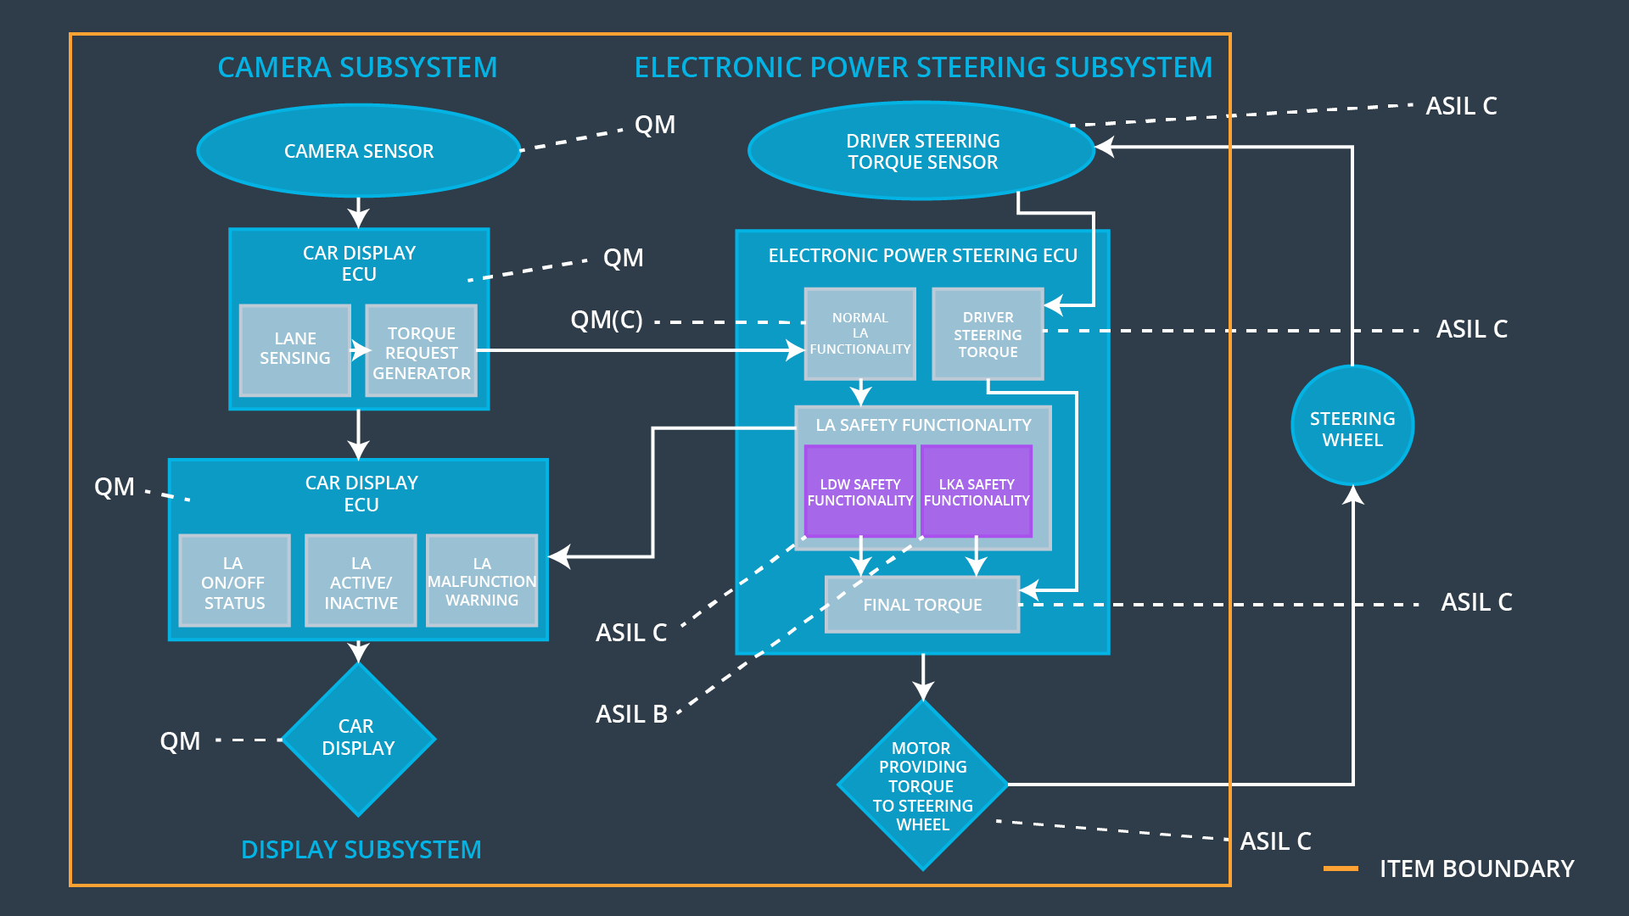

### 

### Functional overview of architecture elements

|  |  |
| --- | --- |
| **Element** | **Description** |
| Camera Sensor | Captures Frames of the road environment from a video feed |
| Camera Sensor ECU - Lane Sensing | Detects the lane on the road and the distance of the center of the car from the lane on either side |
| Camera Sensor ECU - Torque request generator | Estimates the amount of torque required to keep the car in the center of the lane |
| Car Display | HMI to the driver |
| Car Display ECU - Lane Assistance On/Off Status | HMI indication to indicate if Lane assistance is on or off |
| Car Display ECU - Lane Assistant Active/Inactive | HMI indicaion to indicate if Lane assistance item is working properly or not |
| Car Display ECU - Lane Assistance malfunction warning | HMI indication to alert the driver for a handover |
| Driver Steering Torque Sensor | Sensor to detect the amount of torque applied by the driver |
| Electronic Power Steering (EPS) ECU - Driver Steering Torque | ECU receiving the torque from the steering torque sensor |
| EPS ECU - Normal Lane Assistance Functionality | ECU calculating the amount of torque needed for lane assitance |
| EPS ECU - Lane Departure Warning Safety Functionality | ECU to provide driver with a haptic feedback(Vibration) to alert the driver of lane departure warning |
| EPS ECU - Lane Keeping Assistant Safety Functionality | ECU calculating the amount of extra torque needed to keep the vehicle in the lane |
| EPS ECU - Final Torque | ECU to send the torque request to the motor |
| Motor | Motor used to steer the steering wheel |

# Technical Safety Concept

## Technical Safety Requirements

**Lane Departure Warning (LDW) Requirements:**

Functional Safety Requirement 01-01 with its associated system elements

(derived in the functional safety concept)

|  |  |  |  |  |
| --- | --- | --- | --- | --- |
| **ID** | **Functional Safety Requirement** | **Electronic Power Steering ECU** | **Camera ECU** | **Car Display ECU** |
| Functional  Safety  Requirement  01-01 | The lane keeping item shall ensure that the lane departure oscillating torque amplitude is below Max_Torque_Amplitude | X |  |  |

Technical Safety Requirements related to Functional Safety Requirement 01-01 are:

|  |  |  |  |  |  |
| --- | --- | --- | --- | --- | --- |
| **ID** | **Technical Safety Requirement** | **ASIL** | **Fault Tolerant Time Interval** | **Architecture Allocation** | **Safe State** |
| Technical  Safety  Requirement  01-01-01 | The LDW safety component shall ensure that the amplitude of the LDW_Torque_Request sent to the Final Electronic Power Steering Torque component is below Max_Torque_Amplitude | C | 50ms | LDW safety | Set LDW_Torque_request to zero |
| Technical  Safety  Requirement  01-01-02 | The validity and integrity of the data transmission for LDW_Torque_Request signal shall be ensured | C | 50ms | LDW safety | Set LDW_Torque_request to zero |
| Technical  Safety  Requirement  01-01-03 | As soon as a failure is detected by the LDW function, it shall deactivate the LDW feature and the LDW_Torque_Request shall be set to zero | C | 50ms | LDW safety | Set LDW_Torque_request to zero |
| Technical  Safety  Requirement  01-01-04 | As soon as the LDW function deactivates the LDW feature, the LDW Safety software block shall send a signal to the car display ECU to turn on a warning light | C | 50ms | LDW safety | Set LDW_Torque_request to zero |
| Technical  Safety  Requirement  01-01-05 | Memory test shall be conducted at start up of the EPS ECU to check for any faults in memory | A | Ignition cycle | Data transmission Integrity check | Set LDW_Torque_request to zero |

Functional Safety Requirement 01-2 with its associated system elements

(derived in the functional safety concept)

|  |  |  |  |  |
| --- | --- | --- | --- | --- |
| **ID** | **Functional Safety Requirement** | **Electronic Power Steering ECU** | **Camera ECU** | **Car Display ECU** |
| Functional  Safety  Requirement  01-02 | The lane keeping item shall ensure that the lane departure oscillating torque frequency is below Max_Torque_Frequency | X |  |  |

Technical Safety Requirements related to Functional Safety Requirement 01-02 are:

|  |  |  |  |  |  |
| --- | --- | --- | --- | --- | --- |
| **ID** | **Technical Safety Requirement** | **ASIL** | **Fault Tolerant Time Interval** | **Architecture Allocation** | **Safe State** |
| Technical  Safety  Requirement  01-02-01 | The lane departure warning safety subsyste ensures that the LDW_Torque_request is less than the Max_Torque_Frequency | C | 50ms | LDW safety | Set LDW_Torque_request to zero |
| Technical  Safety  Requirement  01-02-02 | On lane departure warning malfunction, the lane departure warning safety system shall deactivate and set Max_Torque_Frequency to zero | C | 50ms | LDW safety | Set LDW_Torque_request to zero |
| Technical  Safety  Requirement  01-02-03 | When LDW is deactivated the LDW safety module shall send a signal to car display ECU to display a warning | C | 50ms | LDW safety | Set LDW_Torque_request to zero |
| Technical  Safety  Requirement  01-02-04 | The integrity of LDW_Torque_request shall be ensured | C | 50ms | LDW safety | Set LDW_Torque_request to zero |
| Technical  Safety  Requirement  01-02-05 | Memory tests shall be conducted on EPS ECU to check for memory problems | A | Ignition cycle | Data transmission Integrity check | Set LDW_Torque_request to zero |

**Lane Keeping Assistance (LKA) Requirements:**

Functional Safety Requirement 02-1 with its associated system elements

(derived in the functional safety concept)

|  |  |  |  |  |
| --- | --- | --- | --- | --- |
| **ID** | **Functional Safety Requirement** | **Electronic Power Steering ECU** | **Camera ECU** | **Car Display ECU** |
| Functional  Safety  Requirement  02-01 | The lane keeping item shall ensure that the lane keeping assistance torque is applied for only Max_Duration | X |  |  |

Technical Safety Requirements related to Functional Safety Requirement 02-01 are:

|  |  |  |  |  |  |
| --- | --- | --- | --- | --- | --- |
| **ID** | **Technical Safety Requirement** | **ASIL** | **Fault Tolerant Time Interval** | **Allocation to Architecture** | **Safe State** |
| Technical  Safety  Requirement  02-01-01 | The lane keep assistance safety function shall apply lane keeping assistance torque for a duration less than Max_Duration | B | 500ms | LKA safety | LKA_Torque_request set to zero |
| Technical  Safety  Requirement  02-01-02 | When lane keeping assitance is deactivated the LKA safety module shall send a signal to car display ECU to display a warning | B | 500ms | LKA safety | LKA_Torque_request set to zero |
| Technical  Safety  Requirement  02-01-03 | On lane keeping assistance malfunction, the lane keeping assistance safety system shall deactivate and set LKA_Torque_request to zero | B | 500ms | LKA safety | LKA_Torque_request set to zero |
| Technical  Safety  Requirement  02-01-04 | The integrity of LKA_Torque_request shall be ensured | B | 500ms | LKA safety | LKA_Torque_request set to zero |
| Technical  Safety  Requirement  02-01-05 | Memory tests shall be conducted on EPS ECU to check for memory problems | A | Ignition cycle | Data transmission Integrity check | LKA_Torque_request set to zero |

## Refinement of the System Architecture

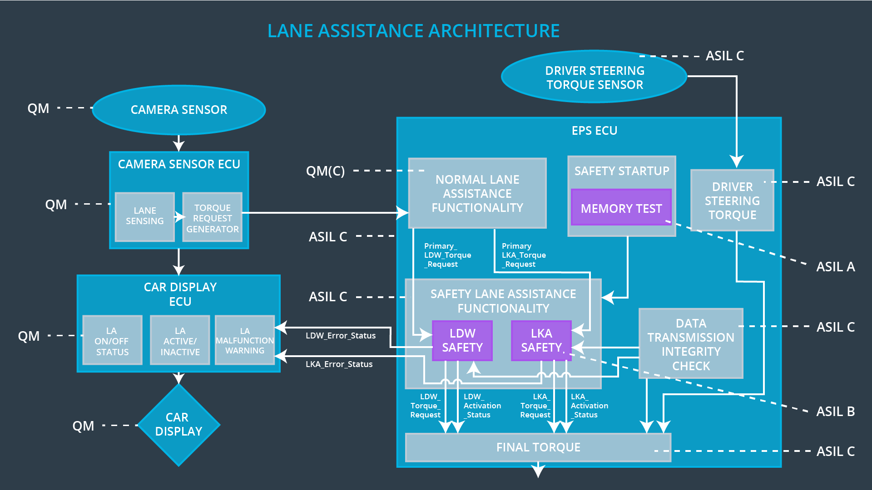

## Allocation of Technical Safety Requirements to Architecture Elements

|  |  |  |  |  |
| --- | --- | --- | --- | --- |
| **ID** | **Technical Safety Requirement** | **Electronic Power Steering ECU** | **Camera ECU** | **Car Display ECU** |
| Technical  Safety  Requirement  01-01-01 | The LDW safety component shall ensure that the amplitude of the LDW_Torque_Request sent to the Final Electronic Power Steering Torque component is below Max_Torque_Amplitude | X |  |  |
| Technical  Safety  Requirement  01-01-02 | The validity and integrity of the data transmission for LDW_Torque_Request signal shall be ensured | x |  |  |
| Technical  Safety  Requirement  01-01-03 | As soon as a failure is detected by the LDW function, it shall deactivate the LDW feature and the LDW_Torque_Request shall be set to zero | x |  |  |
| Technical  Safety  Requirement  01-01-04 | As soon as the LDW function deactivates the LDW feature, the LDW Safety software block shall send a signal to the car display ECU to turn on a warning light | x |  |  |
| Technical  Safety  Requirement  01-01-05 | Memory test shall be conducted at start up of the EPS ECU to check for any faults in memory | x |  |  |
| Technical  Safety  Requirement  01-02-01 | The lane departure warning safety subsyste ensures that the LDW_Torque_request is less than the Max_Torque_Frequency | x |  |  |
| Technical  Safety  Requirement  01-02-02 | On lane departure warning malfunction, the lane departure warning safety system shall deactivate and set Max_Torque_Frequency to zero | x |  |  |
| Technical  Safety  Requirement  01-02-03 | When LDW is deactivated the LDW safety module shall send a signal to car display ECU to display a warning | x |  |  |
| Technical  Safety  Requirement  01-02-04 | The integrity of LDW_Torque_request shall be ensured | x |  |  |
| Technical  Safety  Requirement  01-02-05 | Memory tests shall be conducted on EPS ECU to check for memory problems | x |  |  |
| Technical  Safety  Requirement  02-01-01 | The lane keep assistance safety function shall apply lane keeping assistance torque for a duration less than Max_Duration | x |  |  |
| Technical  Safety  Requirement  02-01-02 | When lane keeping assitance is deactivated the LKA safety module shall send a signal to car display ECU to display a warning | x |  |  |
| Technical  Safety  Requirement  02-01-03 | On lane keeping assistance malfunction, the lane keeping assistance safety system shall deactivate and set LKA_Torque_request to zero | x |  |  |
| Technical  Safety  Requirement  02-01-04 | The integrity of LKA_Torque_request shall be ensured | x |  |  |
| Technical  Safety  Requirement  02-01-05 | Memory tests shall be conducted on EPS ECU to check for memory problems | x |  |  |

## Warning and Degradation Concept

|  |  |  |  |  |
| --- | --- | --- | --- | --- |
| **ID** | **Degradation Mode** | **Trigger for Degradation Mode** | **Safe State invoked?** | **Driver Warning** |
| WDC-01 | Turn off functionality | Malfunction_01  Malfunction_02 | Yes | LDW warning on the screen |
| WDC-02 | Turn off functionality | Malfunction_03 | Yes | LKA warning on the screen, Driver to take over the car |