1)Problem Statement:
You work for XYZ Corporation. Your corporation wants to launch a new
web-based application and they do not want their servers to be running all the
time. It should also be managed by AWS. Implement suitable solutions.
Tasks To Be Performed:
1. Create an Elastic Beanstalk environment with the runtime as PHP.
2. Upload a simple PHP file to the environment once created

TASK 1: Create an Elastic Beanstalk Environment (PHP Runtime)

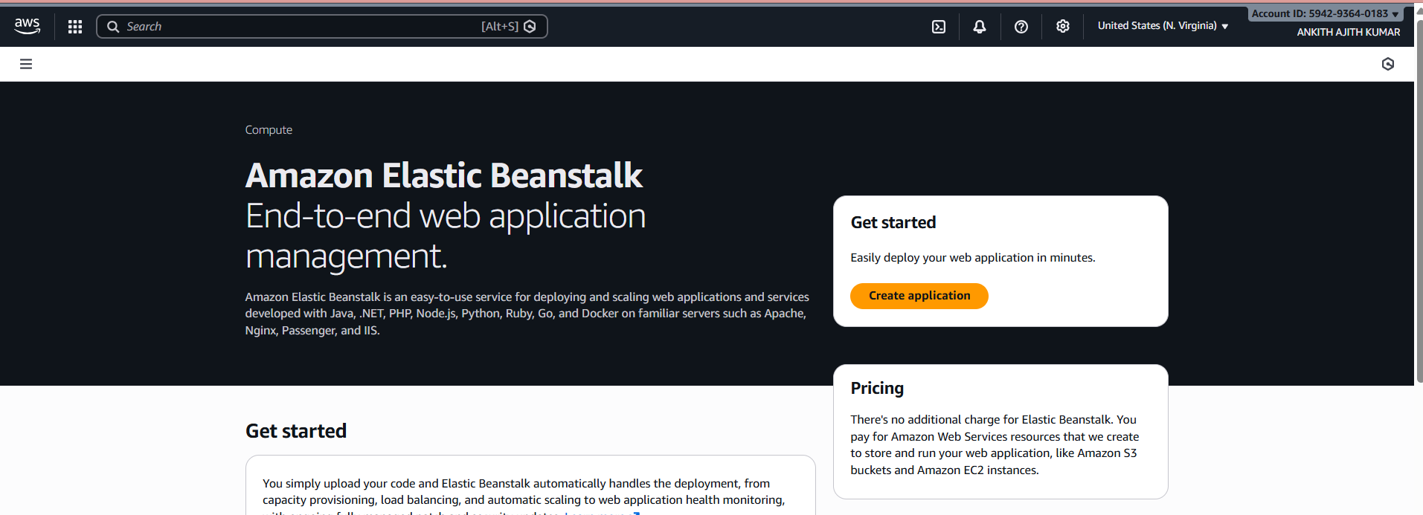
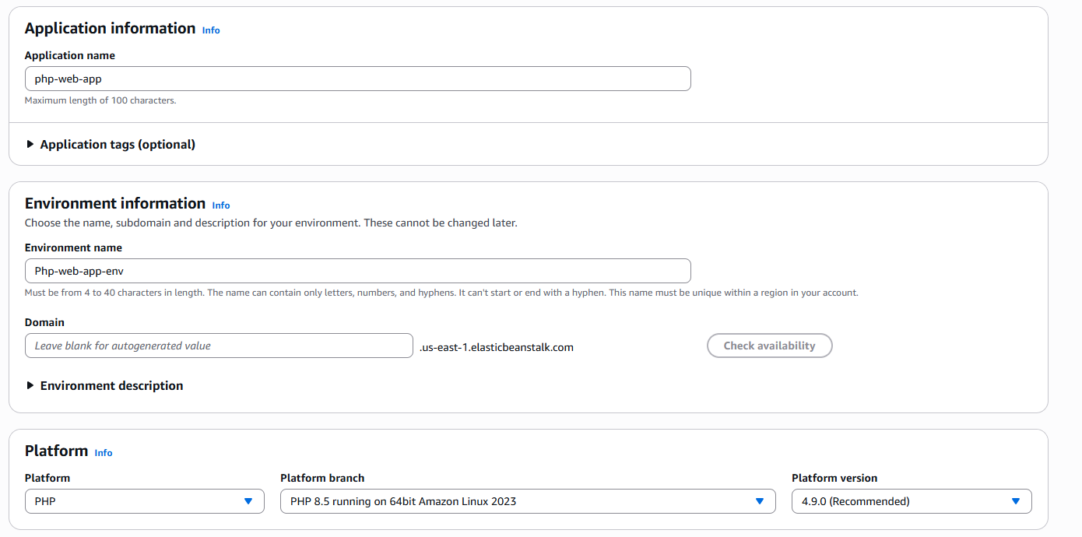

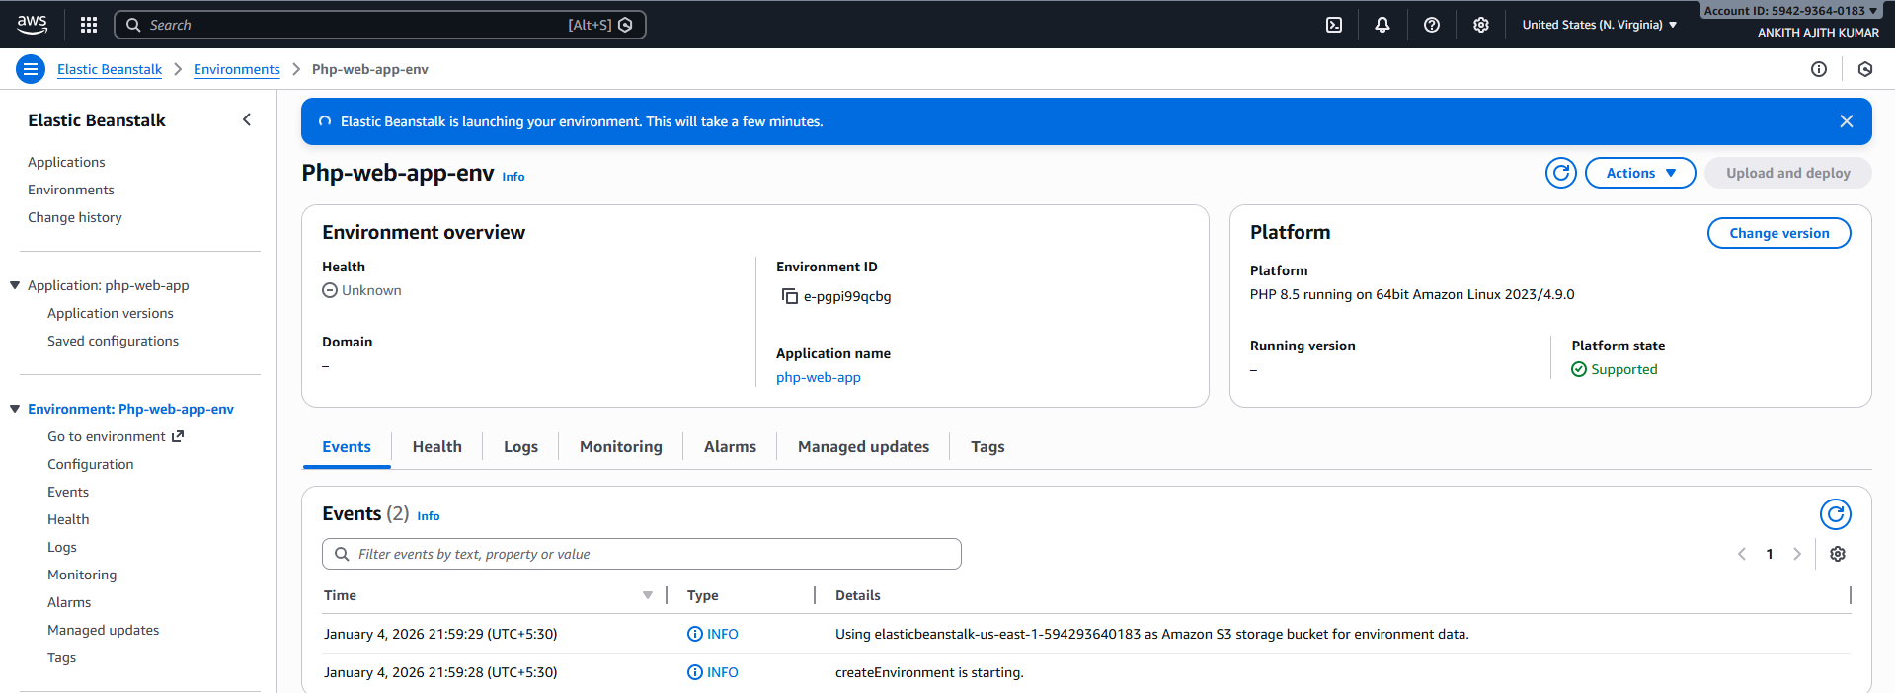
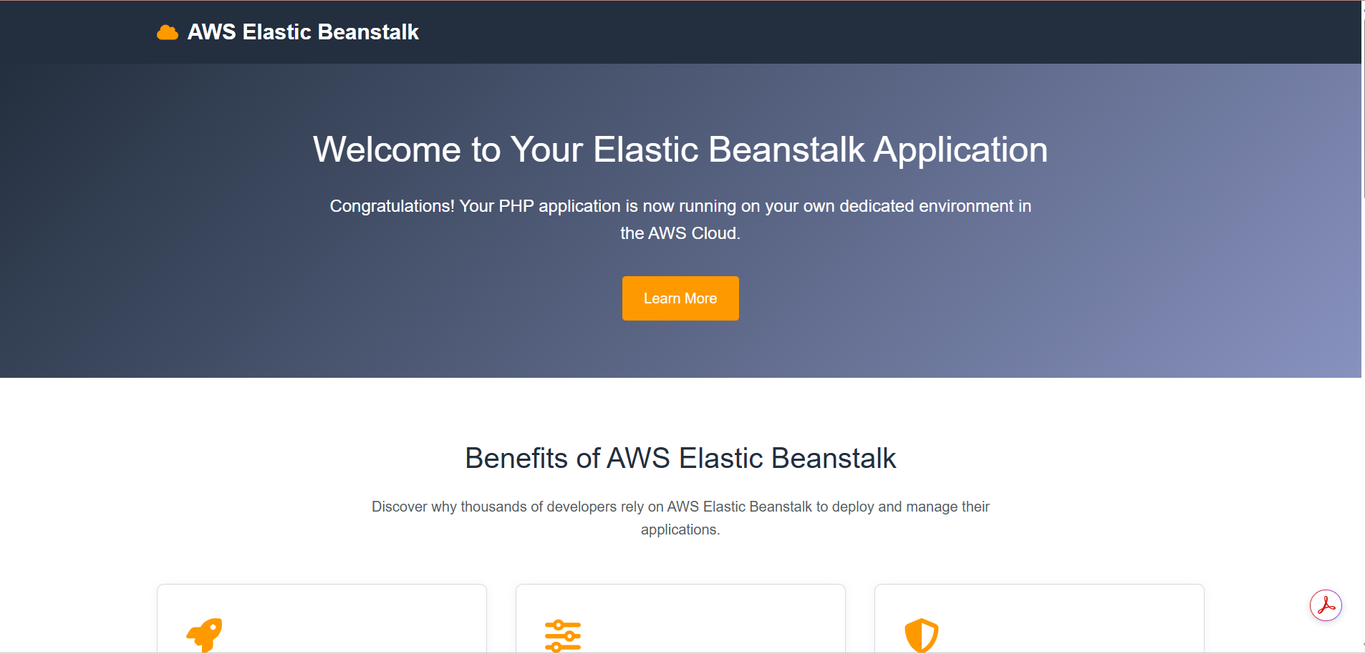
Uploading PHP file to Elastic Beanstalk

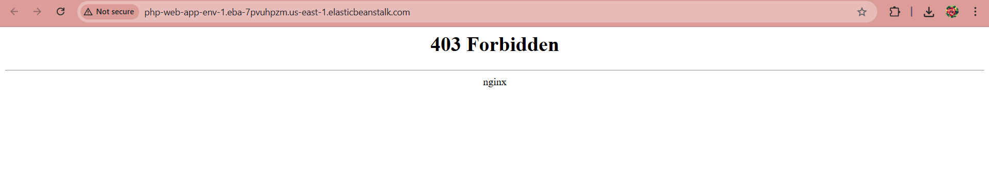
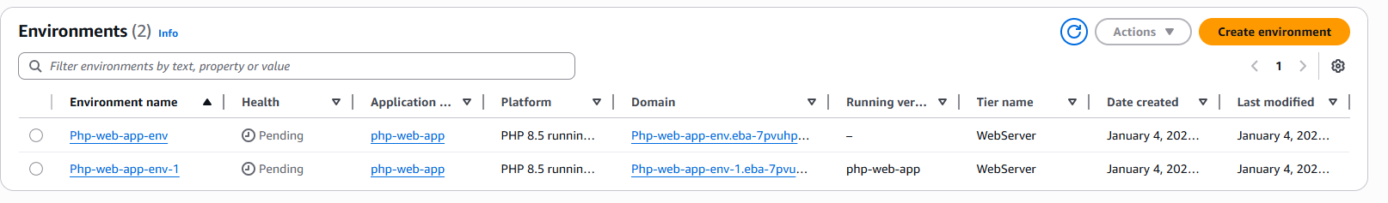

2)Problem Statement:
You work for XYZ Corporation. Your corporation wants to launch a new
web-based application and they do not want their servers to be running all the
time. It should also be managed by AWS. Implement suitable solutions.
Tasks To Be Performed:
1. Create a sample Python Lambda function.
2. Set the Lambda Trigger as SQS and send a message to test invocations.

TASK 1: Create a Sample Python Lambda Function

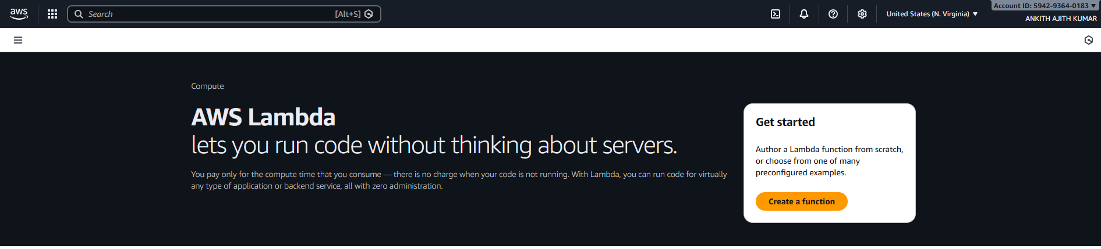
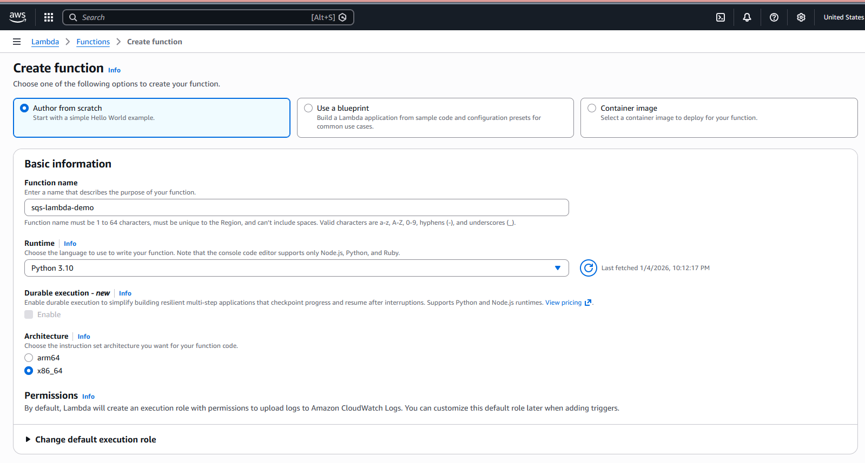
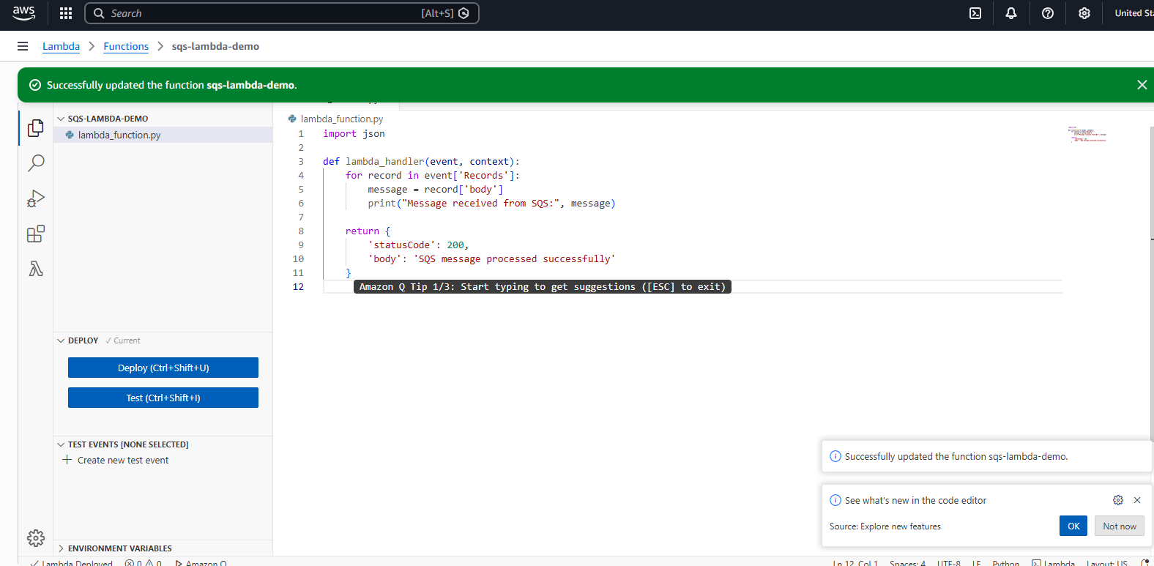
TASK 2: Create an SQS Queue

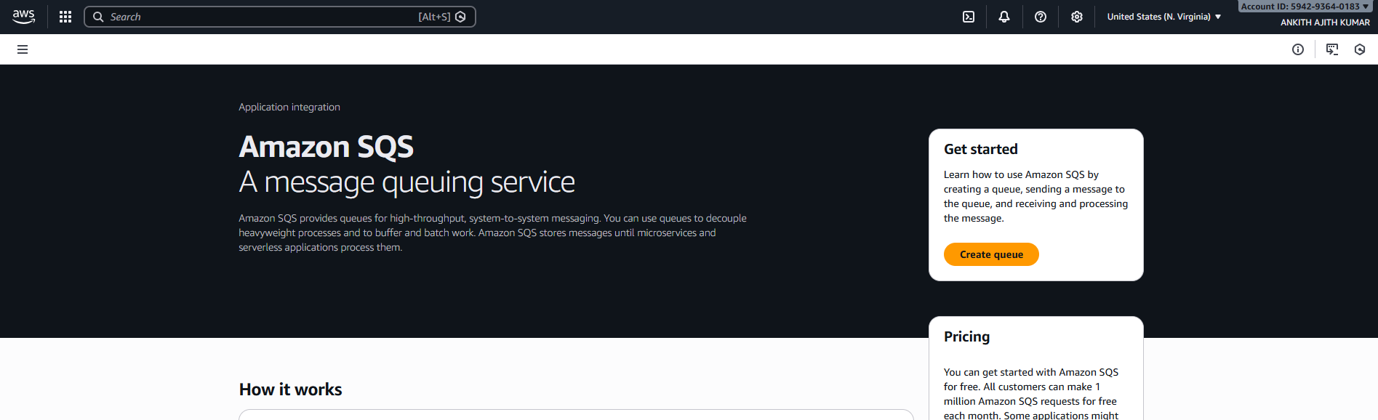
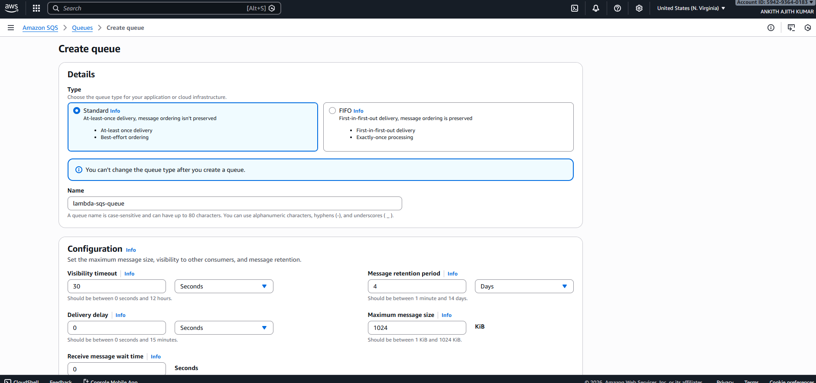

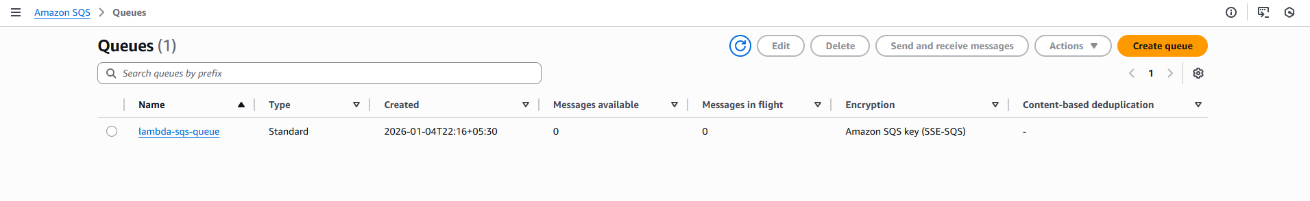
TASK 3: Set SQS as Trigger for Lambda

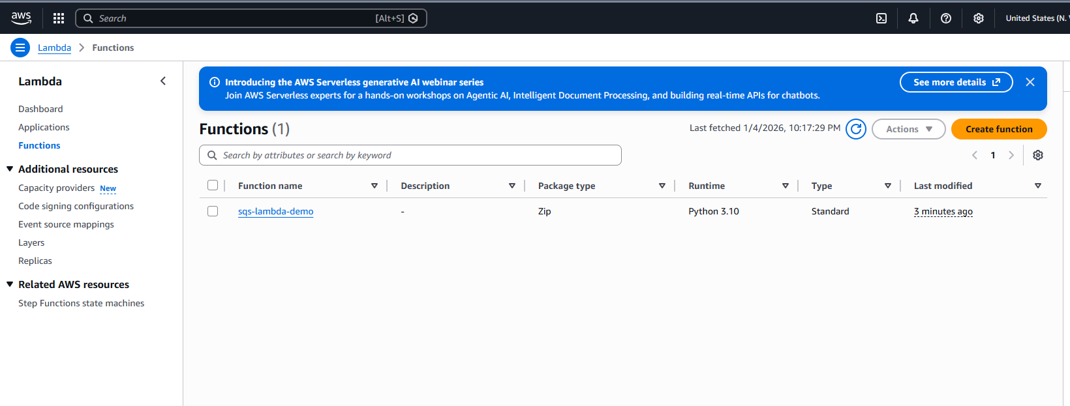
adding trigger

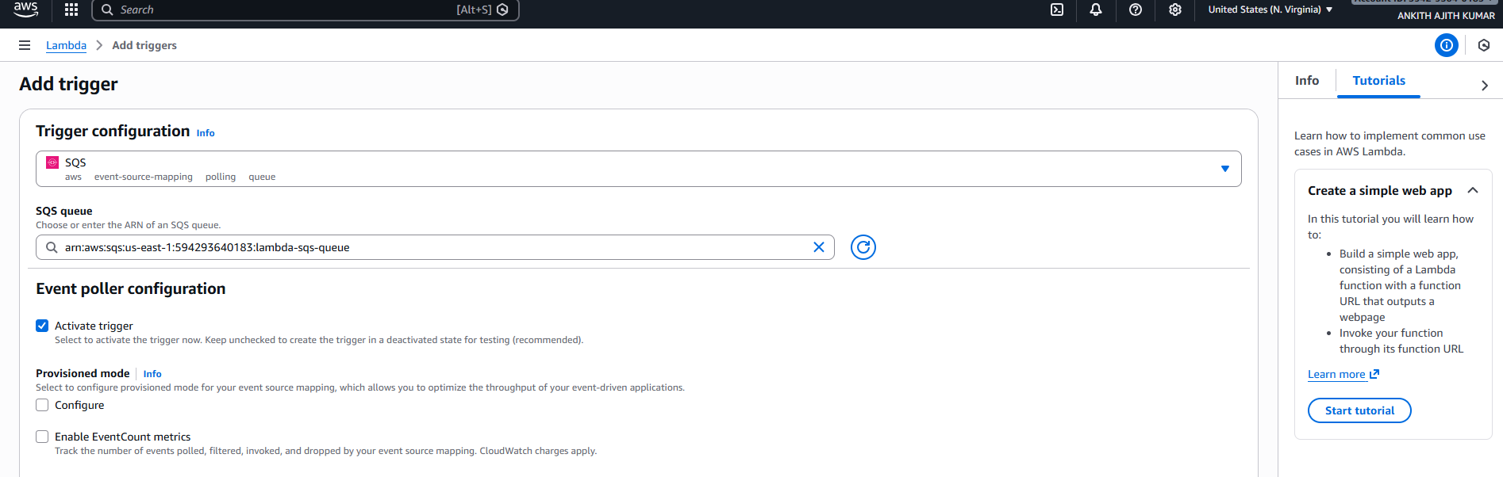

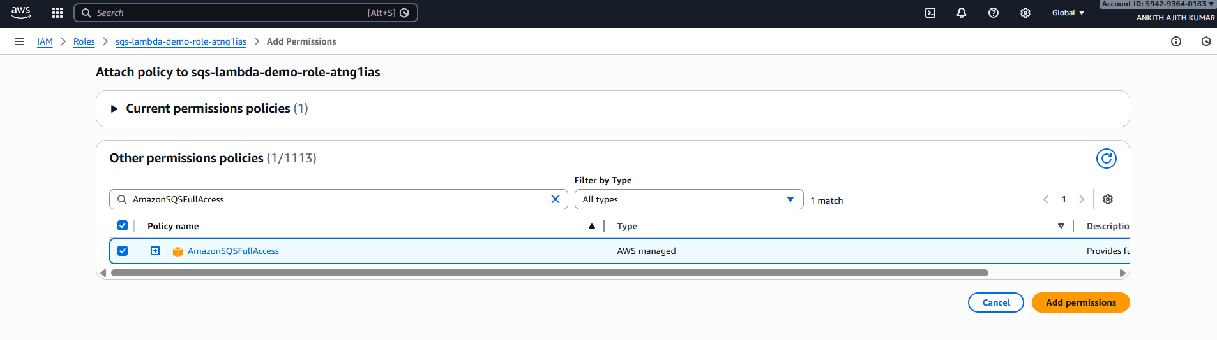

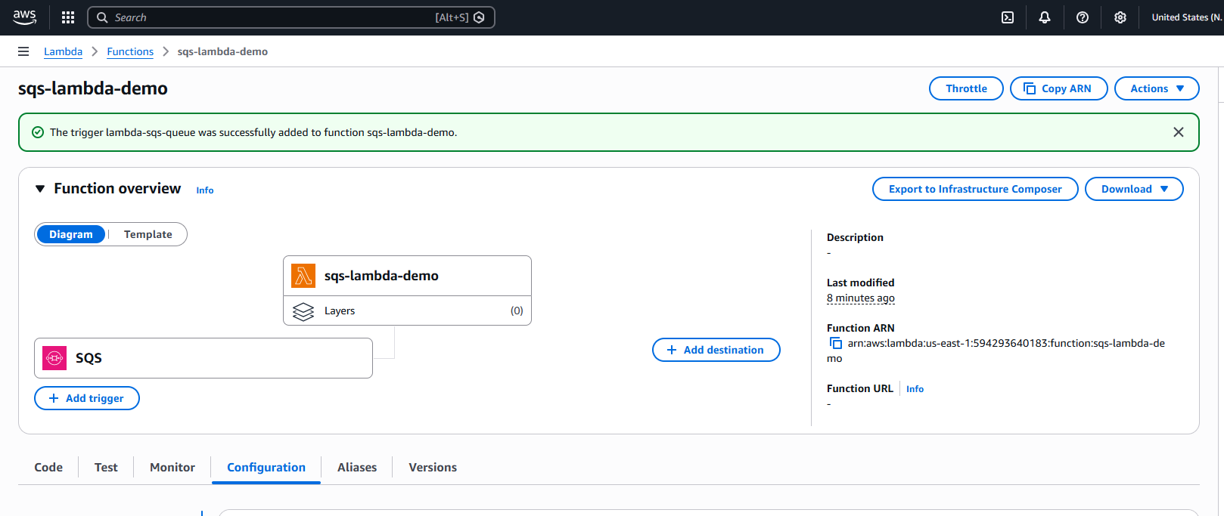
testing:
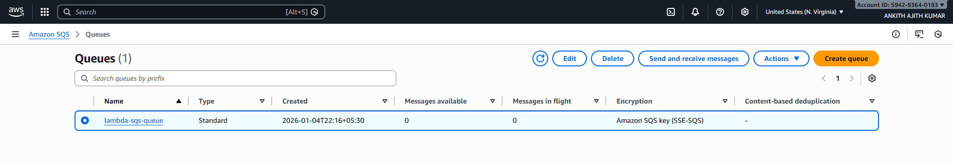
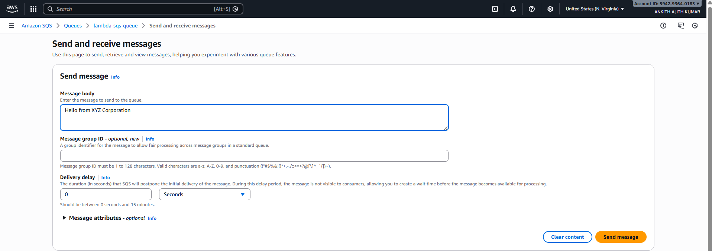
Verifying Logs:

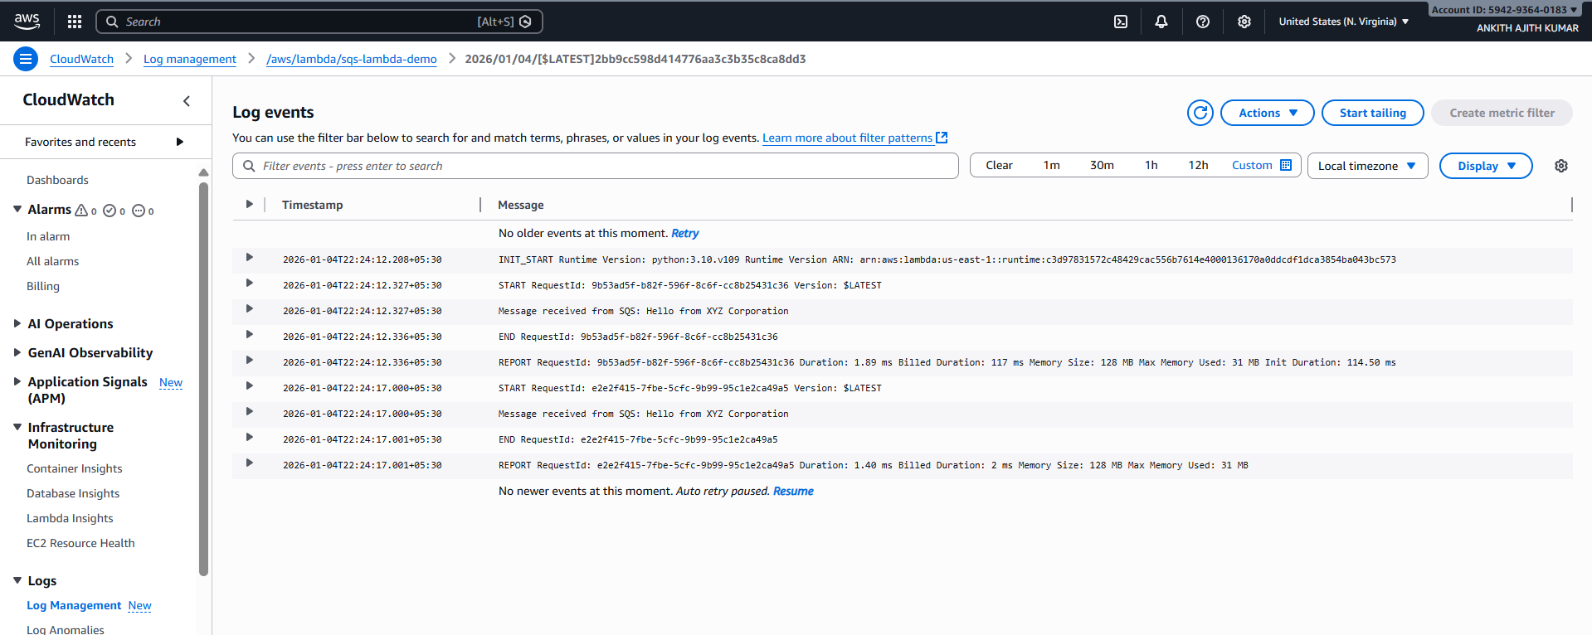
3)Problem Statement:
You work for XYZ Corporation. Your corporation wants to launch a new
web-based application and they do not want their servers to be running all the
time. It should also be managed by AWS. Implement suitable solutions.
Tasks To Be Performed:
1. Create an OpsWorks sample stack, start the instances and deploy the
application.
2. Add 2 more t2.medium instances.
3. Make a change to the repository code and check if it reflects in all the
instances.

Opswork service is not available

