1)Tasks To Be Performed:
1. Trigger a pipeline using Git when push on develop branch
2. Pipeline should pull Git content to a folder

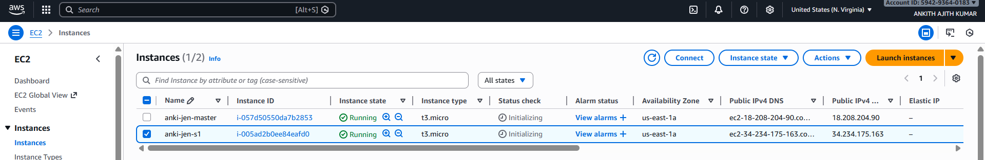
Both in master and slave node

$sudo apt update

$sudo apt install openjdk-17-jre

ubuntu@ip-172-31-15-163:~$ java --version
openjdk 17.0.17 2025-10-21
OpenJDK Runtime Environment (build 17.0.17+10-Ubuntu-122.04)
OpenJDK 64-Bit Server VM (build 17.0.17+10-Ubuntu-122.04, mixed mode, sharing)

ubuntu@ip-172-31-15-163:~$ sudo nano a.sh

sudo wget -O /etc/apt/keyrings/jenkins-keyring.asc \
https://pkg.jenkins.io/debian-stable/jenkins.io-2023.key
echo "deb [signed-by=/etc/apt/keyrings/jenkins-keyring.asc]" \
https://pkg.jenkins.io/debian-stable binary/ | sudo tee \
/etc/apt/sources.list.d/jenkins.list > /dev/null
sudo apt update
sudo apt install fontconfig openjdk-17-jdk -y
sudo apt install jenkins

ubuntu@ip-172-31-15-163:~$ sudo bash a.sh

ubuntu@ip-172-31-15-163:~$ jenkins --version
2.528.3

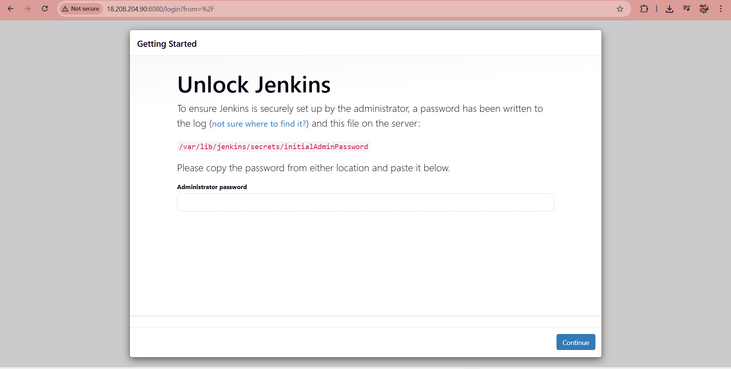
ubuntu@ip-172-31-15-163:~$ sudo cat /var/lib/jenkins/secrets/initialAdminPassword
ff7512b6cbe7493badb6846703cbe254

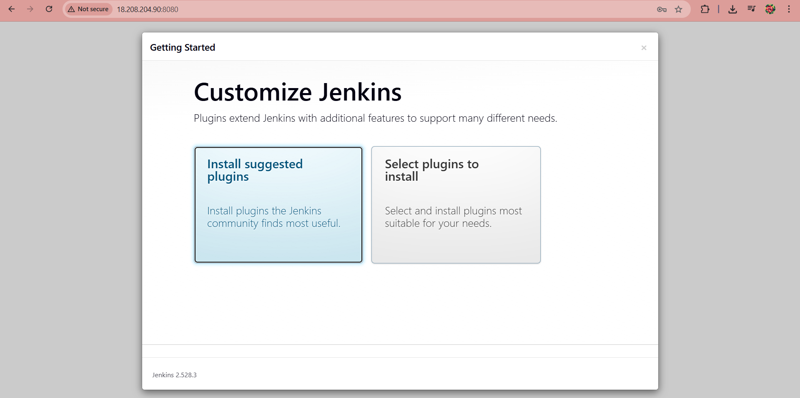
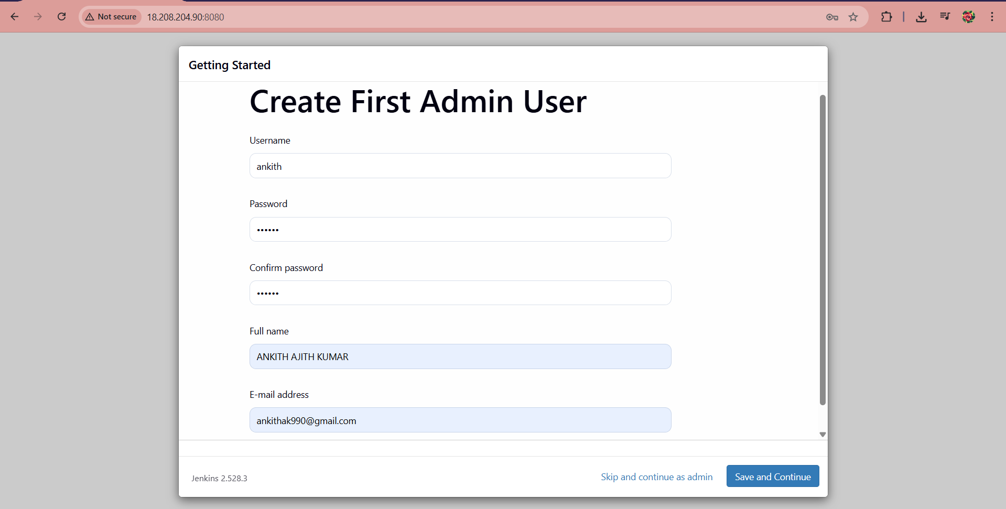
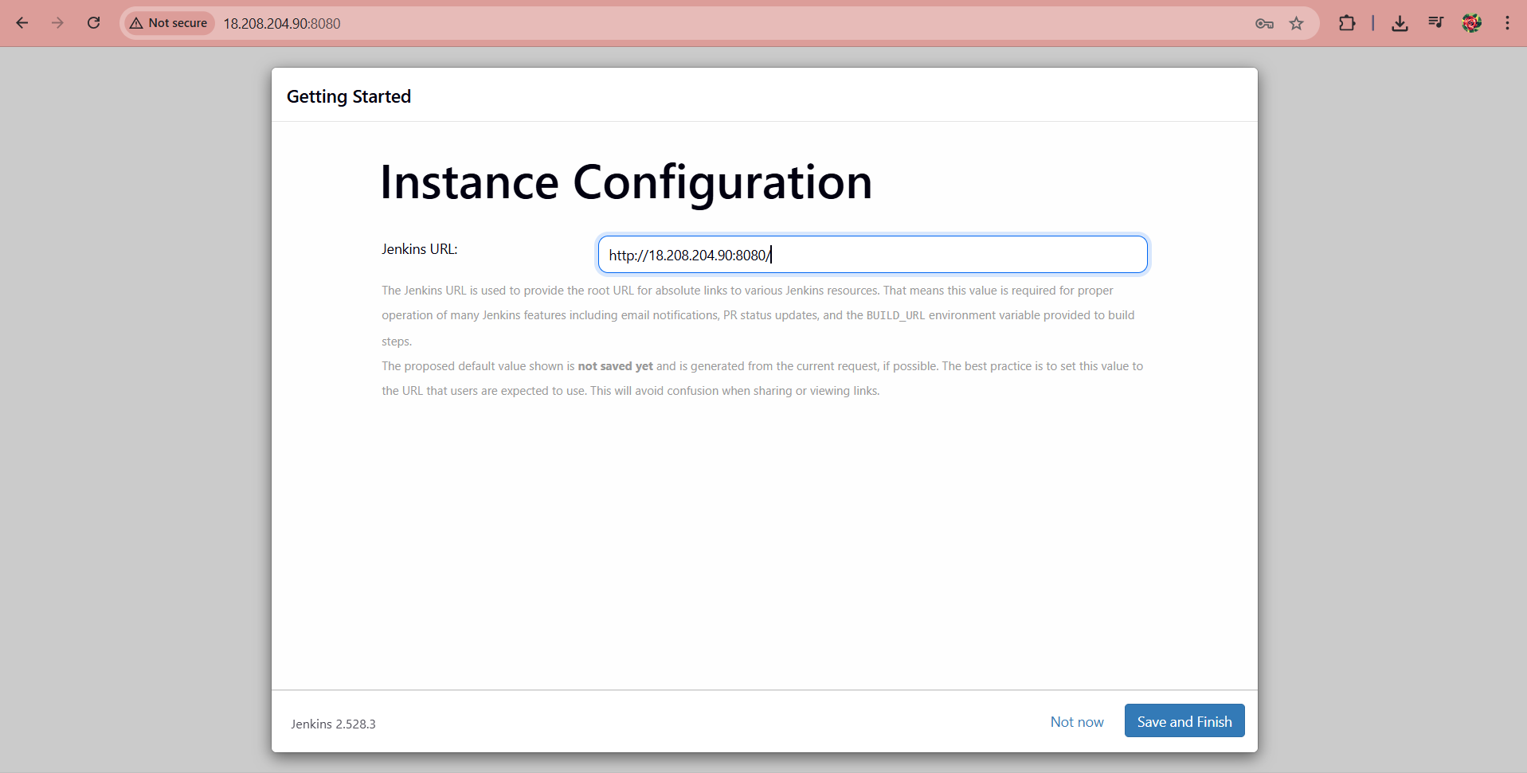
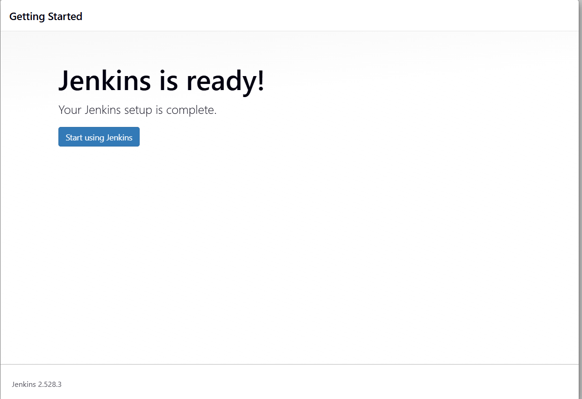
ubuntu@ip-172-31-15-163:~$ sudo systemctl status jenkins
● jenkins.service - Jenkins Continuous Integration Server
Loaded: loaded (/lib/systemd/system/jenkins.service; enabled; vendor preset: enabled)
Active: active (running) since Tue 2026-01-06 14:46:49 UTC; 8min ago
Main PID: 5694 (java)
Tasks: 38 (limit: 1073)
Memory: 462.5M
CPU: 56.436s
CGroup: /system.slice/jenkins.service
└─5694 /usr/bin/java -Djava.awt.headless=true -jar /usr/share/java/jenkins.war --webroot=/var/cache/jenkins/war –httpPort=8080

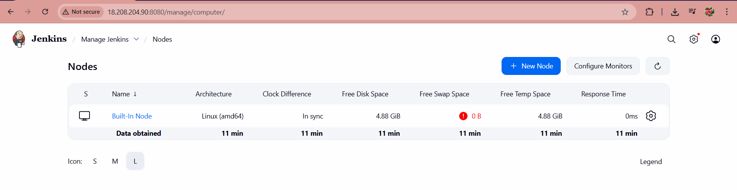

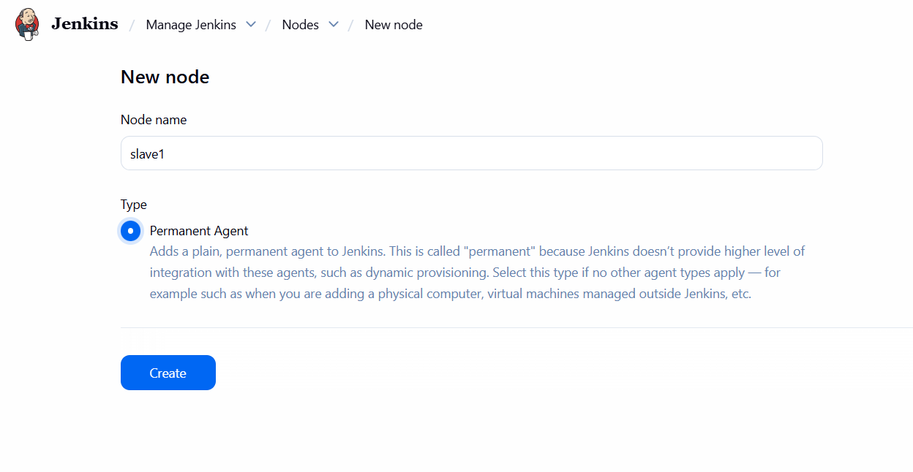
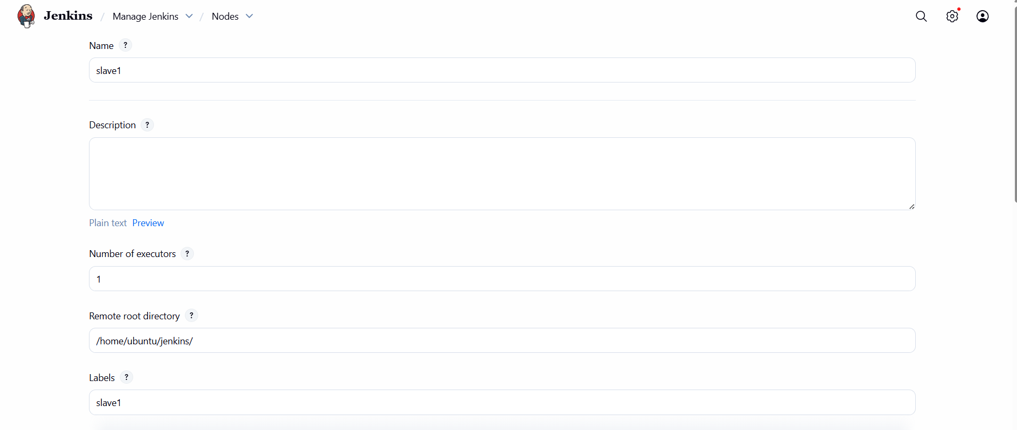
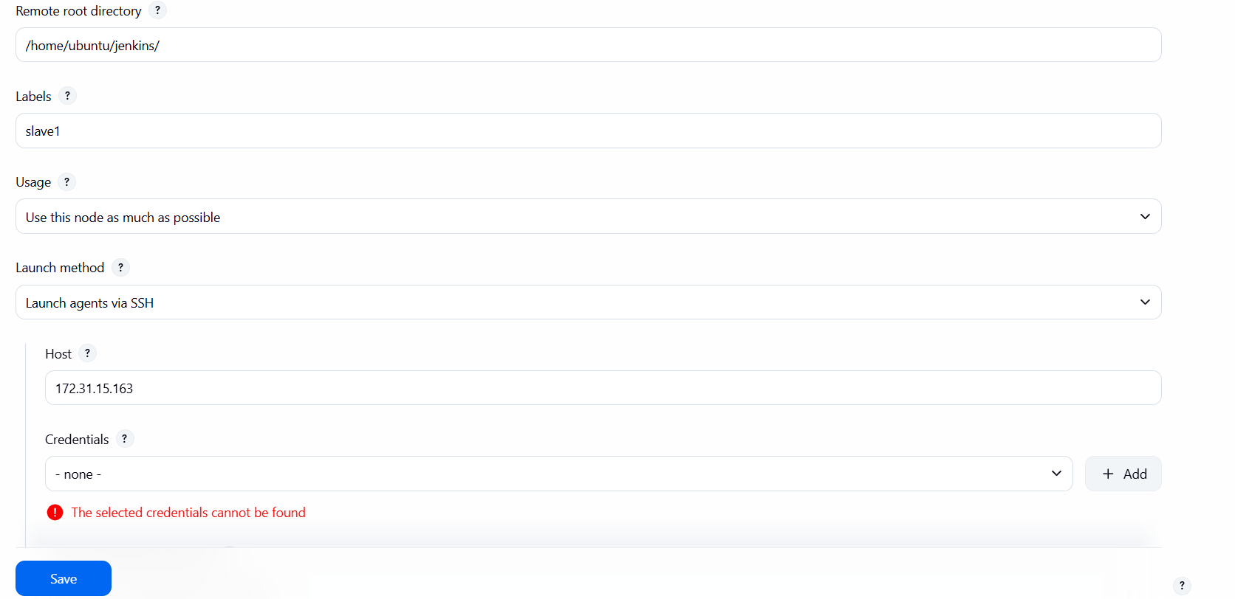
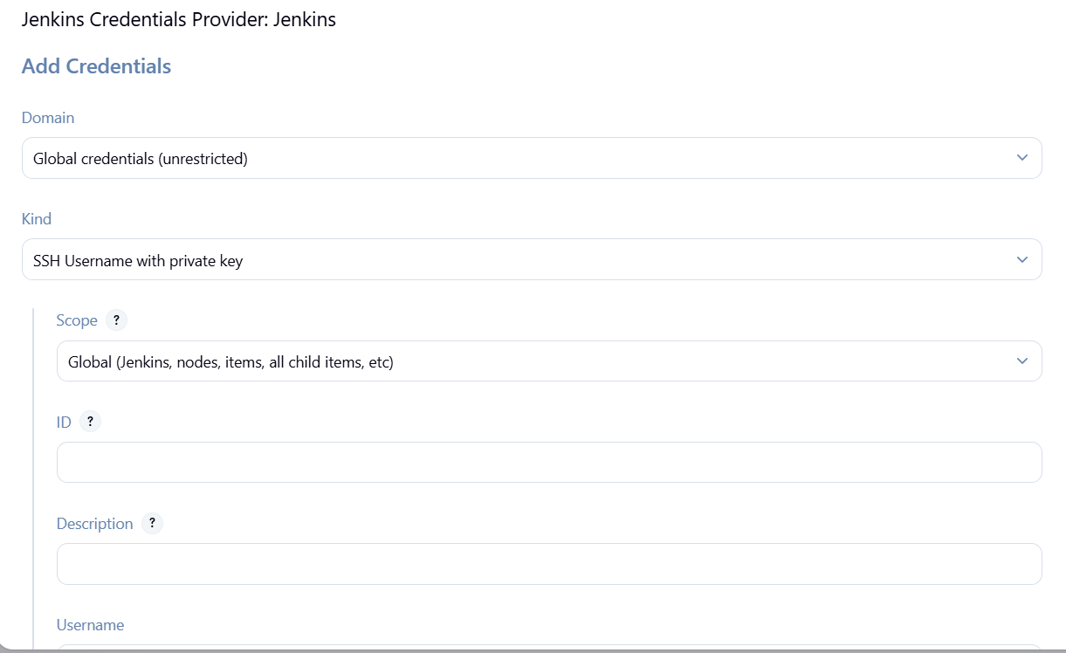
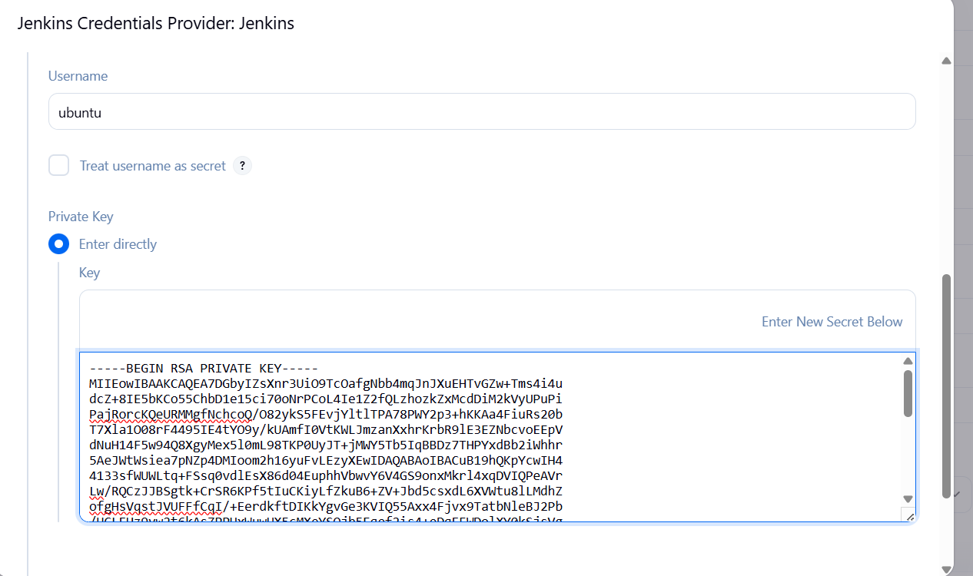
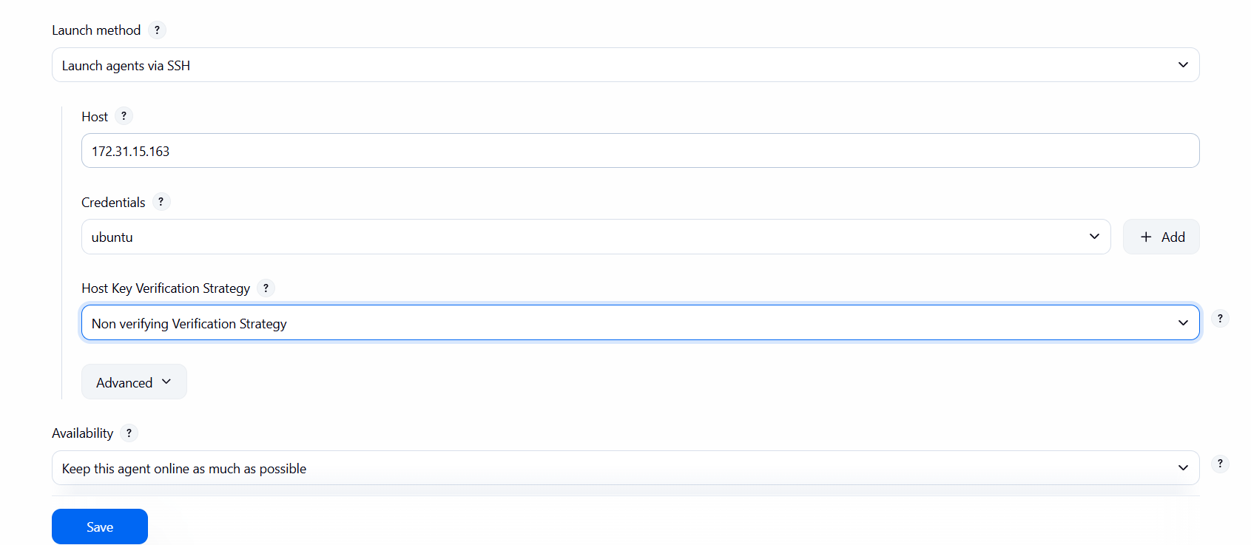
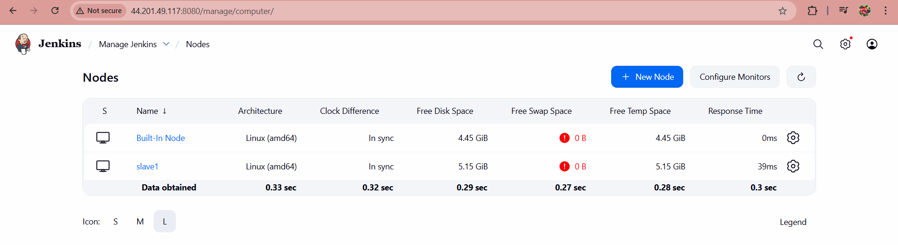

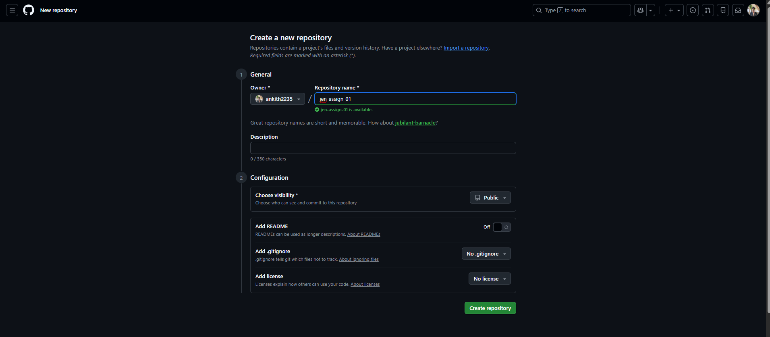
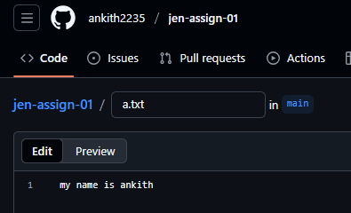

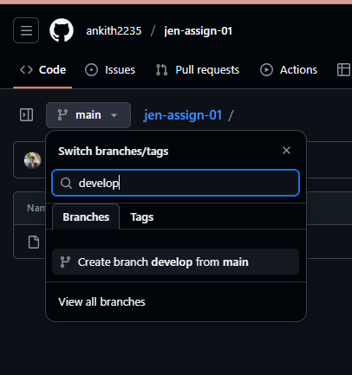

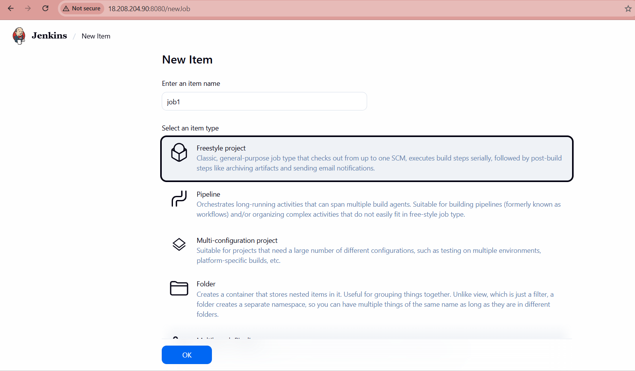
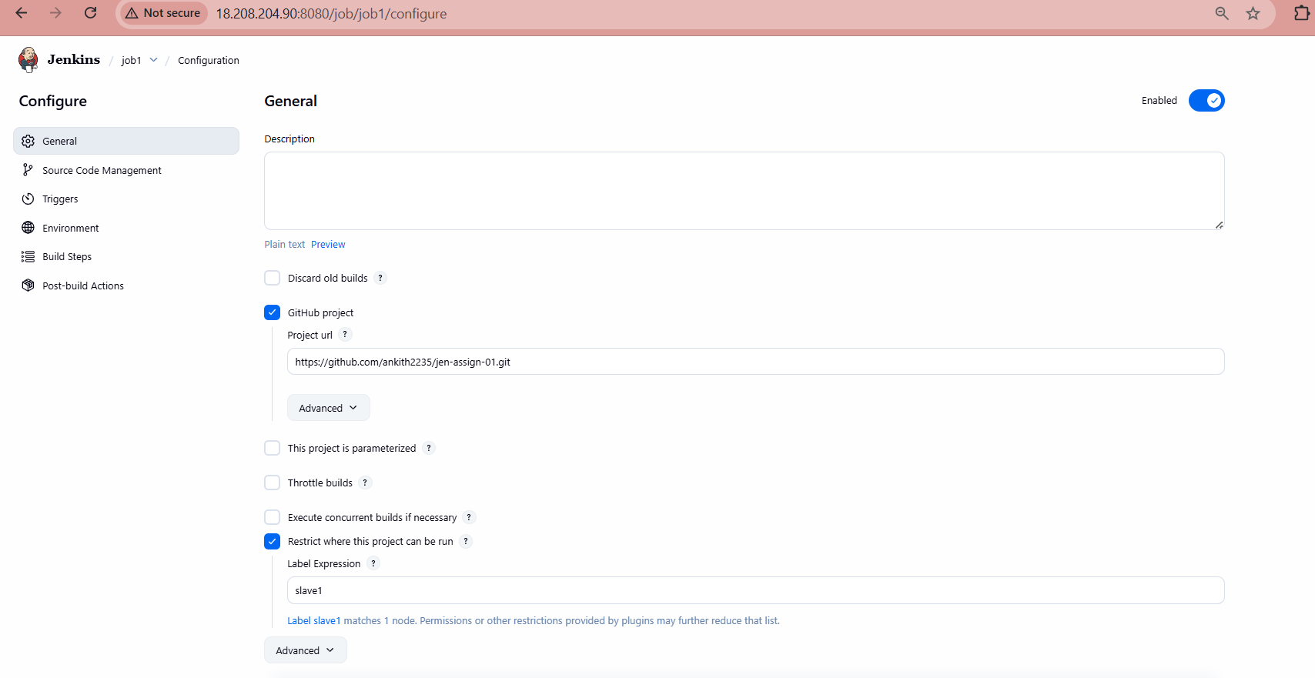

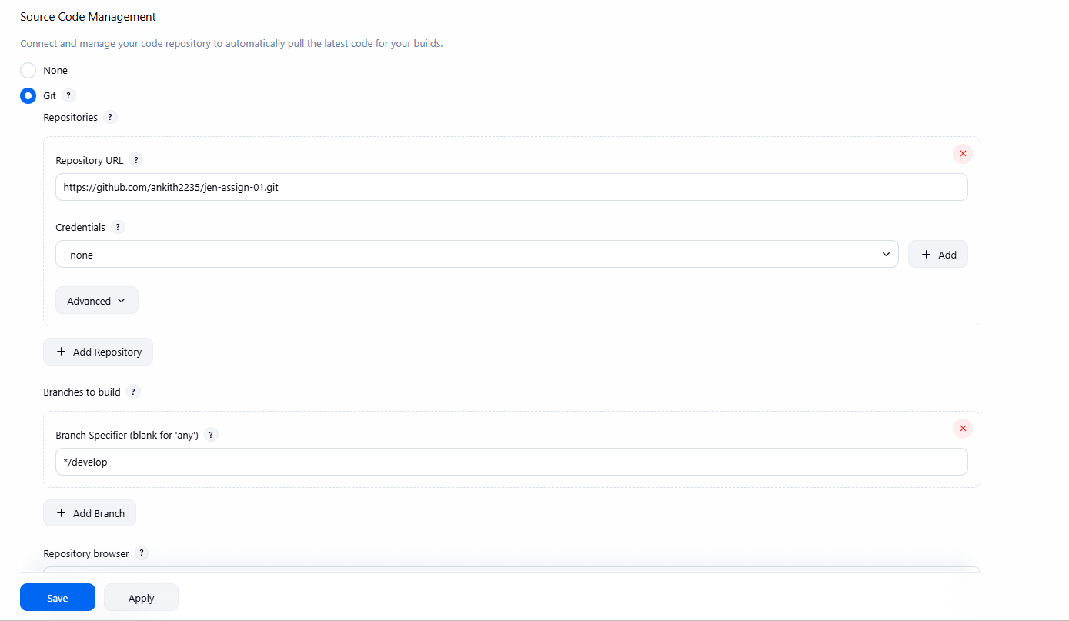

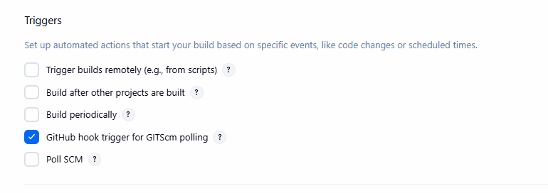
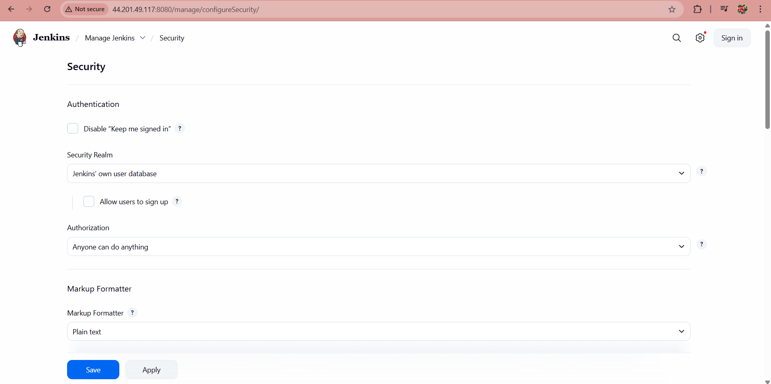
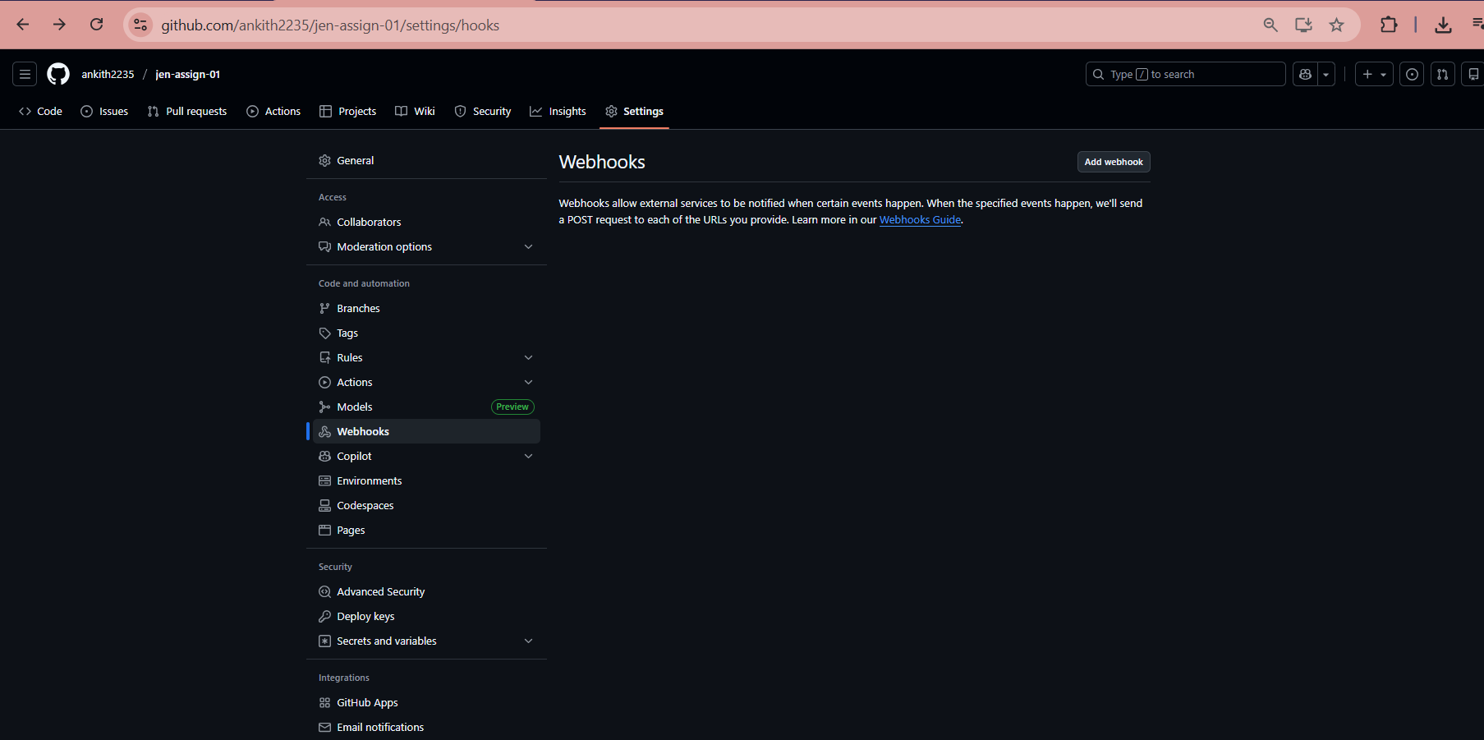

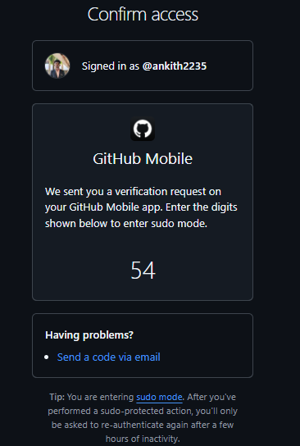

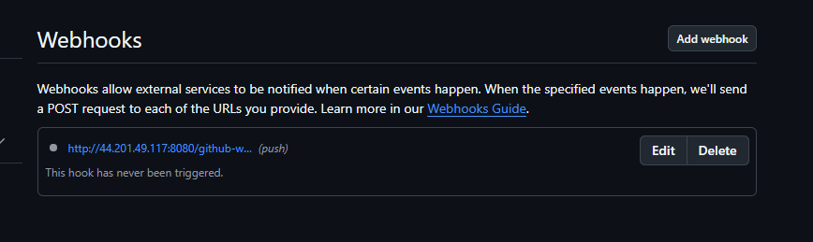

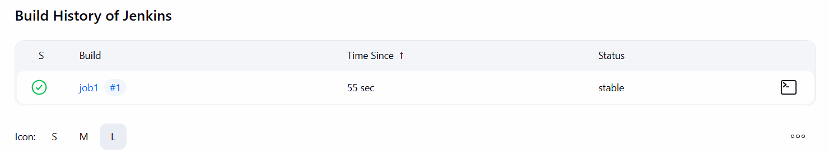

slave1:

ubuntu@ip-172-31-12-104:~$ ls
jenkins
ubuntu@ip-172-31-12-104:~$ cd jenkins
ubuntu@ip-172-31-12-104:~/jenkins$ ls
remoting remoting.jar workspace
ubuntu@ip-172-31-12-104:~/jenkins$ cd workspace
ubuntu@ip-172-31-12-104:~/jenkins/workspace$ ls
job1
ubuntu@ip-172-31-12-104:~/jenkins/workspace$ cd job1
ubuntu@ip-172-31-12-104:~/jenkins/workspace/job1$ ls
a1.txt

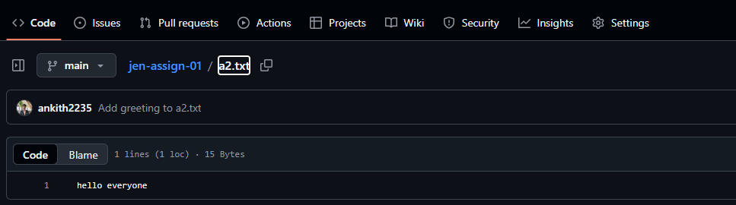

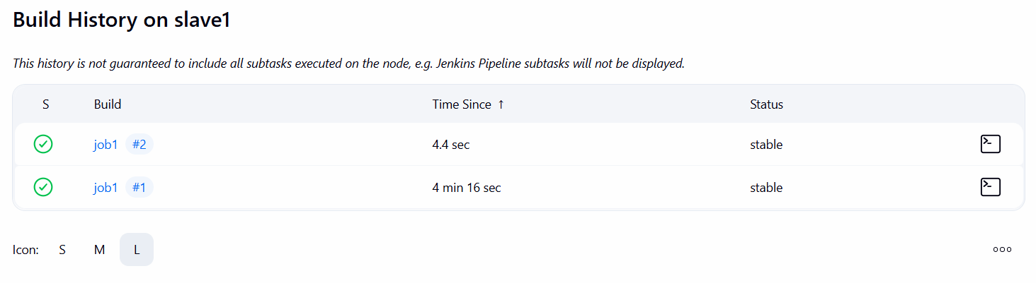

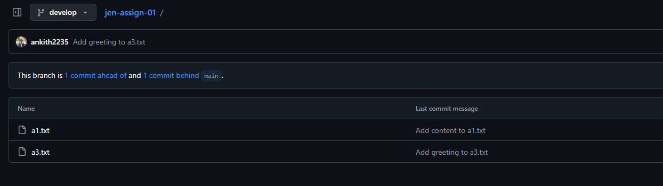

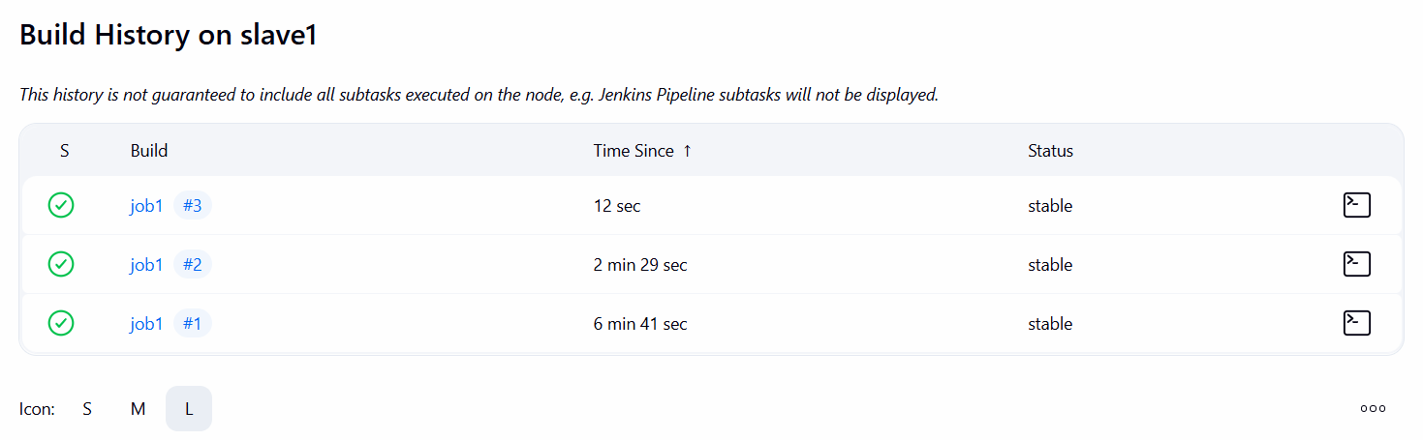
ubuntu@ip-172-31-12-104:~/jenkins/workspace/job1$ ls
a1.txt a3.txt

2)Tasks To Be Performed:
1. Add 2 nodes to Jenkins master
2. Create 2 jobs with the following jobs:
a. Push to test
b. Push to prod
3. Once a push is made to test branch, copy Git files to test server
4. Once a push is made to master branch, copy Git files to prod server

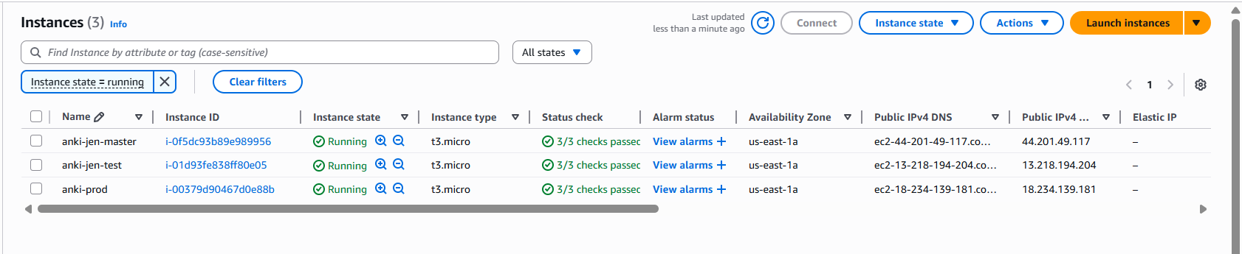
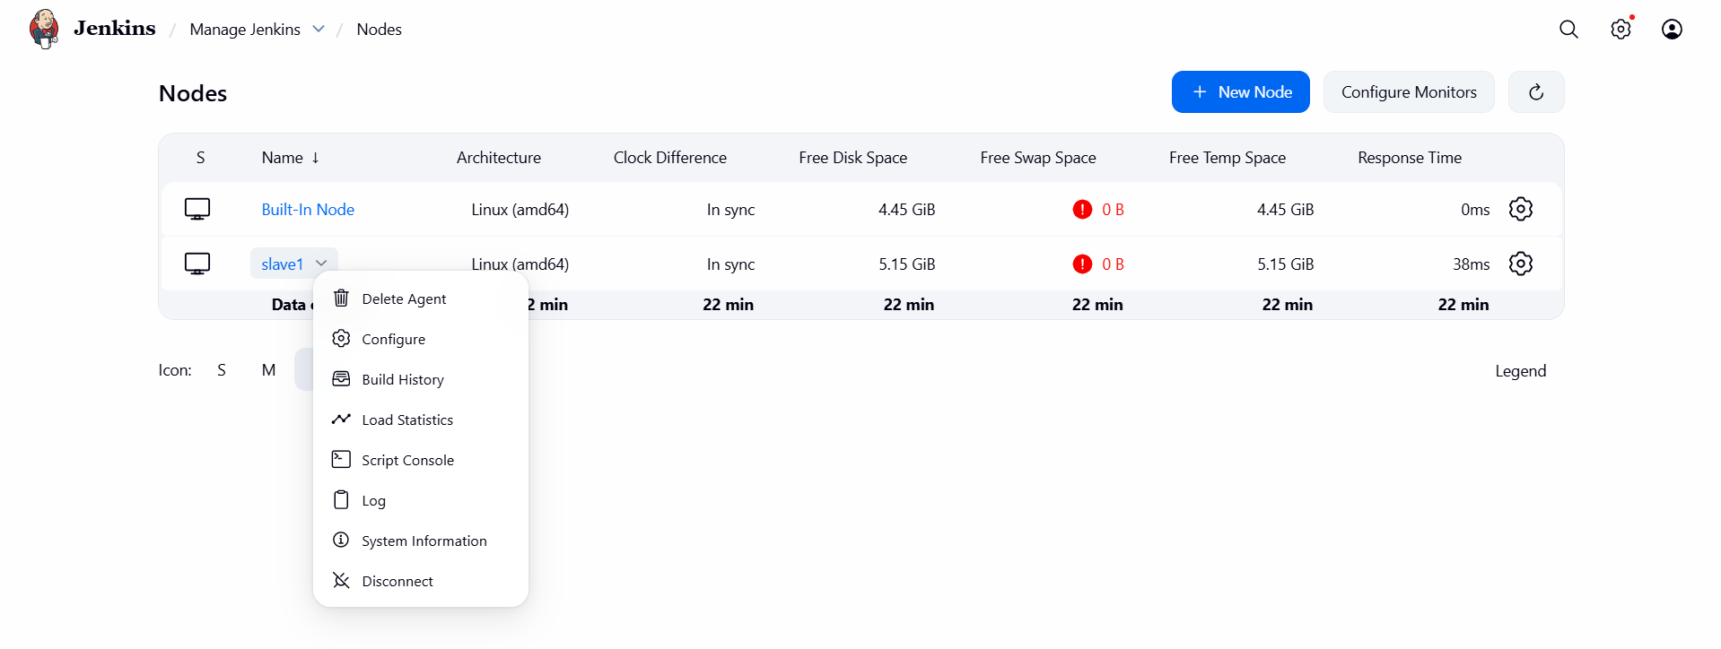
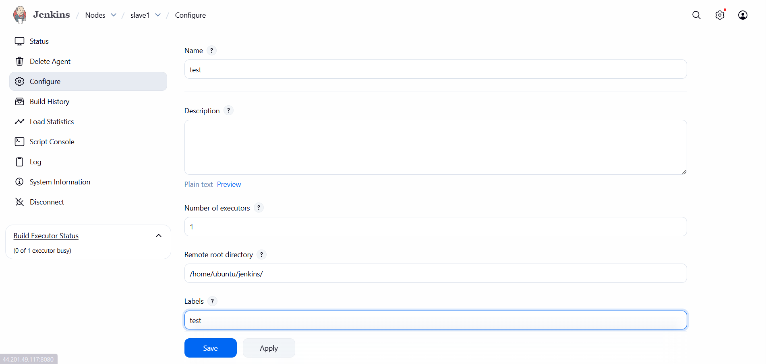

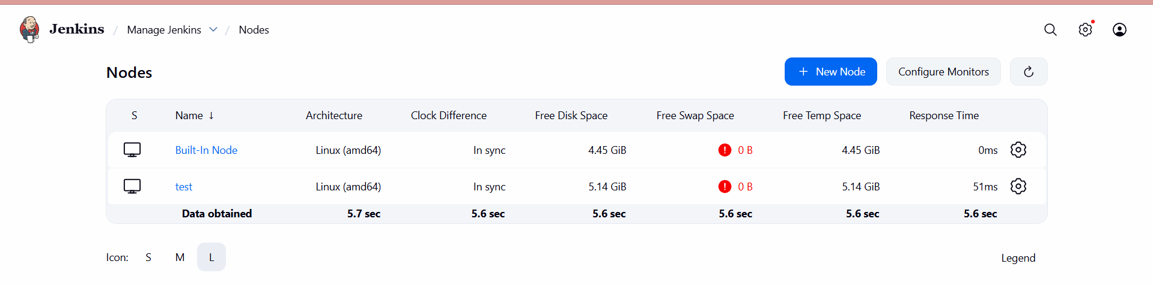
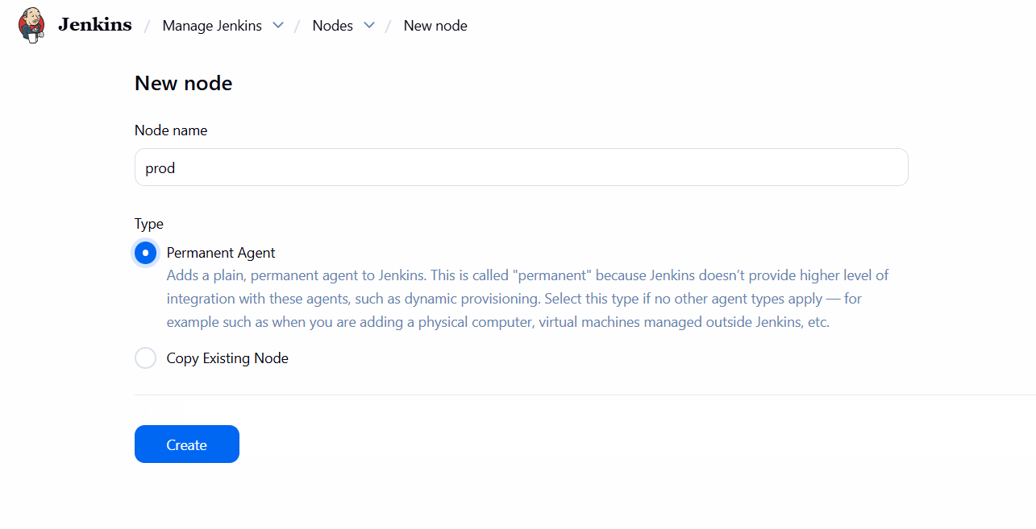
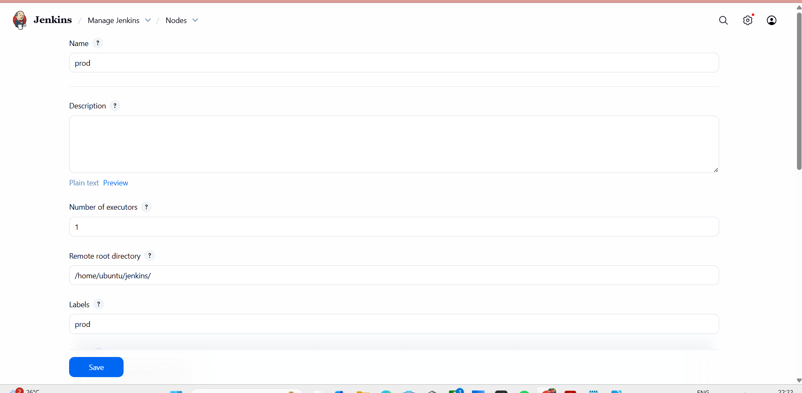

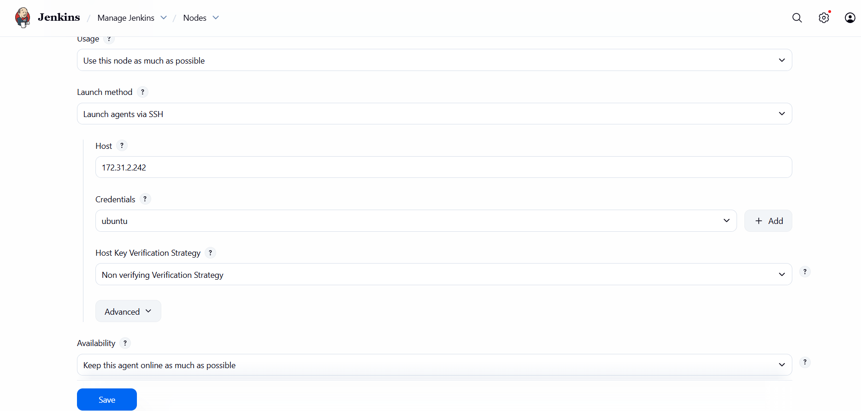
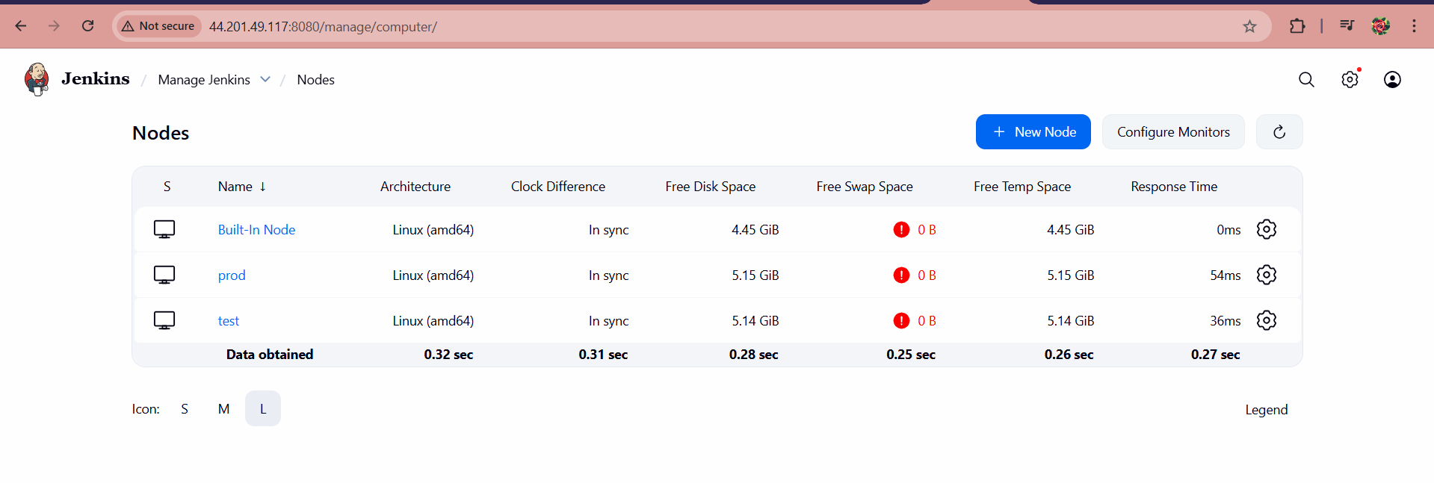
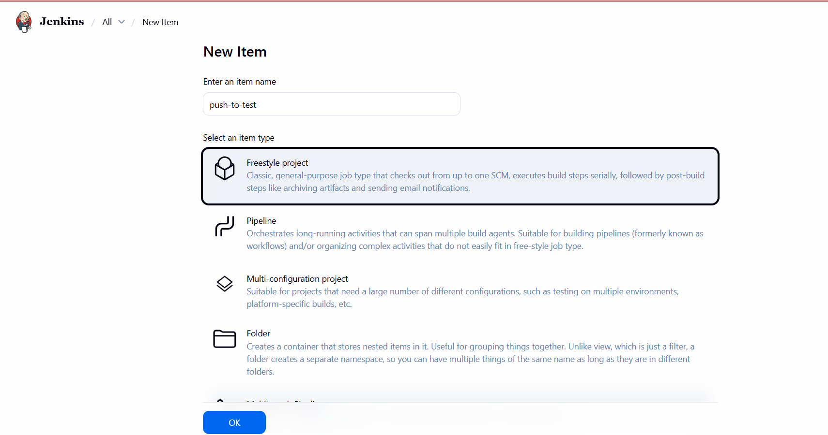

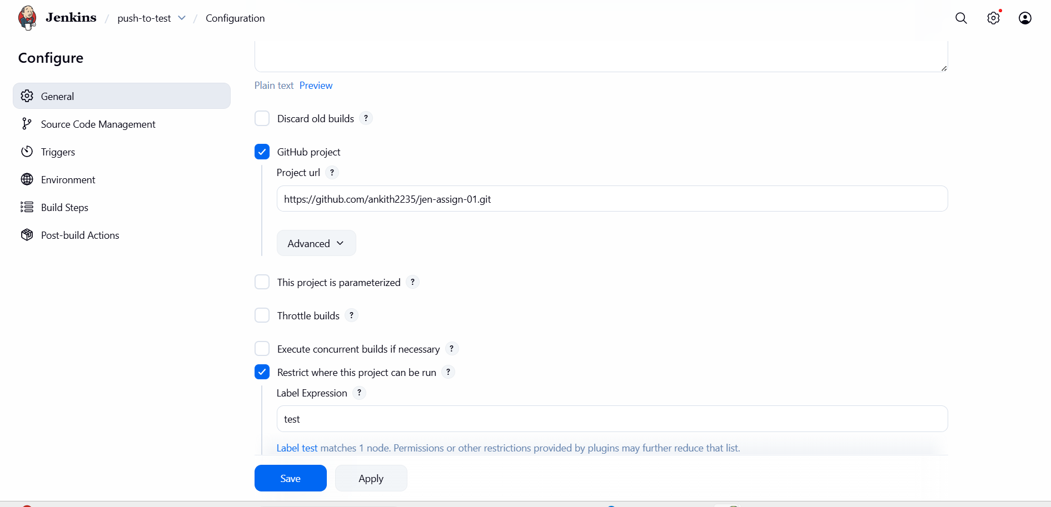

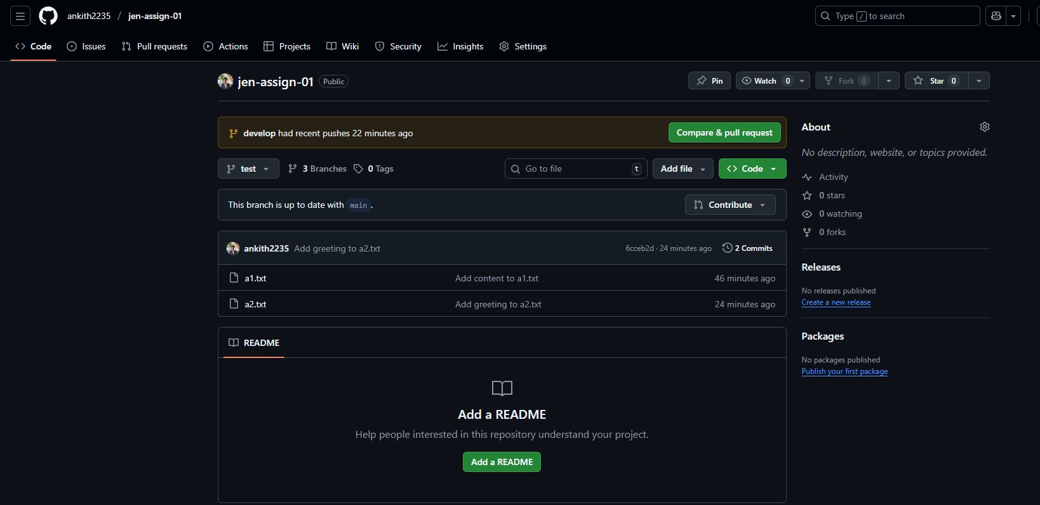
test branch

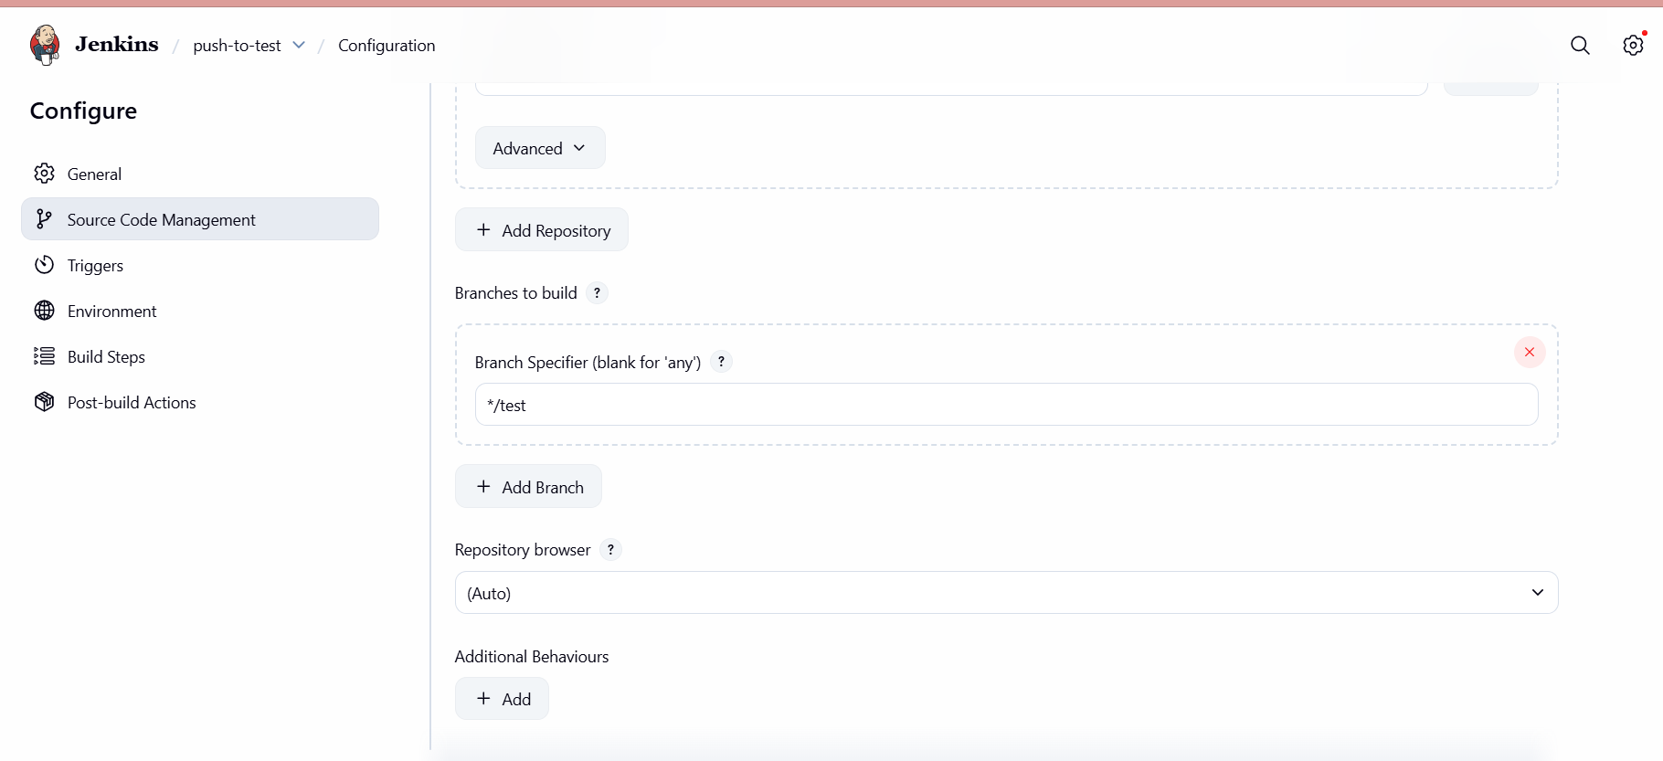
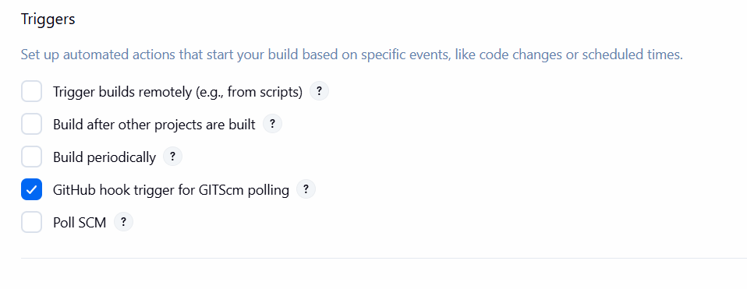
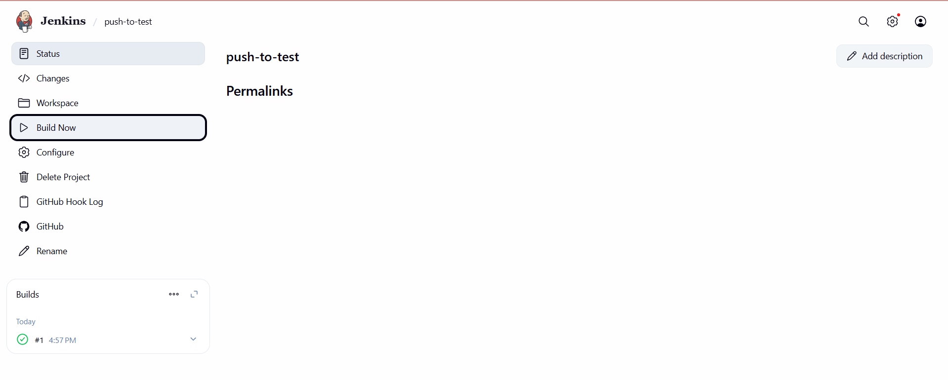
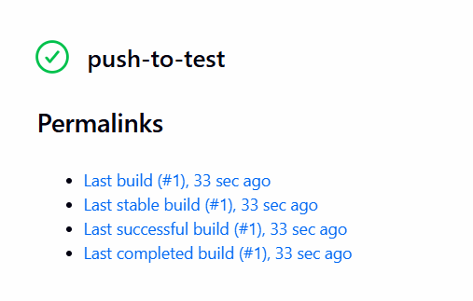
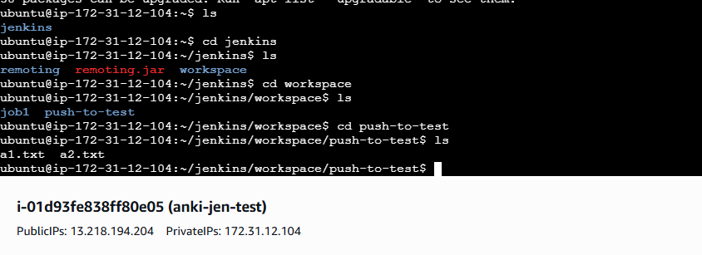
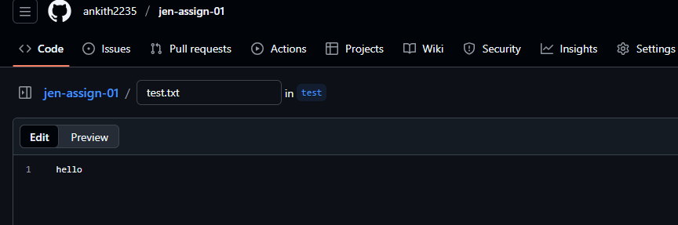
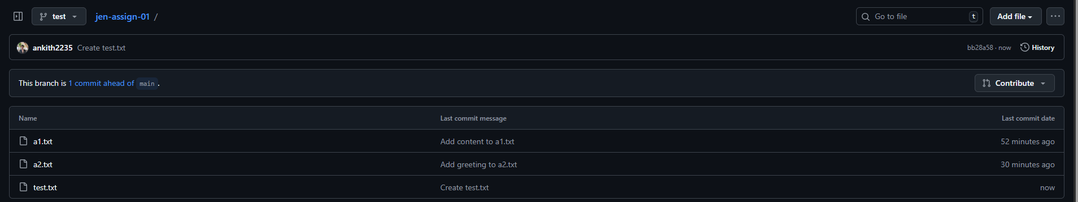
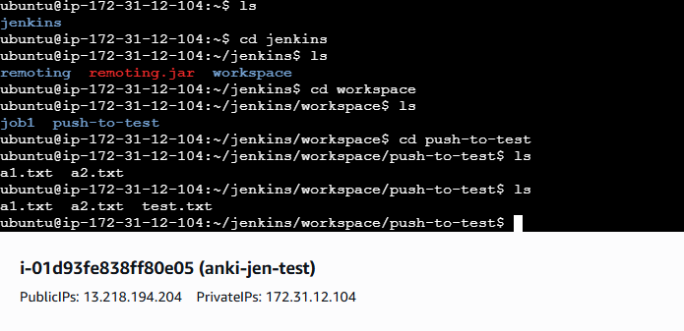
ubuntu@ip-172-31-12-104:~/jenkins/workspace/push-to-test$ sudo cat test.txt
hello

