**Program to implement packet capturing in Python:**

#Packet sniffer in python #For Linux - Sniffs all incoming and outgoing packets :)

import socket, sys

from struct import *

#Convert a string of 6 characters of ethernet address into a dash separated hex string

def eth_addr (a) :

b = "%.2x:%.2x:%.2x:%.2x:%.2x:%.2x" % (ord(a[0]) , ord(a[1]) , ord(a[2]), ord(a[3]), ord(a[4]) , ord(a[5]))

return b

#create a AF_PACKET type raw socket (thats basically packet level)

#define ETH_P_ALL 0x0003 /* Every packet (be careful!!!) */

try:

s = socket.socket( socket.AF_PACKET , socket.SOCK_RAW , socket.ntohs(0x0003))

except socket.error , msg:

print 'Socket could not be created. Error Code : ' + str(msg[0]) + ' Message ' + msg[1]

sys.exit()

x=input("Enter the number of packets you want: ")

count=tcp=icmp=udp=others=0

# receive a packet

while count<x:

packet = s.recvfrom(65565)

packet = packet[0] #packet string from tuple

#parse ethernet header

eth_length = 14

eth_header = packet[:eth_length]

eth = unpack('!6s6sH' , eth_header)

eth_protocol = socket.ntohs(eth[2])

print 'Packet Number: ' + str(count)

count = count+1

print 'Destination MAC : ' + eth_addr(packet[0:6]) + ' Source MAC : ' + eth_addr(packet[6:12]) + ' Protocol : ' + str(eth_protocol)

#Parse IP packets, IP Protocol number = 8

if eth_protocol == 8 :

#Parse IP header

#take first 20 characters for the ip header

ip_header = packet[eth_length:20+eth_length]

#now unpack them :)

iph = unpack('!BBHHHBBH4s4s' , ip_header)

version_ihl = iph[0]

version = version_ihl >> 4

ihl = version_ihl & 0xF

iph_length = ihl * 4

ttl = iph[5]

protocol = iph[6]

s_addr = socket.inet_ntoa(iph[8]);

d_addr = socket.inet_ntoa(iph[9]);

print 'Version : ' + str(version) + ' IP Header Length : ' + str(ihl) + ' TTL : ' + str(ttl) + ' Protocol : ' + str(protocol) + ' Source Address : ' + str(s_addr) + ' Destination Address : ' + str(d_addr)

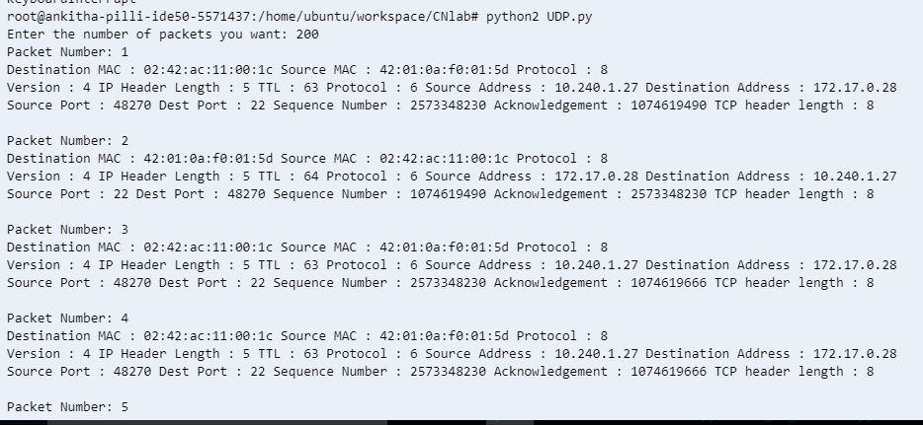

#TCP protocol

if protocol == 6 :

t = iph_length + eth_length

tcp_header = packet[t:t+20]

#now unpack them :)

tcph = unpack('!HHLLBBHHH' , tcp_header)

source_port = tcph[0]

dest_port = tcph[1]

sequence = tcph[2]

acknowledgement = tcph[3]

doff_reserved = tcph[4]

tcph_length = doff_reserved >> 4

print 'Source Port : ' + str(source_port) + ' Dest Port : ' + str(dest_port) + ' Sequence Number : ' + str(sequence) + ' Acknowledgement : ' + str(acknowledgement) + ' TCP header length : ' + str(tcph_length)

tcp=tcp+1

"""h_size = eth_length + iph_length + tcph_length * 4

data_size = len(packet) - h_size

#get data from the packet

data = packet[h_size:]

print 'Data : ' + data"""

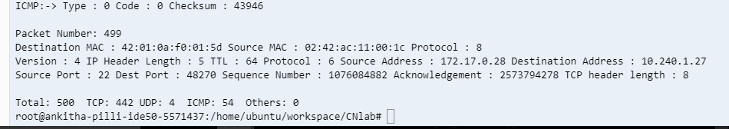

#ICMP Packets

elif protocol == 1 :

u = iph_length + eth_length

icmph_length = 4

icmp_header = packet[u:u+4]

#now unpack them :)

icmph = unpack('!BBH' , icmp_header)

icmp_type = icmph[0]

code = icmph[1]

checksum = icmph[2]

print 'ICMP:-> Type : ' + str(icmp_type) + ' Code : ' + str(code) + ' Checksum : ' + str(checksum)

icmp=icmp+1

"""h_size = eth_length + iph_length + icmph_length

data_size = len(packet) - h_size"""

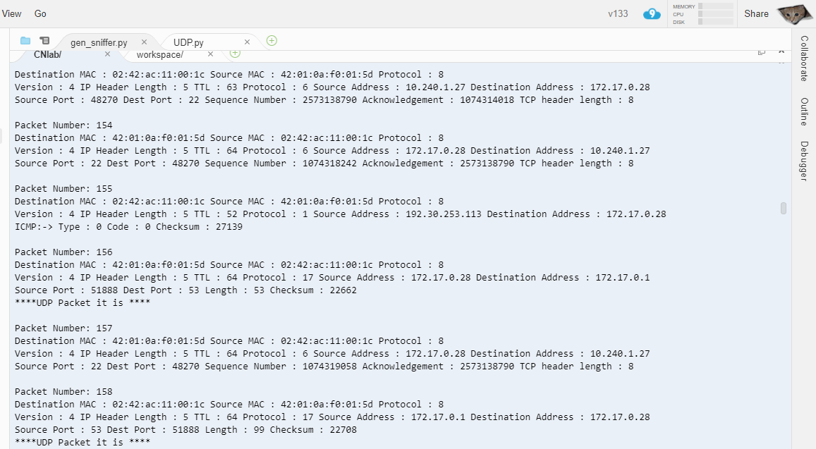

#UDP packets

elif protocol == 17 :

u = iph_length + eth_length

udph_length = 8

udp_header = packet[u:u+8]

#now unpack them :)

udph = unpack('!HHHH' , udp_header)

source_port = udph[0]

dest_port = udph[1]

length = udph[2]

checksum = udph[3]

print 'Source Port : ' + str(source_port) + ' Dest Port : ' + str(dest_port) + ' Length : ' + str(length) + ' Checksum : ' + str(checksum)

udp=udp+1

print '****UDP Packet it is ****'

#some other IP packet like IGMP

else :

print 'Protocol other than TCP/UDP/ICMP'

others=others+1

print

print 'Total: '+str(count)+' TCP: '+str(tcp)+' UDP: '+str(udp)+ ' ICMP: '+str(icmp)+' Others: '+str(others)