ECOMMERCE-MANAGEMENT
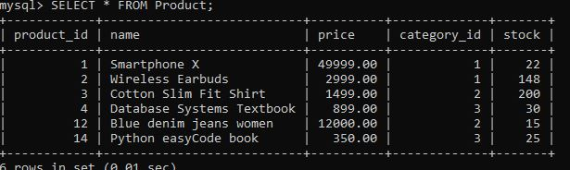
SELECT * FROM Product;
SELECT p.*
FROM Product p
JOIN Category c
ON p.category_id = c.category_id
WHERE c.category_name = 'Electronics';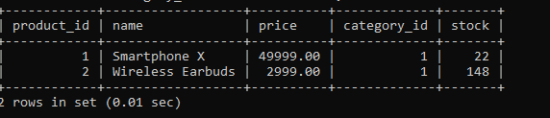
SELECT o.order_id,
o.order_date,
o.total_amount,
c.customer_id,
c.name,
c.email
FROM Orders o
INNER JOIN Customer c
ON o.customer_id = c.customer_id;
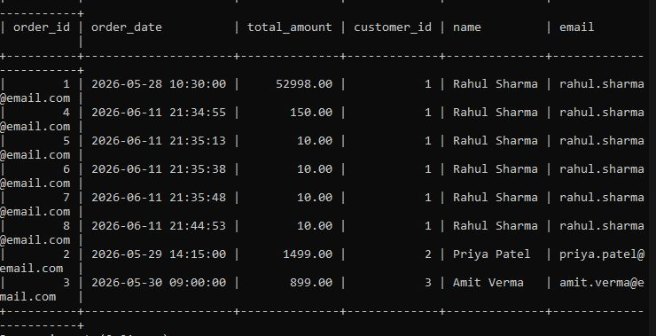
SELECT o.order_id,
c.name AS customer_name,
p.name AS product_name
FROM Orders o
JOIN Customer c
ON o.customer_id = c.customer_id
JOIN OrderDetails od
ON o.order_id = od.order_id
JOIN Product p
ON od.product_id = p.product_id;
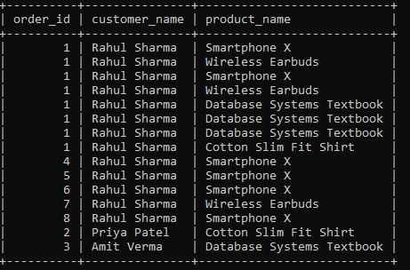
SELECT c.category_name,
COUNT(p.product_id) AS total_products
FROM Category c
LEFT JOIN Product p
ON c.category_id = p.category_id
GROUP BY c.category_name;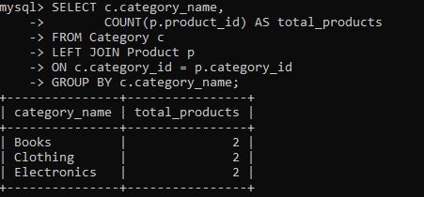
SELECT c.category_name,
COUNT(*) AS total_products
FROM Category c
JOIN Product p
ON c.category_id = p.category_id
GROUP BY c.category_name
HAVING COUNT(*) > 1;
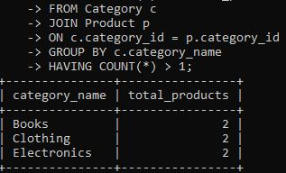
SELECT *
FROM Product
WHERE price >
(
SELECT AVG(price)
FROM Product
);
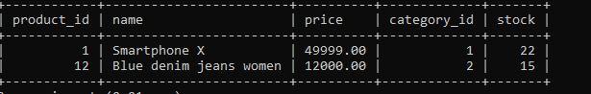
SELECT c.customer_id,
c.name,
o.order_id
FROM Customer c
LEFT JOIN Orders o
ON c.customer_id = o.customer_id;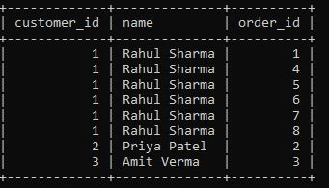
SELECT *
FROM Product p
WHERE NOT EXISTS
(
SELECT *
FROM OrderDetails od
WHERE od.product_id = p.product_id
);
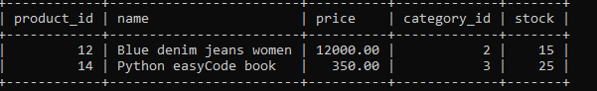
DELIMITER //

CREATE PROCEDURE PlaceOrder(
IN p_customer_id INT,
IN p_product_id INT,
IN p_quantity INT
)
BEGIN

DECLARE v_price DECIMAL(10,2);
DECLARE v_order_id INT;

SELECT price
INTO v_price
FROM Product
WHERE product_id = p_product_id;

INSERT INTO Orders(
customer_id,
order_date,
total_amount
)
VALUES(
p_customer_id,
CURDATE(),
v_price * p_quantity
);

SET v_order_id = LAST_INSERT_ID();

INSERT INTO OrderDetails(
order_id,
product_id,
quantity,
price
)
VALUES(
v_order_id,
p_product_id,
p_quantity,
v_price
);

END //

DELIMITER ;
CALL PlaceOrder(1,2,3);
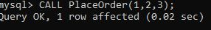
DELIMITER //

CREATE PROCEDURE GenerateInvoice(
IN p_order_id INT
)
BEGIN

SELECT o.order_id,
c.name AS customer_name,
p.name AS product_name,
od.quantity,
od.price,
(od.quantity * od.price) AS amount
FROM Orders o
JOIN Customer c
ON o.customer_id = c.customer_id
JOIN OrderDetails od
ON o.order_id = od.order_id
JOIN Product p
ON od.product_id = p.product_id
WHERE o.order_id = p_order_id;

END //

DELIMITER ;
CALL GenerateInvoice(1);
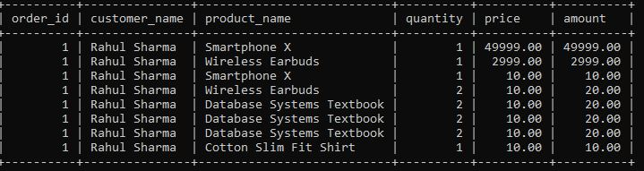
DELIMITER //

CREATE TRIGGER ReduceStock
AFTER INSERT ON OrderDetails
FOR EACH ROW
BEGIN

UPDATE Product
SET stock = stock - NEW.quantity
WHERE product_id = NEW.product_id;

END //

DELIMITER ;

DELIMITER //

CREATE TRIGGER CheckStock
BEFORE INSERT ON OrderDetails
FOR EACH ROW
BEGIN

DECLARE available_stock INT;

SELECT stock
INTO available_stock
FROM Product
WHERE product_id = NEW.product_id;

IF available_stock < NEW.quantity THEN

SIGNAL SQLSTATE '45000'
SET MESSAGE_TEXT = 'Insufficient Stock';

END IF;

END //

DELIMITER ;

