**ABSTRACT**

The Expense Tracking Database Management System DBMS project is a user-friendly application that allows an unlimited number of users to register, log in, and efficiently manage their personal expenses across diverse categories. Users have the flexibility to add, view, and delete expenses, providing a seamless experience for tracking their financial activities. The system also empowers users to manage expenses by sorting them based on months and categories, facilitating a clear overview of their spending habits. Moreover, the DBMS generates detailed expense reports on a daily, monthly, and yearly basis, assisting users in making informed financial decisions. This project simplifies expense tracking and enhances financial management for users of all backgrounds

**Technological Stack:**

Backend:Javascript ,PHP for database connectivity.

Database:MySQL or similar relational database management system

Frontend:CSS is used for styling,HTML for structuring web page.

**E-R DIAGRAM**

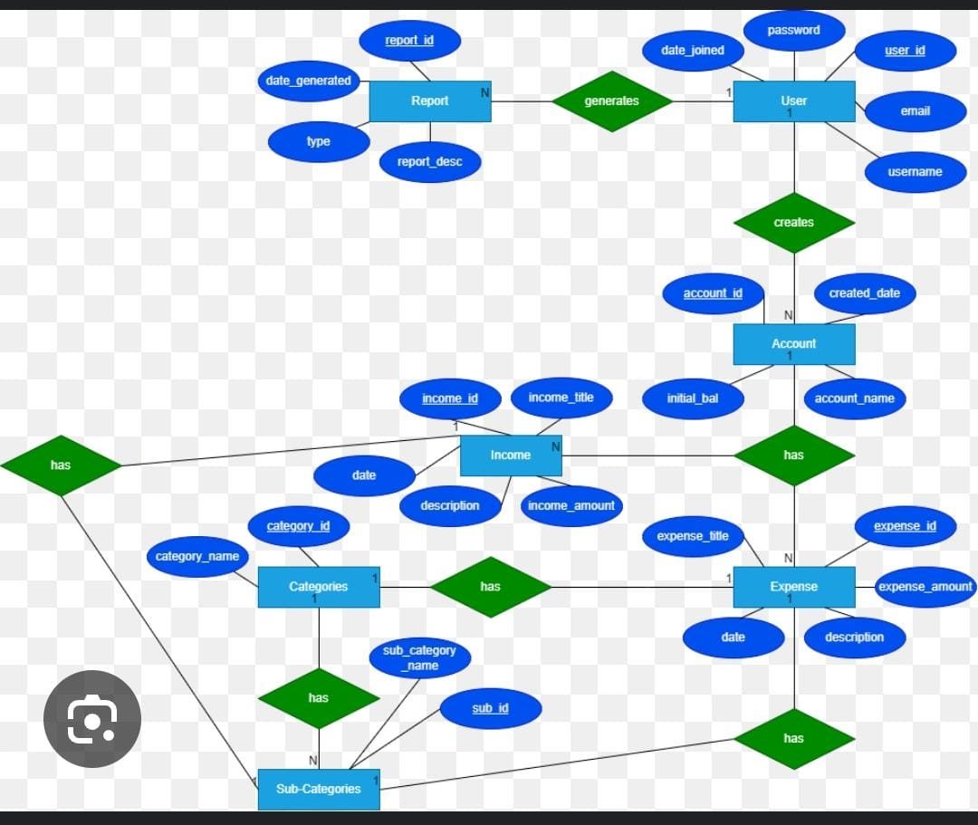

**Schema-Diagram**

**Report**

|  |  |  |  |
| --- | --- | --- | --- |
| Report_id | Report_desc | type | Date_generated |

**User**

|  |  |  |  |  |
| --- | --- | --- | --- | --- |
| id | email | Username | password | Date_joined |

**Account**

|  |  |  |  |
| --- | --- | --- | --- |
| Account_id | Account_name | Initial_bal | Created_date |

**Income**

|  |  |  |  |  |
| --- | --- | --- | --- | --- |
| id | Income_title | date | Income_amt | description |

**Expense**

|  |  |  |  |  |
| --- | --- | --- | --- | --- |
| Expense_id | Expense_title | Expense_amt | date | description |

**Categories**

|  |  |
| --- | --- |
| Category_id | Category_name |

**Subcategories**

|  |  |
| --- | --- |
| subcategory_id | subcategory_name |