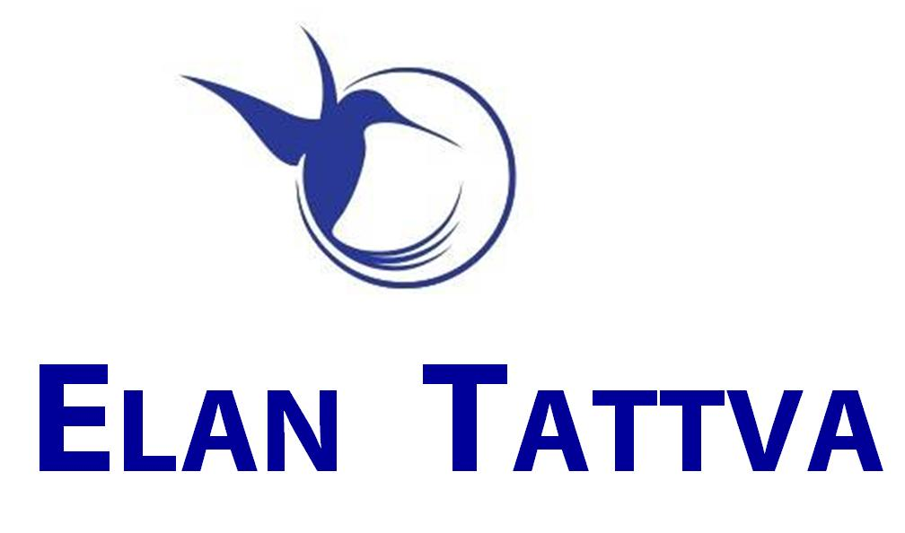



f
A Journey of Insights & Illumination
Set and Pursue 3 Inspiring Primary Goals
+ 4 to 7 Secondary goals

Fully Self-Driven approach
Your Coach is an enabling catalyst.
Get your Coach to support you as an Accountability Partner during the execution phase
Coaching Journey runs parallel to 12 weeks of the Crucial Phase of Actions/Execution of your Most Important Goals. Thereby ensuring a great Support Framework in the Action Phase.

Coaching Processes to tackle limiting patterns/habits & ‘unresourceful’ routines
Highly Practical & Innovative Approach to Planning (with NLP Time-based techniques)
Mind Programming, Creative Visualization

Bonus (Optional):
Personal Stress Profile Analysis to identify your Stress Susceptibility Factors, Coping Strategies & Support System

Sign Up in Nov 2013 & Avail Attractive Rates!!!
Big Increase in Prices from
Dec 2013!!!
One2One EXEC & Life Coaching

The One2One Coaching Engagement typically takes 12 weeks. Work in partnership with your coach to develop & execute highly effective plans, empowering habits & routines to achieve your cherished goals.

• Highly Powerful Goal Mining & Refining
• Week by Week Structured Action Plans &
Thorough Follow-up for your 3 Inspiring Goals
• Coaching Conversations to elicit the most apt
& Actionable Insights
• Review, Refine & Polish your
Daily TIME STRUCTURE
• STRATEGIES for Highly Effective Actions
• Identify STRATEGIES to overcome limitations
& get rid of negative patterns & inhibitors
• Structured VISIONING process for your most
Audacious Goals

Make the Shift & reach your TRUE POTENTIAL

Powerful & Practical
Call → 99722 97259; Email → elantattva@gmail.com; Website → http://www.elantattva.com
Session1 is Free: Know, Explore & Decide
Call & Book Your Free Session1

