

**Barcode Detection**

**COURSE :** Digital Image Processing

**COURSE ID** **:** CS333

**TEAM MEMBERS :** G Vinay (2112001)

G AnkithKumar (2112088)

Amisha Singh (2112100)

**Chapter 1: Introduction**

**1.1 Introduction to Barcode Detection Project**

In today’s fast-paced world, barcodes are an essential component of various industries, from retail and logistics to healthcare and manufacturing.

These machine-readable codes contain vital information that can be quickly and accurately processed, making them a key tool for inventory management, product tracking, and point-of-sale systems. As technology advances, the ability to detect and read barcodes accurately has become even more crucial.

This project aims to design and implement a system that can efficiently detect barcodes. This project explores the fundamentals of barcode technology, including common detection algorithms, and practical applications in real-world scenarios.

**1.2 Need For Barcode Detection**

Barcode detection is a fundamental need for accurate, efficient, and reliable data capture in today's interconnected world, driving improvements in productivity, visibility, and customer satisfaction across diverse industries. Here are key reasons highlighting the significance of barcode detection:

**Efficiency:** Barcode detection streamlines processes by automating data entry tasks. It allows for rapid identification and tracking of items, reducing the time and effort required for inventory management, retail checkout, and other logistical operations.

**Inventory Management:** Barcodes enable precise tracking of inventory levels, facilitating timely replenishment of stock and reducing instances of stockouts or overstocking.

**Product Traceability:** In industries such as food and pharmaceuticals, product traceability is paramount for quality control and compliance with regulatory standards. Barcode detection enables quick and accurate identification of products throughout the supply chain, aiding in recalls and quality assurance processes.

**Customer Experience:** Efficient barcode detection enhances the customer experience by expediting checkout processes and minimizing wait times. It enables retailers to provide faster service, leading to higher customer satisfaction and loyalty.

**Data Analysis:** Barcode data serves as a valuable source of business intelligence, allowing organizations to analyse sales trends, monitor inventory turnover rates, and optimize pricing strategies.

**Integration with Technology:** Barcode detection complements emerging technologies such as mobile devices, IoT sensors, and cloud computing. It enables seamless integration with digital platforms, enhancing connectivity and interoperability in smart environments.

**Chapter 2: Approach**

**2.1 Aim of the project**

The goal of barcode detection is to create a comprehensive solution that enhances the capabilities of digital image processing in barcode-related applications in industries that rely on barcode technology.

This project aims to detect barcodes in digital images. This involves analysing image patterns, identifying distinct barcode features, and applying techniques like edge detection, segmentation, and pattern recognition to accurately locate barcodes within complex scenes.

**2.2 Scope of the project**

The scope of the Barcode Detection Project encompasses a range of components and applications, focusing on the development, implementation, and testing of a barcode detection system. Below is a detailed outline of the project's scope:

**1.Barcode Formats and Variants:**

Address detecting wide range of barcode types, including 1D (linear) barcodes like UPC, EAN, and Code 128.

**2.Image Processing Techniques:**

**a.** Use digital image processing methods for robust barcode detection. This includes techniques like edge detection, segmentation, and feature extraction to isolate barcodes within an image.

**b.** Implement preprocessing methods to enhance image quality and improve detection accuracy, focusing on issues like noise, lighting variations, and geometric distortions.

**3.Real-Time Processing:**

**a.** Focus on real-time barcode detection capabilities, particularly for applications in retail, logistics, and manufacturing, where quick response times are crucial.

**b.** Ensure the system can handle high-throughput environments with large volumes of barcode data.

**4.Applications and Use Cases:**

**a.** Explore various real-world applications for barcode detection, including retail, logistics, inventory management, healthcare, and manufacturing.

**b.** Define specific use cases to demonstrate the system's effectiveness in different environments and industries.

**5.Testing and Validation:**

**a.** Conduct comprehensive testing to ensure accuracy, reliability, and robustness. This includes tests in varying conditions to validate performance.

**b.** Implement quality assurance measures to ensure compliance with industry standards and best practices.

**Chapter 4: Implementation**

* 1. **Functions and their execution:**

1. **Image_to_gray function:**

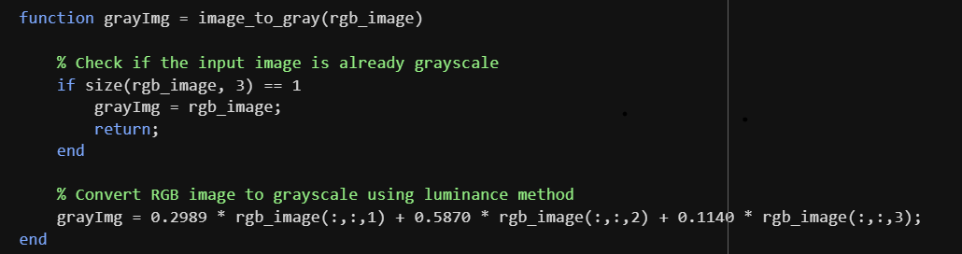

The **image_to_gray** function converts an RGB image to grayscale. If the image is already grayscale (with one channel), it returns the same. Otherwise, it converts the RGB image to grayscale using the luminance method. This method applies specific weights to the Red (0.2989), Green (0.5870), and Blue (0.1140) channels to reflect human perception of brightness, and then sums them to get the grayscale values.

The output is a 2D grayscale image.

1. **compute_gradients function:**

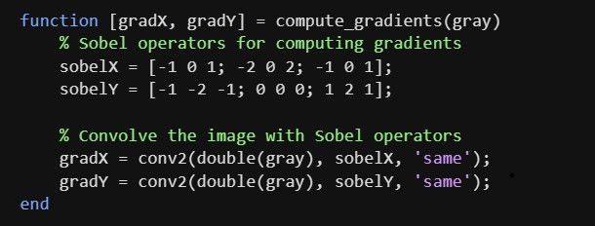

The **compute_gradients** function calculates the gradients in the X and Y directions from a grayscale image. It uses the Sobel operators for this purpose:

**sobelX** and **sobelY** are 3x3 convolutional kernels that compute horizontal and vertical gradients, respectively.

SobelX: [-1 0 1] SobelY: [-1 -2 -1]

[-2 0 2] [ 0 0 0]

[-1 0 1] [ 1 2 1]

The function then uses **conv2** to convolute the grayscale image with these Sobel operators, yielding gradX for horizontal gradients and gradY for vertical gradients. It returns these two gradient matrices, which indicate how pixel intensities change in the X and Y directions.

1. **binarize_image function:**

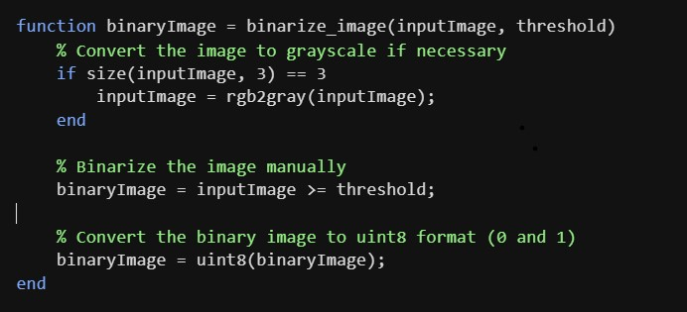

The **binarize_image** function converts an image to a binary (black and white) format based on a given threshold.

* If the inputImage is in RGB format (with three color channels), the function first converts it to grayscale.
* It then applies the given threshold to binarize the grayscale image, pixels with intensity values greater than or equal to the threshold(225 here) are set to 1 (white), while those below the threshold are set to 0 (black).
* Finally, it converts the binary image to uint8 format for compatibility, ensuring the pixel values are either 0 or 1.

1. **create_rectangular_se function:**

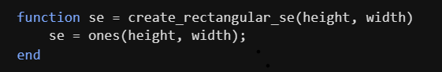

The **create_rectangular_se** function creates a rectangular structuring element, which is used in image processing for morphological operations like erosion and dilation.

The function takes in height and width, specifying the size of the rectangular structuring element. It returns a 2D matrix (se) of ones with the specified height and width.

This rectangular structuring element can be used to define the shape and size for morphological operations in image processing.

1. **dilate_image function:**

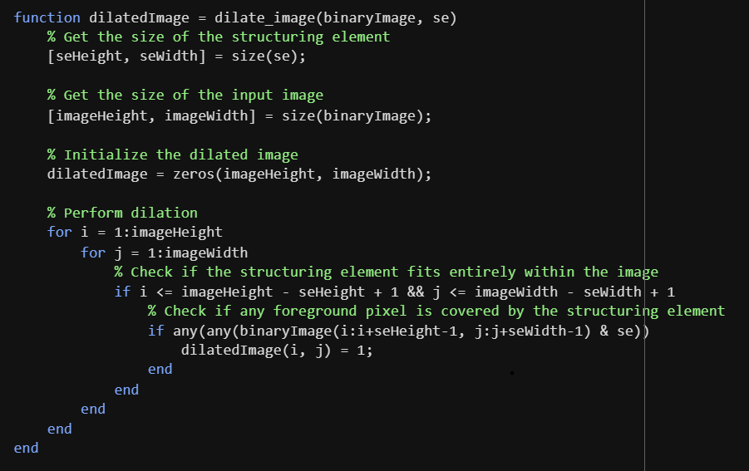

The **dilate_image** function applies morphological dilation to a binary image using a specified structuring element (se).

**Parameters**: It takes a binary image (binaryImage) and a structuring element (se).

**Process**:

* The function initializes an empty dilatedImage of the same size as binaryImage.
* It iterates through each pixel of binaryImage, checking whether the structuring element overlaps with any white (foreground) pixels.
* If it does, the corresponding pixel in dilatedImage is set to 1 (white), indicating that the region has been "dilated."

**Output**: The result is a dilatedImage, where areas around white pixels are expanded based on the size and shape of the structuring element.

1. **connected_components function:**

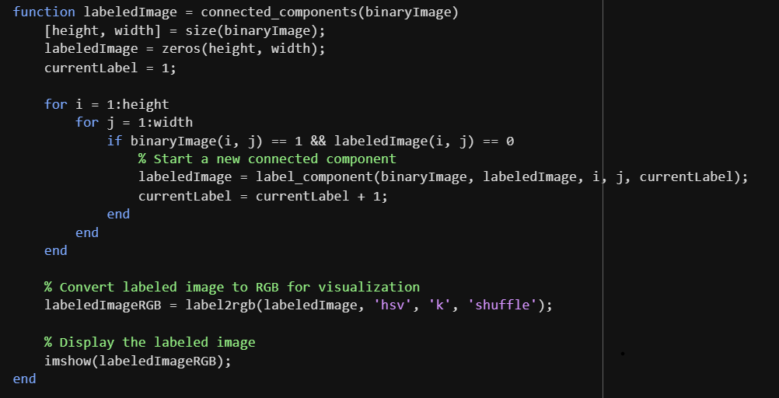

The **connected_components** function identifies and labels connected components in a binary image, then displays them in an RGB format for easy visualization.

**Input**: A binary image (binaryImage) where 1 represents foreground (white) and 0 represents background (black).

**Process**:

* Initialize labeledImage with zeros and set currentLabel to 1.
* Loop through each pixel in binaryImage.
* If a white pixel has not yet been labeled, it indicates a new connected component.
* Call label_component to assign currentLabel to this connected component and all its adjacent white pixels.
* Increment currentLabel for the next distinct component.
* Convert labeledImage to RGB with label2rgb, and display it with imshow function.
* This process visually distinguishes connected regions in a binary image, providing clear separation among components.

**Output**: A labeledImage with unique labels for each connected component, and a color-coded RGB visualization (labeledImageRGB).

1. **label_component function:**

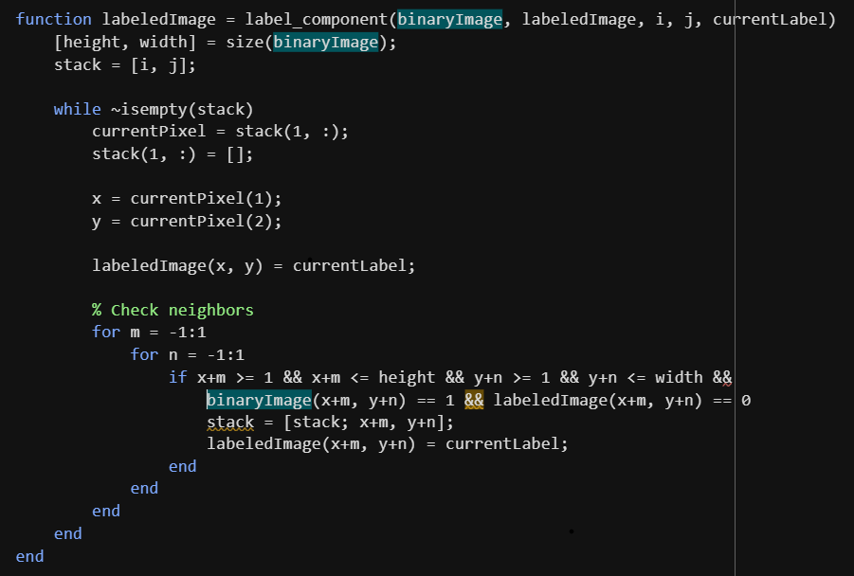

The **label_component** function labels all pixels in a connected component within a binary image, starting from a specified point. It uses a depth-first search approach to explore and mark adjacent foreground pixels.

**Input Parameters**:

* binaryImage: A 2D array where 1 represents foreground (white) and 0 represents background (black).
* labeledImage: A 2D array used to store labels for connected components.
* i, j: Coordinates of the starting pixel.
* currentLabel: The label assigned to the connected component.

**Process**:

* Initialize a stack with the starting pixel (i, j).
* While the stack is not empty, pop the top pixel to process it.
* Assign currentLabel to this pixel in labeledImage.
* Check all 8 neighbors (including diagonals) of the current pixel.
* If a neighbor is within bounds, is part of the foreground (binaryImage value of 1), and is not yet labeled, push it onto the stack and assign the current label to it.

**Output**:

labeledImage, with all pixels in the connected component labeled with currentLabel.

This approach effectively labels all pixels in a connected component, allowing further operations like identifying distinct regions in a binary image.

* 1. **Results:**

**Input-1: Output-1:**

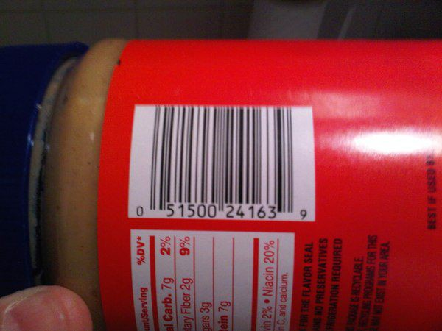 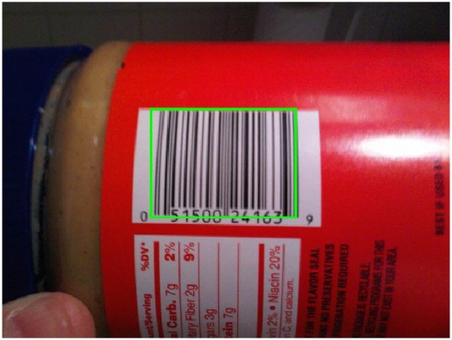

**Input-2:** **Output-2:**

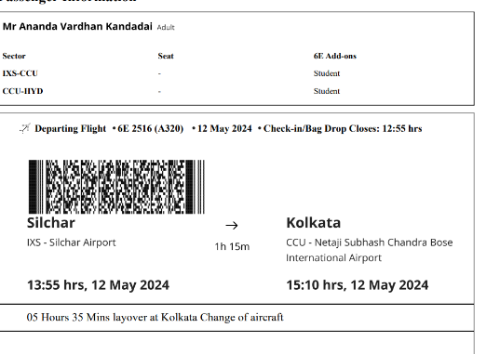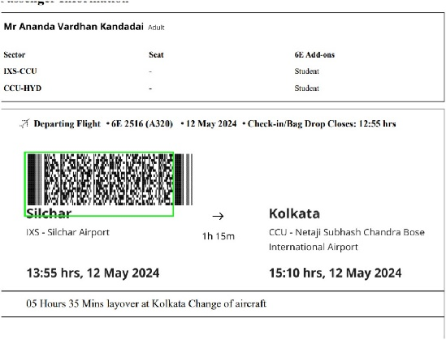

**Input-3:** **Output-3:**

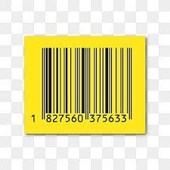 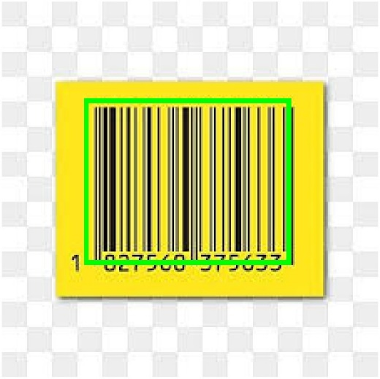

**Input-4:** **Output-4:**

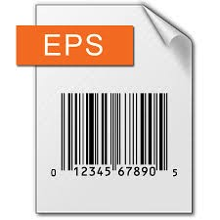 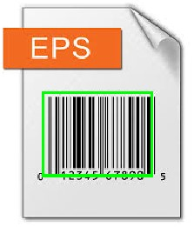

**Input-5:** **Output-5:**

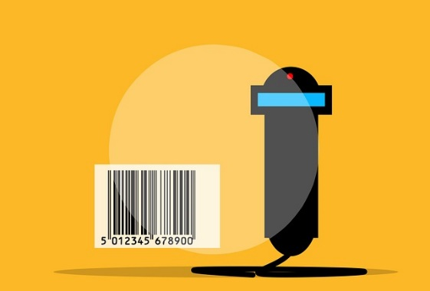 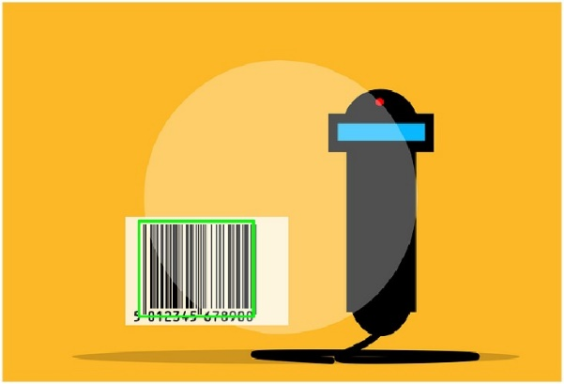

**Input-6:** **Output-6:**

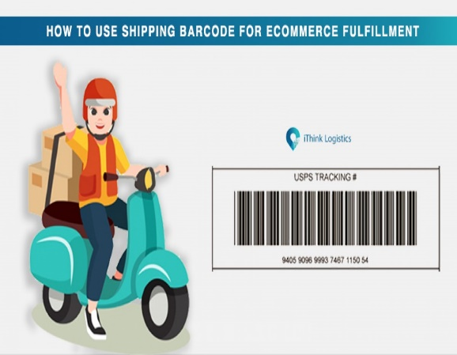 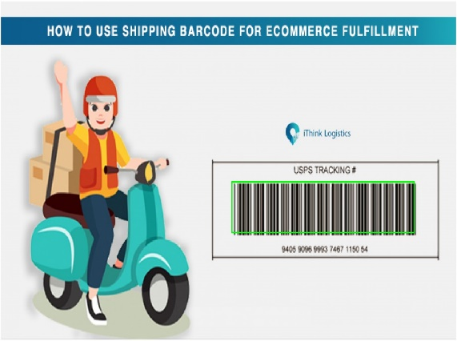

**Input-7:** **Output-7:**

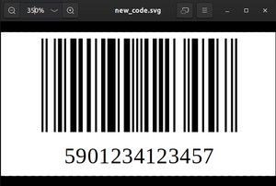 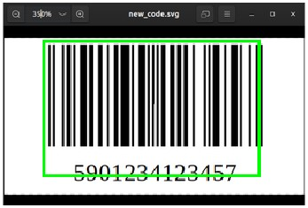

**5. Conclusion:**

The system reliably detected barcodes despite variations in lighting, orientation. The algorithms used were fast enough to enable real-time applications in environments like retail and logistics. The approach worked with different barcode formats, suggesting wide-ranging industrial applicability.

The barcode detection project using digital image processing successfully demonstrated the ability to detect barcodes from digital images with high accuracy.