Experiment 1: Design and Implement a Structured Linux Project Workspace
Source Code
#!/usr/bin/env bash
set -e
PROJECT="${1:-LinuxProject}"
mkdir -p "$PROJECT"/{src,bin,logs,data,docs}
cat > "$PROJECT/README.txt" <<'EOF'
Linux Systems Programming practical workspace
Folders: src, bin, logs, data, docs
EOF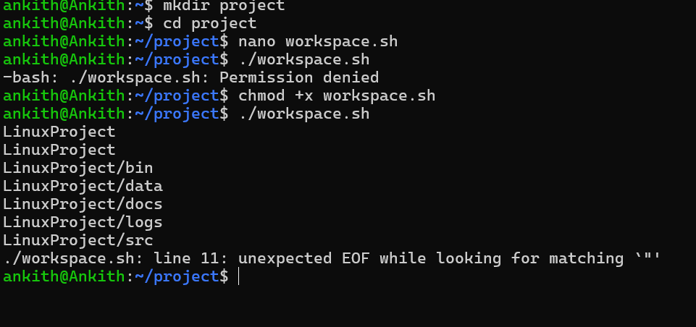
printf '%s\n' "$PROJECT"
find "$PROJECT" -maxdepth 1 -type d | sort
printf 'Workspace created: %s\n' "$PROJECT"

