Experiment 3: Data Stream Composition, Redirection & Pipeline Engineering
Source Code
#!/usr/bin/env bash
set -e
cat > marks.txt <<'EOF'
Anu 82
Ravi 67
Maya 91
John 74
EOF
echo "All records:"
cat marks.txt
echo "Marks >= 75:"
awk '$2 >= 75 {print $1, $2}' marks.txt | sort
echo "Record count:"
wc -l < marks.txt
echo "Pipeline output saved to high_marks.txt"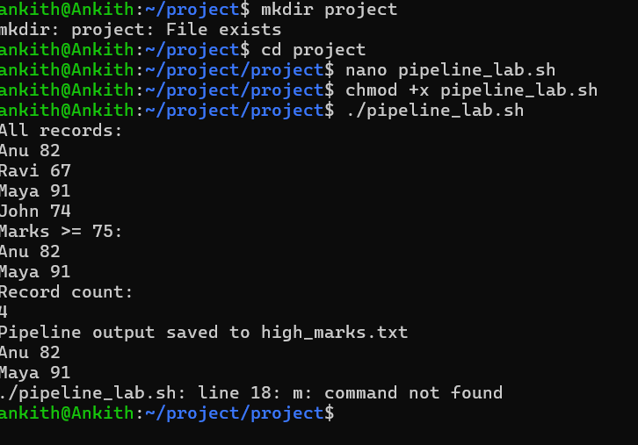
awk '$2 >= 75 {print $1, $2}' marks.txt | sort > high_marks.txt
cat high_marks.txt
m

