Experiment 4: Advanced Text Processing & Log Extraction Automation
Source Code
#!/usr/bin/env bash
set -e
cat > app.log <<'EOF'
INFO service started
WARN disk usage high
ERROR login failed
INFO request completed
ERROR database unavailable
EOF
echo "Error lines:"
grep -n 'ERROR' app.log
echo "Error count:"
grep -c 'ERROR' app.log
echo "Severity summary:"
awk '{count[$1]++} END {for (level in count) print level, count[level]}' app.log | sort
Mkdir
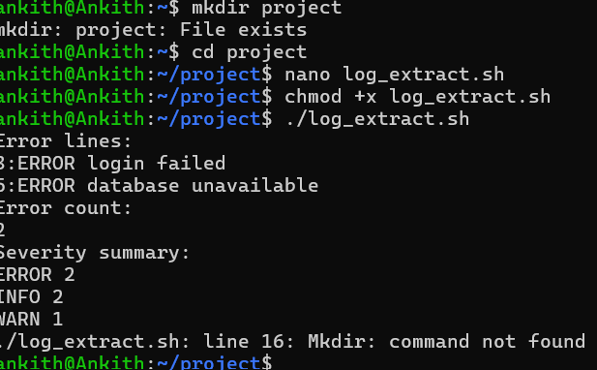clear

