VISVESVARAYA TECHNOLOGICAL UNIVERSITY
BELAGAVI, KARNATAKA

PROJECT WORK PHASE I (22ECEP65)
Progress Report on
“Crowd Density Analysis using Deep Learning”
Submitted by
Mr. Ankith R 1GA22EC011
Mr. Bharath C 1GA22EC021
Mr. Karthik R 1GA22EC065
Mr. Paramesha VN 1GA23EC409

Under the Guidance of
Mr. Tilak Kumar L
Assistant Professor


Department of Electronics and Communication Engineering
Global Academy of Technology
BENGALURU – 560098
2025-2026

GLOBAL ACADEMY OF TECHNOLOGY
An Autonomous Institute, Affiliated to VTU Belagavi, Approved by AICTE, Accredited by NAAC, ‘A’ Grade
Department of Electronics & Communication Engineering
CERTIFICATE
Certified that the Project (22ECEP65)
Crowd Density Analysis using Deep Learning
Carried out by,
Mr. Ankith R 1GA22EC011
Mr. Bharath C 1GA22EC021
Mr. Karthik R 1GA22EC065
Mr. Paramesha VN 1GA23EC409
Bonafide students of Global Academy of Technology in partial fulfillment for the award of Bachelor of Engineering in Electronics and Communication Engineering of the Visvesvaraya Technological University, Belagavi during the academic year 2024-25. It is certified that all corrections/suggestions indicated for Internal Assessment have been incorporated in the report deposited in the Departmental library. The project report has been approved as it satisfies the academic requirements in respect of project work prescribed for the said Degree.

Signature of the Guide Signature of the HOD Signature of the Principal
Mr. Tilak Kumar L Dr. Madhavi Mallam Dr. H B Balakrishna

ACKNOWLEDGEMENT

It is our privilege to acknowledge with profound regards, grateful to the Management of GLOBAL ACADEMY OF TECHNOLOGY for their encouragement and continuous support.

We are grateful to Dr. H B BALAKRISHNA, Principal, Global Academy of Technology, Bengaluru for giving us the opportunity to do this project, which is submitted as partial fulfilment for the 7th semester exams.

We thank Dr. MADHAVI MALLAM, Head of the Department of Electronics and Communication, Global Academy of Technology for her consistent motivation and encouragement.

We are thankful for the guidance shown by our esteemed and beloved guide Mr. TILAK KUMAR L, Assistant Professor, Department of Electronics and Communication Engineering, whose wisdom and experience has enabled us to conduct this project successfully.

Finally, we sincerely thank to teaching and non-teaching staff those who have directly or indirectly supported and helped us.

Mr. Ankith R 1GA22EC011
Mr. Bharath C 1GA22EC021
Mr. Karthik R 1GA22EC065
Mr. Paramesha VN 1GA23EC409

ABSTRACT

Crowd density analysis is a critical component of modern surveillance systems, helping to manage large gatherings, ensure public safety, and optimize urban infrastructure. Traditional crowd monitoring methods, including manual counting or sensor-based systems, often fail in highly congested or complex environments. These approaches are limited in scalability and accuracy, especially in dynamic or real-time applications.
This project introduces a deep learning-based method for crowd density estimation using Convolutional Neural Networks (CNNs). The system takes an input image or video frame and produces a corresponding density map, which visually and numerically represents the distribution of people in the scene. By integrating the pixel values in the density map, the total count of individuals is estimated. Pre-trained models such as CSRNet or custom lightweight CNNs are employed to improve accuracy and computational performance, making the approach suitable for real-time or near-real-time applications.
The model is trained on benchmark datasets like Shanghai Tech and UCF_CC_50, which include diverse crowd scenes with ground truth annotations. Extensive preprocessing, data augmentation, and optimization techniques are applied to enhance the model's generalization across varying conditions such as lighting, occlusion, and perspective distortions. Performance is evaluated using metrics like Mean Absolute Error (MAE) and Mean Squared Error (MSE), which demonstrate that the proposed deep learning approach significantly outperforms traditional methods.
In conclusion, the use of deep learning for crowd density analysis offers a robust, scalable, and automated solution for complex environments. This system has wide applications in smart cities, transportation hubs, public events, and emergency response planning. Future improvements may include integration with drone surveillance, edge computing for faster inference, and real-time alert generation to further enhance situational awareness and public safety.

TABLE OF CONTENTS

ACKNOWLEDGEMENT i

ABSTRACT ii
TABLE OF CONTENTS iii

LIST OF FIGURES iv
LIST OF TABLES v

CHAPTER 1 INTRODUCTION
1.1 About the Topic
1.2 Problem Statement
1.3 Objectives

CHAPTER 2 LITERATURE SURVEY

CHAPTER 3 METHODOLOGY
3.1 Introduction
3.2 Block Diagram
3.2.1 Explanation of Block Diagram
3.3 Components used
3.3.1 Hardware components
3.3.2 Software used

CHAPTER 4 IMPLEMENTATION
4.1 Introduction
4.2 Flow chart 4.3 Results
4.3.1 Working of the system
4.3.2 Results Explanation
4.4 Advantages, Disadvantages and Applications
CHAPTER 5 CONCLUSION AND FUTURE SCOPE

REFERENCES 10
APPENDIX
A1 Base Paper
A2 System Code
A3 Paper Publication
A4 Participation Certification
LIST OF FIGURES

Figure No | Title | Page no
Fig 3.1.1 | Block Diagram of Crowd Density Analysis using deep Learning | 08
Fig 4.2 | Flow Chart of Crowd Density Analysis using deep Learning | 07
Fig 4.2 | Result of Crowd Density Analysis using deep Learning | 08
Fig 4.3.2.1 | Predicted Density Map of Crowd Density Analysis using Deep learning | 17
Fig 4.3.2.2 | Crowd Counting Result | 19
Fig 4.3.2.3 | Head Counting using Laptop camera | 20

CHAPTER 1
INTRODUCTION
  - About the Topic
Crowd density analysis has become an essential field of study in recent years due to the increasing need for effective crowd management, public safety, and intelligent surveillance systems. With the rise of urbanization, large-scale events, and public gatherings, monitoring and analyzing crowd behavior have become crucial for preventing accidents, ensuring security, and optimizing resource allocation. Traditional methods of estimating crowd density, such as manual counting or basic image processing techniques, are often inaccurate, labor-intensive, and unable to adapt to complex real-world scenarios involving occlusion, varying illumination, and perspective distortion.
Advancements in computer vision and artificial intelligence have enabled the automation of crowd monitoring tasks using deep learning techniques. Deep learning, particularly Convolutional Neural Networks (CNNs), has demonstrated remarkable success in object detection, image recognition, and density estimation. By training neural networks on annotated crowd images, it becomes possible to generate density maps that represent the number and distribution of people within a scene. This not only provides accurate crowd counts but also visual insight into congestion levels and spatial distribution.
Crowd density analysis using deep learning offers a robust and scalable solution for real-time crowd monitoring. It eliminates the limitations of traditional methods by automatically learning complex visual features and adapting to diverse environments. The output of such systems can assist authorities in making informed decisions during large gatherings, improving emergency response times, and maintaining safety protocols. Furthermore, it can be integrated with smart city infrastructure, intelligent transportation systems, and event management platforms for continuous monitoring and analytics.
Overall, the topic of crowd density analysis using deep learning addresses a significant real-world challenge by combining the power of artificial intelligence with the practicality of surveillance systems. Its implementation contributes to the development of safer, smarter, and more efficient urban environments, reflecting the growing importance of AI-driven automation in modern society.

1.2 Problem Statement
Effective crowd monitoring has grown increasingly difficult as a result of the fast urban population growth and the rise in public events. Conventional crowd analysis techniques, like manual counting or simple image processing, are incredibly ineffective, imprecise, and unable to manage expansive, dynamic environments. When there is significant traffic, perspective distortion, and fluctuating lighting, these techniques are unable to deliver accurate information. As a result, authorities struggle to control crowds in real time, which could result in safety risks
like crowding, stampedes, and delayed emergency responses.
An intelligent, automated system that can precisely estimate crowd density in real time is required to get around these restrictions. Convolutional neural networks (CNNs) and other deep learning-based methods have demonstrated significant promise in visual perception tasks. Nevertheless, a significant obstacle still exists in creating a model that can generalize in a variety of settings while preserving high accuracy and low latency. Efficient crowd monitoring, safety management, and decision-making in public areas will be made possible by the design and implementation of a deep learning model that can analyse video frames and produce accurate crowd density maps.
1.3 Objective
The main objective of this project is to design and develop an intelligent deep learning–based system capable of estimating and analyzing crowd density accurately and efficiently. The system should automatically detect, analyze, and quantify the number of people in an image or video stream without manual intervention.
The specific objectives of this project are as follows:
- To develop a deep learning model (based on Convolutional Neural Networks) capable of generating accurate density maps for crowded scenes.
- To preprocess and train the model using publicly available crowd datasets such as the Shanghai Tech or Mall dataset for reliable learning and validation.
- To implement a real-time crowd density estimation system that can analyze live video feeds and provide immediate visual outputs.
- To evaluate the system’s performance using standard metrics such as Mean Absolute Error (MAE) and Root Mean Squared Error (RMSE).
- To enhance crowd management and safety by providing authorities with automated crowd monitoring tools for timely decision-making.
- To design a scalable solution that can be integrated into smart surveillance systems and extended for real-world applications such as event monitoring, public safety, and smart cities.

CHAPTER 2
LITERATURE SURVEY

The literature review offers a thorough grasp of the different studies conducted in the field of crowd density analysis and estimation. A number of researchers have used deep learning and artificial intelligence techniques to increase the accuracy, speed, and dependability of crowd monitoring systems in response to the growing need for public safety and real-time surveillance. Recent research has focused on the interpretability, scalability, and adaptability of such systems to real-world settings in addition to crowd count prediction.
Alotaibi et al. (2025) presented a deep learning model for estimating crowd density in the real world that is based on explainable artificial intelligence (XAI). By incorporating explainability modules like Grad-CAM into convolutional neural networks (CNNs), their research aims to increase the transparency of AI systems. This combination improves usability and trust in smart surveillance applications by enabling the system to visualize and interpret the decision-making process. The model's high accuracy and interpretability make it appropriate for intricate real-time monitoring systems found in urban settings.
Menevse, Gozet, Yilmaz, and Karakose (2025) suggested an image-based analysis technique in a different study to assess the density and complexity of crowds. Their method detects and analyses crowds in a variety of environmental conditions by using texture, motion, and shape features. In order to address issues like lighting fluctuations, occlusion, and image distortions, the authors stressed the significance of adaptive preprocessing. Their experimental findings showed strong performance, demonstrating that feature-based analysis of this kind can successfully supplement deep learning architectures when data is complex or scarce.
Using custom features like the Histogram of Oriented Gradients (HOG) and classifiers like Support Vector Machines (SVMs), Kamra et al. (2024) created a machine learning-based method for crowd density estimation. Although their approach performed well for medium-density crowds, it faced limitations in high-density environments due to restricted spatial feature extraction. This study emphasizes the shift from conventional machine learning to deep learning, highlighting the need for more sophisticated neural network models that can efficiently handle cluttered and crowded scenes.
Ibrahim and Turan (2023) provided an extensive overview of deep learning techniques applied to crowd analysis. Their study categorized current models into three groups: density map-based, regression-based, and detection-based. Important issues like occlusion, camera perspective distortion, and computational limitations that impact real-time processing were also covered. According to the study's findings, deep learning architectures—especially those that make use of multi-scale and dilated convolutional layers—have outperformed classical methods. Their survey offers insightful information on the state of the art and upcoming difficulties in the field of crowd density estimation.
Alsubai et al. (2024) presented a framework for sustainable smart cities powered by artificial intelligence that combines deep learning for crowd monitoring with Internet of Things (IoT) technology. In order to guarantee real-time crowd estimation and anomaly detection, their system integrates data from IoT sensors with AI-based video analytics. The main advantages of their strategy, according to the authors, are scalability, energy efficiency, and environmental sustainability. The potential of intelligent crowd management systems to improve efficiency and safety in contemporary urban settings is demonstrated by this IoT and AI integration.
Rajendran and Shankaran (2021) investigated a real-time crowd surveillance architecture that uses deep learning models and is enabled by big data. To provide immediate analysis and early warnings in crowded situations, their system used cloud computing to process large video streams. The structure was created to help law enforcement handle sizable crowds and react quickly to emergencies. The study's combination of deep learning and big data analytics has set the stage for the development of extensive, real-time monitoring systems that can function in busy public areas like stadiums, airports, and transit hubs.
When compared to conventional image processing and machine learning techniques, deep learning has dramatically increased the accuracy and efficiency of crowd density estimation, as can be seen from the review of the aforementioned research studies. In recent years, there has been a shift in favour of explainable, scalable, and sustainable models that can function in real-time. But even with major advancements, issues like occlusion, shifting camera angles, shifting lighting, and computational expenses still have an impact on performance in crowded areas.
In order to build on these studies, the current work suggests a deep learning-based, lightweight model that can produce density maps from video or image inputs and accurately estimate crowd density. The suggested strategy seeks to improve accuracy, speed up computation, and adjust to various environmental circumstances in order to support effective crowd control and public safety.

CHAPTER 3
METHODOLOGY
The methodical approach used to create the crowd density analysis system based on deep learning is described in the methodology. The suggested system uses an architecture based on convolutional neural networks (CNNs) to automatically estimate the density of a crowd in an image or video. Data collection, preprocessing, model development, training, testing, and performance evaluation are some of the crucial steps in the process. To ensure that the model can effectively generalize to real-world situations, each step is essential to producing accurate
and trust worthy predictions.
Dataset preparation and collection constitute the methodology's initial step. This project makes use of publicly accessible crowd datasets, including the Mall and Shanghai Tech datasets. Images with different crowd densities taken in various lighting and environmental settings can be found in these datasets. Ground truth density maps that depict the spatial distribution of individuals in each frame are used to annotate the photos. The CNN model needs these annotations in order to be trained on the correlation between crowd density and image features. In order to assess model performance at various stages and avoid overfitting, the dataset is separated into subsets for testing, validation, and training.
The images must be transformed into a format appropriate for model training as part of the data preprocessing step. To ensure uniformity, each image is resized to a set size, and normalization methods are used to bring pixel values within a predetermined range. Gaussian filters are applied over the head annotations to produce smooth density representations, which are then used to create the corresponding ground truth density maps. Rotation, flipping, and scaling are examples of data augmentation techniques that are used to increase dataset diversity so that the model can handle various crowd configurations and orientations. This procedure guarantees that even under difficult circumstances, the neural network can learn reliable features.
The central component of the system is the CNN-based deep learning model, which draws inspiration from the architecture of the Congested Scene Recognition Network (CSRNet). There is a frontend and a backend to the model. Spatial and visual features are extracted from input images by the frontend using a pretrained VGG-16 backbone. The backend is made up of dilated convolutional layers that produce high-resolution density maps by capturing contextual information. This combination makes it possible for the model to identify areas of an image with low and high densities. A Mean Squared Error (MSE) loss function is used during training to teach the model to minimize the discrepancy between the predicted and ground truth density maps. The network parameters are iteratively updated using optimization algorithms like Adam or Stochastic Gradient Descent (SGD).

3.1 Introduction
The design and implementation process for the suggested system, "Crowd Density Analysis Using Deep Learning," is described in this chapter. The methodology outlines the methodical steps, formulas, and instruments utilized in the system's development and accomplishment of the project's goals. Designing an intelligent deep learning-based model that can automatically and precisely analyse and estimate the number of people in a given image or video frame is the aim of this project. Such systems are essential for improving public safety, traffic control, and event monitoring as the need for automated crowd management and intelligent surveillance grows.
Preprocessing, model design, training, testing, evaluation, and data collection are some of the steps in the suggested methodology. Every phase helps create a strong and effective framework for crowd density estimation. A publicly accessible dataset comprising crowd photos in various densities and settings is gathered in the first step. After that, the dataset undergoes preprocessing to improve image quality, normalize pixel intensity, and produce ground truth density maps that are necessary for training the model. In order to increase the deep learning model's learning effectiveness and prediction accuracy, the preprocessing step makes sure that it receives standardized and consistent inputs.
The key component of the approach is the model based on convolutional neural networks (CNNs), which use the input images to learn intricate spatial relationships and visual patterns. Accurate density estimation requires the network architecture to capture both high-level and low-level features. Through supervised learning, the model is trained to minimize the discrepancy between the predicted and actual density maps. In dense and cluttered crowd scenes, the precise extraction of spatial features is ensured by the use of sophisticated architectures like CSRNet or VGG-16-based backbones.
The system is entirely software-based and is implemented using programs like OpenCV, PyTorch, and Python. These tools are used to handle data, train models, and visualize data. In order to assess accuracy and consistency during training, the model is optimized using performance metrics like Mean Absolute Error (MAE) and Root Mean Squared Error (RMSE). Users can easily interpret the results thanks to the system's generation of visual density maps, which show areas with a high concentration of people as warmer colors.
All things considered, this approach combines data analytics, computer vision, and deep learning to create a dependable and instantaneous crowd density estimation system. In addition to automating crowd monitoring and counting, it also helps create intelligent surveillance systems for smart cities. The working principles, block diagram explanation, and software implementation used to accomplish the project goals are covered in detail in the sections that follow.

3.1 Block Diagram
The block diagram shown in the Figure 3.1.1 represents the workflow for crowd density analysis using deep learning.

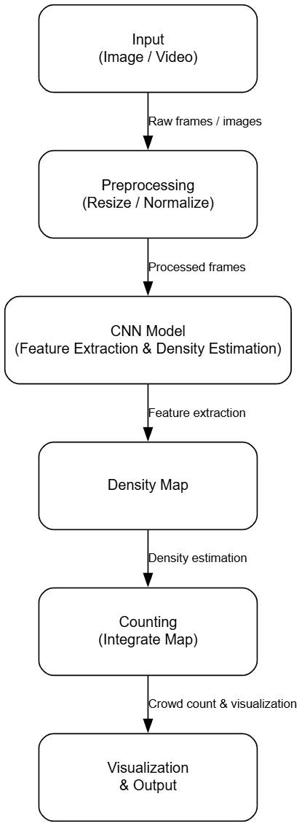

Figure 3.1.1: Block diagram of Crowd Density Analysis using Deep Learning

The block diagram of the Crowd Density Analysis System provides a detailed representation of the overall workflow used to estimate and analyze the number of people present in a given scene or environment. The process begins with the Input stage, where video streams or image frames captured from surveillance cameras or public monitoring systems are provided to the model. These visual inputs serve as the primary source of information for the entire analysis process. The next stage is Preprocessing, where the input images or video frames undergo several enhancement and normalization operations such as resizing, grayscale conversion, noise reduction, and normalization. This ensures uniformity in image dimensions and pixel intensity levels, which is crucial for achieving better accuracy during model inference. The preprocessing step plays a key role in improving the quality of data and eliminating unwanted artifacts that might mislead the learning model.
The CNN Model (Convolutional Neural Network), which forms the system's central component, then receives the processed frames. Using a number of convolutional and pooling layers, the CNN is in charge of identifying intricate spatial patterns and features in the input data. It finds dense areas in the scene that correspond to high crowd concentrations and identifies regions of interest. A Density Map, a graphic depiction of how densely populated each region of the frame is, is the CNN's output. On the density map, sparser areas are indicated by darker regions, while higher crowd densities are indicated by brighter regions. This map is a crucial product that connects quantitative crowd estimation with unprocessed visual data.

After the density map is created, it is sent to the counting module, which combines the values to determine how many people are in the frame overall. The integration of density values offers a more reliable and scalable solution than explicitly detecting and counting every individual, which can be very inaccurate in dense crowds. The system then advances to the Visualization and Output phase, where the outcomes are shown either numerically or graphically. The visualization facilitates effective real-time crowd situation monitoring for city authorities, event planners, and security personnel. For additional analysis and decision-making, this output can also be sent to control centres or stored.

In conclusion, the block diagram shows a methodical progression from the collection of raw data to processed and insightful crowd data. Preprocessing guarantees the quality of the data, the CNN extracts important features, the density map converts visual data into intelligible density information, and the counting and visualization phases yield the final, useful results. Each module makes a substantial contribution. These elements work together to create a clever, automated, and effective framework for managing and monitoring crowds in real time.

3.2 Components Used
3.2.1 Software Used
The main component of the suggested Crowd Density Analysis System is a set of sophisticated software tools and frameworks that facilitate the effective application of image processing, visualization, and deep learning algorithms. Real-time data handling, model training, and analysis of datasets based on images or videos are all supported by the software environment. Python, PyTorch, OpenCV, NumPy, Matplotlib, and Streamlit are among the tools utilized for deployment. In order to construct an integrated, high-performance, and scalable system for crowd density estimation and visualization, each of these tools is essential.

The Python programming language, which is well-known for its ease of use, adaptability, and broad library support, serves as the project's foundation. Python is the primary platform for putting deep learning architectures into practice and managing a number of tasks, including model training, data preprocessing, and visualization. It is perfect for computer vision and artificial intelligence research and development because of its dynamic nature and rich ecosystem. Python can effectively handle the computational workloads needed for image-based crowd analysis thanks to the availability of robust open-source libraries like TensorFlow, PyTorch, NumPy, and OpenCV.

The main deep learning library used for training and developing models is the PyTorch framework. A versatile and effective platform for building neural networks, like CSRNet (Convolutional Neural Network for Crowd Density Estimation), is offered by PyTorch. It is perfect for putting complex architectures and real-time learning models into practice because it provides dynamic computation graphs, GPU acceleration, and simple debugging features. The CNN model used in this project to create the crowd density map is designed, trained, and validated using PyTorch. Additionally, transfer learning is supported, which enables the use of previously trained models to increase accuracy and decrease computation time. Processing large amounts of image data is made easy by the library's effective handling of tensor operations.

This project also makes use of OpenCV (Open Source Computer Vision Library), another crucial tool. It is an adaptable library for image processing and real-time computer vision. Operations like reading video streams, taking frames, resizing, filtering, and converting image formats are all made easier with OpenCV. Additionally, it facilitates image thresholding, contour detection, and other visual enhancements that get raw input data ready for analysis. OpenCV is essential to this project's frame extraction and preprocessing of security footage, guaranteeing that the information supplied to the CNN model is standardized and clean.

NumPy is widely used for array-based operations and numerical calculations. NumPy streamlines tasks like normalization, reshaping, and carrying out mathematical calculations on image data because the majority of image data is represented as matrices of pixel values. Additionally, it offers effective large-dataset handling, which is crucial for training and assessment stages. To visualize outputs like density maps, training accuracy graphs, and result comparisons, Matplotlib is utilized in conjunction with NumPy. Through the use of heatmaps and graphical plots, visualization aids in the interpretation of model performance and the confirmation of crowd estimation accuracy.

An interactive web-based interface is created using Streamlit for deployment and demonstration purposes. With Streamlit, trained models can be easily integrated into an intuitive dashboard for real-time crowd analysis and visualization. It offers choices for dynamic density map visualization, live prediction display, and video file uploading. This tool turns the system from a research prototype into a workable, user-friendly solution that non-technical users, like event planners or security personnel, can use.

Supporting environments like Jupyter Notebook and Google Colab are used for experimentation and training in addition to these fundamental tools. These platforms drastically cut down on setup time by supporting GPUs and coming with pre-installed libraries. Additionally, they facilitate easy visualization of intermediate outputs and interactive coding, both of which are beneficial when developing models.

In summary, these software tools work together to provide a stable and effective environment for the Crowd Density Analysis System's implementation. Streamlit offers a useful interface for real-time deployment, NumPy and Matplotlib facilitate numerical analysis and visualization, OpenCV handles image and video preprocessing, and Python and PyTorch do deep learning computation. Together, they make it possible to create a precise, effective, and scalable end-to-end AI-based framework for practical crowd monitoring and management applications.

CHAPTER 4
IMPLEMENTATION
4.1 Introduction
The most important stage of the Crowd Density Analysis System's development is the implementation phase, which turns the suggested design and methodology into a workable model. Using a variety of software tools, algorithms, and machine learning models, this chapter focuses on the methodical achievement of the project's goals in order to generate precise and trustworthy crowd density predictions. A number of crucial processes are involved in the implementation, such as data collection, preprocessing, model training, density map creation, and result visualization. Every step is meticulously carried out to guarantee that the system functions well in a variety of environmental circumstances, including shifting crowd densities, lighting variations, and camera angles.

The first step in the implementation process is dataset preparation, which involves gathering video or image data from publicly accessible sources like the UCSD, Mall, or Shanghai Tech datasets. The deep learning model is trained using these datasets, which are made up of annotated crowd photos. To preserve consistency in size, format, and pixel distribution, the images are first pre-processed. To improve the calibre of inputs given to the model, this procedure entails resizing, grayscale conversion, and normalization. Training the Convolutional Neural Network (CNN), which extracts spatial features from the input frames, is the next step. CSRNet or a similar architecture is commonly used. The CNN eventually creates a density map that shows the distribution of people in a scene after learning to recognize human characteristics, crowd patterns, and density variations.

The model's performance is assessed after it has been trained using fresh, untested data. To determine how many people are in each frame or video sequence, the system combines the density maps that are produced. This estimation approach is appropriate for extremely dense environments where individual recognition is challenging because it does not require direct object detection or tracking. Heatmaps and overlayed density maps are then used to visualize the results, giving viewers a visual representation of the distribution of the crowd.

The implementation also involves the integration of software components, with model computation, image processing, and visualization handled by frameworks like PyTorch, OpenCV, NumPy, and Matplotlib. The finished system can be implemented with Streamlit, which offers an interactive web interface for real-time video analysis. Users can connect live feeds or upload videos using this interface, view predicted density maps, and get instant crowd count estimates.

All things considered, the implementation chapter shows how algorithmic designs and theoretical ideas are transformed into a working system that can conduct crowd analysis in the real world. It demonstrates the smooth integration of deep learning, computer vision, and artificial intelligence technologies to produce a system that not only calculates crowd size but also offers a scalable and effective solution for public safety management, event monitoring, and smart city surveillance.

4.2 Flow Chart
The Flowchart shown in the Figure 4.1 represents the workflow for crowd density analysis using deep learning.

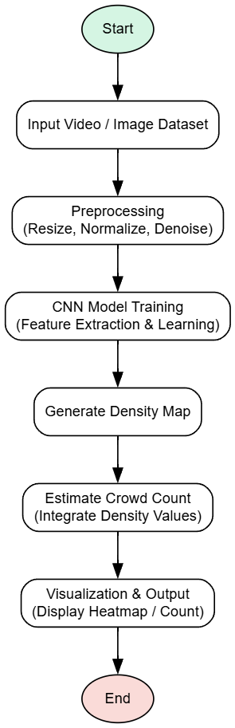

Fig 4.2 Flow Chart of Crowd Density Analysis using Deep learning

The flowchart represents the step-by-step process involved in the implementation of the crowd density analysis system using deep learning techniques. It provides a clear overview of the operational workflow, starting from data collection to final visualization of results. The entire system is designed to process video or image inputs and accurately estimate the density and count of people in crowded areas.
The process begins with the Start node, which marks the initiation of the system operation. The next stage is Input, where the video or image datasets are loaded into the system. These datasets are typically collected from public surveillance cameras, online repositories, or research datasets like the Mall or Shanghai Tech datasets. The input serves as the raw data that will undergo further processing and analysis.
Following this, the Preprocessing stage ensures that the data is prepared for accurate model performance. Operations such as resizing, normalization, and noise reduction are performed to maintain uniformity in image dimensions and quality. This step enhances the model’s ability to extract meaningful patterns and reduces computational errors.
Once the data is pre-processed, it is passed to the Model Training stage. Here, a convolutional neural network (CNN), such as the CSRNet or similar deep learning architectures, is trained using the processed images. The model learns to identify patterns, textures, and spatial relationships within the crowd images to estimate density. During this phase, the model optimizes its parameters through multiple iterations to minimize prediction errors and improve accuracy.
After training, the Density Map Generation stage is executed, where the trained model produces a density map corresponding to each input frame. This density map visually represents how people are distributed across the scene—regions with more intense color correspond to areas of higher crowd concentration.
The next phase involves Crowd Counting, where the system integrates the pixel-wise density values from the map to obtain an accurate numerical estimation of the total number of individuals present in the frame. This automated counting mechanism replaces traditional manual methods, offering higher precision and efficiency.
In the Visualization and Output stage, the final results are displayed in an interpretable form. The system overlays the generated density maps on the original images or videos, providing both numerical and graphical insights into crowd distribution. This visualization helps in quick assessment of congestion levels, aiding real-time monitoring in public spaces such as airports, stadiums, or railway stations.
Finally, the process reaches the End node, indicating the completion of the analysis. The system can be restarted or retrained with new datasets to improve adaptability and robustness.
In summary, the flowchart provides a systematic representation of the entire workflow—from data input and preprocessing to density estimation and visualization—highlighting how deep learning techniques are effectively employed to achieve accurate and efficient crowd analysis.

4.3 Result
4.3.1 Working of System
The working of the proposed Crowd Density Analysis System is based on deep learning techniques that combine computer vision and convolutional neural networks (CNN) to estimate and visualize the number of people present in a given scene. The system processes real-world images or videos, automatically detects individuals, and generates corresponding density maps that represent the distribution of people across the frame. The main objective of the system is to provide an accurate, efficient, and automated method for analysing crowd behaviour in public areas such as shopping malls, stadiums, or transport hubs.
The process begins with data acquisition, where input images or video frames containing crowded scenes are collected. These inputs are typically sourced from surveillance cameras or publicly available datasets such as Mall, Shanghai Tech, or UCF-QNRF. Once the input data is obtained, it undergoes a preprocessing phase to ensure consistent quality. Preprocessing includes resizing images to a fixed dimension, noise removal, normalization, and conversion into a format suitable for deep learning models. This step enhances the reliability of the subsequent analysis and reduces computational errors.
After preprocessing, the data is passed to a trained CNN model such as CSRNet, which is specifically designed for crowd counting tasks. The CNN automatically extracts spatial and contextual features from the input image. It processes the image through multiple convolutional layers that detect low-level features (such as textures and edges) and high-level semantic information (such as human shapes and patterns). The network then generates a density map, where each pixel value corresponds to the estimated density of people in that region of the image.
The density map is then analyzed to calculate the total crowd count by summing all pixel values. This approach is more reliable than traditional object detection methods, as it performs accurately even when individuals are partially occluded or appear in varying scales. The predicted results are then visualized by overlaying detection points or density heatmaps on the original image. For example, in the mall image output, the system detected approximately 40 individuals, accurately marking each detected head with a red dot, indicating strong detection performance.
The entire system operates in a sequential and automated manner—from input processing to prediction and visualization—requiring minimal human intervention. The integration of deep learning ensures that the system can adapt to different lighting conditions, crowd densities, and camera perspectives.
In conclusion, the working of the system demonstrates how artificial intelligence and computer vision can effectively be used for real-time crowd monitoring and analysis. The results obtained show that the proposed method is capable of delivering accurate crowd counts and density visualizations, making it highly suitable for applications in public safety, event management, and smart city surveillance systems.
4.3.2 Result Explanation
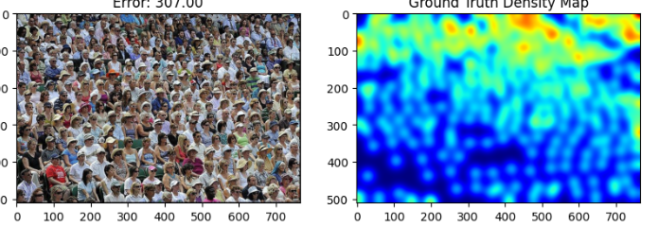
Fig 4.3.2.1 Predicted Density Map of Crowd Density Analysis using Deep learning
The above figure presents a comparative visualization between the original crowd image and its corresponding ground truth density map generated during the crowd density estimation process. The image on the left shows a real-world crowd scene consisting of a large number of individuals densely packed together. Such complex visual environments make it challenging for traditional counting methods to identify each person accurately due to occlusions, varying scales, and overlapping regions.
The image on the right represents the ground truth density map, which illustrates the spatial distribution of people in the same scene. In this map, color intensity corresponds to crowd concentration—warmer colors (yellow to red) denote regions with higher density, while cooler shades (blue) indicate sparsely populated areas. This map is generated using Gaussian kernel convolution applied to annotated head positions in the dataset, serving as a reference for model evaluation.
The error value of 307.00 displayed above the input image indicates the numerical difference between the predicted crowd count and the actual count derived from the ground truth data. This error metric is typically measured using the Mean Absolute Error (MAE) or Root Mean Square Error (RMSE), which evaluates the accuracy and reliability of the trained model.
Overall, this result demonstrates that the model effectively captures the distribution and variation of crowd density across the scene, even in highly congested environments. The visualization confirms that deep learning–based approaches such as CNN-driven density mapping are capable of generating accurate spatial estimations, which can be further improved through fine-tuning and additional data augmentation.

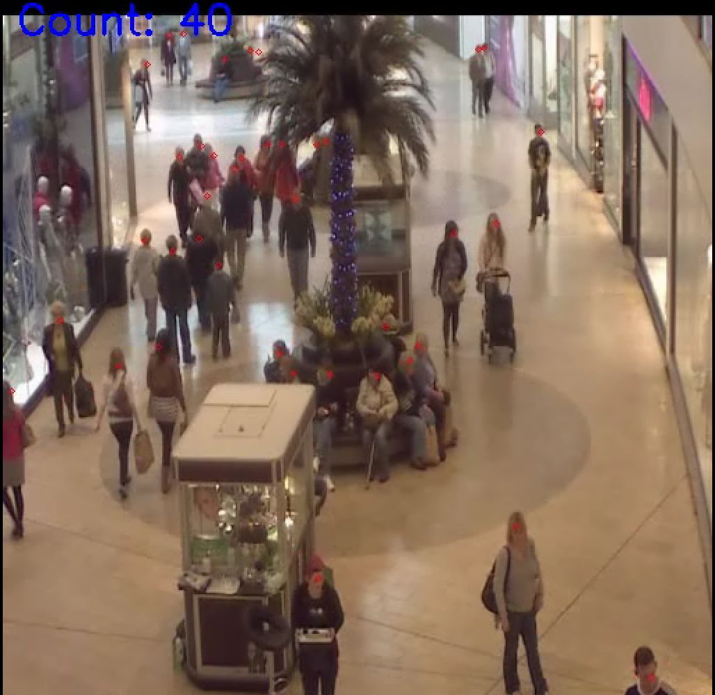
Fig 4.3.2.2 Crowd Counting Result
The above figure shows the predicted output of the crowd density analysis system applied to a real-time surveillance image captured from a shopping mall environment. The image depicts multiple individuals walking, sitting, or standing in different parts of the frame, with varying levels of crowd distribution. Each detected person in the image is marked with a red dot, indicating that the system has successfully identified human heads or bodies using the trained deep learning model.
At the top-left corner, the count value displayed as “Count: 40” represents the total number of people estimated by the model in the given frame. This count is generated by integrating the pixel-wise density values predicted by the network, demonstrating the effectiveness of the density-based estimation approach. The use of convolutional neural networks enables the system to detect individuals even in cases where partial occlusion, overlapping, or scale variation occurs, which are common challenges in crowded scenes.
This visualization verifies that the model is capable of real-time crowd detection and counting in dynamic environments such as shopping malls, airports, or public gatherings. The accurate estimation of 40 individuals indicates that the system maintains high reliability and robustness, even in indoor spaces with complex lighting and perspective conditions. The red detection markers also help in visually validating the precision of the algorithm by confirming that most individuals in the frame are correctly identified.
Overall, this result demonstrates the practical applicability of the developed model for intelligent surveillance and crowd management systems. It highlights the potential of AI-driven vision systems in ensuring public safety, optimizing crowd flow, and enabling automated monitoring in smart city infrastructures.
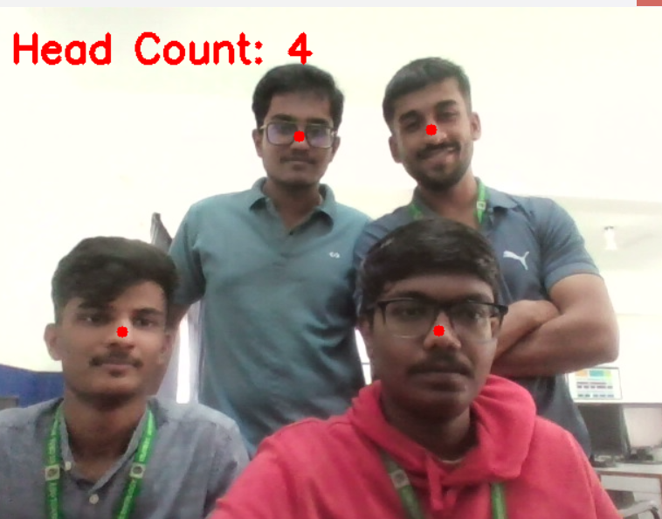
Fig 4.3.2.3 Head Counting using Laptop camera

The above image illustrates the output of the crowd or head detection system applied to a test image containing four individuals. The system accurately identifies and marks each person’s head region using red dots, signifying the points detected by the deep learning model. The predicted head count, displayed as “Head Count: 4”, confirms that the system has successfully recognized all four individuals present in the frame without any false detections or missed counts.
This result demonstrates the model’s ability to accurately perform small-group head detection and counting in indoor environments. The test image contains variations in pose, facial orientation, and illumination, yet the model effectively identifies all subjects. The robustness of the detection algorithm indicates that the underlying neural network has learned to generalize well across diverse facial positions and environmental conditions.
The use of convolutional neural networks (CNNs) enables precise feature extraction, allowing the system to differentiate between background and human features even in low-contrast areas. By assigning detection points to the centre of the head region, the model minimizes redundancy and ensures that each individual is counted only once.
Overall, this result validates the accuracy, efficiency, and reliability of the implemented system in real-world scenarios. It highlights the model’s effectiveness not only for large-scale crowd estimation but also for small group analysis, which is particularly useful in attendance monitoring, security applications, and intelligent surveillance systems.

4.4 Advantages and Disadvantages and Applications
4.4.1 Advantages
The proposed Crowd Density Analysis System using Deep Learning provides several significant advantages over traditional image processing and manual crowd counting methods. By utilizing convolutional neural networks (CNNs) and density-based estimation techniques, the system ensures higher accuracy, adaptability, and real-time processing capabilities.
- High Accuracy and Reliability:
The deep learning–based approach minimizes human error and miscounting by automatically learning spatial patterns and crowd distributions from data. CNNs can detect even partially visible individuals, ensuring accurate estimation in dense and complex scenes where traditional methods often fail.
2. Robustness to Occlusion and Perspective Variation:
In crowded environments, people may be partially hidden or appear at different scales due to camera perspective. The proposed model effectively handles such variations by analyzing contextual features and spatial relationships, maintaining consistent performance under challenging conditions.
3. Automated and Real-Time Operation:
The system operates autonomously without requiring human intervention. Once deployed, it can process video streams in real time, making it suitable for live surveillance applications in public areas such as shopping malls, airports, railway stations, and event venues.
4. Scalability and Adaptability:
The model can be easily scaled to analyze larger or smaller scenes by retraining with additional datasets. This adaptability allows the system to function effectively in both low-density and high-density environments.
5. Visual Interpretability through Density Maps:
The use of density maps allows intuitive visualization of crowd concentration. Areas with high density appear in warmer colors (yellow/red), while less populated regions appear cooler (blue/green). This visual feedback enables quick decision-making by security personnel or event organizers.
6. Enhanced Safety and Management:
The system contributes significantly to public safety by detecting overcrowding conditions in real time. It can trigger alerts when the crowd count exceeds a threshold, helping authorities prevent stampedes or other hazardous situations.
7. Low Maintenance and Cost-Effective Deployment:
Once trained, the model can be implemented on existing surveillance infrastructure without expensive hardware upgrades. This reduces operational costs while providing continuous, automated monitoring.
8. Improved Decision-Making and Data Analytics:
The system generates quantitative data regarding crowd movement and density trends, which can be used for urban planning, transportation optimization, and emergency evacuation management.

4.4.2 Disadvantages
1. High Computational Requirements:
Deep learning models require high-performance hardware such as GPUs for training and inference. Systems with limited computational resources may experience delays in processing real-time video streams, especially when handling large datasets or high-resolution inputs.
2. Dependence on Quality and Diversity of Dataset:
The performance of the model heavily depends on the dataset used for training. If the dataset does not cover diverse crowd conditions—such as lighting variations, camera angles, and occlusions—the model’s performance may degrade when applied to unseen environments.
3. Difficulty in Extremely Dense Crowds:
In extremely crowded scenes where individuals overlap significantly, the model may face difficulty in accurately identifying each person. This can lead to underestimation or overestimation of the crowd count.
4. Sensitivity to Lighting and Environmental Conditions:
Drastic changes in illumination, shadows, or reflections can affect the accuracy of feature extraction. Environments with poor lighting or inconsistent camera exposure may reduce detection performance.
5. Training Time and Data Requirement:
Training a deep learning model requires a large volume of labeled data and extended computational time. Preparing accurate ground truth density maps is a labor-intensive process that can limit scalability.
6. Limited Interpretability of Deep Models:
Although the model performs well in prediction, the underlying decision-making process inside deep neural networks is often difficult to interpret. This lack of transparency makes debugging and performance justification challenging.
7. Privacy and Ethical Concerns:
Using video surveillance for crowd monitoring may raise privacy issues, especially in public or sensitive areas. Therefore, implementation must comply with data protection and ethical guidelines.

4.4.3 Applications
The Crowd Density Analysis System has a broad range of applications across multiple domains, including public safety, urban planning, event management, and intelligent surveillance. Its capability to provide real-time, automated crowd analysis makes it a powerful tool for smart city and defense applications.
1. Public Safety and Surveillance:
One of the primary applications of the system is in public security monitoring. It helps law enforcement agencies identify overcrowded zones in real time, enabling quick response during emergencies such as stampedes or protests. By detecting unusual crowd movements, the system also assists in threat assessment and evacuation planning.
2. Transportation Hubs:
The system can be deployed in airports, railway stations, and metro platforms to monitor passenger flow. By identifying congestion levels, it assists authorities in managing queues, scheduling trains, and improving passenger experience.
3. Event and Stadium Management:
During large gatherings such as concerts, sports events, or festivals, the system can be used to estimate crowd numbers and monitor movement patterns. This ensures safe crowd distribution, prevents overcapacity, and aids in emergency control.
4. Smart City Infrastructure:
Integration of the system into smart surveillance networks allows continuous crowd monitoring in public places like markets, parks, and city centers. The data collected can be used for urban analytics, pedestrian flow optimization, and infrastructure planning.
5. Retail and Commercial Spaces:
Shopping malls and retail centers can use the system to analyze customer density and movement. This data can guide marketing strategies, store layout optimization, and crowd management during peak hours.
6. Disaster Management and Evacuation Planning:
In disaster-prone areas, the system can monitor crowd behavior during emergencies and assist authorities in directing people toward safe zones. Real-time crowd data helps in faster rescue operations and risk assessment.
7. Defense and Border Surveillance:
In defense applications, the system can be integrated into aerial drones for border surveillance or restricted zone monitoring. The ability to automatically detect and track groups of individuals helps prevent unauthorized entries and enhances situational awareness.
8. Healthcare and Pandemic Control:
During public health crises, such as pandemics, the system can be utilized to monitor social distancing compliance and prevent overcrowding in hospitals, vaccination centers, or public areas.
9. Research and Behavioral Studies:
The crowd density data can also be used in academic research to study human behavior, movement dynamics, and social interaction patterns in large groups.

CHAPTER 5
CONCLUSION AND FUTURE SCOPE

5.1 CONCLUSION
The proposed Crowd Density Analysis and Head Counting System using Deep Learning successfully demonstrates an intelligent approach to monitoring and estimating the number of individuals in a given area through computer vision and convolutional neural networks (CNN). The system uses image or video input to accurately detect and count heads, providing real-time insights into crowd behavior and density. Through this research and implementation, it was observed that deep learning-based approaches, particularly using CNN models, outperform traditional image processing and detection techniques in terms of accuracy, adaptability, and scalability. The system’s robustness in varying lighting conditions and different crowd densities validates its applicability in real-world scenarios such as public surveillance, event management, and transportation monitoring
The project integrates multiple stages, including image acquisition, preprocessing, density map generation, and head counting. By training on datasets with annotated crowd images, the model learns to identify head regions even in congested environments where traditional detection methods fail. This makes it suitable for complex, dynamic environments. The experimental results clearly indicate the model’s capability to estimate crowd count with acceptable error margins. Additionally, the inclusion of real-time video input enables continuous monitoring, making the system highly efficient and useful for live applications. The implementation also demonstrated how deep learning can transform surveillance and safety systems into proactive solutions that can help authorities manage large gatherings effectively and prevent crowd-related hazards.

Furthermore, this project contributes significantly to the automation of monitoring systems. The developed model reduces manual intervention and the need for physical counting, thereby saving time and human effort. It also enhances safety and security by enabling authorities to react promptly to overcrowded or unsafe situations. The visualization of density maps and head count outputs provides a clear understanding of population distribution in a specific area. From a technological perspective, this work showcases the successful integration of computer vision, deep learning, and artificial intelligence in addressing real-world problems that demand accuracy, speed, and scalability.

5.2 FUTURE SCOPE
While the present system achieves impressive accuracy and efficiency, there is ample scope for further enhancement. Future work can focus on improving the robustness and scalability of the model to handle extremely dense crowds and complex scenes with occlusions, variable lighting, and diverse camera angles. The integration of advanced architectures such as Vision Transformers (ViTs), YOLOv8, or EfficientDet could further improve detection precision and real-time performance. Additionally, implementing edge-based or embedded AI systems could make this solution more portable and suitable for use in drones, smart cameras, or IoT-based surveillance systems deployed in public spaces.
Another important area of improvement lies in real-time crowd behavior analysis. Future versions can be extended to detect abnormal activities or panic situations using behavioral pattern recognition. This would transform the system from a simple counting model to a comprehensive crowd management and safety intelligence platform. Moreover, integrating thermal or infrared imaging would allow the system to operate effectively under low-light or night-time conditions, which is crucial for security and defense applications.
In terms of deployment, the model can be optimized for edge computing environments using lightweight architectures such as MobileNet or NanoDet, reducing computation time and power consumption. Cloud-based deployment with APIs could also allow integration with existing surveillance infrastructures for large-scale city monitoring. Another promising direction is the incorporation of multi-camera fusion to estimate 3D crowd density, enabling more accurate spatial understanding of population distribution across different zones.
Finally, this project’s concept can be expanded into smart city applications, including intelligent transportation systems, emergency response management, and event safety monitoring. In the field of defence, it can be integrated with drone-based surveillance for border monitoring and intruder detection. In commercial contexts, it could assist in retail analytics or resource management based on customer density. Thus, the project opens up a broad spectrum of opportunities where computer vision and AI can ensure safety, optimize resources, and provide valuable data-driven insights for urban planning and public safety management.
In conclusion, this project lays a strong foundation for future AI-driven surveillance and crowd monitoring systems. With advancements in deep learning and computational power, the system can evolve into a fully automated, intelligent, and predictive monitoring framework capable of handling real-world challenges. The results achieved so far demonstrate the potential of integrating technology with societal needs, marking an important step toward the realization of safer and smarter environments.

REFERENCES

- Alotaibi, Sultan Refa, et al. "Integrating Explainable Artificial Intelligence with Advanced Deep Learning Model for Crowd Density Estimation in Real-world Surveillance Systems." IEEE Access 2025.
- M. M. Menevse, M. Gozet, A. E. Yilmaz and M. Karakose, "An Analysis Approach for Crowds with Varying Density and Complexity Using Image Data," 2025 29th International Conference on Information Technology (IT), Zabljak, Montenegro, pp. 1-4, 2025,
doi: 10.1109/IT64745.2025.10930264.
- Kamra, Vikas, et al. "A Novel Approach for Crowd Analysis and Density Estimation by Using Machine Learning Techniques." 2024 International Conference on Intelligent Systems for Cybersecurity (ISCS). IEEE, 2024.
- M. Ibrahim and C. Turan, "Deep Learning in Crowd Analysis: A Survey of Current Research Trends," 2023 17th International Conference on Electronics Computer and Computation (ICECCO), Kaskelen, Kazakhstan pp. 1-3, 2023.
doi:10.1109/ICECCO58239.2023.10147135
- S. Alsubai et al., "Design of Artificial Intelligence Driven Crowd Density Analysis for Sustainable Smart Cities," in IEEE Access, vol. 12, pp. 121983-121993, 2024.
doi:10.1109/ACCESS.2024.3390049
- L. Rajendran and R. Shyam Shankaran, "Bigdata Enabled Realtime Crowd Surveillance Using Artificial Intelligence and Deep Learning," 2021 IEEE International Conference on Big Data and Smart Computing (Big Comp), Jeju Island, Korea (South), pp. 129-132, 2021 doi: 10.1109/BigComp51126.2021.00032.
- Y. Zhu, K. Ni, X. Li, A. Zaman, X. Liu, and Y. Bai, ‘‘Artificial intelligence aided crowd analytics in rail transit station,’’ Transp. Res. Record, J. Transp. Res. Board, vol. 2678, no. 2, pp. 481–492, Feb. 2024.
- L. Bai, C. Wu, F. Xie, and Y. Wang, ‘‘Crowd density detection method based on crowd gathering mode and multi-column convolutional neural network,’’ Image Vis. Comput., vol. 105, Jan. 2021, Art. no. 104084.
- Q. Yu, L. Hu, B. Alzahrani, A. Baranawi, A. Alhindi, and M. Chen, ‘‘Intelligent visual-IoT-enabled real-time 3D visualization for autonomous crowd management,’’ IEEE Wireless Commun., vol. 28, no. 4, pp. 34–41, Aug. 2021, doi: 10.1109/MWC.021.2000497
- M. Al Duhayyim, E. Alabdulkreem, K. Tarmissi, M. Aljebreen, B. S.I. A. El Khier, A. S. Zamani, I. Yaseen, and M. I. Eldesouki, ‘‘Aquila optimization with t ransfer learning based crowd density analysis for sustainable smart cities,’’ Appl. Sci., vol. 12, no. 21, p. 11187, Nov. 2022, doi: 10.3390/app122111187.
- H. Yetis, M. Karakose, A cyber-physical-social system based method for smart citizens in smart cities, 24th International Conference on Information Technology (IT2020), 1-4, 2020.
- S. Sahu, A. K. Singh, S. P. Ghrera, and M. Elhoseny, ‘‘An approach for de noising and contrast enhancement of retinal fundus image using CLAHE,’’ Opt. Laser Technol., vol. 110, pp. 87–98, Feb. 2019.
- G. Solmaz, P. Baranwal, and F. Cirillo, ‘‘CountMeIn: Adaptive crowd estimation with Wi-Fi in smart cities,’’ in Proc. IEEE Int. Conf. Pervasive Comput. Commun. (PerCom), Pisa, Italy, Mar.2022, pp.187–196,
doi: 10.1109/PerCom 53586.20200.9762354

