REPORT

**The Design of a Universal Decentralized Platform for “Professor-As-A Service”**

**Introduction:**

The "Professor as a Service" educational model is a decentralized system where professors own their expertise and offer courses independently of educational institutions. The model allows students to choose courses from any professor anywhere in the world. The digital platform facilitates course management, student registration, and certification. In this report, we will discuss the system's initial configurations, user roles, and functions.

**Problem Statement:**

The traditional educational system is often centralized and rigid with delegation from educational institutions , and limited options and flexibility for both professors and students.The aim of this project is to develop a software system that leverages software engineering techniques to improve the accessibility and quality of education globally while minimizing the cost of tuition. By holding individuals accountable for their role in enhancing the learning experience, the system seeks to empower learners and create a culture of constant learning, feedback, and continuous improvement.

**Solution Proposed:**

To address these issues, a decentralized educational model, titled "Professor as a Service" is proposed. This model places the power in the hands of the professors, who own their talent and experience and manage their own courses. The Professor as a Service platform provides students with increased flexibility in course selection, and offers professors the autonomy to teach their specialized subject matter while earning direct revenue from tuition fees.

**Design Model:**

The system will be designed as a localized platform where professors from around the world can join and offer their courses remotely. The platform will provide third-party certification authorities to approve degrees earned through the system. The system will also include a reputation index to help students determine which courses are best suited to their needs and enroll from anywhere in the world.

**Class Design Decisions:**

Business: Business

Certifier: Certifier

Courses : Course, CourseCatalogue

GraduateRequest : GraduateRequest, GraduateRequestDirectory

Professor : Professor, ProfessorDirectory

Role : Role, CertifierRole, ProfessorRole, StudentRole, SystemAdminRole

Students : Student, StudentDirectory, Transcript

UserAccount : UserAccount, UserAccountDirectory

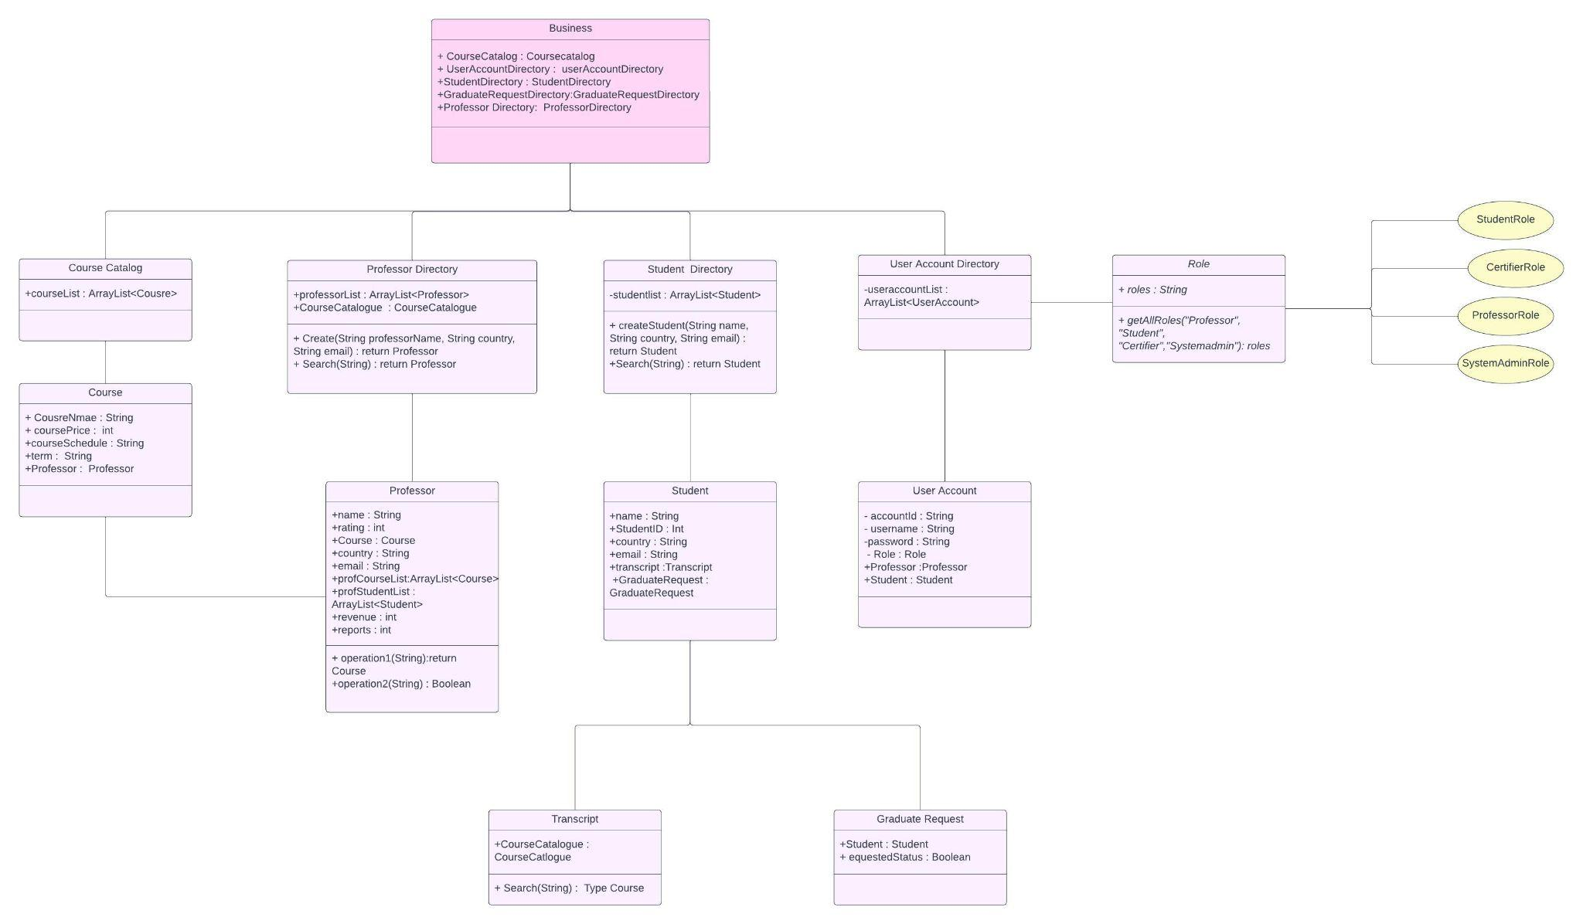

**Initial configuration:**

The system's initial configurations include setting up a SystemAdmin, a Certifier, and a ProfessorDirectory and StudentDirectory as they sign up. The StudentDirectory will store all student information, that has transcripts with courses enrolled, and GraduationRequest. The Certifier will have a list of students from GraduateRequest and their Transcripts. The ProfessorDirectory will store all professors that have information about courses offered on the platform and schedule.

**User Roles:**

The system has several user roles, including Professors, Students,System admin, and Certifier.

Professor: Manage their course catalog and schedule, set course prices, and check students enrolled.

Student: Browse and Register for courses, and declare their intention to graduate.

System Admin: Collect data on Users, and check revenue

Certifier : Review student transcripts and certify their graduation.

**Functionalities:**

System Startup: The platform has Certifier, SystemAdmin, StudentDirectory, and ProfessorDirectory. The system will be tested to ensure all configurations are working correctly.

Professor Sign-Up: Professors will sign up to the service, create a profile, and add their courses to the CourseCatalogue. They will set course prices and schedule for the courses they offer.

Student Sign-Up: Students will sign up to use the system and create a profile with their personal information. The system will create a transcript for each student based on the courses they take.

Course Schedule: Professors will create a course schedule with the term they plan to offer that course. The term will be available on the platform.

Course Search: Students will browse courses available by professor name, course topic, language, etc. The search results will display the professor's rating, reputation index and course information.

Course Registration: Students will register for courses they want to take. The course fee is directly to the professor’s management panel, as they confirm their registration.

Graduation: Students will declare their intention to graduate after completing the required courses. The Certifier will review their transcripts and certify their graduation status.

Performance Dashboard: The SystemAdmin will have a performance dashboard that enables them to collect data on the system's different userAccount, including the number of registered professors, students, and revenue. They can use this data to make informed decisions about the platform's future.

**Scope for future developments:**

Gamification: Gamification elements such as badges, leaderboards, and points can be added to the courses to increase student engagement and motivation.

Social learning: The platform could facilitate social learning by creating communities where students and professors can share resources, discuss course material, and collaborate on projects.

Peer review: The platform could include a peer review system where students review and provide feedback on each other's work, promoting collaboration and enhancing the learning experience.

**Opinion and Conclusion:**

We believe that the Professor as a Service model offers a more flexible and cost-effective approach to education. By placing the focus on individual professors and their unique talents, this model allows for greater diversity in course offerings and promotes accountability for quality education. The platform's decentralized design and third-party certification authorities provide increased transparency and legitimacy, making it an attractive alternative to traditional educational institutions. Overall, we believe that the Professor as a Service model has the potential to revolutionize the education industry and improve the quality of education worldwide.