**Question 1 : Write some network terminology?**

1 - IP Address (Internet Protocol Address): A unique string of numbers separated by periods or colons that identifies each computer using the Internet Protocol to communicate over a network.

2 - MAC Address (Media Access Control Address): A unique identifier assigned to a network interface controller for use as a network address in communications within a network segment.

3 - Subnet Mask: A 32-bit number that divides an IP address into network and host portions, used to determine the subnet an IP address belongs to.

4 - Gateway: A network node that serves as an access point to another network, often involving different protocols.

5 - DNS (Domain Name System): A hierarchical system for naming resources on the Internet, translating human-friendly domain names into IP addresses.

6 - DHCP (Dynamic Host Configuration Protocol): A network management protocol used to dynamically assign an IP address and other network configuration parameters to each device on a network.

7 - LAN (Local Area Network): A network that connects computers within a limited area such as a residence, school, or office building.

8 - WAN (Wide Area Network): A telecommunications network that extends over a large geographic area for the primary purpose of computer networking.

9 - VLAN (Virtual Local Area Network): A logical subnetwork that can group together a collection of devices from different physical LANs.

10 - Router: A device that forwards data packets between computer networks, directing the data along the most efficient routes.

11 - Switch: A device in a computer network that connects other devices together, using packet switching to forward data to its destination.

12 - Firewall: A network security system that monitors and controls incoming and outgoing network traffic based on predetermined security rules.

13 - Bandwidth: The maximum rate of data transfer across a given path, measured in bits per second (bps).

14 - Latency: The time it takes for a data packet to travel from its source to its destination, typically measured in milliseconds.

15 - Protocol: A set of rules and conventions for communication between network devices, such as TCP/IP, HTTP, and FTP.

16 - VPN (Virtual Private Network): A service that allows you to connect to the internet via a server run by a VPN provider, encrypting your data and masking your IP address.

17 - Topology: The physical or logical arrangement of a network, describing how nodes are interconnected. Common types include star, ring, mesh, and bus topologies.

18 - OSI Model (Open Systems Interconnection Model): A conceptual framework used to understand network interactions in seven layers: Physical, Data Link, Network, Transport, Session, Presentation, and Application.

19 - TCP/IP (Transmission Control Protocol/Internet Protocol): The fundamental communication protocol suite for the Internet, consisting of the Transmission Control Protocol (TCP) and the Internet Protocol (IP).

**Question 2 : Draw your Home Network Topology and explain how you are accessing the RPS Lab environment**

FLOW:

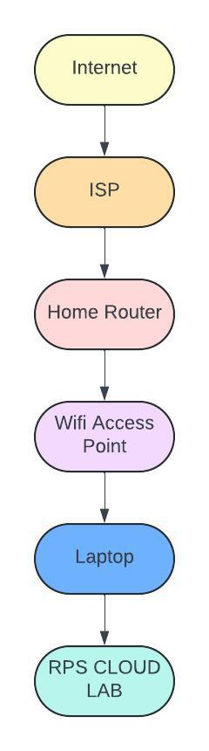

**PROCESS :**

1 - Connect to the Internet: Ensure your home device is connected to your home network (either via Wi-Fi or Ethernet).

2 - Launch VPN Client: Open your VPN client application on your home device and connect to the VPN server using your credentials.

3 - Authenticate: Enter any required authentication details ( username, password, multi-factor authentication).

4 - Establish VPN Tunnel: Once authenticated a secure VPN tunnel is established between your home device and the VPN server.

5 - Access RPS Lab: Use a remote desktop client (e.g., Microsoft Remote Desktop) or an SSH client to connect to the servers in the RPS lab environment.

6 - For RDP: Enter the IP address or hostname of the Windows server in the RPS lab.

For SSH: Enter the IP address or hostname of the Unix/Linux server and provide your SSH credentials.

Authenticate using your SSH credentials (username and password).