**QUESTION : Develop a case study analyzing the implementation of SDLC phases in a real-world engineering project. Evaluate how Requirement Gathering, Design, Implementation, Testing, Deployment, and Maintenance contribute to project outcomes.**

**SDLC process for car scrapping:**

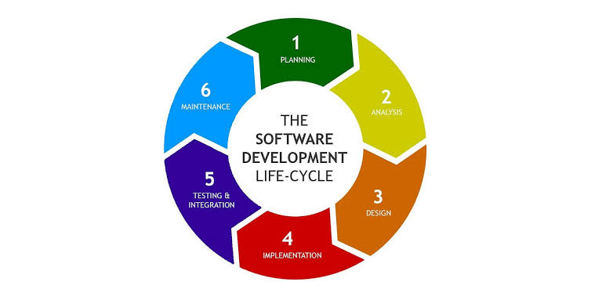

### **1. Requirements**

**Importance**: Establishes features and functionalities based on user and stakeholder inputs.

* **Activities**:
  + Interviews with scrapyard managers
  + Requirement gathering for vehicle tracking, inventory management, scheduling, compliance
* **Connection**: Forms the foundation for design, ensuring essential features are included.

### **2. Design**

**Importance**: Creates the blueprint for the system.

* **Activities**:
  + System architecture diagrams
  + Database schema design
  + User interface design for dashboards and workflows
* **Connection**: Translates requirements into a visual and functional plan.

### **3. Implementation**

**Importance**: Involves coding and building system features.

* **Activities**:
  + Developing front-end interfaces and back-end services
  + Integrating GPS for tracking
  + Ensuring compliance with regulations
* **Connection**: Executes the design plan, creating the system's core functionality.

### **4. Testing**

**Importance**: Ensures the system functions correctly and securely.

* **Activities**:
  + Unit tests
  + Integration tests
  + System tests
  + User acceptance tests (UAT)
* **Connection**: Provides feedback to developers, ensuring a polished system for deployment.

### **5. Deployment**

**Importance**: Releases the system for use.

* **Activities**:
  + Launch planning
  + System deployment on servers
  + User and administrator training
  + Ongoing support and maintenance
* **Connection**: Finalizes the project, enabling real user interactions and gathering new requirements for updates.

### 6. Maintenance

**Activities:**

* Established a dedicated maintenance team for ongoing support and enhancements.
* Implemented a feedback loop to continuously gather user input for system improvements.
* Scheduled regular system audits and updates to maintain performance and compliance.