**QUESTION : Research and compare SDLC models suitable for engineering projects. Present findings on Waterfall, Agile, Spiral, and V-Model approaches, emphasizing their advantages, disadvantages, and applicability in different engineering contexts?**

**SOLUTION :**

**Comparison of SDLC Models for Engineering Projects**

1. **Waterfall Model**

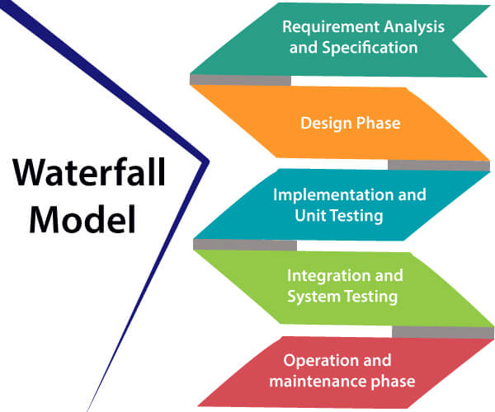

**Advantages**:

* **Structured Approach**: Phases are clearly defined and sequential.
* **Easy to Manage**: Each phase has specific deliverables and review processes.
* **Documentation**: Extensive documentation ensures a clear understanding of requirements and design.

**Disadvantages**:

* **Inflexibility**: Difficult to accommodate changes once a phase is completed.
* **Late Testing**: Testing phase occurs only after development is complete, potentially leading to the discovery of critical issues late in the process.
* **Risk**: Higher risk and uncertainty as problems may not be identified until later stages.

**Applicability**:

* **Engineering Contexts**: Best suited for projects with well-understood requirements that are unlikely to change, such as construction projects or systems with regulatory compliance where upfront planning is critical.

1. **Agile Model**

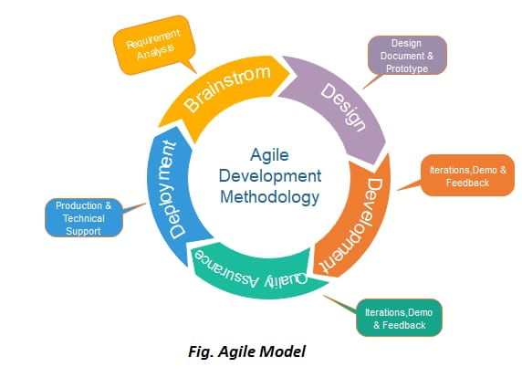

**Advantages**:

* **Flexibility**: Allows for changes and iterative improvements throughout the development process.
* **Customer Collaboration**: Frequent interaction with stakeholders ensures the project meets their needs.
* **Continuous Improvement**: Regular feedback loops and iterations enhance quality and functionality.

**Disadvantages**:

* **Less Predictability**: Project scope and timelines can be less predictable due to constant changes.
* **Documentation**: Less emphasis on comprehensive documentation can lead to knowledge gaps.
* **Requires Discipline**: Teams need to be highly collaborative and disciplined to manage iterations effectively.

**Applicability**:

* **Engineering Contexts**: Ideal for projects with evolving requirements and high uncertainty, such as software development, R&D projects, and innovative engineering solutions where adaptability is crucial.

1. **Spiral Model**

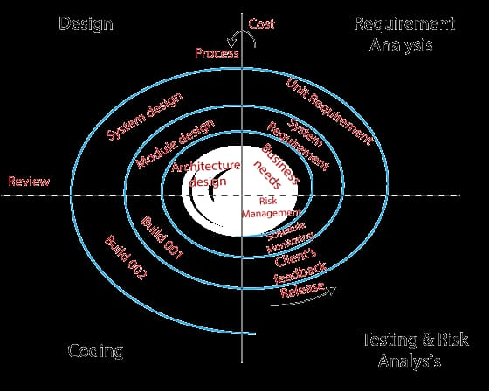

**Advantages**:

* **Risk Management**: Emphasizes early identification and mitigation of risks.
* **Iterative Development**: Combines elements of both design and prototyping in stages, allowing for iterative refinement.
* **Flexibility**: Accommodates changes and iterative improvements based on feedback and risk assessment.

**Disadvantages**:

* **Complexity**: Can be complex to manage due to its iterative nature and focus on risk analysis.
* **Cost**: Potentially higher cost due to extensive planning, prototyping, and iteration phases.
* **Skill Requirement**: Requires highly skilled project managers and developers to handle the iterative and risk-focused processes.

**Applicability**:

* **Engineering Contexts**: Suitable for large, complex projects with high risks and uncertainties, such as aerospace, defense, and large-scale infrastructure projects where thorough risk assessment is crucial.

1. **V-Model (Verification and Validation Model)**

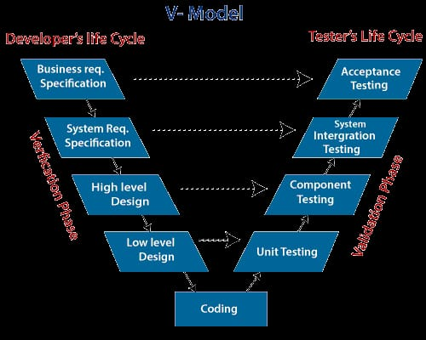

**Advantages**:

* **Clear Structure**: Highly structured approach with a strong emphasis on verification and validation at each phase.
* **Parallel Development and Testing**: Testing activities are planned in parallel with development phases, ensuring early detection of defects.
* **Quality Assurance**: Emphasis on validation and verification ensures high quality and compliance with requirements.

**Disadvantages**:

* **Rigidity**: Inflexible to changes once the process is initiated, similar to the Waterfall model.
* **Late Problem Detection**: Issues found during the validation phases can be costly to resolve if they occur late in the project.
* **Documentation Heavy**: Extensive documentation and review processes can be time-consuming and resource-intensive.

**Applicability**:

* **Engineering Contexts**: Best suited for projects where quality and compliance are critical, such as medical device development, automotive engineering, and projects with stringent safety and regulatory requirements.