**BLOCKCHAIN LOTTERY APPLICATION**

**ANKIT JAIN**

**2020MT93155**

1. **LOTTERY USE CASE IN BLOCKCHAIN ECOSYSTEM**

The lottery is a type of gambling which involves the drawing of specific numbers to win the large prizes. Many people consider it as a gaming product, but it is a high volume industry which can also be called as a commodity.

One of the lottery directors said, “Lotteries are different from any other gaming product. Lottery players risk a small amount of money against very long odds to win a large prize, with the net proceeds going to the public good.”

The lottery industry keeps a 29% share of the entire global gambling revenue.

Increased from $187.1 billion in 2004 to $284.3 billion in 2014, the global lottery represented an annual growth rate of 4.3% over ten years.

But with the growth of the digital economy, the industry faces challenges like the lack of transparency and fairness.

1. **ADVANTAGES**

**Improve fairness with the smart contracts**

A smart contract is a digital agreement between the parties in which computers enforce terms and bring transparency to any transaction. With an online block chain lottery in place, rules which are legible to all parties can never be altered.

Since no centralized authority is there to govern the game, there will be no concerns related to winnings. The player’s funds can directly go into the contract without the interference of intermediaries.

**Privacy and Accessibility**

The use of crypto currency for gambling has become a popular solution for casinos, either as an alternative to fiat currency or as the primary payment system.

With crypto currencies, users can gamble anonymously, without the need to submit copies of the documents.

Also, crypto currencies can make online gambling accessible as it offers a low entry barrier to new players and enables them to avoid gambling regulations applied to fiat currency.

**APPLICATION -1 – MAKING FIRST LOTTERY CONTRACT**

**Tools: NODE, NPM, GANACHE, METAMASK, RINKEBY TEST NETWORK**

**PLATFORM: LINUX VIRTUAL MACHINE**

**UDEMY COURSE LINK:** [**https://sapient.udemy.com/course/ethereum-and-solidity-the-complete-developers-guide**](https://sapient.udemy.com/course/ethereum-and-solidity-the-complete-developers-guide)

**GITHUB LINK:** [**https://github.com/ankitjain-wiz/BitsLotteryContract**](https://github.com/ankitjain-wiz/BitsLotteryContract)

**GOOGLE DRIVE LINK:** [**https://drive.google.com/drive/folders/1LgScTaWX8SCqNvN1wLFndYfF3NaXbo6v?usp=sharing**](https://drive.google.com/drive/folders/1LgScTaWX8SCqNvN1wLFndYfF3NaXbo6v?usp=sharing)

**METAMASK INTSALLATION**

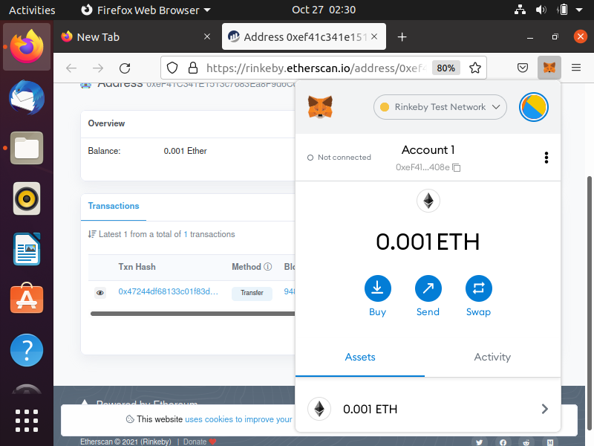

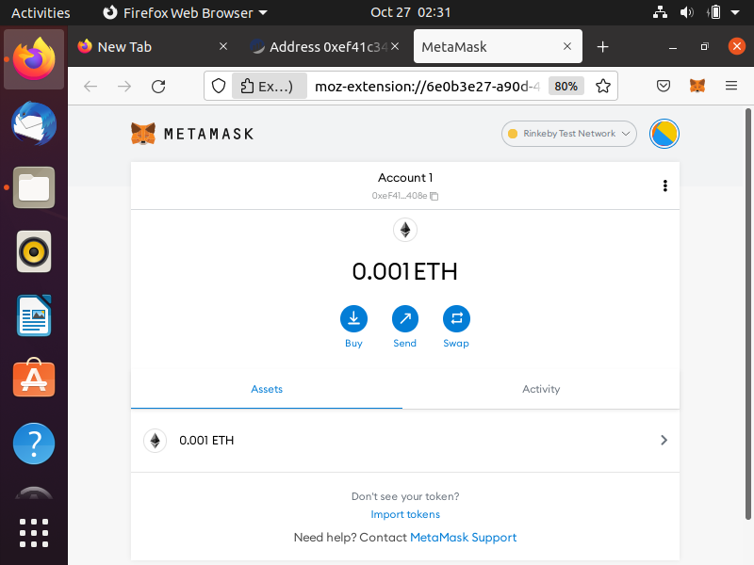

**SECRET RECOVERY IN METAMASK**

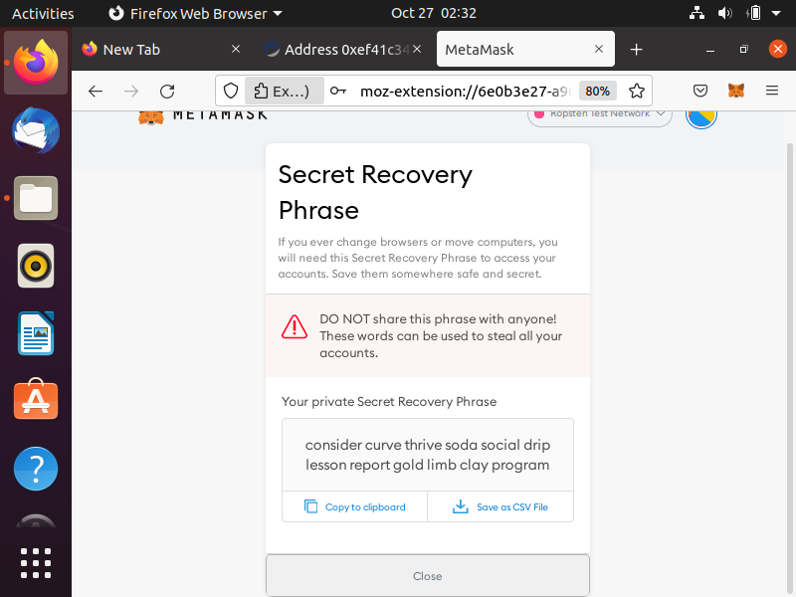

**RINKEBY ETHERSCAN**

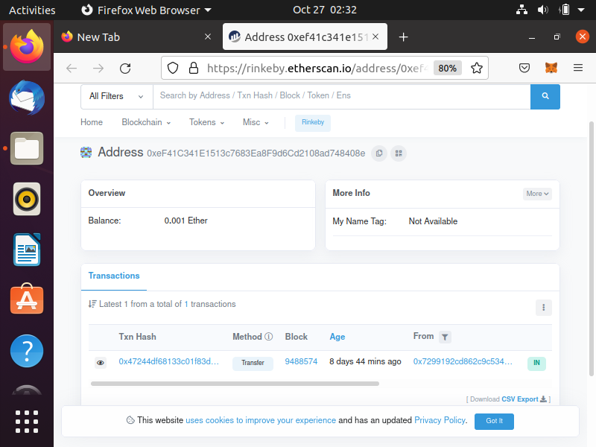

**RINKEBY TEST INFURA**

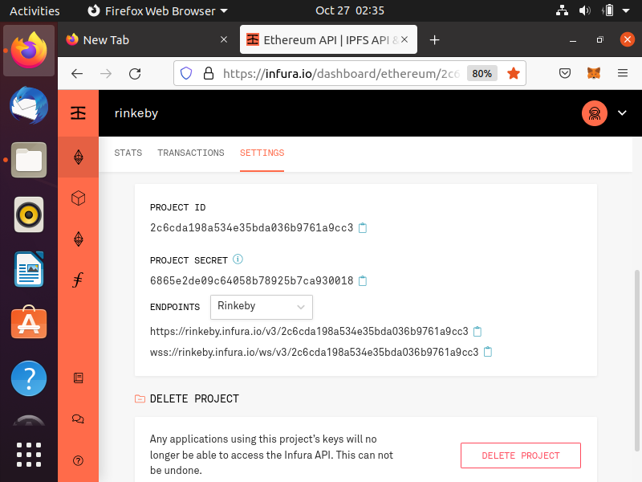

**PROOF OF WORK**

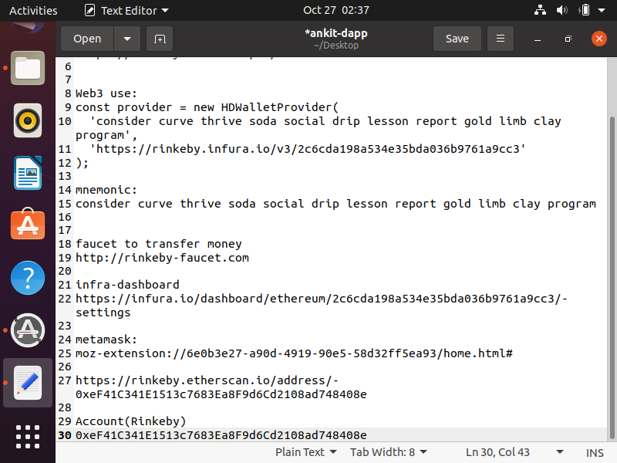

**DEPLOY.JS WITH RINKEBY**

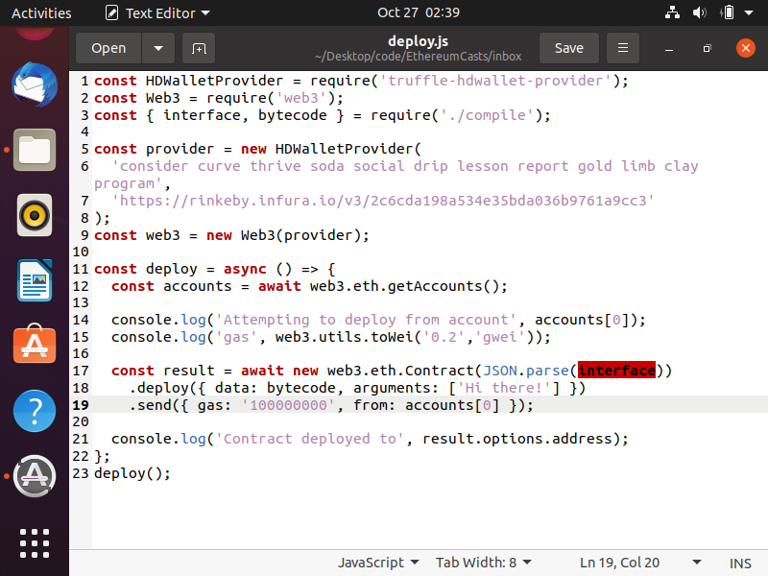

**GANACHE INSTALL**

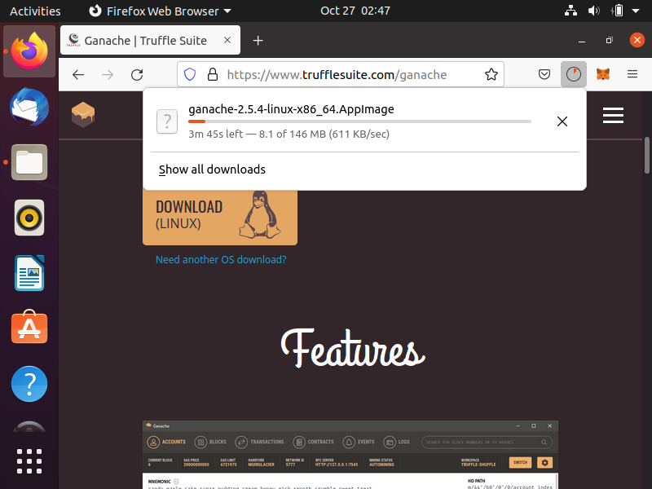

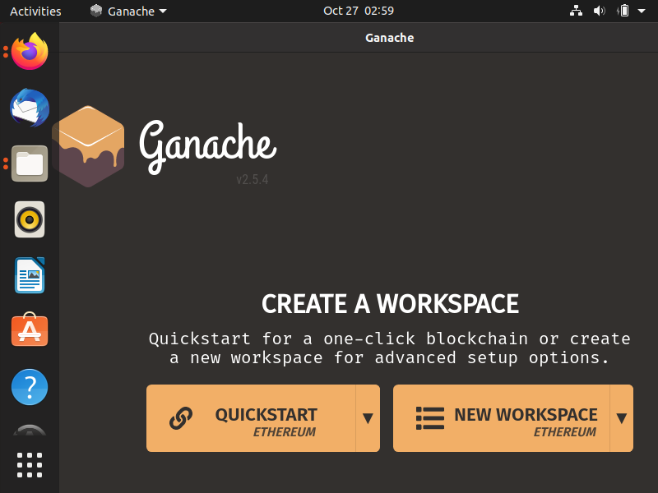

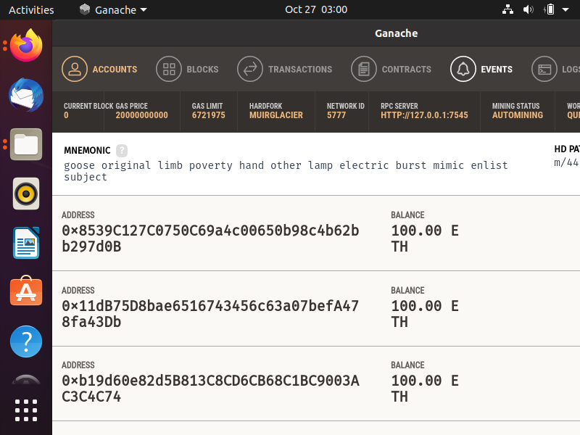

**CONTRACT DEPLOY TO GANACHE NETWORK**

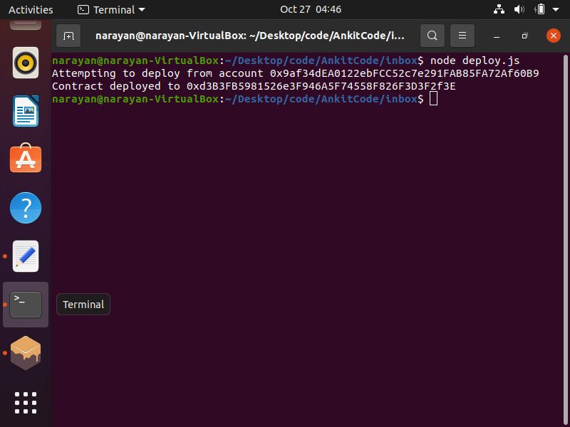

**PROOF OF SUCCESSFUL DEPLOY IN GANACHE**

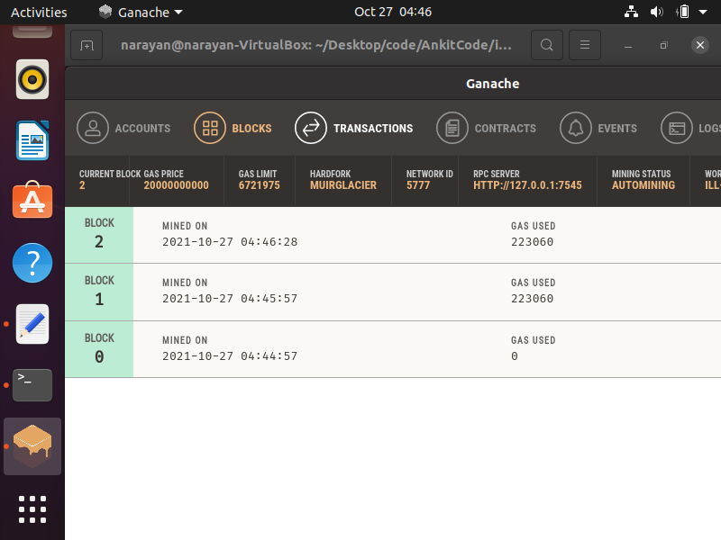

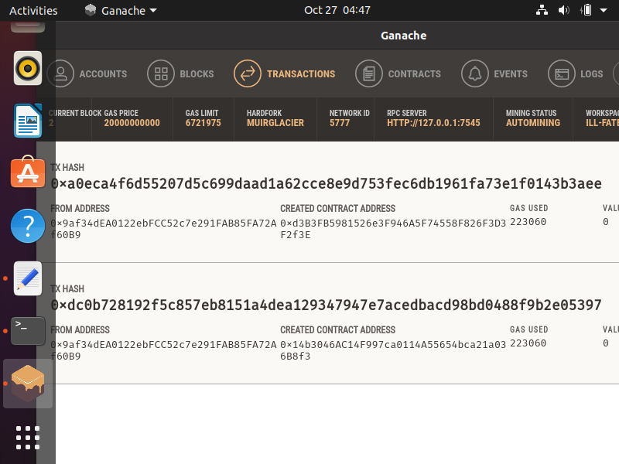

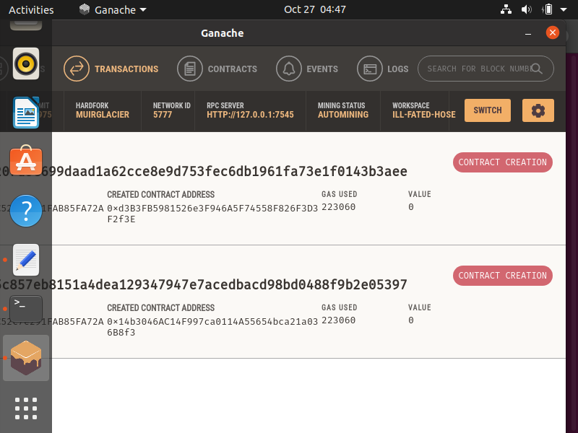

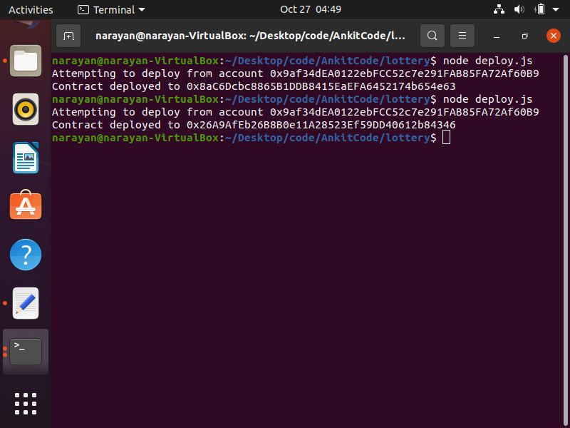

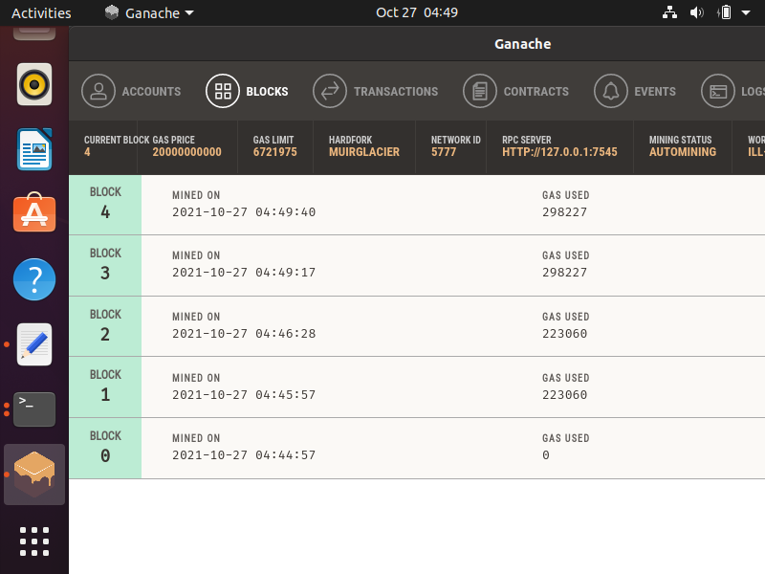

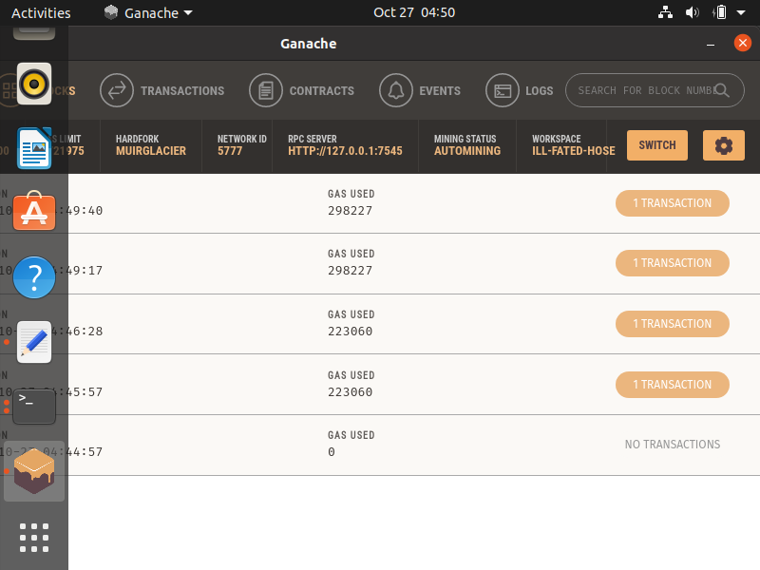

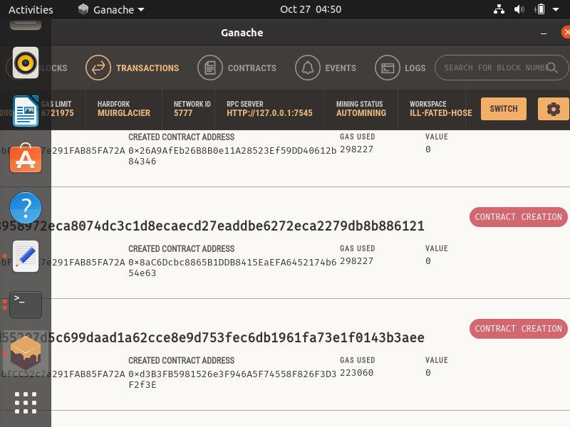

**DEPLOY.JS WITH GANACHE NETWORK**

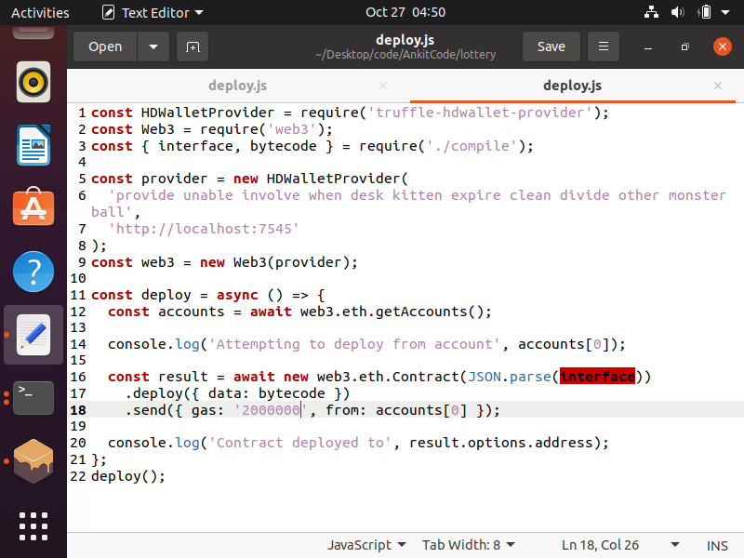

**APPLICATION -2 LOTTERY REST APPLICATION IN BLOCKCHAIN**

**DESC: NOW WE WILL USE THIS CONTRACT CREATED TO DEVELOP A REST SPRINGBOOT JAVA APPLICATION IN BLOCKCHAIN**

**TOOLS: JAVA, MAVEN, SPRINGBOOT, GANACHE, WEB3S**

**PLATFORM: WINDOWS-7**

**GITHUB LINK:** [**https://github.com/ankitjain-wiz/BitsLotteryBlockchainRestApp**](https://github.com/ankitjain-wiz/BitsLotteryBlockchainRestApp)

**GOOGLE DRIVE LINK:** [**https://drive.google.com/drive/folders/1LgScTaWX8SCqNvN1wLFndYfF3NaXbo6v?usp=sharing**](https://drive.google.com/drive/folders/1LgScTaWX8SCqNvN1wLFndYfF3NaXbo6v?usp=sharing)

**ENVIRONMENT IN ECLIPSE:**

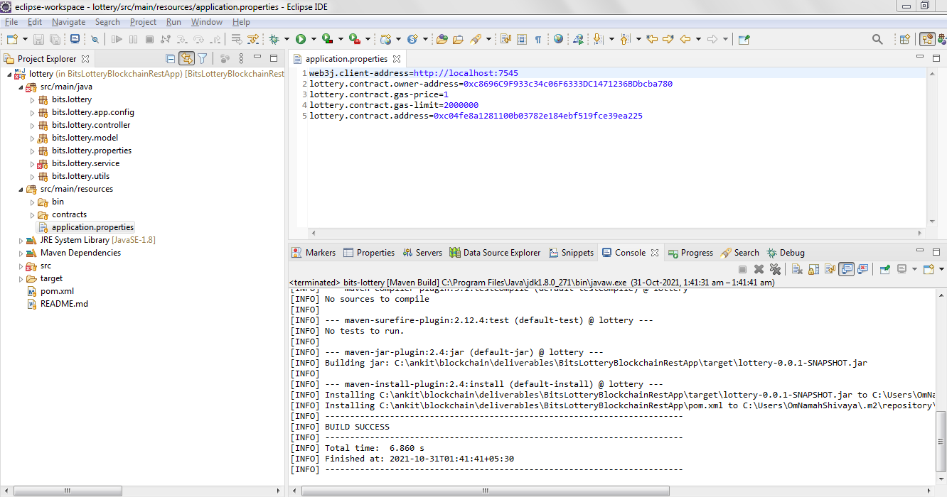

**DEPLOYING LOTTERY CONTRACT USING GANACHE THROUGH APPLICATION**

**PROOF:**

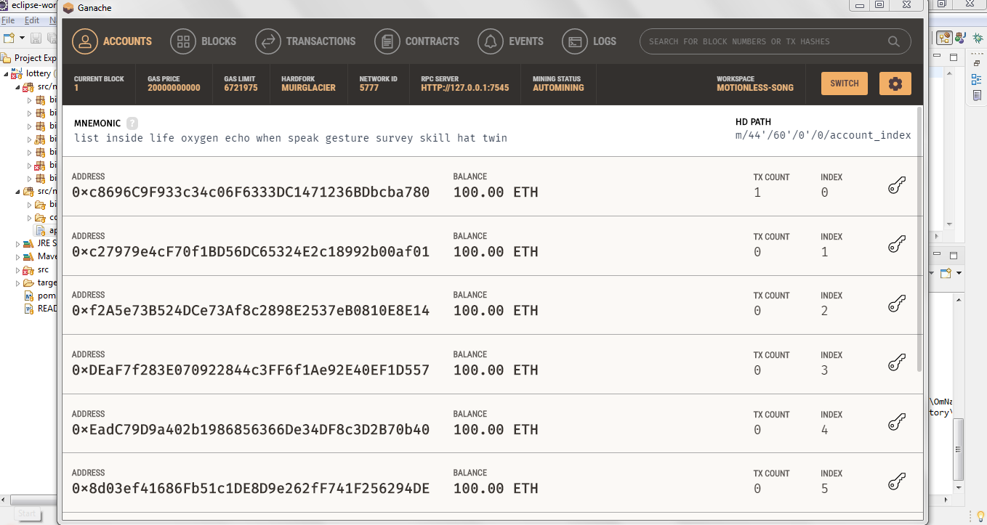

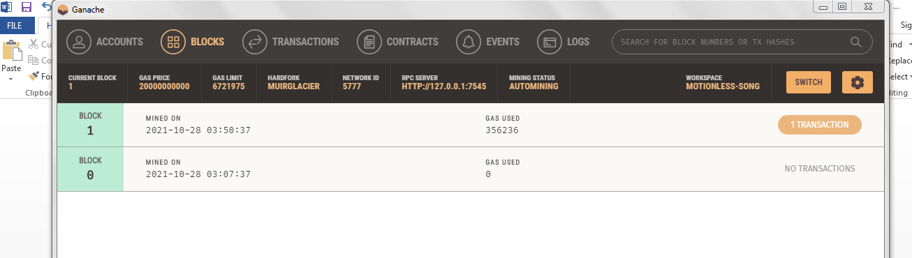

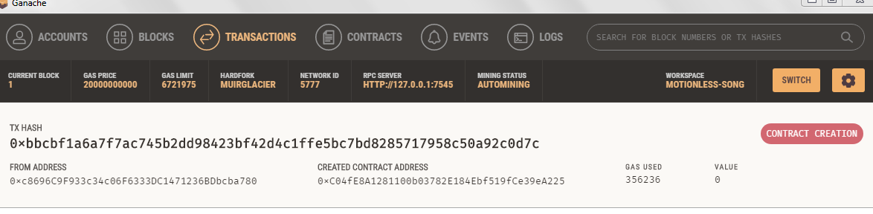

**FRONTEND/REST API**

<http://localhost:8080/owner>

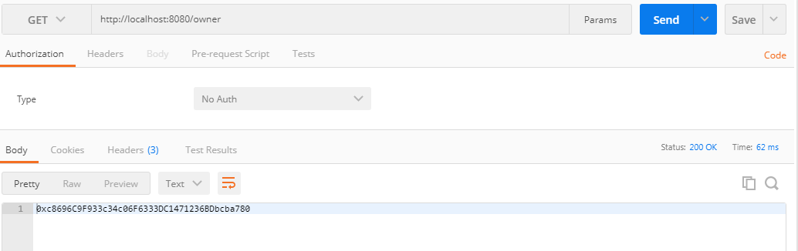

<http://localhost:8080/owner/balance>

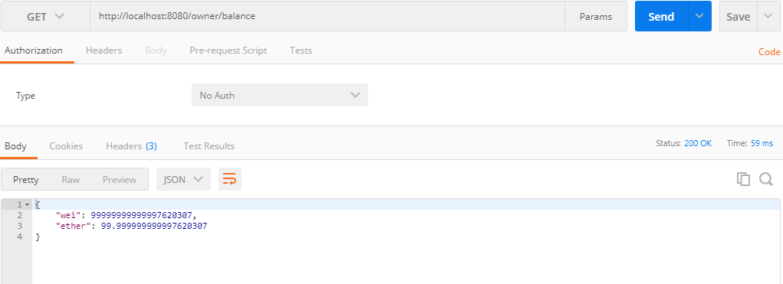

<http://localhost:8080/owner/lottery/players>

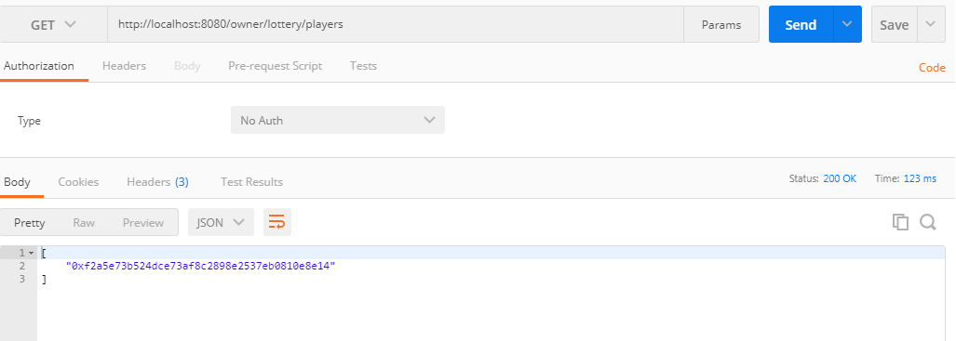

<http://localhost:8080/lottery/balance>

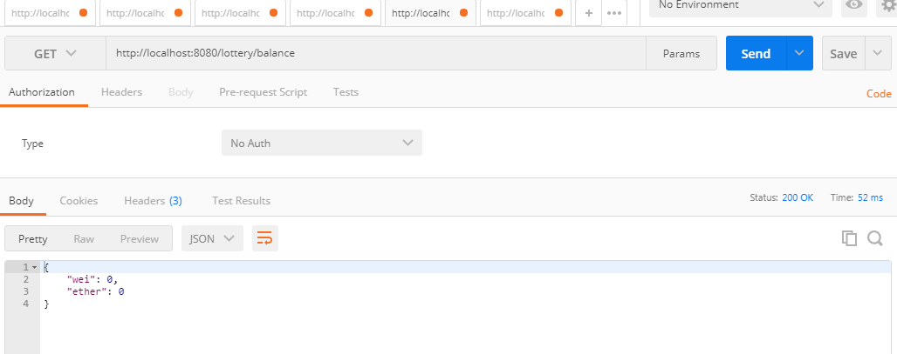

<http://localhost:8080/lottery/join>

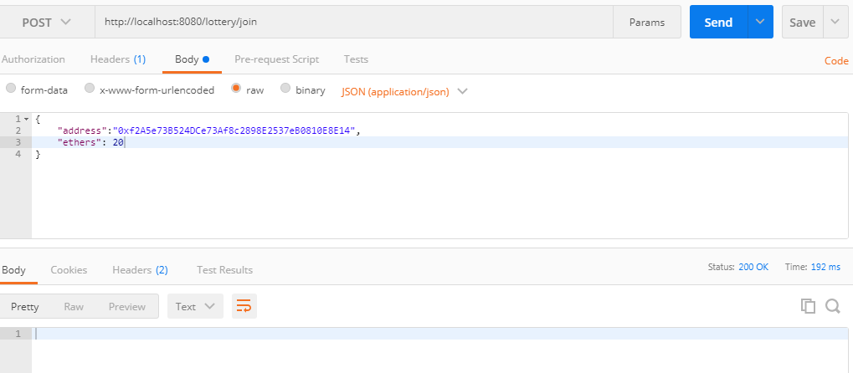

**GANACHE WINDOWS BLOCKS AND TRANSACTION**

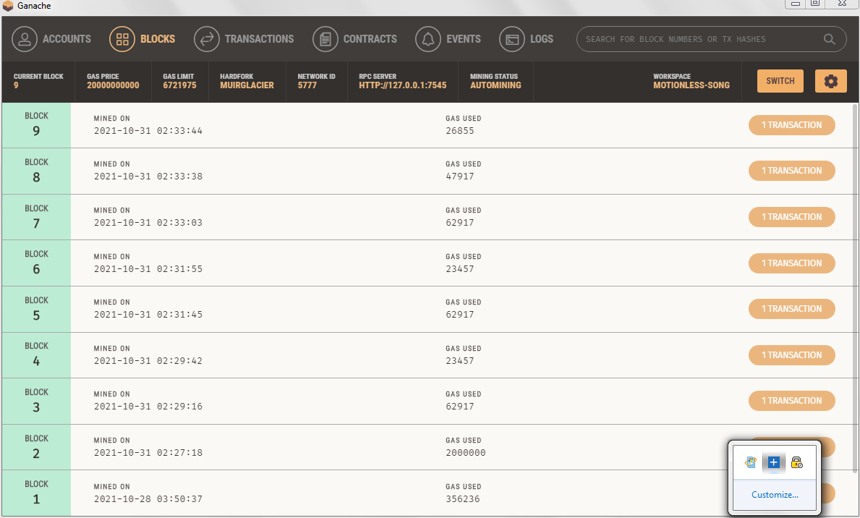

**CONTRACT CREATION VS CONTRACT CALL**

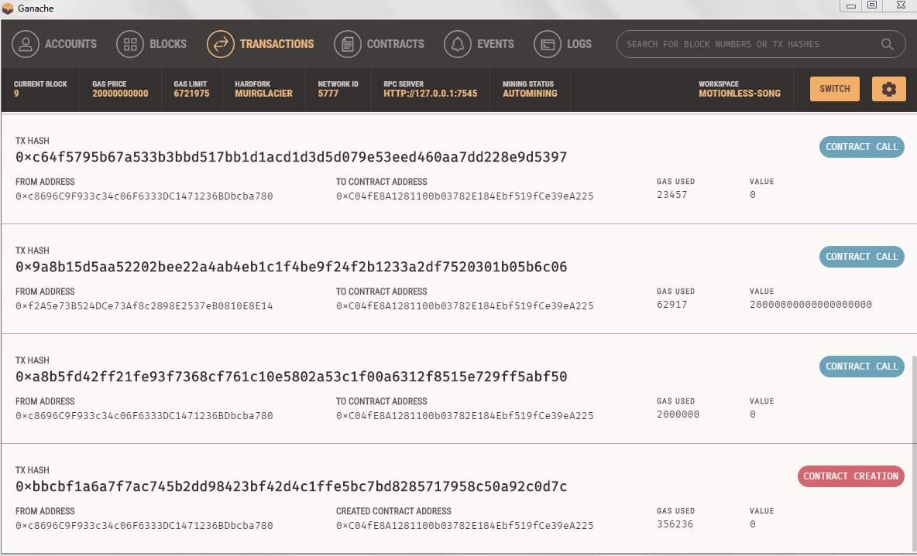

BLOCK 11

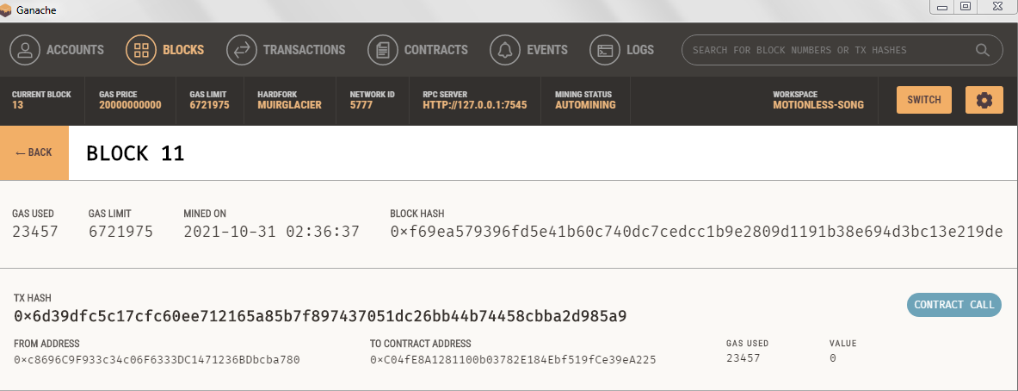

**APPLICATION FLOW:**

**MAKE THE CONTRACT ADDRESS AS EMPTY TO DEPLOY THE CONTRACT**

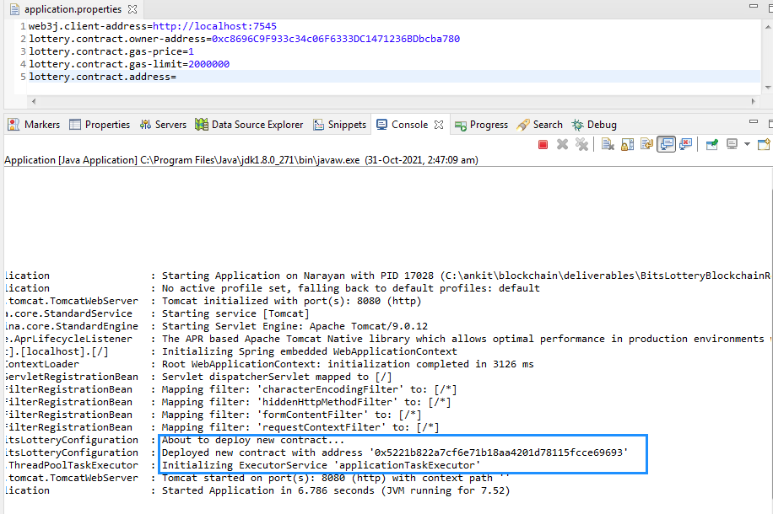

**COPY THE DEPLOYED CONTRACT ADDRESS IN APPLICATION.PROPERTIES TO RUN APPLICATION**

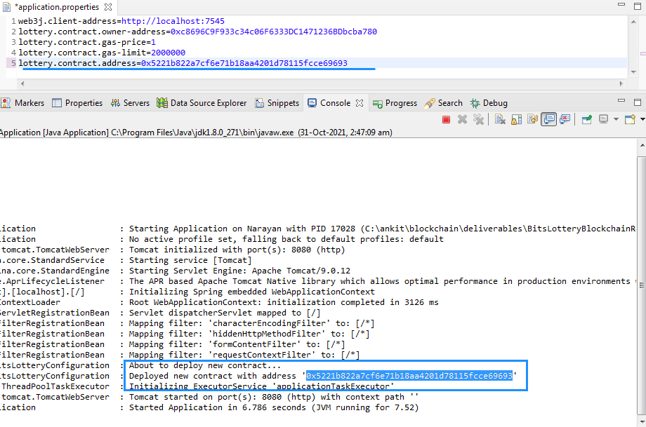

**CONTRACT IS DEPLOYED IN GANACHE**

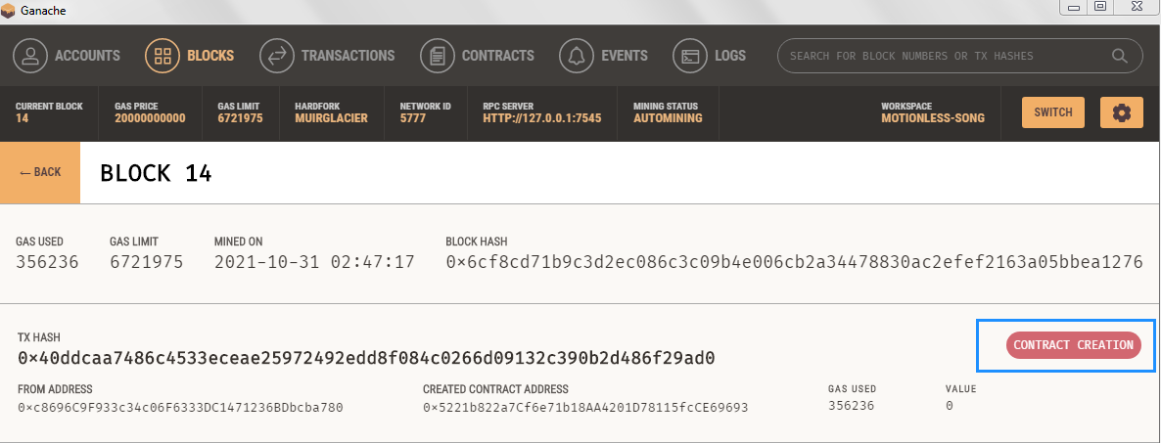

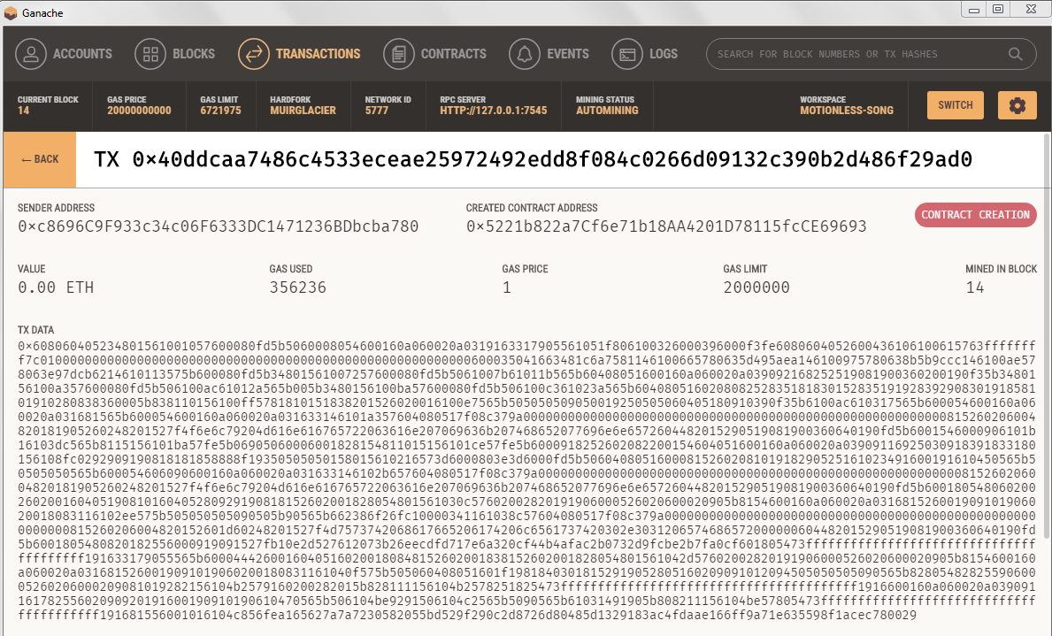

**LOTTERY PLAYERS ARE EMPTY AT CONTRACT CREATION**

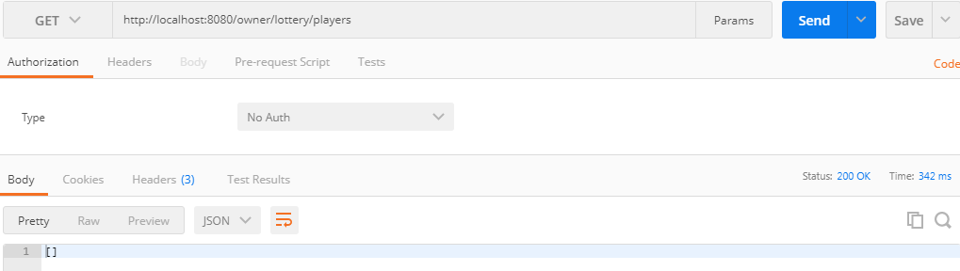

**ADDING LOTTERY PLAYERS**

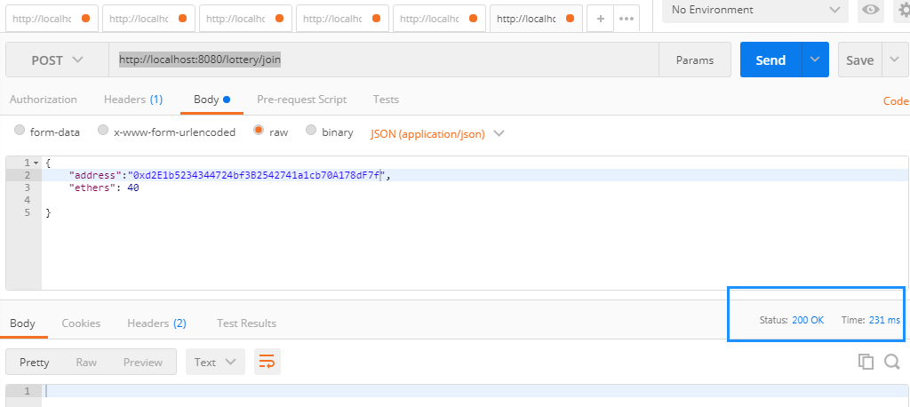

**LOTTERY PLAYERS ADDED**

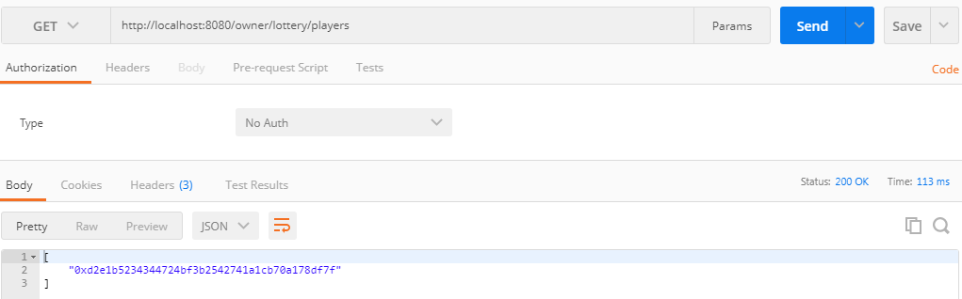

**GANACHE TRANSACTION**

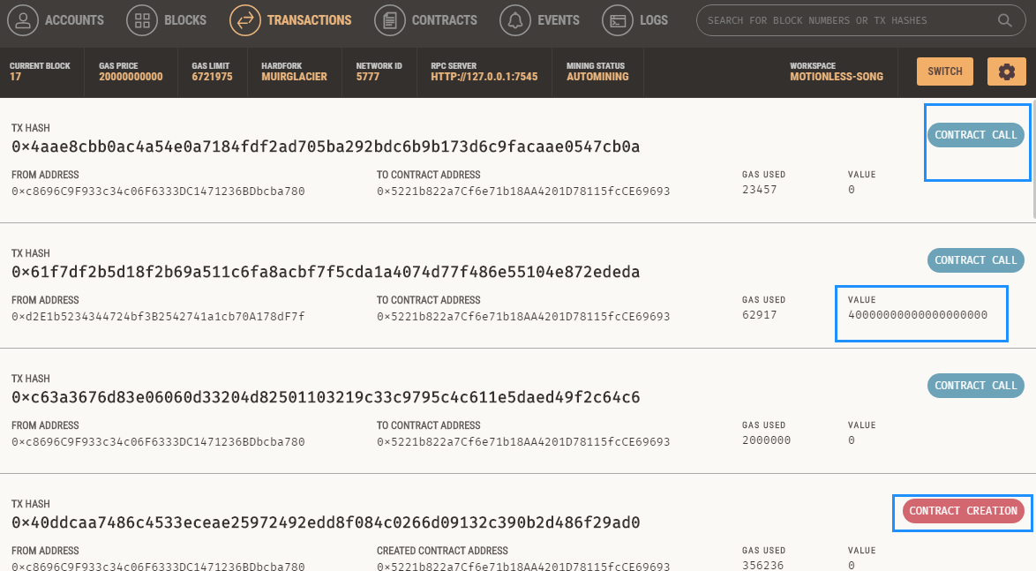

RESOURCES

**APPLICATION -1 – MAKING FIRST LOTTERY CONTRACT**

**Tools: NODE, NPM, GANACHE, METAMASK, RINKEBY TEST NETWORK**

**PLATFORM: LINUX VIRTUAL MACHINE**

**UDEMY COURSE LINK:** [**https://sapient.udemy.com/course/ethereum-and-solidity-the-complete-developers-guide**](https://sapient.udemy.com/course/ethereum-and-solidity-the-complete-developers-guide)

**GITHUB LINK:** [**https://github.com/ankitjain-wiz/BitsLotteryContract**](https://github.com/ankitjain-wiz/BitsLotteryContract)

**GOOGLE DRIVE LINK:** [**https://drive.google.com/drive/folders/1LgScTaWX8SCqNvN1wLFndYfF3NaXbo6v?usp=sharing**](https://drive.google.com/drive/folders/1LgScTaWX8SCqNvN1wLFndYfF3NaXbo6v?usp=sharing)

**APPLICATION -2 LOTTERY REST APPLICATION IN BLOCKCHAIN**

**DESC: NOW WE WILL USE THIS CONTRACT CREATED TO DEVELOP A REST SPRINGBOOT JAVA APPLICATION IN BLOCKCHAIN**

**TOOLS: JAVA, MAVEN, SPRINGBOOT, GANACHE, WEB3S**

**PLATFORM: WINDOWS-7**

**GITHUB LINK:** [**https://github.com/ankitjain-wiz/BitsLotteryBlockchainRestApp**](https://github.com/ankitjain-wiz/BitsLotteryBlockchainRestApp)

**GOOGLE DRIVE LINK:** [**https://drive.google.com/drive/folders/1LgScTaWX8SCqNvN1wLFndYfF3NaXbo6v?usp=sharing**](https://drive.google.com/drive/folders/1LgScTaWX8SCqNvN1wLFndYfF3NaXbo6v?usp=sharing)

**============================================================================================**

**GITHUB LINKS:**

[**https://github.com/ankitjain-wiz/BitsLotteryContract**](https://github.com/ankitjain-wiz/BitsLotteryContract)

[**https://github.com/ankitjain-wiz/BitsLotteryBlockchainRestApp**](https://github.com/ankitjain-wiz/BitsLotteryBlockchainRestApp)

**GOOGLE DRIVE WITH PROOF OF WORK SCREENSHOTS**

**URL:** [**https://drive.google.com/drive/folders/1LgScTaWX8SCqNvN1wLFndYfF3NaXbo6v?usp=sharing**](https://drive.google.com/drive/folders/1LgScTaWX8SCqNvN1wLFndYfF3NaXbo6v?usp=sharing)

**THE END**