FITNESS TRACKER USING DJANGO

A report on
Internet Technology Lab Project
[CSE-3263]

Submitted By
ANKIT KUMAR 210962158
RINCHEN NORBU 210962210



DEPARTMENT OF COMPUTER SCIENCE AND ENGINEERING
MANIPAL INSTITUTE OF TECHNOLOGY,
MANIPAL ACADEMY OF HIGHER EDUCATION
22nd April 2024
FITNESS TRACKER USING DJANGO

Ankit Kumar
Department of Computer Science and Engineering
Manipal Institute of Technology
Manipal Academy of Higher Education, India
ankitk7519@gmail.com
Rinchen Norbu
Department of Computer Science and Engineering
Manipal Institute of Technology
Manipal Academy of Higher Education, India
rinchennorbu441@gmail.com

Abstract— The Fitness Tracker Website, developed using Django, is a comprehensive online platform designed to revolutionize fitness tracking and health management. Focused on delivering an intuitive user experience and robust functionality, the website facilitates seamless tracking of workouts, nutrition, and overall wellness. Users can effortlessly set fitness goals, monitor progress, and access personalized recommendations, enhancing their fitness journey. Key features include user authentication, interactive tracking tools, data visualization, and mobile-responsive interfaces. With an emphasis on scalability, security, and performance optimization, this project aims to redefine fitness tracking by providing a valuable resource for individuals striving for a healthier lifestyle.
Motivation - The motivation behind the Fitness Tracker Website project arises from the growing emphasis on health and wellness in today's society. With lifestyles becoming increasingly hectic, there is a rising need for accessible tools that help individuals track their fitness progress and make informed health decisions. This project aims to fulfil this need by creating a user-friendly online platform that empowers users to take control of their fitness journeys. By offering comprehensive tracking features and personalized recommendations, the website seeks to enhance user well-being and promote a healthier lifestyle.
- Objectives

- Develop a fitness tracking platform with Django for users to monitor health and progress.
- Allow users to set and track fitness goals, including calories, weight, and BMI.
- Provide tools to log daily activities and workouts for routine tracking.
- Offer exercise guides for push, pull, and leg sessions for effective training.
- Create a social feature for users to post updates and interact with likes and dislikes.
- Include a personal info section for managing profile details.
- Ensure secure access with user authentication.
- Design an intuitive interface for easy navigation and engagement.
- Introduction

In today's fast-paced world, health and wellness have become paramount concerns for individuals seeking to lead balanced and active lifestyles. The advent of technology has brought forth innovative solutions, one of which is the Online Fitness Tracking Website developed using Django, a robust Python web framework. This website is designed to cater to the diverse needs of fitness enthusiasts, offering a comprehensive platform for tracking and managing fitness goals effectively.

The Online Fitness Tracking Website represents a paradigm shift in how individuals approach their fitness journeys. It recognizes the importance of accessible, user-friendly tools in promoting well-being and facilitating informed health decisions. By leveraging the power of Django, this website aims to streamline the process of fitness tracking and empower users to take control of their health.

At its core, this Fitness Tracking Website seeks to revolutionize the way individuals engage with their fitness routines. Users can seamlessly register, track workouts, monitor nutrition, set personalized goals, and receive tailored recommendations, all within a secure and intuitive online environment. The website's interactive features and data visualizations enhance user motivation and engagement, fostering a culture of health and wellness.
By emphasizing user experience, scalability, and data security, this Fitness Tracking Website not only meets the current demands of health-conscious individuals but also sets new benchmarks for online fitness tracking platforms. It empowers users to make informed choices, track their progress effectively, and embark on a journey towards a healthier lifestyle.

- Literature review

- GlucoFit: A Web Service for Diabetics
The research paper on "GlucoFit: A Web Service for Diabetics" delves into the development of a platform aimed at assisting diabetics in adopting a healthier lifestyle while managing their condition. GlucoFit integrates exercise monitoring, offers blood glucose and insulin tracking, and includes an exercise suggestion engine. Using Python/Django for backend development, Heroku for deployment, and iOS for the mobile app, GlucoFit provides a comprehensive solution for diabetes management and lifestyle transition.

- Food Calorie Counting Using Django
This research paper presents a system for tracking food calorie intake using the Django web framework. The system calculates the number of calories consumed based on the user's age, height, weight, and the caloric content of their meals. The study emphasizes the importance of a user-friendly interface, social feasibility, and the use of Django for quick development and logical design. The project's main goal is to promote healthy diet and nutrition by providing an easy-to-use platform for tracking calorie intake.

- Body Posture Detection
This paper discusses the integration of a health tracker with a web application using Django for body posture detection and motion tracking. The system uses machine learning models to track the user's exercise count and display it on the screen. The application also includes a section for displaying diet recommendations provided by the doctor. The study highlights the need for continuous monitoring of exercise and diet plans, especially for senior citizens and those living in remote areas.

- Real-Time health monitoring system
This project work aims to develop a real-time health monitoring system for monitoring a patient's heart rate, blood pressure, and temperature. The system uses Python Django as the web framework for developing interactive web pages and HeartPy for creating simulations of a patient's health status. The proposed model enables users to improve health-related risks and reduce healthcare costs by collecting, recording, analyzing, and sharing large data streams in real-time.
- Methodology

The development process of the Fitness Tracker Website was meticulously structured, involving a series of iterative steps to ensure the creation of a robust, user-centric platform tailored to the unique needs of fitness enthusiasts and health-conscious individuals. The methodology encompassed the following key stages:

Planning and Requirements Analysis: The project initiation phase was characterized by in-depth planning and extensive requirements analysis. This involved conducting stakeholder interviews, surveys, and market research to gain a deep understanding of user preferences, pain points, and expectations. Key considerations included user demographics, fitness goals, preferred tracking metrics, and desired features.
A detailed project roadmap was developed, outlining milestones, deliverables, timelines, and resource allocation. This strategic planning phase laid the foundation for subsequent development activities, ensuring alignment with user needs and project objectives.

Database Design and Implementation: Utilizing SQLite as the backend database management system, the project integrated a relational database model consisting of 14 tables. These tables, including 'Home_account','Home_activity', 'Home_dislikedpost', 'Home_likedpost', 'Home_socialpost', 'auth_group', 'auth_group_permissions', 'auth_permission', 'auth_user', 'django_admin_log', 'auth_user_groups', 'auth_user_user_permissions', 'django_content_type', and 'django_migrations', were meticulously designed to store and manage essential data related to user profiles, job listings, authentication permissions, and session management.

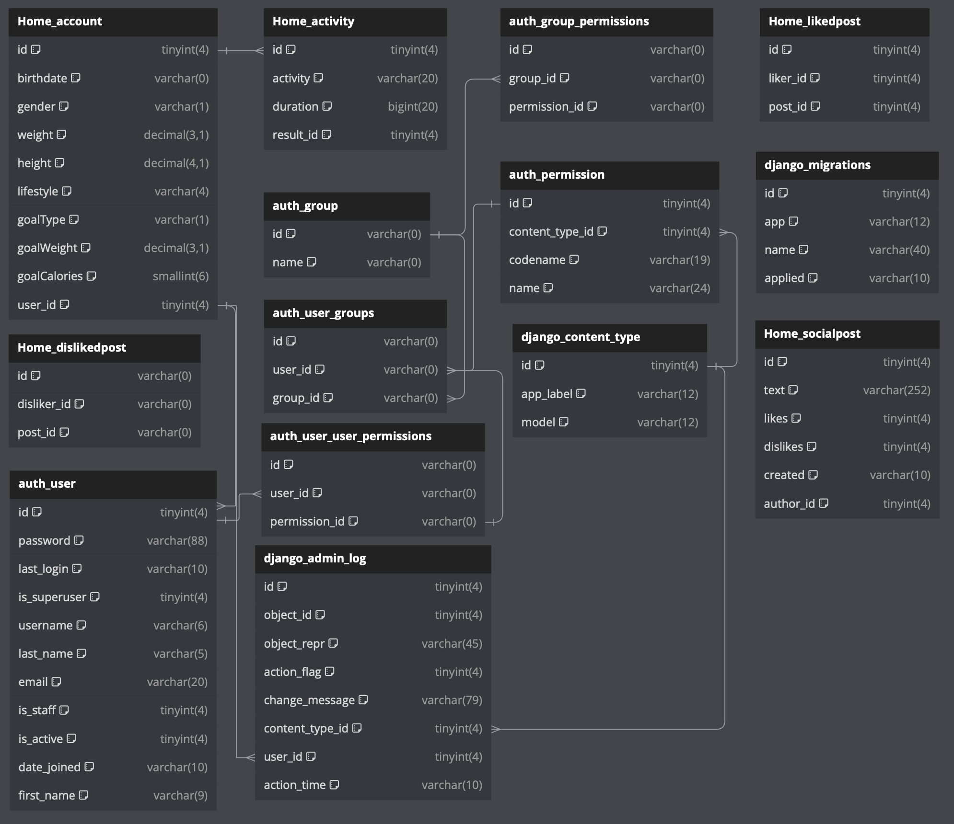
Fig. 9. ER Diagram for database

Frontend and Backend Development: The frontend of the Fitness Tracker was developed using HTML, CSS, and JavaScript, complemented by Bootstrap for responsive design. Meanwhile, Django's powerful ORM facilitated seamless integration between the backend Python code and the SQLite database, enabling efficient data manipulation, retrieval, and storage.
User Authentication and Authorization: Security was paramount in the development process, with Django's built-in authentication system employed to authenticate users, manage user sessions, and enforce access control. User roles and permissions were defined and managed through the integration of Django's authorization mechanisms.
User Interface Design and Experience Optimization: Emphasis was placed on creating an intuitive and engaging user interface to enhance user experience. User-centric design principles guided the development of interfaces for Weight and BMI tracker, calorie tracker, training guide and user dashboard functionalities.
Testing and Quality Assurance: Rigorous testing methodologies, including unit testing, integration testing, and user acceptance testing, were employed to identify and rectify any bugs, errors, or inconsistencies within the system. Thorough testing ensured the reliability, performance, and security of the Fitness tracker across various use cases and scenarios.
- results

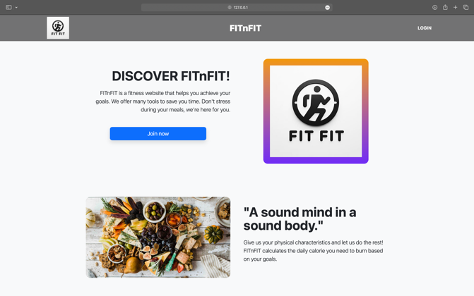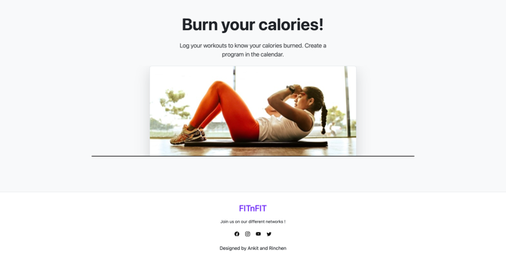
Fig. 2. Home Page

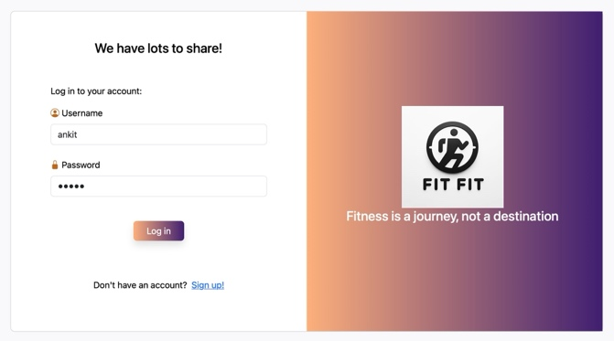
Fig. 3. Login Page

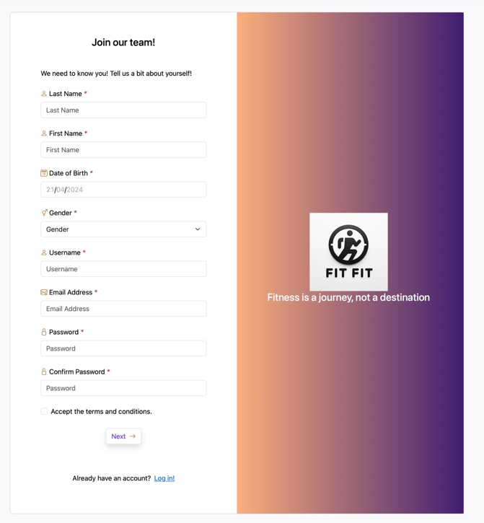Fig. 4. Registration Page

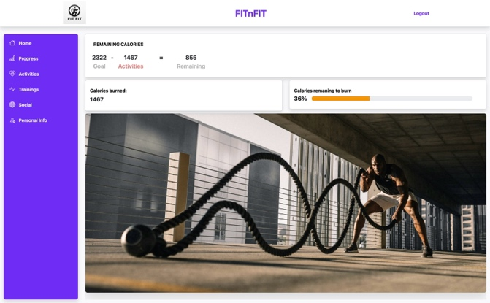
Fig. 5. Account Home Page

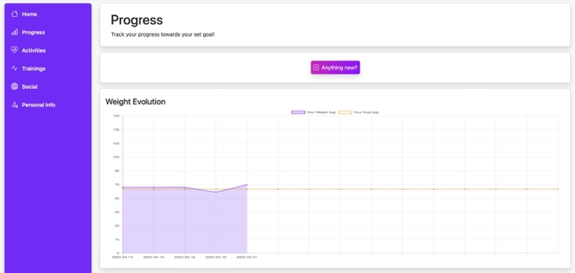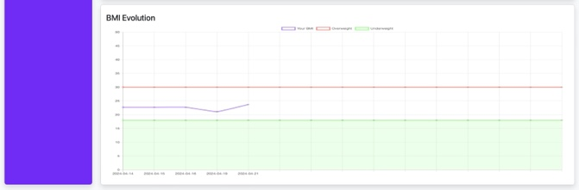
Fig. 6. Progress Page

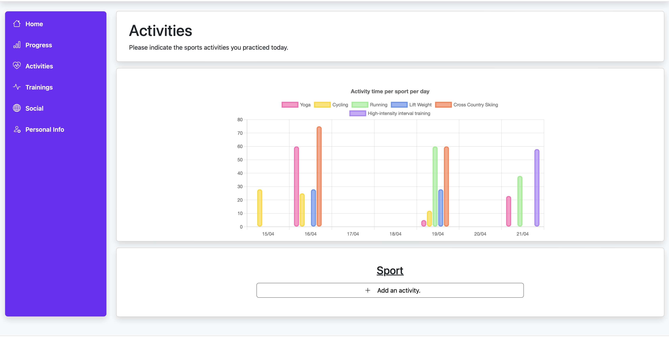
Fig. 7. Activities Page

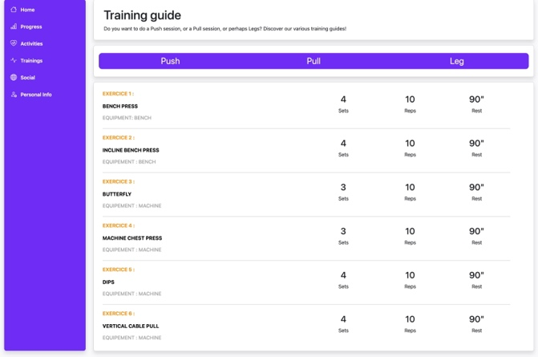
Fig. 8. Training Page

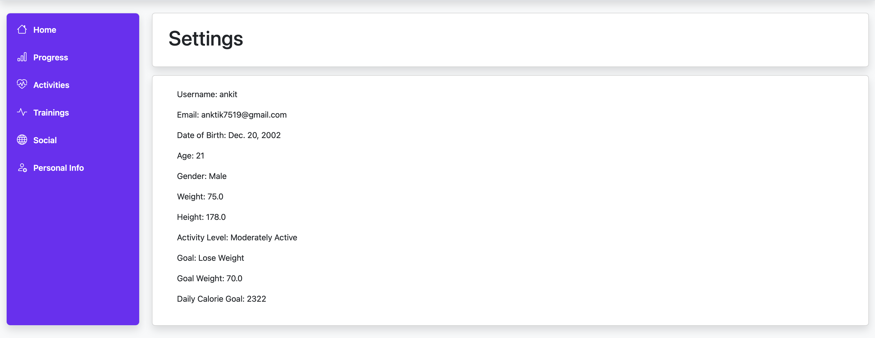
Fig. 9. Personal Page

- Conclusions

The Fitness Tracker Website represents a ground-breaking advancement in health and wellness management, leveraging the robust capabilities of Django and SQLite to provide users with a secure, intuitive, and comprehensive platform. Built upon a foundation of user-centric design principles, the platform offers a seamless experience for individuals striving to achieve their fitness goals effectively. Key features include centralized tracking of weight management, BMI calculations, daily activities, workout sessions, all accessible through a customizable dashboard and interactive charts. Robust authentication mechanisms ensure data privacy and security, allowing users to securely access their accounts and engage with social features. The adaptable design of the platform ensures optimal performance across various devices, including desktops, laptops, tablets, and smartphones, enhancing accessibility and usability for users on-the-go. Looking ahead, the platform holds substantial potential for further enhancements, such as integration with wearable devices, gamification elements, advanced analytics, social features, and personalized coaching, contributing significantly to the progression of fitness tracking methodologies and empowering users to take control of their health and well-being in today's dynamic and competitive landscape.
- Limitations and Possible Improvements

While the Fitness Tracker Website represents a significant step forward in fitness tracking technology, it is essential to acknowledge certain limitations:

- User Engagement: Maintaining consistent user engagement could be a challenge, as users might lose interest over time. Encouraging regular usage and providing incentives or rewards for engagement may be necessary to keep users active on the platform.

- Data Privacy and Security Concerns: Despite rigorous security measures, the fitness tracking website could still face data privacy and security risks. Potential vulnerabilities and data breaches are possible, necessitating continuous security monitoring and regular audits. Encryption of sensitive user data and adherence to privacy regulations such as GDPR are essential to enhance data security and protect user privacy.

- Scalability Challenges: As the fitness tracking website experiences increased user engagement, scalability challenges may emerge. Handling a growing user base and higher data volume could strain the platform's performance. To address this, scalable infrastructure solutions like cloud-based hosting with auto-scaling features can be implemented to ensure optimal performance during peak usage periods.
For future enhancements of the Fitness Tracker, several avenues can be explored to improve and extend their applicability:
- Integration with Wearable Devices: One limitation is the current lack of integration with wearable fitness devices, such as smartwatches and fitness trackers. Future iterations of the platform could explore integration options to enable real-time data syncing, activity tracking, and health monitoring directly from wearable devices, enhancing the accuracy and convenience of fitness data collection.

- Advanced Analytics and Insights: The platform currently provides basic analytics and progress tracking features. Future work could focus on implementing advanced analytics algorithms to derive actionable insights from user data. This could include trend analysis, predictive modelling, and personalized recommendations based on user goals, preferences, and historical data patterns.

- User Feedback and Iterative Improvements: Incorporating user feedback and conducting iterative improvements based on user insights is critical for ongoing success. Future work should prioritize regular user testing, feedback collection mechanisms, and agile development practices to iteratively enhance the platform's functionality, usability, and overall user experience.

- Gamification and Engagement: While the platform includes social features for user interaction, there is potential for further gamification elements to enhance user motivation and engagement. Gamified challenges, rewards systems, achievement badges, and leaderboards could encourage users to stay active, set new goals, and collaborate with peers for a more interactive fitness experience.

- Accessibility and Inclusivity: Ensuring accessibility and inclusivity for users with diverse needs and abilities is an ongoing area of improvement. Future iterations could focus on optimizing the platform's interface, navigation, and content presentation to accommodate users with disabilities, language preferences, and varying levels of tech proficiency.

References

- B. Gislason et al., "Introducing GlucoFit: An Assistive Technology for Monitoring and Managing Diabetes," 2012 Seventh International Conference on Broadband, Wireless Computing, Communication and Applications, Victoria, BC, Canada, 2012, pp. 414-419, doi: 10.1109/BWCCA.2012.74.

- Divya Sri, K.Sai Kalyani, N.Shalini, N.Gnaneswar, "Food Calorie Counting Using Django," Journal of Emerging Technologies and Innovative Research (JETIR), April 2023, Volume 10, Issue 4, pp. a411-a415.

- S.S. Coughlin, M. Whitehead, J.Q. Sheats, J. Mastromonico, D. Hardy, S.A. Smith, "Body Posture Detection and Motion Tracking using AI for Medical Applications," ITM Web of Conferences, April 2022, Volume 44, pp. 03043

- REAL-TIME HEALTH MONITORING SYSTEM," Academia.edu, 2020.

