NLP Applications (AIMLCZG519)
Assignment 2 - Sentiment Analysis Application
Main Assignment Report

Group #37
Team Members
Ankit Kumar Agarwal - 2024aa05560
Chandrababu Yelamuri - 2024aa05820
Preety Gupta - 2023ac05892
Srithin Nair - 2024ab05197
Deepan KG - 2024aa05755

Table of Contents
Executive Summary 3
1 Local Execution Instructions 4
2 Design Choices & Challenges 4
2.1 Design Choices 4
2.2 Challenges Faced 5
3 Screenshots 6
3.1 Proof of BITS OSHA Cloud Lab Usage 6
3.2 Application Opening Screen 8
3.3 Sentiment Analysis – Single chunk 9
3.4 Sentiment Analysis – Multiple chunks (File Upload option) 10
3.5 Details of Multiple Chunks Analysis 11

Executive Summary
This document presents a comprehensive details related to the Assignment Part-A Task-A – “Simple application that can accurately analyze the sentiment (positive, negative, or neutral) of user-provided text.”, including:
- Instructions for running the application locally.
- Design choices and any challenges faced during implementation.
- Screenshots that explain the entire flow of the application.

1 Local Execution Instructions
Follow below steps to set up and run the application on your local machine:
- Prerequisites
- Python 3.8 or higher installed.
- Modern web browser (Chrome, Firefox, Edge).

- Step 1: Install Dependencies
Open your terminal in the project directory and run the below command:
pip install -r requirements.txt

Note: This will install Flask, NLTK, TextBlob, and security extensions like JWT and Limiter.

- Step 2: Start the Backend Server
Run the Flask application:
python app.py

Wait for the message: * Running on http://127.0.0.1:5000.
Note: On the first run, the app will automatically download necessary NLTK corpora (VADER, Tokenizers, WordNet).

- Step 3: Launch the Frontend
You can launch the user interface in two ways:
- Directly: Right-click index.html and "Open with Browser".
- Local Server (Recommended): Visit the site http://127.0.0.1:5000.

2 Design Choices & Challenges

2.1 Design Choices
- Hybrid Sentiment Engine
Instead of relying on a single analyzer, we implemented a Hybrid Decision Logic:
- VADER: Used for its strength in handling social media text, emojis, and intensity (e.g., "GREAT!!!" vs "great").
- TextBlob: Used to validate results through polarity and subjectivity scoring.
- Custom Weighting: We added a keyword-weighing layer (e.g., giving extra "Negative" weight to words like "disappointed" or "waste") to handle edge cases where statistical models often miss.
- UI Layout (Optimized 3-Column Dashboard)
We chose a fixed-height, 3-column grid layout that is visible on a single screen:
- Input (Left): Context-switching between direct text and file uploads (using a tabbed layout)
- Result Metrics (Middle): Immediate visual feedback via color-coded badges and a High-Contrast Bar Chart for score distribution.
- Detailed Analysis (Right): Granular sentence-level breakdown and token visualization.
- Visual Feedback: Integrated CSS animations and an SVG loading timer to enhance user experience during heavy processing.
- Batch Processing Logic
The application automatically detects paragraph breaks in uploaded files. This allows the UI to provide a "Topic Navigator," where users can see the sentiment of the entire file summary or drill down into specific sections.

2.2 Challenges Faced
- Fixed Threshold Bias
- Problem: Default VADER thresholds often labeled mixed reviews (e.g., "It was a good attempt but ultimately a waste of time") as Positive because of the word "good."
- Solution: We fine-tuned the thresholds (shifting the "Neutral" zone from ±0.05 to ±0.1) and added a "negation-checker" that penalizes positive words when follow-up disappointment keywords are detected.
- UI Alignment & Column Synchronization
- Problem: With varying text lengths, the three columns often had uneven heights.
- Solution: Matched the height of all columns to ensure that the dashboard always looks like a professional desktop application, regardless of screen size.
- Processing Performance for Large Files
- Problem: Large .txt documents (up to 50,000 characters) caused the browser to hang while waiting for a response.
- Solution: Optimized the backend with efficient regex cleaning and chunk-based processing, while adding a robust frontend loading state to prevent redundant API calls.

3 Screenshots

Proof of BITS OSHA Cloud Lab Usage
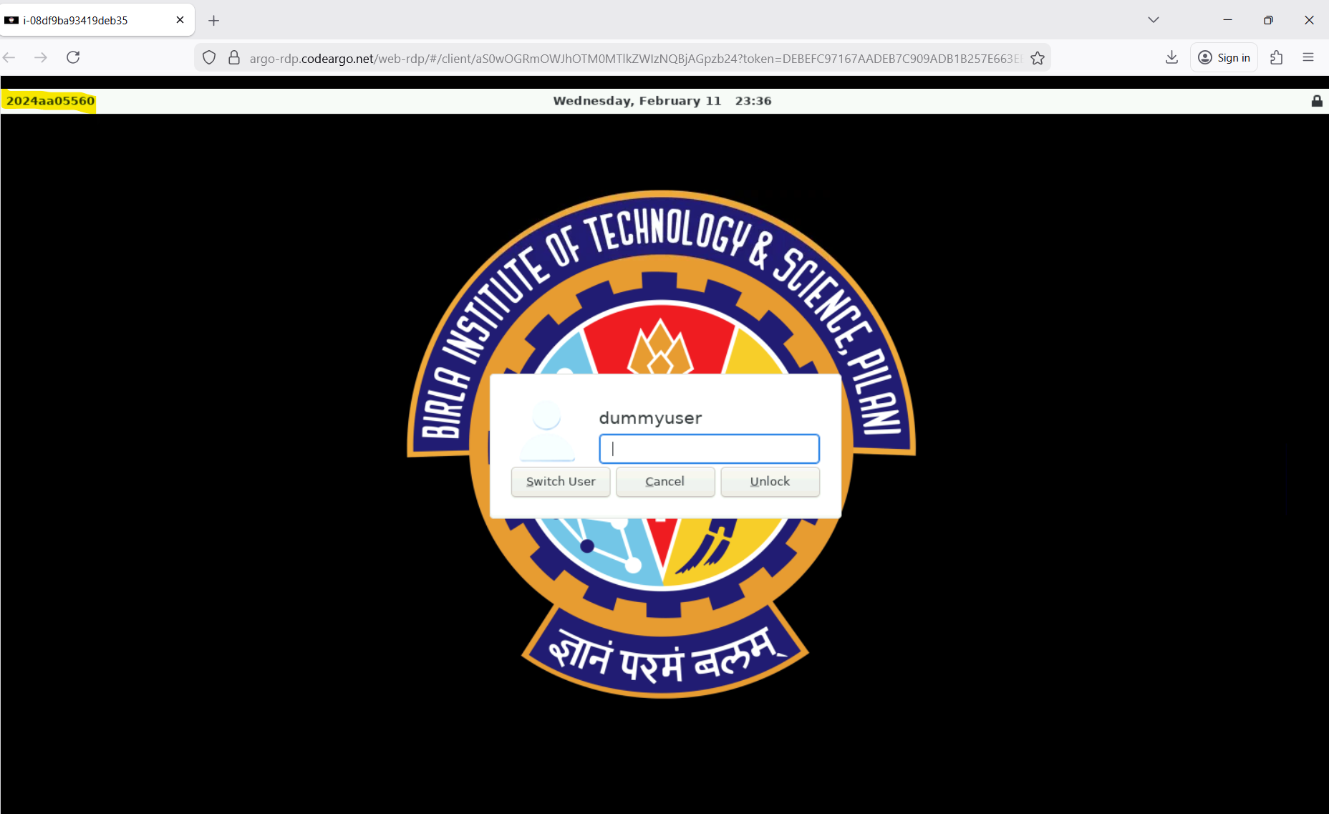
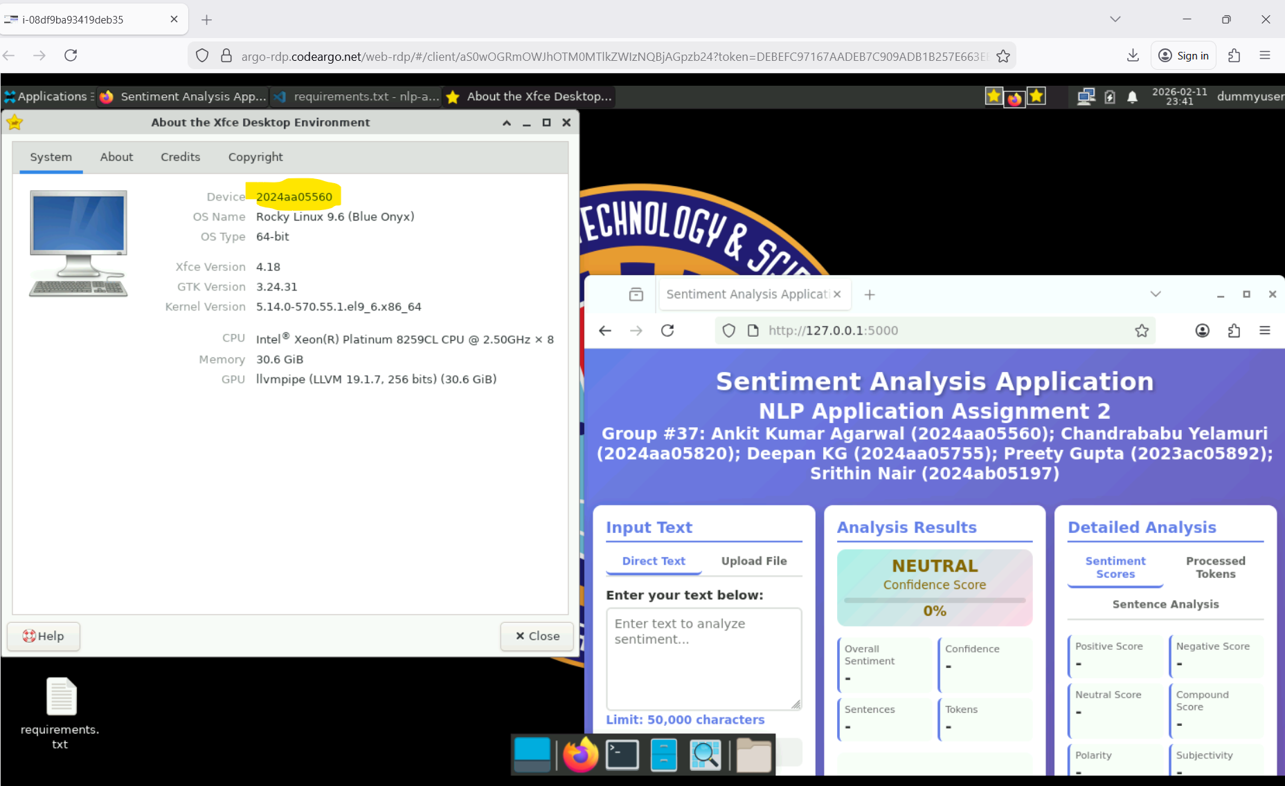
Figure 1: BITS OSHA Lab with BITS Logo on the RDP and Student ID highlighted
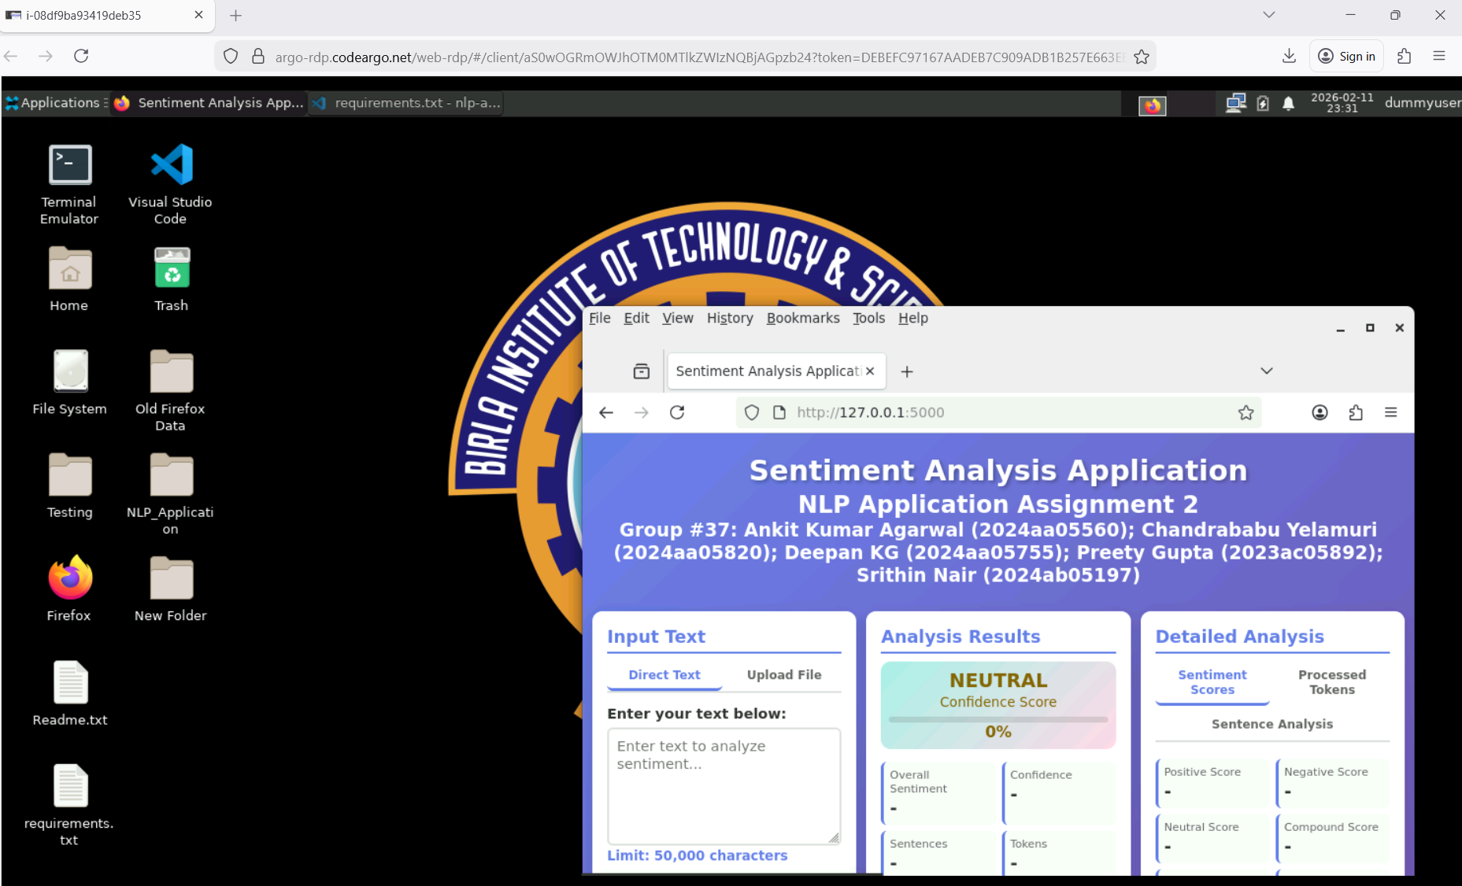
Figure 2: Application GUI running in the Browser on the BITS OSHA Cloud RDP
Note: The BITS logo on the Desktop shows that the application is running on the BITS OSHA Lab portal

Application Opening Screen
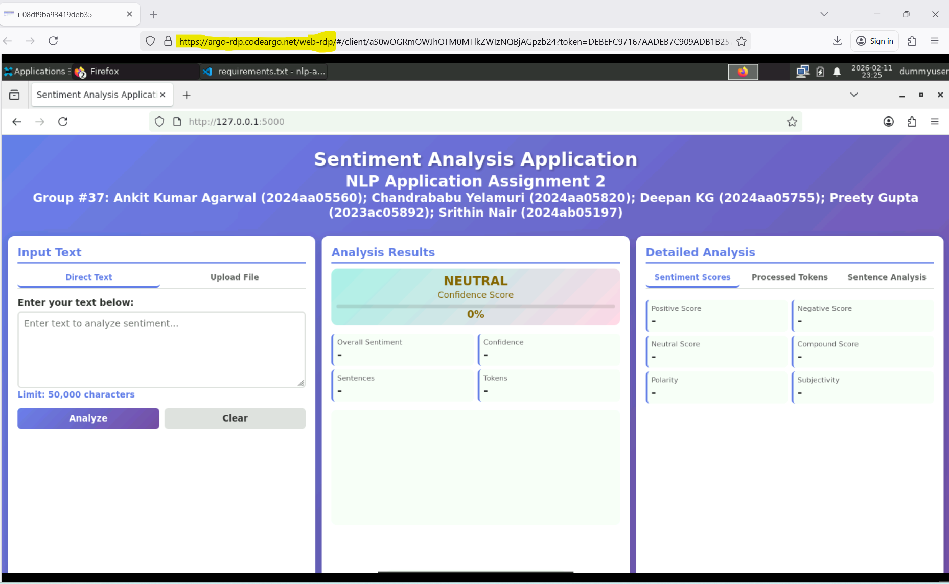
Figure 3: Application GUI opening screen on the browser

Sentiment Analysis – Single chunk
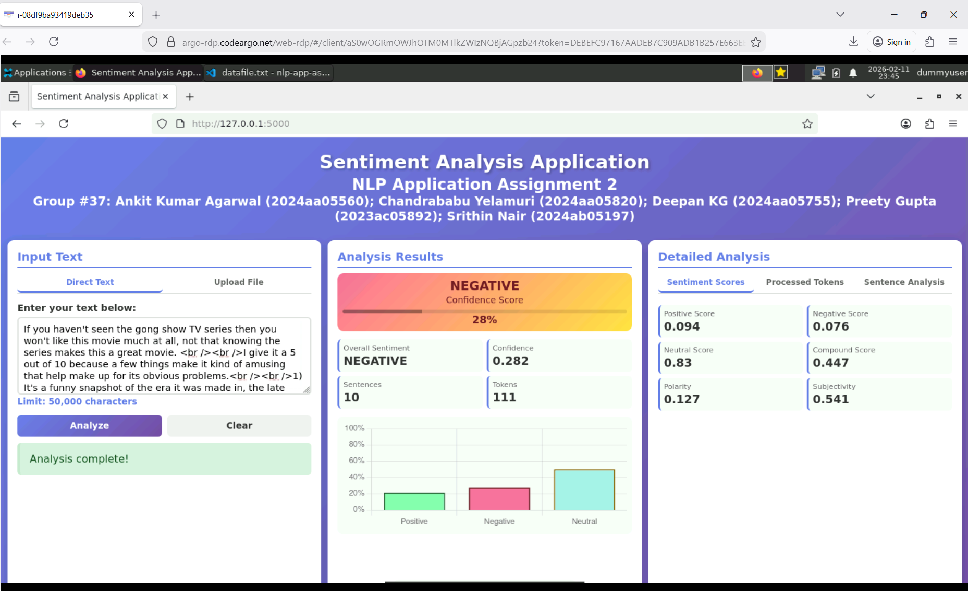
Figure 4: Example showing Sentiment Analysis of single chunk of text

Sentiment Analysis – Multiple chunks (File Upload option)
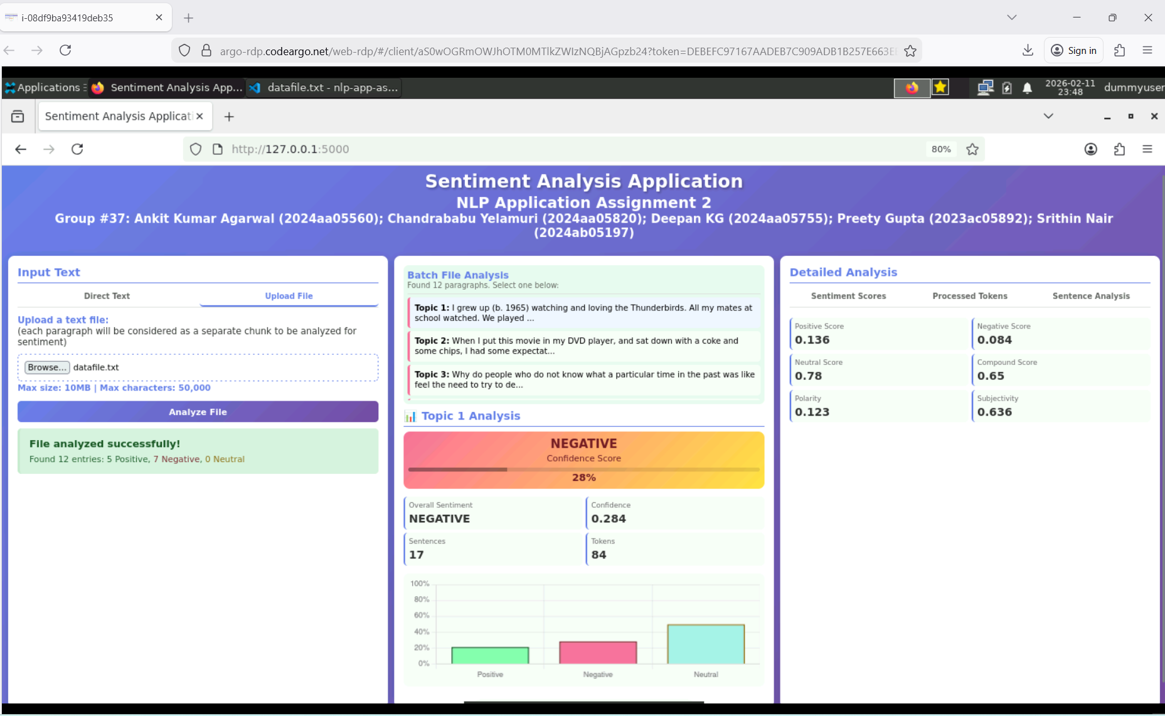
Figure 4: Example showing Sentiment Analysis of multiple chunks in an uploaded text file

Details of Multiple Chunks Analysis
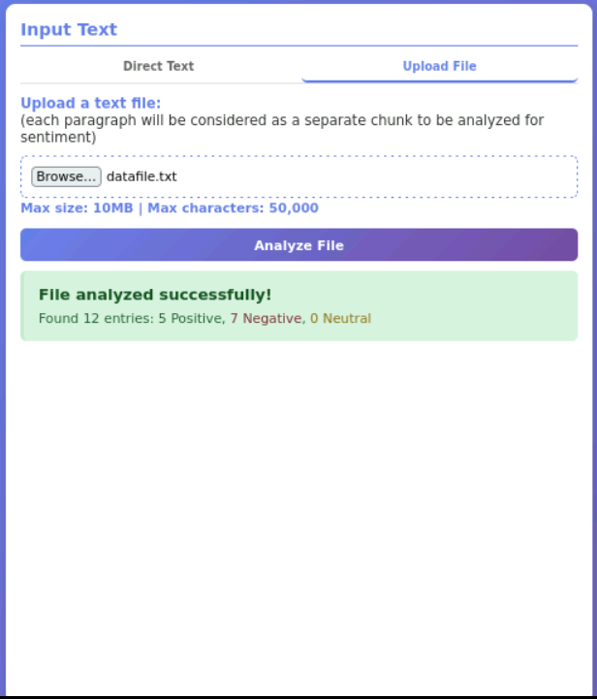
Figure 5: After analysis, “Input Text” column shows a quick summary of the content shows total number of entries, with Positive/Negative/Neutral entries
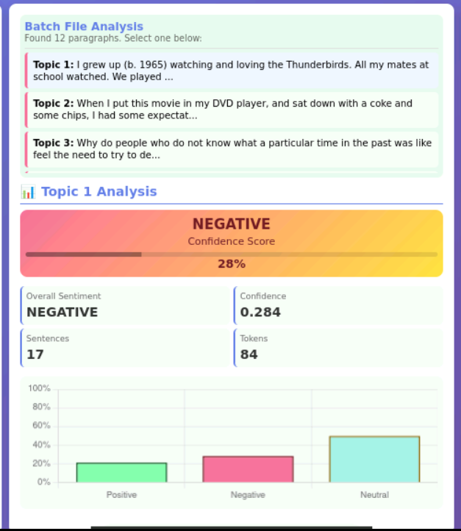
Figure 6: After analysis, “Batch File Analysis” column lists all the chunks at the top and shows the analysis of the selected chunk at the bottom
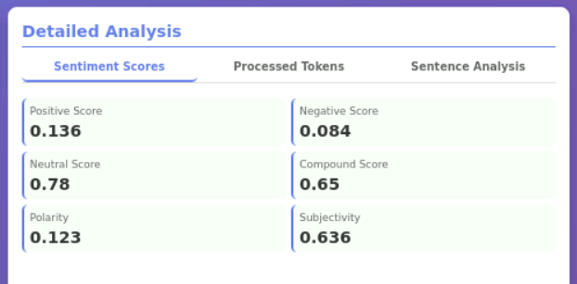
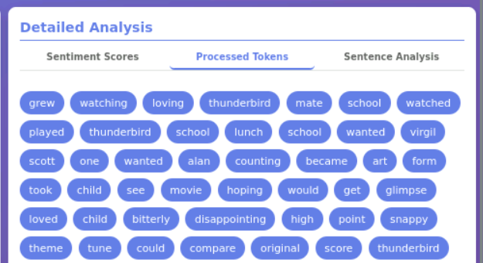
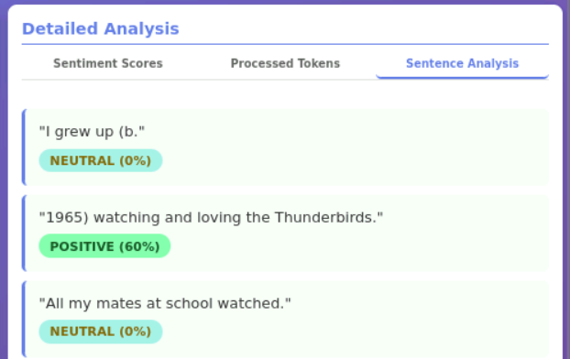
Figure 7: “Detailed Analysis” column shows the Sentiment Scores, list of Processed Tokens and individual Sentence Analysis for the selected chunk

