PMD and Sonar reports are attached in the folder with DDL and DML queries. Also class diagram is attached in the folder and also present in the resources folder of the project.

Database Set Up

Database used is MySQL .

Run DDL queries present in DB_DDL_QUERIES

Run DML queries present in DB_DML_QUERIES

Maven Build

Import the project into Eclipse and

Build the maven project from eclipse by right clicking pom.xml and build

Manual Step:

Extract the project named “SecureAppFormLogin” and go inside it and open command prompt from there as pom.xml is present there.

mvn clean

mvn compile

Bootstrapping The Application

Go to class named com.xebia.app. SecureAppApplication and run the application

Now go to browser and hit <http://localhost:8084/login> and below screen will appear :

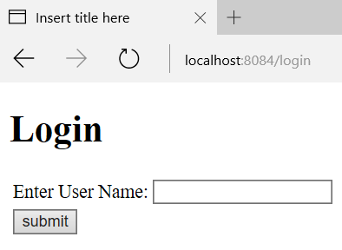

Enter the user name ankit, alok or vishal . this data can be found in TB_USER table . and press enter and below screen will appear :

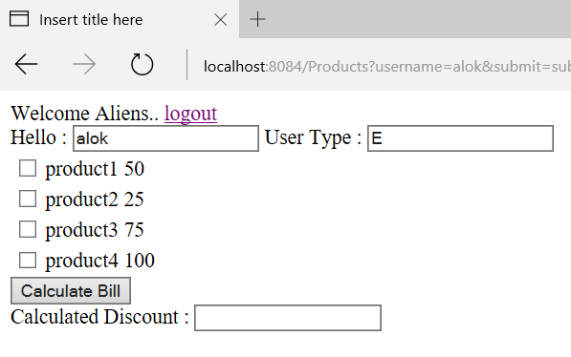

Select the products and press calculate bill and net payable amount will be shown to user.