‍‍****

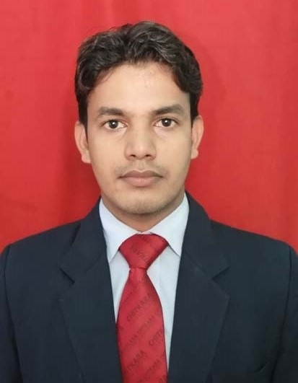

**CHITKARA INSTITUTE OF ENGINEERING & TECHNOLOGY**

Ankit Keshari

#H17, Gangapur, Varanasi, UP

Pin code:221302

+91-9501671533,

ankitkeshri719@gmail.com

Education

|  |  |  |  |  |
| --- | --- | --- | --- | --- |
| **Qualification** | **College/School** | **Percentage/CGPA** | **University/Board** | **Year** |
| B.E(CSE) | Chitkara School of Engg, & Tech, Punjab | 7.96 | Chitkara University | 2013-2017 |
| Class XII | Sant Atulanand Convent School Varanasi | 68.8% | CBSE | 2012-2013 |
| Class X | Oasis Public School, Varanasi | 8.8 | CBSE | 2010-2011 |

Project and Training

* **Underwent an Online course on Android app development Training at Udacity from Oct’15 – Jan’15.**

The training involved tools to create apps, including Android Studio, Android SDK, and testing devices. Also learned some of the core classes that make apps including activities, layouts, views, list views and adapter.

**Project made: Movie DB App (Dec’15)**

A movie database app which helps user to find the latest information of movies with photos and trailers. It includes a user interface with a grid of movies posters which allowed users to get information’s about latest, popular and top-rated movies and also provide a screen with additional information about a particular movies selected by the user.

Technologies used: Java, MYSQL, XML

* **Underwent Core Java Training at HCL, Chandigarh from May’15 – July’15.**

The training included working on Java based software and learning based on current technologies and also some graphical user interface (GUI) application.

**Project made: Scientific Calculator (July’15)**

A simple scientific calculator with logarithmic, exponential, trigonometry function along with simple mathematical function.

Technologies used: Java

* **Underwent CCNA Networking Training at Chitkara University, Rajpura from June’14’ to July ‘14’.**

The training included working on networking based component like router, switch and cisco packet tracer software and its learning based on current communication technology skill.

**Language and Technology**

* **Programming Language and Algorithm:** Java (proficient); C; Data Structure; SQL(MYSQL)
* **Application Software:** Android Studio; Net Beans
* **Operating System:** window 8; window 10

**Achievement**

* **Academic**
* Member of University Code Academy (UCA) since 2015.
* Secured Second Position in Inter-College Computer Science competition “Trend Setter” in 2014.
* **Sports**
* Won 2nd Prize in Chitkara University’s T20 League (CTL) held in April 2014.
* Won 1st Prize in School Cricket competition held in April 2010.
* Won 1st Prize in School Volleyball competition held in April 2010.

CO-CURRICULAR ACTIVIES

* Participated in the workshop organized on Android by Mr. Manish Kumar in University, 2015.
* Participated in event named “Pirates of Silicon Valley” organized by IEEE & ACM in Collage on TECHXPLORE in 2014.
* Participated in “International Youth Fellowship (IYF) World Camp” organized by Christian in Collage in Oct’13.

**Hobbies and Interest**

* Video editing
* Playing Cricket
* Travelling

**(Ankit Keshari)**