Product Design

Team | Team 39,  Word Sense Disambiguation Using Crowd Sourcing Mode  Abhinav Pandey, Ankit Kotak, Jayanth Katuri,  Anubhav Srivastava, Nazrul Haque Athar

Architectural Model

Administrative interface | Component state  - Enables user to take the input a word and the translation of the word in the given sentence and its reasoning.  - Enables the user to add a word,delete a word and delete a account.  Component behavior  - Component enables the application to take user input from the administrator.  - Component stores the response provided by the user into the database.
User interface | Component state  - Enables user to take the input of a word and the translation of the word in the given sentence and its reasoning.  Component Behaviour  - Component enables the application to take user input from the administrator.  - Component stores the response provided by the user into the database.
SQL backend | Component state  - Stores the input provided by the user using MySQL  Component behavior  - Enables the application to take the input a word and its translation.  - Component stores the user input into the database.

User
<<user>>
Admin
<<user>>
Admin Interface
<<interface>>
User Interface
<<interface>>
SQL Backend
<<database>>

Class Diagram(s)

user
Name : String
Id: Int
email_id: String
select_word()
select_sentence()
give_reasons(reason)
give_translation(translation)

word
word: string
id: int
sentence
e_sentence: string
h_sentence: string
Resons:string
Admin
Name: string
Id: int
email_id: string
select_word()
select_sentence()
give_reasons(reason)
give_translation(translation)
add_word(word)
delete_word(word)
add_sentence(sentence)
delete_account(account_id)
Database
Is part of
add / select
select / add / delete
select

Sequence Diagram(s)

ADMINISTRATOR INTERFACE
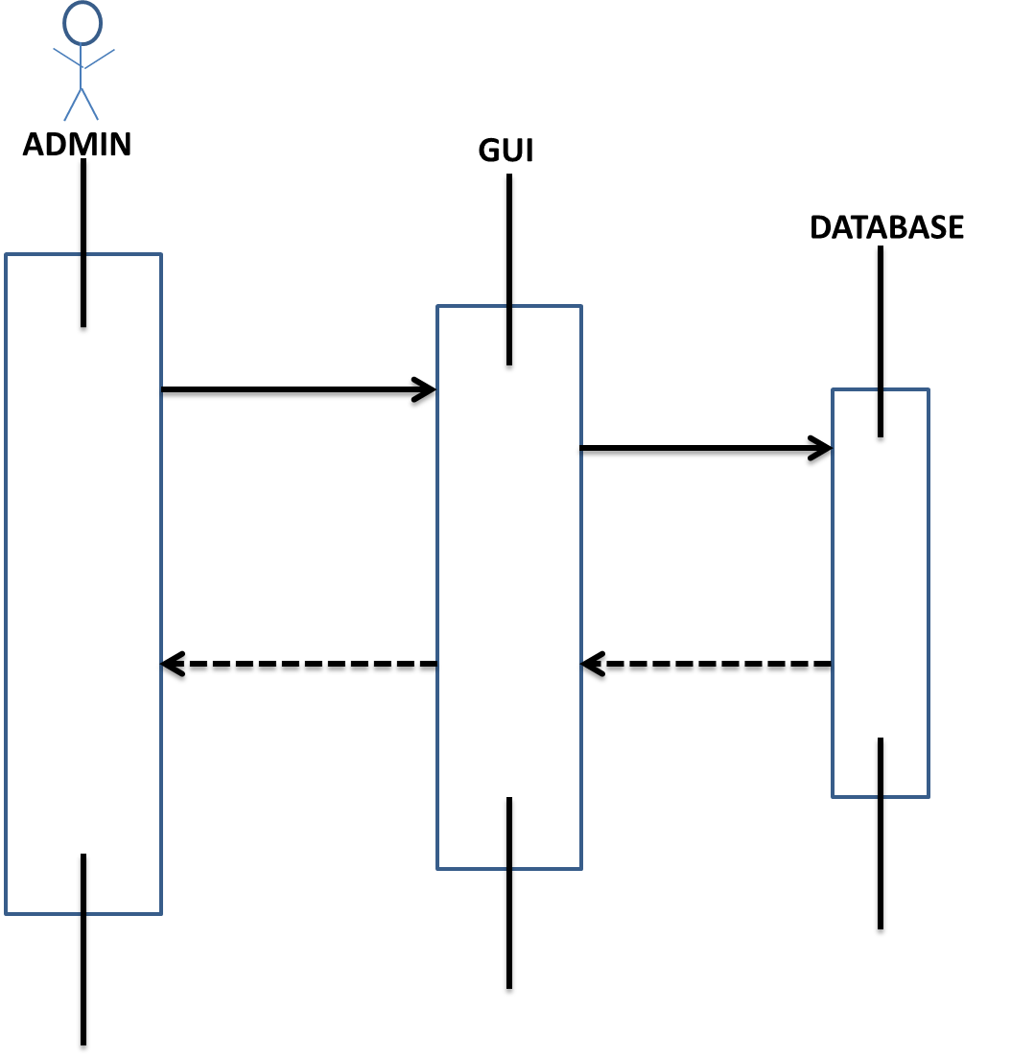
.

USER INTERFACE

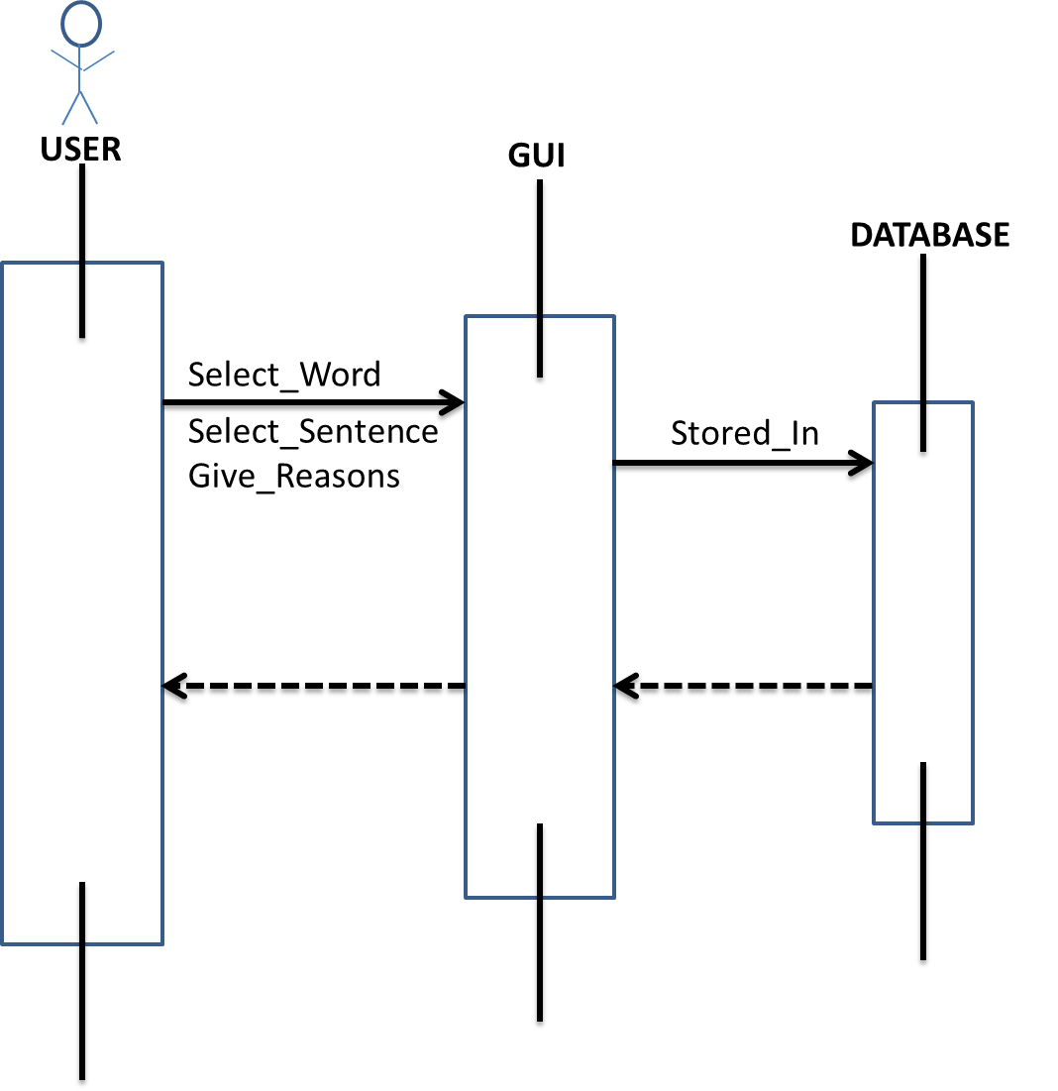

Design Rationale
The Problems initially faced by the team was that everybody was new to the problem being addressed . So measures were taken to substantially break down work for different members of the team so as to give a more productive output.
- The application User Interface was not so user friendly and interactive .Later we realized that it has to be more user friendly and hence better features were added to make it more interesting.
- The application was more focused on taking the reasons in a more direct way. However after communication with the client , appropriate changes were made to the procedure of taking the reasons from the user to make it more detailed .
- We have included a competitive rating system to encourage the user to actively participate in providing input to the application which leads to more accurate results in crowd-sourcing mode.

