Technical Design Document

Project name: **Loan Service App**

By- Ankit Kumar Pandey

Emp Id- 46022665

**Introduction**

**Loan Service App** is created to meet the needs of applying a loan through ABC Bank. The different functional requirements in the project are as follows:

**Functional Requirements**

* Login
* Register
* Apply Loan
* Show Balance
* Foreclose Loan
* Pay EMI
* Calculate EMI
* Print Transaction

**Overall Architecture Diagram**

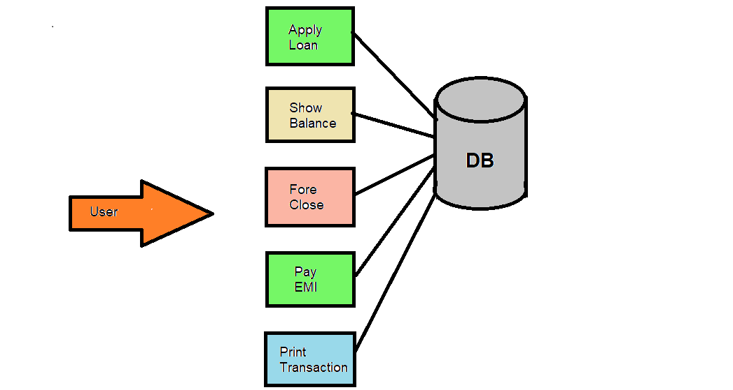

**Entity Relationship Diagram**

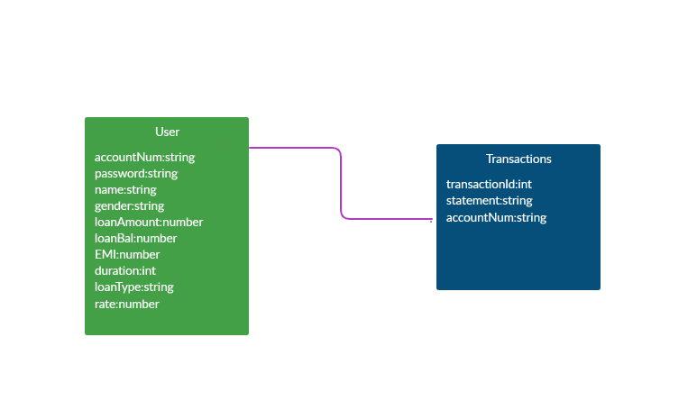

**Class Diagram:**

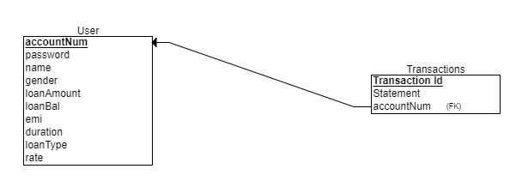

**Activity Diagram**

**Login:**

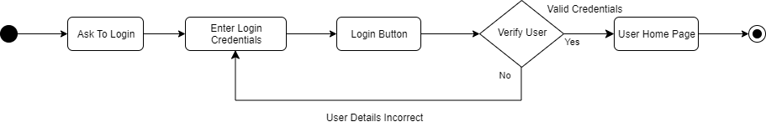

**Register:**

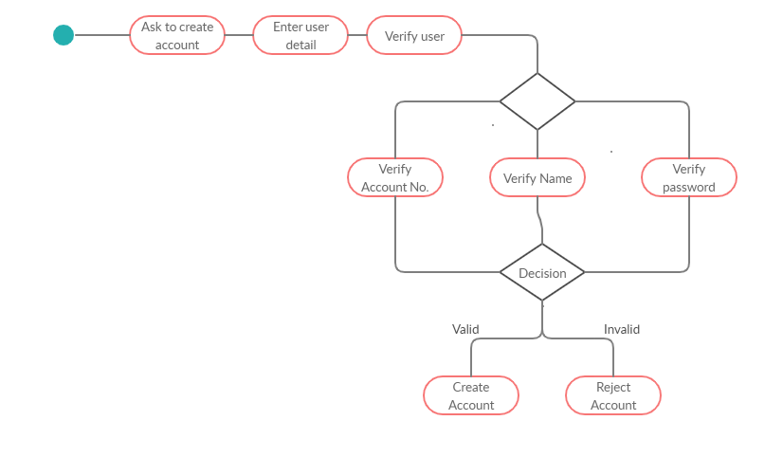

**Apply Loan:**

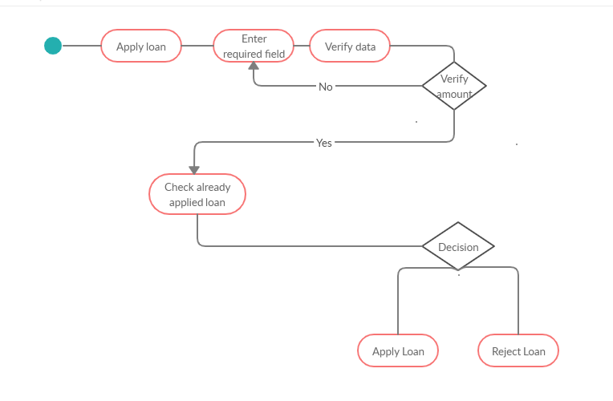

**Foreclose:**

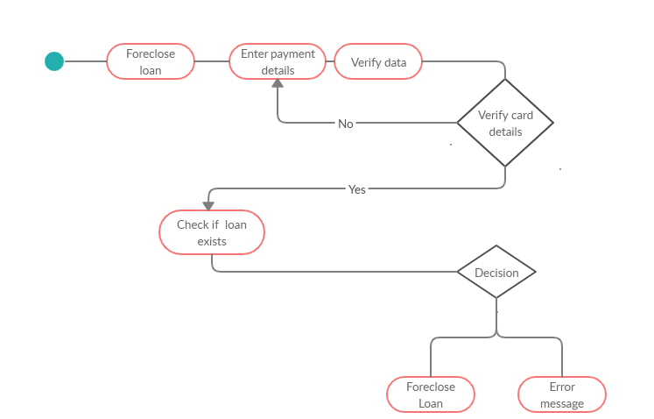

**Pay EMI:**

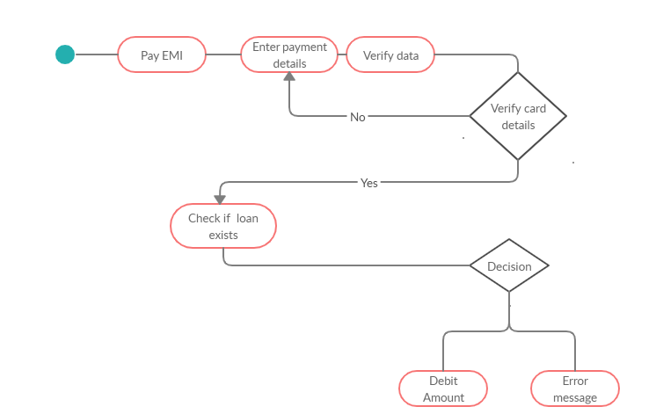

**Wireframes**

**Login:**

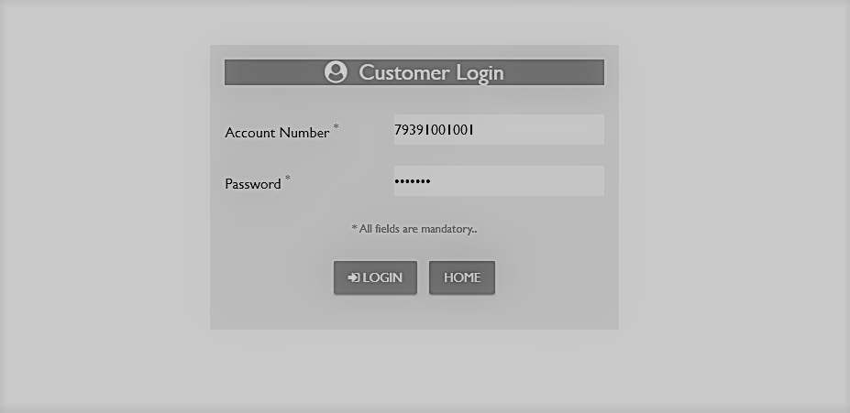

**Register:**

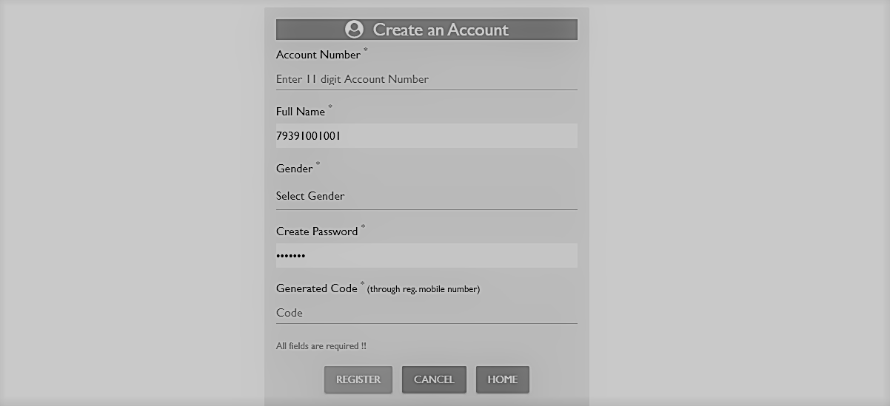

**Apply Loan:**

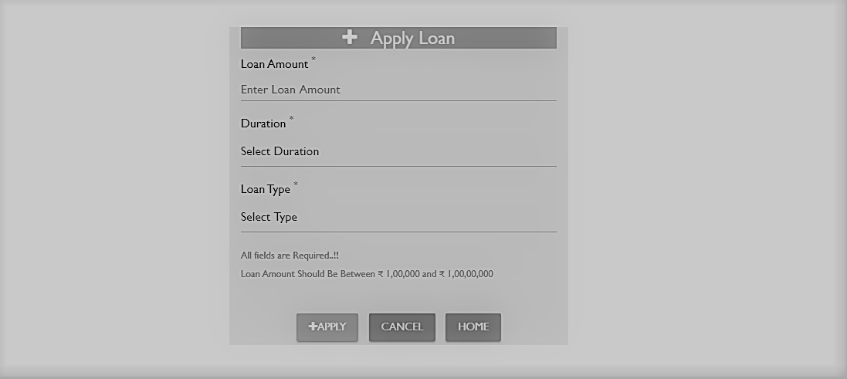

**Balance:**

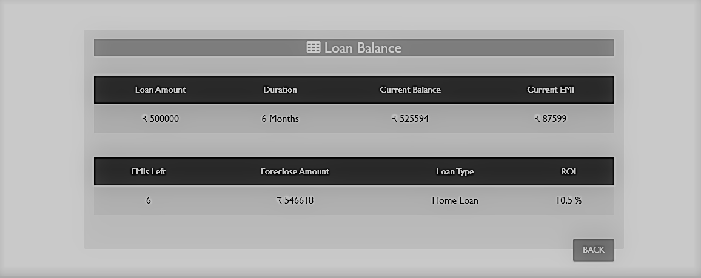

**Foreclose:**

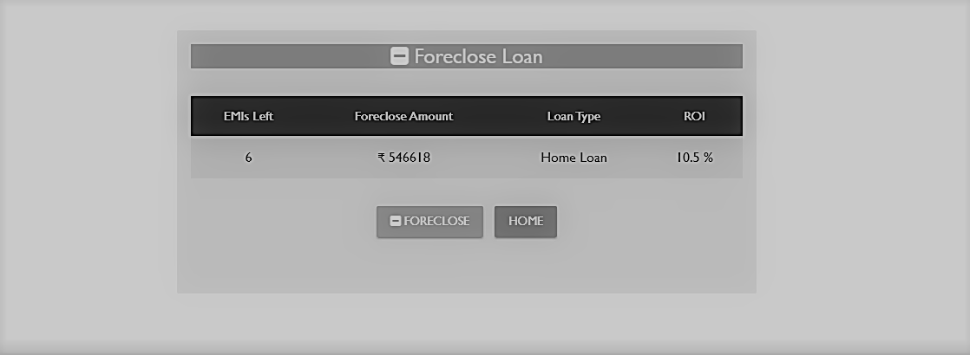

**Pay EMI:**

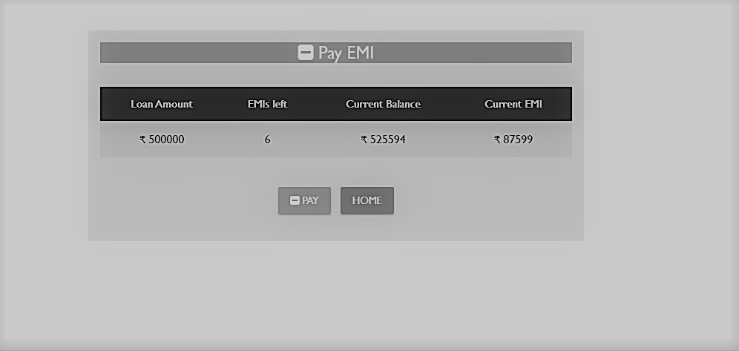

**Payment:**

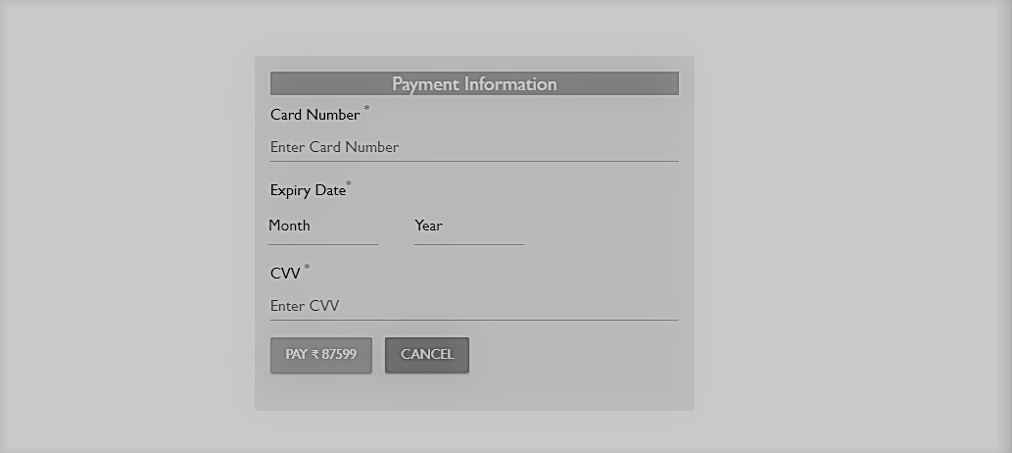

**Calculate EMI:**

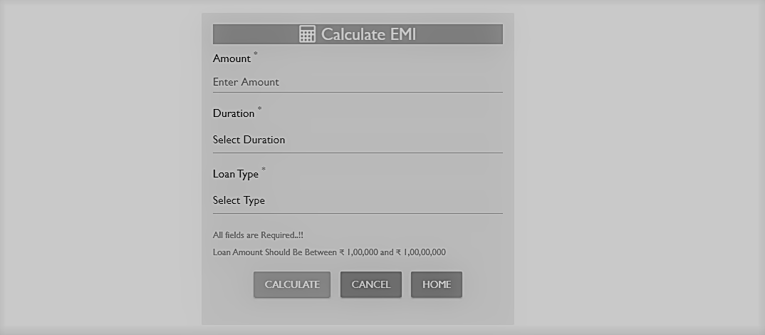

**Print:**

