Apache Kafka
Consolidated Study Notes
Architecture · Delivery Guarantees · Reliability Patterns · Kafka vs RabbitMQ
Compiled from: kafka notes.pdf · kafkaoverview.pdf (Cloudera Runtime) · kfkA details VS RMQ.pdf · Kafka_vs_RabbitMQ_Comparison.docx
Gaps against the target syllabus (idempotent producers, exactly-once semantics, and dead-letter queues) were researched and added — see the “What Was Added” note in each relevant section and the summary on the final page.

Table of Contents

1. Kafka Introduction

1.1 The Data Problem
Modern applications need a way to move data between systems quickly and reliably. Two requirements make this hard:
- You need a way to send data to a central storage location quickly.
- Because machines inevitably fail, you also need data replicated so failures don't cause downtime or data loss.
Apache Kafka is a publish/subscribe based, durable, distributed streaming platform originally developed at LinkedIn and later open-sourced under the Apache Software Foundation. It is written in Java and Scala.

1.2 What Kafka Provides
- Persistent messaging with O(1) disk access — read/write performance is independent of the amount of data already stored.
- High throughput — supports hundreds of thousands to millions of messages per second, even on modest hardware.
- Explicit partitioning — messages are distributed over a cluster of machines to allow data streams larger than the capacity of any one machine.
- Multiple producers and consumers at any time — unlike many traditional queues where one message is consumed by exactly one client, Kafka allows many independent producers and consumer groups to use the same topic without interfering with each other.
- Disk-based retention — consumers do not need to process messages in real time; messages are committed to disk and retained for a configurable period, so there is no danger of losing data while a consumer is offline.
- Online horizontal scalability — the cluster can be expanded with zero downtime and no impact on availability.

1.3 Why Is Kafka Fast?
- Zero copy — Kafka calls the OS kernel directly (sendfile) to move data from disk/page-cache to the network socket, rather than copying through the application (JVM) layer.
- Batching — records are batched into chunks before being sent, which minimizes the network round-trips and per-message overhead.
- Sequential disk I/O — Kafka is designed to always append to the end of a log and read sequentially, avoiding slow random disk access; sequential I/O on spinning disks can rival the throughput of random access in memory.
- Horizontal scale — a single topic can have thousands of partitions spread across thousands of machines, so aggregate throughput scales with the cluster.

1.4 Typical Use Cases
- Activity tracking — the original LinkedIn use case: capturing user activity (page views, clicks, searches) as a stream of events.
- Messaging — decoupled application-to-application notifications, without producers needing to know how consumers will format or use the data.
- Metrics and logging — aggregating operational metrics and logs from many distributed services into a central stream.
- Commit log / Change Data Capture (CDC) — database changes are published to Kafka so downstream applications can react to live updates.
- Stream processing — transforming, joining, and aggregating high-volume datasets in real time (e.g., with Kafka Streams or ksqlDB).
- Big data ingestion — Kafka is a common “speed layer” that offloads data into systems such as HDFS, and feeds real-time applications simultaneously.

1.5 Kafka vs. an Ideal Publish/Subscribe System
An ideal publish-subscribe system would offer unlimited lookback, unlimited storage, no downtime, and unlimited scaling with constant delivery latency. Kafka's architecture approximates this ideal but makes deliberate trade-offs:
- Messaging is implemented on top of a replicated, distributed commit log rather than pure in-memory queues.
- The client (producer/consumer) carries more responsibility and logic than in a “dumb client, smart broker” system — Kafka brokers stay comparatively simple.
- Messaging is optimized for batches of records instead of individual messages.
- Messages are retained on disk even after consumption, so they can be re-read or replayed.
These decisions give Kafka extreme horizontal scalability, very high throughput, high availability, and configurable delivery semantics — at the cost of additional operational and client-side complexity compared to a simpler broker.

2. Kafka Architecture
This section covers the core building blocks of Kafka: brokers, topics, partitions, offsets, consumer groups, and replication — the exact topics required for a solid grasp of Kafka's architecture.
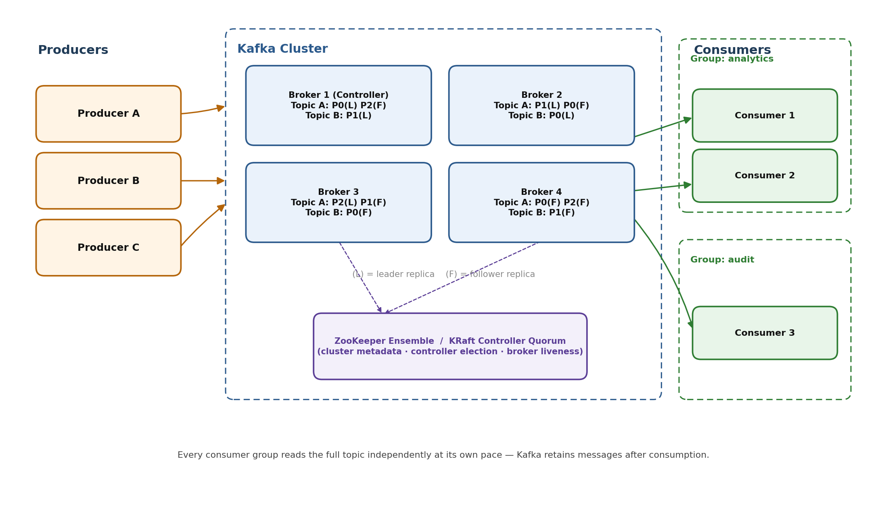
Figure 1. A Kafka cluster: producers writing in, four brokers holding leader/follower partition replicas, the metadata quorum (ZooKeeper/KRaft), and two independent consumer groups reading out.

2.1 Brokers and Clusters
A broker is a single Kafka server. In publish/subscribe terms, a broker is the intermediary that brings together producers and consumers that don't necessarily know about each other. A broker receives messages from producers, assigns them offsets, and commits the messages to storage on disk. Brokers are designed to run as part of a cluster — one broker per host is typical.
- Every broker is also called a “bootstrap server.” A client only needs to know the address of one broker; after the initial connection, the client discovers the whole cluster (all brokers, topics, and partitions), because every broker knows about every other broker.
- If a host goes offline, Kafka does its best to keep the remaining hosts running — this is central to Kafka's “no downtime” and “unlimited scaling” goals.

The Controller
In every cluster, exactly one broker also acts as the cluster controller at any given time. The first broker to start in the cluster typically becomes the controller. In addition to normal broker duties, the controller:
- Performs administrative operations: assigning partitions to brokers and monitoring for broker failures.
- Elects partition leaders (see Replication, below) when a broker holding a leader replica goes down.
Historically, cluster membership and controller election were coordinated through Apache ZooKeeper: brokers register with ZooKeeper, and ZooKeeper acts as the consistent store of configuration information — tracking which brokers are alive, and holding topic and partition metadata. (Newer Kafka versions can instead run in “KRaft” mode, where Kafka manages this metadata itself via a Raft-based quorum of controller nodes, removing the ZooKeeper dependency — the concepts below apply to both.)

2.2 Topics
A topic is a named, logical stream of records — analogous to a database table or a folder in a filesystem. Producers write records to a topic; one or more consumers read from it. A topic is identified by its name (e.g. orders, customers, payments) and that name is part of the cluster's global namespace.
Internally, Kafka stores a topic as an append-only, totally-ordered sequence of records called a log (configured via the log.dir setting, which specifies where log data lives on disk). To let a single topic scale beyond the capacity or throughput of one server, Kafka splits each topic's log into partitions.

2.3 Partitions
A partition is the unit of parallelism and redundancy in Kafka. Each topic is broken down into a number of partitions, and each partition can be hosted on a different broker — allowing a single topic to be scaled horizontally across many machines.

Why Partitions Matter
- They increase throughput by letting multiple brokers, producers, and consumers work on the same topic in parallel.
- They let topic messages spread across several machines so a topic isn't limited by the disk space of a single broker.
- More partitions generally means better parallelism and more consumers can be run concurrently in a group — but also more elections for ZooKeeper/the controller to perform and more file handles opened on the brokers, so partition count is a trade-off, not a “more is always better” knob.

Partition vs. Log
It's easy to conflate a partition with a log, but they describe different things:
- Log: the physical file(s) on disk that back a partition.
- Partition: the logical unit used to split a topic for redundancy and scalability. You can point to the log on disk; the partition itself is a logical concept managed by Kafka.

Partition Assignment and Keys
When a producer sends a message, it can optionally attach a key. If a key is present, Kafka uses a hash of the key to choose the target partition:
Producer -> message(key, value) -> Kafka
target_partition = hash(key) % number_of_partitions
Records with the same key are always routed to the same partition and therefore stay in order relative to one another. If no key is supplied, Kafka distributes records round-robin (or in “sticky” batches, in newer client versions) across the available partitions to balance load. If ordering across the whole topic matters, note that Kafka only guarantees order within a single partition, never across partitions — the two practical ways to get global ordering are to use a single partition (which caps throughput) or to reorder downstream after consumption using a bounded time window.

Records / Messages
In Kafka, a publish-subscribe message is called a record. A record consists of a key/value pair plus metadata, including a timestamp and optional headers (application-specific key-value metadata). Kafka stores keys and values simply as byte arrays — it does not otherwise care about their format, which is why a schema registry (see §2.7) is commonly layered on top.

Logs and Log Segments
Each partition does not keep all of its records in a single file. Instead, Kafka breaks each partition's log into log segments — smaller files bounded by a size limit (log.segment.bytes) or a time limit (log.segment.ms), whichever comes first. The segment currently being written to is called the active segment; it is never deleted, even if retention rules would otherwise remove it. Administration tasks (deletion, compaction) happen at the segment level, not on individual records.

2.4 Producers and Consumers

Producers
A producer creates and publishes records to a topic. The producer does not need to know or care which partition a message lands on — by default it balances messages across all partitions of a topic evenly — but it can direct related messages to the same partition using a message key, as described above.
Flow of sending a message:
- The application creates a ProducerRecord, which must include the target topic and a value, and may optionally include a key and/or an explicit partition.
- The key and value are serialized into byte arrays so they can travel over the network.
- The record is handed to a partitioner. If the record already specifies a partition, the partitioner honors it; otherwise the partitioner selects one (by key hash or round-robin).
- Once a partition is chosen, the producer adds the record to a batch of records destined for that same topic and partition.
- A separate thread sends the batch to the broker that leads that partition.
- When the broker receives the batch, it responds. On success it returns a RecordMetadata object containing <topic, partition, offset>. On failure it returns an error, and the producer may retry sending the message some number of times before giving up.
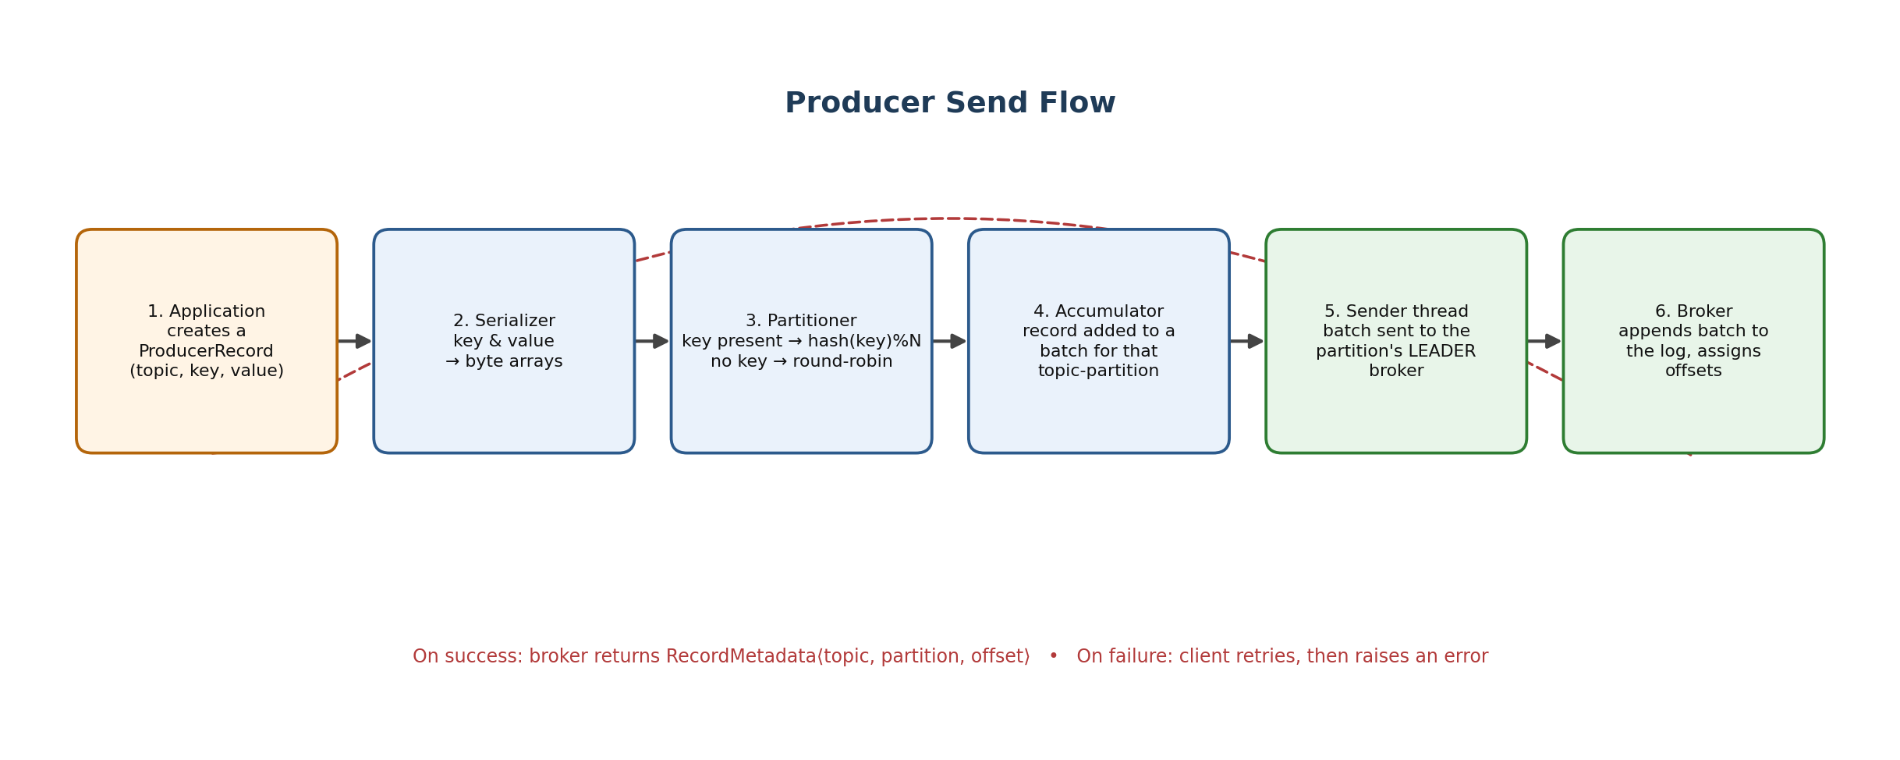
Figure 3. The producer send pipeline, from ProducerRecord creation through serialization, partitioning, and batching to the broker's acknowledgment.

Consumers
A consumer subscribes to one or more topics and reads records in the order they were produced within each partition. A consumer tracks its own position in a partition using the offset — a simple, monotonically increasing integer that Kafka uses to identify a record's position within a partition (starting from 0).
Consumers operate as part of a consumer group: one or more consumers that cooperate to consume a topic. Kafka's key parallelism guarantee is: a partition is only ever consumed by one member of a given consumer group at a time; a single consumer, however, can consume multiple partitions in parallel. If a consumer in the group fails, the remaining members rebalance the partitions to take over the missing member's work.
- If the number of consumers in a group exceeds the number of partitions in a topic, the extra consumers sit idle — they receive no messages.
- Each application (or logical use case) that needs to see the full stream of messages independently should use its own consumer group; every consumer group gets its own copy of the offset-tracking state, so multiple groups can read the same topic at their own pace without interfering with one another.
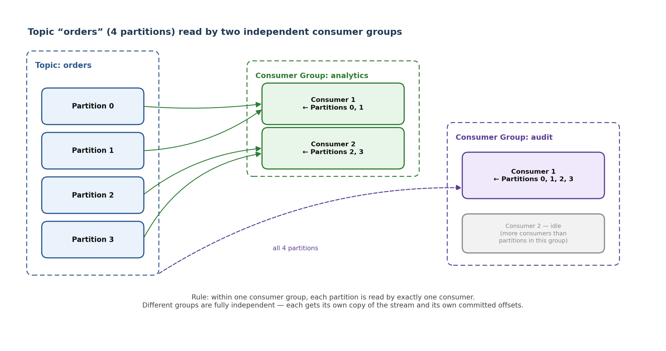
Figure 4. One topic, two independent consumer groups: partitions split across members only within a group; extra consumers beyond the partition count sit idle.

2.5 Consumer Groups and Rebalancing
Coordinating group membership is the job of a group coordinator — one of the Kafka brokers, elected specifically for that group. When a consumer wants to join a group, it sends a request to the group coordinator; the first consumer to join becomes the group leader and is responsible for computing the partition assignment, which the coordinator then distributes to the rest of the group.
Whenever a consumer joins or leaves a group (including a crash, a graceful shutdown, or a newly added consumer), the group coordinator triggers a rebalance: the set of partitions is reassigned across the current members. During an active rebalance, none of the consumers in the group are allowed to read messages, so frequent rebalances directly hurt throughput.

Controlling Consumer Liveness
Setting | Purpose
session.timeout.ms (default 10s) | If the coordinator receives no heartbeat from a consumer within this window, that consumer is presumed dead and the group rebalances. Lowering it makes failure detection — and therefore rebalancing — faster, at the cost of more false positives under transient slowness.
heartbeat.interval.ms (default 3s) | How often the consumer's background heartbeat thread pings the group coordinator to prove it is still alive. Should be well below session.timeout.ms (commonly a third of it).
max.poll.interval.ms | The maximum time allowed between calls to poll(). If application processing takes longer than this, the consumer is considered stuck/dead even though its heartbeat thread is still running, and the group rebalances.

2.6 Offsets and Offset Management
The offset is the position of a record within a partition; it is the mechanism Kafka uses to let a consumer resume exactly where it left off. Kafka distinguishes two related but different offsets per partition, per consumer:
- Current offset: records delivered to the consumer so far.
- Committed offset: records the consumer has finished processing and explicitly acknowledged.
Committed offsets are stored in a special, internal, compacted Kafka topic named __consumer_offsets. If a consumer dies and a new one takes its place (or the group rebalances), the replacement resumes reading from the last committed offset for its assigned partitions — this is what makes Kafka consumption fault-tolerant. If a consumer group doesn't commit progress for a configurable window (offset.retention.minutes, default 7 days) its committed offsets can be aged out.
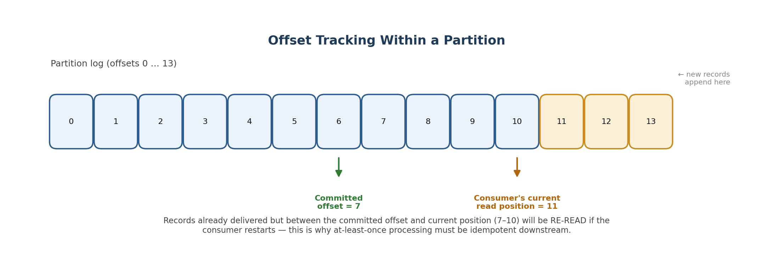
Figure 5. Current position vs. committed offset within a partition — the gap between them is what gets re-read after a restart.

Offset Reset Behaviour
When a consumer has no valid committed offset for a partition (e.g., a brand-new consumer group), auto.offset.reset controls where it starts reading:
- earliest — start from the beginning of the log (replays all retained history).
- latest — start from the end of the log (only new messages from now on).
- none — throw an exception if no committed offset is found, rather than silently picking a starting point.

Committing Offsets
There are two broad strategies for committing (“acknowledging”) offsets:
- Automatic commit (enable.auto.commit=true, tuned via auto.commit.interval.ms) — the client library periodically commits the current offset in the background. This is simple but risky: if a rebalance or crash happens between the auto-commit and the completion of processing, records can be silently skipped (an at-most-once-leaning behaviour) unless processing is kept synchronous with the poll loop.
- Manual commit (enable.auto.commit=false) — the application explicitly commits after it has finished processing a batch, using either:
  - commitSync() — blocks until the broker acknowledges the commit; simple and safe, but adds latency.
  - commitAsync() — non-blocking, higher throughput, but does not automatically retry on failure (retrying a stale async commit can incorrectly overwrite a later, correct commit, so care is needed).

2.7 Replication
Replication is at the heart of Kafka's durability and availability story: it guarantees that a broker failure does not mean data loss or an unavailable partition. Each partition of a topic is copied — replicated — across multiple brokers, according to the topic's replication factor.
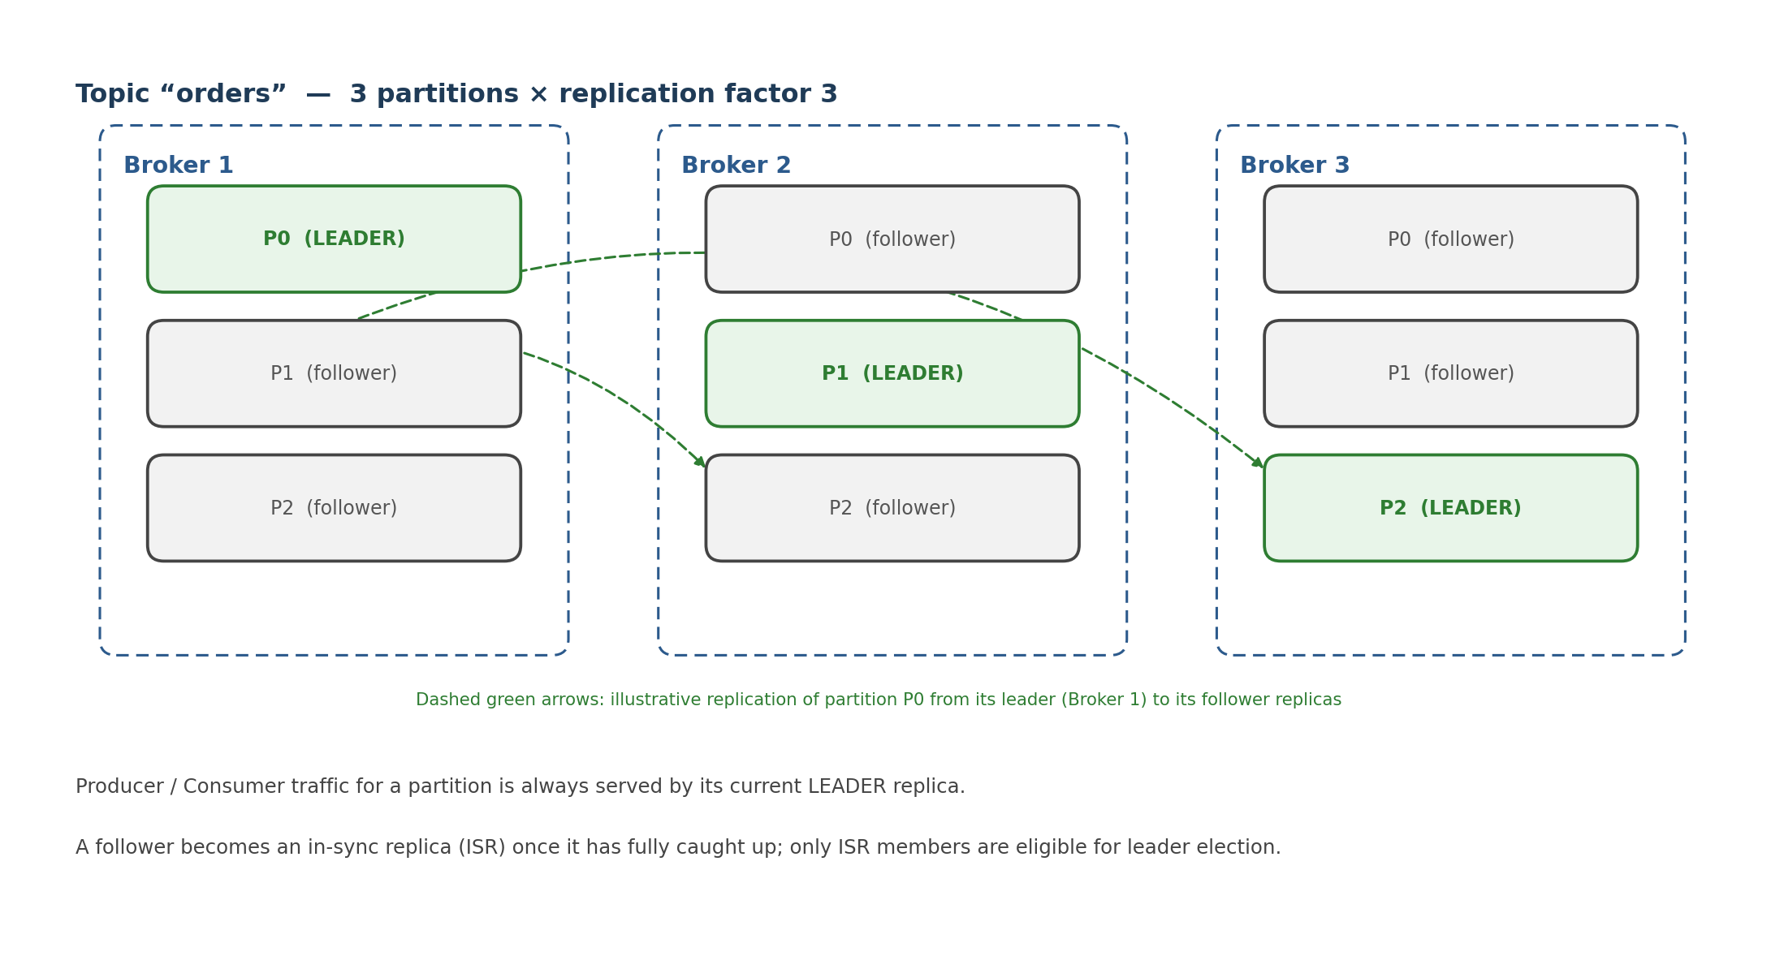
Figure 2. Topic “orders” with 3 partitions and replication factor 3: each partition's leader (bold) lives on a different broker, with the other two brokers holding its follower replicas.

Leaders and Followers
- Leader replica: each partition designates exactly one replica as the leader. All produce and consume requests for that partition go through the leader, which is what lets Kafka guarantee consistency without needing distributed consensus on every read/write. Each partition also has a preferred leader — the replica that was the leader when the topic was first created.
- Follower replica: every other replica of that partition. Followers never serve client reads or writes directly; their only job is to continuously fetch and replicate the leader's most recent records so they can take over quickly if needed.

In-Sync Replicas (ISR)
A follower that has fully caught up to the leader's most recent records is called an in-sync replica (ISR). Only in-sync replicas are eligible to be elected as the new leader if the current leader fails — this protects against “clean but stale” data loss. When the controller detects that a broker has left the cluster, it elects a new leader (from the ISR set) for every partition that broker used to lead.

Choosing a Replication Factor
Replication factor (N) should typically be at least 2, usually 3, and rarely more than 4:
- A higher N tolerates more simultaneous broker failures (N−1 brokers can fail without data loss).
- A higher N also means more copies to write on every produce request, which increases replication traffic and can raise latency, especially with acks=all.
Sizing rule of thumb: with N brokers and topic replication factor M: if M < N, each broker holds a subset of a topic's partitions; if M = N, every broker holds a full copy of the topic's partitions.

Schema Registry (context)
Because Kafka only stores bytes and has no built-in data validation, a bad producer can silently corrupt every downstream consumer. A schema registry is commonly layered in front of Kafka so that data is self-describing and producers/consumers can evolve their data formats (e.g., adding fields) without breaking each other.

3. Delivery Guarantees & Reliability Semantics
What was added: the source notes only briefly named the three delivery semantics and left the “Idempotent Producer” section unfinished, and exactly-once semantics (EOS) via transactions was not covered at all. This section keeps the original material and adds the missing mechanics (idempotent producer internals, and the transactional/EOS protocol), verified against Confluent's engineering documentation.

3.1 The Three Delivery Semantics
“Delivery semantics” describes what a consumer can guarantee about how many times it processes each record, relative to when it commits its offset. Kafka supports all three classical semantics — which one you get is a function of producer and consumer configuration, not a fixed property of the broker.
Semantic | Mechanism | Trade-off
At-most-once | Consumer commits the offset as soon as the message is received, before processing it. | If processing then fails, the message is lost — it will never be re-delivered. Lowest overhead, weakest guarantee.
At-least-once (usually preferred default) | Consumer commits the offset only after the message has been fully processed. | If processing fails or the consumer crashes after processing but before committing, the message is re-delivered and processed again — so downstream processing must be idempotent to avoid duplicate side-effects (e.g. double-charging a payment).
Exactly-once | Requires end-to-end coordination — in Kafka this means either (a) idempotent + transactional producers writing to Kafka, combined with a read_committed consumer, or (b) an external sink with its own idempotent write/upsert semantics. | Strongest guarantee, but only fully available for Kafka-to-Kafka pipelines (e.g. Kafka Streams) out of the box; extra coordinator round-trips add some throughput/latency cost.
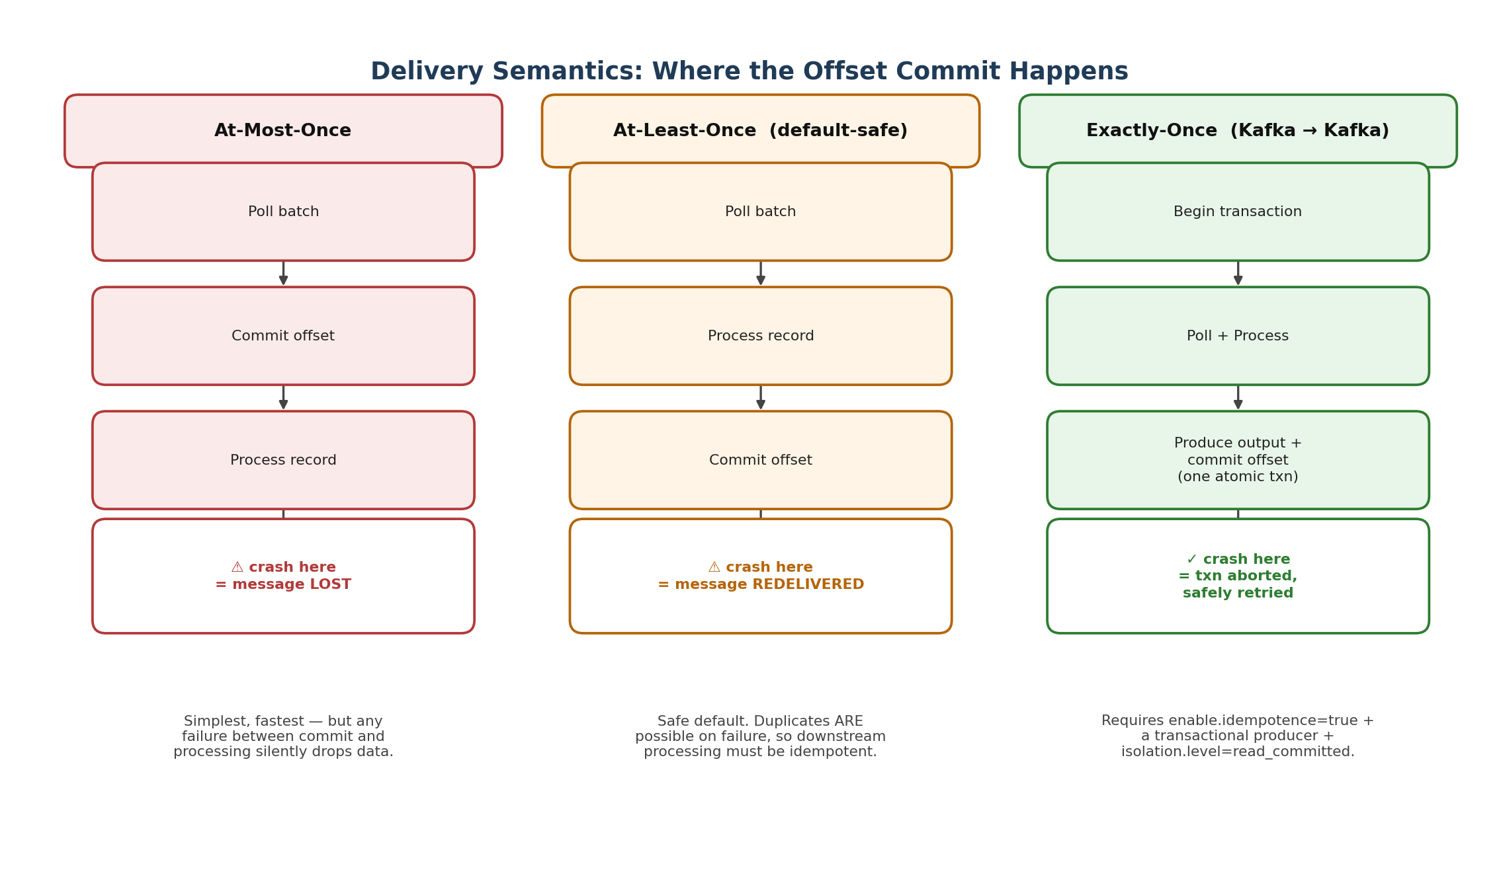
Figure 6. The same poll → process → commit steps, reordered (or wrapped in a transaction) to trade off data loss against duplicate delivery.
On the producer side, a related but distinct setting is acks, which controls how many replicas must acknowledge a write before the producer considers it successful:
- acks=0 — fire-and-forget; the producer doesn't wait for any acknowledgment. Highest throughput, but messages can be silently lost.
- acks=1 — the producer waits only for the partition leader to write the record locally, then moves on. A leader crash before followers replicate can still lose the message.
- acks=all (a.k.a. acks=-1) — the producer waits until every in-sync replica has the record. Combined with min.insync.replicas, this is the strongest durability setting: with replication.factor=3, min.insync.replicas=2, acks=all, the system tolerates one broker outage before the producer starts receiving exceptions on send.

3.2 Idempotency and the Idempotent Producer
Without any special configuration, a Kafka producer can create duplicate messages purely because of network errors: if a broker successfully writes a batch but its acknowledgment is lost in transit, the producer's client-side retry logic sends the same batch again, and the broker — having no way to recognize the resend — appends it a second time. This is the classic cause of duplicate records in an otherwise “at-least-once” pipeline.

How the Idempotent Producer Prevents Duplicates
Setting enable.idempotence=true turns on Kafka's built-in de-duplication for producer retries:
- When an idempotent producer starts, the broker assigns it a unique Producer ID (PID), invisible to the application.
- Every batch the producer sends is tagged with that PID plus a per-partition sequence number that increases by exactly one for every batch.
- The broker tracks the last committed sequence number per (PID, partition) persistently in the replicated log itself — not just in an in-memory connection state, the way TCP sequence numbers work.
- If a batch arrives whose sequence number the broker has already seen and durably recorded for that PID/partition, the broker discards it as a duplicate and simply re-acknowledges the original write, instead of appending it again.
- Because the sequence state lives in the replicated log, this protection survives a leader failover — whichever broker becomes the new leader also knows whether an incoming resend is a duplicate.
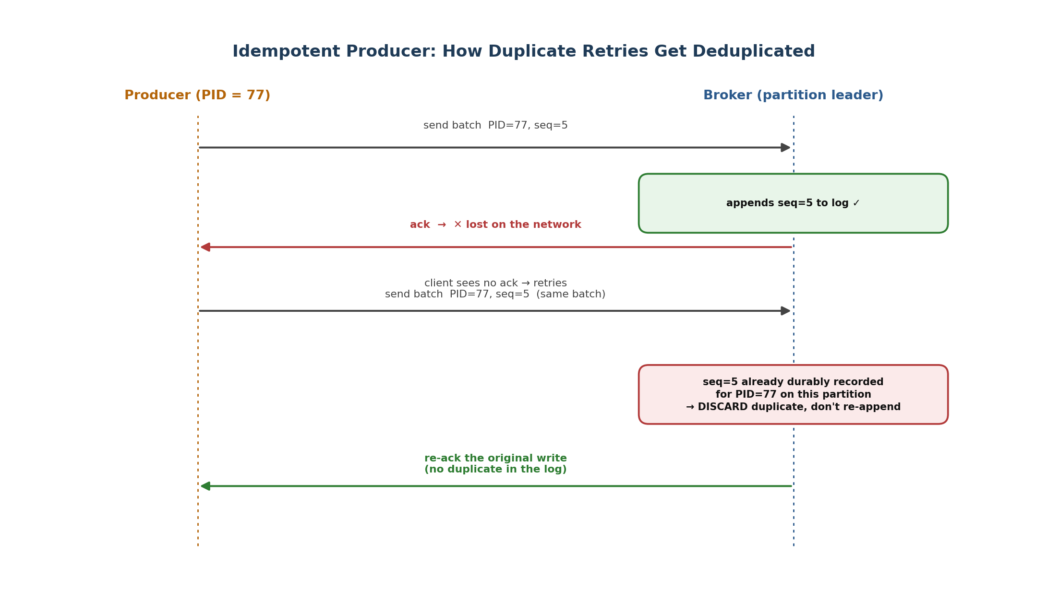
Figure 7. A lost acknowledgment causes the client to retry; the broker recognizes the (PID, sequence) pair it already appended and discards the duplicate instead of writing it twice.
The idempotent producer only removes duplicates caused by producer-side retries on a single “logical send.” It guarantees no duplicates and preserves ordering per partition for a single producer session, but it does not, by itself, make a multi-record or multi-partition operation atomic — that is what transactions (below) add. The overhead is small: a PID and a sequence number per batch.

3.3 Exactly-Once Semantics (EOS) via Transactions
Exactly-once semantics extends idempotency from “no duplicate writes from one producer” to “all the writes and offset-commits of a logical unit of work either all become visible, or none do” — even across multiple partitions and multiple topics, and even including a consumer's own offset commit. Kafka implements this with a transactional producer API (KIP-98), built on top of the idempotent producer described above.

Key Moving Parts
- transactional.id: a stable identifier configured on the producer. It lets Kafka recognize the same logical producer across process restarts, recover its in-flight transaction state, and fence off “zombie” instances of a producer that may still be running after a new instance has taken over (an old instance attempting to write with a stale/expired epoch is rejected).
- Transaction coordinator: a component that runs inside a broker (elected the same way partition leaders are) and manages the transaction state for each transactional.id — tracking whether a transaction is open, committing, or aborting.
- Control messages / transaction markers: invisible marker records that Kafka writes into each partition involved in the transaction to signal COMMIT or ABORT. Consumers use these markers to decide what to expose, based on their isolation level.
- Consumer isolation.level:
  - read_committed — the consumer only sees non-transactional records and records from transactions that have committed; records from open or aborted transactions are withheld.
  - read_uncommitted (default) — the consumer sees every record in offset order as soon as it's written, regardless of whether its transaction ever commits.

The Read-Process-Write Pattern
The canonical exactly-once use case is a stream processor that reads from an input topic, transforms the data, and writes to an output topic (the pattern Kafka Streams uses internally):
- beginTransaction() starts a new transaction on the transactional producer.
- The application produces its output record(s) to one or more output topics/partitions.
- The application also sends its consumer group's offsets for the input records as part of the same transaction, via sendOffsetsToTransaction() — this is what makes “I consumed this input” and “I produced this output” atomic with each other.
- commitTransaction() (or abortTransaction() on failure) tells the coordinator to write the COMMIT (or ABORT) markers to every partition touched by the transaction.
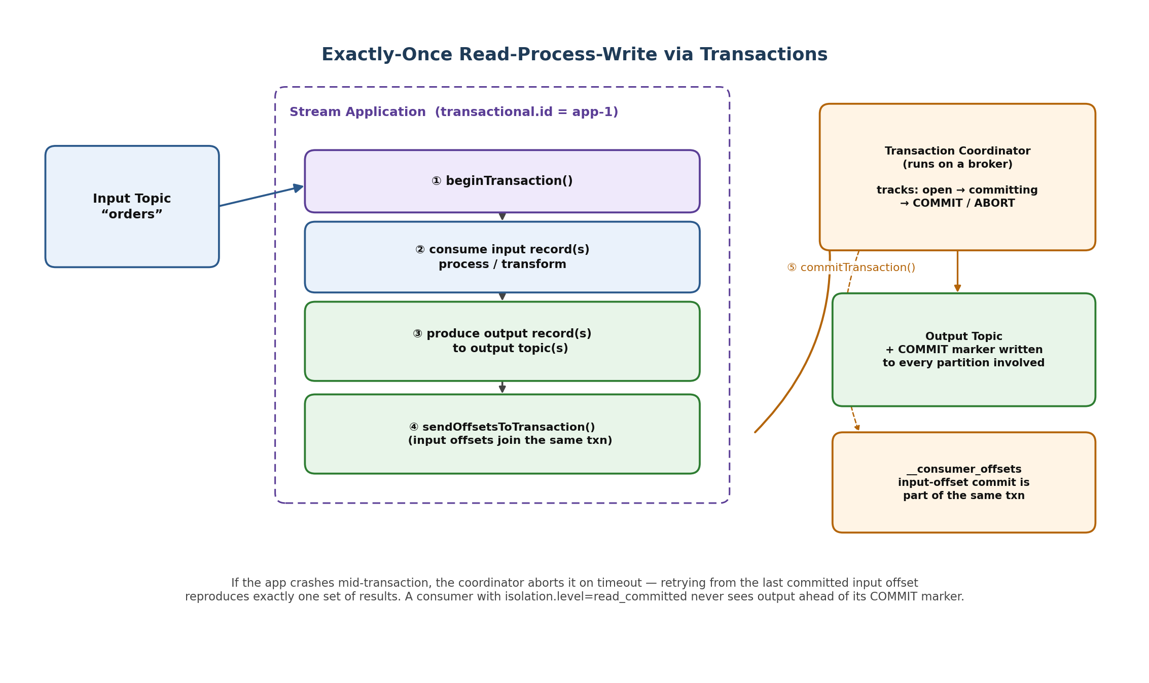
Figure 8. Read-process-write inside one transaction: the output records and the input-offset commit land in the same atomic unit, coordinated by the transaction coordinator.
If the process crashes mid-transaction, the transaction coordinator's timeout eventually aborts the dangling transaction, and a read_committed consumer never sees the partial output — so a retry from the last committed input offset reproduces exactly one set of visible output records, with no duplicates and no gaps.
Scope of the guarantee: Kafka's exactly-once semantics is guaranteed end-to-end for Kafka-to-Kafka pipelines. When the final destination is an external system (a database, a REST API, a file store), true exactly-once delivery additionally requires that external write to be idempotent (e.g. an upsert keyed by a unique record id) — Kafka cannot make an arbitrary external side-effect transactional on its own.

3.4 Practical Reliability Configuration
A commonly recommended “never lose an event” configuration combines settings from all three layers:
Layer | Recommended settings
Producer | enable.idempotence=true, acks=all, retries=Long.MAX_VALUE (effectively unlimited, bounded by delivery.timeout.ms), max.in.flight.requests.per.connection≤ 5 (=1 if strict ordering is required without idempotence)
Broker / Topic | replication.factor ≥ 3, min.insync.replicas = 2, unclean leader election disabled (so a stale, out-of-sync replica can never silently become leader and lose committed data)
Consumer | enable.auto.commit=false; commit offsets only after the corresponding output/side-effect has been durably applied

4. Dead-Letter Queues (DLQ)
What was added: none of the source documents mentioned dead-letter queues. This entire section is new, researched from Confluent's Kafka Connect error-handling documentation.

4.1 What a Dead-Letter Queue Is
A dead-letter queue (DLQ) is a separate topic used to capture messages that a consumer, connector, or stream processor could not process successfully — a poison-pill payload, a malformed record that fails deserialization, a downstream call that keeps failing validation, and so on. Instead of blocking the entire partition (or silently dropping the record), the failing record is routed to the DLQ topic so the rest of the stream keeps flowing, and the bad record remains available for inspection, alerting, or a later reprocessing attempt.

4.2 Why Kafka Has No Built-in DLQ (Unlike RabbitMQ)
RabbitMQ has first-class, broker-enforced dead-lettering: a queue can declare a dead-letter-exchange, and the broker itself automatically routes a message there when it is rejected, expires (TTL), or exceeds a queue length limit — no consumer code is required. Kafka has no equivalent broker-level concept. Kafka treats every topic uniformly as an append-only log and has no message-level acknowledgment/rejection or per-message TTL; the broker has no notion of a message “failing.” Responsibility for detecting a failure and routing the record elsewhere therefore falls entirely on the application or connector framework, not the broker.

4.3 Implementation Patterns

Pattern A — Kafka Connect's Built-in DLQ (Sink Connectors)
Since Kafka 2.0, Kafka Connect includes native error handling for its converter and transformation stages. It is configured per-connector:
errors.tolerance = all
errors.deadletterqueue.topic.name = my-connector-dlq
errors.deadletterqueue.topic.replication.factor = 3
errors.deadletterqueue.context.headers.enable = true
- errors.tolerance=none (the default) — fail fast; the connector stops on the first bad record. Appropriate when a bad record signals an upstream problem that must be fixed before continuing.
- errors.tolerance=all with no DLQ configured — bad records are silently dropped. This is risky: data loss becomes invisible without separate monitoring.
- errors.tolerance=all with errors.deadletterqueue.topic.name set — the recommended pattern: processing continues, and the offending record is written to the DLQ topic with headers capturing the source topic/partition/offset, the connector name, the failing stage (converter/transform), the exception class, and the stack trace — enough context to trace the record back and diagnose it later.
Limitation: this connector-level DLQ only covers the converter and transformation stages of the pipeline. It does not cover connector start-up errors, a source connector's own polling failures, or a sink connector's put() call into the external system — source connectors in particular need custom, application-level error handling.

Pattern B — Consumer-Side try/catch (Custom Applications)
For a hand-written consumer (or a sink connector's put() logic), the DLQ pattern is implemented explicitly:
- Consume the record and attempt to process it normally.
- On an exception, catch it, attach error context (original topic/partition/offset, exception message, timestamp) as record headers or an envelope, and produce the record to a dedicated <topic>-dlq topic.
- Log the failure for observability, then commit the original offset and continue with the next record — so one bad record never blocks the whole partition.
try {
process(record);
} catch (Exception e) {
ProducerRecord<K,V> dlqRecord = new ProducerRecord<>(
"orders-dlq", record.key(), record.value());
dlqRecord.headers()
.add("x-original-topic", record.topic().getBytes())
.add("x-original-partition", String.valueOf(record.partition()).getBytes())
.add("x-original-offset", String.valueOf(record.offset()).getBytes())
.add("x-error-message", e.getMessage().getBytes());
dlqProducer.send(dlqRecord);
}

Pattern C — Retry Topics with Backoff
A single DLQ conflates “transient failure, will succeed on retry” with “permanently bad record.” A more resilient pipeline chains a series of retry topics with increasing delay before finally giving up to a true DLQ:
- orders → (failure) → orders-retry-1 (consumed after a short delay, e.g. 30s)
- orders-retry-1 → (failure again) → orders-retry-2 (longer delay, e.g. 5 min) — exponential backoff
- orders-retry-2 → (still failing) → orders-dlq — final resting place for manual investigation
This pattern (popularized by frameworks such as Spring Kafka's non-blocking retry support) avoids hammering a downstream dependency that is only briefly unavailable, while still guaranteeing that a genuinely malformed record eventually lands somewhere visible instead of looping forever.
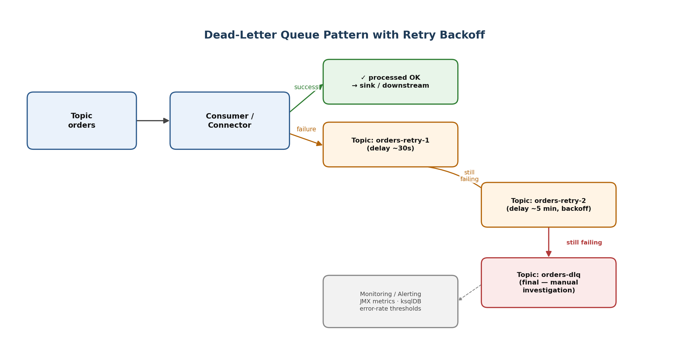
Figure 9. Failed records escalate through staged retry topics with increasing backoff before finally landing in the DLQ; monitoring watches error rates at every stage.

4.4 Monitoring the DLQ
A DLQ is only useful if someone is watching it. Common practice is to:
- Track DLQ topic message counts / rates via JMX metrics or a stream-processing aggregation (e.g. ksqlDB), and alert when the error rate crosses a threshold.
- Keep the DLQ retention long enough for a human to triage, but not indefinite — pair it with a runbook and, where possible, automated reprocessing once the root cause is fixed.
- Never treat errors.tolerance=all as “fire and forget” without a DLQ and monitoring — unattended, it converts silent failures into a silent, unbounded data-loss risk.

5. Apache Kafka vs. RabbitMQ

5.1 Two Different Design Philosophies
Apache Kafka is an open-source distributed event streaming platform written in Java and Scala. It stores data as a durable, replayable log and is optimized for high-throughput, low-latency streaming analytics, data integration, and mission-critical, real-time data feeds. Kafka uses a pull-based model: consumers request batches of messages starting from a specific offset, rather than having messages pushed to them.
RabbitMQ is an open-source, general-purpose message broker designed for efficient message delivery in complex routing scenarios. It runs as a cluster of nodes with queues distributed across them, and originally implemented the Advanced Message Queuing Protocol (AMQP). RabbitMQ uses a push model: the broker pushes messages to consumers, throttled by a consumer-configured prefetch limit.
In short: Kafka and RabbitMQ serve the same broad purpose — moving messages/events between systems — but with different strengths. Both are open-source, widely used, and commercially supported.
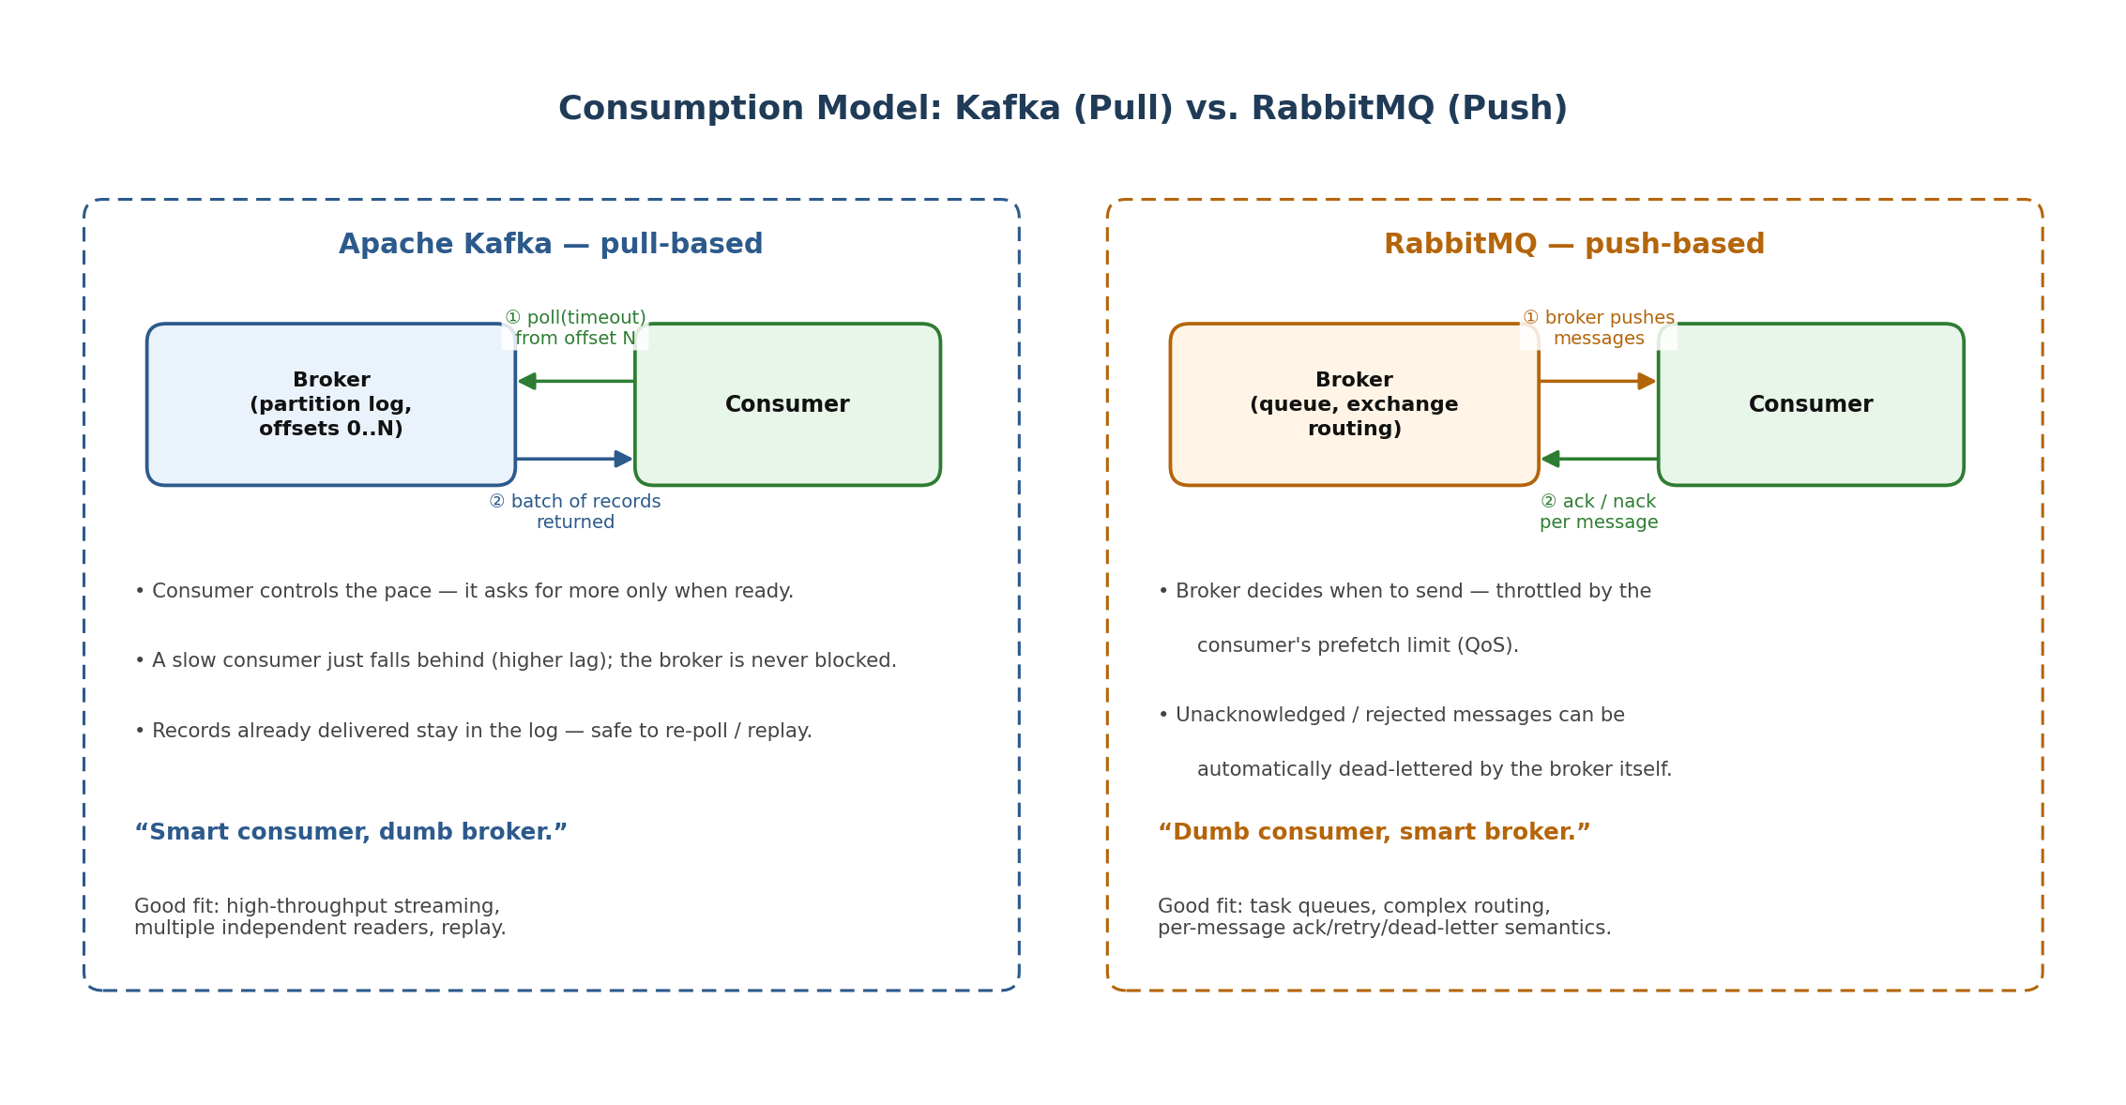
Figure 10. The core mechanical difference: Kafka consumers pull batches at their own pace from a retained log; RabbitMQ's broker pushes messages and manages per-message ack/retry/dead-letter state itself.

5.2 Architecture and Data Model
Aspect | Kafka | RabbitMQ
Data model | Distributed, log-based streaming platform; high-throughput, low-latency distributed “commit log” | Traditional message broker with a queue-based model; supports multiple protocols (AMQP, MQTT, STOMP)
Storage | Messages are stored on disk and replicated across brokers, with each message assigned a durable offset used to track and re-fetch it | Messages may be stored in memory or on disk depending on configuration; supports both durable and transient messages
Clustering | Brokers, producers, and consumers coordinate for high availability and fault tolerance; partitions replicated across brokers | Nodes are clustered into a single logical broker; queues/messages replicated across nodes for HA
Routing / Topology | Publish/subscribe on named topics, split into partitions; no server-side routing logic | Exchange types — direct, topic, fanout, headers — give fine-grained, broker-side routing of messages to queues
Consumer mode | Pull-based: “smart consumer, dumb broker” — consumers request batches from a specific offset | Push-based: “dumb consumer, smart broker” — the broker pushes messages, gated by a per-consumer prefetch limit
Event storage structure | Logs (append-only, retained per a retention policy) | Queues (messages removed once acknowledged/consumed)
Data flow | Continuous, unbounded stream of key-value records | Bounded, discrete message packets

5.3 Performance and Scalability
Kafka: optimized for very high throughput and low latency — commonly cited benchmarks are on the order of ~1 million messages/second (some sources cite up to 2 million writes/second on modest hardware). It scales horizontally by adding brokers and increasing partition count; expansions can happen online with no impact on availability.
RabbitMQ: optimized for reliable message delivery with rich acknowledgment, retry, and dead-lettering semantics; typical throughput is in the range of roughly 4,000–10,000 messages/second (heavily dependent on configuration, message size, and durability settings). It scales horizontally by adding nodes, with load balancing and failover across the cluster.
Default payload-size behaviour also differs: Kafka defaults to a 1 MB per-message limit (configurable, but Kafka is optimized for many small messages rather than a few very large ones), while RabbitMQ has no comparably strict default payload constraint.

5.4 Delivery, Durability, and Consistency
Kafka: durable store that allows replay — consumers can rewind and re-read historical data because messages are retained (per a retention policy) even after consumption. Delivery is primarily asynchronous/streaming; “synchronicity” in the traditional request/response sense isn't the primary model.
RabbitMQ: messages are typically removed once consumed and acknowledged (no built-in replay of history), but delivery can be modeled either synchronously or asynchronously depending on the application, and it offers strong, per-message delivery guarantees (ack/nack, requeue, and native dead-lettering) that fit transactional-style workloads well.

5.5 Summary Comparison Table
# | Parameter | Kafka | RabbitMQ
1 | Performance | ~1 million messages/sec (up to ~2M in optimized benchmarks) | ~4k–10k messages/sec
2 | Default payload size | 1 MB | No strict size constraint
3 | Message synchronicity | Durable store, allows replay | Can be synchronous or asynchronous
4 | Data unit | Continuous stream | Discrete message
5 | Data type / use | Operational / event streaming | Transactional / task messaging
6 | Topology | Publish/Subscribe on topics + partitions | Exchanges: Fanout, Topic, Direct, Headers
7 | Data flow | Continuous, unbounded key-value pairs | Bounded, distinct message packets
8 | Event storage structure | Logs | Queues
9 | Message delivery model | Pull-based (consumer requests messages) | Push-based (broker pushes to queues)
10 | Consumer / broker intelligence | Smart consumer / “dumb” broker | “Dumb” consumer / smart broker
11 | Native dead-lettering | None — must be implemented in the application/connector (see §4) | Built-in: broker routes to a configured dead-letter-exchange automatically

5.6 When to Use Which

Favor Kafka when…
- Very high, sustained message throughput is required (100K+ events/sec).
- Consumers need to replay history or multiple independent consumer groups need their own view of the same stream.
- The use case is real-time analytics, event sourcing, log/metric aggregation, or CDC-style data integration.

Favor RabbitMQ when…
- Consumers are added dynamically without needing to change publishers, and complex, broker-side routing logic (topic/header-based fan-out) is valuable.
- Message replay is not necessary — once processed and acknowledged, a message can be discarded.
- The system must speak legacy or standard protocols such as AMQP 0-9-1, AMQP 1.0, STOMP, or MQTT.
- It's a classic task-queue / job-distribution workload, or communication between microservices where native dead-lettering and fine-grained per-message acknowledgment are important out of the box.

6. Configuration & Tuning Reference

6.1 Hardware Sizing

Disk
- Faster disk writes translate directly into lower produce latency; SSDs give the best seek/access times and overall performance.
- Estimate capacity from expected daily traffic × retention period. Example: 1 TB/day of traffic with 7 days of retention requires a minimum of 7 TB of usable storage per broker (before accounting for replication).
- Use RAID 10 for the Kafka data disks for resiliency against a single disk failure.

Memory
- More memory available for the OS page cache directly improves consumer read performance, since recently-written data is usually served from cache rather than disk.
- Broker JVM heap generally doesn't need more than 4–8 GB — the rest of a broker's memory should be left for the page cache.

Cluster Sizing
- At least 3 dedicated ZooKeeper nodes for a production cluster (5 is common at larger scale; a single node is fine only for test clusters).
- At least 3 broker nodes; in general, the node count should be ≥ the highest replication factor used, and it's wise to keep some headroom above the strict minimum for growth and resilience.

6.2 Partitions and Replication Factor
Partition count and replication factor are the two most consequential parameters set at topic-creation time, since both impact performance and durability for the life of the topic.
- Each partition can typically handle a throughput on the order of a few MB/s (heavily workload-dependent).
- Rough sizing guideline: for a small cluster (<6 brokers), partitions per topic ≈ 2 × number of brokers; for a large cluster (>12 brokers), partitions per topic ≈ 1 × number of brokers.
- A more precise formula: #partitions = max(NP, NC), where NP = target total throughput ÷ max throughput of one producer to one partition, and NC = target total throughput ÷ max throughput of one consumer from one partition.
- Reducing partition count later is not supported — the only path is to create a new topic with fewer partitions and copy the data over, so it's better to under-provision cautiously and grow than to over-provision from day one.
- Guideline ceilings for healthy operation: no more than ~4,000 partitions per broker, and no more than ~200,000 partitions across a cluster — large partition counts add pressure on the metadata layer (ZooKeeper/KRaft) and increase client-side memory and file-descriptor usage.
- Replication factor: at least 2, usually 3, rarely above 4 (see §2.7 for the durability/latency trade-off).

6.3 Topic Configuration: Retention and Compaction
Retention is how long Kafka durably stores messages before removing them. log.cleanup.policy controls the removal strategy:
- delete (default) — removes whole segments once they age out, governed by:
  - log.retention.hours — age-based limit (default one week); a higher number needs more disk, a lower number risks consumers missing data if they fall behind.
  - log.retention.bytes — size-based limit per partition (default -1, i.e. unlimited).
- compact — retains only the most recent value for each key in the topic; only meaningful for topics whose records always carry a key. Old duplicate keys are removed once the active segment is committed. Deleted records (“tombstones”) remain visible for delete.retention.ms before being purged, so downstream consumers have time to observe the deletion.

6.4 Producer Configuration
Setting | Purpose
bootstrap.servers | List of host:port for initial cluster discovery; include at least two so the producer can still connect if one goes down.
acks | 0 / 1 / all — durability vs. throughput trade-off (see §3.1).
retries / delivery.timeout.ms | How many times / how long the producer retries a failed send before giving up.
max.in.flight.requests.per.connection | How many produce requests can be in flight in parallel; cap at 1 to guarantee strict ordering if not using the idempotent producer.
buffer.memory | Memory reserved for records waiting to be sent (default 32 MB / 33554432 bytes). If exceeded, send() blocks for up to max.block.ms before throwing.
compression.type | none / gzip / lz4 / snappy. Compression shrinks request size, speeds up network transfer, and improves disk utilization at the cost of producer/consumer CPU. snappy or lz4 are recommended in production; gzip is comparatively slow. Compression is more effective the bigger the batch.
linger.ms / batch.size | linger.ms adds a small deliberate delay to let more records accumulate into a batch (default batch.size is 16 KB, often raised to 32–64 KB); larger batches improve throughput and compression ratio at a small latency cost. A batch is allocated per partition, so don't set it excessively high.
client.id | Logical name brokers use to identify the producer, useful for quota enforcement and logging.
By default Kafka tries to send records as soon as possible, allowing up to 5 requests in flight at once; if more records arrive while others are already in flight, Kafka automatically starts batching them together for the next request.

6.5 Consumer Configuration Recap
- session.timeout.ms / heartbeat.interval.ms — liveness detection and rebalance trigger speed (see §2.5).
- auto.offset.reset — earliest / latest / none (see §2.6).
- enable.auto.commit / auto.commit.interval.ms — automatic vs. manual offset commits (see §2.6).
- offset.retention.minutes — how long committed offsets survive with no new commits (default 7 days) before they're eligible for deletion from __consumer_offsets.

6.6 Kafka Internals: Request Processing
Kafka uses its own binary protocol that precisely specifies the format of client requests and broker responses. Each broker runs:
- Acceptor thread(s): accept new client connections.
- Processor / network threads: read requests off client connections, place them on an internal request queue, and later pick up completed responses to send back to clients.
The two core request types are Produce requests and Fetch requests. A third, metadata requests, let a client discover where to send its actual requests: the client sends the list of topics it's interested in, and the broker responds with the partitions of those topics, the replicas for each partition, and which replica is currently the leader.
Client -> metadata request(list of interested topics) -> Server(Leader)
Server -> respond { partitions of the topic, the replicas for each partition,
which replica is the leader } -> Client
Clients cache this metadata and periodically refresh it (controlled by metadata.max.age.ms). If a broker is added or replicas move to a different broker, an outdated client receives a “Not a Leader” error and refreshes its metadata before retrying the request.

6.7 Physical Storage

Partition Allocation
Example: with 6 brokers, a new topic created with 10 partitions and a replication factor of 3 needs 10 × 3 = 30 partition replicas placed across those 6 brokers — 5 replicas per broker on average. For each partition, every one of its replicas is placed on a different broker; if rack information is configured, Kafka additionally tries to spread a partition's replicas across different racks for extra fault tolerance.

File Management
A Kafka administrator configures, per topic, both the amount of time to keep messages and how much data to store before older messages are purged. Each partition is split into segments, where each segment holds either a configured size (e.g. 1 GB) or a configured time window (e.g. one week) of data — whichever limit is hit first. The segment currently being appended to is the active segment and is never deleted, regardless of retention settings.

7. Case Studies / Illustrative Use Cases
These worked examples illustrate how the architectural building blocks above combine in real systems.

7.1 Video Analytics — “MovieFlix”
- Resume video playback exactly where a user left off.
- Build a real-time user profile from viewing behaviour.
- Recommend the next show in real time.
- Persist all interaction data into an analytics store for offline model training.

7.2 Ride-Hailing — “GetTaxi”
- Match a rider with a nearby driver in real time.
- Dynamically “surge” pricing when the number of available drivers is low relative to demand.
- Stream all position data before and during a ride into an analytics store so trip cost can be computed accurately after the fact.

7.3 Social Platform — “MySocial Media”
- Support posting, liking, and commenting as a stream of events.
- Show like/comment counts per post in near real time.
- Handle a high volume of data from day one of launch.
- Surface “trending” posts computed from the live event stream.

7.4 Finance — “MyBank”
- Real-time banking with the ability to alert users about large transactions as they happen.
- Transaction data already lives in a database; Kafka (via CDC) streams changes out to the alerting pipeline instead of the alerting logic polling the database.
- Users can configure their own alert thresholds.

8. Operational FAQ Highlights

8.1 Monitoring Consumer Lag
Consumer lag — how far behind the end of the log a consumer group is — is the primary health signal for a consumer. It is inspected with the kafka-consumer-groups CLI tool:
$ bin/kafka-consumer-groups.sh --bootstrap-server localhost:9092 --describe --group my-group
TOPIC PARTITION CURRENT-OFFSET LOG-END-OFFSET LAG CONSUMER-ID HOST CLIENT-ID
my-topic 0 2 4 2 consumer-1-69d6 /127.0.0.1 consumer-1
my-topic 1 2 3 1 consumer-1-69d6 /127.0.0.1 consumer-1
my-topic 2 2 3 1 consumer-2-9bb2 /127.0.0.1 consumer-2
If everything is healthy, each consumer's CURRENT-OFFSET should be close to LOG-END-OFFSET. A partition with persistently high LAG points to a slow consumer, an undersized consumer group, or a downstream bottleneck. The same tool (with --execute --reset-offsets) can reset a group's offsets to a specific point — an administrative escape hatch for recovering from corrupted records or a failed host, not a routine operation.

8.2 Rebalancing an Existing Cluster
Adding new brokers or disks does not automatically rebalance existing partitions onto them. The kafka-reassign-partitions tool is the supported way to move replicas after growing a cluster. Recommended caveats: move only a small number of replicas per command (to limit the extra replication load on the cluster while the move is in progress), never use it to promote an out-of-sync replica straight to leader, and use the --throttle flag to bound the bandwidth reassignment consumes so client traffic isn't starved.

8.3 Sizing Guidance Summary
Question | Guidance
How many partitions per topic? | Small cluster: ~2 × broker count. Large cluster (12+ brokers): ~1 × broker count. Refine with #partitions = max(NP, NC) from real throughput targets.
How much disk? | (daily ingest volume) × (retention period) × (replication factor), plus headroom; remember RAID 10 halves usable capacity.
How many ZooKeeper / controller nodes? | 3 for most clusters; 5 only at the largest scale.
What's the biggest single risk metric to watch? | Leader-partition imbalance across brokers — if leaders cluster on one broker, that broker's workload (and therefore cluster throughput) becomes the bottleneck, and failures make the imbalance worse.

9. Coverage Checklist
This document was checked against the requested topic list. Status:
Required Topic | Status | Where Covered
Kafka architecture: partitions | Present in source | §2.3
Kafka architecture: consumer groups | Present in source | §2.4–§2.5
Kafka architecture: offsets | Present in source | §2.6
Kafka architecture: brokers | Present in source | §2.1
Kafka architecture: replication | Present in source | §2.7
Delivery guarantees (at-least-once / exactly-once) | Expanded — EOS mechanics added | §3.1, §3.3
Idempotency | Added — source section was left unfinished | §3.2
Dead-letter queues | Added — missing entirely from sources | §4
Kafka vs RabbitMQ | Present in source | §5
Diagrams / workflow visuals | Added on request | throughout §2–§5
Interview questions | Added on request | §10

10. Interview Questions
Forty questions spanning the material in this document, grouped the way an interview usually escalates: fundamentals first, then producer/consumer mechanics, replication, reliability semantics, dead-letter handling, Kafka vs RabbitMQ, and finally operational/scenario questions. Each answer is deliberately compact — cross-reference the section noted for the full explanation.

10.1 Fundamentals & Architecture
Q. What is Apache Kafka, in one sentence?
A. A distributed, publish/subscribe event streaming platform that stores records as durable, replicated, append-only logs and lets many independent producers and consumers read and write them in parallel. (§1)
Q. What is a topic, and how does it relate to a partition?
A. A topic is a named, logical stream of records — the closest analogy is a database table. Kafka splits a topic into partitions so it can be spread across multiple brokers for parallelism and scale; a partition is the physical/logical unit that actually gets stored and replicated. (§2.2–§2.3)
Q. What is a broker, and what is a cluster controller?
A. A broker is a single Kafka server that stores partitions and serves producer/consumer requests. Exactly one broker in a cluster additionally acts as the controller at any time — it assigns partitions to brokers, monitors broker liveness, and elects new partition leaders when a broker fails. (§2.1)
Q. How does Kafka decide which partition a record goes to?
A. If the record has a key, Kafka hashes the key and uses hash(key) % numPartitions, so records with the same key always land on the same partition and stay in order relative to each other. If there's no key, Kafka distributes records round-robin (or in sticky batches) across partitions. A producer can also target a partition explicitly. (§2.3)
Q. Does Kafka guarantee message ordering?
A. Only within a single partition, never across an entire topic. If a use case needs strict global ordering, the practical options are a single-partition topic (which caps throughput) or downstream reordering within a bounded time window. (§2.3)
Q. What is the difference between a partition and a log segment?
A. A partition is the logical unit Kafka uses to split a topic for scalability and redundancy. Internally, each partition's data is stored not as one giant file but as a series of log segments, bounded by size (log.segment.bytes) or time (log.segment.ms); only the current active segment is ever written to, and it's never deleted regardless of retention settings. (§2.3)
Q. What role does ZooKeeper (or KRaft) play in a Kafka cluster?
A. It's the cluster's metadata and coordination layer: it tracks which brokers are alive, holds topic/partition metadata, and manages controller election. Newer Kafka versions can replace ZooKeeper with KRaft, a built-in Raft-based quorum of controller nodes that does the same job without an external dependency. (§2.1)
Q. What is a record's key used for besides partitioning?
A. It can also drive log compaction — a compacted topic keeps only the latest value per key — and it's commonly used to co-locate related events (e.g. all events for one customer ID) so a single consumer sees them in order. (§2.3, §6.3)

10.2 Producers
Q. Walk through what happens when a producer calls send().
A. The app builds a ProducerRecord (topic, optional key, value, optional partition); the key/value are serialized to byte arrays; the partitioner picks a partition (or honors an explicit one); the record joins a batch for that topic-partition; a sender thread ships the batch to the partition's leader broker; the broker appends it and returns a RecordMetadata⟨topic, partition, offset⟩, or an error that may trigger a retry. (§2.4, Figure 3)
Q. What does the acks setting control, and what are the three values?
A. It controls how many replicas must confirm a write before the producer treats it as successful. acks=0 doesn't wait at all (fastest, can silently lose data); acks=1 waits only for the partition leader (a leader crash before replication can still lose the record); acks=all waits for every in-sync replica (strongest durability, combine with min.insync.replicas). (§3.1)
Q. Why would you increase linger.ms or batch.size?
A. Both trade a small amount of latency for throughput: linger.ms makes the producer wait briefly so more records accumulate into a batch before sending, and a larger batch.size allows bigger batches. Bigger batches also compress better, since compression.type works over the whole batch. (§6.4)
Q. What happens if a producer's buffer.memory fills up?
A. New calls to send() block for up to max.block.ms waiting for space to free up (as batches are sent and acknowledged); if that timeout elapses, send() throws an exception. It's a backpressure signal that the producer is generating records faster than the cluster can absorb them. (§6.4)
Q. What's the difference between retries and max.in.flight.requests.per.connection?
A. retries controls how many times the producer resends a batch that failed; max.in.flight.requests.per.connection controls how many unacknowledged produce requests can be outstanding at once. With idempotence enabled, Kafka safely allows up to 5 in-flight requests without risking reordering; without it, capping this at 1 is the only way to guarantee order under retries. (§6.4, §3.2)

10.3 Consumers & Consumer Groups
Q. What is a consumer group, and what's the one rule that defines it?
A. One or more consumers cooperating to read a topic. The rule: within a single consumer group, each partition is consumed by exactly one member at a time — but one consumer can own multiple partitions. Different consumer groups are fully independent and each gets its own copy of the stream. (§2.4, Figure 4)
Q. What happens if you have more consumers in a group than partitions?
A. The extra consumers sit idle — they're assigned no partitions and receive nothing, since Kafka never splits a single partition across two consumers in the same group. (§2.4, Figure 4)
Q. What triggers a consumer group rebalance, and what happens during one?
A. A consumer joining, leaving (gracefully or via crash), or being judged dead (missed heartbeats past session.timeout.ms, or exceeded max.poll.interval.ms) triggers a rebalance: the group coordinator recomputes the partition assignment across the current members. No member of the group can read messages while a rebalance is in progress, so frequent rebalances hurt throughput. (§2.5)
Q. What's the difference between session.timeout.ms and max.poll.interval.ms?
A. session.timeout.ms bounds how long the coordinator waits for a heartbeat before declaring a consumer dead — it detects a hung or crashed process/thread. max.poll.interval.ms bounds how long application code can spend between poll() calls — it detects a consumer that's technically alive (still heartbeating) but stuck in slow processing. (§2.5)
Q. What's the difference between current offset and committed offset?
A. Current offset is how far the consumer has read (delivered records); committed offset is how far it has confirmed processing of. The gap between them is exactly what gets redelivered if the consumer restarts before committing. (§2.6, Figure 5)
Q. commitSync() vs commitAsync() — when would you use each?
A. commitSync() blocks until the broker acknowledges the commit — simpler and safer, but adds latency to the poll loop. commitAsync() doesn't block and gives higher throughput, but it won't automatically retry a failed commit (and blindly retrying a stale async commit risks overwriting a later, correct one), so it needs care in the retry/callback logic. (§2.6)

10.4 Replication & Fault Tolerance
Q. What is an in-sync replica (ISR)?
A. A follower replica that has fully caught up to the leader's most recent records. Only ISR members are eligible to be elected the new leader if the current leader fails — this is what prevents a stale replica from silently becoming the source of truth and losing committed data. (§2.7, Figure 2)
Q. What does min.insync.replicas actually enforce?
A. It's a broker-side floor on how many in-sync replicas (including the leader) must exist for an acks=all write to succeed. With replication.factor=3 and min.insync.replicas=2, the cluster can tolerate one broker outage; if in-sync replica count drops below the minimum, the producer starts getting exceptions instead of silently getting a weaker durability guarantee. (§2.7, §3.4)
Q. Why is replication factor usually capped around 3–4 instead of going higher?
A. Diminishing returns vs. cost: each additional replica improves fault tolerance (N−1 brokers can fail) but adds more replication traffic on every write, more disk usage, and — with acks=all — more latency waiting for every in-sync replica to catch up. (§2.7)
Q. What happens when the broker hosting a partition's leader goes down?
A. The cluster controller detects the broker left (via ZooKeeper/KRaft), and elects a new leader for every partition that broker used to lead — chosen from that partition's current ISR set, so no committed data is lost. (§2.1, §2.7)
Q. What is “unclean leader election,” and why would you disable it?
A. Normally only an in-sync replica can become leader. Unclean leader election allows an out-of-sync replica to become leader when no ISR member is available, trading availability for the possibility of silently losing committed records. Production clusters that prioritize durability disable it. (§3.4)

10.5 Delivery Guarantees, Idempotency & Exactly-Once
Q. Explain the difference between at-most-once, at-least-once, and exactly-once in Kafka terms.
A. At-most-once commits the offset before processing, so a failure after commit loses the message. At-least-once commits after processing, so a failure before commit causes redelivery and duplicate processing. Exactly-once (Kafka-to-Kafka) wraps consumption, production, and the offset commit in one atomic transaction, so a crash never leaves a partially-visible result. (§3.1, Figure 6)
Q. Why does at-least-once processing require idempotent downstream logic?
A. Because redelivery is a normal, expected outcome of that semantic — the same record can be processed more than once. If the side effect isn't idempotent (e.g. “charge the card” instead of “ensure this charge-id is applied”), a duplicate delivery becomes a real duplicate charge. (§3.1)
Q. How does the idempotent producer prevent duplicate writes?
A. Kafka assigns the producer a Producer ID (PID) and tags every batch with a per-partition sequence number. The broker durably records the last sequence number it committed for each (PID, partition) in the replicated log itself. If a retried batch arrives with a sequence number already recorded, the broker discards it and just re-acknowledges — so a lost-ack-then-retry never double-writes. (§3.2, Figure 7)
Q. Does the idempotent producer alone give you exactly-once semantics?
A. No — it only removes duplicates from a single producer's retries on a single partition. It doesn't make writes to multiple partitions/topics atomic, and it says nothing about the consumer's offset commit. Full exactly-once needs the transactional producer API on top of idempotence. (§3.2)
Q. What is a transactional.id for, and why does it matter after a restart?
A. It's a stable identifier that lets Kafka recognize the same logical producer instance across restarts, recover any in-flight transaction state, and fence off “zombie” producers — an old instance that's still alive after a new one has taken over gets rejected because its epoch is stale. Without it, a crashed-and-restarted producer could clash with itself. (§3.3)
Q. What's the difference between isolation.level=read_committed and read_uncommitted?
A. read_uncommitted (the default) delivers every record in offset order the instant it's written, including ones from transactions that later abort. read_committed withholds records from open or aborted transactions and only exposes records once their transaction's COMMIT marker is written — this is what a consumer must set to actually see exactly-once results. (§3.3, Figure 8)
Q. In the read-process-write pattern, why call sendOffsetsToTransaction() instead of committing offsets normally?
A. Because it folds the input-offset commit into the same atomic transaction as the output records. If it committed the offset separately, a crash between “commit input offset” and “write output” (or vice versa) could either skip input records or duplicate output — sendOffsetsToTransaction() makes “I consumed X” and “I produced Y” succeed or fail together. (§3.3, Figure 8)
Q. Is Kafka's exactly-once guarantee end-to-end for any external system?
A. No — it's guaranteed end-to-end only for Kafka-to-Kafka pipelines. Writing exactly once into an external system (a database, an API) additionally requires that write to be idempotent on its own (e.g. an upsert keyed by a unique record ID), because Kafka can't make an arbitrary external side effect part of its transaction. (§3.3)

10.6 Dead-Letter Queues & Error Handling
Q. Why doesn't Kafka have a built-in dead-letter queue the way RabbitMQ does?
A. RabbitMQ has broker-enforced dead-lettering (a queue can declare a dead-letter-exchange and the broker automatically routes rejected/expired/overflowed messages there). Kafka has no equivalent: every topic is just a uniform append-only log with no message-level ack/reject or TTL concept, so the broker has no notion of a message “failing” — that responsibility falls entirely on the application or connector. (§4.1–§4.2)
Q. How does Kafka Connect's built-in DLQ support work?
A. Set errors.tolerance=all plus errors.deadletterqueue.topic.name on a sink connector; failed records are then routed to that topic (with headers capturing the source topic/partition/offset, connector name, failing stage, and exception) instead of stopping the connector or silently dropping the record. It only covers the converter/transformation stages, though — not connector start-up or a sink's put() call. (§4.3)
Q. What's the risk of setting errors.tolerance=all without configuring a DLQ topic?
A. Bad records are silently dropped. Processing keeps flowing, which looks healthy, but data loss becomes invisible unless it's separately monitored — the DLQ is what turns a silent drop into a visible, inspectable failure. (§4.3)
Q. Why use staged retry topics (retry-1, retry-2, ...) instead of sending straight to the DLQ on first failure?
A. A single DLQ conflates “transient failure that would succeed on retry” with “permanently bad record.” Staged retry topics with increasing backoff give a transient failure (e.g. a downstream dependency blip) a chance to resolve itself without hammering that dependency, while still guaranteeing a genuinely bad record eventually reaches a true DLQ instead of retrying forever. (§4.3, Figure 9)

10.7 Kafka vs. RabbitMQ
Q. What's the single biggest architectural difference between Kafka and RabbitMQ?
A. The consumption model: Kafka is pull-based (“smart consumer, dumb broker”) — consumers poll for batches at their own pace and messages stay in the log after consumption. RabbitMQ is push-based (“dumb consumer, smart broker”) — the broker pushes messages, throttled by a consumer's prefetch limit, and messages are typically removed once acknowledged. (§5.1–§5.2, Figure 10)
Q. When would you pick RabbitMQ over Kafka?
A. When you need rich, broker-side routing (exchange types: direct/topic/fanout/headers), native per-message acknowledgment/retry/dead-lettering, dynamic consumer addition without touching publishers, or you must speak a legacy protocol like AMQP 0-9-1 or MQTT — classic task-queue and microservice-messaging workloads. (§5.6)
Q. When would you pick Kafka over RabbitMQ?
A. When you need very high sustained throughput, multiple independent consumer groups reading the same stream at their own pace, the ability to replay history, or the workload is fundamentally about a durable, ordered event log (event sourcing, CDC, real-time analytics, log/metric aggregation). (§5.6)
Q. Does RabbitMQ support message replay the way Kafka does?
A. Not natively — RabbitMQ messages are generally removed from a queue once consumed and acknowledged, so there's no built-in “rewind and re-read history” the way a Kafka consumer can seek to an earlier offset in a topic that's still within its retention window. (§5.2, §5.4)

10.8 Operations, Performance & Scenario-Based
Q. Why is sequential disk I/O central to Kafka's performance story?
A. Kafka always appends to the end of a partition's log and reads sequentially, avoiding slow random disk seeks — sequential I/O on spinning disks can approach the throughput of random access in memory. Combined with zero-copy transfer and batching, this is why Kafka can sustain very high throughput even on modest hardware. (§1.3)
Q. Consumer lag for one partition keeps climbing while the others are fine — what do you check?
A. Whether that partition's records are unusually large or expensive to process, whether the assigned consumer instance is under-resourced or stuck (check its CURRENT-OFFSET vs LOG-END-OFFSET with kafka-consumer-groups --describe), and whether partition leadership for it recently moved (temporary replication catch-up). Persistently high single-partition lag often points to a hot key skewing load onto one partition. (§8.1)
Q. A producer with acks=all suddenly starts throwing exceptions on every send — likely cause?
A. The number of in-sync replicas for the target partition has dropped below min.insync.replicas (e.g. two of three replicas are down or lagging) — the broker refuses acks=all writes rather than silently downgrading the durability guarantee. Check broker health and replication lag first. (§3.4, §2.7)
Q. Why can't you just decrease a topic's partition count if you over-provisioned it?
A. Kafka doesn't support reducing partitions in place, because doing so would break the key→partition hash mapping and could reorder or orphan existing data. The supported path is to create a new topic with fewer partitions and migrate/copy the data across — which is why the guidance is to under-provision cautiously and grow rather than over-provision up front. (§6.2)
Q. Your consumer group keeps rebalancing every couple of minutes even though no one is restarting consumers — what would you look at?
A. First suspect max.poll.interval.ms: if processing occasionally takes longer than that window, the coordinator evicts the consumer even though its heartbeat thread is fine. Also check session.timeout.ms tuned too aggressively for the network, and whether autoscaling or a deployment tool is silently cycling consumer pods. (§2.5)

11. References

Source Material
- kafka notes.pdf — personal study notes compiled from books, courses, and blog posts.
- kafkaoverview.pdf — “Apache Kafka Overview,” Cloudera Runtime 7.2.15 documentation.
- kfkA details VS RMQ.pdf — Kafka internals walkthrough and Kafka vs. RabbitMQ notes.
- Kafka_vs_RabbitMQ_Comparison.docx — structured Kafka vs. RabbitMQ comparison.

Additional Research (for §3 and §4)
- Confluent Engineering Blog — “Exactly-once Semantics Is Possible: Here's How Apache Kafka Does It.”
- Confluent Engineering Blog — “Kafka Connect Deep Dive: Error Handling and Dead Letter Queues.”
- Apache Kafka KIP-98 — “Exactly Once Delivery and Transactional Messaging.”

Also Referenced in the Original Notes
- Kafka: The Definitive Guide (O'Reilly)
- Kafka Streams in Action (Manning)
- Apache Kafka Tutorials — Learning Journal (YouTube)

