STATIC AND DYNAMIC TESTING

INTRODUCTION:-

Testing is defined as a software testing type, conducted through scripts with the motive of finding errors in software. It deals with tests for the entire application.
It helps to enhance the quality of your applications while reducing costs, maximizing ROI, and saving development time.
In Software Engineering, testing can be done in various categories like GUI, functionality, database (back-end), load test, etc.
the testing lifecycles involve various phases which include requirement analysis, test planning, test analysis, test design, test execution & bug reporting, etc.
STATIC TESTING:-
Static Testing is a software testing technique which is used to check defects in software application without executing the code. Static testing is done to avoid errors at an early stage of development as it is easier to identify the errors and solve the errors. It also helps finding errors that may not be found by Dynamic Testing.

DYNAMIC TESTING:-
Dynamic testing is one of the most important parts of Software testing, which is used to analyse the code's dynamic behaviour.
The dynamic testing is working with the software by giving input values and verifying if the output is expected by implementing a specific test case that can be done manually or with an automation process.
The dynamic testing can be done when the code is executed in the run time environment. It is a validation process where functional testing [unit, integration, system, and user acceptance testing] and non-functional testing [Performance, usability, compatibility, recovery and security testing] are performed.

STATIC TESTING
- Static Testing is type of testing in which the code is not executed. It can be done manually or by a set of tools.
- This type of testing checks the code, requirement documents and design documents and puts review comments on the work document.
- Static testing can be done on work documents like requirement specifications, design documents, source code, test plans, test scripts and test cases, web page content.

THE STATIC TESTING TECHNIQUE INCLUDES:
- Informal Reviews
- Walk-through
- Technical Reviews
- Inspection

DYNAMIC TESTING

Dynamic testing is done when the code is in operation mode. Dynamic testing is performed in runtime environment. When the code being executed is input with a value, the result or the output of the code is checked and compared with the expected output. With this we can observe the functional behaviour of the software, monitor the system memory, CPU response time, performance of the system. Dynamic testing is also known as validation testing , evaluating the finished product.

Two types: Functional Testing and Non functional testing.

Unit Testing: Testing of individual modules by developers.. The source code is tested in it.
Integration Testing: Testing the interface between different modules then they are joined.
System Testing: Testing performed on the system as a whole.
Acceptance Testing: Testing done from user point of view at user’s end performed directly on the software product.
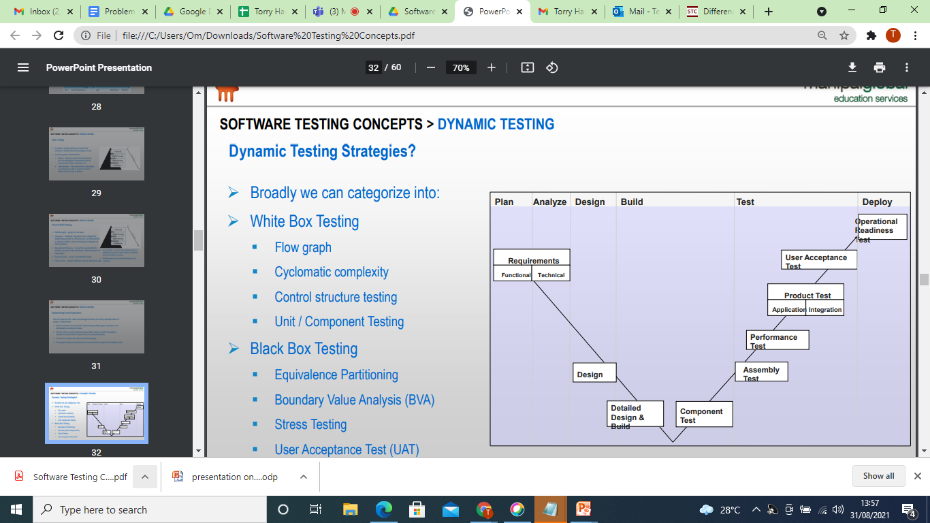

.
Features of Dynamic Testing:
It helps detect defects in the software.
Determines the quality attributes of the code.
Assists the team in identifying bugs and bottlenecks of the software.
Testing is done by executing the program.
Helps the team in validating the consistency of the software product.
Unlike other testing techniques, dynamic testing is pe

Differences between Static and Dynamic Testing
static testing
1. It is performed in the early stage of the software development
2. In static testing whole code is not executed.

3. Static testing is performed before code deployment.

4. Static Testing involves checklist for testing process.

5. Static Testing may complete 100% statement coverage in comparably less time.

Example:- Verification

Dynamic testing

It is performed at the later stage of the software development.

In dynamic testing whole code is executed.

Dynamic testing is performed after code deployment.

Dynamic Testing involves test cases for testing process

While dynamic testing only achieves less than 50% statement coverage.

Validation
Advantages of static testing
Improves product quality :
Static testing will enhance the product quality because it identifies the flaws or bugs in the initial stage of software development.
Improved the efficiency of dynamic testing:
The code gets cleaner and better after executing Static Testing.
Reduced SDLC cost:
The Static Testing reduced the SDLC cost because it identifies the bugs in the earlier stages of the software development life cycle. So, it needs less hard work and time to change the product and fix them.

Immediate evaluation & feedback
The static testing provides us immediate evaluation and feedback of the software during each phase while developing the software product.
Exact location of bug is traced:
When we perform the static testing, we can easily identify the bugs' exact location compared to the dynamic Testing.

Static and Dynamic testing examples
Static Testing is a type of software testing in which software application is tested without code execution.
Examples Static Testing and Dynamic Testing:
Online Shopping Cart
Static Test Techniques:
- Review the requirement documents, design documents initially
- Checking the GUI of the application.
- Checking the database structure of the application.

Dynamic Testing Techniques:
- Testing the functionality of the different page.
- Checking the checkout process and payment methods.
- Testing the interfaces between different pages.

Advantages of static testing
Improves product quality :
Static testing will enhance the product quality because it identifies the flaws or bugs in the initial stage of software development.
Improved the efficiency of dynamic testing:
The code gets cleaner and better after executing Static Testing.
Reduced SDLC cost:
The Static Testing reduced the SDLC cost because it identifies the bugs in the earlier stages of the software development life cycle. So, it needs less hard work and time to change the product and fix them.
Immediate evaluation & feedback
The static testing provides us immediate evaluation and feedback of the software during each phase while developing the software product.
Exact location of bug is traced:
When we perform the static testing, we can easily identify the bugs' exact location compared to the dynamic Testing.

Disadvantages of Static Testing
- Automated tools works with few programming languages
- Automated tools may provide false positives and false negatives
- Automated tools only scan the code
4. Automated tools cannot pinpoint weak points that may create troubles in run-time.

Advantages of Dynamic Testing
Considered High Level Exercise:
1. it can always find errors that static testing cannot find and that is the reason why it is considered as high level exercise.
2. Improves Quality:
It improves the quality of software because Dynamic Testing means executing the software and when we execute the software chances are higher for finds many bugs in the application so it ensures error free software to some extent and hence increases the quality of a product and project.
Disadvantages of Dynamic Testing

Time Consuming:
Main disadvantage of Dynamic Testing is that it is always considered as a time consuming task because its aim is to execute the application/software or code and hence as a result more test cases are needed to execute, so obviously executing more test cases can result in waste of time means consume lots of time.
2. Increases cost of Product:
Another disadvantage of Dynamic Testing is that it increases the cost of project/product because it is not starting early in the software life cycle and hence bugs fixed in later stages can result in increase of cost.
3. Execution Costly:
One of the main and most important disadvantages of Dynamic Testing is that its execution is costly because as you know Dynamic Testing means execution of software so it requires more man power to complete its task and hence resulted in higher cost to perform Dynamic Testing.

