1 PROJECT REPORT

CleverPath AI: AI-Driven Paths for Future-Ready Learning

Submitted in partial fulfilment of the requirement for the award of the degree of
BACHELOR OF TECHNOLOGY
IN
COMPUTER SCIENCE & ENGINEERING
Submitted by
Ankit Kumar University Roll No - 2218368

Aman Singh Dhek University Roll No - 2218326

Under the guidance of
Preeti Chaudhary
ASSISTANT PROFESSOR

Project Group No: 619


Department of Computer Science and Engineering Graphic Era Hill University June 2025



ACKNOWLEDGEMENT

I would like to particularly thank my Project Mentor Miss Preeti Chaudhary for his patience, support and encouragement throughout the completion of this Project.
Also, I am greatly indebted to all the other persons who directly or indirectly helped me during this project.

Ankit kumar Aman Singh Dhek
Roll No - 2218368 Roll No - 2218326

ABSTRACT

This project aims to design and implement an intelligent,Ed-Tech platform that provides students and instructors with a centralized, interactive, and scalable learning environment. CleverPath AI focuses on enhancing online education by integrating modern full-stack development with AI-driven assistance and smart content discovery.

Cloud-based Ed-Tech Platform →
The system is designed to be hosted on the cloud, allowing users to access the platform anytime and from anywhere. Cloud deployment ensures scalability, reliability, and availability without requiring users to manage local servers or infrastructure.

Ed-Tech Platform →
CleverPath AI functions as an online education system where instructors can create and manage courses, and students can enroll, learn, and interact with educational content. The platform supports structured learning, progress tracking, and feedback, making it suitable for academic and skill-based education.

AI-powered Assistance →
The platform integrates AI features such as a chatbot for instant doubt resolution and user guidance, along with a smart search mechanism that understands user intent. These features reduce dependency on instructors for basic queries and improve learning efficiency and engagement.

MERN Stack →
The project is developed using the MERN stack, which ensures a robust and scalable full-stack architecture:
MongoDB → Database used to store users, courses, enrollments, and learning data.
Express.js → Backend framework for handling APIs, authentication, and business logic.
React.js → Frontend library used to build an interactive and responsive user interface.
Node.js → Server-side runtime environment that powers the backend services.
Cloud & Security Infrastructure →
The platform is designed to be cloud-ready with secure authentication and role-based access control. Cloud services can be used for hosting, database management, and secure data storage, ensuring reliability, performance, and data protection.
.

TABLE OF CONTENT
ACKNOWLEDGEMENT 3
ABSTRACT 4
LIST OF TABLE 8
LIST OF FIGURES 8

1. INTRODUCTION 9
1.1 Background 9
1.2 Problem Domain 10
1.3 Proposed Solution 11

2. OBJECTIVE 14
2.1 Primary Content 14
2.2 Literature Review 19
2.3 Background Study 23

3. SOFTWARE AND HARDWARE REQUIREMENT
3.1 Software Requirement 30
3.2 Hardware Requirement 35

4. PROJECT METHODOLOGY 37
4.1 Development Methodology 37
4.2 System Architecture 42

5. IMPLEMENTATION AND RESULT 46
5.1 Implementation Overview 46
5.2 Results Achieved 46
5.3 System Performance and Observation 47

6. CONCLUSION AND FUTURE SCOPE 49
6.1 Conclusion 49
6.2 Future Scope 50

LIST OF TABLES

Sno. | Table  Description/Caption | Page no.
1 | 2.1 | 26
2 | 5.1 | 47

LIST OF FIGURES
Sno. | Figure  Description/Caption | Page no.
1 | Figure 4.1 | 34
2 | Figure 4.2 | 37
3 | Figure 4.3 | 39
4 | Figure 5.1 | 41
5 | Figure 5.2 | 42
6 | Figure 5.3 | 44
7 | Figure 5.4 | 47

CHAPTER 1

INTRODUCTION AND MOTIVATION

1.1 Background
In the contemporary digital era, the field of education has undergone a significant transformation due to the rapid advancement of internet technologies, cloud computing, and digital platforms. Traditional methods of learning, which were once confined to physical classrooms and fixed schedules, are increasingly being complemented and, in many cases, replaced by online learning systems. Online education platforms have become an integral component of the modern learning ecosystem, enabling students, professionals, and lifelong learners to access educational resources with unprecedented flexibility and convenience.

The proliferation of affordable internet connectivity and the widespread adoption of smartphones and computers have played a pivotal role in accelerating the growth of online education. Learners from diverse geographical locations, including remote and underserved areas, can now access high-quality educational content without the constraints of physical infrastructure. This has contributed to making education more inclusive, democratized, and scalable.

Online learning platforms offer a wide range of features, including video lectures, interactive quizzes, assignments, discussion forums, certification programs, and peer collaboration tools. These platforms cater to various learning needs, such as academic support, competitive exam preparation, skill development, and professional upskilling. Domains such as web development, data science, artificial intelligence, machine learning, and cybersecurity have witnessed a surge in demand, with learners actively seeking online resources to stay competitive in the evolving job market.

One of the key advantages of online education is its flexibility. Learners can study at their own pace, revisit concepts multiple times, and customize their learning schedules according to their personal and professional commitments. This self-paced learning model is particularly beneficial for working professionals and students preparing for exams, as it allows them to balance multiple responsibilities effectively.

Despite these advantages, existing online education platforms exhibit several limitations that hinder their ability to deliver a truly effective and engaging learning experience. A major concern is the lack of personalization. Most platforms adopt a uniform approach to content delivery, where the same learning materials are presented to all users regardless of their individual skill levels, learning preferences, or career goals. This one-size-fits-all model often results in inefficiencies, as beginners may find the content too advanced, while experienced learners may find it too basic.

Another critical issue is the absence of intelligent learning support. While platforms provide access to vast amounts of content, they do not actively assist learners in understanding concepts, resolving doubts, or navigating through the learning process. As a result, students often feel overwhelmed and struggle to maintain motivation and consistency.

The challenge of content discovery further exacerbates the problem. With the availability of thousands of courses and resources, learners often find it difficult to identify the most relevant and suitable content. Traditional search mechanisms rely heavily on exact keyword matching, which limits their effectiveness, especially for users who are unfamiliar with technical terminology.

From an instructor’s perspective, managing courses and interacting with a large number of students can be equally challenging. Many platforms lack efficient tools for content management, student engagement tracking, and query handling. This leads to increased workload for instructors and reduces the overall quality of support provided to learners.

In response to these challenges, there is a growing need for intelligent, user-centric, and scalable educational platforms that go beyond simple content delivery. Such systems should be capable of providing personalized guidance, real-time assistance, efficient content discovery, and seamless integration of various learning resources.

To address these requirements, CleverPath AI is proposed as an advanced Ed-Tech platform that combines the power of full-stack web development with artificial intelligence. By integrating features such as AI-powered chatbot support, intelligent search mechanisms, and a centralized learning environment, CleverPath AI aims to enhance the overall learning experience and create a more interactive, efficient, and engaging educational ecosystem.

1.2 Problem Domain
Despite the rapid growth and widespread adoption of online education platforms, several persistent challenges continue to limit their effectiveness. These issues impact both learners and instructors, leading to inefficiencies, reduced engagement, and suboptimal learning outcomes.

1.2.1 Lack of Instant Doubt Resolution
One of the most significant challenges faced by students in online learning environments is the inability to resolve doubts instantly. During the learning process, students frequently encounter difficulties in understanding concepts, solving problems, or interpreting instructions. In traditional classroom settings, these doubts can be addressed immediately through direct interaction with instructors. However, in online platforms, this level of immediacy is often missing.

Most platforms rely on discussion forums, email communication, or scheduled sessions for doubt resolution. This introduces delays, as students must wait for instructors or peers to respond. In many cases, learners turn to external resources such as search engines, video tutorials, or community forums, which may not always provide accurate or relevant information. This fragmented approach disrupts the learning flow, reduces concentration, and negatively affects knowledge retention.

The lack of real-time support also impacts learner motivation. When students are unable to resolve doubts quickly, they may lose interest, skip important topics, or abandon courses altogether.
Therefore, the absence of instant doubt resolution is a critical limitation that needs to be addressed.

1.2.2 Inefficient Content Discovery Mechanisms
Another major issue in existing platforms is the inefficiency of content discovery systems. With the increasing volume of educational content available online, finding the right course or resource has become a challenging task. Most platforms use keyword-based search algorithms that require users to input precise terms to retrieve relevant results.

However, learners—especially beginners—may not be familiar with the correct terminology or keywords. For example, a student searching for “how to build websites” may not know that the relevant courses are categorized under “web development” or “frontend engineering.” As a result, they may receive irrelevant results or fail to find suitable content altogether.

This limitation leads to frustration, wasted time, and missed learning opportunities. It also prevents learners from exploring new topics effectively, thereby limiting their growth and development.

1.2.3 Limited Intelligent Assistance and Scalability
Existing online education platforms largely depend on human instructors for query resolution and guidance. While instructors play a crucial role in the learning process, relying solely on them for all types of queries is not scalable. As the number of users increases, the demand for support also grows, making it difficult for instructors to respond to every query in a timely manner.

Many student queries are repetitive and involve basic concepts or platform navigation issues.
Handling such queries manually is inefficient and increases the workload on instructors. This not only affects the quality of support but also limits the platform’s ability to scale and accommodate a large user base.

The absence of intelligent assistance systems, such as AI-based chatbots, prevents platforms from automating routine tasks and improving operational efficiency. As a result, both learners and instructors face challenges in managing their respective activities effectively.

1.2.4 Fragmented Learning Experience
A fragmented learning experience is another critical issue in online education. In many cases, learning resources are distributed across multiple tools and platforms. For example, video lectures may be hosted on one platform, assignments on another, and discussions on a separate forum.

This lack of integration creates confusion and disrupts the continuity of learning. Students are required to switch between different interfaces, which reduces focus and increases cognitive load. It also makes it difficult to track progress and maintain consistency.

A unified and centralized system is essential to provide a seamless learning experience, where all resources and activities are accessible in one place.

1.3 Proposed Solution: CleverPath AI
To address the challenges identified in the problem domain, CleverPath AI proposes a comprehensive and intelligent solution that leverages modern web technologies and artificial intelligence. The platform is designed to provide a seamless, interactive, and user-centric learning experience for both students and instructors.

1.3.1 MERN Stack-Based Architecture
CleverPath AI is built using the MERN stack, which includes MongoDB, Express.js, React.js, and Node.js. This technology stack is widely used for developing scalable and high-performance web applications.
MongoDB is used as a NoSQL database to store user data, course content, and interactions efficiently.
Express.js provides a robust backend framework for handling API requests and server-side logic.
React.js is used to create a dynamic and responsive user interface.
Node.js enables efficient server-side execution and supports real-time communication.

This architecture ensures that the platform is scalable, maintainable, and capable of handling a large number of users.
1.3.2 Centralized Learning Platform
The platform provides a unified environment where all learning activities are integrated. Students can browse courses, enroll, access materials, complete assignments, and track their progress within a single interface. This eliminates the need for multiple tools and enhances the overall learning experience.
Instructors are provided with tools to create and manage courses, upload content, and monitor student performance. This improves efficiency and ensures better course delivery.

1.3.3 AI-Powered Chatbot
A key feature of CleverPath AI is the integration of an AI-powered chatbot that provides real-time assistance to users. The chatbot is capable of:
Answering frequently asked questions
Explaining basic concepts
Assisting with platform navigation
Providing guidance on course selection

This feature ensures 24×7 availability of support, reduces dependency on instructors, and improves learning continuity.

1.3.4 Intelligent Search System
The platform incorporates an advanced search mechanism that understands user intent rather than relying solely on keywords. By using natural language processing techniques, the system can interpret user queries more effectively and provide relevant results.

This enables learners to discover courses and content even when they are unsure of exact terminology, thereby improving accessibility and efficiency.

1.3.5 Security and Access Control
CleverPath AI implements secure authentication mechanisms and role-based access control to protect user data. Different roles, such as students and instructors, have specific permissions, ensuring that users can only access authorized features.

1.3.6 Scalability and Future Enhancements
The platform is designed to be scalable and cloud-ready, allowing it to handle increasing user demand. Its modular architecture makes it easy to integrate additional features such as:
Personalized learning recommendations
Advanced analytics and reporting
Gamification features
Mobile application support

CHAPTER 2

OBJECTIVES
The primary objective of the CleverPath AI project is to design and develop an advanced, intelligent, and scalable online education platform that significantly enhances the overall learning and teaching experience. The platform aims to overcome the limitations of traditional Ed-Tech systems by integrating modern full-stack technologies with artificial intelligence-driven features.

The system is designed to provide a centralized and user-friendly learning environment where students can access educational resources efficiently, while instructors can manage and deliver content effectively. By incorporating intelligent tools such as AI-powered chatbots and smart search mechanisms, the platform focuses on improving accessibility, interactivity, personalization, and efficiency in the learning process.

2.1 Primary Objectives
1. To design and develop a robust Ed-Tech platform using the MERN stack
- The first and foremost objective of the project is to build a strong and reliable foundation for the platform using the MERN stack (MongoDB, Express.js, React.js, and Node.js).
- The MERN stack ensures a full-stack JavaScript-based development environment, which simplifies development and improves maintainability.
- MongoDB provides a flexible and scalable database solution for storing user data, course information, and interactions.
- Express.js and Node.js enable efficient backend development, handling APIs, authentication, and server-side logic.
- React.js ensures a dynamic, responsive, and interactive user interface, enhancing user experience.
- By using this stack, the system becomes highly scalable, fast, and capable of handling real-time interactions, making it suitable for large-scale deployment.

2. To implement secure user authentication and role-based authorization for students and instructors
- Security is a critical aspect of any online platform. This objective focuses on ensuring that user data and system functionalities are protected.
- The platform will implement secure authentication mechanisms, such as login and registration systems using encrypted credentials.
- Role-based access control will be applied to differentiate between students and instructors, ensuring that each user type has access only to relevant features.
For example:
- Students can enroll in courses and access learning materials.
- Instructors can create, edit, and manage course content.
This ensures data privacy, system integrity, and controlled access, which are essential for a secure learning environment.

3. To enable instructors to create, manage, and update courses efficiently
This objective focuses on empowering instructors with tools that simplify course management.
Instructors will be able to:
- Create new courses with structured modules and lessons
- Upload learning materials such as videos, notes, and assignments
- Edit and update course content as needed
- Monitor student progress and engagement
The system will provide an intuitive dashboard for instructors, reducing complexity and improving productivity.
This feature ensures that instructors can deliver high-quality content efficiently and keep their courses up-to-date with evolving knowledge and industry trends.

4. To allow students to enroll in courses, access learning content, and provide course ratings and feedback
The platform aims to provide a seamless learning experience for students.
- Students will be able to:
- Browse and search for courses
- Enroll in courses of their interest
- Access all learning materials in a structured manner
- Track their learning progress
- Additionally, students can:
- Provide ratings and feedback for courses
- Share their learning experiences
This feedback mechanism helps improve course quality and allows instructors to refine their teaching methods. It also helps other students make informed decisions.

5. To integrate an AI-powered chatbot for real-time doubt resolution and user assistance
One of the most important objectives is to provide instant support through an AI-powered chatbot.
The chatbot will:
- Answer frequently asked questions
- Provide explanations for basic concepts
- Assist users in navigating the platform
- Offer guidance on course selection
- It will be available 24×7, ensuring continuous support without delays.
This reduces dependency on instructors for basic queries and ensures that students can continue learning without interruptions, thereby improving engagement and efficiency.

6. To develop a smart search mechanism that enables intelligent and intent-based content discovery
Traditional search systems rely on exact keyword matching, which is often inefficient. This objective focuses on implementing a smarter search system.

The search mechanism will:
- Understand user intent rather than exact keywords
- Provide relevant results even for vague or incomplete queries
- Improve the discovery of courses and learning materials
For example:
- A query like “how to build apps” can return results related to “mobile app development” or “Android development.”
This significantly enhances the user experience by making content discovery faster, easier, and more accurate.

7. To ensure system scalability, reliability, and usability for a large number of users
The platform is designed to support a growing number of users without performance degradation.
- Scalability ensures that the system can handle:
- Increasing users
- Large volumes of data
- High traffic loads
- Reliability ensures that the system:
- Functions consistently without failures
- Easy navigation and accessibility
This objective ensures that the platform remains efficient, stable, and user-friendly, even as it expands.

2.2 Literature Review
The development of modern online education platforms is strongly influenced by recent research and advancements in educational technology, artificial intelligence, and user experience design. Various studies highlight the importance of integrating intelligent systems to improve learning outcomes and user engagement.

2.2.1 Importance of Personalized and Instant Learning Support
Recent research emphasizes that personalized learning experiences significantly enhance student performance and satisfaction.
Traditional platforms provide static content, which does not adapt to individual learning needs.
- Studies show that students benefit more when:
- Learning paths are tailored to their skill levels
- Feedback is provided instantly
- Support is available during the learning process
These findings highlight the need for platforms like CleverPath AI to incorporate real-time assistance and adaptive learning features.

2.2.2 Role of AI Chatbots in Education
Artificial Intelligence has become a key component in modern educational systems, particularly through the use of chatbots.

- AI-powered chatbots are capable of answering student queries,instantly by providing explanations and guidance
- Handling repetitive questions efficiently
- Research shows that chatbots improve student engagement
- Reduce response time
- Decrease instructor workload
- By offering 24×7 availability, chatbots ensure that students receive continuous support, which is especially beneficial in self-paced learning environments.
These findings strongly support the integration of an AI chatbot in CleverPath AI to enhance learning efficiency and user satisfaction.

2.2.3 NLP-Based Smart Search Systems
Advancements in Natural Language Processing (NLP) have revolutionized search mechanisms in digital platforms.
Traditional keyword-based search systems have limitations, as they:
- Require exact input
- Fail to understand context
- Provide less relevant results
- NLP-based search systems:
- Analyze user queries semantically
- Understand intent and context
- Deliver more accurate and meaningful results
- Research indicates that such systems improve content discovery,enhance user experience,reduce search time
Incorporating NLP-based search in CleverPath AI ensures that users can easily find relevant courses and materials, even with incomplete or unclear queries.

2.2.4 Cloud-Based Collaboration and Scalability
Modern educational platforms increasingly rely on cloud technologies to support collaboration and scalability.

- Cloud-based systems provide:
- Remote access to resources
- Real-time updates and synchronization
- Scalable infrastructure
- They enable seamless interaction between students and instructors
- Efficient data management
- Cost-effective system expansion
Research highlights that cloud integration is essential for building flexible, scalable, and collaborative learning environments.

2.3 Background Study

- Introduction to Background Study
The background study of this project focuses on analyzing the current state of online education systems and understanding their strengths, limitations, and areas of improvement. With the rapid advancement of digital technologies, online learning platforms have become a fundamental part of modern education. These platforms have transformed the way knowledge is delivered, making learning more accessible, flexible, and scalable.

The purpose of this background study is to examine existing systems, identify the challenges faced by users, and establish the need for an improved and intelligent solution. By studying current platforms, it becomes possible to understand the gaps in functionality, particularly in areas such as real-time support, intelligent interaction, and personalized learning. These insights form the foundation for the development of CleverPath AI, which aims to address these shortcomings through the integration of artificial intelligence and modern web technologies.

- Overview of Existing Systems
Several well-established online education platforms, such as Coursera, Udemy, and Unacademy, have played a significant role in the expansion of digital learning across the globe. These platforms provide a wide range of courses covering various domains, including technology, business, science, arts, and competitive exam preparation.
Key Features of Existing Platforms
These platforms typically offer the following features:
- Extensive Course Libraries: Thousands of courses across multiple disciplines
- Video-Based Learning: Pre-recorded lectures delivered by industry experts and educators
- Assessments and Certifications: Quizzes, assignments, and certificates upon course completion
- Discussion Forums: Platforms for interaction between students and instructors
- Flexible Learning: Self-paced learning models that allow users to learn anytime
These features have contributed significantly to making education more accessible and convenient. Learners can acquire new skills, enhance their knowledge, and improve their career prospects without the constraints of traditional classroom settings.

- Limitations of Existing Systems
Despite their success and widespread adoption, current online education platforms exhibit several limitations that impact the overall learning experience.

3.1 Lack of Real-Time Doubt Resolution
One of the most critical shortcomings of existing systems is the absence of instant doubt resolution.
- Students often encounter difficulties while learning complex topics.
- Instead of receiving immediate assistance, they must post queries on discussion forums
- Wait for instructors or peers to respond
- Search for solutions on external platforms
This delay disrupts the continuity of learning and reduces efficiency. In many cases, learners lose focus or skip difficult topics due to unresolved doubts. The absence of real-time support negatively affects knowledge retention and overall learning outcomes.

3.2 Inefficient Search and Content Discovery
Most platforms rely on traditional keyword-based search mechanisms.
These systems require users to enter exact keywords to retrieve relevant results beginners or non-technical users often struggle because they may not know the correct terminology their queries may be vague or incomplete

For example,
A student searching for “how to create apps” may not find relevant results if the courses are labeled under “mobile app development” or “Android programming.”

This inefficiency leads to:
- Difficulty in discovering suitable courses
- Increased time spent searching
- Frustration and reduced user satisfaction

3.3 Lack of Intelligent Interaction
Existing platforms primarily focus on content delivery rather than interactive learning support.

There is minimal use of AI or intelligent systems to:
- Assist learners in real-time
- Provide personalized guidance
- Recommend learning paths
Students are left to navigate the platform independently, which can be overwhelming, especially for beginners. The lack of intelligent assistance reduces engagement and makes the learning process less interactive.

3.4 One-Size-Fits-All Learning Approach
Most platforms follow a uniform content delivery model.
The same content is presented to all learners regardless of their prior knowledge learning pace and individual goals

This approach has several drawbacks:
- Beginners may find content too difficult
- Advanced learners may find it too basic
- Learning becomes less effective and less engaging
A personalized learning experience is essential to cater to diverse user needs, which is largely missing in current systems.
3.5 Limited Instructor Support Tools
While these platforms provide basic tools for instructors, they often lack advanced features for efficient course management.

Instructors may face challenges in:
- Managing large numbers of students
- Handling repetitive queries
- Tracking student engagement effectively
Without automation and intelligent assistance, instructors become overburdened, which affects the quality of education delivery.

3.6 Fragmented Learning Experience
In many cases, learning resources are not fully integrated students may need to use different tools for watching lectures ,completing assignments and participating in discussions
This fragmented approach:
- Reduces focus
- Increases complexity
- Disrupts the learning process
A unified platform is essential to provide a seamless and efficient learning experience.

COMPARISON OF CLEVERPATH AI WITH OTHER PLATFORM
TABLE-:2.1

Feature | Traditional Platforms | CleverPath AI
Tech Stack | Varies | MERN Stack
Chatbot Support | Limited / None | AI-powered Chatbot
Learning Experience | Content-centric | User-centric
Search Mechanism | Keyword-based | Smart:Intent-Based Search
Scalability | Platform dependent | Highly Scalable

CHAPTER 3

SOFTWARE AND HARDWARE REQUIREMENTS

3.1 Introduction
The successful development and deployment of the CleverPath AI platform require a well-defined set of software and hardware resources. These requirements ensure that the system operates efficiently, supports scalability, and delivers a seamless user experience. The software requirements include programming languages, frameworks, development tools, and libraries, while the hardware requirements specify the physical infrastructure needed for development, testing, and deployment.

3.2 Software Requirements
The software requirements for CleverPath AI are categorized into system software, development tools, frameworks, and supporting technologies.

1 Operating System
The platform can be developed and executed on multiple operating systems, ensuring flexibility for developers.

- Windows (10/11)
- Linux (Ubuntu or other distributions)
- macOS
These operating systems provide compatibility with modern development tools and support for fullstack web development.

2.Programming Languages
The development of CleverPath AI involves multiple programming languages:

- JavaScript
- Primary language for both frontend and backend development
- Used in React.js (frontend) and Node.js (backend) • Python (Optional for AI integration)

3.Frontend Technologies
The frontend is responsible for the user interface and user experience.
React.js
A JavaScript library for building dynamic and responsive user interfaces ,enables component-based architecture and Improves performance using virtual DOM

Tailwind CSS
Used for responsive design and UI styling
Ensures compatibility across devices (desktop, tablet, mobile)

Axios / Fetch API
Used for making HTTP requests to the backend

4. Backend Technologies
The backend handles server-side logic, APIs, and data processing.
Node.js
Provides a runtime environment for executing JavaScript on the server
Supports asynchronous and event-driven architecture
Express.js
A lightweight framework for building RESTful APIs
Handles routing, middleware, and server logic
These technologies ensure fast performance and efficient request handling.

5. Database Management System
MongoDB
A NoSQL database used to store user data, course information, and interactions ,provides flexibility with schema-less design and supports scalability and high performance

Mongoose (ODM)
Used for interacting with MongoDB
Simplifies database operations and schema definition

6 AI and Chatbot Technologies
The AI-powered chatbot is a key feature of CleverPath AI.
- Natural Language Processing (NLP) Libraries Used to understand and process user queries
Examples: NLTK, spaCy (if Python-based AI is used)
- OpenAI API / Custom Chatbot Logic
Enables intelligent conversation and query resolution
- Dialog Management System
Handles user interaction flow and responses
These technologies allow the chatbot to provide real-time assistance and intelligent responses.

7 Smart Search Technologies
- NLP-Based Search Algorithms
Understand user intent rather than exact keywords
- Elasticsearch
Improves search speed and relevance
Enables advanced search features like filtering and ranking
This ensures efficient and accurate content discovery.

8 Development Tools
Visual Studio Code
- Lightweight and powerful code editor
- Supports extensions for web development
Postman
- Used for testing backend APIs
Git
- Tracks code changes and enables collaboration
GitHub
- Stores project repository and supports team collaboration

9 Web Browser
  - Google Chrome
  - Mozilla Firefox
Browsers are used for testing and accessing the web application. .

3.3 Hardware Requirements
The hardware requirements depend on the development environment and expected system usage.

1 Minimum Hardware Requirements
For development and testing:
- Processor: Intel i3 or equivalent
- RAM: 4 GB
- Storage: 256 GB HDD/SSD
- Internet Connection: Stable broadband connection
- This configuration is sufficient for basic development tasks.

2 Recommended Hardware Requirements
For efficient development and smooth performance:
- Processor: Intel i5/i7 or AMD Ryzen 5/7
- RAM: 8 GB or higher
- Storage: 512 GB SSD or higher
- Graphics: Integrated or dedicated GPU
- Internet: High-speed connection
This setup ensures faster compilation, smoother multitasking, and better performance.

3 Server Hardware Requirements (For Deployment)
- For hosting the platform:
- Processor: Multi-core CPU
- RAM: 8–16 GB
- Storage: SSD-based storage
- Network: High-speed internet with low latency
- Cloud servers can also be used to scale resources dynamically.

4 User-End Requirements
For students and instructors accessing the platform:
- Device: Laptop, desktop, tablet, or smartphone
- Browser: Updated web browser
- Internet: Stable internet

CHAPTER 4

PROJECT METHODOLOGY/DESIGN
The System Methodology of CleverPath AI defines the structured approach used to design, develop, test, and deploy the platform. It ensures that the system is built in a systematic, efficient, and scalable manner. The methodology combines a modular and incremental development approach with a multilayered architecture, enabling flexibility, maintainability, and continuous improvement throughout the development lifecycle.

4.1 Development Methodology
The CleverPath AI project follows a modular and incremental development model, where the system is divided into smaller modules, and each module is developed and integrated step by step. This approach allows for easier debugging, faster development, and better adaptability to changes.
Each phase of development is clearly defined as follows:

    - Requirement Analysis
The Requirement Analysis phase is the foundation of the entire project. In this stage, all system requirements are carefully identified and documented.
Key Activities:
Understanding the needs of end users (students and instructors)
Identifying core features such as:
- Course management
- User authentication
- AI chatbot
- Smart search

1 System Design
The CleverPath AI ed-tech platform consists of three main components: the front end, the back end, and the database. The platform follows a client-server architecture, with the front end serving as the client and the back end and database serving as the server.
Front-end
The front end of the platform is built using ReactJS, which is a popular JavaScript library for building user interfaces. ReactJS allows for the creation of dynamic and responsive user interfaces, which are critical for providing an engaging learning experience to the students. The front end communicates with the back end using RESTful API calls.
Back-end
The back end of the platform is built using NodeJS and ExpressJS, which are popular frameworks for building scalable and robust server-side applications. The back end provides APIs for the front end to consume, which include functionalities such as user authentication, course creation, and course consumption. The back end also handles the logic for processing and storing the course content and user data.
Database
The database for the platform is built using MongoDB, which is a NoSQL database that provides a flexible and scalable data storage solution. MongoDB allows for the storage of unstructured and semi-structured data, which is useful for storing course content such as videos, images, and PDFs. The database stores the course content, user data, and other relevant information related to the platform.
Architecture Diagram
Here is a high-level diagram that illustrates the architecture of the CleverPath Ai ed-tech platform:
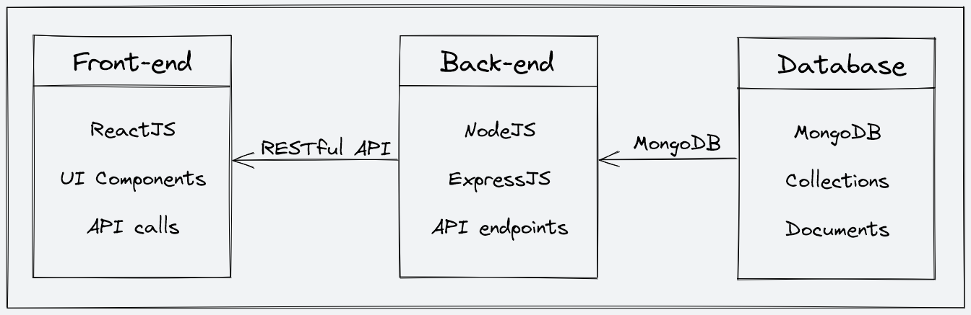
FIGURE-:4.1
Architecture Diagram
- Front-end
The front end is part of the platform that the user interacts with. It's like the "face" of the platform that the user sees and interacts with. The front end of CleverPath AI is designed using a tool called Figma, which is a popular design tool that allows for the creation of clean and minimal user interfaces.
The front end of CleverPath AI has all the necessary pages that an ed-tech platform should have. Some of these pages are:
For Students:
- Homepage: This page will have a brief introduction to the platform, as well as links to the course list and user details.
- Course List: This page will have a list of all the courses available on the platform, along with their descriptions and ratings.
- Wishlist: This page will display all the courses that a student has added to their wishlist.
- Cart Checkout: This page will allow the user to complete the course purchase.
- Course Content: This page will have the course content for a particular course, including videos, and other related material.
- User Details: This page will have details about the student's account, including their name, email, and other relevant information.
- User Edit Details: This page will allow the student to edit their account details.
For Instructors:
- Dashboard: This page will have an overview of the instructor's courses, as well as the ratings and feedback for each course.
- Insights: This page will have detailed insights into the instructor's courses, including the number of views, clicks, and other relevant metrics.
- Course Management Pages: These pages will allow the instructor to create, update, and delete courses, as well as manage the course content and pricing.
- View and Edit Profile Details: These pages will allow the instructor to view and edit their account details.

Back-end
Description of the Back-end Architecture:
CleverPath AI uses a monolithic architecture, with the backend built using Node.js and Express.js, and MongoDB as the primary database. Monolithic architecture refers to a design approach where all the modules of the application are combined into a single large program, with a single codebase, to enable better control, security, and performance.
Node.js is a popular JavaScript runtime that allows us to run JavaScript code outside of the browser. Express.js is a web application framework that simplifies the process of building web applications in Node.js. MongoDB is a popular NoSQL database that allows for flexible data storage and retrieval, making it a suitable choice for complex applications like CleverPath AI.
Features and Functionalities of the Back-end:
The back end of CleverPath AI provides a range of features and functionalities, including:
- User authentication and authorization: Students and instructors can sign up and log in to the platform using their email addresses and password. The platform also supports OTP (One-Time Password) verification and forgot password functionality for added security.
- Course management: Instructors can create, read, update, and delete courses, as well as manage course content and media. Students can view and rate courses.
- Payment Integration: Students will purchase and enrol on courses by completing the checkout flow that is followed by Razorpay integration for payment handling.
- Cloud-based media management: CleverPath AI uses Cloudinary, a cloud-based media management service, to store and manage all media content, including images, videos, and documents.
- Markdown formatting: Course content in document format is stored in Markdown format, which allows for easier display and rendering on the front end.
Frameworks, Libraries, and Tools used:
The back end of CleverPath Ai uses a range of frameworks, libraries, and tools to ensure its functionality and performance, including:
- Node.js: Node.js is used as the primary framework for the back end.
- MongoDB: MongoDB is used as the primary database, providing a flexible and scalable data storage solution.
- Express.js: Express.js is used as a web application framework, providing a range of features and tools for building web applications.
- JWT: JWT (JSON Web Tokens) are used for authentication and authorization, providing a secure and reliable way to manage user credentials.
- Bcrypt: Bcrypt is used for password hashing, adding an extra layer of security to user data.
- Mongoose: Mongoose is used as an Object Data Modeling (ODM) library, providing a way to interact with MongoDB using JavaScript.
Data Models and Database Schema:
The back end of CleverPath Ai uses a range of data models and database schemas to manage data, including:
- Student schema: Includes fields such as name, email, password, and course details for each student.
- Instructor schema: Includes fields such as name, email, password, and course details for each instructor.
- Course schema: Includes fields such as course name, description, instructor details, and media content.
Overall, the back-end of CleverPath Ai is designed to provide a robust and scalable solution for an ed-tech platform, with a focus on security, reliability, and ease of use. By using the right frameworks, libraries, and tools, we can ensure that the platform functions smoothly and provides an optimal user experience for all its users.
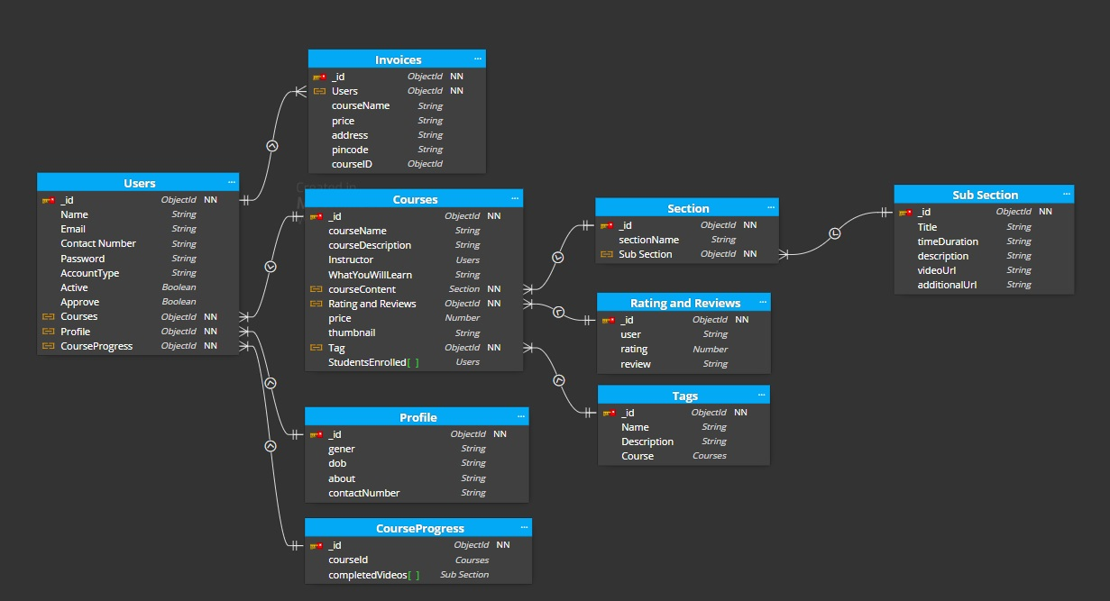
FIGURE-:4.2
- AI Layer (Intelligent Layer)
This layer introduces intelligence into the system and enhances user experience. a. AI Chatbot
Functions:
- Provides instant doubt resolution
- Answers frequently asked questions
- Assists in navigation

Benefits:
- Reduces waiting time
- Improves learning continuity
- Decreases instructor workload

4.3 Advantages of the Proposed Methodology
The chosen methodology offers several advantages:
- Modularity: Easy to develop and maintain
- Scalability: Can handle increasing users and data
- Flexibility: Easy to update and extend
- Efficiency: Faster development and debugging
- User-Centric Design: Focus on user experience

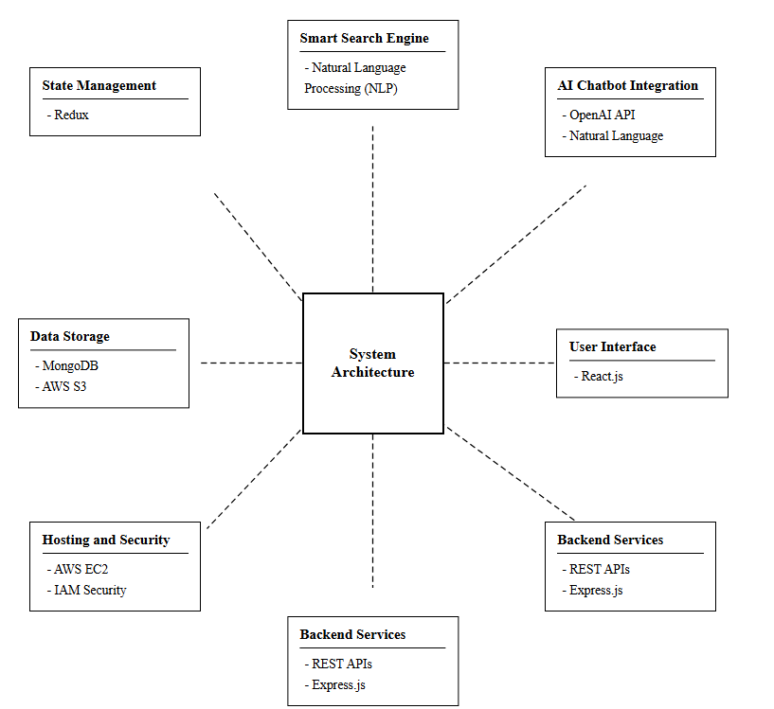
Figure 4.3
ARCHITECTURE DIAGRAM

CHAPTER 5

IMPLEMENTATION AND RESULTS
This chapter presents the outcomes obtained after the implementation of the proposed CleverPath AI system. It highlights the functionalities achieved, system performance, and the deliverables produced during the development phase. The implementation focuses on building a full-stack EdTech platform using the MERN stack, ensuring smooth integration between frontend and backend components.

5.1 Implementation Overview
The CleverPath AI platform has been developed using a structured and modular approach. The system is implemented as a web-based application where the frontend and backend are integrated to provide seamless interaction between users and the system.
- The frontend is developed using React.js, providing a dynamic and responsive user interface. • The backend is implemented using Node.js and Express.js, handling server-side logic and API communication.
- The database is managed using MongoDB, ensuring efficient storage and retrieval of data.
The implementation process focused on creating core functionalities required for an online education platform, ensuring usability, performance, and scalability.

5.2 Results Achieved
The following results have been successfully achieved during the implementation phase:=
The CleverPath AI project has been partially implemented as a full-stack Ed-Tech platform using the MERN stack. The frontend and backend modules have been successfully developed and integrated, ensuring smooth communication between client-side and server-side components.

The system currently supports essential features such as:
- User registration and login

FIGURE-:5.1
LOGIN PAGE

Pseudo Code:-
FUNCTION login(email, password):

IF email or password is empty:
RETURN "Missing credentials"

FIND user by email

IF user not found:
RETURN "User not registered"

COMPARE password with hashed password

IF password matches:
CREATE JWT token

ATTACH token to user

REMOVE password from response

SET cookie with token

RETURN success response

ELSE:
RETURN "Incorrect password"
- Secure authentication system

FIGURE-:5.2
SIGNUP PAGE

Pseudo Code:-
FUNCTION signUp(userData):

EXTRACT all fields from request

IF any required field is missing:
RETURN "Fill all details"

IF password != confirmPassword:
RETURN "Passwords do not match"

CHECK if user already exists
IF exists:
RETURN "Email already exists"

FETCH latest OTP for email

IF OTP not found:
RETURN "OTP not found"

IF entered OTP != stored OTP:
RETURN "Invalid OTP"

HASH password using bcrypt

CREATE user profile (default empty values)

CREATE new user with:
- name
- email
- hashed password
- account type
- profile reference
- default image

RETURN success response

- Course creation by instructors

FIGURE-:5.3
INSTRUCTOR PAGE

Pseudo Code-:
FUNCTION createCourse(courseData, file):

EXTRACT all required fields

IF any field is missing:
RETURN "All fields are required"

GET instructorId from logged-in user

FIND category by ID
IF not found:
RETURN "Category not found"

UPLOAD thumbnail image to cloud

CREATE new course with:
- course details
- instructor ID
- thumbnail URL

ADD course ID to category

ADD course ID to instructor profile

RETURN success response
- Course listing and browsing
- Access to course content for enrolled students

The platform demonstrates efficient data handling through MongoDB, enabling quick storage and retrieval of user and course information.
A responsive and user-friendly interface has been developed using React.js, allowing users to easily navigate the platform across different devices.
Role-based access control has been implemented to differentiate between students and instructors, ensuring that each user has access only to relevant features.
Secure authentication mechanisms have been integrated to protect user data and maintain system integrity.
The current implementation provides a strong foundation for future enhancements, ensuring that additional features can be integrated without major restructuring.

5.3 System Performance and Observations
- The system performs efficiently for core functionalities such as authentication, course management, and data retrieval.
- API response time is optimized due to the use of Node.js and efficient database queries.
- The frontend ensures smooth rendering and user interaction through React.js.
- The modular design allows easy debugging and future scalability.

PROJECT STATUS AND COMPLETION
TABLE-:5.1

Phase | Completion
Requirement Analysis | 100%
System Design | 100%
Backend Development | 100%
Frontend Development | 100%
AI Integration | 85%
Testing(Front+Backend) | 100%
Documentation | 95%
Overall Completion Status:- Approximately 95% Completed

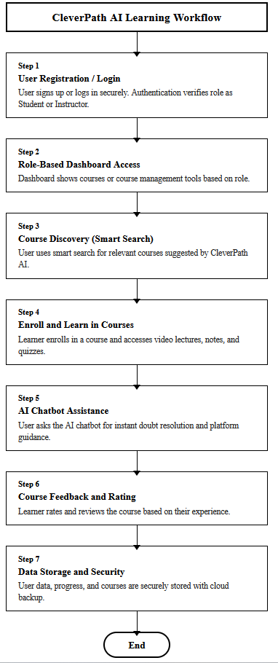

CHAPTER 6 CONCLUSION AND FUTURE SCOPES

6.1 Conclusion
The CleverPath AI project represents a significant step toward enhancing the effectiveness and efficiency of modern online education platforms. The primary objective of the system was to develop an intelligent and scalable Ed-Tech platform that integrates full-stack web technologies with advanced AI-based features to improve the overall learning experience.

Through the implementation of the MERN stack, the platform successfully establishes a strong and reliable foundation for delivering educational content. The integration of frontend and backend components ensures smooth communication between users and the system, while the use of MongoDB enables efficient data storage and management. Core functionalities such as user authentication, course creation, course enrollment, and content access have been successfully implemented, demonstrating the feasibility and effectiveness of the proposed solution.

One of the key achievements of this project is the development of a centralized learning environment that simplifies the interaction between students and instructors. The platform provides a user-friendly interface, secure access control, and efficient course management capabilities, which collectively enhance usability and engagement.

Although advanced AI features such as the chatbot and smart search are still under development, their planned integration highlights the innovative nature of the system. These features are expected to address major limitations of existing platforms, such as delayed doubt resolution and inefficient content discovery.

Overall, the CleverPath AI platform successfully demonstrates how modern technologies can be leveraged to build an intelligent, scalable, and user-centric online education system. The project lays a strong foundation for future enhancements and provides valuable insights into the development of next-generation Ed-Tech solutions.

6.2 Future Scope
While the current implementation of CleverPath AI provides essential functionalities, there are several opportunities for future enhancements that can significantly improve the system’s capabilities and user experience. These enhancements focus on incorporating advanced artificial intelligence, improving accessibility, and expanding platform features.

- Advanced AI-Based Personalization
In the future, the platform can incorporate advanced AI algorithms to deliver personalized learning experiences. The system can analyze user behavior, learning patterns, and preferences to recommend customized learning paths. This will ensure that each student receives content tailored to their skill level and learning goals, improving engagement and learning outcomes.

- Machine Learning-Driven Course Recommendations
The integration of machine learning models can enable intelligent course recommendation systems. By analyzing user activity, past enrollments, and performance data, the platform can suggest relevant courses to learners. This feature will help users discover new learning opportunities and make informed decisions, enhancing content accessibility and usability.

- Voice-Enabled Chatbot
The AI chatbot can be further enhanced by integrating voice recognition capabilities. A voiceenabled chatbot will allow users to interact with the system through speech, making the platform more accessible and user-friendly. This feature will be particularly beneficial for users who prefer voice-based interaction or have accessibility needs.

- Mobile Application Support
To increase accessibility and reach a wider audience, a mobile application can be developed for
CleverPath AI. A dedicated mobile app will allow users to access courses, interact with the chatbot and track progress on their smartphones. This will provide greater flexibility and convenience, enabling learning anytime and anywhere.

- Advanced Analytics and Dashboards
Future enhancements can include the development of advanced analytics and dashboards for both students and instructors. These dashboards can provide insights such as:
- Student progress and performance tracking
- Course completion rates
- Engagement metrics
Such analytics will help instructors improve course quality and enable students to monitor their learning journey effectively.

Final Remarks

The future scope of CleverPath AI highlights its potential to evolve into a comprehensive and intelligent learning platform. By integrating advanced technologies such as artificial intelligence, machine learning, and mobile computing, the system can further enhance user experience, scalability, and efficiency. These improvements will position CleverPath AI as a next-generation solution in the field of online education.

REFERNENCES
[1] Artificial Intelligence: A Modern Approach, S. Russell and P. Norvig, Artificial Intelligence: A Modern Approach, 4th ed., Pearson, 2021..
[2] Speech and Language Processing, D. Jurafsky and J. H. Martin, Speech and Language Processing, 3rd ed., Pearson, 2023.
[3] Institute of Education Sciences. (2023). Education Resources Information Center (ERIC). U.S. Department of Education. https://eric.ed.gov.
[4] React Documentation, “React Official Documentation,” [Online]. Available: https://react.dev/
[5] Designing Data-Intensive Applications, M. Kleppmann, Designing Data-Intensive Applications, O’Reilly Media, 2017.
[6] HolonIQ. (2023). Global EdTech market intelligence report. HolonIQ. https://www.holoniq.com
EdSurge. (2023). EdTech research and reports. https://www.edsurge.com/research

[7] 1EdTech Consortium. (2023). Learning Tools Interoperability (LTI) specification. https://www.imsglobal.org/activity/learning-tools-interoperability
Advanced Distributed Learning Initiative. (2023). Experience API (xAPI) specification. U.S. Department of Defense. https://adlnet.gov/projects/xapi
World Wide Web Consortium. (2018). Web Content Accessibility Guidelines (WCAG) 2.1. https://www.w3.org/TR/WCAG21/

