**ARCHITECTURAL PROJECT** **DESCRIPTION**

PROJECT NAME

|  |  |  |
| --- | --- | --- |
| LIMUPA |  |  |
| COMPANY NAME | AUTHOR | DATE |
| ---------- | ANKIT DATANIYA | 07/10/2023 |

# 1. PROJECT SUMMARY

|  |
| --- |
| This is a LIMUPA it's Digital-Products-Store-Ecommerce Web site. this project was made in PHP language. PHP is a server scripting language, and a powerful tool for making dynamic and interactive Web pages.  and we also use Larave. Laravel - The PHP Framework For Web Artisans. Limupa connected eith Databass.  we also sale digital products like mobile, tv, smart watch, games, headphone and etc admi was want. user can register and login with hesh name an email or password. then he also sow Home page there was see gidigital products. user can buy any produst onlin, user can use many payment methods, user can add his wishilisht and use also sow our offers.  Limupa was creat admin page. admin can change any products and offers. admi handeled add user's updates and details. admin cand remove products and change. admin can ban anny user's and admi handel all peyment methods. admin was connete with Databass.  Limupa's all users and product allso connect with Databass. admin can sow all databass ditails like user's table (name, image, username, email, mobile and time.) and product table like product name, image, prise, discription and time.  LImupa Header hsa Limupa logo and search bar after in penal Home page, Catalog, New Productd list, Products Page, Pages, FAQ Location.  on Home page its sow Smart Watches, Smart Tv's, Laltps, sid penal ang games.  in Catslog Samart Tv's brand, Smart watche's brands, games brand, heardphone brand, new Products and offers. in Featured Products has new latest Products.  Limupa Footer has Limupa logo We are a team of designers and developers who creates high quality premium Shopify themes.  ADDRESS:  CALL :9099777400  EMAIL:mehul561995@gmail.com  Main Menu  Home  Catalog  Featured Products  Product Pages  Pages  FAQ Page  Main Menu |

# 2. DESIGN GOALS

## 2.1 GOAL 1

|  |
| --- |
| Limupa Header |
| MID-SEASON SALE UP TO 70% OFF. USE CODE: “SALE70”. SHOP NOW x  Telephone Enquiry: 9099777400    Limupa - Electronic Store Shopify Theme Search entire store here...  HOME  CATALOG  FEATURED PRODUCTS  PRODUCT PAGES  PAGES  FAQ PAGE |

## 2.2 GOAL 2

|  |
| --- |
| Home page |
| logo, Search bar, Katelog, New Products, all Products and faq. all are in drop dow list function. sow products ditails like name, image, price and wishlist. shot side penal all bran and product catogorys.  register, login and my account product sow all catogury wise alo see products images, product Name, Product Discription amd Product buy. |

## 2.3 GOAL 3

|  |
| --- |
| Footer |
| Our Brands  Free Delivery  And free returns. See checkout for delivery dates.  Safe Payment  Pay with the world’s most popular and secure payment methods.  Shop With Confidence  Our Buyer Protection covers your purchasefrom click to delivery.  24/7 Help Center |

## **DISCLAIMER**

Any articles, templates, or information provided by Smartsheet on the website are for reference only. While we strive to keep the information up to date and correct, we make no representations or warranties of any kind, express or implied, about the completeness,

accuracy, reliability, suitability, or availability with respect to the website or the information, articles, templates, or related graphics contained on the website. Any reliance you place on such information is therefore strictly at your own risk.

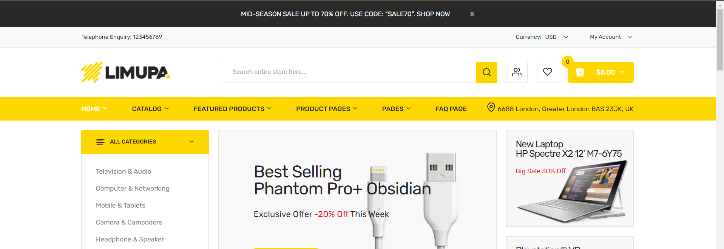

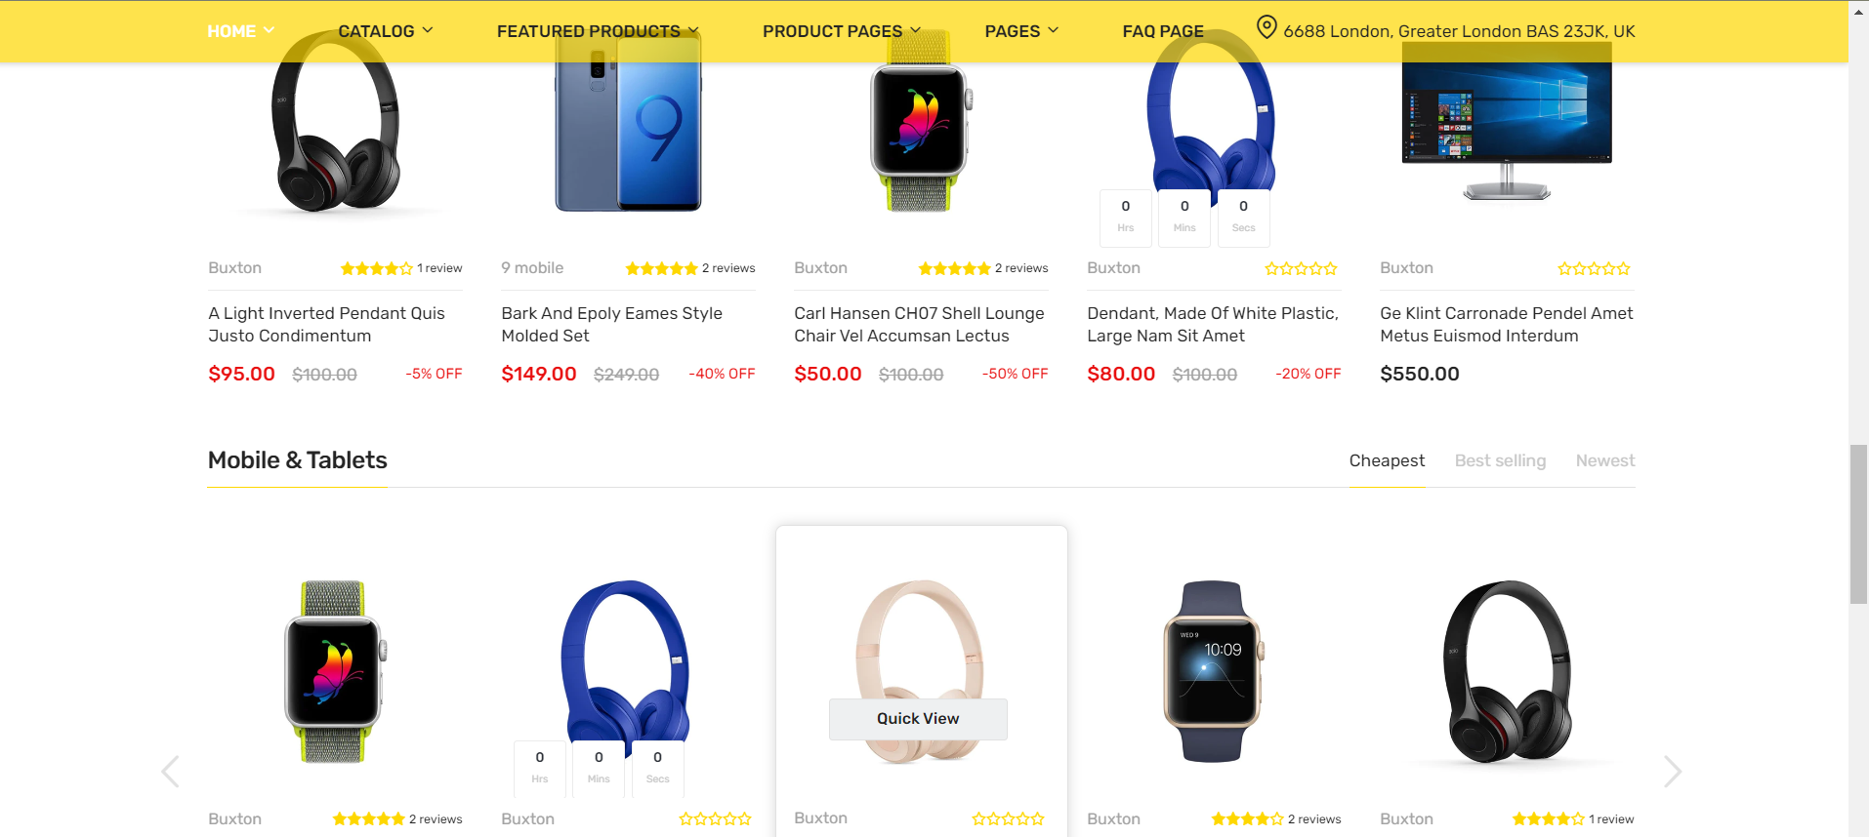cv