MODULE – 4(Advance PHP)

• What Is Object Oriented Programming?

OOP in PHP alludes to a programming style having an association of the class, objects, and various components. PHP is a server-side programming language used for web development. Object-oriented programming in PHP helps developers build reusable and complex web applications. Object-oriented programming is a programming style that refers to the association of various components and revolves around the inheritance, polymorphism, encapsulation, and abstraction concepts.

• What Are Properties Of Object Oriented Systems?

Object-oriented programming in PHP helps developers build reusable and complex web applications. Object-oriented programming is a programming style that refers to the association of various components and revolves around the inheritance, polymorphism, encapsulation, and abstraction concepts.

• What Is Difference Between Class And Interface?

Interface:

Interface comes under fully abstraction.

Interfaces can maintain only abstract methods.

In interfaces, we can't create the variables.

In interface, we can use only public access specifier.

By using 'implement' keyword we can get interface from derived class.

By using interfaces multiple inheritance is possible.

class:

Class comes under partial abstraction.

Classes can maintain abstract methods and non abstract methods.

Classes, we can create the variables.

Classes, we can use any access specifier.

By using 'extends' keyword we can access the class features from derived class.

Multiple inheritance is not possible.

• What Is Overloading?

Overloading is the ability to create multiple functions of the same name with different implementations. Function overloading in PHP? Function overloading in PHP is used to dynamically create properties and methods. These dynamic entities are processed by magic methods which can be used in a class for various action types. Function overloading contains same function name and that function performs different task according to number of arguments. For example, find the area of certain shapes where radius are given then it should return area of circle if height and width are given then it should give area of rectangle and others. Like other OOP languages function overloading can not be done by native approach. In PHP function overloading is done with the help of magic function call. This function takes function name and arguments.

• What Is T_PAAMAYIM_NEKUDOTAYIM (Scope Resolution Operator (::) with Example

For those of you who don't know, in PHP T_PAAMAYIM_NEKUDOTAYIM is the token name for ::, the static separator. It's Hebrew for double colon.

Examples:

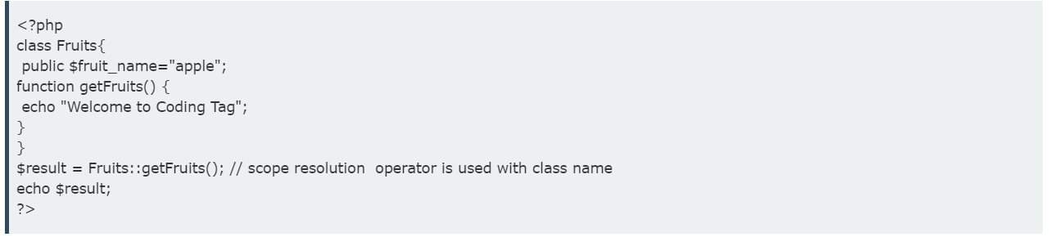

Output:

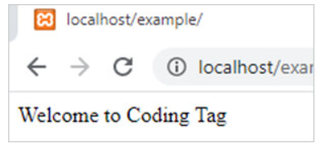

Example 2:

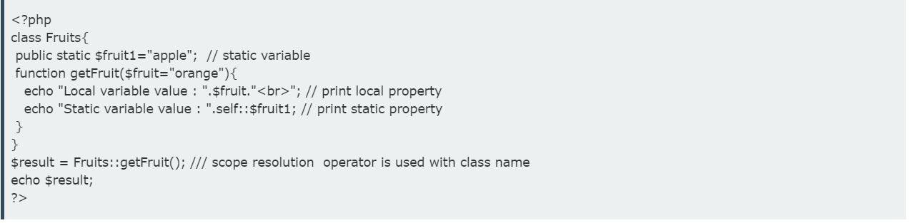

Output:

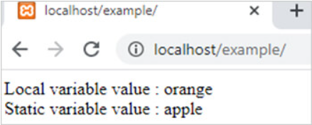

• What are the differences between abstract classes and interfaces?

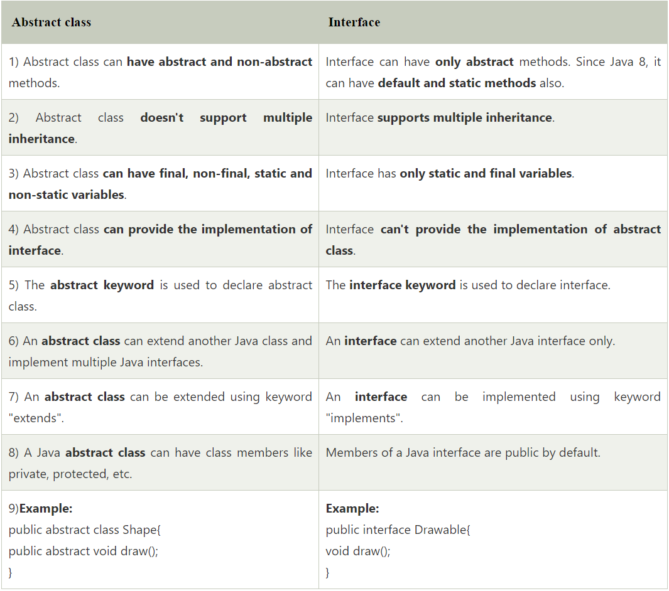

• Define Constructor and Destructor?

Constructors are the very basic building blocks that define the future object and its nature. You can say that the Constructors are the blueprints for object creation providing values for member functions and member variables. Once the object is initialized, the constructor is automatically called. Destructors are for destroying objects and automatically called at the end of execution.

__construct():

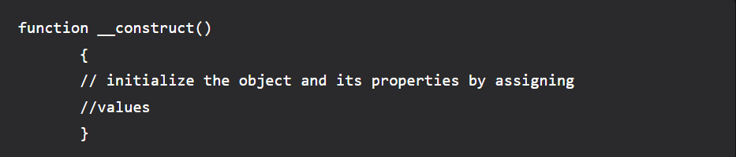

__destruct():

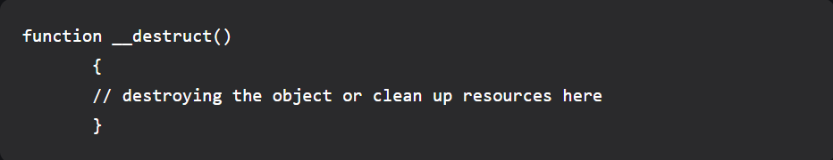

In this article, we are going to learn about object-oriented concepts of constructors and destructors.

• How to Load Classes in PHP?

In order to use class defined in another PHP script, we can incorporate it with include or require statements. However, PHP's autoloading feature doesn't need such explicit inclusion. Instead, when a class is used (for declaring its object etc.) PHP parser loads it automatically, if it is registered with spl_autoload_register() function. Any number of classes can thus be registered. This way PHP parser gets a laast chance to load class/interface before emitting error.

• How to Call Parent Constructor?

In PHP, you can call the parent constructor from the constructor of the child class using the parent::__construct(arguments) syntax. If the child class doesn’t have a constructor, the parent constructor will be called automatically .

Here’s an example: 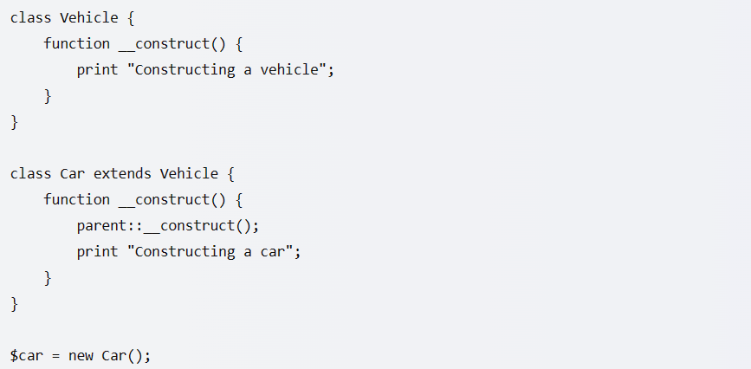

In this example, when you create a new instance of Car, PHP will call the constructor of Car. However, since Car doesn’t have a constructor, PHP will continue to search for the constructor of its parent class, Vehicle. It then invokes the constructor of Vehicle using parent::__construct().

• Are Parent Constructor Called Implicitly When Create An ObjectOf Class?

when an object of a class is created, the parent constructor is called implicitly . If the child class does not define a constructor, the default constructor is called, which in turn calls the parent class’s default constructor 3. If the child class defines a constructor, it must explicitly call the parent class’s constructor using the super() keyword . This is known as constructor chaining.

• What Happen, If Constructor Is Defined As Private Or Protected?

If a constructor is defined as private or protected, it cannot be called from outside the class . This means that you cannot create an object of that class using the new keyword from outside the class. However, you can still create objects of that class from within the class itself or from its child classes . If you want to prevent a class from being instantiated, you can define its constructor as private. This is useful when you want to create a class that only contains static methods and properties 2. On the other hand, if you define a constructor as protected, it can be called from within the class itself and its child classes, but not from outside the class . This is useful when you want to create a base class that should not be instantiated directly but should be extended by other classes . Here’s an example

• What are PHP Magic Methods/Functions? List them

In PHP, magic methods are special methods that override PHP’s default action when certain actions are performed on an object 1. They are called automatically when certain conditions are met 2. The following method names are considered magical:

* __construct()
* __destruct()
* __call()
* __callStatic()
* __get()
* __set()
* __isset()
* __unset()
* __sleep()
* __wakeup()
* __serialize()
* __unserialize()
* __toString()
* __invoke()
* __set_state()
* __clone()
* __debugInfo().

• Write program for Static Keyword in PHP?

In PHP, the static keyword is used to declare properties and methods of a class as static. Static properties and methods can be used without creating an instance of the class. The static keyword is also used to declare variables in a function which keep their value after the function has ended .

• Use of The $this keyword.

In PHP, $this is a reserved keyword that refers to the calling object It is usually the object to which the method belongs, but possibly another object if the method is called statically from the context of a secondary object This keyword is only applicable to internal methods. You can use $this to access the properties and methods of the current object within the class using the object operator (->)