**ROBOT FRAMEWORK DOCUMENTATION**

**ROBOT FRAMEWORK.**   
Robot Framework is a generic open-source automation framework. It can be used for [test automation](https://robotframework.org/test-automation/) and [robotic process automation (RPA)](https://robotframework.org/rpa/).

Robot Framework has an easy syntax, utilizing human-readable keywords.

**WHY ROBOT FRAMEWORK?**

Robot Framework is a test automation framework that may be used for acceptance testing and test-driven development (ATDD). It's a tabular test data syntax keyword-driven testing framework.

**ADVANTAGES OF ROBOT FRAMEWORK:**

* Open source
* Very easy to install
* Robot Framework is application and platform independent
* Debugging Problem
* User doesn't need a programming language to write a Robot Framework test case & run it.

**DISADVANTAGES OF ROBOT FRAMEWORK:**

* Less community supports
* Less flexibility - No features like author tag, skip the test, No nested loops, etc.
* Conditions and Loops are not easy to use.

**WHERE ROBOT FRAMEWORK IS USED.**

* Automation resources are not good at programming languages
* When there is no time for Framework design (as Robot Framework is readily available)

**WORKING WITH ROBOT FRAMEWORK WHAT TOOLS AND LIBRARIES NEED?**

* PYTHON
* PYCHARM IDE OR VS CODE
* SELENIUM
* ROBOT FRAMEWORK

**FOLDER STRUCTURE.**

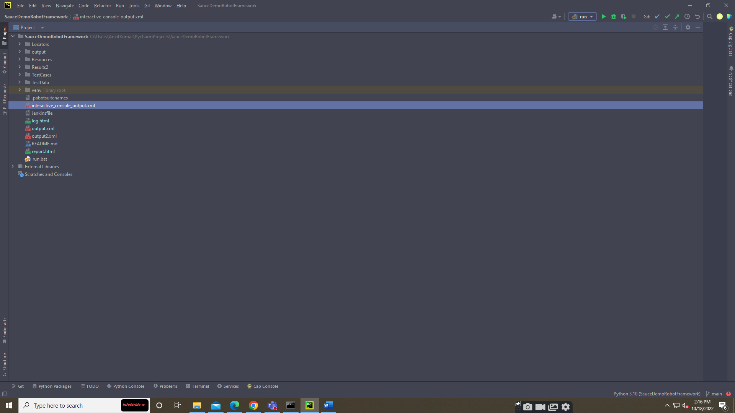

**FIRST TEST CASE.**

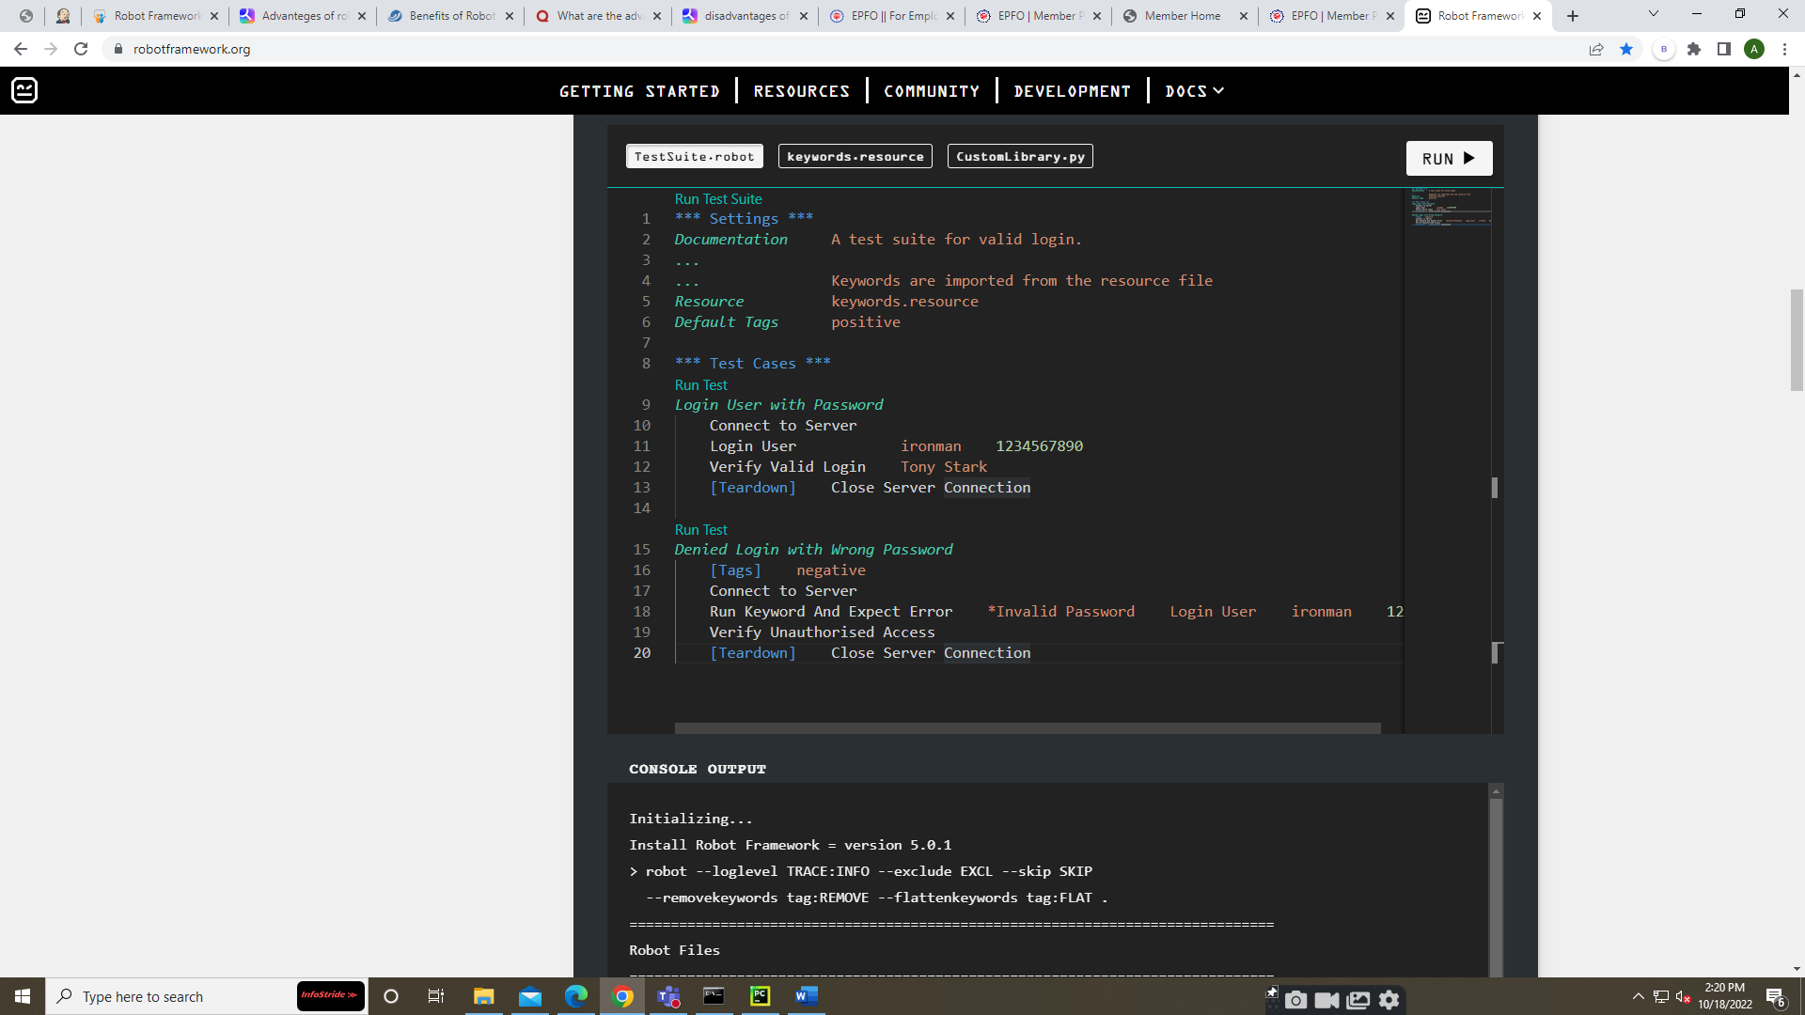

**HYBRID FRAMEWORK.**

In Hybrid Framework, used Page Object Model and Data-Driven.

**LOCATORS FOLDER.**

This folder contains all the web locators (XPath, elements) that are used in the project.

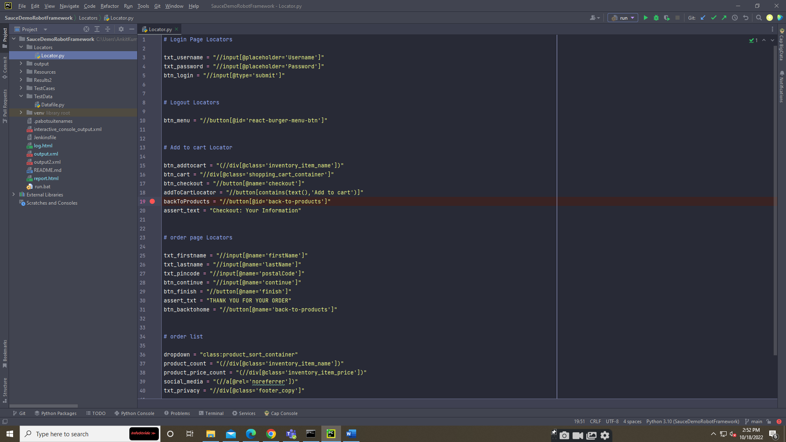

**RESOURCES FOLDER.**

This folder contains all the pages and the keyword that are used.

**TESTCASE FOLDER.**

This folder contains test cases.

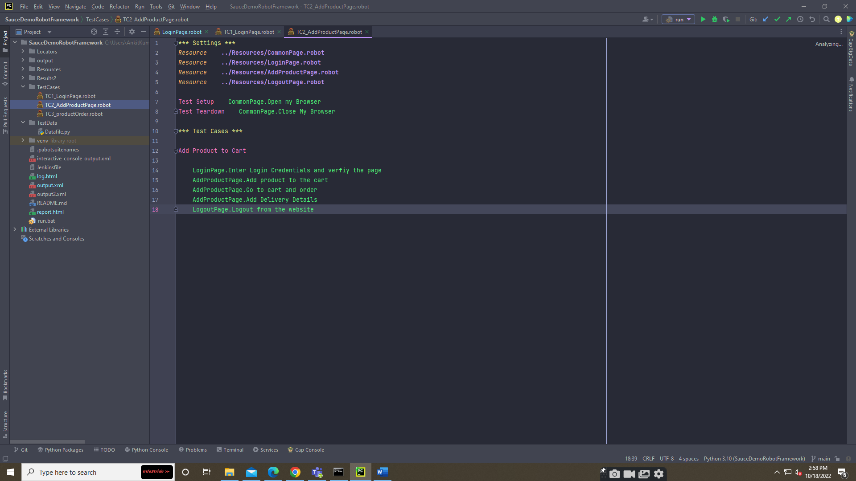

**TEST DATA FOLDER.**

This contains data used in the project.

**REPORTS.**

The Robot Framework created its Reports.

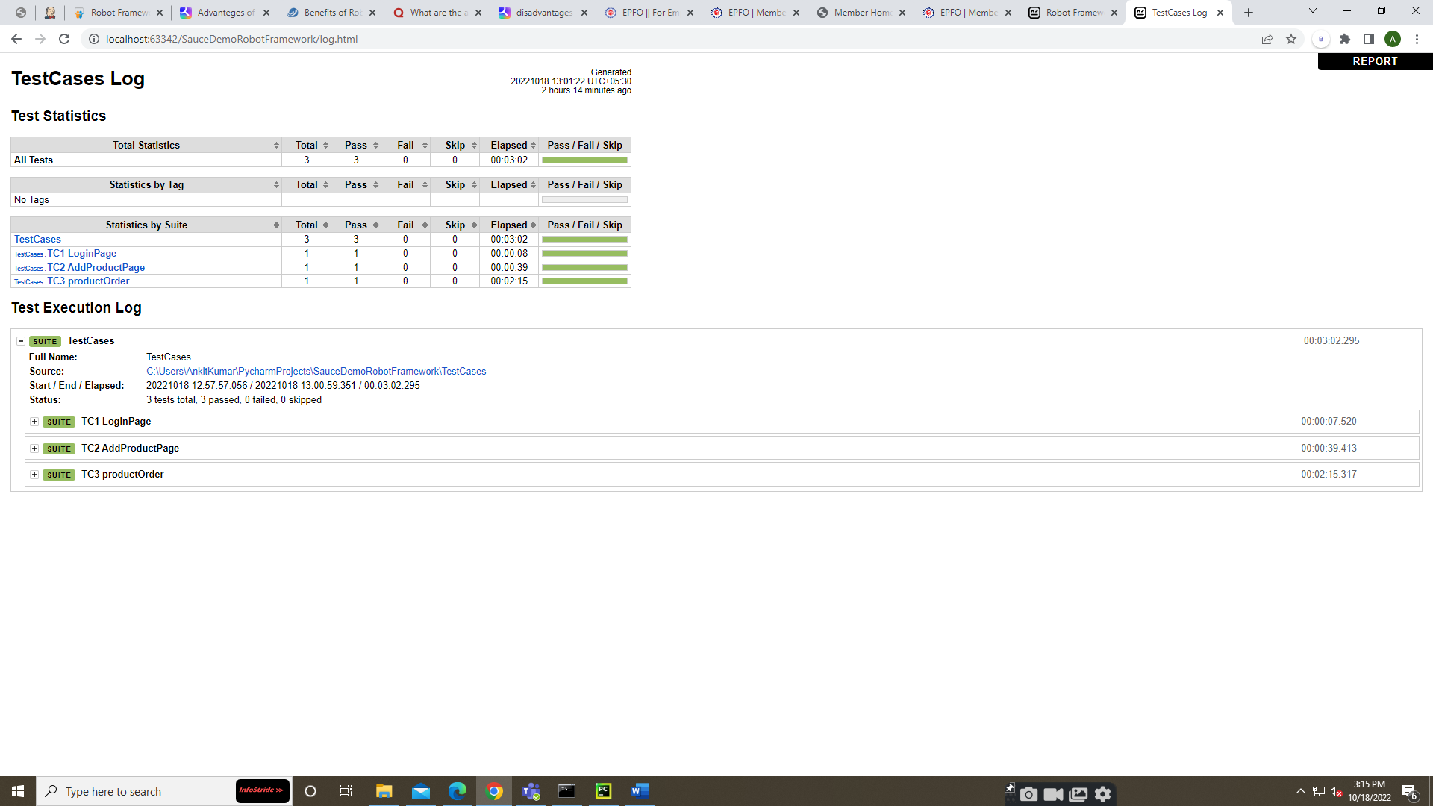

**HOW TO RUN TEST CASES**

Go to the terminal or cmd and enter the commands.

1. **robot TestCases\TC1_LoginPage.robot:** This is used to run a single test case.
2. **robot TestCases\:** It runs all the test cases
3. **robot -i [Tag name] Testcases\testcase name:**
4. **robot --listener AllureReportLibrary.AllureListener TestCases; allure serve output\allure:** This will execute all test cases and create a folder in the project for the allure report and after executing the whole test cases, it generates the allure report in the runtime.
5. **robot --exitonfailure TestCases:** This will be used if the URL or credentials got changed in the project
6. **robot --exitonfailure --listener allure_robotframework Testcases; allure serve output\allure**