DEPARTMENT OF COMPUTER SCIENCE

**LOVELY PROFESSIONAL UNIVERSITY**

#PHAGWARA



PROJECT SYNOPSIS

**PROPERTY WEBSITE**

**WHICH IS A BONAFIDE WORK OF**

**RAVI RAWAT (11918684- K19VQ-48)**

**ANKIT KUMAR (11913462-K19VQ-46)**

**RAJAT TIWARI (11915487-K19VQ-47)**

**Student of Bachelor of Computer Applications**

**Under the guidance of**

**MOIN HASAN SIR**

**Department of computer science**

DEPARTMENT OF COMPUTER SCIENCE

**PROPERTY WEBSITE**

CONTENTS

|  |  |
| --- | --- |
| ***SL.NO*** | ***TOPICS*** |
| ***1*** | ***ACKNOWLEDGEMENT*** |
| ***2*** | ***INTRODUCTION OF PROJECT*** |
| ***3*** | ***SOME DESIRE ABLE FEATURE OF PROJECT*** |
| ***4*** | ***OBJECTS OF PROJECT*** |
| ***5*** | ***PROJECT DESCRIPTION*** |
| ***6*** | ***SCREEN SHOTS*** |
| ***7*** | ***SOURCE CODE***  ***HTML CODE CSS CODE*** |
| ***8*** | ***CONCLUSION AND BIBILOGRAPHY*** |
|  |  |

ACKN0WLEDGEMENT

The development of this project has been quite challenging and it has been sincere effort to bring this project to its completion.

We make use of this opportunity to thank all those who have helped us in bringing out this project.

We would like to take this opportunity to acknowledge enthusiastic sustain to Mr. MOIN HASAN, (Faculty of Computer Science Department) for granting us permission to carry out the project work at college.

We also sincerely thank our friends for their valuable suggestions and for helping us.

Thanking you yours faithfully,

Ravi Rawat

RAJAT

ANKIT

**PROPERTY WEBSITE**

INTRODCTION TO PROJECT

The main objective of this project is to bring the real estate industry online and enabling real estate industry participants to benefit from the Internet. Site acts as an interface between Individuals, brokers and realtors. Here the user can advertise his property for buying or for selling. Site provides online real-estate service committed to helping you make wise and profitable decisions related to buying, selling, renting and leasing of properties, in India. We will provide a fresh new approach to our esteemed users to search for properties to buy or rent, and list their properties for selling or leasing. Property promises to be the most preferred way of finding your dream property and we are committed to help you make a wiser property decision, as a buyer or a seller.

SOME OF THE DESIRABLE FEATURES OF THE PROJECT

* BOX BUTTONS
* HOVER EFFECT
* SEARCH BUTTON
* DIVISIONS
* IMAGE ZOOM EFFECT
* VARITY OF INTERFACE

OBJECTS OF PROJECTS (HTML AND CSS)

IN HTML -

1. **USING-** The **div** tag is known as **Division** tag. The **div** tag is used **in HTML** to make divisions of content in the web page like (text, images, header, footer, navigation bar, etc ) Basically of the section.
2. **USING-** HTML **Unordered List** <ul> or Bulleted List displays elements in bulleted format. We can use **unordered list** where we do not need to display items in any particular order.
3. **USING-** An HTML **form** is a section of a document which contains controls such as text fields, password fields, checkboxes, radio buttons, submit button, menus etc. using form we made text section and various button.
4. **USING-**AN HTML **PRE TAG** is used in the project for the desire space we want .
5. **Using -**LINK TAG for the linking of the CSS file ,using ID for the control on particular section,using CLASS for control the particular section or for styling and various HEADING tags.

IN CSS-

1. **Using –** For styling the different section we use the id and class for the styling of the HTML page.
2. **Using –**BACKGROUND-COLOR , COLOR for changing the different color of the text.
3. **Using –** HEIGHT for the height for the division , blocks etc.
4. **Using –** WIDTH for the width of the division, block etc.
5. **Using –**using the hover effect ,transition and image zoom in and zoom out and opacity.
6. **Using–**using the margin,padding ,border.

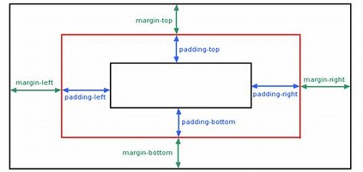

**PROJECT DESCRIPTION**

**PROJECT OVERVIEW**:

* The main objective of our project is to create a property website using HTML AND CSS.
* To provide buy, sell , rent services of the property.
* You can search and select different property

SCREEN SNAPSHOTS OF THE PROJECT

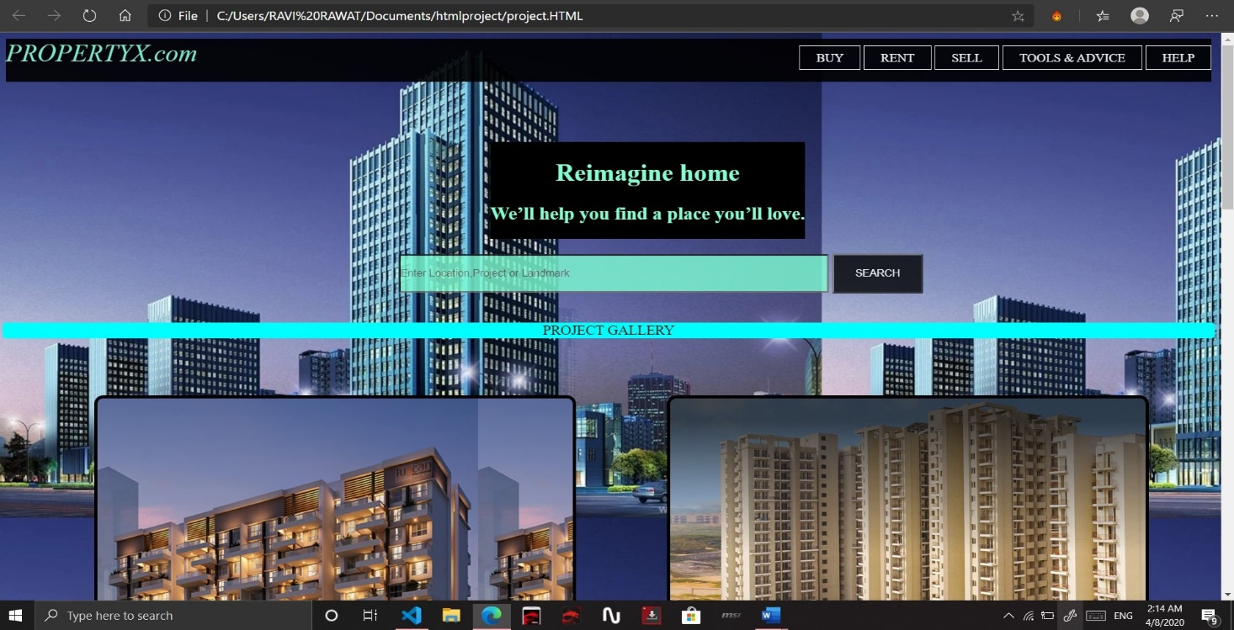

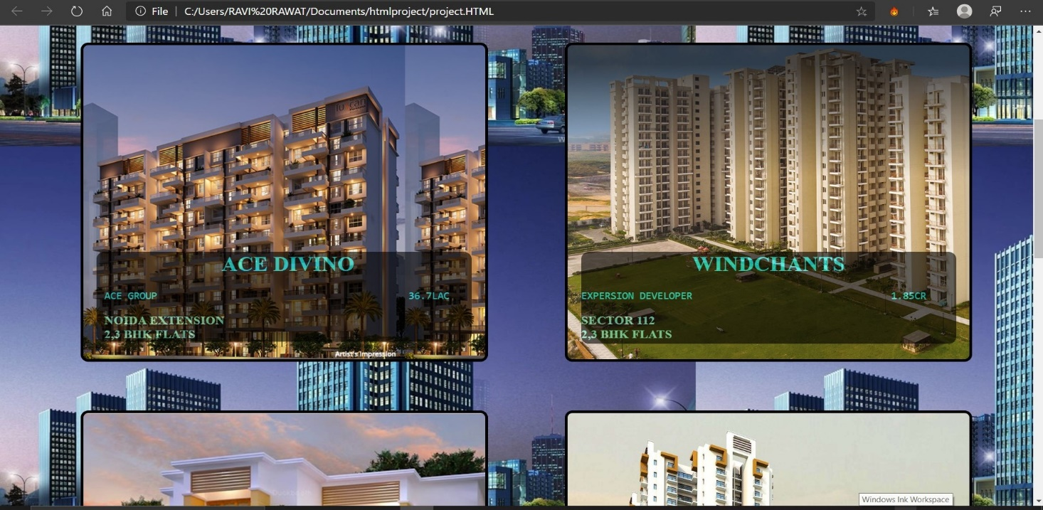

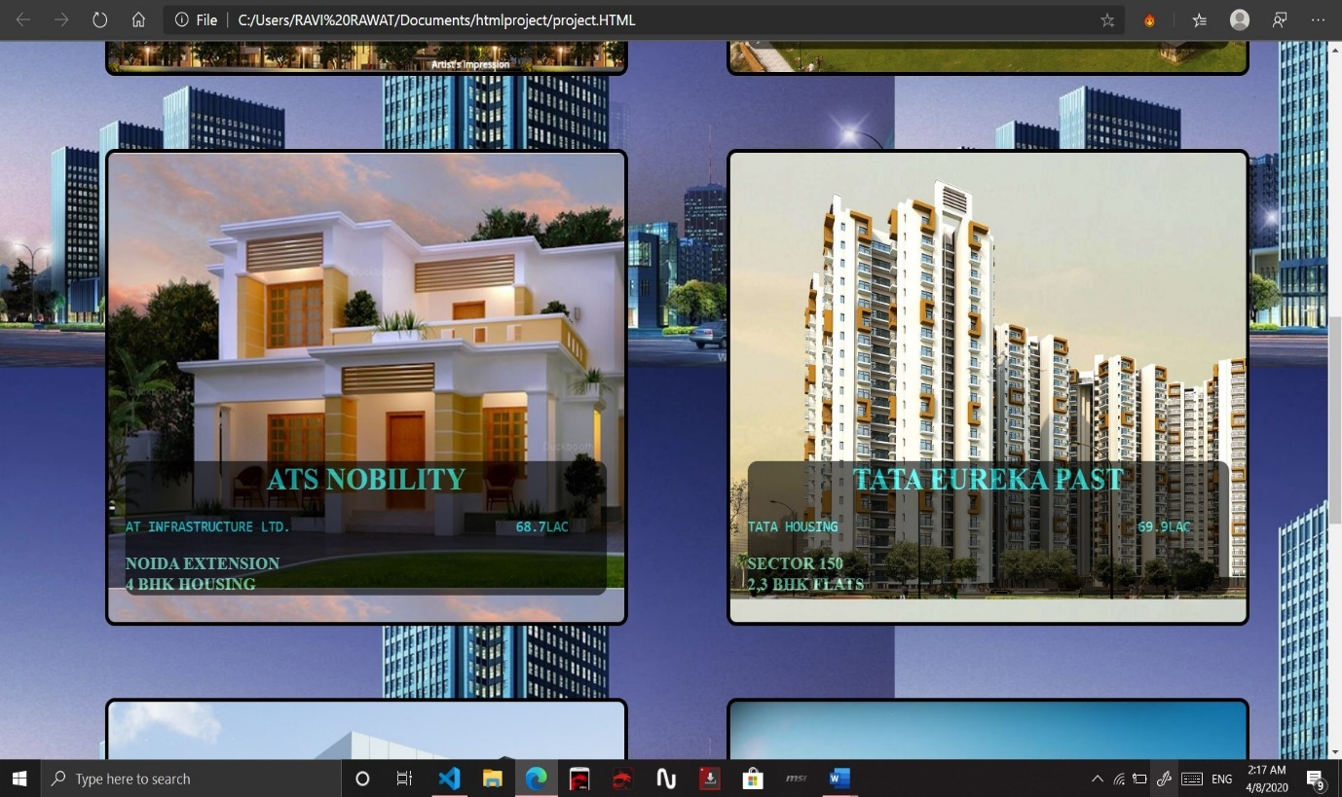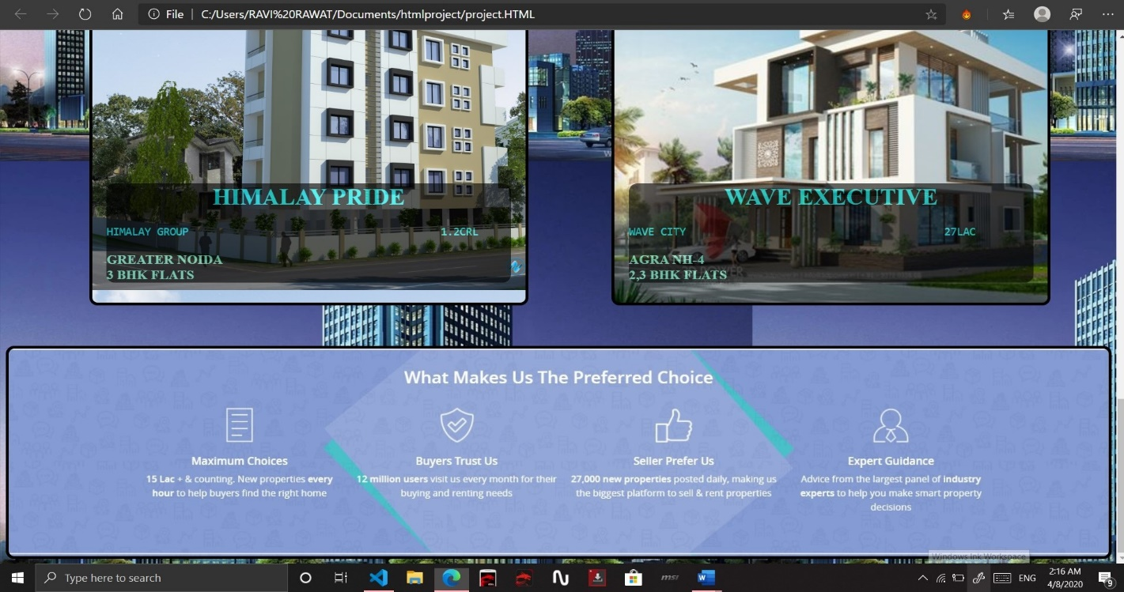

**SOURCE CODE**

**HTML CODE-----**

<!DOCTYPE html>

<HTML>

    <head>

        <title>propertiex.com</title>

        <link href="prostyke.css" rel="stylesheet">

    </head>

    <body>

             <div id="containor">

               <div id="c">

                   <g>    PROPERTYX.com</g>

                <ul>

                    <li><a href="#">BUY</a></li>

                    <li><a href="#">RENT</a></li>

                    <li><a href="#">SELL</a></li>

                    <li><a href="#">TOOLS & ADVICE</a></li>

                    <li><a href="#">HELP</a></li>

                </ul>

               </div>

               <div id="ss">

                <h1>Reimagine home<h1>

               <h2> We’ll help you find a place you’ll love.</h1>

               </div>

               <div id="sss">

                   <form >

                     <input type="text" placeholder="Enter Location,Project or Landmark" style="width:14cm ;height: 1.2cm ;background-color:aquamarine; box-shadow: black;">

                     <button style="width: 3cm; height:1.4cm ;">SEARCH</button>

                   </form>

               </div>

               <div id="project">PROJECT GALLERY</div>

               <div id="zoom1" class="tiles">

              <div id="sub1">

                  <h1>ACE DIVINO </h1>

                 <pre id="sup1">ACE GROUP                                           36.7LAC </pre><h3>NOIDA EXTENSION<br>2,3 BHK FLATS</h3>

          </div>

           </div>

               <div id="zoom2" class="tiles">

                <div id="sub2">

                  <h1> WINDCHANTS</h1>

                  <pre id="sup1">EXPERSION DEVELOPER                                  1.85CR </pre><h3>SECTOR 112<br>2,3 BHK FLATS</h3>

           </div>

              </div>

               </div>

               <div id="zoom3" class="tiles">

                <div id="sub3">

                  <h1>ATS NOBILITY </h1>

                  <pre id="sup1">AT INFRASTRUCTURE LTD.                              68.7LAC</pre><h3>NOIDA EXTENSION<br>4 BHK HOUSING</h3>

           </div>

              </div>

               </div>

               <div id="zoom4" class="tiles">

                <div id="sub4">

                  <h1>TATA EUREKA PAST </h1>

                  <pre id="sup1">TATA HOUSING                                        69.9LAC </pre><h3>SECTOR 150<br>2,3 BHK FLATS</h3>

           </div>

              </div>

               </div>

               <div id="zoom5" class="tiles">

                <div id="sub5">

                  <h1>HIMALAY PRIDE </h1>

                  <pre id="sup1">HIMALAY GROUP                                        1.2CRL </pre><h3>GREATER NOIDA<br>3 BHK FLATS</h3>

            </div>

              </div>

               </div>

               <div id="zoom6" class="tiles">

                <div id="sub6">

                  <h1>WAVE EXECUTIVE </h1>

                  <pre id="sup1">WAVE CITY                                         27LAC </pre><h3>AGRA NH-4<br>2,3 BHK FLATS</h3>

              </div>

                 </div>

                 </div>

                    <div id="zoom7">

               </div>

               </div>

              </div>

    </body>

</HTML>

**CSS CODE-----**

#c{

    background-color: black;

    color: aquamarine;

height:1.5cm ;

width: fit-screen;

margin:0.1cm;

opacity: 90%;

}

body{

    background-image: url( build.jpeg);

   }

ul{

    float: right;

     margin-bottom:60px;

}

ul li{

    display: inline-block;

}

ul li a{

    text-decoration: wavy;

    color: white;

    padding: 6px 20px;

    border: 1px solid #fff;

}

ul li a:hover{

    background-color: aqua;

    color: black;

}

g{

    font-style: italic;

    font-size: xx-large;

    font-size-adjust: inherit;

    text-align: initial;

}

h1{

    text-align: center;

    font-size: xx-large;

    color:aquamarine;

}

h2{

    color:aquamarine;

}

#ss{  background-color: black;

    backface-visibility: hidden;

     content: normal;

    position: absolute;

    margin-top: 2cm;

    margin-right: 6cm;

    margin-left: 16cm;

}

#sss

{

    margin-top: 6cm;

    margin-left: 13cm;

    opacity: 80%;

     border-radius: 1cm;

}

#sss button{

   display: inline-block;

   background-color: black;

   color: #fff;

}

#sss button:hover{

    background-color: aqua;

    color: black;

}

#project{

    background-color: aqua;

    margin-top: 1cm;

    text-align: center;

    font-size: large;

    border:black;

    border-radius: 0.1cm;

}

.tiles{

  height: 450px;

  width: 550px;

  margin-left: 3cm;

  margin-top: 2cm;

  padding: 20px;

border:0.1cm solid black;

border-radius: 0.3cm;

  float: left;

}

#zoom1{

background-image: url(image1.jpg);

background-size: 80%;

transition: 1.5s;

}

#zoom2{

    background-image: url(image2.jpg);

    background-size: 150%;

    transition: 1.5s;

     }

#zoom3{

    background-image: url(image4.jpg);

    background-size: 130%;

    transition: 1.5s;

     }

#zoom4{

    background-image: url(image6.jpg);

    background-size: 140%;

    transition: 1.5s;

     }

#zoom5{

    background-image: url(image8.jpg);

    background-size: 120%;

    transition: 1.5s;

    }

#zoom6{

    background-image: url(image89.jpg);

    background-size: 115%;

    transition: 1.5s;

    }

#zoom1:hover{

    background-size:100%;

}

#zoom2:hover{

    background-size:170%;

}

#zoom3:hover{

    background-size:150%;

}

#zoom4:hover{

    background-size:160%;

}

#zoom5:hover{

    background-size:140%;

}

#zoom6:hover{

    background-size:135%;

}

#zoom7{

    margin-top:47cm ;

border:0.11cm solid black ;

border-radius: 0.3cm;

    width:39.6cm;

    height: 7.7cm;

    background-image: url(screen1.jpg);

    background-size:100% ;

}

#sub1{

    background-color: black;

    margin: auto;

    height: 3.7cm;

    margin-top: 8cm;

    border-radius: 0.3cm;

    opacity: 60%;

padding-left: 0.3cm;

}

#sub2{

    background-color: black;

    margin: auto;

    height: 3.8cm;

    margin-top: 8cm;

    border-radius: 0.3cm;

    opacity: 60%;

}

#sub3{

    background-color: black;

    margin: auto;

    height: 3.7cm;

    margin-top: 8cm;

    border-radius: 0.3cm;

    opacity: 60%;

}

#sub4{

    background-color: black;

    margin: auto;

    height: 3.7cm;

    margin-top: 8cm;

    border-radius: 0.3cm;

    opacity: 60%;

}

#sub5{

    background-color: black;

    margin: auto;

    height: 3.7cm;

    margin-top: 8cm;

    border-radius: 0.3cm;

    opacity: 60%;

}

#sub6{

    background-color: black;

    margin: auto;

    height: 3.7cm;

    margin-top: 8cm;

    border-radius: 0.3cm;

    opacity: 60%;

}

#sub1 h1{

    color: aqua;

}

#sub1 h3{

    color: aquamarine;

}

#sup1 {

    color: aqua;

    font-size:larger;

}

#sub2 h1{

    color: aqua;

}

#sub2 h3{

    color: aquamarine;

} #sub3 h1{

    color: aqua;

}

#sub3 h3{

    color: aquamarine;

} #sub4 h1{

    color: aqua;

}

#sub4 h3{

    color: aquamarine;

} #sub5 h1{

    color: aqua;

}

#sub5 h3{

    color: aquamarine;

}

#sub6 h1{

    color: aqua;

}

#sub6 h3{

    color: aquamarine;

}

**CONCLUSION-**

* THIS CODE IS WRITTEN ON VISUAL BASIC APPLICATION
* ADVANTAGE -

1-EASY TO USE .

2.LOTS OF OPTION.

3-HANDLING OF PROJECT IS VERY EASY.

* HAVE COMMAND ON HTML AND CSS
* KNOW HOW TO MAKE WEBSITE.

**BIBILIOGRAPHY**

WEBSITES REFERED:

[www.google.com](http://www.google.com)

www.w2schools.com

[www.quora.com](http://www.quora.com)

THANK YOU……..