PREFACE:

This report aims at the Blood bank management software developed for a blood bank.
This report depicts only the basic logic of the software developed along with flowchart so that any reader can understand the logic of the software. However the implicate have not been included in the report.

ACKNOWLEDGEMENT

And finally we would like to admit that this is not our project alone. We are just representing the endeavor of so many people involved directly or indirectly in the completion of this project. First of all we would like to thank our project guides………
who despite our repetitive disturbances always bestowed us with their unmatched guidance in all stages of our project. We can’t forget the lab staff that became an indispensable part of our project without the co-operation of whom this project would have immense toil. They facilitated us by providing us basic help and also helping us to store our files at safe places. This project has been done by taking help from the people at Samarpan Blood Bank who never sidelined the project as just an academic curriculum. Finally this project has helped us grow at large. Now we believe and have a sense of faith in teamwork. It’s only with these kinds of project that we will be able to pursue our dreams of becoming professionals, as this project has given us insight of what it takes for a project to materialize.

SYNOPSIS

Title: BLOOD BANK MANAGEMENT SYSTEM

This system is mainly based on collection, storage and usage of blood in needy situations. City life is turning hectic as we move in 21st century. Day by day all the newspapers that were filled with motivating articles and some important news is now filled with either Bollywood stuffs or some kinds of crime, bomb blasts becoming one of the main events. Hence the need of blood is the crucial subject of consideration. Also many diseases are seen to be creped in our day to day life. One of which can be instanced as Thallesmania. One that is affected by this disease also needs the transmission of the blood week by week. Hence blood bank is the most suitable option then.

Problem definition:

In emergency situations, it is very difficult for a blood bank to maintain the databases of the donor’s and acceptors manually. This can lead in the delay of transmission of blood within specified amount of time. Also file maintenance is a very hectic job during natural calamities. Hence our software helps to maintain the databases efficiently and accurately. Also quick access to the databases is possible.

Front End:

The proposed system made by us is been developed in Microsoft tools of Visual Studio package “Visual Basic” (i.e. the whole package is GUI based with much software designs).

Back End:

The backend is MS Access with proper integrity levels and security levels.

System Architecture:

Hospitals or needy persons

Blood bank system process

Blood bank

Blood donor

Claims:

Module 1:
Stock Module: Contains details about stock availability.

Module 2:
Hospital Module: Contains the details of various hospitals and their
Demands.

Module 3:
Donor Module: Contains the details of the donors and their blood
Groups.

Conclusions:

The proposed package is made so user friendly that it becomes very easier for any person with little computer knowledge to work on it.

Security is provided to the data and software with logon screens. The person who logs on is allowed to work on smart soft only when all proper rights are given to him, as the new User ID is only created by the previous having administrator rights.

PROJECT DOCUMENTATION

INSTITUTIONAL PROFILE

Nature of Topic: Blood Bank Management

The working of Blood Bank involves collecting, storing, maintaining and issuing of blood. As the blood bank is functional round the clock for efficient management, the unit needs to have a system that gives the provision of fast stock look up, immediate donor search and easy storage of business related information.

WORKING OF THE CURRENT SYSTEM

Blood bank is a place where blood or fractions of blood are stored in retrievable forms, to be used in case of emergency. The emergency may arise as a result of accidents and in cases of hemophilia, anemia and major surgical operations.
At emergency the donor of particular group may not be available on the spot. Hence, blood of different groups is collected, preserved and stored at low temperature so that it can be used at the time of emergency.

Functions of blood bank are:

- To collect blood from the donors.
- Screening of blood for pathogens.
- Grouping and labeling of blood as per ABO system and Rh factor.
- Preservation of blood as a whole or in fractions.
- Proper distribution of blood to needy persons.

Our current system is a manual system. The system deals with collection of blood from the donors, its grouping as ABO system and Rh factor, storage under refrigeration and finally distribution to needy persons. Blood bank has connection with many hospitals which demand for the blood in need to save the patient’s life. The information of the donors, storage of blood and demands of various hospitals are been maintained in bunch of formal registers. The blood bank usually accepts blood from Donors, supplies to different Hospitals and patients. For stock maintenance blood bank also gets blood units form hospitals. It maintains the records of all donors, recipients and test result of each donor. It also maintains the stock of accepted blood bags and discarded blood bags.

A record of donor details is maintained like personal details test results and the type of donor the person is.

The blood bank keeps the track of blood bags issued and also maintains the details of the recipients (patient details).

The blood of the donor is tested for various diseases. If the blood unit is found to be infected its discarded otherwise added to the stock.

The records of the discarded blood bags are maintained in different register.

The blood bank also maintains information about various hospitals it is tied up with.

Registers in use are:

Donors register: It contains the details about the person who donates the blood i.e. name, address, date, etc. Through this register the system also checks that a particular donor is not permitted to donate the blood for the next time with in 3 months.

Hospital register: This register contains details about the hospitals (name, location) and group and quantity of blood that they are demanding.

Stock register: This register contains the details about the grouping and labeling of blood as per ABO system and Rh factor and also their availability. The preserved blood must be used within 30 days else it is disqualified.

Payment register: This register contains the details about various payment details in register, their mode of payment i.e. in cash or cheque, balance and paid amount.

Receipt register: This register contains the details about the patient’s receipts including the name of the hospital they have been admitted.

Drawbacks of the current system

1. A donor-Id is given to each owner when he makes a donation. But when he comes for next time to donate the blood a new donor-id is given. This causes repetition of data.

2. All the work and data are maintained in the forms and registers. To search for a donor or blood bag becomes a tedious job. Hence, it also results in huge amount of paperwork.

3. Since all the work is done manually, many errors creep into the database. Also it results in large volume of data accumulation.

4. Time and energy is also wasted. It affects the pace of the work and results in inefficient management.

5. It ultimately leads to a poor performance.

PROPOSED SYSTEMS

The proposed system is fully computerized the total human work in the information processing in the current system is reduced. The proposed system has the feature of giving a unique donor-id to each donor and saving his personnel information. This saves the job of saving personal details of donor each time he visits. The only details that needed to be entered for a donor each time he comes after the first visit are his test results.

It also provides a provision for donor look-up. When there is urgent requirement for a particular blood group search feature. This helps in easy search for a particular blood group when required.

The system stores the details of the patient giving him a unique patient id. It also has a provision for patient search.

The details of the hospitals that are tied up with the blood bank are also maintained. Also the record of debit and credit of each hospital is maintained.

The system also provides an easy search for hospital.

ADVANTAGES

The installation of this system will benefit the institution in following ways:

1. The system will provide easy data entry.

2. The system is very user friendly so the basic computer knowledge will be sufficient to operate the system.

3. The system has efficient search features which enables fast look-ups for donors, patients and hospitals.

4. This system has automated stock module so that the expired blood is automatically disqualified from the bank and record is deleted from the database automatically.

5. Report generation will take place automatically when demanded.

6. Accuracy and performance increases.

System Study and Analysis

Methodology :
The way that is followed while carrying on which the development application is as follows:
Defining a problem
Defining the problem is one of the important activities of the project. The Objective is to define precisely the business problem to be solved and thereby determine the scope of the new system. This phase consists of 2 main tasks. The 1st task within this activiy is to review the business needs that originally initiated the project. The 2nd task is to identify, at an abstract or general level, the excepted capabilities of the new system.thus it helps us to define the goal to be achieved and the boundary of the system. A clear understanding of the problem will help us build a better system and reduce the risk if project failure. It also specifies the resources that have to be made available to the project.
Three important factors project goal, project bounds and the resource limit are sometimes called the project’s term of references.
The output of this phase consists of project goal; it’s bound and terms of Reference.

Feasibility Study :
The feasibility study proposes one or more conceptual solutions to the problem set for the project. The objective in assessing feasibility is to determine whether a development project has a reasonable chance of success. It helps us to determine the input and output of the system. The following are the criteria that are considered to confirm the project feasibility.
1) Technical Feasibility :
At first it is necessary to check that the proposed system is technically feasible or not and to determine the technology and skill necessary to carry out the project. If they are not available then find out the solution to obtain them. Hardware is already available in the system.
2) Operational Feasibility :
The operational feasibility is obtained by consulting with the system users. Check that proposed solution satisfies the users need or not. There is no resistance from users since new system is helpful. The exiting system is a manual system, while the new system is computerized and extremely user friendly.

System Analysis :-
This phase is detailed appraisal of the exiting system. This appraisal includees how the system whole and what it does. It also includees finding out in more detail – what are the problems with the system and what user requires from the new system or any new change in system.
The output of this phase results in the details model of the system. The model describes the system functions and data and system information flow. The phase also contains the detail set of user requirements and these requirements are used to set objectives for the new system.
System Study :-
It is always to study and recognize the problems of the exiting system, which will help in finding out the requirements for the new system. System study helps in finding different alternatives for better solution.
The project study basically deals with different operations and steps involved in generation of various reports. Its includes :
Data gathering
Study of exiting system
Analyzing problem
Studying various documents
Feasibility study for further improvements.
Following are the steps taken during the initial study :
Initially, we collected all the information, which they wanted to store
Then we studied the configuration of the current system. We noted the limitation of that system which motivated them to have a new system.
Then we analysed the format of the reports generated by that system. With the help of these documents we got basic ideas about the system as well as input and output of our project.

System Development
MS Access is a relational database management system. MS Access gives us a way of doing three things in an understandable and reasonably uncomplicated way. MS Access basically does three things. How the data is captured, edited, modified and stored how we keep it securely and how we get it out to manipulate and report on it. MS Access is a means of easily turning data into information.
In RDBMS all users requests into insert data in a table or update delete or view data in a table must be routed through the RDBMS engine only. Direct calls for data cannot be made to table themselves. Hence there is single point of control when it comes to data manipulation; this gives rise to excellent data security.
MS Access provides features such as:
It is fully user friendly.
No data redundancy.
More database security.
Since MS Access has following advantages, we use this application package:
Master information has to be entered only once.
Data processing handled instantly.
Faster processing of data to generate reports.
Easy to and maintain as it is flexible.
MSAccess has a number of tools that can be used as seperately and can be Integrated. This tool allows the user to create database objects. The tools we use for the system developments in MS Access.

Also we use Visual Basic 6.0 as our front end to develop various user interactive forms that are easily understandable and accessible by any person that don’t have much knowledge about computer hardware and software’s.

The Waterfall Model

The Waterfall Model is the earliest method of structured system development. Although it has come under attack in recent years for being too rigid and unrealistic when it comes to quickly meeting customer’s needs, the Waterfall Model is still widely used. It is attributed with providing the theoretical basis for other Process Models, because it most closely resembles a “generic” model for software development.

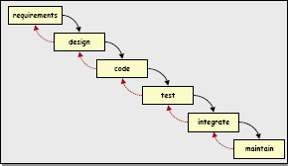

Figure 1. Waterfall Model

In waterfall model, the phases are organized in linear order. the phases of this model are as follows:
System requirements: It is also called as analysis and planning. Planning is the crucial activity in software development. A good plan is based on the requirements of the system and should be done before later phases
System Conceptualization. System Conceptualization refers to the consideration of all aspects of the targeted business function or process, with the goals of determining how
each of those aspects relates with one another, and which aspects will be incorporated into the system.
System Analysis. This step refers to the gathering of system requirements, with the goal of determining how these requirements will be accommodated in the system. Extensive communication between the customer and the developer is essential.
System Design. Once the requirements have been collected and analyzed, it is necessary to identify in detail how the system will be constructed to perform necessary tasks. More specifically, the System Design phase is focused on the data requirements (what information will be processed in the system?), the software construction (how will the application be constructed?), and the interface construction (what will the system look
like? What standards will be followed?).
Coding. Also known as programming, this step involves the creation of the system software. Requirements and systems specifications from the System Design step are translated into machine readable computer code.
Testing. As the software is created and added to the developing system, testing is performed to ensure that it is working correctly and efficiently. Testing is generally focused on two areas: internal efficiency and external effectiveness. The goal of external effectiveness testing is to verify that the software is functioning according to system design, and that it is performing all necessary functions or sub-functions. The goal of internal testing is to make sure that the computer code is efficient, standardized, and well documented. Testing can be a labor-intensive process, due to its iterative nature.

Linear ordering of activities has some important consequences. First to clearly identify the end of each phase and beginning of the next, some certification mechanism has to be employed at the end of each phase. This is usually done by some verification and validation means that will ensure the output of the phase is consistent with its input and that the output of the phase is consistent with the overall requirements of the system.
The consequences of the need for certification are that each phase must have some defined output that can be evaluated and certified. The outputs of the earlier phases are often called as work products and are usually in form of documents. The general outputs are:

Requirements document.
Project plan
Design documents
Test plan
Final code
Software manuals

One of the major advantages of this model is its simplicity. It is conceptually straightforward and divides the large task of building a software system into series of cleanly divided into phases, each phase dealing with a separate logical concern.

Problems/Challenges associated with the Waterfall Model

Although the Waterfall Model has been used extensively over the years in the production of many quality systems, it is not without its problems. In recent years it has come under attack, due to its rigid design and inflexible procedure. Criticisms fall into the following categories:
It assumes that the requirements of a system can be frozen before the design begins. This is possible for systems designed to automate an existing manual system. But for new systems, determining the requirements is difficult as the user does not even know the requirements. Hence, real projects rarely follow the sequential flow that the model proposes.
Freezing the requirements in the beginning usually requires choosing the hardware. A large project might take few years to complete. If the hardware is selected earlier, then due to the speed at which hardware technology is changing, it is likely that the final software will use the hardware technology on verge of becoming obsolete.
At the beginning of most projects there is often a great deal of uncertainty about requirements and goals, and it is therefore difficult for customers to identify these criteria on a detailed level. The model does not accommodate this natural uncertainty very well.
It is document driven process that requires formal document at the end of each phase.

ENTITY RELATIONSHIP

The entity-relationship (E-R) data model perceives the real world as consisting of basic objects, called entities and relationships among those objects. It was developed to facilitate database design by allowing specification of an enterprise schema, which represents the overall logical structure of a database. The E-R model is one of the several semantic data models; the semantic aspect of the model lies in representation of the meaning of the data. The E-R model is very useful in mapping the meanings and interactions of the real world enterprise onto a conceptual schema. Because of this usefulness, many database design tools draw on concepts from the E-R model.
Symbols mainly used in E-R diagram:

E
Entity Set

A
Attribute

R

Relationship Set

A
Primary Key

E-R data model employs three basic notions: entity sets, relationship sets and attributes.

Entity set : an entity is a thing or object in the real world that is distinguishable from all other objects. An entity has a set of properties and values of some properties uniquely define the entities. An entity set is the set of all the entities of same type that share same properties or attributes.
Attributes: attributes are the descriptive properties possessed by each member of an entity set. Each entity may have its own value for each attribute. For each attribute, there is a set of permitted values, called as domain or value set of an attribute.
Relationship set: a relationship is an association among several entities. A relationship set is the set of the relationships of same type. The function that an entity plays in a relationship is the entity’s role. A relationship may also have attributes called as descriptive attributes.

Marital status
Address
Bloodgroup
Rh
Age
Occupation

Name
Gender

Phone
DonorId
BBDonor

Donor

Phone
Occupation
Patient Id
Gender
Address

Age
Name
Patient
Issue
Patient

Hospital Id

Address
Phone

Name
Area
BBHospital
Hospital

Expirydate
Bloodgroup
Entrydate

TestResult
Collectiondate

BloodBagId
Quantity

Rh
Enteredby

Blood Bank

CONTEXT DIAGRAM

This is the first step to study the physical environment in data flow diagrams. During this, DFD of the current non-automated system is drawn showing input and output data flows of the system, how data flows through the system and what processes are operating on system. It might contain specific controls for data flows and processes used in physical environment. This is called as context level diagram. In this entire system is treated as single process and all its inputs and outputs sinks and sources are identified.
In the following context diagram, we have our main process for which the software is build i.e. the Blood Bank Management System. The main process includes:

Patient requests for the blood bag to the blood bank. Then the blood bank either issues or denies the blood bag depending on stock availability.
Donor gives the blood to the blood bank and in turn receives the DonorID.
Hospitals provide the blood for stock maintenance and in response receives the acknowledgement.
Hospitals request for the blood bag to the bank. Then the blood bank either issues or denies the blood bag depending on the stock availability.

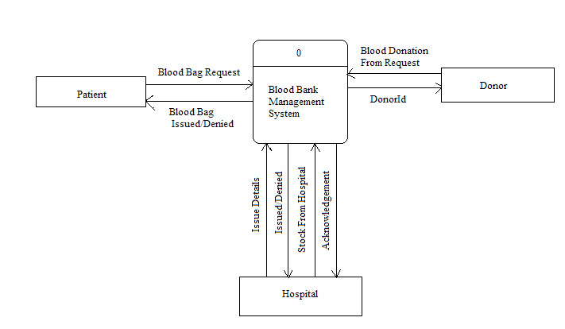

EVENT PARTITIONED DFD’S

Data Flow Diagrams are commonly used during problem analysis. They are quite general and are limited to the problem analysis for software requirement specification. DFD’s are very used in understanding the system and can be efficiently used during analysis. A DFD shows the flow of data through a system. It views the system as the function that transfers the inputs into design outputs. The agent that performs the transformation of data from one state to another is called as a process.
DFD model flows the following symbols for transformation of data:

External Entity

Data flow

Or Process

Or Data store or data files

The need for multiple data flows by a process is represented by a ‘*’ between the data flows. This symbol represents the AND relationship. Similarly the OR relationship is represented by ‘+’ symbol.
DFD is not a flowchart. It represents the flow of data, while flowchart shows the flow of control. One way to construct a DFD is to start by identifying the major inputs and outputs to the process. Minor inputs and outputs should be ignored first. Then starting from inputs, work towards the outputs identifying the major transforms in the way. An alternative is to work down from output towards the inputs.

Good style conventions which should be observed in drawing of DFD’s:

1. Process names, file names and Data flows names must be meaningful in the context of the problem.
2. DFD’s names must be developed top down while lower levels giving more details
3. Data should be conserved. A process can’t create the new data. It can only transform input data to create output data parallel to any data retrieved from file that must have been stored in it earlier.
4. Data flow should not act as a signal to activate or initialize the process.

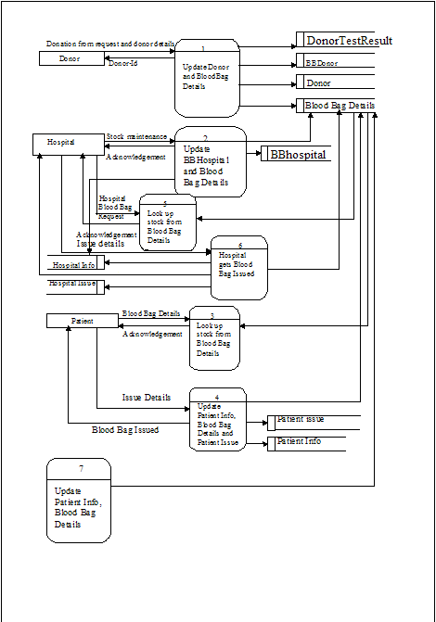

Firstly, donor donates the blood and provides all his details which are stored in donors register. Blood donated is first test for various diseases. These test results are been maintained in the test results file of donor. If the test results are negative the blood is send for stock maintenance else discarded. Donor also have look table for the quick access of the important details. Also updation of the stock details of the blood is done and finally the donor is given the donor id

Now the hospital can also send the blood for the stock maintenance. Hence, hospital details are stored in the hospital info file and easy look up table is provided. Updation is done in the Blood bag details file. When any hospital requires blood from the blood bank the request for the blood is made by the hospital and referring to the stock availability of the blood, the acknowledgement is given to the hospital. If there is a positive acknowledgement, then the issue details is provided by the hospital and blood is received else request is cancelled. Also hospital info is updated and updation of the issue details file of the hospital is done.

When a patient needs blood it request the blood bank for the blood hence stock availability of blood is checked and the acknowledgement is given. If there is enough stock to fulfill the request the patient receives the blood and provides the issue details which are stored in patient issue file and the patient details are maintained in patient info file. Also the blood bank stock details are updated.

Lastly, final update of stock details is done.

DATA FLOW DIAGRAM (LEVEL 1):

Many systems are too large for a single DFD’s to describe the data processing clearly. It is necessary that some decomposition and abstraction mechanism be used for such systems. DFD’s can be hierarchically organized, which helps in progressively portioning and analyzing systems. Such DFD’s together are called as leveled DFD sets.
A leveled DFD has a starting DFD, which is very abstract representation of the system, identifying the major inputs, outputs and processes of the system. Then each process is refined and a DFD is drawn for each process. For the hierarchy to be consistent it is important that the net inputs and outputs for the DFD’s of the process are same as the inputs and outputs of the higher level DFD.
In the leveled sets of DFD’s it is important that the consistency is maintained. Consistency can be easily lost if new data flows are added to DFD during modification. If such changes are made, appropriate changes should be made in parent or child DFD. That is , if new data flow is added to the lower DFD, it should be reflected in higher level DFD’s. similarly if data flow is added to higher level DFD, the DFD’s for the processes affected by the change should be appropriately modified.

1

Update Donor and Blood Bag Details
Donor
Donor info.
Donor
Blood Bag Details
Donor ID
Donor Test Results

BBDonor

2

Update HospitalInfo, BBHospital and Blood Bag Details

Blood bag sent for stock
maintenance Hospital Info
Hospital

BBHospital
Acknowledgement
Blood Bag Details

3

look up stock from blood bag details

Blood bag
Request Blood bag Details
Patient

patient

Acknowledgement

4

Update Patient Info, Blood Bag Details and Patient Issue

Issue Details Patient info
Patient

issued Blood Bag Details

Patient Issue

5

Look up stock from Blood Bag Details
5
Hospital Blood
Bag request
Hospital
Blood Bag Details
Acknowledgement

6

Update Hospital Info, Blood Bag Details and Hospital Issue

Hospital Info
Issue details
Hospital
Hospital Issue
Issued
Blood Bag Details

7

Updation of BloodBag Details

Blood Bag details

DETAILED DFD’S (LEVEL 2):

1.1

Record Donor Info

Donor Details Donor Details
Donor

Donor Test Results

DonorID
1.2

Record Blood Bag Details

Blood Bag Details

Blood Bag Donor

2.1

Record Hospital Information

Blood Bag sent for Hospital Info
Hospital

Stock maintenance

2.2

Record Blood Bag Details

BBHospital
Acknowledgement
Blood Bag Details

4.1

Record Patient Information
Patient Details
Patient
Patient Info

4.2

Patient gets Blood Bag Issued

Blood Bag Issued BloodBagDetails

Patient Issue

6.1

Update Hospital
Information

Hospital Information
Hospital
Hospital Info

6.2

Hospital gets Blood Bag Issued

Blood Bag Issued Blood Bag Details

BloodBagHospital

PROCESS DESCRIPTION:

Process (1.1) Record Donor Information

Get donor details from donor

If new donor Then
Validate donor details
If valid donor details Then
Add donor’s personal details to Donor data store
Add donor’s test results to DonorTestResults data store
Else
Display error message
End if
Else
Validate donor details
If valid donor details Then
Update donor’s personal details to Donor data store
Add donor’s test results to DonorTestResults data store
Else
Display error message
End if
End if

Process (1.2) Record Donor Blood Bag Information

For valid donor entry

Validate donor details
If valid donor details Then
Add donor’s blood bag details to BBDonor data store
Add donor’s blood bag details to BBDonor data store
Else
Display error message
End if

End For

Process (2.1) Record Hospital Information

Get Hospital details from Hospital

If new hospital Then
Validate hospital details
If valid hospital details Then
Add hospital details to HospitalInfo data store
Else
Display error message
End if
Else
Exit sub
End if

Process (2.2) Record Hospital Blood Bag Information

For valid hospital entry

Validate blood bag details
If valid blood bag details Then
Add Hospital blood bag details to BBHospital data store
Add Hospital blood bag details to BloodBagDetails data store
Else
Display error message
End if

End For

Process (4.1) Record Patient Information

Get patient details from hospital

If new patient Then
Validate patient details
If valid patient details Then
Add patient details to PatientInfo data store
Else
Display error message
End if
Else
Exit Sub
End if

Process (4.2) Patient gets blood bag issued

For valid Patients entry
Add patients issue details to PatientIssue data store
Add patients issue details to BlooodBagDetails data store

End For

Process (6.1) Record Hospital Information

Get hospital details from hospital

If new hospital Then
Validate hospital details
If valid hospital details Then
Add hospital details to HospitalInfo data store
Else
Display error message
End if
Else
Exit Sub
End if

Process (6.2) Hospital gets blood bag issued

For valid Hospital entry
Add hospital issue details to HospitalIssue data store
Add hospital issue details to BlooodBagDetails data store

End For

FLOWCHARTS

1. RECORD DONOR INFORMATION

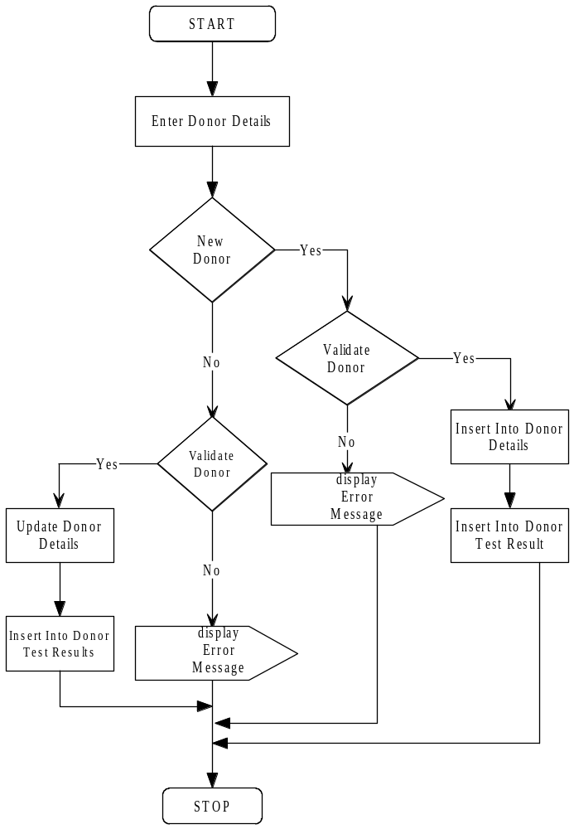

2.RECORD DONOR BLOOD BAG INFORMATION

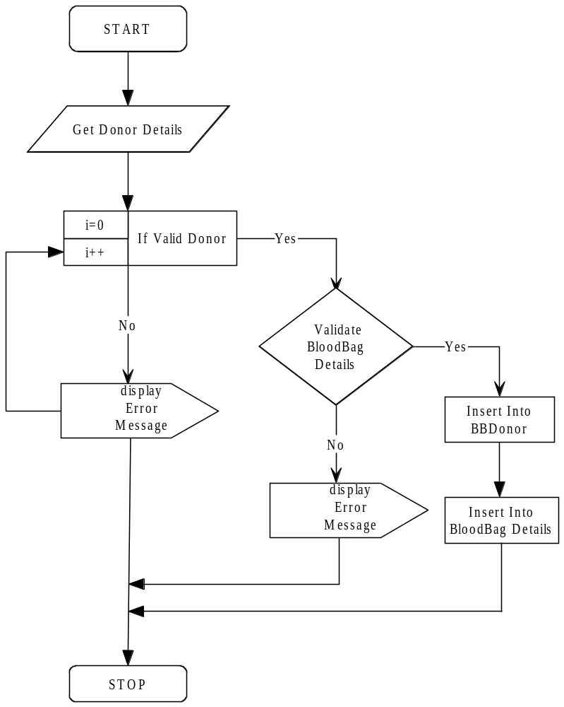

3.RECORD HOSPITAL INFORMATION

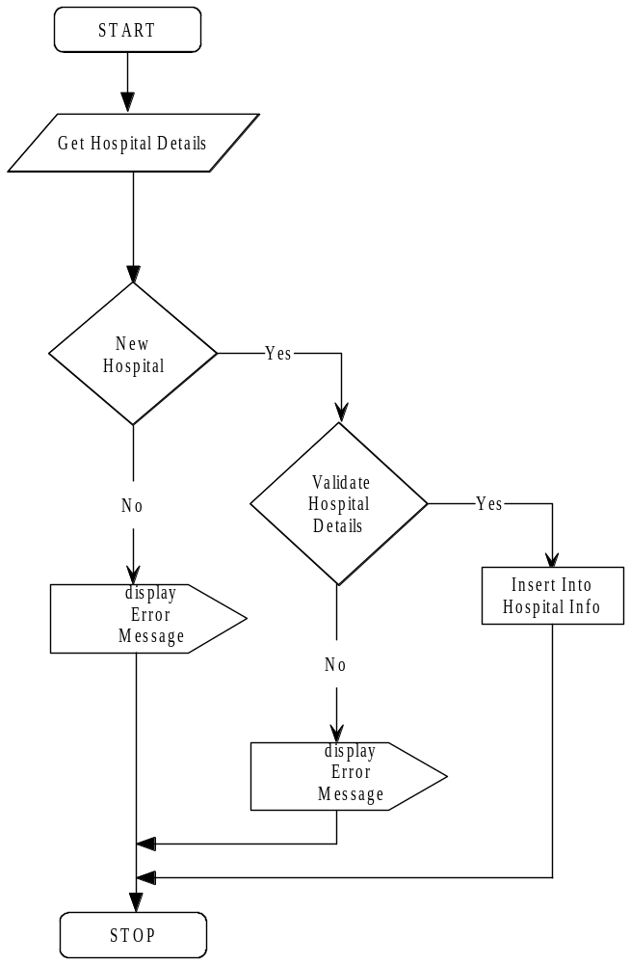

4. RECORD HOSPITAL BLOOD BAG INFORMATION

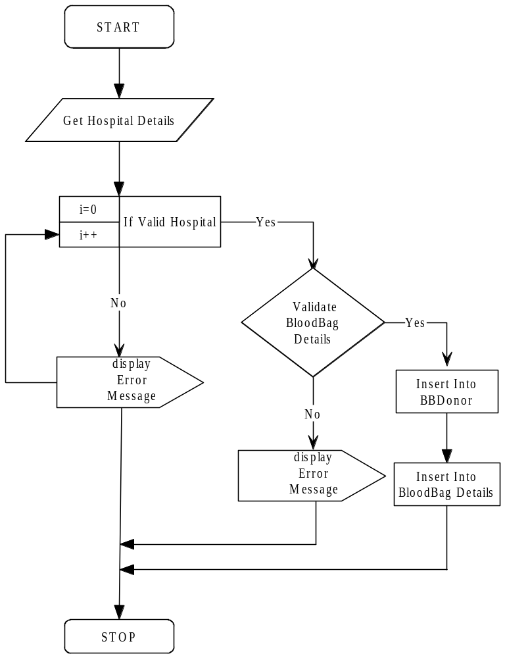

5. RECORD PATIENT INFORMATION

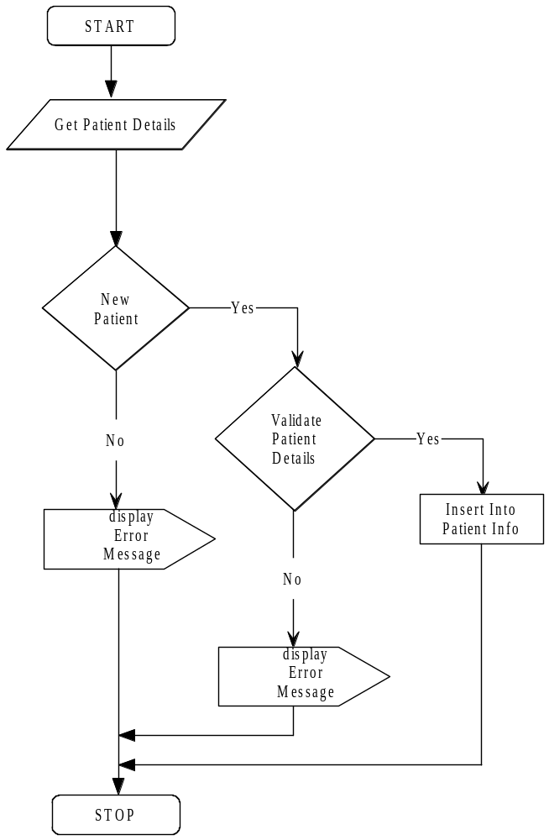

6. PATIENT GETS BLOOD BAG ISSUED

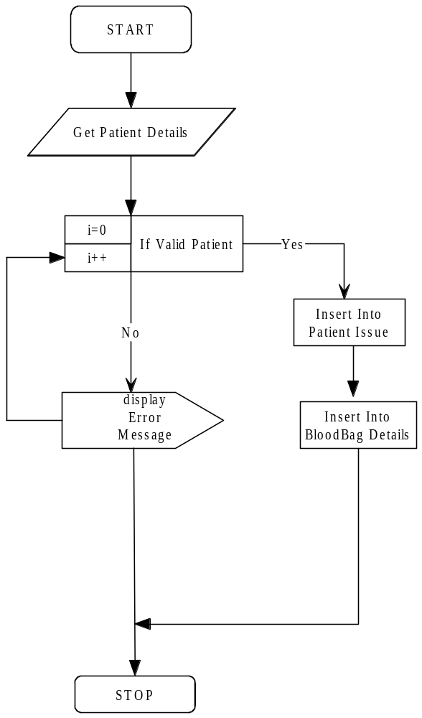

7. RECORD HOSPITAL INFORMATION

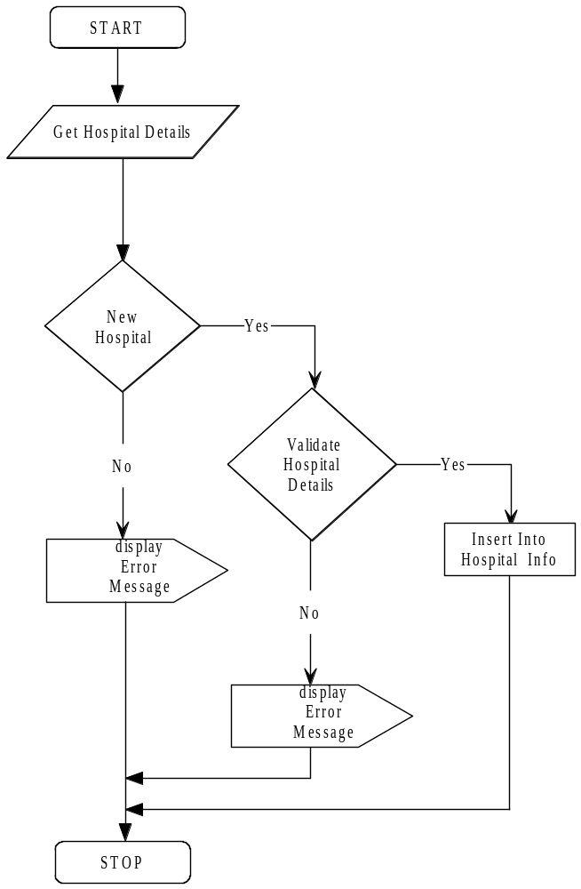

8. HOSPITAL GETS BLOOD BAG ISSUED

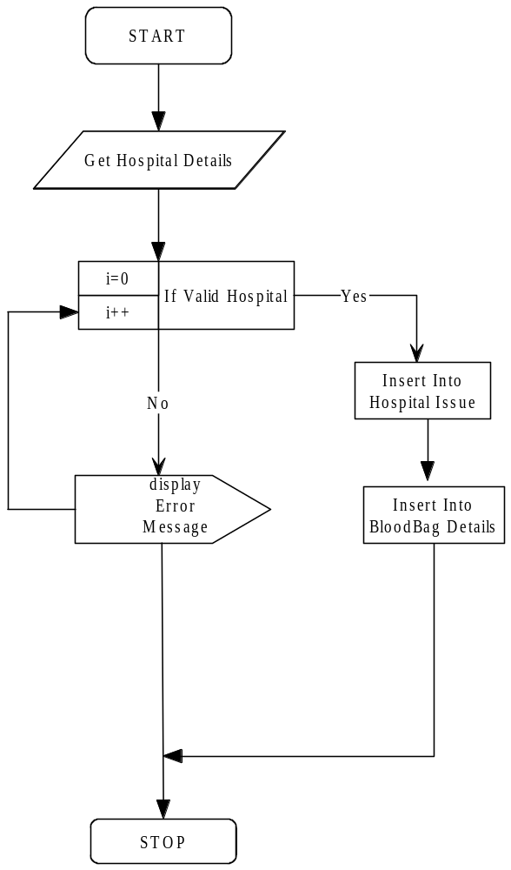

SYSTEM FLOWCHART

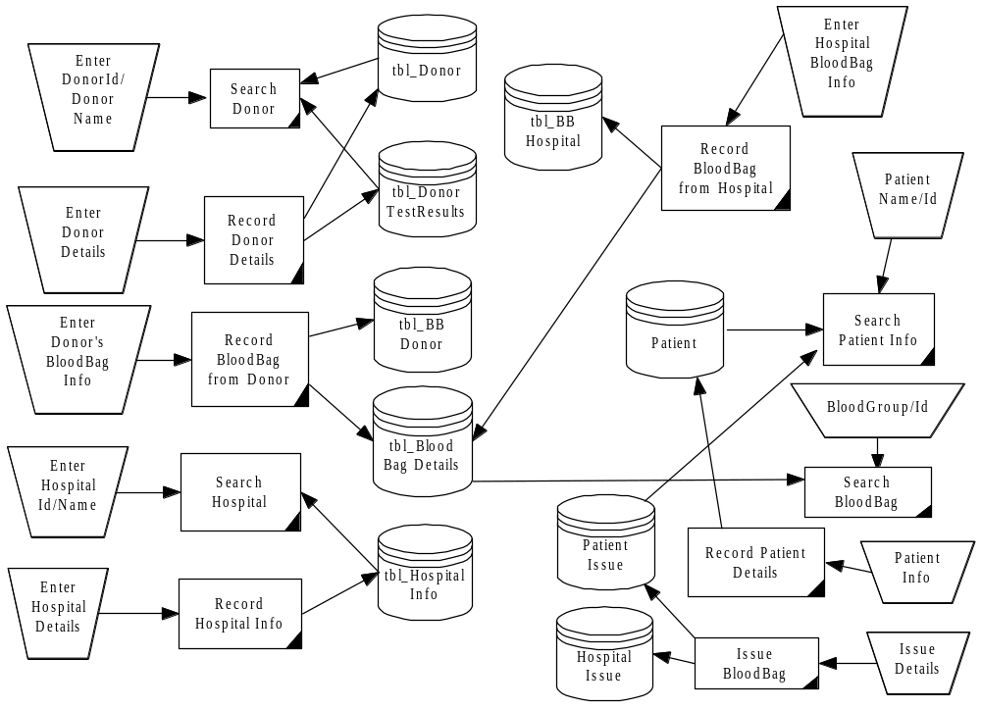

STRUCTURED CHART

For a function oriented design, the design can be represented graphically by the structured charts. The structure of the program is made up of modules. In the structure chart module is represented by a box with the name of the module written within the box. In general, procedural information is not represented in the structure chart and the focus is on representing the hierarchy of the modules. Certain information like loops or decisions can also be represented by structure chart. All the subordinate modules activated within the common loop are enclosed within the same looping arrow. Major decisions can be represented by a diamond shape box. Modules in the system can be categorized into few classes. There are some modules that obtain information from their subordinates and then pass it to your super-ordinate. This kind of module is input module. Similarly there are output modules that take information from their super-ordinate and pass it onto its subordinates. There are many module that exist for the sake of transforming data into some form. Such a module is called transform module. There are modules whose primary concern is to manage the flow of data to and from different subordinates. Such modules are called as the co-ordinate modules. There are some composite modules that can perform the functions of more than one type of module. A structure chart is a nice representation mechanism for a design that uses functional abstraction.

Blood Bank Management System

Donor
Blood Bag
Hospital
Patient
Reports

Donor

Selection
flag
Get selection
Record donor details

Selection data search data

Donor search

Blood Bag

Hospital-id/ Patient-id
Blood bag data

Store Blood bag details
Blood bag issue

Selection
flag

Search data
Selection data
Get selection
Blood bag look up

Hospitals

Hospital data
Selection flag Selection
data Search data
Store hospital details
Get Selection
Hospital look up

Patient

Selection flag Patient data

Selection Search
Data Data
Get Selection
Store patient details

Patient look up

Report

Date of donation Hospital report

Donor
Report
HospitalId
Donor Report
Hospital Report

MENU TREE
BLOOD BANK MANAGEMENT SYSTEM

Login
Donor information
Hospital
Blood Bag
Patient
Reports

Login

Login

Log out

Close
New User
Change Password
Find/Delete User

Hospital

Hospital Info
Hospital Look up

Blood Bag entry

Patient

Patient Info
Patient Look up

Reports

Hospital Report

Donor Report

Donor

Donor Details
Donor Search

Blood bag from donor

Blood bag

Blood bag Look up

Blood bag Issue

LIST OF TABLES and TABLE DESCRIPTION

Tbl_Donor

FIELD NAME | DATA TYPE | CONSTRAINT
Donor Id | Text | Primary key
DonorSName | Text | ------
Donors Name | Text | ------
DonorMName | Text | -----
Address | Text | -----
Phone | Text | ------
Gender | Text | -----
Age | Number | Greater than 18
Marital status | Text | ------
Blood group | Text | ------
Rh | Text | ------
Occupation | Text | ------
DonorType | Text | ------
LastDonateDate | DateTime | -------

TABLE DESCRIPTION

This table contains all the details about the donor. Each donor is given its donor id that uniquely identifies each donor each time the donor comes to donate the blood , the donor is referred with the same donor id. This donor id is not renewed each time the donor donates the blood. This results in non repetition of the data in the donor’s table. Hence the donor’s table is not updated every time. This table contains all the information about the donor like its name, address, phone-number, gender, marital status, age, blood group, RH factor, occupation. For donating the blood, donor should be above 18 years and weight should be above 50.

FIELD DESCRIPTION

DonorID: This field stores the donor ID given to uniquely identify each donor
DonorSName: This field stores the Surname of the donor
DonorName: This field stores the name of the donor
DonorMName: This field stores the middle name of the donor
Address: This field stores the address of the donor
PhoneRes: This field stores the residential phone number of the donor
PhoneOff: This field stores the office phone number of the donor(if any)
Mobile: This field stores the Mobile number of the donor(if any)
Gender: This field stores the gender of the donor
Age: This field stores the age of the donor
MaritalStatus: This field stores the marital status of the donor
BloodGroup: This field stores the bloodgroup of the donor
Rh: This field stores the Rh factor of the blood donated by the donor
Occupation: This field stores the occupation
DonorType: This field stores the type of donation done by the donor
LastDonateDate: This field stores the date on which the donor has lastly donated the blood

Tbl_DonorTestResults

FIELD NAME | DATA TYPE | CONSTRAINT
Donor Id | Text | Primary key
TestVDRL | Text | Positive/Negetive
TestHBsAG | Text | Positive/Negetive
TestMP | Text | Positive/Negetive
TestHCV | Text | Positive/Negetive
TestHIV | Text | Positive/Negetive
Entered By | Text | -------
Entered date | Date/Time | Less than current date

TABLE DESCRIPTION

The donated blood by the donor undergoes various tests and the test results determine to either preserve the blood or discard the blood. The test results are been maintained in separate table for donor’s test result. It also contains the name of the person who entered the details in this table so that for any reference for that donor’s test results he can be consulted. It also contains the date of entry to determine for how many days the blood can be preserved further. Here also the donor id is used as primary key to avoid repetition. When the donor again donates the blood , only that record is updated and there is no need to insert the record again.

FIELD DESCRIPTION

DonorID: This field stores the respective Donor ID given to the donor at the time of donation
TestVDRL: This field stores the test result for the Vinryl Disease Research Laboratory
TestHBsAG: This field stores the test result for the Hepatatis B surface AntiGen
TestMP: This field stores the test results for the Malarial Parasites
TestHCV: This field stores the test results for the Hepatatis C Virus
TestHIV: This field stores the test result for Human Immune Virus
EnteredBy: This field stores the name of the staff that entered this particular record
EnteredDate: This field stores the date time for which the entry is done

Tbl_BBDonor

FIELD NAME | DATA TYPE | CONSTRAINT
BloodBagID | Integer | ----------
DonorID | Text | ----------
EnteredDate | DateTime | ----------

TABLE DESCRIPTION
It is the look up table provide for the donor to have the quick access to the important details.

FIELD DESCRIPTION
BloodBagID: This field stores the valid blood bag ID taken from the blood bag details available.
DonorID: This field stores the valid donor Id that have donated the blood with the BloodBagId corresponding to it.
EnteredDate: This field stores the date time for which the entry is done

Tbl_PatientIssue

FIELD NAME | DATA TYPE | CONSTRAINT
PatientId | Text | Primary key
BloodBagID | Integer | ------
Product | Text | ------
IssuedBy | Text | ------
IssuedDate | datetime | Less than current date

TABLE DESCRIPTION
When a certain patient needs the blood it consults the blood bank. Hence the patient issue details for that blood bag are maintained within this table. It contains the valid patient Id given to the patient to uniquely identify the patient. This table also is uniquely identified by the Patient Id. It also contains the BloodBagId of the blood bag that is issued to the patient. Also for diseases even the parts of the blood i.e. Red Blood Corpuscles, White Blood Corpuscles and the plasma and not the blood is curable. So for that diseases also the amount of blood is issued along with the blood bag. Along with this details issue date is also recorded and the persons name who issued that blood is also recorded.

FIELD DESCRIPTION

PatientId: This stores the Patient ID given to each individual patient
BloodBagID: This field stores the Blood Bag ID given to uniquely identify each blood bag in the stock
Product: This field stores the Different components of the blood needed by the patient
IssuedBy: This field stores the name of the person in charge of issuing of the blood to the patient
IssuedDate:This field stores the Date time for which entry is made

Tbl_BloodBagDetails

FIELD NAME | DATA TYPE | CONSTRAINT
Blood Bag Id | Integer | Primary key
BloodGroup | Text | ------
Rh | Text | ------
Quantity | Text | ------
DateOfCollection | Date/Time | -----
DateOfExpiry | Date/Time | -----
TestResults | Text | ------
Status | Text | ------
EnteredBy | Text | -----
Entrydate | Date/Time | -------

TABLE DESCRIPTION

Blood bank maintains the table of the details of blood bags that are available in the stock. It is the most important table of the blood bank management system. Without this table all the system fails to work. Each blood bag in the blood bank is uniquely identified by the ID given to each blood bag available in the stock. Blood in the stock is preserved for 32 days else it is discarded from the blood bank. Hence, this can be easily done by the blood bagId maintained in the table. A trigger can be maintained by the database of the system so that whenever the date of the collection exceeds 32 days a message has to be given to the user warning to discard the blood from the stock of the blood bank and deleting the blood bag id by itself. Hence, this reduces the work of the user to check daily the collection date and the expiry date of each and every blood bag everyday. it also contains the information of the blood group of that blood bag and the RH factor. Also the quantity of the blood collected in each blood bag is maintained. It also have details of the collection date and the expiry date of every blood bag to enhance the trigger created by the user. The blood collected undergoes various tests for verifying the purification of the blood. Hence the test result are maintained in this table. Also in contains the information of the person that has maintained this record and the date at which this record entry as done.

FIELD DESCRIPTIONS

BloodBagID: This field stores the ID of the blood bag to uniquely identify each blood bag
BloodGroup: This field stores the bloodgroup of the Blood bag
Rh: This field stores the Rh factor of the blood
Quantity: This field stores the Quantity of the Blood bag
DateOfCollection: This field stores the Collection date of the blood bag
DateOfExpiry: This field stores the expiry date of the blood bag
TestResults: This field stores the test results of all the test carried out for each bag of blood
Status: This field stores the status of the blood bag
EnteredBy: This field stores the name of the staff that entered this particular record
Entrydate: This field stores the date time for which the entry is done

Login

FIELD NAME | DATA TYPE | CONSTRAINT
Username | Text | -------
Password | Text | -------

TABLE DESCRIPTION

Login form is the start up form. This form is given at the starting of the system. It contains the field such as username and password. This form is linked to all other files. If the valid user name and password is not given then the system will not respond. To access the whole system software we need the correct user name and password. this form is included for security purpose and to authorize the user. Hence the valid username and password is maintained in this table. For easier access the user group is maintained. Hence all the usernames and passwords are maintained in this table.

FIELD DESCRIPTION

Username: this field stores the name of the users authorized to access the software
Password: This field stores the Passwords of the respective users

Tbl_BBHospital

FIELD NAME | DATA TYPE | CONSTRAINT
BloodBagID | Integer | --------
HospitalID | Text | --------
EnteredDate | DateTime | --------

TABLE DESCRIPTION

This is the look up table for the hospital. It gives the easier access to any hospital. If one quickly wants to look up for the hospitals that have issued the particular blood bag with a particular id then this look up table is very much useful. It contains the information like the hospital id of the particular hospital and the blood bag id for the particular blood bag issued by the hospital. It becomes very tedious in situations to link two tables and get the information from two tables. A few seconds are devoted to take the information. Avoiding this we can use this look up table for easy access.

FIELD DESCRIPTION

BloodBagID: This field stores the valid blood bag ID taken from the blood bag details available.
HospitalID: This field stores the valid hospital Id that have given the blood .
EnteredDate: This field stores the date time for which the entry is done

Tbl_HospitalIssue

FIELD NAME | DATATYPE | CONSTRAINT
HospitalID | Text | -----
BloodBagID | Integer | -----
Product | Text | -----
IssuedBy | Text | -----
IssuedDate | Date/Time | -----

TABLE DESCRIPTION

This table provides the information who isssues the blood bag in needy situations. When any hospital claims for blood bag it registers its details for issuing the blood bag. Each record in this table is uniquely identified by this hospital Id. This table also contains the information about the blood bag Id of the blood that is issued to that hospital. Also it contains information about the product of the blood like Red blood corpuscles, white blood corpuscles and plasma that is additionally given to some hospital for curing some diseases. Also it contains information about the person who issued the blood from the blood bank and the date at which the blood was issued to the hospital.

FIELD DESCRIPTION

BloodBagID: This field stores the valid blood bag ID taken from the blood bag details available.
HospitalID: This field stores the valid hospital Id that have given the blood .
Product: This field stores the Different components of the blood needed by the hospital
IssuedBy: This field stores the name of the person in charge of issuing of the blood to the hospital
IssuedDate:This field stores the Date time for which entry is made

Tbl_HospitalInfo

FIELD NAME | DATA TYPE
HospitalID  (primary key) | Text
Hospital | Text
HospitalAddress | Text
Phone1 | Text
Area | Text

TABLE DESCRIPTION

This table contains the information about the hospitals that have the access with the blood bank. Hospitals can provide the blood bags for the stock maintenance and also during emergencies it can issue the blood bags from the blood bank. Hence maintaining the information about the hospitals is the major issue for the blood bank. Each hospital is given a unique hospital id by which it referred during every process of the system. Hence every time we do not need to add the record in this hospital table. We just need to perform certain updates in the database. This table contains all the details of the hospital like hospital name, hospital address, its phone number and the area in which the hospital resides.

FIELD DESCRIPTION

HospitalID: This field stores the valid hospital Id that have given the blood .
Hospital: This field stores the name of the Hospital
HospitalAddress: This Field stores the address location of the Hospital
Phone1: This Field stores the phone number of the Hospital
Area:This field stores the area in which the hospital is located

Tbl_PatientInfo

FIELD NAME | DATA TYPE
Patient Id  (primary key) | Text
Patient name | Text
Address | Text
Phone | Text
Occupation | Text
Gender | Text
Age | Text

TABLE DESCRIPTION

Patients can also issue the blood from the blood bank. Hence patients issuing the blood register their details in this table. This contains a primary key Patient Id that uniquely identifies the each patient that issues the blood from the blood bank. Using this Patient Id , patient is referred to any of the processes. Also other information like name, address, phone, occupation, gender, age is maintained in this table.

FIELD DESCRIPTION

PatientID: This field stores the Patient ID given to uniquely identify each donor
PatientSurname: This field stores the Surname of the Patient
PatientName: This field stores the name of the Patient
Address: This field stores the address of the Patient
Phone: This field stores the phone number of the Patient
Gender: This field stores the gender of the Patient
Age: This field stores the age of the Patient
Occupation: This field stores the occupation of the patient

LIST OF REPORTS

Donor Report

The report displays the details of all the donors who have selected blood on the selected date. The contents of the report are DonorID, DonorSurname, DonorNameGender, BloodGroup, Rh and Donor Type.

Hospital Report

The report displays the list of all the blood bags that have been issued to the selected HospitalID. The contents of the report are BloodBagId, BloodGroup, Rh and IssueDate.

SYSTEM TESTING

The importance of testing and its impact on software cannot be underestimated. Testing is a fundamental component of software quality assurance and represents a review of specification, design and coding. The design of software testing can be a challenging process. The objective of testing is to have the highest likelihood of finding the most errors with a minimum amount of timing and effort. A large number of test case design methods have been developed that offer a systematic approach to testing.

Testing objectives

A number of rules that act as testing objectives are:

Testing is a process of executing a program with the aim of finding errors.
A good test case will have a good chance of finding an undiscovered error.
A successful test case uncovers a new error.

Test cases and test criteria:

Having test cases that are good at revealing the presence of faults is central to successful testing. The reason for this is that if there is fault in the program, the program can still provide the expected behavior for many inputs. Only for the set of input that exercise faults in the program will the output of the program deviate from the actual behavior

While selecting a test case the primary objective is to ensure that if there is an error or fault in the program, it is exercised by one of the test cases. An ideal test is the one that succeeds only if there are no errors in the program one possible ideal set of test cases include all the possible input to the program. This is often called exhaustive testing. However exhaustive testing is impractical and infeasible as even for small program the number of the elements in the input domain can be extremely large

Test criteria serves as the basis of the element to be include in the domain of test cases. For a given program p and its specification S test selection criteria defines the conditions that must be satisfied by the test cases t. the criteria becomes basis for the test selection case selection. There are 2 fundamental properties of test selection criteria: reliability and validity. A criterion is reliable if all he sets that satisfy the criteria detect the same errors. A criterion is valid if for any error in the program there is some set satisfying the criteria that will reveal the error.

The different testing techniques followed while testing Web Crawler are as follows:

White Box Testing

White box testing is nothing but knowing the internal workings of the system inside out. It is performed to see if they jell together. Using white box testing approach, the following test cases were produced that

- Ensure all independent paths in a module have been exercised at least once.

- Exercise all logical decisions.

- Execute all loops at their boundaries and in their operational bounds.

- Exercise internal data structures to maintain their validity.

It is mainly concerned with testing the implementation of the program. The intent of this testing is not to determine all input and output conditions but to exercise all different programming structures and data structures used in the program. It is also called as Structural testing. It aims to achieve test cases that will force the desired coverage of different structures

Black Box Testing

Black box testing is nothing but knowing the specified functions that the system has been designed to perform, tests can be performed that show that each function is fully operational. Black box testing allows the software engineer to produce groups of input situations that will fully exercise all functional requirements for a program. Black box testing is not an alternative to white box techniques. It is a complementary approach that is likely to uncover a different type of errors that the white box approaches.
In black box testing, the structure of the program is not considered. Here, test cases are decided solely on the basis of requirements and specifications of the program or module and the internals of the module or program are not considered for selection of test cases. The tester only knows the inputs that can be given to the system and what output the system should give. The basis of deciding this testing is the requirements or specifications of the system or module. It is also called functional or behavioral testing.

3. Unit Testing

Unit testing concentrates verification on the smallest element of the program – the module. Using the detailed design description important control paths are tested to establish errors within the bounds of the module. Since Web Crawler has around 3 modules unit testing formed an important part of the testing activity. In this different modules are tested against their specification produced during design of the module. It is also essential for the verification of the code produced during coding phase and hence the goal is to test the internal logic of the modules.

Test cases

Module
Interface,
Local data structures Independent paths
Error-handling paths

The tests that are performed as part of unit testing are shown in the figure above. The module interface is tested to ensure that information properly flows into and out of the program unit being tested. The local data structure is considered to ensure that data stored temporarily maintains its integrity. All independent paths through the control structure are exercised to ensure that all statements in been executed once. Finally, all error-handling paths are examined.

Integration Testing

Once all the individual units have been tested there is a need to test how they were put together to ensure no data is lost across interface, one module does not have an adverse impact on another and a function is not performed correctly. Integration testing is a systematic approach that produces the program structure while at the same time producing tests to identify errors associated with interfacing.

System testing: Here entire system software is tested. The reference document for this process is the requirement document and the goal is to if software meets its requirements it is only validation activity.

Acceptance: Sometimes testing is performed with realistic data of the clients to demonstrate the software is working satisfactorily. Testing here focuses on external behavior of the system and internal logic is not considered

Regression: When system is complete and if any modifications are to be made it again starts up the whole development process. After some changes are made to the existing system, any modification done to the system needs to be checked to see if it is working properly. This is called as acceptance testing.

Top-Down integration

Top-down integration is an incremental approach to the production of program structure. Modules are integrated by moving downwards through the control hierarchy, starting with the main control module. Modules subordinate to the main control module are included into the structure in either a depth-first or breadth-first manner.

The integration process is performed in a series of five stages:

- The main control module is used as a test driver and stubs are substituted for all modules directly subordinate to the main control module.

- Depending on the integration technique chosen, subordinate stubs are replaced one at a time with actual modules.

- Tests are conducted as each module is integrated.

- On the completion of each group of tests, another stub is replaced with the real module.

- Regression testing may be performed to ensure that new errors have been introduced.

4. Functional Testing:

Functional tests involves exercising the code with nominal input values for which the expected results and boundary values are known.

5. Performance Testing:

Performance test are design to verify response time. During the testing, each module is tested separately by giving test inputs and comparing the result with the excepted one. If the user suggest any modifications, then the requirement is fulfilled. If wrong data is entered, then system doesn’t allow it. After complete testing of our project, user find it easier to operate.

PROGRAM DOCUMENTATION

PROGRAM CODING

modGeneral(module)

Public Con As New ADODB.Connection
Public rs As New ADODB.Recordset
Public Positive As String
Public Negative As String
Public strDonorId As String
Public strUsername As String
Public strHospitalID As String
Public strBBID As String
Public c As String
Public s As String
Public ans As String
Public strDontestres As String
Public flag As Boolean

Public Sub main()
openConnection
End Sub

Public Sub CloseConnection()
Con.Close
Set Con = Nothing
End Sub

Public Sub openConnection()
Set Con = New ADODB.Connection
Con.ConnectionString = "Provider=Microsoft.Jet.OLEDB.4.0;Data Source=Blood.mdb;Persist Security Info=False"
Con.Open
If Con.State Then
frmSplash.Show
End If
End Sub

Public Sub open_recordset(r As String)
Set rs = New ADODB.Recordset
rs.Open "select * from " & r, Con, adOpenStatic, adLockOptimistic
End Sub
Public Sub close_recordset()
Set rs = Nothing
End Sub

Public Sub CenterForm(frm As Form)
frm.Top = (Screen.Height - frm.Height) / 2 - 1200
frm.Left = (Screen.Width - frm.Height) / 2
End Sub

Function numericcheck(i As Integer) As Integer
If i >= 48 And i <= 57 Then
Numeric = i
Else
Numeric = 0
MsgBox "Please enter numbers only"
End If
End Function

Function lettercheck(i As Integer) As Integer
If i >= 65 And i <= 90 Or i >= 97 And i <= 122 Or i = 8 Or i = 32 Then
lettercheck = i
Else
lettercheck = 0
MsgBox "Please enter letters only"
End If
End Function

Public Function CheckExpiry()
Dim strsql As String
Dim strSql1 As String
Dim rssearch As New ADODB.Recordset
Dim str As String

strsql = "Select BloodBagID from tbl_BloodBagDetails where DateOfExpiry <='" & Date & "' and Status IN ('Existing') "
rssearch.Open strsql, Con, adOpenKeyset, adLockOptimistic
If rssearch.BOF = False And rssearch.EOF = False Then
rssearch.MoveFirst
For i = 0 To rssearch.RecordCount - 1
str = str & " " & "'" & rssearch("BloodBagID") & "'"
rssearch.MoveNext
Next i
strSql1 = "UPDATE tbl_BloodBagDetails SET Status='Expired' where DateOfExpiry<='" & Date & "' "
Con.Execute strSql1

MsgBox "SOME BLOOD BAGS HAVE EXPIRED.", vbInformation, "MEDICINES"
MsgBox "Their Blood Bag ID's are: " + vbCrLf + str
Else
Exit Function
End If
End Function

frmSplash(Splash screen)

Private Sub cmdGo_Click()
Unload frmSplash
MDIForm1.Show
End Sub

Private Sub Timer1_Timer()
Unload frmSplash
MDIForm1.Show
End Sub

MDIform1(MAIN MDI FORM)

Private Sub MDIForm_Load()
mnuDonorSearch.Enabled = False
mnuDonorDetails.Enabled = False
mnuHospitalInfo.Enabled = False
mnuHospitalLookUp.Enabled = False
mnuBloodBagLookUp.Enabled = False
mnuBloodBagIssue.Enabled = False
mnuPatientInfo.Enabled = False
mnuPatientLookUp.Enabled = False
mnuHospitalReport.Enabled = False
mnuDonorReport.Enabled = False
mnuPatient.Enabled = False
mnuBloodBag.Enabled = False
mnuChange.Enabled = False
mnuNewUser.Enabled = False
mnudonorInfo.Enabled = False
mnuHospitals.Enabled = False
mnuReports.Enabled = False
mnuFindDeleteUser.Enabled = False

End Sub

Private Sub mnuBloodBagDetails_Click()
frmBloodBagDetails.Show
End Sub

Private Sub mnuBloodBagIssue_Click()
frmBloodBagIssue.Show
End Sub

Private Sub mnuBloodBagLookUp_Click()
frmBBLookUp.Show
End Sub

Private Sub mnuBloodBagReport_Click()
frmBloodBagReport.Show
End Sub

Private Sub mnuChange_Click()
frmChangePass.Show
End Sub

Private Sub mnuClose_Click()
Dim response As String
response = MsgBox("Do you want to Quit ?", vbQuestion + vbYesNo, "LOGIN")
Select Case (response)
Case vbYes:
Unload Me
End
Case vbNo:
Exit Sub
End Select
End Sub

Private Sub mnuDonorDetails_Click()
frmDonorDetails.Show
End Sub

Private Sub mnuDonorReport_Click()
'Dim intcount As Integer
'Dim rsdon As ADODB.Recordset
'rsdon.Open "SELECT count(*) FROM tbl_Donor", Con
'intcount = rsdon.RecordCount
MsgBox "Donor report"
End Sub

Private Sub mnuFindDeleteUser_Click()
frmFDUser.Show
End Sub

Private Sub mnuHospitalLookUp_Click()
frmHospitalLookUp.Show
End Sub

Private Sub mnuHospitalReport_Click()
MsgBox ("Hospital Report")
End Sub

Private Sub mnuLogOut_Click()
Dim response As Integer
response = MsgBox("Do you surely want to LOG OUT ?", vbYesNo + vbQuestion, "CLOSE")
If response = vbYes Then
mnuLogout.Enabled = False
mnuMainLogin.Enabled = True
mnuDonorSearch.Enabled = False
mnuDonorDetails.Enabled = False
mnuHospitalInfo.Enabled = False
mnuHospitalLookUp.Enabled = False
mnuPatientInfo.Enabled = False
mnuPatientLookUp.Enabled = False
mnuBloodBagLookUp.Enabled = False
mnuBloodBagIssue.Enabled = False
mnuDonorReport.Enabled = False
mnuHospitalReport.Enabled = False
mnuPatient.Enabled = False
mnuBloodBag.Enabled = False
mnuChange.Enabled = False
mnuNewUser.Enabled = False
mnudonorInfo.Enabled = False
mnuHospitals.Enabled = False
mnuReports.Enabled = False
mnuFindDeleteUser.Enabled = False
Else
Exit Sub
End If
End Sub

Private Sub mnuMainLogin_Click()
frmLogin.Show
End Sub

Private Sub mnuNewUser_Click()
frmnewuser.Show
End Sub

Private Sub mnuPatientInfo_Click()
frmPatient.Show
End Sub

Private Sub mnuPatientLookUp_Click()
frmPatientLookUP.Show
End Sub

Private Sub mnuDonorSearch_Click()
frmDonorSearch.Show
End Sub

Private Sub mnuHospitalInfo_Click()
frmHospitalInfo.Show
End Sub

Frmlogin

Private Sub cmdCancel_Click()
Dim response As String
response = MsgBox("Do you want to Quit ?", vbQuestion + vbYesNo, "LOGIN")
Select Case (response)
Case vbYes:
Unload Me
End
Case vbNo:
txtUserName.Text = ""
txtPwd.Text = ""
txtUserName.SetFocus
Case Default
Unload Me
End
End Select
End Sub

Private Sub cmdLogin_Click()
Dim rsLogin As New ADODB.Recordset
Dim storeit As String
If Len(Trim(txtUserName.Text)) = 0 Then
MsgBox "Please enter UserName."
txtUserName.SetFocus
Exit Sub
End If
If Len(Trim(txtPwd.Text)) = 0 Then
MsgBox "Please enter password."
txtPwd.SetFocus
Exit Sub
End If

rsLogin.Open "SELECT * FROM Login WHERE Username='" & txtUserName.Text & "' ", Con, adOpenKeyset, adLockOptimistic

If rsLogin.BOF = True And rsLogin.EOF = True Then
MsgBox "Invalid User"
txtUserName.Text = ""
txtPwd.Text = ""
txtUserName.SetFocus
Exit Sub
ElseIf txtUserName.Text = rsLogin("Username") And txtPwd.Text = rsLogin("Password") Then

MDIForm1.mnuDonorDetails.Enabled = True
MDIForm1.mnuDonorSearch.Enabled = True
MDIForm1.mnuLogout.Enabled = True
MDIForm1.mnuMainLogin.Enabled = False
MDIForm1.mnuHospitalInfo.Enabled = True
MDIForm1.mnuHospitalLookUp.Enabled = True
MDIForm1.mnuBloodBagLookUp.Enabled = True
MDIForm1.mnuBloodBagIssue.Enabled = True
MDIForm1.mnuPatientInfo.Enabled = True
MDIForm1.mnuPatientLookUp.Enabled = True
MDIForm1.mnuDonorReport.Enabled = True
MDIForm1.mnuHospitalReport.Enabled = True
MDIForm1.mnuPatient.Enabled = True
MDIForm1.mnuBloodBag.Enabled = True
MDIForm1.mnuChange.Enabled = True
MDIForm1.mnuNewUser.Enabled = True
MDIForm1.mnudonorInfo.Enabled = True
MDIForm1.mnuHospitals.Enabled = True
MDIForm1.mnuReports.Enabled = True
MDIForm1.mnuFindDeleteUser.Enabled = True
Unload Me
CheckExpiry

Else
txtUserName.Text = ""
txtPwd.Text = ""
txtPwd.SetFocus
txtUserName.SetFocus
MsgBox "Either User Name or Password is Incorrect."
Exit Sub
End If
Set rsLogin = Nothing
End Sub

Private Sub Form_Load()

frmLogin.Height = 4425
frmLogin.Width = 4725
CenterForm frmLogin

End Sub

frmnewuser

Option Explicit

Private Sub cmdCancel_Click()
Dim response As String
response = MsgBox("Do you want to Quit ?", vbQuestion + vbYesNo, "LOGIN")
Select Case (response)
Case vbYes:
Unload Me
Case vbNo:
txtUser.Text = ""
txtPwd.Text = ""
txtCPwd.Text = ""
txtUser.SetFocus
Case Default
Unload Me
End Select
End Sub

Private Sub cmdSaveUser_Click()
Dim rsnew As New ADODB.Recordset
Dim strquery As String
If (Len(Trim(txtUser.Text)) = 0) Then
MsgBox "First enter the User Name", vbInformation, "Username"
txtUser.SetFocus
Exit Sub
End If
If (Len(Trim(txtPwd.Text)) = 0) Then
MsgBox "First enter the Password", vbInformation, "Password"
txtPwd.SetFocus
Exit Sub
End If
If (Len(Trim(txtCPwd.Text)) = 0) Then
MsgBox "Please Confirm the Password", vbInformation, "Password"
txtCPwd.SetFocus
Exit Sub
End If
rsnew.Open "SELECT * FROM Login WHERE Username='" & txtUser.Text & "'", Con, adOpenKeyset, adLockOptimistic
If rsnew.BOF And rsnew.EOF Then

If Trim(txtPwd.Text) = Trim(txtCPwd.Text) Then
strquery = "INSERT INTO Login VALUES('" & txtUser.Text & "','" & txtPwd.Text & "')"
Con.Execute strquery
MsgBox "The new user is saved."
Exit Sub
Else
MsgBox "Re-type password again!"
txtPwd.Text = ""
txtCPwd.Text = ""
txtPwd.SetFocus
Exit Sub
End If
Else
MsgBox "This user already exists"
txtUser.Text = ""
txtPwd.Text = ""
txtCPwd.Text = ""
txtUser.SetFocus
Exit Sub
End If
Set rsnew = Nothing
txtUser.Text = ""
txtPwd.Text = ""
txtCPwd.Text = ""
End Sub

Private Sub Form_Load()
frmnewuser.Height = 4470
frmnewuser.Width = 4740
CenterForm frmnewuser
End Sub

frmChangePass

Option Explicit

Private Sub cmdCancel_Click()
Dim response As String
response = MsgBox("Do you want to Quit ?", vbQuestion + vbYesNo, "LOGIN")
Select Case (response)
Case vbYes:
Unload Me

Case vbNo:
txtUser.Text = ""
txtPwd.Text = ""
txtNPwd.Text = ""
txtUser.SetFocus
Case Default
Unload Me
End Select
End Sub

Private Sub cmdSave_Click()
Dim rschange As New ADODB.Recordset
Dim str As String
If (Len(Trim(txtUser.Text)) = 0) Then
MsgBox "First enter the User Name", vbInformation, "Username"
txtUser.SetFocus
Exit Sub
End If
If (Len(Trim(txtPwd.Text)) = 0) Then
MsgBox "First enter the Password", vbInformation, "Password"
txtPwd.SetFocus
Exit Sub
End If
If (Len(Trim(txtNPwd.Text)) = 0) Then
MsgBox "Enter the new Password", vbInformation, "Confirm Password"
txtNPwd.SetFocus
Exit Sub
End If
rschange.Open "SELECT * FROM Login WHERE Username='" & txtUser.Text & "'", Con, adOpenKeyset, adLockOptimistic

If rschange.BOF = True And rschange.EOF = True Then
MsgBox "Invalid User", vbExclamation, "CHANGE PASSWORD"
txtUser.Text = ""
txtPwd.Text = ""
txtNPwd.Text = ""
txtUser.SetFocus
Set rschange = Nothing
Exit Sub
ElseIf txtUser.Text = rschange("Username") And txtPwd.Text = rschange("Password") Then
' rschange.Fields("Password").Value = "'" & txtNPwd.Text & "'"
rschange.Update "Password", txtNPwd.Text
'str = "Update Login set Password='" & txtNPwd.Text & "',Username='" & txtUser.Text & "'"
MsgBox "User Updated with the new password", vbInformation, "CHANGE PASSWORD"
Unload Me
End If
Set rschange = Nothing
End Sub

Private Sub Form_Load()
frmChangePass.Height = 4080
frmChangePass.Width = 4590
CenterForm frmChangePass
End Sub

frmFDUser

Option Explicit

Private Sub cmdCancel_Click()
Dim response As String
response = MsgBox("Do you want to Quit ?", vbQuestion + vbYesNo, "FDUser")
Select Case (response)
Case vbYes:
Unload Me
End
Case vbNo:
msflgDetails.Clear
Case Default
Unload Me
End
End Select
End Sub

Private Sub cmdChangePass_Click()
If Len(msflgDetails.TextMatrix(msflgDetails.Row, 1)) = 0 Then
MsgBox "First Find the user for which you want to change password.", vbExclamation, "FDUser"
Else
strUsername = msflgDetails.TextMatrix(msflgDetails.Row, 1)
frmChangePass.Show
Unload Me
End If
End Sub

Private Sub cmdDeleteUser_Click()
Dim strsql As String
Dim response As String
If Len(msflgDetails.TextMatrix(msflgDetails.Row, 1)) = 0 Then
MsgBox "Select Username"
Else
Con.BeginTrans
MsgBox "User is " & msflgDetails.TextMatrix(msflgDetails.Row, 1), vbInformation, "FDUser"
response = MsgBox("Do you want to delete?", vbQuestion + vbYesNo, "FDUser")
Select Case response
Case vbYes:
strsql = "DELETE FROM Login WHERE Username='" & msflgDetails.TextMatrix(msflgDetails.Row, 1) & "' "
Con.Execute strsql
Con.CommitTrans
MsgBox "User Deleted"
For i = 1 To msflgDetails.Cols - 1
msflgDetails.TextMatrix(msflgDetails.Row, i) = ""
Next i
End Select
End If
End Sub

Private Sub cmdFindUser_Click()
Dim rssearch As New ADODB.Recordset
Dim srno As Integer
Dim strresponse As String
strresponse = InputBox("Enter the username you want to find", "FDUser")
rssearch.Open "SELECT * FROM Login WHERE Username='" & strresponse & "'", Con, adOpenDynamic, adLockOptimistic

srno = 1
msflgDetails.Clear
msflgDetails.Rows = 2
msflgDetails.FormatString = "SRNO |USERNAME | PASSWORD"
msflgDetails.ColWidth(2) = 2000

If rssearch.BOF And rssearch.EOF Then MsgBox "No records found for this criteria."

While Not rssearch.EOF
msflgDetails.TextMatrix(srno, 0) = srno
msflgDetails.TextMatrix(srno, 1) = rssearch("Username") & ""
msflgDetails.TextMatrix(srno, 2) = rssearch("Password") & ""
rssearch.MoveNext
srno = srno + 1
ssIf msflgDetails.Rows = srno Then msflgDetails.Rows = msflgDetails.Rows + 1
Wend
rssearch.Close
Set rssearch = Nothing
End Sub

Private Sub Form_Load()
frmFDUser.Height = 4845
frmFDUser.Width = 5070
CenterForm frmFDUser
End Sub

frmDonorDetails

Option Explicit
Dim i As Integer

Private Sub cmdAdd_Click()
Dim n As String
open_recordset "tbl_Donor"
n = rs(1)
If n = "0" Then
txtDonorId.Text = "d1"
Else
n = rs.RecordCount + 1
txtDonorId.Text = "d" + Trim(n)
End If
close_recordset

txtName.Text = ""
txtSurname.Text = ""
txtMiddleName.Text = ""
txtAddress.Text = ""
txtResPhone.Text = ""
txtOffPhone.Text = ""
txtMobile.Text = ""
txtAge.Text = ""
cmbMarStatus.Text = ""
cmbOccupation.Text = ""
cmbDonorType.Text = ""
chkVdrl.Value = 0
chkHbsag.Value = 0
chkmp.Value = 0
chkHCV.Value = 0
chkHiv.Value = 0
cmbBloodGroup.Text = ""
cmbRH.Text = ""
txtEnteredBy.Text = ""
dtplastdate.Value = Date
End Sub

Private Sub cmdBBIssue_Click()
open_recordset "tbl_Donor"
For i = 0 To rs.RecordCount - 1
If rs("DonorID") = txtDonorId.Text Then
Exit For
End If
rs.MoveNext
Next i

If rs.EOF Then
MsgBox "This Donor does not exist", vbExclamation, "DONOR DETAILS"
Exit Sub
End If
close_recordset

'd1 = txtLastDate.Text
'd2 = Date
'If (d2 - d1 < 120) Then
'MsgBox ("This donor is not eligible to donate the blood")
'Exit Sub
'End If

If Resultscheck(txtDonorId.Text) = False Then
MsgBox "This donor is not eligible to donate the blood", vbExclamation, "DONOR DETAILS"
End If

frmBBFromDonor.Show
End Sub

Private Sub cmdCancel_Click()
Dim response As String
response = MsgBox("Do you want to Quit ?", vbQuestion + vbYesNo, "DONOR DETIALS")
Select Case (response)
Case vbYes:
Unload Me

Case vbNo:
txtDonorId.Text = ""
txtName.Text = ""
txtSurname.Text = ""
txtMiddleName.Text = ""
txtAddress.Text = ""
txtResPhone.Text = ""
txtOffPhone.Text = ""
txtMobile.Text = ""
txtAge.Text = ""
cmbMarStatus.Text = ""
cmbOccupation.Text = ""
cmbDonorType.Text = ""
chkVdrl.Value = 0
chkHbsag.Value = 0
chkmp.Value = 0
chkHCV.Value = 0
chkHiv.Value = 0
cmbBloodGroup.Text = ""
cmbRH.Text = ""
txtEnteredBy.Text = ""
dtplastdate.Value = Date
Case Default
Unload Me

End Select
End Sub

Private Sub cmdmove_Click(Index As Integer)
Dim i As Integer
Dim rsmove As New ADODB.Recordset
open_recordset "tbl_Donor"
rsmove.Open "Select * from tbl_DonorTestResults", Con, adOpenKeyset, adLockOptimistic
Select Case Index
Case 0:
rs.MoveFirst
txtDonorId.Text = rs("DonorID")
txtName.Text = rs("DonorName")
txtSurname.Text = rs("DonorSName")
txtMiddleName.Text = rs("DonorMName")
txtAddress.Text = rs("Address")
txtResPhone.Text = rs("PhoneRes")
txtOffPhone.Text = rs("PhoneOff")
txtMobile.Text = rs("Mobile")

If rs("Gender") = "Male" Then
optMale.Value = True
Else
optFemale.Value = True
End If
txtAge.Text = rs("Age")
cmbMarStatus.Text = rs("MaritalStatus")
cmbOccupation.Text = rs("Occupation")
cmbDonorType.Text = rs("DonorType")
cmbBloodGroup.Text = rs("BloodGroup")
cmbRH.Text = rs("RH")
rsmove.MoveFirst
If rsmove("TestVDRL") = 0 Then chkVdrl.Value = 0 Else chkVdrl.Value = 1
If rsmove("TestHBsAG") = 0 Then chkHbsag.Value = 0 Else chkHbsag.Value = 1
If rsmove("TestMP") = 0 Then chkmp.Value = 0 Else chkmp.Value = 1
If rsmove("TestHCV") = 0 Then chkHCV.Value = 0 Else chkHCV.Value = 1
If rsmove("TestHIV") = 0 Then chkHiv.Value = 0 Else chkHiv.Value = 1
txtEnteredBy.Text = rsmove("EnteredBy")
dtplastdate.Value = rs("LastDonateDate")
Set rsmove = Nothing
close_recordset
Case 1:

For i = 0 To rs.RecordCount
If rs("DonorID") = txtDonorId.Text Then
rs.MovePrevious
If rs.BOF Then
rs.MoveLast
Exit For
End If
Exit For
Else
rs.MoveNext
End If
Next i

For i = 0 To rsmove.RecordCount
If rsmove("DonorID") = txtDonorId.Text Then
rsmove.MovePrevious
If rsmove.BOF Then
rsmove.MoveLast
Exit For
End If
Exit For
Else
rsmove.MoveNext
End If
Next i
txtDonorId.Text = rs("DonorID")
txtName.Text = rs("DonorName")
txtSurname.Text = rs("DonorSName")
txtMiddleName.Text = rs("DonorMName")
txtAddress.Text = rs("Address")
txtResPhone.Text = rs("PhoneRes")
txtOffPhone.Text = rs("PhoneOff")
txtMobile.Text = rs("Mobile")

If rs("Gender") = "Male" Then
optMale.Value = True
Else
optFemale.Value = True
End If
txtAge.Text = rs("Age")
cmbMarStatus.Text = rs("MaritalStatus")
cmbOccupation.Text = rs("Occupation")
cmbDonorType.Text = rs("DonorType")
cmbBloodGroup.Text = rs("BloodGroup")
cmbRH.Text = rs("RH")
If rsmove("TestVDRL") = 0 Then chkVdrl.Value = 0 Else chkVdrl.Value = 1
If rsmove("TestHBsAG") = 0 Then chkHbsag.Value = 0 Else chkHbsag.Value = 1
If rsmove("TestMP") = 0 Then chkmp.Value = 0 Else chkmp.Value = 1
If rsmove("TestHCV") = 0 Then chkHCV.Value = 0 Else chkHCV.Value = 1
If rsmove("TestHIV") = 0 Then chkHiv.Value = 0 Else chkHiv.Value = 1
txtEnteredBy.Text = rsmove("EnteredBy")
dtplastdate.Value = rs("LastDonateDate")
Set rsmove = Nothing
close_recordset
Case 2:
rs.MoveFirst
For i = 0 To rs.RecordCount
If rs("DonorID") = txtDonorId.Text Then
rs.MoveNext
If rs.EOF Then
rs.MoveFirst
Exit For
End If
Exit For
Else
rs.MovePrevious
If rs.BOF Then
rs.MoveLast
End If
End If
Next i

rsmove.MoveFirst
For i = 0 To rsmove.RecordCount
If rsmove("DonorID") = txtDonorId.Text Then
rsmove.MoveNext
If rsmove.EOF Then
rsmove.MoveFirst
Exit For
End If
Exit For
Else
rsmove.MovePrevious
If rsmove.BOF Then
rsmove.MoveLast
End If
End If
Next i
txtDonorId.Text = rs("DonorID")
txtName.Text = rs("DonorName")
txtSurname.Text = rs("DonorSName")
txtMiddleName.Text = rs("DonorMName")
txtAddress.Text = rs("Address")
txtResPhone.Text = rs("PhoneRes")
txtOffPhone.Text = rs("PhoneOff")
txtMobile.Text = rs("Mobile")

If rs("Gender") = "Male" Then
optMale.Value = True
Else
optFemale.Value = True
End If
txtAge.Text = rs("Age")
cmbMarStatus.Text = rs("MaritalStatus")
cmbOccupation.Text = rs("Occupation")
cmbDonorType.Text = rs("DonorType")
cmbBloodGroup.Text = rs("BloodGroup")
cmbRH.Text = rs("RH")
If rsmove("TestVDRL") = 0 Then chkVdrl.Value = 0 Else chkVdrl.Value = 1
If rsmove("TestHBsAG") = 0 Then chkHbsag.Value = 0 Else chkHbsag.Value = 1
If rsmove("TestMP") = 0 Then chkmp.Value = 0 Else chkmp.Value = 1
If rsmove("TestHCV") = 0 Then chkHCV.Value = 0 Else chkHCV.Value = 1
If rsmove("TestHIV") = 0 Then chkHiv.Value = 0 Else chkHiv.Value = 1
txtEnteredBy.Text = rsmove("EnteredBy")
dtplastdate.Value = rs("LastDonateDate")
Set rsmove = Nothing
close_recordset
Case 3:
rs.MoveLast
rsmove.MoveLast
txtDonorId.Text = rs("DonorID")
txtName.Text = rs("DonorName")
txtSurname.Text = rs("DonorSName")
txtMiddleName.Text = rs("DonorMName")
txtAddress.Text = rs("Address")
txtResPhone.Text = rs("PhoneRes")
txtOffPhone.Text = rs("PhoneOff")
txtMobile.Text = rs("Mobile")

If rs("Gender") = "Male" Then
optMale.Value = True
Else
optFemale.Value = True
End If
txtAge.Text = rs("Age")
cmbMarStatus.Text = rs("MaritalStatus")
cmbOccupation.Text = rs("Occupation")
cmbDonorType.Text = rs("DonorType")
cmbBloodGroup.Text = rs("BloodGroup")
cmbRH.Text = rs("RH")
If rsmove("TestVDRL") = 0 Then chkVdrl.Value = 0 Else chkVdrl.Value = 1
If rsmove("TestHBsAG") = 0 Then chkHbsag.Value = 0 Else chkHbsag.Value = 1
If rsmove("TestMP") = 0 Then chkmp.Value = 0 Else chkmp.Value = 1
If rsmove("TestHCV") = 0 Then chkHCV.Value = 0 Else chkHCV.Value = 1
If rsmove("TestHIV") = 0 Then chkHiv.Value = 0 Else chkHiv.Value = 1
txtEnteredBy.Text = rsmove("EnteredBy")
dtplastdate.Value = rs("LastDonateDate")
Set rsmove = Nothing
close_recordset
End Select
End Sub

Private Sub cmdSave_Click()
Dim strsql As String
Dim count As Integer
Dim i As Integer
Dim rsdtr As New ADODB.Recordset
On Error GoTo errPara
open_recordset "tbl_Donor"
rsdtr.Open "Select * from tbl_DonorTestResults", Con, adOpenKeyset, adLockOptimistic
rs.MoveFirst
For i = 0 To rs.RecordCount
If rs("DonorID") = txtDonorId.Text Then
count = count + 1
End If
rs.MoveNext
If rs.EOF Then
rs.MoveFirst
End If
Next i
If Validatedata = False Then
Exit Sub
Else
If count > 0 Then
Con.BeginTrans
strsql = "UPDATE tbl_Donor SET Address='" & txtAddress.Text & "',PhoneRes='" & txtResPhone.Text _
& "',PhoneOff='" & txtOffPhone.Text & "',Mobile='" & txtMobile & "',Age=" & txtAge.Text & ",Gender='" & IIf(optMale.Value = True, "Male", "Female") & "',MaritalStatus='" & cmbMarStatus.Text & "',Occupation='" & cmbOccupation.Text _
& "',DonorType='" & cmbDonorType.Text & "',LastDonateDate='" & dtplastdate.Value & "' WHERE DonorID='" & txtDonorId.Text & "'"
Con.Execute strsql
rsdtr.MoveFirst
'strsql = "UPDATE tbl_DonorTestResults SET TestVDRL=" & IIf(chkVdrl.Value = 1, 1, 0) & ",TestHB&AG=" & IIf(chkHbsag.Value = 1, 1, 0) & ",TestMP=" & IIf(chkmp.Value = 1, 1, 0) & ",TestHCV=" & IIf(chkHCV.Value = 1, 1, 0) & ",TestHIV=" & IIf(chkHiv.Value = 1, 1, 0) & ",EnteredBy='" & txtEnteredBy.Text & "',EnteredDate=" & Date & " WHERE DonorID='" & txtDonorId.Text & "'"
For i = 0 To rs.RecordCount
If rsdtr("DonorID") = txtDonorId.Text Then
rsdtr.Update "TestVDRL", IIf(chkVdrl.Value = 1, 1, 0)
rsdtr.Update "TestHBsAG", IIf(chkHbsag.Value = 1, 1, 0)
rsdtr.Update "TestMP", IIf(chkmp.Value = 1, 1, 0)
rsdtr.Update "TestHCV", IIf(chkHCV.Value = 1, 1, 0)
rsdtr.Update "TestHIV", IIf(chkHiv.Value = 1, 1, 0)
rsdtr.Update "EnteredBy", txtEnteredBy.Text
rsdtr.Update "EnteredDate", Date
Exit For
End If
rs.MoveNext
If rs.EOF Then
rs.MoveFirst
End If
Next i
Con.CommitTrans
Else
Con.BeginTrans
strsql = "INSERT INTO tbl_Donor (DonorID, DonorSName,DonorName,DonorMName,Address,PhoneRes,PhoneOff,Mobile," _
& "Gender , Age, MaritalStatus, BloodGroup, RH, Occupation, DonorType,LastDonateDate) VALUES ('" & txtDonorId.Text & "','" & txtSurname.Text & "','" & txtName.Text & "','" & txtMiddleName.Text & "','" _
& txtAddress.Text & "','" & txtResPhone.Text & "','" & txtOffPhone.Text & "','" & txtMobile.Text & "','" _
& IIf(optMale.Value = True, "Male", "Female") & "'," & txtAge.Text & ",'" & cmbMarStatus.Text & "','" & cmbBloodGroup.Text & "','" & cmbRH.Text & "','" _
& cmbOccupation.Text & "','" & cmbDonorType.Text & "','" & dtplastdate.Value & "')"
Con.Execute strsql
strsql = "INSERT INTO tbl_DonorTestResults (DonorID,TestVDRL, TestHBsAG, TestMP, TestHCV, TestHIV,EnteredBy,EnteredDate) VALUES ('" & txtDonorId.Text & "'," _
& IIf(chkVdrl.Value = 1, 1, 0) & "," & IIf(chkHbsag.Value = 1, 1, 0) & "," _
& IIf(chkmp.Value = 1, 1, 0) & "," & IIf(chkHCV.Value = 1, 1, 0) & "," _
& IIf(chkHiv.Value = 1, 1, 0) & ",'" & txtEnteredBy.Text & "','" & Date & "')"
Con.Execute strsql
Con.CommitTrans
End If
End If
MsgBox "Data is saved."
strDonorId = txtDonorId.Text

Exit Sub
errPara:
MsgBox Err.Description
Con.RollbackTrans
Load MDIForm1
MsgBox "The entry is not allowed"
Exit Sub

End Sub

Public Function Validatedata() As Boolean
Validatedata = True

If Len(Trim(txtDonorId.Text)) = 0 Then
MsgBox "Please enter Donor ID"
Validatedata = False
txtDonorId.SetFocus
Exit Function
End If

If Len(Trim(txtName.Text)) = 0 Then
MsgBox "Please enter name"
Validatedata = False
txtName.SetFocus
Exit Function
End If

If Len(Trim(txtAddress.Text)) = 0 Then
MsgBox "Please enter Address"
Validatedata = False
txtAddress.SetFocus
Exit Function
End If

If Len(txtAge.Text) = 0 Then
MsgBox "Please enter age"
Validatedata = False
txtAge.SetFocus
Exit Function
ElseIf (txtAge.Text < 18 Or txtAge.Text > 60) Then
MsgBox "Age should be between 18 to 60"
Validatedata = False
txtAge.Text = ""
txtAge.SetFocus
Exit Function
End If

If Len(cmbMarStatus.Text) = 0 Then
MsgBox "Please enter Marital status"
Validatedata = False
cmbMarStatus.SetFocus
Exit Function
End If

If Len(cmbBloodGroup.Text) = 0 Then
MsgBox "Please select Blood Group"
Validatedata = False
cmbBloodGroup.SetFocus
Exit Function
End If

If Len(cmbRH.Text) = 0 Then
MsgBox "Please select RH"
Validatedata = False
cmbRH.SetFocus
Exit Function
End If

If Len(txtEnteredBy.Text) = 0 Then
MsgBox "Please enter DEO's Name "
Validatedata = False
txtEnteredBy.SetFocus
Exit Function
End If

If Len(cmbOccupation.Text) = 0 Then
MsgBox "Please select Occupation"
Validatedata = False
cmbOccupation.SetFocus
Exit Function
End If

If Len(cmbDonorType.Text) = 0 Then
MsgBox "Please select Donor Type"
Validatedata = False
cmbDonorType.SetFocus
Exit Function
End If
End Function

Private Sub cmdClear_Click()
txtDonorId.Text = ""
txtName.Text = ""
txtSurname.Text = ""
txtMiddleName.Text = ""
txtAddress.Text = ""
txtResPhone.Text = ""
txtOffPhone.Text = ""
txtMobile.Text = ""
txtAge.Text = ""
cmbMarStatus.Text = ""
cmbOccupation.Text = ""
cmbDonorType.Text = ""
chkVdrl.Value = 0
chkHbsag.Value = 0
chkmp.Value = 0
chkHCV.Value = 0
chkHiv.Value = 0
cmbBloodGroup.Text = ""
cmbRH.Text = ""
txtEnteredBy.Text = ""
dtplastdate.Value = Date
End Sub

Private Sub cmdShow_Click()
txtName.Text = ""
txtSurname.Text = ""
txtMiddleName.Text = ""
txtAddress.Text = ""
txtResPhone.Text = ""
txtOffPhone.Text = ""
txtMobile.Text = ""
txtAge.Text = ""
cmbMarStatus.Text = ""
cmbOccupation.Text = ""
cmbDonorType.Text = ""
chkVdrl.Value = 0
chkHbsag.Value = 0
chkmp.Value = 0
chkHCV.Value = 0
chkHiv.Value = 0
cmbBloodGroup.Text = ""
cmbRH.Text = ""
txtEnteredBy.Text = ""
dtplastdate.Value = Date

open_recordset "tbl_Donor"
For i = 0 To rs.RecordCount - 1
If rs("DonorID") = txtDonorId.Text Then

txtName.Text = rs("DonorName")
txtSurname.Text = rs("DonorSName")
txtMiddleName.Text = rs("DonorMName")
txtAddress.Text = rs("Address")
txtResPhone.Text = rs("PhoneRes")
txtOffPhone.Text = rs("PhoneOff")
txtMobile.Text = rs("Mobile")

If rs("Gender") = "Male" Then
optMale.Value = True
Else
optFemale.Value = True
End If
txtAge.Text = rs("Age")
cmbMarStatus.Text = rs("MaritalStatus")
cmbOccupation.Text = rs("Occupation")
cmbDonorType.Text = rs("DonorType")
cmbBloodGroup.Text = rs("BloodGroup")
cmbRH.Text = rs("RH")
dtplastdate.Value = rs("LastDonateDate")

Exit For
End If
rs.MoveNext
Next i

If rs.EOF Then
MsgBox ("No such entry in Donor_Details")
End If

close_recordset
open_recordset "tbl_DonorTestResults"

For i = 0 To rs.RecordCount - 1
If rs("DonorID") = txtDonorId.Text Then
If rs("TestVDRL") = 0 Then chkVdrl.Value = 0 Else chkVdrl.Value = 1
If rs("TestHBsAG") = 0 Then chkHbsag.Value = 0 Else chkHbsag.Value = 1
If rs("TestMP") = 0 Then chkmp.Value = 0 Else chkmp.Value = 1
If rs("TestHCV") = 0 Then chkHCV.Value = 0 Else chkHCV.Value = 1
If rs("TestHIV") = 0 Then chkHiv.Value = 0 Else chkHiv.Value = 1
txtEnteredBy.Text = rs("EnteredBy")
Exit For
End If
rs.MoveNext
Next i

close_recordset
End Sub

Private Sub Form_Load()
Dim n As String
open_recordset "tbl_Donor"

n = rs.RecordCount
If n < 9 Then
n = rs.RecordCount + 1
txtDonorId.Text = "d0" + Trim(n)
ElseIf n = 9 Then
txtDonorId.Text = "d09"
Else
n = rs.RecordCount + 1
txtDonorId.Text = "d" + Trim(n)
End If

close_recordset
frmDonorDetails.Height = 6870
frmDonorDetails.Width = 11880
CenterForm frmDonorDetails
dtplastdate.Value = Date
End Sub

Private Sub txtAge_keypress(keyascii As Integer)
If keyascii = 8 Then Exit Sub
If (keyascii < 48 Or keyascii > 57) Then
MsgBox "Please enter only digits."
keyascii = 0
End If
End Sub

Private Sub fillDetails(strDonorId As String)
Dim strsql As String
Dim rsDetail As New ADODB.Recordset

If strDonorId = "" Then Exit Sub

strsql = "SELECT * FROM tbl_Donor WHERE DonorID='" & strDonorId & "'"
rsDetail.Open strsql, Con, adOpenKeyset, adLockOptimistic

txtDonorId.Text = rsDetail("DonorID")
txtName.Text = rsDetail("DonorName")
txtSurname.Text = rsDetail("DonorSName")
txtMiddleName.Text = rsDetail("DonorMName") & ""
txtAddress.Text = rsDetail("Address") & ""
txtResPhone.Text = rsDetail("PhoneRes") & ""
txtOffPhone.Text = rsDetail("PhoneOff") & ""
If rsDetail("Gender") = "Male" Then
optMale.Value = True
Else
optFemale.Value = True
End If
txtAge.Text = rsDetail("Age")
cmbMarStatus.Text = rsDetail("MaritalStatus")
cmbBloodGroup.Text = rsDetail("bloodGroup")
cmbRH.Text = rsDetail("RH")
cmbOccupation.Text = rsDetail("Occupation")
cmbDonorType.Text = rsDetail("DonorType")

End Sub

Private Sub txtMobile_KeyPress(keyascii As Integer)
If keyascii = 8 Then Exit Sub
If (keyascii < 48 Or keyascii > 57) Then
MsgBox "Please enter only digits."
keyascii = 0
End If
txtMobile.SetFocus
End Sub

Private Sub txtOffPhone_KeyPress(keyascii As Integer)
If keyascii = 8 Then Exit Sub
If (keyascii < 48 Or keyascii > 57) Then
MsgBox "Please enter only digits."
keyascii = 0
End If
txtOffPhone.SetFocus
End Sub

Private Sub txtResPhone_KeyPress(keyascii As Integer)
If keyascii = 8 Then Exit Sub
If (keyascii < 48 Or keyascii > 57) Then
MsgBox "Please enter only digits."
keyascii = 0
End If
txtResPhone.SetFocus
End Sub

Public Function Resultscheck(strDonorId As String) As Boolean
Dim strsql As String
Dim rsres As New ADODB.Recordset
Dim count As Integer
count = 0
If strDonorId = "" Then Exit Function

strsql = "select * from tbl_DonorTestResults where DonorID='" & strDonorId & "'"
rsres.Open strsql, Con, adOpenKeyset, adLockOptimistic

If rsres("TestVDRL") = True Then
count = count + 1
End If
If rsres("TestHBsAG") = True Then
count = count + 1
End If

If rsres("TestMP") = True Then
count = count + 1
End If

If rsres("TestHCV") = True Then
count = count + 1
End If

If rsres("TestHIV") = True Then
count = count + 1
End If

If count > 0 Then
Resultscheck = False
Else
Resultscheck = True
End If
rsres.Close
Set rsres = Nothing
End Function

frmDonorSearch

Option Explicit

Private Sub cmdClose_Click()
Dim response As String
response = MsgBox("Do you want to Quit ?", vbQuestion + vbYesNo, "DONOR DETIALS")
Select Case (response)
Case vbYes:
Unload Me
Case vbNo:
txtDonorNumber.Text = ""
txtDonorName.Text = ""
cmbBloodGroup.Text = ""
cmbRh.Text = ""
optDonorNumber.Value = False
optDonorName.Value = False
optBloodGroup.Value = False
optDonorNumber.Enabled = True
optDonorName.Enabled = True
optBloodGroup.Enabled = True
msflgDetails.Clear
msflgDetails.Rows = 2
msflgTestResults.Clear
msflgTestResults.Rows = 2
Case Default
Unload Me
End Select
End Sub

Private Sub cmdDelete_Click()
Dim strdonor As String
Dim strquery As String
Dim strresponse As String
Dim i As Integer

If Len(msflgDetails.TextMatrix(msflgDetails.Row, 1)) = 0 Then
MsgBox "First search for the Donor You want to Delete", vbExclamation, "DONOR SEARCH"
Exit Sub
End If

strresponse = MsgBox("Are you sure you want to delete", vbQuestion + vbYesNo)
Select Case strresponse
Case vbYes:
Con.BeginTrans
strquery = "DELETE FROM tbl_Donor WHERE DonorID='" & msflgDetails.TextMatrix(msflgDetails.Row, 1) & "' "
For i = 1 To msflgDetails.Cols - 1
msflgDetails.TextMatrix(msflgDetails.Row, i) = ""
Next i
Con.Execute strquery
Con.CommitTrans
MsgBox "Record Deleted", vbInformation + vbOKOnly, "Delete"
msflgTestResults.Clear
End Select
End Sub

Private Sub cmdDonorDetails_Click()
Dim rsnew As New ADODB.Recordset
Dim i As Integer
Dim srno As Integer
srno = 1
rsnew.Open "Select * from tbl_Donor ", Con, adOpenKeyset, adLockOptimistic
rsnew.MoveFirst
For i = 0 To rsnew.RecordCount - 1
msflgDetails.TextMatrix(srno, 0) = srno
msflgDetails.TextMatrix(srno, 1) = rsnew("DonorID") & ""
msflgDetails.TextMatrix(srno, 2) = rsnew("DonorSName") & ""
msflgDetails.TextMatrix(srno, 3) = rsnew("DonorName") & ""
msflgDetails.TextMatrix(srno, 4) = rsnew("DonorMName") & ""
msflgDetails.TextMatrix(srno, 5) = rsnew("Address") & ""
msflgDetails.TextMatrix(srno, 6) = rsnew("PhoneRes") & ""
msflgDetails.TextMatrix(srno, 7) = rsnew("PhoneOff") & ""
msflgDetails.TextMatrix(srno, 8) = rsnew("Mobile") & ""
msflgDetails.TextMatrix(srno, 9) = rsnew("Gender") & ""
msflgDetails.TextMatrix(srno, 10) = rsnew("Age") & ""
msflgDetails.TextMatrix(srno, 11) = rsnew("MaritalStatus") & ""
msflgDetails.TextMatrix(srno, 12) = rsnew("BloodGroup") & ""
msflgDetails.TextMatrix(srno, 13) = rsnew("RH") & ""
msflgDetails.TextMatrix(srno, 14) = rsnew("Occupation") & ""
msflgDetails.TextMatrix(srno, 15) = rsnew("DonorType") & ""
msflgDetails.TextMatrix(srno, 16) = rsnew("LastDonateDate") & ""
rsnew.MoveNext
srno = srno + 1
If msflgDetails.Rows = srno Then
msflgDetails.Rows = msflgDetails.Rows + 1
End If
Next i
Set rsnew = Nothing
End Sub

Private Sub cmdSearch_Click()
Dim strsql As String
Dim srno As Integer
Dim rssearch As New ADODB.Recordset
Dim i As Integer
On Error GoTo errPara
If optDonorNumber.Value = True Then
If (Len(Trim(txtDonorNumber.Text)) = 0) Then
MsgBox "First enter the Donor ID", vbInformation, "DonorID"
txtDonorNumber.SetFocus
Else
rssearch.Open "SELECT * FROM tbl_Donor WHERE DonorID='" & txtDonorNumber.Text & "'", Con, adOpenKeyset, adLockOptimistic
End If
ElseIf optDonorName.Value = True Then
If (Len(Trim(txtDonorName.Text)) = 0) Then
MsgBox "First enter the Donor Name", vbInformation, "DonorName"
txtDonorName.SetFocus
Else
rssearch.Open "SELECT * FROM tbl_Donor WHERE DonorName='" & txtDonorName.Text & "'", Con, adOpenKeyset, adLockOptimistic
End If
ElseIf optBloodGroup.Value = True Then
If Len(Trim(cmbBloodGroup.Text)) <> 0 Then
If Len(Trim(cmbRh.Text)) <> 0 Then
rssearch.Open "SELECT * FROM tbl_Donor WHERE BloodGroup='" & cmbBloodGroup.Text & "' And RH='" & cmbRh.Text & "'", Con, adOpenKeyset, adLockOptimistic
Else
MsgBox "Please select RH Value."
Exit Sub
End If
Else
MsgBox "Please select BloodGroup Value."
Exit Sub
End If
End If

srno = 1
msflgDetails.Clear
msflgDetails.Rows = 2
msflgTestResults.Clear
msflgTestResults.Rows = 2
msflgDetails.FormatString = "srno |DonorID | DonorSName | DonorName | DonorMName | Address | PhoneRes | PhoneOff | Mobile | Gender | Age | MaritalStatus | BloodGroup | RH | Occupation | DonorType | LastDonateDate"
'msflgDetails.ColWidth(2) = 2000

If rssearch.BOF And rssearch.EOF Then
MsgBox "No records found for this criteria."
Else
If rssearch.RecordCount > 0 Then

For i = 0 To rssearch.RecordCount - 1
msflgDetails.TextMatrix(srno, 0) = srno
msflgDetails.TextMatrix(srno, 1) = rssearch("DonorID") & ""
msflgDetails.TextMatrix(srno, 2) = rssearch("DonorSName") & ""
msflgDetails.TextMatrix(srno, 3) = rssearch("DonorName") & ""
msflgDetails.TextMatrix(srno, 4) = rssearch("DonorMName") & ""
msflgDetails.TextMatrix(srno, 5) = rssearch("Address") & ""
msflgDetails.TextMatrix(srno, 6) = rssearch("PhoneRes") & ""
msflgDetails.TextMatrix(srno, 7) = rssearch("PhoneOff") & ""
msflgDetails.TextMatrix(srno, 8) = rssearch("Mobile") & ""
msflgDetails.TextMatrix(srno, 9) = rssearch("Gender") & ""
msflgDetails.TextMatrix(srno, 10) = rssearch("Age") & ""
msflgDetails.TextMatrix(srno, 11) = rssearch("MaritalStatus") & ""
msflgDetails.TextMatrix(srno, 12) = rssearch("BloodGroup") & ""
msflgDetails.TextMatrix(srno, 13) = rssearch("RH") & ""
msflgDetails.TextMatrix(srno, 14) = rssearch("Occupation") & ""
msflgDetails.TextMatrix(srno, 15) = rssearch("DonorType") & ""
msflgDetails.TextMatrix(srno, 16) = rssearch("LastDonateDate") & ""
srno = srno + 1
If msflgDetails.Rows = srno Then
msflgDetails.Rows = msflgDetails.Rows + 1
End If
rssearch.MoveNext
If rssearch.EOF Then
rssearch.MoveFirst
End If
Next i
End If
End If
Set rssearch = Nothing
txtDonorNumber.Text = ""
txtDonorName.Text = ""
cmbBloodGroup.Text = ""
cmbRh.Text = ""
optDonorNumber.Value = False
optDonorName.Value = False
optBloodGroup.Value = False
optDonorNumber.Enabled = True
optDonorName.Enabled = True
optBloodGroup.Enabled = True
Exit Sub
errPara:
If rssearch.State = 1 Then
'rsSearch.Close
Set rssearch = Nothing
End If
MsgBox "Error in code"
End Sub

Private Sub Form_Load()
frmDonorSearch.Height = 6540
frmDonorSearch.Width = 6735
CenterForm frmDonorSearch
txtDonorName.Enabled = False
cmbBloodGroup.Enabled = False
txtDonorNumber.Enabled = False
cmbRh.Enabled = False
msflgDetails.FormatString = " DonorID | DonorSName | DonorName | DonorMName | Address | PhoneRes | PhoneOff | Mobile | Gender | Age | MaritalStatus | BloodGroup | RH | Occupation | DonorType | LastDonateDate"
msflgTestResults.FormatString = " DonorID | TestVDRL | TestHBsAG | TestMP | TestHCV | TestHIV | EnteredBy | EnteredDate"
End Sub

Private Sub msflgDetails_Click()
Dim srno As Integer
Dim strsql As String
Dim rsSearchDetails As New ADODB.Recordset

srno = 1
strsql = "SELECT * FROM tbl_DonorTestResults WHERE DonorID='" & msflgDetails.TextMatrix(msflgDetails.Row, 4) & "'"
rsSearchDetails.Open "SELECT * FROM tbl_DonorTestResults WHERE DonorID='" & msflgDetails.TextMatrix(msflgDetails.Row, 1) & "'", Con

'msflgTestResults.Clear
'msflgTestResults.Rows = 2
msflgTestResults.FormatString = "SNo | DonorID | VDRL | HBsAG | M.P. | HCV | HIV | Entered By | Entered Date"

While Not rsSearchDetails.EOF
msflgTestResults.TextMatrix(srno, 0) = srno
msflgTestResults.TextMatrix(srno, 1) = rsSearchDetails("DonorID") & ""
msflgTestResults.TextMatrix(srno, 2) = IIf(rsSearchDetails("TestVDRL") = True, "+VE", "-VE")
msflgTestResults.TextMatrix(srno, 3) = IIf(rsSearchDetails("TestHBsAG") = True, "+VE", "-VE")
msflgTestResults.TextMatrix(srno, 4) = IIf(rsSearchDetails("TestMP") = True, "+VE", "-VE")
msflgTestResults.TextMatrix(srno, 5) = IIf(rsSearchDetails("TestHCV") = True, "+VE", "-VE")
msflgTestResults.TextMatrix(srno, 6) = IIf(rsSearchDetails("TestHIV") = True, "+VE", "-VE")
msflgTestResults.TextMatrix(srno, 7) = rsSearchDetails("EnteredBy") & ""
msflgTestResults.TextMatrix(srno, 8) = rsSearchDetails("EnteredDate") & ""
rsSearchDetails.MoveNext
srno = srno + 1
If msflgTestResults.Rows = srno Then msflgTestResults.Rows = msflgTestResults.Rows + 1
Wend
rsSearchDetails.Close
Set rsSearchDetails = Nothing
End Sub

Private Sub optBloodGroup_Click()
txtDonorName.Text = ""
txtDonorNumber.Text = ""
txtDonorName.Enabled = False
cmbBloodGroup.Enabled = True
txtDonorNumber.Enabled = False
cmbRh.Enabled = True
optDonorName.Value = False
optDonorNumber.Value = False
cmbBloodGroup.Text = ""
cmbRh.Text = ""
optDonorNumber.Enabled = False
optDonorName.Enabled = False
cmbBloodGroup.SetFocus
End Sub

Private Sub optDonorName_Click()
txtDonorName.Text = ""
txtDonorNumber.Text = ""
cmbBloodGroup.Text = ""
cmbRh.Text = ""
txtDonorName.Enabled = True
cmbBloodGroup.Enabled = False
txtDonorNumber.Enabled = False
cmbRh.Enabled = False
optDonorNumber.Value = False
optBloodGroup.Value = False
optDonorNumber.Enabled = False
optBloodGroup.Enabled = False
txtDonorName.SetFocus
End Sub

Private Sub optDonorNumber_Click()
txtDonorName.Text = ""
txtDonorNumber.Text = ""
cmbBloodGroup.Text = ""
cmbRh.Text = ""
txtDonorName.Enabled = False
cmbBloodGroup.Enabled = False
txtDonorNumber.Enabled = True
cmbRh.Enabled = False
optDonorName.Value = False
optBloodGroup.Value = False
optDonorName.Enabled = False
optBloodGroup.Enabled = False
txtDonorNumber.SetFocus
End Sub

frmBBfromDonor

Option Explicit

Private Sub cmdClose_Click()
Dim response As String
response = MsgBox("Do you want to Quit ?", vbQuestion + vbYesNo, "DONOR DETIALS")
Select Case (response)
Case vbYes:
Unload Me
Case vbNo:
txtDonorNumber.Text = ""
txtDonorName.Text = ""
cmbBloodGroup.Text = ""
cmbRh.Text = ""
optDonorNumber.Value = False
optDonorName.Value = False
optBloodGroup.Value = False
optDonorNumber.Enabled = True
optDonorName.Enabled = True
optBloodGroup.Enabled = True
msflgDetails.Clear
msflgDetails.Rows = 2
msflgTestResults.Clear
msflgTestResults.Rows = 2
Case Default
Unload Me
End Select
End Sub

Private Sub cmdDelete_Click()
Dim strdonor As String
Dim strquery As String
Dim strresponse As String
Dim i As Integer

If Len(msflgDetails.TextMatrix(msflgDetails.Row, 1)) = 0 Then
MsgBox "First search for the Donor You want to Delete", vbExclamation, "DONOR SEARCH"
Exit Sub
End If
strresponse = MsgBox("Are you sure you want to delete", vbQuestion + vbYesNo)
Select Case strresponse
Case vbYes:
Con.BeginTrans
strquery = "DELETE FROM tbl_Donor WHERE DonorID='" & msflgDetails.TextMatrix(msflgDetails.Row, 1) & "' "
For i = 1 To msflgDetails.Cols - 1
msflgDetails.TextMatrix(msflgDetails.Row, i) = ""
Next i
Con.Execute strquery
Con.CommitTrans
MsgBox "Record Deleted", vbInformation + vbOKOnly, "Delete"
msflgTestResults.Clear
End Select
End Sub

Private Sub cmdDonorDetails_Click()
Dim rsnew As New ADODB.Recordset
Dim i As Integer
Dim srno As Integer
srno = 1
rsnew.Open "Select * from tbl_Donor ", Con, adOpenKeyset, adLockOptimistic
rsnew.MoveFirst
For i = 0 To rsnew.RecordCount - 1
msflgDetails.TextMatrix(srno, 0) = srno
msflgDetails.TextMatrix(srno, 1) = rsnew("DonorID") & ""
msflgDetails.TextMatrix(srno, 2) = rsnew("DonorSName") & ""
msflgDetails.TextMatrix(srno, 3) = rsnew("DonorName") & ""
msflgDetails.TextMatrix(srno, 4) = rsnew("DonorMName") & ""
msflgDetails.TextMatrix(srno, 5) = rsnew("Address") & ""
msflgDetails.TextMatrix(srno, 6) = rsnew("PhoneRes") & ""
msflgDetails.TextMatrix(srno, 7) = rsnew("PhoneOff") & ""
msflgDetails.TextMatrix(srno, 8) = rsnew("Mobile") & ""
msflgDetails.TextMatrix(srno, 9) = rsnew("Gender") & ""
msflgDetails.TextMatrix(srno, 10) = rsnew("Age") & ""
msflgDetails.TextMatrix(srno, 11) = rsnew("MaritalStatus") & ""
msflgDetails.TextMatrix(srno, 12) = rsnew("BloodGroup") & ""
msflgDetails.TextMatrix(srno, 13) = rsnew("RH") & ""
msflgDetails.TextMatrix(srno, 14) = rsnew("Occupation") & ""
msflgDetails.TextMatrix(srno, 15) = rsnew("DonorType") & ""
msflgDetails.TextMatrix(srno, 16) = rsnew("LastDonateDate") & ""
rsnew.MoveNext
srno = srno + 1
If msflgDetails.Rows = srno Then
msflgDetails.Rows = msflgDetails.Rows + 1
End If
Next i
Set rsnew = Nothing
End Sub

Private Sub cmdSearch_Click()
Dim strsql As String
Dim srno As Integer
Dim rssearch As New ADODB.Recordset
Dim i As Integer
On Error GoTo errPara
If optDonorNumber.Value = True Then
If (Len(Trim(txtDonorNumber.Text)) = 0) Then
MsgBox "First enter the Donor ID", vbInformation, "DonorID"
txtDonorNumber.SetFocus
Else
rssearch.Open "SELECT * FROM tbl_Donor WHERE DonorID='" & txtDonorNumber.Text & "'", Con, adOpenKeyset, adLockOptimistic
End If
ElseIf optDonorName.Value = True Then
If (Len(Trim(txtDonorName.Text)) = 0) Then
MsgBox "First enter the Donor Name", vbInformation, "DonorName"
txtDonorName.SetFocus
Else
rssearch.Open "SELECT * FROM tbl_Donor WHERE DonorName='" & txtDonorName.Text & "'", Con, adOpenKeyset, adLockOptimistic
End If
ElseIf optBloodGroup.Value = True Then
If Len(Trim(cmbBloodGroup.Text)) <> 0 Then
If Len(Trim(cmbRh.Text)) <> 0 Then
rssearch.Open "SELECT * FROM tbl_Donor WHERE BloodGroup='" & cmbBloodGroup.Text & "' And RH='" & cmbRh.Text & "'", Con, adOpenKeyset, adLockOptimistic
Else
MsgBox "Please select RH Value."
Exit Sub
End If
Else
MsgBox "Please select BloodGroup Value."
Exit Sub
End If
End If

srno = 1
msflgDetails.Clear
msflgDetails.Rows = 2
msflgTestResults.Clear
msflgTestResults.Rows = 2
msflgDetails.FormatString = "srno |DonorID | DonorSName | DonorName | DonorMName | Address | PhoneRes | PhoneOff | Mobile | Gender | Age | MaritalStatus | BloodGroup | RH | Occupation | DonorType | LastDonateDate"
'msflgDetails.ColWidth(2) = 2000

If rssearch.BOF And rssearch.EOF Then
MsgBox "No records found for this criteria."
Else
If rssearch.RecordCount > 0 Then

For i = 0 To rssearch.RecordCount - 1
msflgDetails.TextMatrix(srno, 0) = srno
msflgDetails.TextMatrix(srno, 1) = rssearch("DonorID") & ""
msflgDetails.TextMatrix(srno, 2) = rssearch("DonorSName") & ""
msflgDetails.TextMatrix(srno, 3) = rssearch("DonorName") & ""
msflgDetails.TextMatrix(srno, 4) = rssearch("DonorMName") & ""
msflgDetails.TextMatrix(srno, 5) = rssearch("Address") & ""
msflgDetails.TextMatrix(srno, 6) = rssearch("PhoneRes") & ""
msflgDetails.TextMatrix(srno, 7) = rssearch("PhoneOff") & ""
msflgDetails.TextMatrix(srno, 8) = rssearch("Mobile") & ""
msflgDetails.TextMatrix(srno, 9) = rssearch("Gender") & ""
msflgDetails.TextMatrix(srno, 10) = rssearch("Age") & ""
msflgDetails.TextMatrix(srno, 11) = rssearch("MaritalStatus") & ""
msflgDetails.TextMatrix(srno, 12) = rssearch("BloodGroup") & ""
msflgDetails.TextMatrix(srno, 13) = rssearch("RH") & ""
msflgDetails.TextMatrix(srno, 14) = rssearch("Occupation") & ""
msflgDetails.TextMatrix(srno, 15) = rssearch("DonorType") & ""
msflgDetails.TextMatrix(srno, 16) = rssearch("LastDonateDate") & ""
srno = srno + 1
If msflgDetails.Rows = srno Then
msflgDetails.Rows = msflgDetails.Rows + 1
End If
rssearch.MoveNext
If rssearch.EOF Then
rssearch.MoveFirst
End If
Next i
End If
End If
Set rssearch = Nothing
txtDonorNumber.Text = ""
txtDonorName.Text = ""
cmbBloodGroup.Text = ""
cmbRh.Text = ""
optDonorNumber.Value = False
optDonorName.Value = False
optBloodGroup.Value = False
optDonorNumber.Enabled = True
optDonorName.Enabled = True
optBloodGroup.Enabled = True
Exit Sub
errPara:
If rssearch.State = 1 Then
'rsSearch.Close
Set rssearch = Nothing
End If
MsgBox "Error in code"
End Sub

Private Sub Form_Load()
frmDonorSearch.Height = 6540
frmDonorSearch.Width = 6735
CenterForm frmDonorSearch
txtDonorName.Enabled = False
cmbBloodGroup.Enabled = False
txtDonorNumber.Enabled = False
cmbRh.Enabled = False
msflgDetails.FormatString = " DonorID | DonorSName | DonorName | DonorMName | Address | PhoneRes | PhoneOff | Mobile | Gender | Age | MaritalStatus | BloodGroup | RH | Occupation | DonorType | LastDonateDate"
msflgTestResults.FormatString = " DonorID | TestVDRL | TestHBsAG | TestMP | TestHCV | TestHIV | EnteredBy | EnteredDate"
End Sub

Private Sub msflgDetails_Click()
Dim srno As Integer
Dim strsql As String
Dim rsSearchDetails As New ADODB.Recordset

srno = 1
strsql = "SELECT * FROM tbl_DonorTestResults WHERE DonorID='" & msflgDetails.TextMatrix(msflgDetails.Row, 4) & "'"
rsSearchDetails.Open "SELECT * FROM tbl_DonorTestResults WHERE DonorID='" & msflgDetails.TextMatrix(msflgDetails.Row, 1) & "'", Con

'msflgTestResults.Clear
'msflgTestResults.Rows = 2
msflgTestResults.FormatString = "SNo | DonorID | VDRL | HBsAG | M.P. | HCV | HIV | Entered By | Entered Date"

While Not rsSearchDetails.EOF
msflgTestResults.TextMatrix(srno, 0) = srno
msflgTestResults.TextMatrix(srno, 1) = rsSearchDetails("DonorID") & ""
msflgTestResults.TextMatrix(srno, 2) = IIf(rsSearchDetails("TestVDRL") = True, "+VE", "-VE")
msflgTestResults.TextMatrix(srno, 3) = IIf(rsSearchDetails("TestHBsAG") = True, "+VE", "-VE")
msflgTestResults.TextMatrix(srno, 4) = IIf(rsSearchDetails("TestMP") = True, "+VE", "-VE")
msflgTestResults.TextMatrix(srno, 5) = IIf(rsSearchDetails("TestHCV") = True, "+VE", "-VE")
msflgTestResults.TextMatrix(srno, 6) = IIf(rsSearchDetails("TestHIV") = True, "+VE", "-VE")
msflgTestResults.TextMatrix(srno, 7) = rsSearchDetails("EnteredBy") & ""
msflgTestResults.TextMatrix(srno, 8) = rsSearchDetails("EnteredDate") & ""
rsSearchDetails.MoveNext
srno = srno + 1
If msflgTestResults.Rows = srno Then msflgTestResults.Rows = msflgTestResults.Rows + 1
Wend
rsSearchDetails.Close
Set rsSearchDetails = Nothing
End Sub

Private Sub optBloodGroup_Click()
txtDonorName.Text = ""
txtDonorNumber.Text = ""
txtDonorName.Enabled = False
cmbBloodGroup.Enabled = True
txtDonorNumber.Enabled = False
cmbRh.Enabled = True
optDonorName.Value = False
optDonorNumber.Value = False
cmbBloodGroup.Text = ""
cmbRh.Text = ""
optDonorNumber.Enabled = False
optDonorName.Enabled = False
cmbBloodGroup.SetFocus
End Sub

Private Sub optDonorName_Click()
txtDonorName.Text = ""
txtDonorNumber.Text = ""
cmbBloodGroup.Text = ""
cmbRh.Text = ""
txtDonorName.Enabled = True
cmbBloodGroup.Enabled = False
txtDonorNumber.Enabled = False
cmbRh.Enabled = False
optDonorNumber.Value = False
optBloodGroup.Value = False
optDonorNumber.Enabled = False
optBloodGroup.Enabled = False
txtDonorName.SetFocus
End Sub

Private Sub optDonorNumber_Click()
txtDonorName.Text = ""
txtDonorNumber.Text = ""
cmbBloodGroup.Text = ""
cmbRh.Text = ""
txtDonorName.Enabled = False
cmbBloodGroup.Enabled = False
txtDonorNumber.Enabled = True
cmbRh.Enabled = False
optDonorName.Value = False
optBloodGroup.Value = False
optDonorName.Enabled = False
optBloodGroup.Enabled = False
txtDonorNumber.SetFocus
End Sub

frmHospitalInfo

Private Sub cmdCancel_Click()
Dim response As String
response = MsgBox("Do you want to Quit ?", vbQuestion + vbYesNo, "DONOR DETIALS")
Select Case (response)
Case vbYes:
Unload Me

Case vbNo:
txtArea.Text = ""
txtHospitalAddress.Text = ""
txtHospitalID.Text = ""
txtHospitalName.Text = ""
txtPhone1.Text = ""

Case Default
Unload Me

End Select
End Sub

Private Sub cmdSave_Click()
Dim strsql As String
Dim response As String
Dim n As Integer
On Error GoTo errPara

If Validatedata = False Then
Exit Sub
Else

Con.BeginTrans
strsql = "INSERT INTO tbl_HospitalInfo(HospitalID,Hospital,HospitalAddress,Phone1,Area)VALUES('" & txtHospitalID & "','" & txtHospitalName.Text & "','" _
& txtHospitalAddress.Text & "' , '" & txtPhone1.Text & "' , '" & txtArea.Text & "')"
Con.Execute strsql
Con.CommitTrans
End If
MsgBox "Data saved"
response = MsgBox("Do you want to add next patient in database.", vbQuestion + vbYesNo, "Patient")
Select Case response
Case vbYes:

txtHospitalID.Text = ""
txtHospitalName.Text = ""
txtHospitalAddress.Text = ""
txtPhone1.Text = ""
txtArea.Text = ""

open_recordset "tbl_HospitalInfo"
n = rs.RecordCount
If n < 9 Then
n = rs.RecordCount + 1
txtHospitalID.Text = "h0" + Trim(n)
ElseIf n = 9 Then
txtHospitalID.Text = "h09"
Else
n = rs.RecordCount + 1
txtHospitalID.Text = "h" + Trim(n)
End If
close_recordset

End Select
Exit Sub
errPara:
MsgBox Err.Description

Con.RollbackTrans
Load MDIForm1
Exit Sub
End Sub

Private Sub Form_Load()
Dim n As String
frmHospitalInfo.Height = 3270
frmHospitalInfo.Width = 6945
CenterForm frmHospitalInfo

open_recordset "tbl_HospitalInfo"
n = rs.RecordCount
If n < 9 Then
n = rs.RecordCount + 1
txtHospitalID.Text = "h0" + Trim(n)
ElseIf n = 9 Then
txtHospitalID.Text = "h09"
Else
n = rs.RecordCount + 1
txtHospitalID.Text = "h" + Trim(n)
End If

close_recordset
End Sub

Public Function Validatedata() As Boolean
Validatedata = True

If Len(Trim(txtHospitalID.Text)) = 0 Then
MsgBox "Please enter Hospital ID"
Validatedata = False
txtHospitalID.SetFocus
Exit Function
End If

If Len(Trim(txtHospitalName.Text)) = 0 Then
MsgBox "Please enter Hospital Name"
Validatedata = False
txtHospitalName.SetFocus
Exit Function
End If

If Len(Trim(txtHospitalAddress.Text)) = 0 Then
MsgBox "Please enter Hospital Address"
Validatedata = False
txtHospitalAddress.SetFocus
Exit Function
End If

If Len(Trim(txtPhone1.Text)) = 0 Then
MsgBox "Please enter Phone Number"
Validatedata = False
txtPhone1.SetFocus
Exit Function
End If

If Len(Trim(txtArea.Text)) = 0 Then
MsgBox "Please enter Area"
Validatedata = False
txtArea.SetFocus
Exit Function
End If
End Function

Private Sub txtPhone1_KeyPress(keyascii As Integer)
If keyascii = 8 Then Exit Sub
If (keyascii < 48 Or keyascii > 57) Then
MsgBox "Please enter only digits."
keyascii = 0
End If
txtPhone1.SetFocus
End Sub

frmHospitalLookUp

Private Sub cmdBBEntry_Click()
If Len(msflgHospitalDetails.TextMatrix(msflgHospitalDetails.Row, 1)) = 0 Then
MsgBox "No rows selected."
Else
strHospitalID = msflgHospitalDetails.TextMatrix(msflgHospitalDetails.Row, 1)
frmBBFromHos.Show
Unload Me
End If
End Sub

Private Sub cmdCancel_Click()
Dim response As String
response = MsgBox("Do you want to Quit ?", vbQuestion + vbYesNo, "HOSPITAL DETIALS")
Select Case (response)
Case vbYes:
Unload Me
Case vbNo:
msflgHospitalDetails.Clear
msflgHospitalDetails.Rows = 2
optHospitalName.Enabled = True
optHospitalID.Enabled = True
optArea.Enabled = True
optHospitalName.Value = False
optHospitalID.Value = False
optArea.Value = False
txtHospitalID.Enabled = True
txtHospitalName.Enabled = True
txtArea.Enabled = True
txtHospitalName.Text = ""
txtHospitalID.Text = ""
txtArea.Text = ""
Case Default
Unload Me
End Select
End Sub

Private Sub cmdSearch_Click()
Dim strsql As String
Dim srno As Integer
Dim rssearch As New ADODB.Recordset
If optHospitalID.Value = True Then
If (Len(Trim(txtHospitalID.Text)) = 0) Then
MsgBox "First enter the Hospital ID", vbInformation, "HospitalID"
txtHospitalID.SetFocus
Exit Sub
Else
rssearch.Open "SELECT * FROM tbl_HospitalInfo WHERE HospitalID='" & txtHospitalID.Text & "'", Con, adOpenKeyset, adLockOptimistic
End If
ElseIf optHospitalName.Value = True Then
If (Len(Trim(txtHospitalName.Text)) = 0) Then
MsgBox "First enter the Hospital Name", vbInformation, "Hospital Name"
txtHospitalName.SetFocus
Exit Sub
Else
rssearch.Open "SELECT * FROM tbl_HospitalInfo WHERE Hospital='" & txtHospitalName.Text & "'", Con, adOpenKeyset, adLockOptimistic
End If
ElseIf optArea.Value = True Then
If Len(Trim(txtArea.Text)) = 0 Then
MsgBox "First enter the area.", vbInformation, "Hospital Area"
txtArea.SetFocus
Exit Sub
Else
rssearch.Open "SELECT * FROM tbl_HospitalInfo WHERE Area='" & txtArea.Text & "'", Con, adOpenKeyset, adLockOptimistic
End If
End If
srno = 1
msflgHospitalDetails.Clear
msflgHospitalDetails.Rows = 2
msflgHospitalDetails.FormatString = "SNo | HospitalID |Hospital Name |Hospital Address | Phone1 | Area "
If rssearch.BOF And rssearch.EOF Then
MsgBox "No records found for this criteria."
Else
While Not rssearch.EOF
msflgHospitalDetails.TextMatrix(srno, 0) = srno
msflgHospitalDetails.TextMatrix(srno, 1) = rssearch("HospitalID") & ""
msflgHospitalDetails.TextMatrix(srno, 2) = rssearch("Hospital") & ""
msflgHospitalDetails.TextMatrix(srno, 3) = rssearch("HospitalAddress") & ""
msflgHospitalDetails.TextMatrix(srno, 4) = rssearch("Phone1") & ""
msflgHospitalDetails.TextMatrix(srno, 5) = rssearch("Area") & ""
rssearch.MoveNext
srno = srno + 1
If msflgHospitalDetails.Rows = srno Then
msflgHospitalDetails.Rows = msflgHospitalDetails.Rows + 1
End If
Wend
rssearch.Close
Set rssearch = Nothing
End If
optHospitalName.Enabled = True
optHospitalID.Enabled = True
optArea.Enabled = True
optHospitalName.Value = False
optHospitalID.Value = False
optArea.Value = False
txtHospitalID.Enabled = True
txtHospitalName.Enabled = True
txtArea.Enabled = True
txtHospitalName.Text = ""
txtHospitalID.Text = ""
txtArea.Text = ""
End Sub

Private Sub Form_Load()
frmHospitalLookUp.Height = 4110
frmHospitalLookUp.Width = 6045
CenterForm frmHospitalLookUp
End Sub

Private Sub optArea_Click()
optHospitalName.Enabled = False
optHospitalID.Enabled = False
txtHospitalName.Text = ""
txtHospitalID.Text = ""
txtHospitalName.Enabled = False
txtArea.Enabled = True
txtHospitalID.Enabled = False
txtArea.Text = ""
txtArea.SetFocus
End Sub

Private Sub optHospitalID_Click()
optHospitalName.Enabled = False
optArea.Enabled = False
txtArea.Text = ""
txtHospitalName.Text = ""
txtHospitalName.Enabled = False
txtArea.Enabled = False
txtHospitalID.Enabled = True
txtHospitalID.Text = ""
txtHospitalID.SetFocus
End Sub

Private Sub optHospitalName_Click()
optHospitalID.Enabled = False
optArea.Enabled = False
txtArea.Text = ""
txtHospitalID.Text = ""
txtHospitalName.Enabled = True
txtArea.Enabled = False
txtHospitalID.Enabled = False
txtHospitalName.Text = ""
End Sub
frmBBfromHospital

Option Explicit

Private Sub cmdAdd_Click()
Dim n, max As Integer
Dim i As Integer
txtBloodBagNo.Text = ""
txtQuantity.Text = ""
txtEnteredBy.Text = ""
cmbBloodGroup.Text = ""
cmbRh.Text = ""
dtpexpdate.Value = Date
max = 0
open_recordset "tbl_BloodBagDetails"
n = rs.RecordCount
If n = 0 Then
txtBloodBagNo.Text = 1
close_recordset
Else
For i = 0 To rs.RecordCount - 1
If (max < rs("BloodBagID")) Then
max = rs("BloodBagID")
End If
Next i
txtBloodBagNo.Text = rs.RecordCount + 1
End If
close_recordset
End Sub

Private Sub cmdCancel_Click()
Dim response As String
response = MsgBox("Do you want to Quit ?", vbQuestion + vbYesNo, "DONOR DETIALS")
Select Case (response)
Case vbYes:
Unload Me

Case vbNo:
txtBloodBagNo.Text = ""
dtpexpdate.Value = Date
dtpcollectiondate.Value = Date
txtEnteredBy.Text = ""
txtQuantity.Text = ""
txtHospitalID.Text = ""
txtStatus.Text = ""
txtTestResults.Text = ""

Case Default
Unload Me

End Select
End Sub

Private Sub cmdSave_Click()
Dim strsql As String
On Error GoTo errPara
If Validatedata = False Then
Exit Sub
Else
Con.BeginTrans
strsql = "INSERT INTO tbl_BloodBagDetails(BloodBagID,BloodGroup,Rh,Quantity,DateOfCollection,DateOfExpiry,TestResults," _
& "Status,EnteredBy,Entrydate)VALUES('" & txtBloodBagNo.Text & "' , '" & cmbBloodGroup.Text & "' , '" & cmbRh.Text & "' , '" _
& txtQuantity.Text & "' , '" & dtpcollectiondate.Value & "' , '" & dtpexpdate.Value & "' , '" & txtTestResults.Text & "' , '" _
& txtStatus.Text & "' , '" & txtEnteredBy.Text & "' , '" & Now() & "')"
Con.Execute strsql

strsql = "INSERT INTO tbl_BBHospital(BloodBagID,HospitalID,EnteredDate) VALUES ('" & txtBloodBagNo.Text & "' ,'" & txtHospitalID & "','" & Now() & "')"
Con.Execute strsql

Con.CommitTrans
MsgBox "data saved"
End If
Exit Sub
errPara:
MsgBox Err.Description

Con.RollbackTrans
Load MDIForm1
Exit Sub
End Sub

Private Sub dtpexpdate_Click()
dtpexpdate.Value = dtpcollectiondate.Value + 35
End Sub

Private Sub Form_Load()
Dim n, max As Integer
Dim i As Integer
frmBBFromHos.Height = 4590
frmBBFromHos.Width = 7800
dtpcollectiondate.Value = Date
dtpexpdate.Value = Date
fillhosdetails strHospitalID
txtTestResults.Text = "NEGATIVE"
CenterForm frmBBFromHos
max = 0
open_recordset "tbl_BloodBagDetails"
n = rs.RecordCount
If n = 0 Then
txtBloodBagNo.Text = 1
close_recordset
Else
For i = 0 To rs.RecordCount - 1
If (max < rs("BloodBagID")) Then
max = rs("BloodBagID")
End If
Next i
txtBloodBagNo.Text = rs.RecordCount + 1
End If

close_recordset
End Sub

Private Sub txtQuantity_GotFocus()
txtQuantity.Text = "350"
End Sub

Public Function Validatedata() As Boolean
Validatedata = True
If Len(Trim(txtBloodBagNo.Text)) = 0 Then
MsgBox "Please enter Blood Bag ID"
Validatedata = False
txtBloodBagNo.SetFocus
Exit Function
End If

If Len(Trim(txtQuantity.Text)) = 0 Then
MsgBox "Please enter Quantity"
Validatedata = False
txtQuantity.SetFocus
Exit Function
End If

If Len(Trim(txtStatus.Text)) = 0 Then
MsgBox "Please click to get the status of the blood bag "
Validatedata = False
txtStatus.SetFocus
Exit Function
End If

If Len(Trim(cmbBloodGroup.Text)) = 0 Then
MsgBox "Please select BloodGroup."
Validatedata = False
cmbBloodGroup.SetFocus
Exit Function
End If

If Len(Trim(cmbRh.Text)) = 0 Then
MsgBox "Please select Rh."
Validatedata = False
cmbRh.SetFocus
Exit Function
End If

If Len(Trim(txtEnteredBy.Text)) = 0 Then
MsgBox "Please enter DEO's Name."
Validatedata = False
txtEnteredBy.SetFocus
Exit Function
End If
End Function

Private Sub fillhosdetails(strHospitalID As String)
Dim strsql As String
Dim rsDetail As New ADODB.Recordset

If strHospitalID = "" Then
Exit Sub
Else
rsDetail.Open "SELECT * FROM tbl_HospitalInfo WHERE HospitalID='" & strHospitalID & "'", Con, adOpenKeyset, adLockOptimistic
txtHospitalID.Text = rsDetail("HospitalID")
End If
Set rsDetail = Nothing
End Sub

Private Sub txtStatus_GotFocus()
If txtTestResults.Text = "NEGATIVE" Then
txtStatus.Text = "Existing"
End If
End Sub

frmBBLookUp

Option Explicit

Private Sub cmdCancel_Click()
Dim response As String
response = MsgBox("Do you want to Quit ?", vbQuestion + vbYesNo, "BLOOD BAG LOOK UP")
Select Case (response)
Case vbYes:
Unload Me

Case vbNo:
optBloodBagID.Value = False
optBloodGroup.Value = False
txtBloodBagID.Text = ""
cmbBloodGroup.Text = ""
cmbRh.Text = ""
msflgBBSearch.Clear
msflgBBSearch.Rows = 2
Case Default
Unload Me

End Select
End Sub

Private Sub cmdDelete_Click()
Dim strsql As String
Dim response As String
Dim i As Integer
i = msflgBBSearch.TextMatrix(msflgBBSearch.Row, 1)
If Len(i) = 0 Then
MsgBox "select BloodBag ID"
Exit Sub
End If
response = MsgBox("Do you want to delete the record.", vbQuestion + vbYesNo, "BBLookUp")
Select Case response
Case vbYes:
Con.BeginTrans
MsgBox "Record No is" & i, vbInformation, "BBLookUp"
strsql = "DELETE FROM tbl_BloodBagDetails WHERE BloodBagID=" & Val(i)
Con.Execute strsql
Con.CommitTrans
MsgBox "record deleted"
For i = 1 To msflgBBSearch.Cols - 1
msflgBBSearch.TextMatrix(msflgBBSearch.Row, i) = ""
Next i
txtBloodBagID.Text = ""
End Select
End Sub

Private Sub cmdSearchExisting_Click()
cmdDelete.Enabled = False
Dim strsql As String
Dim srno As Integer
Dim rssearch As New ADODB.Recordset

If Len(Trim(cmbBloodGroup.Text)) <> 0 Then
If Len(Trim(cmbRh.Text)) = 0 Then
MsgBox "Please select RH Value."

Else
strsql = "SELECT BloodBagID,BloodGroup,Rh,DateOfCollection,DateOfExpiry,TestResults,Status FROM tbl_BloodBagDetails WHERE BloodGroup = '" & cmbBloodGroup.Text & "' and Rh='" & cmbRh.Text & "' AND Status='Existing' "
End If
Else
MsgBox "Please enter search data."
Exit Sub
End If
rssearch.Open strsql, Con, adOpenKeyset, adLockOptimistic

srno = 1
msflgBBSearch.Clear
msflgBBSearch.Rows = 2

msflgBBSearch.FormatString = "SNo |BloodBagId |Blood Group | TestResults | Status | DateOfCollection | DateOfExpiry "
msflgBBSearch.ColWidth(2) = 2000

If rssearch.BOF And rssearch.EOF Then MsgBox "No records found for this criteria."

While Not rssearch.EOF
msflgBBSearch.TextMatrix(srno, 0) = srno
msflgBBSearch.TextMatrix(srno, 1) = rssearch("BloodBagID") & ""
msflgBBSearch.TextMatrix(srno, 2) = rssearch("BloodGroup") & " " & rssearch("RH") & ""
msflgBBSearch.TextMatrix(srno, 3) = rssearch("TestResults") & ""

msflgBBSearch.TextMatrix(srno, 4) = rssearch("Status") & ""
msflgBBSearch.TextMatrix(srno, 5) = rssearch("DateOfCollection") & ""
msflgBBSearch.TextMatrix(srno, 6) = rssearch("DateOfExpiry") & ""

rssearch.MoveNext
srno = srno + 1
If msflgBBSearch.Rows = srno Then msflgBBSearch.Rows = msflgBBSearch.Rows + 1
Wend
rssearch.Close
Set rssearch = Nothing
Exit Sub
End Sub

Private Sub cmdSearch_Click()
cmdDelete.Enabled = True
Dim strsql As String
Dim srno As Integer
Dim rssearch As New ADODB.Recordset
If optBloodBagID.Value = True Then
If (Len(Trim(txtBloodBagID.Text)) = 0) Then
MsgBox "First enter the Blood Bag ID", vbInformation, "BloodBagID"
txtBloodBagID.SetFocus
Else
rssearch.Open "SELECT * FROM tbl_BloodBagDetails WHERE BloodBagID=" & Val(txtBloodBagID.Text), Con, adOpenKeyset, adLockOptimistic
End If

ElseIf optBloodGroup.Value = True Then
If Len(Trim(cmbBloodGroup.Text)) <> 0 Then
If Len(Trim(cmbRh.Text)) <> 0 Then
rssearch.Open "SELECT * FROM tbl_BloodBagDetails WHERE BloodGroup='" & cmbBloodGroup.Text & "' And RH='" & cmbRh.Text & "'", Con, adOpenKeyset, adLockOptimistic
Else
MsgBox "Please select RH Value."
Exit Sub
End If
Else
MsgBox "Please select BloodGroup Value."
Exit Sub
End If
End If

srno = 1
msflgBBSearch.Clear
msflgBBSearch.Rows = 2

msflgBBSearch.FormatString = "SNo |BloodBagId |Blood Group | TestResults | Status | DateOfCollection | DateOfExpiry "
msflgBBSearch.ColWidth(2) = 2000

If rssearch.BOF And rssearch.EOF Then MsgBox "No records found for this criteria."

While Not rssearch.EOF
msflgBBSearch.TextMatrix(srno, 0) = srno
msflgBBSearch.TextMatrix(srno, 1) = rssearch("BloodBagID") & ""
msflgBBSearch.TextMatrix(srno, 2) = rssearch("BloodGroup") & "" & rssearch("Rh") & ""
msflgBBSearch.TextMatrix(srno, 3) = rssearch("TestResults") & ""

msflgBBSearch.TextMatrix(srno, 4) = rssearch("Status") & ""
msflgBBSearch.TextMatrix(srno, 5) = rssearch("DateOfCollection") & ""
msflgBBSearch.TextMatrix(srno, 6) = rssearch("DateOfExpiry") & ""

rssearch.MoveNext
srno = srno + 1
If msflgBBSearch.Rows = srno Then msflgBBSearch.Rows = msflgBBSearch.Rows + 1
Wend
rssearch.Close
Set rssearch = Nothing
Exit Sub
End Sub

Private Sub cmdSearchExp_Click()
cmdDelete.Enabled = True
Dim strsql As String
Dim srno As Integer
Dim rssearch As New ADODB.Recordset

rssearch.Open "SELECT * FROM tbl_BloodBagDetails WHERE DateOfExpiry <='" & Now() & "' ", Con, adOpenKeyset, adLockOptimistic

srno = 1
msflgBBSearch.Clear
msflgBBSearch.Rows = 2

msflgBBSearch.FormatString = "SNo |BloodBagId |Blood Group | DateOfCollection | DateOfExpiry | TestResults | Status "
msflgBBSearch.ColWidth(2) = 2000

If rssearch.BOF And rssearch.EOF Then MsgBox "NO BLOOD BAGS EXPIRED TODAY"

While Not rssearch.EOF
msflgBBSearch.TextMatrix(srno, 0) = srno
msflgBBSearch.TextMatrix(srno, 1) = rssearch("BloodBagID") & ""
msflgBBSearch.TextMatrix(srno, 2) = rssearch("BloodGroup") & "" & rssearch("RH") & ""
msflgBBSearch.TextMatrix(srno, 3) = rssearch("DateOfCollection") & ""
msflgBBSearch.TextMatrix(srno, 4) = rssearch("DateOfExpiry") & ""
msflgBBSearch.TextMatrix(srno, 5) = rssearch("TestResults") & ""
msflgBBSearch.TextMatrix(srno, 6) = rssearch("Status") & "
rssearch.MoveNext
srno = srno + 1
If msflgBBSearch.Rows = srno Then msflgBBSearch.Rows = msflgBBSearch.Rows + 1
Wend
rssearch.Close
Set rssearch = Nothing
Exit Sub
End Sub

Private Sub Form_Load()
frmBBLookUp.Height = 3975
frmBBLookUp.Width = 9225
CenterForm frmBBLookUp
End Sub

Private Sub optBloodBagID_Click()
optBloodGroup.Value = False
cmbRh.Enabled = False
cmbBloodGroup.Enabled = False
txtBloodBagID.Enabled = True
txtBloodBagID.Text = ""
txtBloodBagID.SetFocus
cmdSearchExisting.Enabled = False
End Sub

Private Sub optBloodGroup_Click()
optBloodBagID.Value = False
cmdSearchExisting.Enabled = True
cmbRh.Enabled = True
cmbBloodGroup.Enabled = True
txtBloodBagID.Text = ""
txtBloodBagID.Enabled = False
cmbBloodGroup.SetFocus
End Sub

frmBloodBagIssue

Option Explicit

Private Sub Cancel_Click()
Dim response As String
response = MsgBox("Do you want to Quit ?", vbQuestion + vbYesNo, "BLOOD BAG DETIALS")
Select Case (response)
Case vbYes:
Unload Me

Case vbNo:
optHospital.Value = False
optPatient.Value = False
txtBloodBagID.Text = ""
txtHospitalID.Text = ""
txtIssuedBy.Text = ""
txtPatientID.Text = ""
txtProduct.Text = ""

Case Default
Unload Me

End Select
End Sub

Private Sub cmdHSearch_Click()
frmHospitalLookUp.Show
End Sub

Private Sub cmdIssue_Click()
Dim strsql As String
Dim strSql1 As String
On Error GoTo errPara
If Validatedata = False Then
Exit Sub
Else
If optHospital.Value = True Then

Con.BeginTrans
strsql = "INSERT INTO tbl_HospitalIssue(HospitalID,BloodBagID,Product,IssuedBy,IssuedDate) VALUES ('" & txtHospitalID.Text & "','" _
& txtBloodBagID.Text & "' ,'" & txtProduct.Text & "' , '" & txtIssuedBy.Text & "' , '" & Now() & "')"
Con.Execute strsql

strSql1 = "UPDATE tbl_BloodBagDetails SET Status='Issued' WHERE BloodBagID=" & Val(txtBloodBagID.Text)
Con.Execute strSql1

Con.CommitTrans
MsgBox "Blood bag issued"

ElseIf optPatient.Value = True Then

Con.BeginTrans
strsql = "INSERT INTO tbl_PatientIssue(PatientID,BloodBagID,Product,IssuedBy,IssueDate) VALUES ('" & txtPatientID.Text & "','" _
& txtBloodBagID.Text & "' ,'" & txtProduct.Text & "' , '" & txtIssuedBy.Text & "' , '" & Now() & "')"
Con.Execute strsql
strSql1 = "UPDATE tbl_BloodBagDetails SET Status='Issued' WHERE BloodBagID=" & Val(txtBloodBagID.Text)
Con.Execute strsql

Con.CommitTrans
MsgBox " Blood bag issued"

End If
End If
Exit Sub
errPara:

MsgBox Err.Description
MsgBox "The entry is not allowed"
Load MDIForm1
Con.RollbackTrans
End Sub

Private Sub cmdPSearch_Click()
frmPatientLookUP.Show
End Sub

Private Sub Form_Load()
frmBloodBagIssue.Height = 3135
frmBloodBagIssue.Width = 8400
Dim BBID As Integer, i As Integer
BBID = InputBox("Enter any valid bloodbagID:", "Blood Bag ID")
open_recordset "tbl_BloodBagDetails"
rs.MoveFirst
For i = 0 To rs.RecordCount - 1
If rs("BloodBagID") = BBID Then
fillDetails BBID
CenterForm frmBloodBagIssue
Exit For
End If
rs.MoveNext
Next i
If rs.EOF Then
MsgBox "This is not a valid BloodBagID.", vbInformation, "BloodBagIssue"
close_recordset
Unload frmBloodBagIssue
End If
close_recordset

End Sub

Private Sub optHospital_Click()
optPatient.Enabled = False
txtPatientID.Text = ""
txtPatientID.Enabled = False
txtHospitalID.Text = ""
txtHospitalID.Enabled = True
txtHospitalID.SetFocus
End Sub

Private Sub optPatient_Click()
optHospital.Enabled = False
txtPatientID.Text = Clear
txtPatientID.Enabled = True
txtHospitalID.Text = Clear
txtHospitalID.Enabled = False
txtPatientID.SetFocus

End Sub

Private Sub fillDetails(BID As Integer)
Dim strsql As String
Dim rsDetail As New ADODB.Recordset

If BID = 0 Then
Exit Sub
Else
strsql = "SELECT * FROM tbl_BloodBagDetails WHERE BloodBagID=" & BID
rsDetail.Open strsql, Con, adOpenKeyset, adLockOptimistic
txtBloodBagID.Text = rsDetail("BloodBagID")
End If
End Sub

Public Function Validatedata() As Boolean
Validatedata = True
Dim strSql1 As String
Dim rshos As New ADODB.Recordset
strSql1 = "SELECT * from tbl_HospitalInfo WHERE HospitalID='" & txtHospitalID.Text & "' "
rshos.Open strSql1, Con, adOpenDynamic, adLockOptimistic

Dim strsql2 As String
Dim rspat As New ADODB.Recordset
strsql2 = "SELECT * from tbl_PatientInfo WHERE PatientID='" & txtPatientID.Text & "'"
rspat.Open strsql2, Con, adOpenDynamic, adLockOptimistic

If Len(txtBloodBagID.Text) = 0 Then
MsgBox "Please enter BloodBagID"
Validatedata = False
txtBloodBagID.SetFocus
Exit Function
End If

If Len(txtProduct.Text) = 0 Then
MsgBox "Please enter product"
Validatedata = False
txtProduct.SetFocus
Exit Function
End If

If optHospital.Value = True Then
If txtHospitalID.Text = "" Then
MsgBox "Enter Hospital ID"
Validatedata = False
txtHospitalID.SetFocus
Exit Function
End If
ElseIf optPatient.Value = True Then
If txtPatientID.Text = "" Then
MsgBox "Enter Patient ID"
Validatedata = False
txtPatientID.SetFocus
Exit Function
End If
End If

If Len(txtIssuedBy.Text) = 0 Then
MsgBox "Please enter DEO's name"
Validatedata = False
txtIssuedBy.SetFocus
Exit Function
End If

If optHospital.Value = True Then
If rshos.BOF And rshos.EOF Then

MsgBox "INVALID HOSPITALID.BLOOD BAG CAN NOT BE ISSUED"
ans = MsgBox("PLEASE SAVE THE DEATILS OF THE HOSPITAL BEFORE ISSUING A BLOOD BAG", vbYesNo)
If ans = vbYes Then

frmHospitalInfo.Show
Validatedata = False
Exit Function
Else
Validatedata = False
txtHospitalID.Text = ""
Exit Function
End If
rshos.MoveNext
End If

rshos.Close
Set rshos = Nothing

End If

If optPatient.Value = True Then
If rspat.BOF And rspat.EOF Then
MsgBox "INVALID PATIENTID.BLOOD BAG CAN NOT BE ISSUED"
ans = MsgBox("PLEASE SAVE THE DETAILS OF THE PATIENT BEFORE ISSUING A BLOOD BAG", vbYesNo)
If ans = vbYes Then

frmPatient.Show
Validatedata = False
Exit Function
Else
Validatedata = False
txtPatientID.Text = ""
Exit Function
End If
rspat.MoveNext
End If

rspat.Close
Set rspat = Nothing

End If
End Function

frmPatient

Private Sub cmdCancel_Click()
Dim response As String
response = MsgBox("Do you want to Quit ?", vbQuestion + vbYesNo, "DONOR DETIALS")
Select Case (response)
Case vbYes:
Unload Me
Case vbNo:
optFemale.Enabled = True
optFemale.Value = False
optMale.Enabled = True
optMale.Enabled = True
txtAddress.Text = ""
txtAge.Text = ""
txtName.Text = ""
txtPatientID.Text = ""
txtPhone.Text = ""
txtSurname.Text = ""
cmbOccupation.Text = ""
Case Default
Unload Me
End Select
End Sub

Private Sub cmdClear_Click()
txtSurname.Text = Clear
txtPatientID.Text = Clear
txtName.Text = Clear
txtAddress.Text = Clear
txtPhone.Text = Clear
txtAge.Text = Clear
optMale.Value = False
optFemale.Value = False
cmbOccupation.Text = Clear
txtSurname.SetFocus
End Sub

Private Sub cmdSave_Click()
Dim strsql As String
Dim rssearch As New ADODB.Recordset
Dim response As String
Dim n As Integer
On Error GoTo errPara
If Validatedata = False Then
Exit Sub
Else
Con.BeginTrans
strsql = "INSERT INTO tbl_PatientInfo (PatientID,PatientSurname,PatientName,Address," _
& "Phone, Occupation,Gender,Age) VALUES ('" & txtPatientID.Text & "','" & txtSurname.Text & "','" & txtName.Text & "','" & txtAddress.Text & "','" _
& txtPhone.Text & "','" & cmbOccupation.Text & "','" & IIf(optMale.Value = True, "Male", "Female") & "','" _
& txtAge.Text & "')"

Con.Execute strsql
Con.CommitTrans

MsgBox "data saved"
End If
response = MsgBox("Do you want to add next hospital in database.", vbQuestion + vbYesNo, "Hospital")
Select Case response
Case vbYes:
txtSurname.Text = Clear
txtPatientID.Text = Clear
txtName.Text = Clear
txtAddress.Text = Clear
txtPhone.Text = Clear
txtAge.Text = Clear
optMale.Value = False
optFemale.Value = False
cmbOccupation.Text = Clear
txtSurname.SetFocus

open_recordset "tbl_PatientInfo"
n = rs.RecordCount
If n < 9 Then
n = rs.RecordCount + 1
txtPatientID.Text = "p0" + Trim(n)
ElseIf n = 9 Then
txtPatientID.Text = "p09"
Else
n = rs.RecordCount + 1
txtPatientID.Text = "p" + Trim(n)
End If
close_recordset

End Select
Exit Sub
errPara:
MsgBox Err.Description

Con.RollbackTrans
Load MDIForm1
Exit Sub
End Sub

Private Sub Form_Load()
Dim n As String
frmPatient.Height = 4830
frmPatient.Width = 6690
CenterForm frmPatient
open_recordset "tbl_PatientInfo"

n = rs.RecordCount
If n < 9 Then
n = rs.RecordCount + 1
txtPatientID.Text = "p0" + Trim(n)
ElseIf n = 9 Then
txtPatientID.Text = "p09"
Else
n = rs.RecordCount + 1
txtPatientID.Text = "p" + Trim(n)
End If
close_recordset
End Sub

Private Sub txtAge_keypress(keyascii As Integer)
If keyascii = 8 Then Exit Sub
If (keyascii < 48 Or keyascii > 57) Then
MsgBox "Please enter only digits."
keyascii = 0
End If
End Sub

Public Function Validatedata() As Boolean
Validatedata = True

If Len(Trim(txtSurname.Text)) = 0 Then
MsgBox "Please enter Sur name"
Validatedata = False
txtSurname.SetFocus
Exit Function
End If

If Len(Trim(txtName.Text)) = 0 Then
MsgBox "Please enter name"
Validatedata = False
txtName.SetFocus
Exit Function
End If

If Len(Trim(txtPatientID.Text)) = 0 Then
MsgBox "Please enter PatientID "
Validatedata = False
txtPatientID.SetFocus
Exit Function
End If

If Len(Trim(txtAddress.Text)) = 0 Then
MsgBox "Please enter Address"
Validatedata = False
txtAddress.SetFocus
Exit Function
End If

If Len(Trim(cmbOccupation.Text)) = 0 Then
MsgBox "Please Select Occupation"
Validatedata = False
Exit Function
End If

If Len(Trim(txtAge.Text)) = 0 Then
MsgBox "Please enter Age"
Validatedata = False
txtAge.SetFocus
Exit Function
End If

If Len(Trim(txtPhone.Text)) = 0 Then
MsgBox "Please enter Phone number"
Validatedata = False
txtPhone.SetFocus
Exit Function
End If
End Function

Private Sub txtPhone_KeyPress(keyascii As Integer)
If keyascii = 8 Then Exit Sub
If (keyascii < 48 Or keyascii > 57) Then
MsgBox "Please enter only digits."
keyascii = 0
End If
txtPhone.SetFocus
End Sub

Private Sub txtSurname_keypress(keyascii As Integer)
keyascii = lettercheck(keyascii)
End Sub

Private Sub txtName_keypress(keyascii As Integer)
keyascii = lettercheck(keyascii)
End Sub

frmPatientLookUp

Private Sub cmdCancel_Click()
Dim response As String
response = MsgBox("Do you want to Quit ?", vbQuestion + vbYesNo, "PATIENT DETIALS")
Select Case (response)
Case vbYes:
Unload Me

Case vbNo:
txtName.Text = ""
txtName.Enabled = True
txtPatientID.Text = ""
txtPatientID.Enabled = True
optName.Value = False
optPatientID.Value = False
optName.Enabled = True
optPatientID.Enabled = True
msflgPatientDetails.Clear
msflgPatientDetails.Rows = 2
msflgPatIssueDetails.Clear
msflgPatIssueDetails.Rows = 2
Case Default
Unload Me

End Select
End Sub

Private Sub cmdSearch_Click()
Dim strsql As String
Dim srno As Integer
Dim rssearch As New ADODB.Recordset
On Error GoTo errPara
If optPatientID.Value = True Then
If (Len(Trim(txtPatientID.Text)) = 0) Then
MsgBox "First enter the patient ID", vbInformation, "PatientID"
txtPatientID.SetFocus
Exit Sub
Else
rssearch.Open "SELECT * FROM tbl_PatientInfo WHERE PatientID='" & txtPatientID.Text & "'", Con, adOpenKeyset, adLockOptimistic
End If
ElseIf optName.Value = True Then
If (Len(Trim(txtName.Text)) = 0) Then
MsgBox "First enter the Name", vbInformation, "Name"
txtName.SetFocus
Exit Sub
Else
rssearch.Open "SELECT * FROM tbl_PatientInfo WHERE Patient='" & txtName.Text & "'", Con, adOpenKeyset, adLockOptimistic
End If
End If

srno = 1
msflgPatientDetails.Clear
msflgPatientDetails.Rows = 2
msflgPatIssueDetails.Clear
msflgPatIssueDetails.Rows = 2
msflgPatientDetails.FormatString = " SNo |Patient Name | Patient ID | Address | Phone | Occupation | Gender | Age "
msflgPatientDetails.ColWidth(2) = 2000

If rssearch.BOF And rssearch.EOF Then
MsgBox "No records found for this criteria."
Else
While Not rssearch.EOF
msflgPatientDetails.TextMatrix(srno, 0) = srno
msflgPatientDetails.TextMatrix(srno, 1) = rssearch("PatientName") & " " & rssearch("PatientSurname")
msflgPatientDetails.TextMatrix(srno, 2) = rssearch("PatientID") & ""
msflgPatientDetails.TextMatrix(srno, 3) = rssearch("Address") & ""
msflgPatientDetails.TextMatrix(srno, 4) = rssearch("Phone") & ""
msflgPatientDetails.TextMatrix(srno, 5) = rssearch("Occupation") & ""
msflgPatientDetails.TextMatrix(srno, 6) = rssearch("Gender") & ""
msflgPatientDetails.TextMatrix(srno, 7) = rssearch("Age") & ""
rssearch.MoveNext
srno = srno + 1
If msflgPatientDetails.Rows = srno Then msflgPatientDetails.Rows = msflgPatientDetails.Rows + 1
Wend
End If
rssearch.Close
Set rssearch = Nothing
txtName.Enabled = True
txtName.Text = ""
txtPatientID.Text = ""
txtPatientID.Enabled = True
optName.Value = False
optPatientID.Value = False
optName.Enabled = True
optPatientID.Enabled = True

Exit Sub
errPara:
If rssearch.State = 1 Then
rssearch.Close
Set rssearch = Nothing
End If
MsgBox "Error in code"
End Sub

Private Sub Form_Load()
CenterForm frmPatientLookUP
frmPatientLookUP.Height = 6135
frmPatientLookUP.Width = 6270
End Sub

Private Sub msflgPatientDetails_Click()
Dim srno As Integer
Dim strsql As String
Dim rsSearchDetails As New ADODB.Recordset
srno = 1
rsSearchDetails.Open "SELECT * FROM tbl_PatientIssue WHERE PatientId='" & msflgPatientDetails.TextMatrix(msflgPatientDetails.Row, 2) & "'", Con, adOpenKeyset, adLockOptimistic

msflgPatIssueDetails.Clear
msflgPatIssueDetails.Rows = 2
msflgPatIssueDetails.FormatString = "SNo | Patient ID | BloodBag ID | Product | Issued By | Issue Date"
If rsSearchDetails.BOF And rsSearchDetails.EOF Then MsgBox "No records found for this criteria."

While Not rsSearchDetails.EOF
msflgPatIssueDetails.TextMatrix(srno, 0) = srno
msflgPatIssueDetails.TextMatrix(srno, 1) = rsSearchDetails("PatientId") & ""
msflgPatIssueDetails.TextMatrix(srno, 2) = rsSearchDetails("BloodBagID") & ""
msflgPatIssueDetails.TextMatrix(srno, 3) = rsSearchDetails("Product") & ""
msflgPatIssueDetails.TextMatrix(srno, 4) = rsSearchDetails("IssuedBy") & ""
msflgPatIssueDetails.TextMatrix(srno, 5) = rsSearchDetails("IssueDate")

rsSearchDetails.MoveNext
srno = srno + 1
If msflgPatIssueDetails.Rows = srno Then msflgPatIssueDetails.Rows = msflgPatIssueDetails.Rows + 1
Wend
rsSearchDetails.Close
Set rsSearchDetails = Nothing
End Sub

Private Sub optName_Click()
optPatientID.Enabled = False
txtPatientID.Text = ""
txtPatientID.Enabled = False
txtName.Text = Clear
txtName.Enabled = True
txtName.SetFocus
End Sub

Private Sub optPatientID_Click()
txtPatientID.Enabled = True
txtPatientID.Text = Clear
txtPatientID.SetFocus
optName.Enabled = False
txtName.Text = ""
txtName.Enabled = False
End Sub

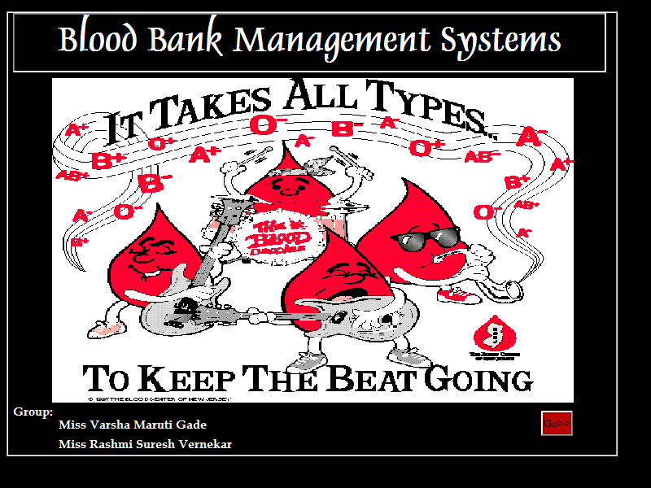

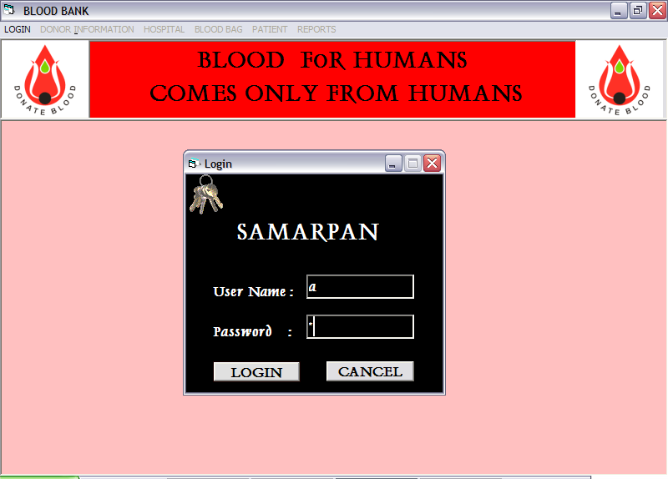

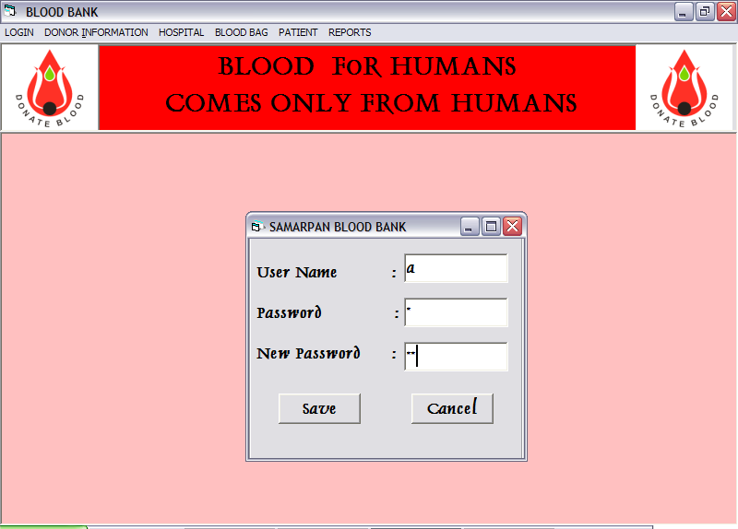

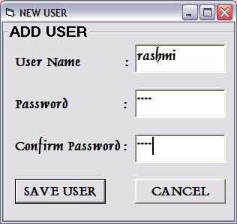

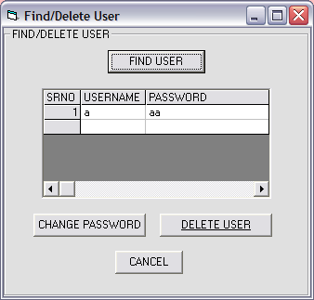

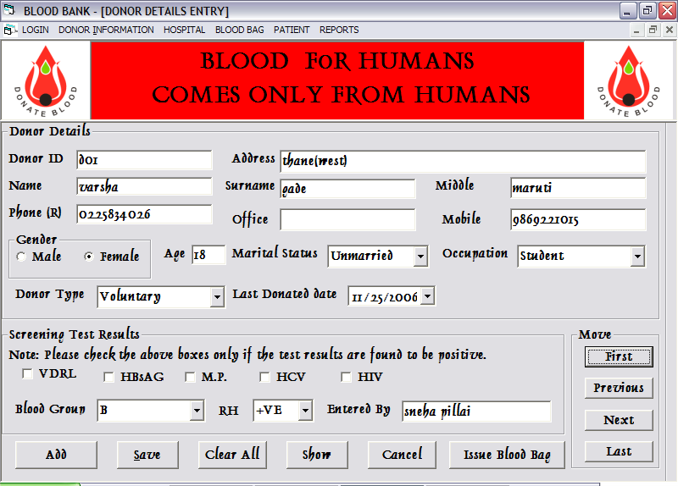

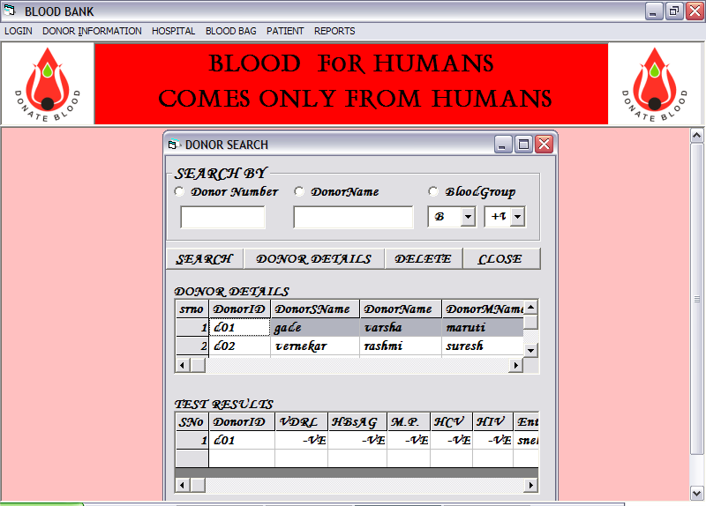

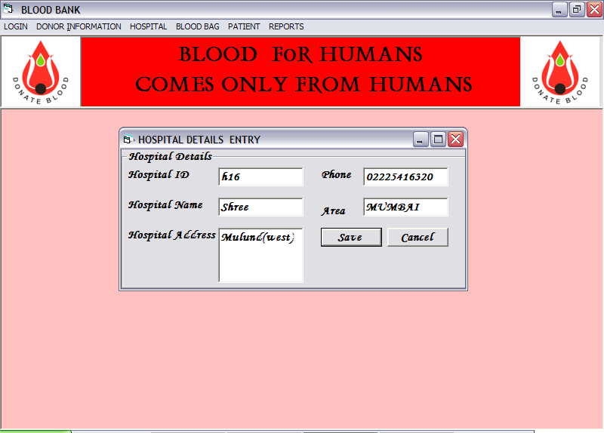

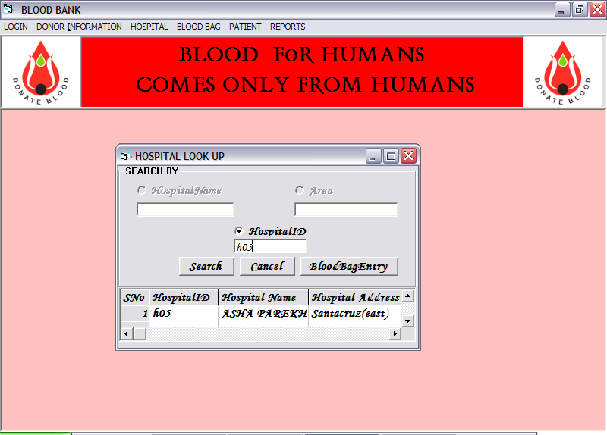

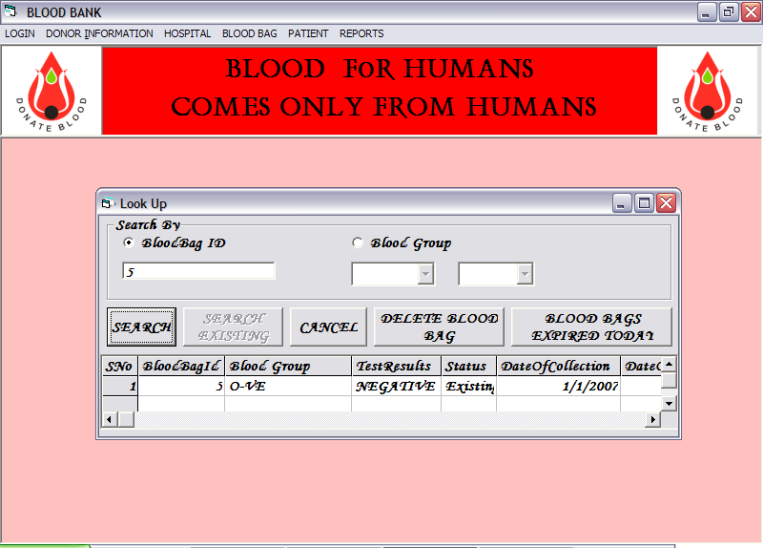

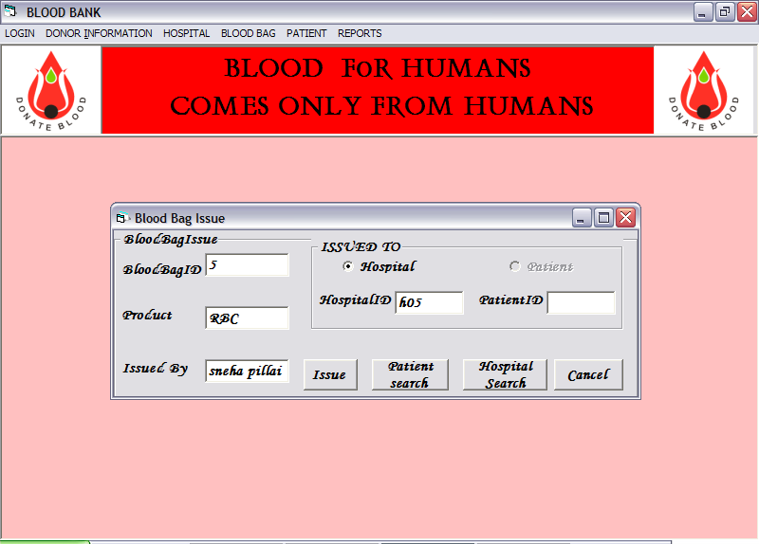

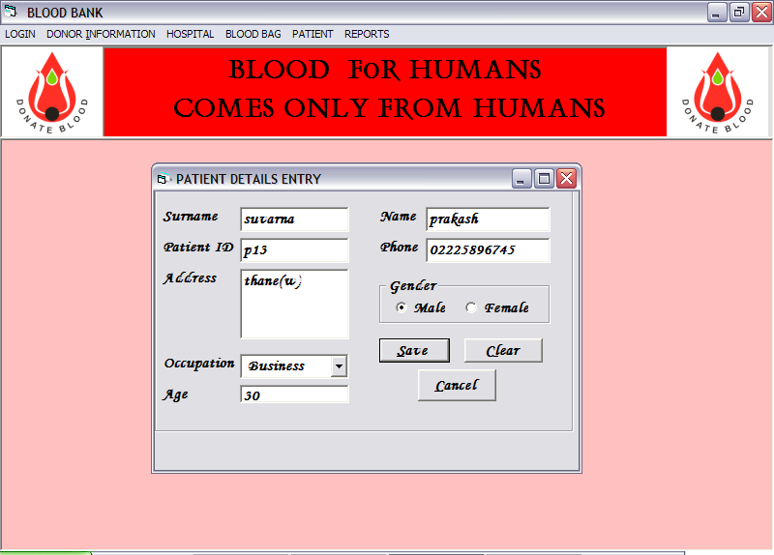

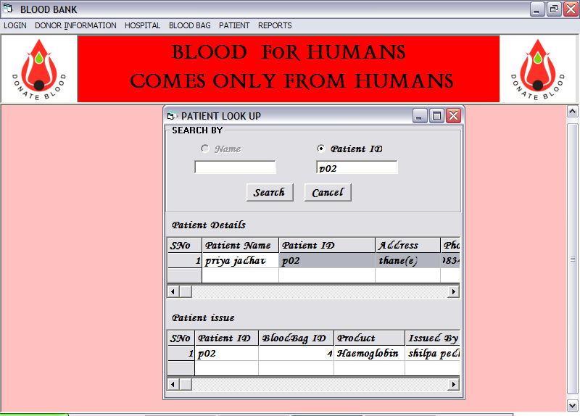

REFERENCES:

- DATABASE SYSTEM CONCEPTS
-KORTH
- SUDERSHAN

- An Integrated approach to Software Engineering
-PANKAJ JALOTE

- PROGRAMMING IN VISUAL BASIC 6.0
-JULIA CASE BRADLEY

- MASTERING VISUAL BASIC 6.0
-EVANGELOS PETERONTSOS

- THE COMPLETE REFERENCE VB 6.0
-NOEL JERHA

- THE COMPLETE REFERENCE SQL
-JAMES GROFF
-PAUL WEINBERG

