**Systems Programming**

**Project**

**Parser for SQL: DELETE Statement**

* DO’s and DON’Ts
* The grammar will accept all the queries following the syntax mentioned below:

(Standard order to be followed according to the syntax.)

DELETE [LOW_PRIORITY] [QUICK] [IGNORE]

FROM table_name [[AS] table_alias]

[PARTITION (partition_name [, partition_name] ...)]

[WHERE where_condition]

[ORDER BY ...]

[LIMIT row_count]

* The grammar is not made for multiple tables and hence does not work for queries involving SQL JOIN.
* The grammar will only accept queries followed by semicolon.

Following are some of the snapshots from the Command Prompt screen showing the parser accepting queries written in accordance with valid syntax:

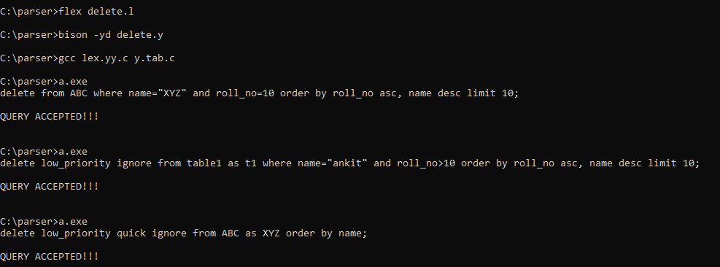

SEMICOLON ’;’ missing:

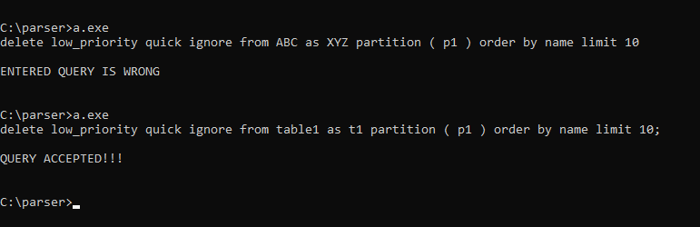

Standard order violated:

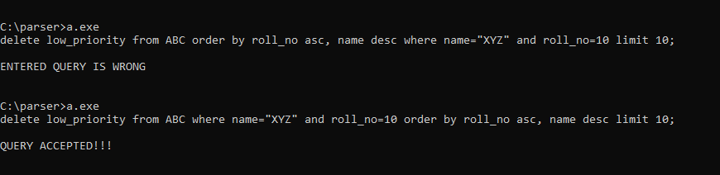

A file (delete.sql) containing various queries following the standard syntax is attached below. All the queries following the aforementioned grammar will be ‘accepted’.

