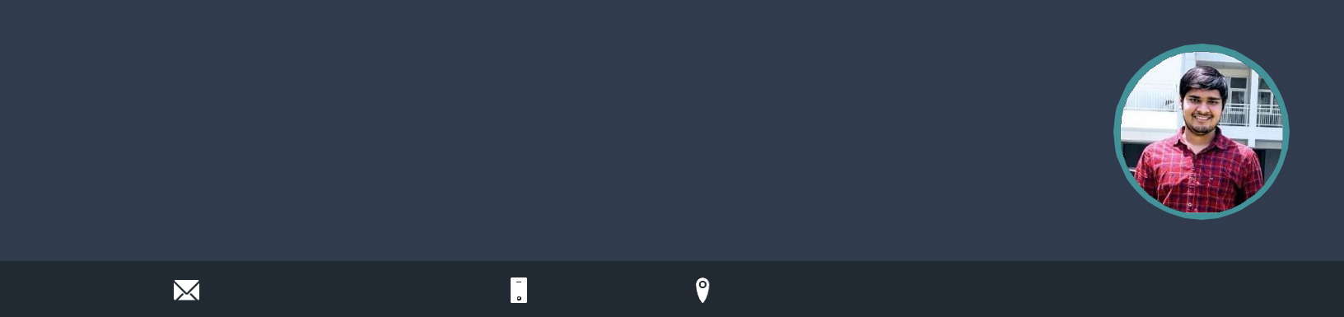
Ankit Kumar

Software Development Engineer

I'm a quick learner and detail oriented person. I have 1+ year experience of working in Java/Springboot , Sql/PostgreSql.

Experience of working in large codebases and have understanding of majority of tools.

connectwithankit1@gmail.com 9315528848

WORK EXPERIENCE

Software Development Engineer OYO

08/2021 - Present,

Achievements/Tasks

Automated generation of reconciliations , reduced eﬀorts of sending manual recons during month end for various countries.

Created a new service for the patrons where they would be able to allot a certain number of inventory per month to be sold at a price plan (Deeply discounted/Free of cost) selected by them. Opting this service will provide free room nights to gain more long term customers.

Created a generic reconciliation platform which was one stop solution for all the home and hotel business. This reduced dev eﬀorts to develop on multiple stacks. Any New Bills/Charges which needs additional development eﬀort was made configurable.

New Delhi, India linkedin.com/in/ankitwin

SKILLS

C++ | Java | C | SpringBoot |  | Git and github
Ruby on Rails |  | PostgreSql / SQL |  |  | HTML
Data Structure |  | OOPS |  | Python


PERSONAL PROJECTS

Student Course Registration

Created Crud Application using Java/SpringBoot , which admits student to an organisation, and help them to pick and register their course.

It enables admin and student login, and help them to drop or update their course .

SDE Intern

OYO

01/2021 - 07/2021,

Achievements/Tasks

Worked under Finance tech team of Oyo and created, managed and updated reconciliations for Hotels across India and abroad.

Coordinate with cross-functional areas like finance, supply and business to drive a complete development lifecycle.

Solved various bugs during oncalls and on month ends during closure of reconciliations.

Teaching Assistant

PEPCODING

12/2019 - 02/2020,

Achievements/Tasks

Mentored students in building a conceptual understanding of Data Structures and Algorithms.

Took doubt sessions on coding and OOPS related queries.

EDUCATION

Btech (Electronics and Communication)

Delhi Technological University

08/2017 - 07/2021, 7.97 CGPA

CBSE(12th boards)

Kendriya Vidyalaya NTPC

04/2016 - 03/2017, 90.40%

CBSE(10th boards)

Kendriya Vidyalaya NTPC

04/2014 - 03/2015, 10 CGPA

Ecommerce Website

An e-commerce website which sells diﬀerent mobile phones and store/manage data of customers.

Role : Frontend and Backend

ACADEMICS

Coursera

Scored 100% marks in the Final assessment of Data Structure and Algorithmic Toolbox(COURSERA).

Coding Ninjas contest 2020

Secured 502 rank in Coding Ninjas contest 2020 among 30k participants.

LANGUAGES

C++ Java

Full Professional Proficiency Full Professional Proficiency

C Ruby

Full Professional Proficiency Professional Working Proficiency

Python

Professional Working Proficiency

INTERESTS

Watching technical videos Solving puzzles


Playing Chess

