

**IDENTITY CARD FORM**



|  |  |
| --- | --- |
| Employee Name | Ankit Kumar |
| Employee ID (Quess ID number) | 10026848 |
| Name of the company | Monster.com India Pvt. Ltd. |
| Office Location | Noida |
| Complete office address (To be filled by Admin Team) |  |
| Telephone (To be filled by Admin Team) |  |
| Department (Sub Vertical) | Recruiter |
| Blood Group | A+ |
| Do you require Lanyard (Yes/ No) | Yes |
| Do you require Yoyo (Yes/ No) | Yes |

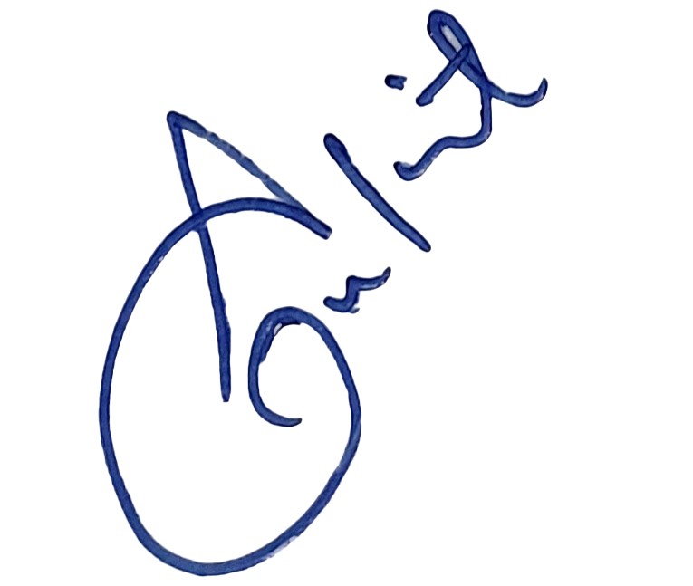

------------------ --------------------

Employee Signature