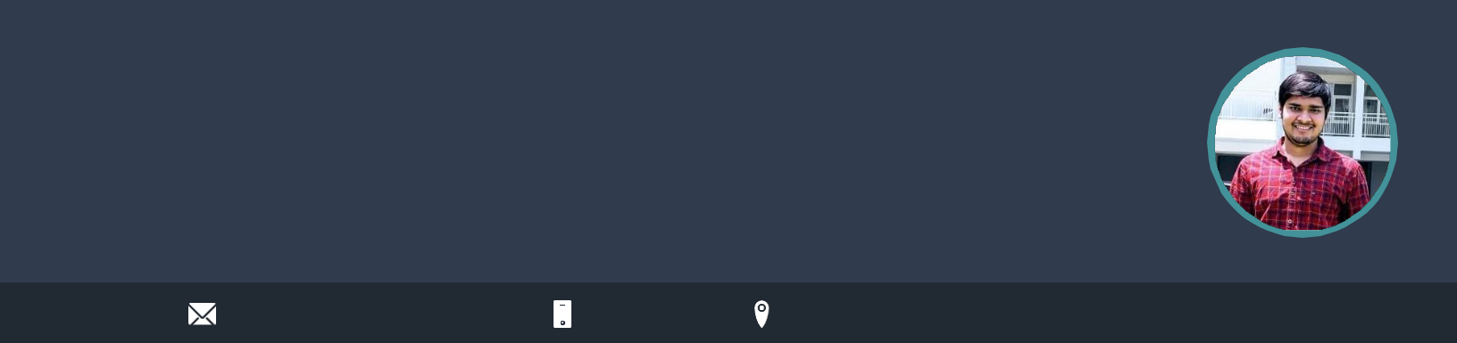Ankit Kumar

Software Development Engineer

I'm a quick learner and detail oriented person. I have 1+ year experience of working in Java/Springboot , Sql/PostgreSql.

Experience of working in large codebases and have understanding of majority of tools.

connectwithankit1@gmail.com 9315528848

**WORK EXPERIENCE**

**Software Development Engineer** OYO

*08/2021 - Present*,

*Achievements/Tasks*

Automated generation of reconciliations , reduced eﬀorts of sending manual recons during month end for various countries.



Created a new service for the patrons where they would be able to allot a certain number of inventory per month to be sold at a price plan (Deeply discounted/Free of cost) selected by them. Opting this service will provide free room nights to gain more long term customers.



Created a generic reconciliation platform which was one stop solution for all the home and hotel business. This reduced dev eﬀorts to develop on multiple stacks. Any New Bills/Charges which needs additional development eﬀort was made configurable.



New Delhi, India  [linkedin.com/in/ankitwin](https://www.linkedin.com/in/ankitwin/)

**SKILLS**



|  |  |  |  |  |  |
| --- | --- | --- | --- | --- | --- |
| C++ | Java | C | SpringBoot | | Git and github |
| Ruby on Rails | | PostgreSql / SQL | | | HTML |
| Data Structure | | OOPS | | Python |  |



**PERSONAL PROJECTS**

Student Course Registration

Created Crud Application using Java/SpringBoot , which admits student to an organisation, and help them to pick and register their course.



It enables admin and student login, and help them to drop or update their course .



**SDE Intern**

OYO

*01/2021 - 07/2021*,

*Achievements/Tasks*

Worked under Finance tech team of Oyo and created, managed and updated reconciliations for Hotels across India and abroad.



Coordinate with cross-functional areas like finance, supply and business to drive a complete development lifecycle.



Solved various bugs during oncalls and on month ends during closure of reconciliations.



**Teaching Assistant**

PEPCODING

*12/2019 - 02/2020*,

*Achievements/Tasks*

Mentored students in building a conceptual understanding of Data Structures and Algorithms.



Took doubt sessions on coding and OOPS related queries.



**EDUCATION**

**Btech (Electronics and Communication)**

Delhi Technological University

*08/2017 - 07/2021*, *7.97 CGPA*

**CBSE(12th boards)**

Kendriya Vidyalaya NTPC

*04/2016 - 03/2017*, *90.40%*

**CBSE(10th boards)**

Kendriya Vidyalaya NTPC

*04/2014 - 03/2015*, *10 CGPA*

Ecommerce Website

An e-commerce website which sells diﬀerent mobile phones and store/manage data of customers.



Role : Frontend and Backend



**ACADEMICS**

Coursera

*Scored 100% marks in the Final assessment of Data Structure and Algorithmic Toolbox(COURSERA).*

Coding Ninjas contest 2020

*Secured 502 rank in Coding Ninjas contest 2020 among 30k participants.*

**LANGUAGES**

C++ Java

*Full Professional Proficiency* *Full Professional Proficiency*

C Ruby

*Full Professional Proficiency* *Professional Working Proficiency*

Python

*Professional Working Proficiency*

**INTERESTS**



Watching technical videos Solving puzzles



Playing Chess