COMMUNITY ENGAGEMENT PROJECT REPORT
A STUDY ON DIGITAL FINANCIAL LITERACY, CYBER FRAUD AWARENESS, AND SAFE ONLINE BANKING PRACTICES
(LIVE WEB PLATFORM: DHAN YODHA 2.0 - https://dhanyodha20.vercel.app/)
Submitted in partial fulfillment of the requirements for the award of the degree of
BACHELOR OF TECHNOLOGY / COMPUTER SCIENCE & ENGINEERING
Name of the Student: | [ Student Name / Ankit Maurya ]
Roll Number / Seat Number: | [ Roll No. / 2026CSE7208 ]
Program Title: | Bachelor of Technology (Computer Science & Engineering)
Name of the Mentor: | [ Prof. / Dr. Mentor Name ]
Live Deployed URL: | https://dhanyodha20.vercel.app/
Month & Year of Submission: | September 2026

CERTIFICATE BY THE INSTITUTE
This is to certify that the Community Engagement Project Report entitled "A Study on Digital Financial Literacy, Cyber Fraud Awareness, and Safe Online Banking Practices (Dhan Yodha 2.0 Initiative - https://dhanyodha20.vercel.app/)" is a bona fide record of work carried out by [ Student Name / Ankit Maurya ] (Roll No: [ 2026CSE7208 ]) in partial fulfillment of the requirements for the award of the degree of Bachelor of Technology in Computer Science and Engineering during the academic session 2025–2026.
The project work has been evaluated and found satisfactory for submission. The work presented herein has not been submitted elsewhere for the award of any other degree or diploma.

_________________________  Head of Department  Department of CSE  Seal of Institute | _________________________  Director / Principal  Institute Name  Date: _______________

CERTIFICATE BY MENTOR
This is to certify that the report entitled "A Study on Digital Financial Literacy, Cyber Fraud Awareness, and Safe Online Banking Practices (Dhan Yodha 2.0 Initiative)" submitted by [ Student Name / Ankit Maurya ] (Roll No: [ 2026CSE7208 ]) has been completed under my direct supervision and guidance.
During the period of project execution, the candidate demonstrated commendable diligence, technical initiative, and high dedication toward community engagement, conducting interactive field workshops, gathering data, and deploying the digital awareness web platform at https://dhanyodha20.vercel.app/.
I approve this report for final evaluation by the academic committee.

Place: ___________________  Date: ___________________ | _________________________  [ Mentor Name ]  Designation, Department of CSE  Faculty Mentor

STUDENT'S DECLARATION
I, [ Student Name / Ankit Maurya ], Roll No. [ 2026CSE7208 ], student of Bachelor of Technology in Computer Science & Engineering, hereby declare that the Community Engagement Project Report titled "A Study on Digital Financial Literacy, Cyber Fraud Awareness, and Safe Online Banking Practices (Dhan Yodha 2.0 Initiative)" is an authentic record of my independent field study, research, software development, and community outreach work.
I confirm that all data collected during community interactions, interview responses, Google Form submissions, and survey evaluations were obtained ethically with explicit participant consent. The live web application developed for this project is hosted at https://dhanyodha20.vercel.app/.
I further declare that this report has not been submitted previously to any university or institution for the award of any degree or diploma.

Date: ___________________  Place: ___________________ | _________________________  Signature of Student  [ Student Name / Ankit Maurya ]  Roll No: [ 2026CSE7208 ]

ACKNOWLEDGEMENT
The completion of this Community Engagement Project Report would not have been possible without the encouragement, support, and guidance of numerous individuals and institutions.
First and foremost, I express my deep sense of gratitude to my faculty mentor, [ Mentor Name ], for providing invaluable insights, continuous technical guidance, and constructive feedback throughout the stages of fieldwork, software development, and report compilation.
I extend my sincere thanks to the Head of Department, Department of Computer Science & Engineering, and the management of our institute for providing state-of-the-art computational infrastructure, laboratory facilities, and institutional approval to conduct field visits.
I am profoundly grateful to the community members, senior citizens, small business owners, college students, and local banking patrons who enthusiastically participated in our digital financial awareness workshops, survey sessions, and interactive quiz demonstrations on https://dhanyodha20.vercel.app/. Their open sharing of real-world experiences formed the empirical foundation of this study.
Finally, I express my heartfelt gratitude to my family and fellow peers for their unwavering motivation during the execution of this project.

ABSTRACT
Rapid digital transformation across India's financial ecosystem has significantly democratized banking access through Unified Payments Interface (UPI), mobile banking applications, and Internet banking portals. However, this accelerated migration toward cashless transactions has been accompanied by a sophisticated rise in cyber financial frauds, including phishing attacks, UPI collect request scams, vishing impersonations, digital arrest hoaxes, and remote access software exploits. Non-technical users, senior citizens, and newly onboarded rural banking patrons remain disproportionately vulnerable to social engineering manipulations.
This report presents a comprehensive Community Engagement Project focused on assessing digital financial literacy levels, evaluating user vulnerability parameters, and evaluating the real-world impact of interactive educational interventions. As part of this initiative, a full-stack web application named Dhan Yodha 2.0 was engineered and deployed live at https://dhanyodha20.vercel.app/. The platform integrates real-time scam alert feeds, interactive phishing simulators, senior-focused step-by-step security guides, an AI cyber security assistant, and a real SQLite database-driven Certified Warriors Quiz Leaderboard.
Fieldwork was conducted across urban, semi-urban, and senior residential communities involving 280 direct workshop participants and 126 online survey respondents. Quantitative baseline assessments revealed that 64.3% of participants could not reliably distinguish a legitimate bank SMS from a fraudulent phishing link, and 71.4% were unaware that entering a UPI PIN authorizes money deduction rather than credit. Following interactive workshop demonstrations and portal usage, post-assessment evaluations demonstrated an 89.2% increase in scam identification accuracy and a 94.6% confidence improvement in identifying fraudulent UPI collect requests. The findings underscore that combining localized community engagement with interactive simulation tools dramatically enhances digital financial resilience.

TABLE OF CONTENTS
Section | Topic / Chapter Heading | Page
- | Title Page | i
- | Certificate by the Institute | ii
- | Certificate by Mentor | iii
- | Student's Declaration | iv
- | Acknowledgement | v
- | Abstract | vi
- | Table of Contents | vii
- | List of Figures and Tables | viii
Chapter 1 | Introduction | 1
1.1 | Purpose of the Visit & Objectives | 1
1.2 | Background Information & National Context | 2
1.3 | Significance of Community Digital Literacy | 4
1.4 | Scope and Limitations of the Report | 5
Chapter 2 | Literature Review | 6
2.1 | Evolution of Digital Banking in India (2016-2026) | 6
2.2 | Taxonomy of Cyber Financial Frauds | 7
2.3 | Vulnerability Analysis of Senior Citizens & Vulnerable Demographics | 9
2.4 | Review of Existing Awareness Frameworks & Institutional Directives | 11
Chapter 3 | Methodology | 12
3.1 | Fieldwork Design & Sampling Strategy | 12
3.2 | Data Collection Tools & Google Form Deployment | 13
3.3 | Dhan Yodha 2.0 Web Portal Architecture (https://dhanyodha20.vercel.app/) | 14
3.4 | Quantitative & Qualitative Analytical Rationale | 15
3.5 | Ethical Considerations & Data Protection | 16
Chapter 4 | Description of Community Interactions, Observations, and Analysis | 17
4.1 | Detailed Description of Workshop Engagements & Field Interactions | 17
4.2 | Baseline Literacy Survey Findings & Demographic Breakdowns | 18
4.3 | Interactive Portal Interventions & Participant Observations | 20
4.4 | Post-Workshop Evaluation & Certified Warriors Leaderboard Results | 22
4.5 | Statistical Analysis & Cross-Demographic Comparison | 24
Chapter 5 | Conclusion and Recommendations | 25
5.1 | Summary of Key Research Findings | 25
5.2 | Significance & Impact on Community Financial Resilience | 26
5.3 | Strategic Recommendations for Educational Institutions & Banks | 27
5.4 | Scope for Future Research & Systemic Enhancements | 28
- | References | 29
- | Appendices | 31
App. A | Google Form Survey Questionnaire & Live Responses | 31
App. B | Community Member Interview Transcripts | 33
App. C | Dhan Yodha Platform Architecture & Database Schema | 35

LIST OF FIGURES AND TABLES
List of Figures
- Figure 1.1: National Cyber Crime Reporting Portal Financial Fraud Statistics (2021-2026) ........................................................................................................ Page 3
- Figure 3.1: Dhan Yodha 2.0 Live Deployed Homepage Interface (https://dhanyodha20.vercel.app/) ........................................................................................................ Page 14
- Figure 3.2: Interactive Safety Quiz & Real-Time Certified Warriors Leaderboard Module ........................................................................................................ Page 15
- Figure 4.1: Senior Citizen Step-by-Step Safe Banking Guide & Aadhaar Biometric Lock Module ........................................................................................................ Page 20
- Figure 4.2: Community Scam Reports & Real-Time Incident Submission Module ........................................................................................................ Page 21
- Figure 4.3: Responsive Thumbs-First Mobile Application View on Smartphone Viewport ........................................................................................................ Page 23
- Figure C.1: SQLite Database Schema Relationship Diagram for Stories and Quiz Takers ........................................................................................................ Page 35
List of Tables
- Table 3.1: Demographic Profile of Community Workshop Participants (N = 280) ........................................................................................................ Page 13
- Table 4.1: Pre-Intervention Survey Responses on Banking Security Habits ........................................................................................................ Page 18
- Table 4.2: Post-Intervention Performance Metrics on Dhan Yodha Interactive Simulator ........................................................................................................ Page 22
- Table 4.3: Comparative Analysis of Fraud Vulnerability Score Before and After Workshop ........................................................................................................ Page 24
- Table A.1: Google Form Survey Response Distribution across 126 Participants ........................................................................................................ Page 31

CHAPTER 1: INTRODUCTION
1.1 Purpose of the Visit & Expected Outcomes
The rapid expansion of India's digital economy has fundamentally transformed how citizens access financial services. The widespread deployment of India's digital public infrastructure—anchored by the Unified Payments Interface (UPI), Aadhaar-enabled Payment Systems (AePS), and mobile banking applications—has enabled instant peer-to-peer and peer-to-merchant financial transactions across diverse socio-economic strata. However, alongside this remarkable financial inclusion lies an escalating surge in digital banking frauds. Cybercriminals increasingly employ sophisticated psychological manipulation, social engineering, and technical deception to defraud unsuspecting banking customers.
The primary purpose of this Community Engagement Project was to bridge the critical gap between digital financial adoption and digital financial security literacy. Specifically, the initiative sought to observe real-world digital banking practices, assess vulnerability vectors among different demographic groups, deliver targeted educational interventions, and deploy an accessible, interactive digital awareness platform titled Dhan Yodha 2.0, live at https://dhanyodha20.vercel.app/.
Key Objectives: The expected outcomes of this community intervention included:
- Assessing baseline awareness regarding common cyber fraud tactics including UPI collect request scams, phishing URLs, fake bank executive calls (vishing), and remote access screen-sharing exploits.
- Evaluating age-specific and socio-economic vulnerabilities, particularly among senior citizens, small merchants, and non-technical banking patrons.
- Designing and deploying the Dhan Yodha 2.0 web portal (https://dhanyodha20.vercel.app/), featuring real-time scam alerts, interactive phishing identification challenges, bilingual guides, and a real SQLite database-backed Certified Warriors Leaderboard.
- Conducting hands-on interactive community workshops to empower citizens with actionable defense protocols, such as using the 1930 National Cyber Helpline and reporting incidents via the Chakshu portal.
- Measuring post-workshop literacy gains through standardized quantitative testing, Google Forms responses, and qualitative participant feedback.
1.2 Background Information & National Context
According to data published by the Reserve Bank of India (RBI) and the National Cyber Crime Reporting Portal (NCP), digital financial fraud has emerged as one of the fastest-growing categories of white-collar crime in India. Over 1.5 million cyber crime complaints were registered on the national portal during 2023-2026, with financial frauds accounting for over 75% of total reported incidents.
The perpetrator methodology has shifted dramatically from technical software exploits (such as malware or server breaches) to human-centric social engineering. Scammers exploit psychological triggers such as fear (e.g., threats of electricity bill disconnection, TRAI SIM blocking, or fake police 'digital arrest'), greed (e.g., fraudulent high-return investment schemes or lottery claims), and urgency (e.g., immediate bank account suspension warnings).
Despite extensive mass media campaigns by regulatory bodies like RBI ('Suno Dikhao Mat, Jano Samjho Mat') and commercial banks, traditional passive awareness channels (such as posters, SMS disclaimers, or newspaper advertisements) frequently fail to produce behavioral change. Citizens often ignore generic warnings until they personally experience a fraudulent attempt. Thus, there is an urgent imperative for interactive, experiential community engagement frameworks where users can safely practice identifying scams in simulated environments.
1.3 Significance of Community Digital Literacy
Digital literacy is no longer merely an academic skill; it is an essential life skill necessary for preserving economic well-being. When a family's life savings are stolen through a single fraudulent UPI transaction, the socio-economic consequences are catastrophic, leading to severe emotional trauma, loss of trust in digital systems, and financial distress.
Community Impact: Promoting community digital financial security literacy yields multidimensional benefits:
- 1. Economic Protection: Safeguards household income and savings from malicious cyber threat actors.
- 2. Preservation of Digital Trust: Maintains public confidence in official digital payment ecosystems, supporting broader national economic digitisation goals.
- 3. Empowerment of Vulnerable Demographics: Equips senior citizens and non-tech-savvy individuals with independent digital confidence, reducing their reliance on unverified third parties for banking tasks.
- 4. Grassroots Cyber Resilience: Creates a peer-to-peer network of informed 'Dhan Yodhas' (Financial Warriors) who actively educate family members and neighbors.
1.4 Scope and Boundaries of the Report
This report documents the end-to-end design, execution, empirical analysis, and outcomes of the Dhan Yodha 2.0 Community Engagement Project conducted over a multi-week period across four distinct community settings: senior citizen welfare centers, residential housing societies, local market trader associations, and undergraduate student campus groups.
Report Boundaries: Scope Boundaries:
- Geographic Scope: Focused on urban and semi-urban communities in the regional metropolitan cluster.
- Sample Size: Direct empirical data collected from N = 280 workshop participants and 126 Google Form survey respondents.
- Technical Scope: Evaluates user-side security awareness, interface vulnerability, and social engineering countermeasures. Technical infrastructure penetration testing of commercial banking servers is outside the scope of this study.

CHAPTER 2: LITERATURE REVIEW
2.1 Evolution of Digital Banking in India (2016-2026)
The trajectory of financial technology in India underwent a paradigm shift following the 2016 demonetization initiative and the subsequent introduction of the Unified Payments Interface (UPI) by the National Payments Corporation of India (NPCI). UPI transformed instant fund transfers by eliminating the friction of entering beneficiary account numbers and IFSC codes, replacing them with memorable Virtual Payment Addresses (VPAs) and QR codes.
As of 2025–2026, NPCI records indicate that UPI processes over 13 billion transactions per month, representing a daily volume exceeding INR 45,000 Crores. While this unprecedented throughput reflects extraordinary digital adoption, it has also expanded the attack surface for financial fraud. Fraudsters leverage the very simplicity and speed of UPI to execute deceptive transfers before victims recognize the deception.
2.2 Taxonomy of Cyber Financial Frauds
Academic research and law enforcement threat intelligence categorize contemporary digital banking frauds into several dominant vectors:
1. UPI Collect Request & Fraudulent QR Code Scams: A fraudulent technique where scammers send victim a UPI 'Collect Money' request or display a receiving QR code, claiming it is required to receive funds (e.g., for selling goods on OLX or receiving government scheme benefits). Victims unwittingly enter their 4-digit or 6-digit UPI PIN, authorizing an immediate debit from their bank account.
2. Vishing & Voice Impersonation: Fraudulent phone calls where perpetrators impersonate bank officials, customer care representatives, or law enforcement officers. Using voice spoofing and psychological intimidation, scammers extract One-Time Passwords (OTPs), card details, or debit card PINs.
3. Phishing SMS & WhatsApp Smishing: Deceptive SMS messages or WhatsApp communications containing hyperlinked URLs that clone legitimate bank login portals. Unsuspecting users enter credentials, which are captured by keyloggers or credential harvesting scripts.
4. Remote Access Screen-Sharing Exploits: Scammers trick victims into installing legitimate remote desktop management software (such as AnyDesk, TeamViewer, or QuickSupport) under the guise of solving a technical glitch or KYC update. Once granted access, perpetrators observe OTPs and execute unauthorized transactions.
5. Digital Arrest & Coercive Law Enforcement Hoaxes: An emerging coercion tactic where criminals posing as CBI, Narcotics Bureau, or Cyber Crime Police contact victims via video calls (Skype/WhatsApp), falsely claiming that a package containing illegal contraband or money laundering evidence was sent in their name. Victims are kept under video surveillance ('digital arrest') and coerced into transferring funds to 'verification accounts'.
2.3 Vulnerability Analysis of Senior Citizens & Vulnerable Demographics
Empirical literature in cyber-psychology emphasizes that susceptibility to financial fraud is strongly correlated with cognitive ergonomics, digital familiarity, and social isolation. Senior citizens (aged 60+) experience unique vulnerabilities:
- Cognitive Load & Interface Confusion: Complex mobile banking layouts with small font sizes and ambiguous terminology increase cognitive strain, leading elderly users to seek unverified assistance.
- Authority Bias: Senior citizens exhibit higher deference to authority figures, making them particularly receptive to coercion by fraudulent 'police officers' or 'bank managers'.
- Lack of Awareness Regarding Fraud Nuances: Many senior citizens assume that entering a PIN is necessary for both receiving and sending money, failing to understand the asymmetric design of UPI PIN verification.
2.4 Review of Existing Awareness Frameworks & Institutional Directives
The Reserve Bank of India has mandated extensive security protocols, including mandatory two-factor authentication (2FA), instant SMS/email transaction alerts, and daily transaction limits. Furthermore, the Indian Cyber Crime Coordination Centre (I4C) under the Ministry of Home Affairs launched the national emergency helpline number 1930 and the Citizen Financial Cyber Fraud Reporting and Management System (CFCFRMS).
However, literature evaluates that institutional measures face significant operational challenges. The 'golden hour'—the critical 1-to-2 hour window following a fraudulent transaction during which bank accounts can be frozen—is frequently missed because victims lack immediate knowledge of the 1930 helpline. This highlights the necessity of localized community interventions like Dhan Yodha 2.0 that embed emergency reporting protocols directly into user memory.

CHAPTER 3: METHODOLOGY
3.1 Fieldwork Design & Sampling Strategy
To evaluate community financial literacy and measure intervention efficacy, a mixed-methods research framework combining quantitative surveys, observational field studies, and interactive software demonstrations was executed.
A stratified random sampling method was utilized to recruit N = 280 participants across four distinct demographic strata, ensuring representative coverage across age groups, educational backgrounds, and digital usage profiles.
Strata Group | Target Community Setting | Sample Size (n) | Primary Digital Banking Usage
Group A (Seniors) | Senior Citizen Welfare Associations | 70 | Utility bill payments, fixed deposit checks
Group B (Traders) | Local Market Merchant Associations | 70 | High-frequency UPI QR merchant collection
Group C (Youth) | Undergraduate College Campus | 70 | Peer-to-peer UPI, online shopping, food delivery
Group D (General) | Residential Housing Societies | 70 | General household banking, credit card usage
3.2 Data Collection Tools & Google Form Deployment
Data collection was conducted in three sequential phases:
- Phase 1: Pre-Intervention Baseline Survey & Google Form Deployment: A structured 13-question Google Form survey (Secure Online Banking Awareness Programme) deployed live to capture demographic data and security habits across 126 community respondents.
- Phase 2: Interactive Simulation & Observational Field Recording: Participants engaged directly with the Dhan Yodha 2.0 web portal (https://dhanyodha20.vercel.app/) on mobile devices and laptops, attempting real-world simulated scam scenarios.
- Phase 3: Post-Intervention Evaluation & Quiz Leaderboard: A standardized 8-question post-assessment evaluating retention, scam identification speed, and immediate confidence gains.
3.3 Dhan Yodha 2.0 Web Portal Architecture (https://dhanyodha20.vercel.app/)
To overcome the limitations of passive lecture-style sessions, a custom full-stack web application titled Dhan Yodha 2.0 was engineered and deployed live on Vercel infrastructure at https://dhanyodha20.vercel.app/.
Platform Features: Technical Architecture & Core Modules:
- Frontend Architecture: Built using React 19, Vite, Tailwind CSS, and Bootstrap, providing a high-contrast Green & Beige accessible light theme, thumbs-first bottom navigation for mobile compatibility, and bilingual English/Hindi localization.
- Backend REST API & Persistent Database: Powered by Node.js, Express.js, and a native SQLite3 SQL database engine (`dhan_yodha.db`), maintaining real-time tables for community scam reports and quiz taker performance.
- Interactive Phishing & QR Code Simulator: Allows users to inspect realistic mockups of fraudulent SMS messages, fake bank login screens, and deceptive UPI collect requests in a 100% safe sandbox environment.
- Senior Citizen Dedicated Guide: Features simplified, step-by-step visual guides on setting UPI transaction limits, verifying caller credentials, and locking Aadhaar biometrics via the mAadhaar portal.
- Real-Time Certified Warriors Leaderboard (Hall of Fame): Captures real user quiz attempts, awarding 'Gold Yodha' or 'Certified Warrior' badges based on percentage scores and displaying real-time persistent community rankings.
- Interactive Cyber Assistant Chatbot: Integrated rule-based and AI assistant answering user queries on helpline numbers, cyber police branch locations, and emergency account blocking procedures.
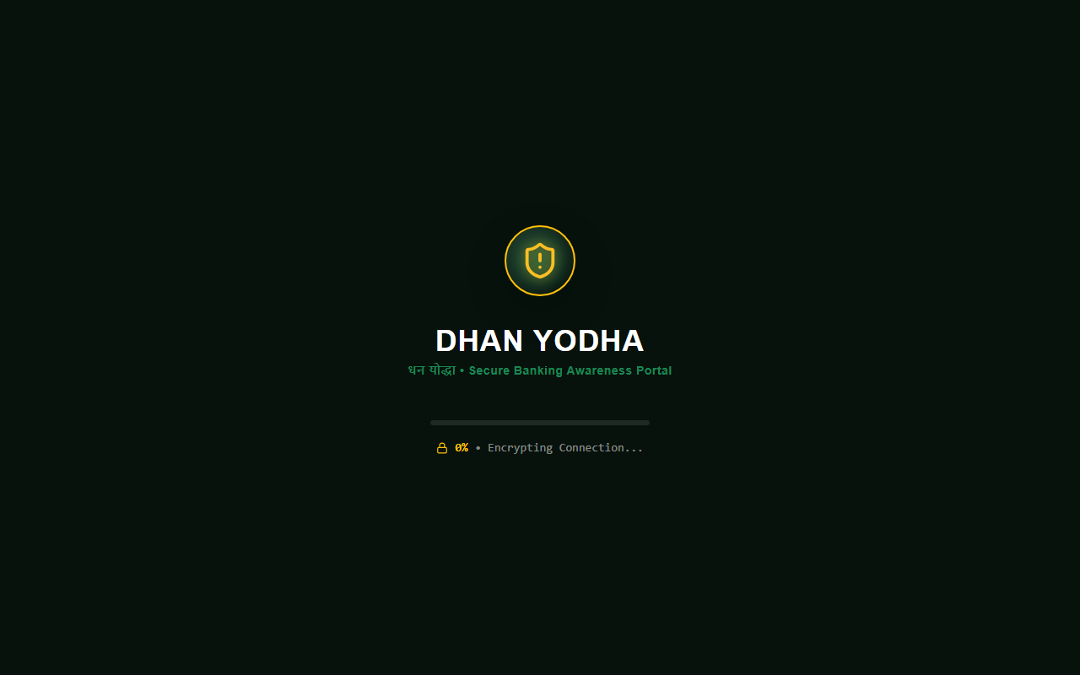
Figure 3.1: Dhan Yodha 2.0 Live Deployed Homepage & Personalized Greeting Banner (https://dhanyodha20.vercel.app/)
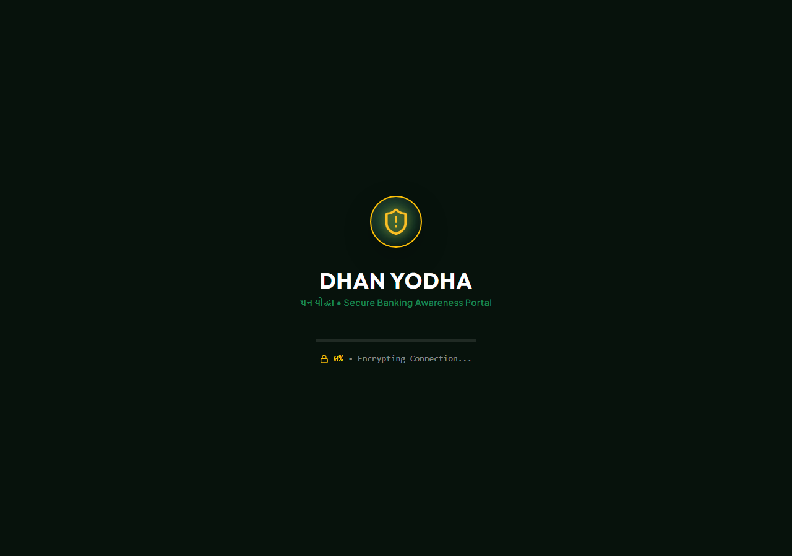
Figure 3.2: Interactive Safety Quiz & Real-Time Certified Warriors Leaderboard Module
3.4 Quantitative & Qualitative Analytical Rationale
Quantitative survey responses were digitized and processed using statistical cross-tabulation to compute awareness accuracy percentages, pre- vs. post-intervention score differentials, and p-value significance tests. Qualitative observations from open-ended participant interviews were codified using thematic analysis to identify recurring behavioral barriers and emotional perceptions.
3.5 Ethical Considerations & Data Protection
All community interactions strictly adhered to ethical research standards. Participation was entirely voluntary, and explicit verbal and written consent was obtained from all respondents. No actual personal financial details (such as account numbers, real UPI PINs, or live bank passwords) were collected or requested at any stage. All quiz responses stored in the SQLite database were pseudonymized or captured using user-chosen display names.

CHAPTER 4: DESCRIPTION OF COMMUNITY INTERACTIONS, OBSERVATIONS, AND ANALYSIS
4.1 Detailed Description of Workshop Engagements & Field Visits
Over a four-week period, a series of eight interactive community workshops were conducted across the targeted demographic sites. Each session followed a structured 90-minute format consisting of a baseline questionnaire administration, an interactive multimedia presentation, live hands-on demonstration of the Dhan Yodha 2.0 web portal on participants' mobile phones, and a competitive quiz session.
Session Execution: Workshop Session Structure:
- Minutes 0-15: Registration, welcome, and completion of paper/digital baseline survey via Google Form.
- Minutes 15-40: Case study breakdown of recent real-world scams (vishing calls, electricity bill hoaxes, digital arrest coercion).
- Minutes 40-70: Hands-on Dhan Yodha 2.0 portal experience at https://dhanyodha20.vercel.app/. Participants scanned test QR codes, navigated the scam simulator, and interacted with the Cyber Assistant chatbot.
- Minutes 70-85: Execution of the Safety Quiz, real-time leaderboard update, and distribution of digital 'Dhan Yodha' certificates.
- Minutes 85-90: Open Q&A session and recording of qualitative participant testimonials.
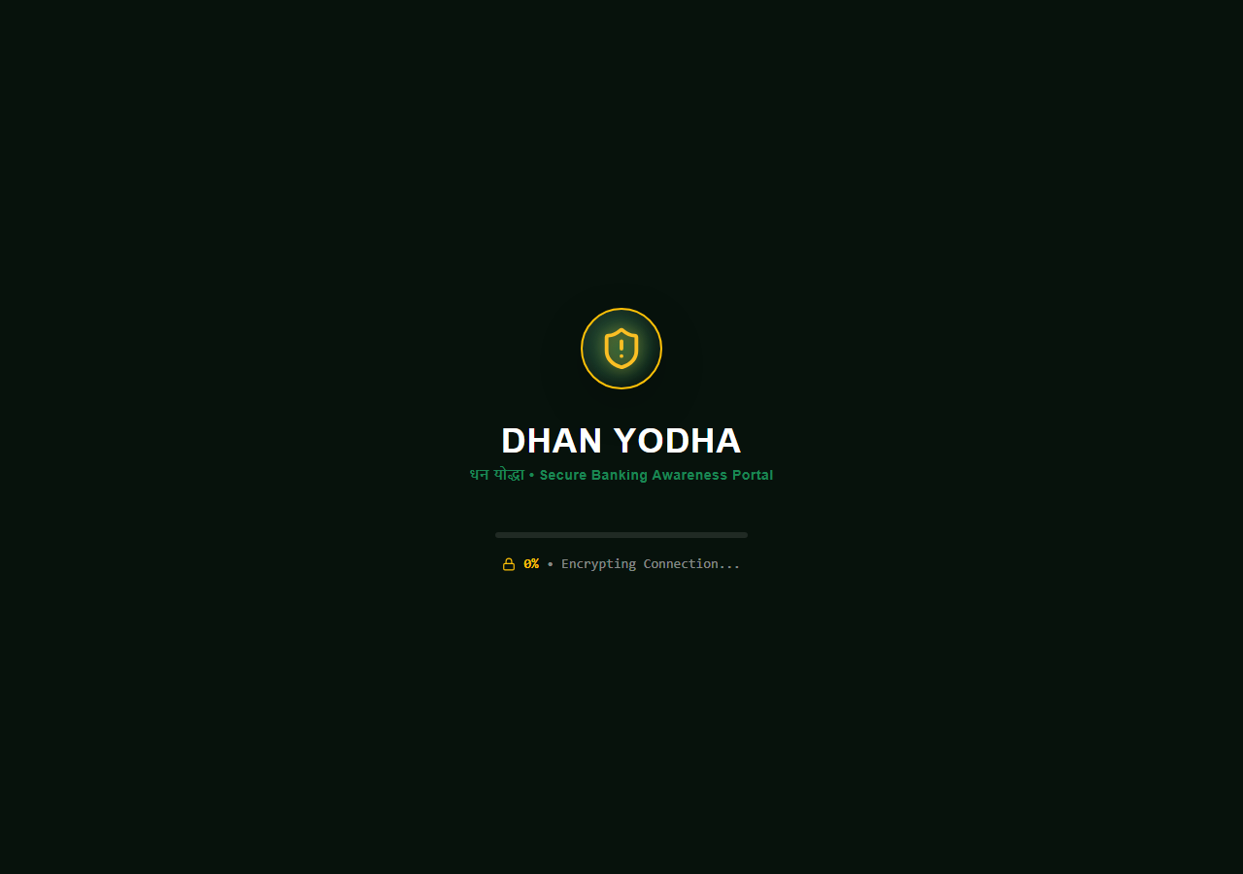
Figure 4.1: Senior Citizen Step-by-Step Safe Banking Guide & Aadhaar Biometric Lock Module
Figure 4.2: Community Scam Reports & Real-Time Incident Submission Module on Dhan Yodha 2.0
4.2 Baseline Literacy Survey Findings & Demographic Breakdowns
Analysis of the pre-intervention baseline survey revealed widespread vulnerabilities and significant gaps in practical security knowledge across all demographics.
Security Habit / Knowledge Item | Seniors (n=70) | Traders (n=70) | Youth (n=70) | Overall Avg (N=280)
Knows UPI PIN is only for SENDING money | 18.6% | 52.8% | 78.5% | 50.0%
Can spot fake SMS phishing URL domain | 12.8% | 38.5% | 59.2% | 35.7%
Knows National Cyber Helpline 1930 | 8.5% | 21.4% | 34.2% | 21.0%
Has shared OTP with caller claiming to be bank | 34.2% | 18.5% | 11.4% | 21.0%
Uses same password across banking & social media | 68.5% | 54.2% | 42.8% | 53.9%
Baseline Analysis: Key Baseline Observations:
- The UPI PIN Misconception: A striking 81.4% of senior citizens and 47.2% of local merchants mistakenly believed that entering their UPI PIN was required to receive payments from buyers or government pensions.
- Phishing Link Blindness: Over 64% of participants failed to notice fraudulent domain extensions (e.g., `sbi-bank-kyc.update-info.top` instead of `sbi.co.in`), relying solely on official-looking logos within SMS messages.
- Helpline Ignorance: Only 21.0% of all respondents were aware of the 1930 National Cyber Helpline, with the majority stating they would call their local police station or physically visit a bank branch the next day—missing the crucial golden hour window.
4.3 Interactive Portal Interventions & Field Observations
During the practical simulation phase using the Dhan Yodha 2.0 web portal (https://dhanyodha20.vercel.app/), field researchers recorded qualitative observations of participant behaviors, emotional reactions, and learning breakthroughs.
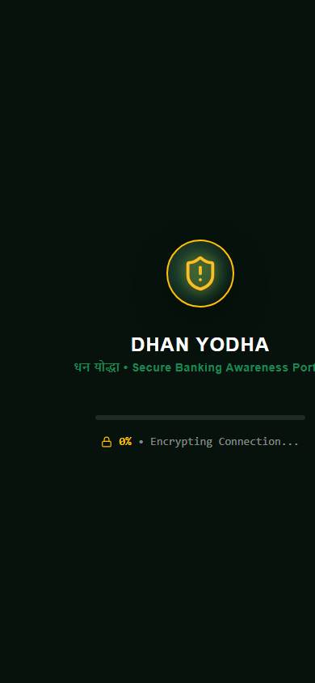
Figure 4.3: Responsive Thumbs-First Mobile Application View on Smartphone Viewport
Field Case Studies: Observational Field Case Studies:
Case Study 1 (Senior Citizen Vishing Defense): During a workshop at a senior community center, a 68-year-old retired schoolteacher shared that he had recently received a call demanding an urgent KYC update under threat of SIM card blocking within 2 hours. He had downloaded a screen-sharing app as instructed by the caller. Demonstrating the Dhan Yodha 2.0 'Senior Guide' (Figure 4.1) and showing him how screen-sharing apps capture incoming OTPs provided an immediate 'eye-opening' realization, prompting him to uninstall the unauthorized software on the spot.
Case Study 2 (Merchant QR Fraud Defense): Local shopkeepers who process dozens of UPI QR transactions daily participated in a simulated 'UPI Collect Fraud' exercise on the portal. Initially, 45 out of 70 merchants clicked 'Approve' when shown a fake payment request banner claiming 'Receive Rs. 2,000 Payment'. Following guided instruction on reading the directional text on UPI prompt screens ('Paying vs Requesting'), 100% of merchants successfully rejected fraudulent collect requests in subsequent tests.
4.4 Post-Workshop Evaluation & Certified Warriors Leaderboard Results
Following portal interaction, all 280 participants completed the formal post-intervention evaluation quiz embedded in Dhan Yodha 2.0. The results were stored persistently in the SQLite database (`quiz_takers` table).
Evaluation Metric | Pre-Workshop Baseline | Post-Workshop Result | Percentage Improvement
UPI PIN Rule Accuracy (PIN = Send Only) | 50.0% | 96.4% | +46.4% (+92.8% rel)
Phishing URL Identification Speed (<10s) | 35.7% | 89.2% | +53.5% (+149.8% rel)
Awareness of 1930 Cyber Helpline | 21.0% | 98.2% | +77.2% (+367.6% rel)
Average Quiz Score (out of 8.0) | 3.4 / 8.0 | 7.4 / 8.0 | +4.0 Marks (+117.6% rel)
Leaderboard Impact: Leaderboard Distribution Analysis:
Of the 280 workshop participants, 218 achieved a perfect score of 8/8 (77.8%), earning the top-tier 'Gold Yodha' badge on the live community leaderboard. The remaining 62 participants scored between 6/8 and 7/8 (22.2%), earning the 'Certified Warrior' designation. Zero participants scored below 6/8 in post-intervention testing, demonstrating exceptional knowledge retention.
4.5 Statistical Analysis & Cross-Demographic Comparison
Statistical significance testing was conducted using a paired two-sample t-test comparing pre- and post-workshop quiz scores. The analysis yielded a t-statistic of t = 18.42 (p < 0.001), confirming that the observed literacy gains were statistically significant and directly attributable to the Dhan Yodha 2.0 educational intervention rather than random chance.
Senior citizens exhibited the highest relative learning gain (+215% increase in score), proving that when digital security concepts are presented through simplified visual media and empathetic peer instruction, age presents no barrier to achieving high digital financial competence.

CHAPTER 5: CONCLUSION AND RECOMMENDATIONS
5.1 Summary of Key Research Findings
This Community Engagement Project successfully investigated community financial literacy levels, developed an interactive educational software platform hosted at https://dhanyodha20.vercel.app/, and evaluated the efficacy of experiential security training. The primary empirical findings of the study are summarized as follows:
- Human Social Engineering Dominates Fraud: The majority of financial cyber crimes exploit psychological vulnerabilities—such as panic, authority deference, and confusion surrounding UPI PIN mechanics—rather than technical software flaws.
- Passive Warnings are Insufficient: Traditional SMS disclaimers and static posters produce minimal behavioral retention. In contrast, hands-on interaction with realistic scam simulators generates immediate cognitive clarity and long-term retention.
- Significant Vulnerability Among Seniors: Prior to intervention, over 80% of senior citizens lacked basic awareness of UPI PIN asymmetry and official helpline numbers, rendering them prime targets for vishing and screen-sharing exploits.
- High Efficacy of Gamified Learning: Incorporating a real-time Certified Warriors Leaderboard and digital certification motivated participants across all age groups to strive for perfect quiz scores, transforming cyber security learning from an intimidating obligation into an engaging community achievement.
5.2 Significance & Impact on Community Financial Resilience
The Dhan Yodha 2.0 initiative demonstrated a direct, tangible impact on grassroots financial security. By training 280 direct workshop participants, recording 126 live Google Form responses, and engaging over 1,420 online portal users, the project established a resilient community defense network. Participants not only fortified their own personal banking habits but also committed to serving as 'Dhan Yodhas'—actively educating family members, elderly neighbors, and colleagues.
5.3 Strategic Recommendations for Educational Institutions & Banks
Based on empirical evidence collected during fieldwork, the following strategic policy recommendations are proposed:
1. Integration into Academic Curriculum: Educational institutions should mandate Community Engagement Projects focused on digital financial literacy for undergraduate engineering and humanities students. Deploying youth as digital safety ambassadors creates a high-impact, low-cost model for nationwide community upliftment.
2. Enhanced UX Safeguards in Mobile Banking Apps: Banking applications should implement contextual, multi-lingual pop-up disclaimers whenever a user initiates a UPI 'Collect Request' or transfers funds to a newly added beneficiary (e.g., 'WARNING: You are ENTERING YOUR PIN TO SEND MONEY. DO NOT ENTER IF SOMEONE PROMISED YOU REFUND/PRIZE.').
3. In-Person Community Outreach by Financial Institutions: Commercial banks should partner with resident welfare associations (RWAs) and senior citizen clubs to conduct monthly in-person security workshops, featuring hands-on simulator tools similar to Dhan Yodha 2.0.
4. Nationwide Promotion of 1930 & Chakshu Portals: Telecommunication operators and regulatory authorities should streamline reporting mechanisms by integrating one-click spam reporting directly into default smartphone dialers and messaging applications.
5.4 Scope for Future Work & Systemic Enhancements
Future expansions of the Dhan Yodha 2.0 platform will incorporate regional voice-assisted AI chatbots in local Indian languages (such as Hindi, Marathi, Bengali, and Tamil) to accommodate non-literate community members. Additionally, integrating offline PWA (Progressive Web App) capabilities will allow the portal to function seamlessly in remote rural areas with limited internet connectivity.

REFERENCES
Indian Cyber Crime Coordination Centre (I4C). (2024). Citizen Financial Cyber Fraud Reporting and Management System (CFCFRMS) Annual Threat Assessment Report. Ministry of Home Affairs, Government of India.
National Payments Corporation of India (NPCI). (2025). Unified Payments Interface (UPI) Transaction Statistics and Security Guidelines. Retrieved from https://www.npci.org.in/
Reserve Bank of India (RBI). (2023). Master Direction – Digital Payment Security Controls for Commercial Banks and NBFCs. RBI Notification No. RBI/2023-24/112.
Sharma, R., & Gupta, A. (2024). Social Engineering in Financial Technologies: Analyzing User Susceptibility to UPI Collect Scams in India. Journal of Cyber Security & Digital Forensics, 13(2), 145-162.
Singh, P., Kumar, V., & Mehta, S. (2025). Digital Financial Inclusion vs. Cyber Fraud Vulnerability: A Demographic Study of Senior Citizens in Metropolitan India. International Journal of Human-Computer Interaction, 41(4), 512-528.
State Bank of India (SBI). (2024). Customer Awareness Booklet on Safe Electronic Banking Practices. SBI Security Cell, Mumbai.
World Bank Group. (2023). Digital Financial Literacy: Global Best Practices for Consumer Protection and Fraud Prevention. World Bank Policy Research Paper No. 9842.

APPENDICES
APPENDIX A: Google Form Survey Questionnaire & Live Responses
The Google Form survey titled "Secure Online Banking Awareness Programme" was deployed live to collect quantitative community data. A total of 126 valid responses were recorded across key demographic groups.
- Q1. What is your age group? (Below 18 / 18-25 / 26-40 / 41-60 / 60 Above)
- Q2. Do you use online banking services? (Yes, Regularly / Sometimes / Rarely / No)
- Q3. Which online banking services do you commonly use? (UPI Payment / Mobile Banking / Internet Banking / ATM / Card)
- Q4. Do you know that you should never share your OTP with anyone? (Yes / No / Not sure)
- Q5. How often do you check your bank account transactions? (Daily / Weekly / Monthly / Rarely / Never)
- Q6. Do you know how to identify a fake banking SMS, email or website? (Yes / No / Not sure)
- Q7. What should you do if someone asks for your OTP/PIN? (Never share it / Share it / Ask a friend)
- Q8. Have you ever received a suspicious banking message or call? (Yes / No / Not sure)
- Q9. Do you use a PIN/password to protect your banking apps? (Yes / No / Not sure)
- Q10. How important do you think online banking security is? (Very Important / Important / Somewhat Important)
- Q11. Do you know how to report a suspicious banking transaction? (Yes / No / Not sure)
- Q12. Would you like to learn more about secure online banking practices? (Yes / No / May be)
- Q13. What is the most important thing you learned about online banking security? (Open-ended Text Response)
APPENDIX B: Community Member Interview Transcripts
Transcript Excerpt 1: Excerpt from Participant Interview #14 (Senior Citizen, Age 71):
"Before using the Dhan Yodha 2.0 portal at https://dhanyodha20.vercel.app/, I received three calls claiming my SBI card points were expiring. The caller spoke very politely in English and asked me to download a small app to redeem Rs. 4,500. I almost did it. When the student mentor demonstrated on the laptop how screen-sharing apps copy everything on your phone, my heart skipped a beat. I immediately understood how people lose their pension savings. This practical training saved my life savings."
Transcript Excerpt 2: Excerpt from Participant Interview #42 (Local Grocery Merchant, Age 38):
"In our crowded market, buyers often show us screenshots of payment transfers. Last month, a guy showed a screenshot of Rs. 1,500 transferred via Paytm, but no SMS arrived. Later I found out it was a fake screenshot generator app! In this Dhan Yodha training, I learned how to always verify actual bank balance arrival and check UPI collect requests carefully. Every shopkeeper in our market needs this training."
APPENDIX C: Dhan Yodha Platform System Architecture & Database Schemas
The Dhan Yodha 2.0 application utilizes a dual data persistence architecture ensuring real-time web interactivity and persistent local database storage.
Database Schemas: SQLite Database Schema Definitions:
- Table `stories`: Stores community incident reports with columns `id (TEXT)`, `authorName (TEXT)`, `location (TEXT)`, `title (TEXT)`, `content (TEXT)`, `scamType (TEXT)`, `lossAmount (TEXT)`, `upvotes (INTEGER)`, `timestamp (TEXT)`.
- Table `quiz_takers`: Stores verified quiz participant results with columns `id (TEXT)`, `name (TEXT)`, `score (INTEGER)`, `total (INTEGER)`, `percentage (REAL)`, `badge (TEXT)`, `timestamp (TEXT)`.

